MiniSwiggy Tutorial
Installation, usage manual and demo guide

Registration number: 23MCCE11
Distributed Computing Mini Project
September 2026

Contents
1. What is in the project folder 3
2. Installation 3
2.1 Requirements 3
2.2 Check Java 3
2.3 Get the code 3
2.4 Build 4
3. Run the automated tests 4
4. Run the scripted demo 4
Step 1 and 2: start-up 5
Step 3: concurrent orders with live updates 5
Step 4: round-robin load balancing 7
Step 5: crash of the primary and failover 7
Step 6: recovery 8
Step 7: consistency check and summary 9
5. Usage manual: running the parts yourself 9
5.1 Customer commands 10
5.2 Restaurant commands 10
5.3 Rider commands 10
5.4 A complete order by hand 10
5.5 Program options 11
5.6 Try the failure yourself 11
5.7 Running on more than one computer 11
6. Talking to the gateway without a client 11
7. Troubleshooting 12
8. About the screenshots 12

1. What is in the project folder
MiniProject_23MCCE11/
README.md short overview and quick start
src/common/ message format, protocol names, socket helpers, order + menu data
src/node/ OrderNode (order server) and OrderStore (in-memory data)
src/gateway/ Gateway (load balancer, heartbeats, failover), PubSub
src/client/ CustomerClient, RestaurantClient, RiderClient + shared client code
src/demo/ DemoRunner (scripted demo)
tests/ TestRunner (automated tests)
scripts/ build / run-tests / run-demo (.ps1 for Windows, .sh for Linux/macOS)
docs/ the project documents (.docx and .doc)
screenshots/ terminal output from real runs
presentation/ slides (.pptx)
logs/ full output of the last demo, test and protocol runs
MiniSwiggy has five kinds of programs. All of them talk over TCP sockets:
Program | Class | Default port
Order node N1 | node.OrderNode | 9101
Order node N2 | node.OrderNode | 9102
Gateway | gateway.Gateway | 9000
Customer / Restaurant / Rider apps | client.CustomerClient, client.RestaurantClient, client.RiderClient | -

2. Installation

2.1 Requirements
- A Java Development Kit (JDK), version 17 or newer. The project was developed and tested with JDK 25.0.2 on Windows 11. Any JDK from Oracle, Eclipse Adoptium (Temurin) or Microsoft should work.
- Nothing else. There are no libraries to download and no Maven or Gradle.

2.2 Check Java
Open a terminal (PowerShell on Windows, Terminal on Linux/macOS) and type:
java -version
javac -version
Both must print version 17 or higher. If javac is not found, you have only a runtime (JRE): install a JDK and open a new terminal.

2.3 Get the code
- Unzip MiniProject_23MCCE11.zip to any folder.
- Open a terminal in that folder (the one containing README.md).
- Windows only: if PowerShell says running scripts is disabled, run this once in the same window:
Set-ExecutionPolicy -Scope Process Bypass
This only affects the current window.

2.4 Build
.\scripts\build.ps1 (Windows)
sh scripts/build.sh (Linux / macOS)
You should see Build OK: 21 source files compiled into out\. The compiled classes are in the out folder. If you prefer to build by hand:
javac --release 17 -d out (all .java files under src and tests)

3. Run the automated tests
.\scripts\run-tests.ps1 (Windows; add -Verbose to see every component's log)
sh scripts/run-tests.sh (Linux / macOS)
The tests start two nodes and a gateway inside one Java process on free ports. They check every feature, including a crash of the primary and its recovery. The run takes about 10 seconds and must end with 14 passed, 0 failed.
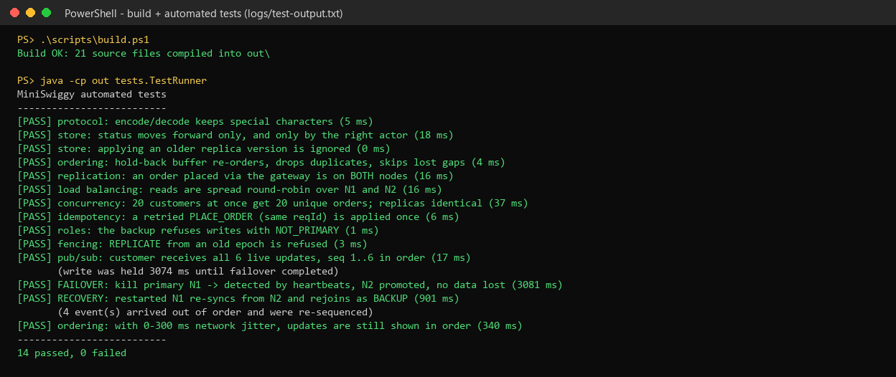
Screenshot 1: build and automated tests (real output)
Notes printed under two tests are measurements from that run:
- "write was held ... ms until failover completed" is how long a customer's order waited while the gateway detected the crash and promoted N2. It is about 3 seconds: 3 missed heartbeats, one per second.
- "... event(s) arrived out of order and were re-sequenced" counts how many updates overtook each other under simulated network delay and were put back in order by the client. This number changes from run to run.

4. Run the scripted demo
.\scripts\run-demo.ps1 (Windows)
sh scripts/run-demo.sh (Linux / macOS)
The demo starts 11 separate Java processes (2 nodes, the gateway, 2 restaurants, 2 riders and several customers). All their output is merged into your terminal, and also saved to logs/demo-transcript.txt. It takes about 30 seconds and ends with ALL CHECKS PASSED. Ports 9000, 9101 and 9102 must be free.
Each line has the form time [who] message, where who is N1, N2, GATEWAY, a client ID or DEMO. In the screenshots, colours were added to make important lines stand out; the real terminal shows plain text.

Step 1 and 2: start-up
The nodes start. Each tries to copy data from its peer, which is empty on the first start. Then the gateway starts heartbeats. The gateway elects N1 as PRIMARY (epoch 1) and tells N2 it is BACKUP. Restaurants and riders connect in automatic mode.
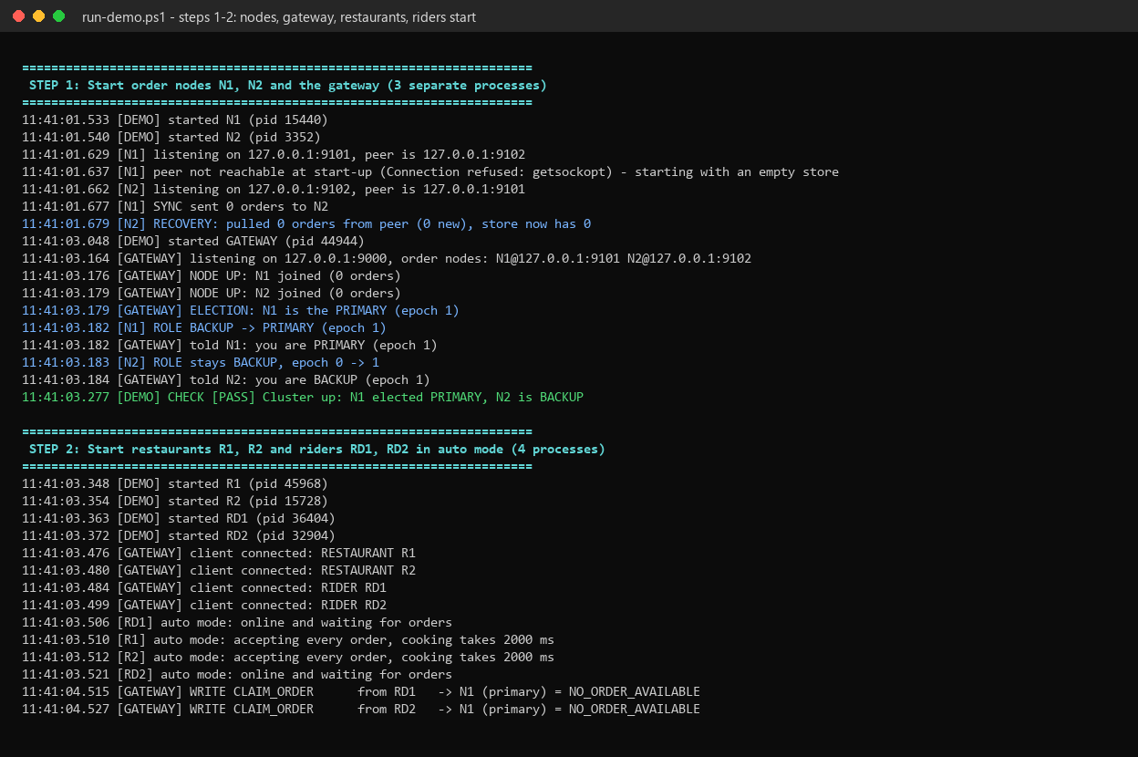
Screenshot 2: cluster start-up

Step 3: concurrent orders with live updates
Three customer processes order at the same time. Things to notice:
- READ ... -> N2 (round-robin): reads go to both nodes.
- REPLICA O-1 v1 on N2 is printed before WRITE ... (replicated to peer) on N1. The backup stores the order first, then the primary commits it.
- LIVE O-2 #3 ... lines: updates pushed to the customer, numbered by sequence.
- <- arrived out of order, held back and re-sequenced: the demo gateway adds 0-250 ms random delay to each pushed event, so some events overtake others. The client still prints them in the right order.
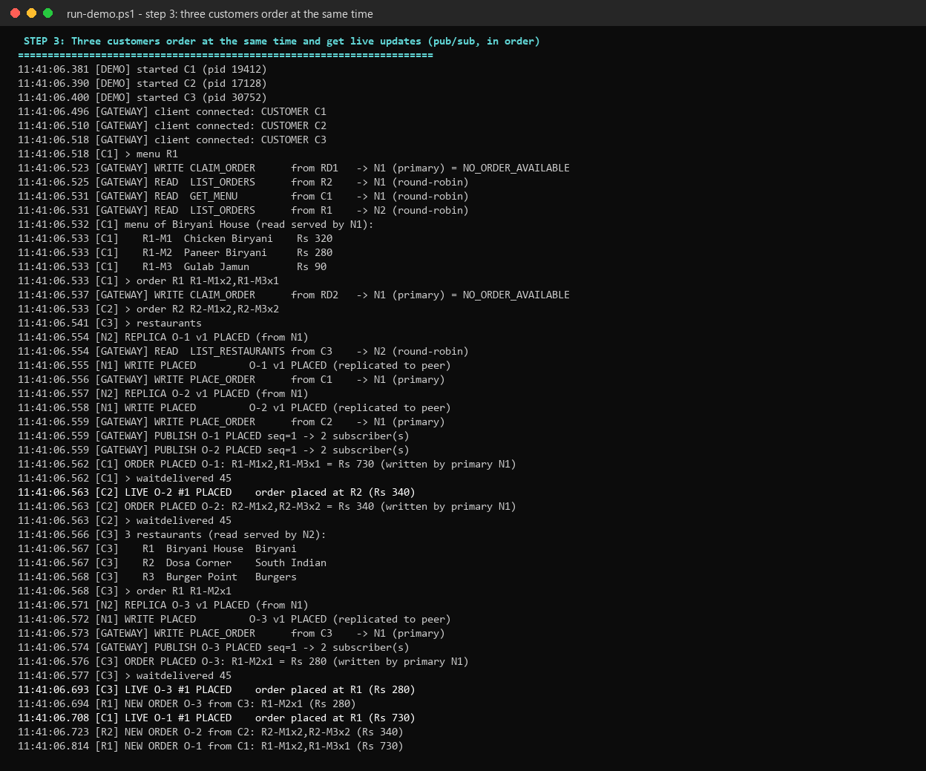
Screenshot 3: three customers order at the same time
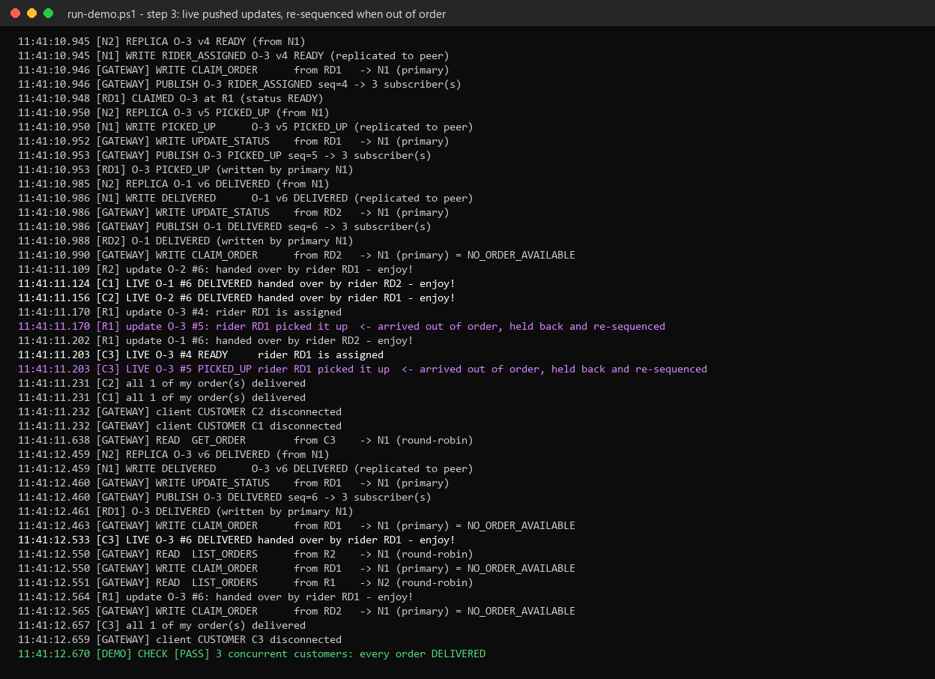
Screenshot 4: live updates, including one re-sequenced event

Step 4: round-robin load balancing
Six reads through the gateway alternate between N2 and N1.
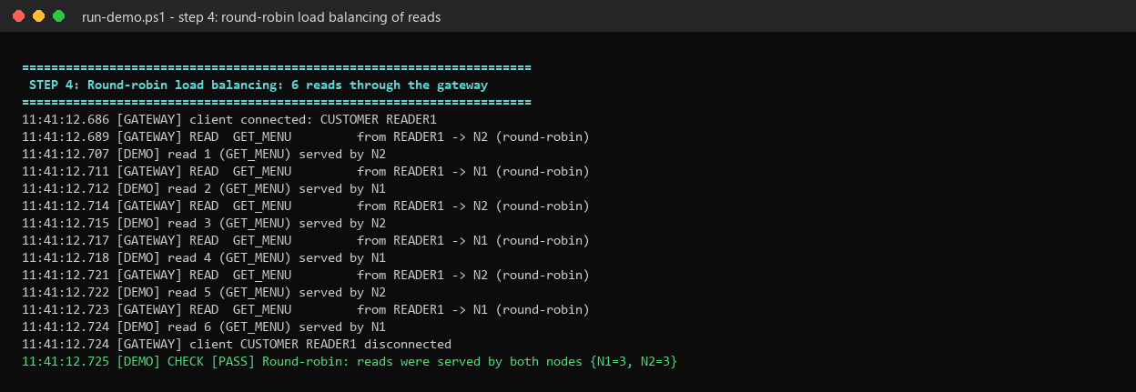
Screenshot 5: round-robin reads

Step 5: crash of the primary and failover
Two customers order. While the food is being prepared, the demo kills N1's process (a hard kill, like kill -9). A third customer orders immediately after. Then:
- The gateway reports heartbeat to N1 missed (1/3), then (2/3), then (3/3).
- Writes to N1 fail and are held: holding it until failover.
- FAILURE DETECTED and FAILOVER: ... promoting N2 to PRIMARY (epoch 2).
- The held writes are delivered to N2: - delivered after failover.
- N2 has no peer, so it writes NOT replicated, peer down. This is degraded mode.
- All three orders are still delivered.
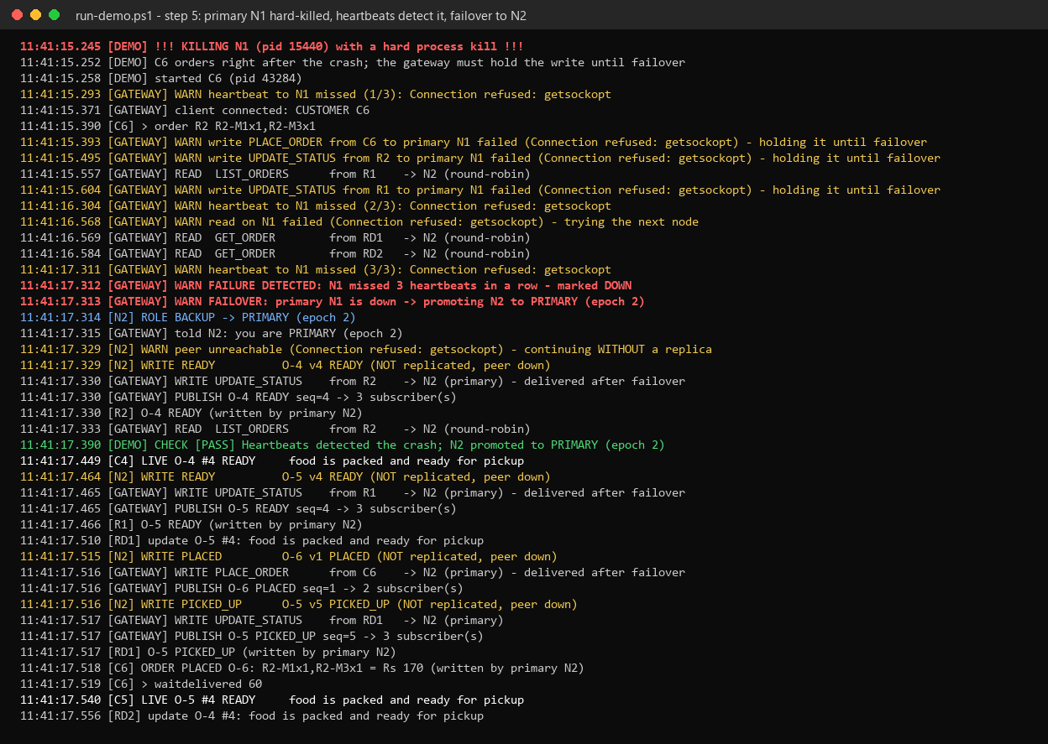
Screenshot 6: failure detection and failover

Step 6: recovery
N1 is started again. It pulls a snapshot of 6 orders from N2 (RECOVERY: pulled 6 orders), becomes ready, and the gateway marks it RECOVERED and makes it BACKUP in epoch 2. The next order is replicated from N2 to N1 (replication resumed), and reads use both nodes again.
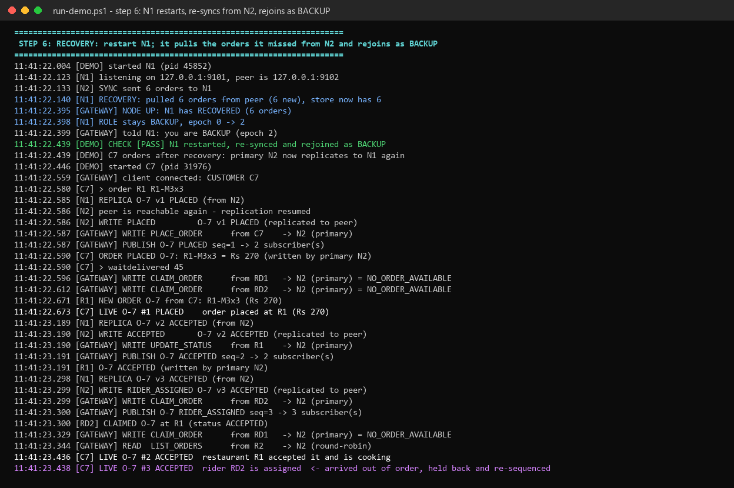
Screenshot 7: recovery and re-sync

Step 7: consistency check and summary
The demo asks both nodes directly for their order count and a checksum of all orders. Both must match, and all 7 orders must be DELIVERED. The summary lists 10 automatic checks.
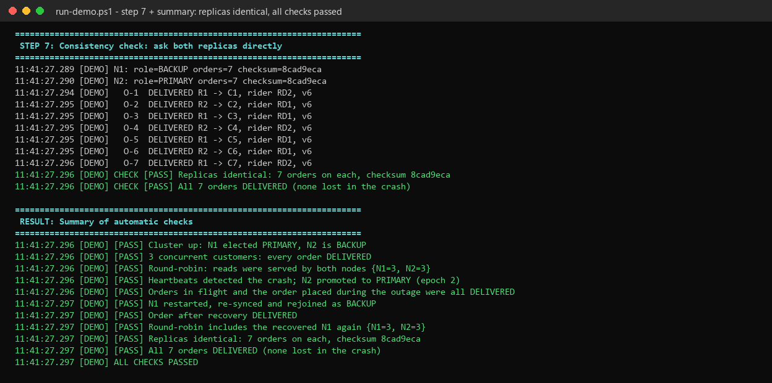
Screenshot 8: consistency check and results

5. Usage manual: running the parts yourself
Build first. Then open six terminals in the project folder and start one program in each:
java -cp out node.OrderNode --id N1 --port 9101 --peer 127.0.0.1:9102
java -cp out node.OrderNode --id N2 --port 9102 --peer 127.0.0.1:9101
java -cp out gateway.Gateway --port 9000 --nodes N1=127.0.0.1:9101,N2=127.0.0.1:9102
java -cp out client.RestaurantClient --id R1
java -cp out client.RiderClient --id RD1
java -cp out client.CustomerClient --id C1
Start the two nodes and the gateway first. Every client prints its commands at start-up; type help to see them again, and quit to leave.

5.1 Customer commands
Command | Example | What it does
restaurants | restaurants | List restaurants
menu | menu R1 | Show a menu with item IDs and prices
order | order R1 R1-M1x2,R1-M3x1 | Order 2 x R1-M1 and 1 x R1-M3 from R1
track | track O-1 | Show the current state of an order
myorders | myorders | List all my orders
waitdelivered | waitdelivered 60 | Wait (up to 60 s) until all my orders are delivered
wait | wait 5 | Pause 5 s (useful in scripts)

5.2 Restaurant commands
Command | Example | What it does
orders | orders | List orders for this restaurant
accept | accept O-1 | PLACED -> ACCEPTED
ready | ready O-1 | ACCEPTED -> READY

5.3 Rider commands
Command | Example | What it does
claim | claim | Take the oldest accepted order that has no rider
pickup | pickup O-1 | READY -> PICKED_UP (only your own order)
deliver | deliver O-1 | PICKED_UP -> DELIVERED

5.4 A complete order by hand
Type these in the three client windows, in this order:
C1> menu R1
C1> order R1 R1-M1x2,R1-M3x1 -> ORDER PLACED O-1
R1> accept O-1 -> C1 sees: LIVE O-1 #2 ACCEPTED
RD1> claim -> CLAIMED O-1
R1> ready O-1 -> C1 and RD1 see READY
RD1> pickup O-1
RD1> deliver O-1 -> C1 sees: LIVE O-1 #6 DELIVERED
Try a mistake as well, for example deliver O-1 before pickup. You get a clear error such as ERROR INVALID_TRANSITION, and nothing changes.

5.5 Program options
Program | Option | Default | Meaning
all clients | --id | C1 / R1 / RD1 | Who you are. For restaurants it must be R1, R2 or R3
all clients | --gateway | 127.0.0.1:9000 | Where the gateway is
CustomerClient | --script "cmd; cmd" | - | Run commands without typing, then exit (exit code 0 = all OK)
RestaurantClient | --auto, --prep-ms | off, 2000 | Accept every order and mark it ready after prep-ms
RiderClient | --auto, --ride-ms | off, 1500 | Claim, pick up and deliver automatically
Gateway | --port, --nodes | 9000, N1/N2 on 9101/9102 | Listening port and the order nodes (first = preferred primary)
Gateway | --jitter-ms | 0 | Random 0..n ms delay on each pushed event (simulates a slow network)
OrderNode | --id, --port, --peer | -, 9101, required | Node name, listening port, the other node's address
Gateway, OrderNode | --bind | 127.0.0.1 | Use 0.0.0.0 to accept connections from other computers

5.6 Try the failure yourself
With everything running from 5.4, press Ctrl+C in the N1 window. This stops the process at once, like the hard kill used in the demo. Within about 3 seconds the gateway window shows three missed heartbeats, FAILURE DETECTED and FAILOVER. Place another order from C1: it works, and the reply says written by primary N2. Start N1 again with the same command. It prints RECOVERY: pulled ... orders from peer, and the gateway shows NODE UP: N1 has RECOVERED.

5.7 Running on more than one computer
Start the nodes and the gateway with --bind 0.0.0.0. Use the real IP addresses in --peer, --nodes and --gateway, and allow the ports through the firewall. This was not tested for this report; all tests ran on one computer.

6. Talking to the gateway without a client
Because the protocol is plain text, you can talk to the gateway with any TCP tool. The PowerShell lines below are a shorter version of the script used for Screenshot 9, and were tested as shown. The nodes and the gateway must be running first:
$c = New-Object System.Net.Sockets.TcpClient("127.0.0.1", 9000); $c.ReceiveTimeout = 400
$st = $c.GetStream(); $w = New-Object System.IO.StreamWriter($st); $w.AutoFlush = $true
$r = New-Object System.IO.StreamReader($st)
function Say($m) { ">> $m"; $w.WriteLine($m)
while ($true) { try { $l = $r.ReadLine(); if ($l -eq $null) { break }; "<< $l" } catch { break } } }
Say "HELLO|role=CUSTOMER|id=RAW1|reqId=2"
Say "PLACE_ORDER|restaurant=R2|items=R2-M1x1%2CR2-M3x1|reqId=4"
$c.Close()
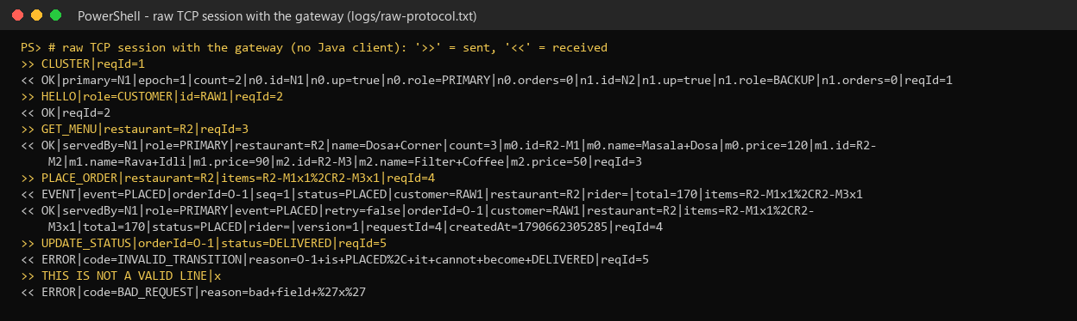
Screenshot 9: a raw protocol session (real output)
The full message list is in RequirementSpecificationSimpleApp_23MCCE11, section 8.

7. Troubleshooting
Problem | Cause and fix
Address already in use: bind | An old node or gateway still runs. Close its window. On Windows find it with Get-NetTCPConnection -LocalPort 9000,9101,9102 and stop that process ID; on Linux/macOS use lsof -i :9000.
javac not recognised | Only a JRE is installed, or PATH is not set. Install a JDK 17+ and open a new terminal.
Scripts are blocked in PowerShell | Run Set-ExecutionPolicy -Scope Process Bypass in that window.
no reply from gateway / connection refused | The gateway is not running or is on another port.
NO_NODE_AVAILABLE | Both order nodes are down, or no primary was found within 10 s. Start a node.
ERROR NOT_ALLOWED | You tried to change an order that is not yours (wrong restaurant or rider).
Demo says SOME CHECKS FAILED | Look for [FAIL] in logs/demo-transcript.txt. The most common cause is a port that is already in use.
Stopping a background Java process in PowerShell does not free the port | On some Windows set-ups java is a small launcher that starts the real JVM as a child process. Stop the process that owns the port (see the first row).

8. About the screenshots
Screenshots 1-9 were made from the real text output of the runs described in this tutorial (logs/test-output.txt, logs/demo-transcript.txt, logs/raw-protocol.txt). The text is unchanged; it was drawn into a terminal-style image, with colours added for readability. They are not photos of the screen.

