Insurance Policy Generator (MERN + Chatbot)

Internship Project Report

Name: Aravindhan V

Company: Infowave Technologies Pvt. Ltd.

Duration: February 26, 2025 – April 30, 2025

Submitted in partial fulfillment of Internship Requirements

Date: April 20, 2025

# Table of Contents

1. Abstract

2. Introduction

3. Problem Statement

4. Objectives

5. System Architecture

6. Technology Stack

7. System Design

8. Modules Description

9. Premium Calculation Logic

10. Database Design

11. Frontend Design

12. Conclusion

13. Future Enhancements

14. References

# 1. Abstract

This project, "Insurance Policy Generator", was developed using the MERN stack and Botpress chatbot framework   
to automate the process of policy generation for Life, Health, Vehicle, and Home insurance types. The system interacts with users via a chatbot,  
collects required data, calculates premiums, and generates policy documents efficiently. The backend handles dynamic form generation, data storage, and PDF policy creation.

# 2. Introduction

The insurance industry is rapidly adopting digital solutions for customer convenience and operational efficiency.   
This project integrates a chatbot with a full-stack web application to streamline policy creation, improve user interaction, and reduce manual efforts.

# 3. Problem Statement

Manual insurance policy processing is time-consuming and prone to errors. Customers often find it difficult to understand various policy types   
and fill lengthy forms. This project solves these issues using an interactive chatbot and a dynamic backend for automated policy generation.

# 4. Objectives

- Create an interactive chatbot interface to guide users in selecting and applying for insurance policies.  
- Dynamically collect and validate policy-related data.  
- Implement backend logic for premium calculation.  
- Generate downloadable insurance policy documents.  
- Maintain user data securely in a MongoDB database.

# 5. System Architecture

The system uses a modular architecture integrating frontend, backend, chatbot, and database components.

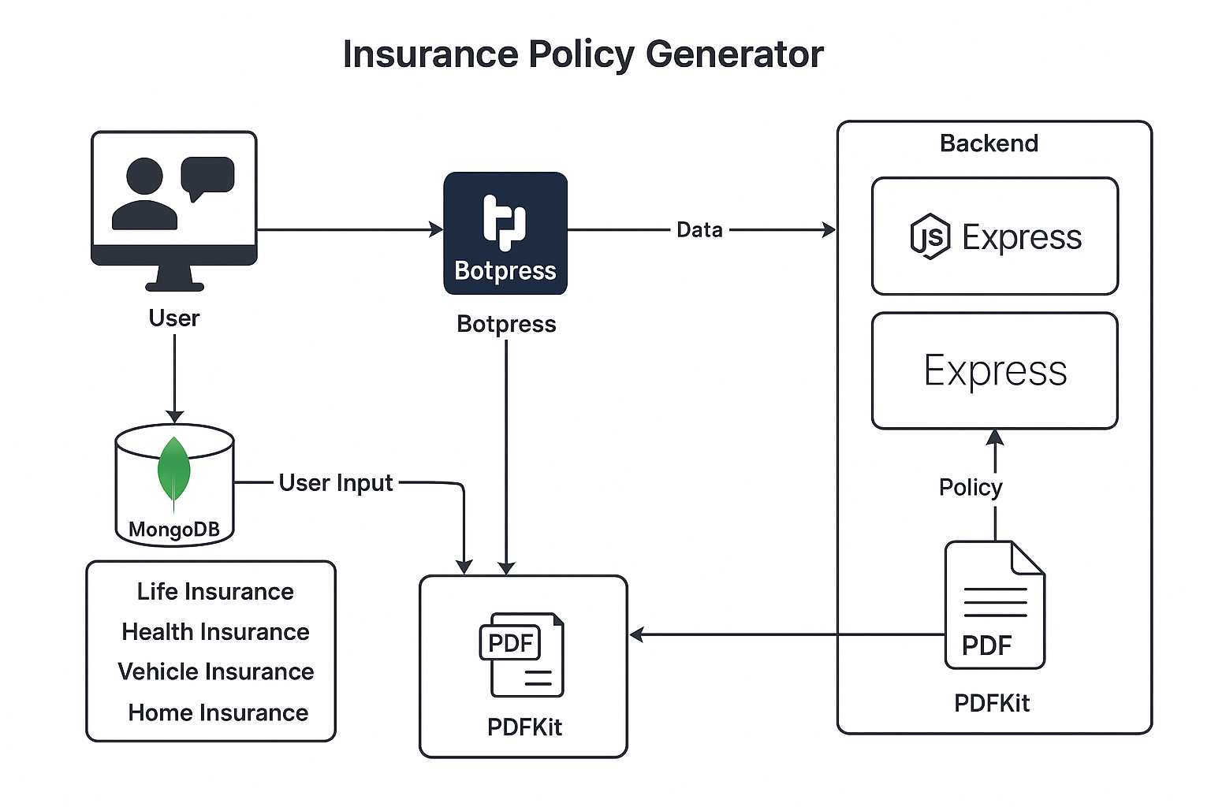

# 6. Technology Stack

- Frontend: React.js  
- Backend: Node.js + Express.js  
- Database: MongoDB (via Mongoose)  
- Chatbot: Botpress  
- Libraries: PDFKit (PDF generation), Axios, Mongoose

# 7. System Design

The following flowchart describes the interaction between user and the system through the chatbot:



Flowchart: User interaction through Botpress, backend processing, and policy generation.