**INSURANCE POLICY GENERATOR**

**Internship Project Report**

**Name** : **Aravindhan** **V**

**Company** : **TCS**

**Duration** : **8** **Weeks**

**Introduction:**

This project is about simplifying the process of insurance policy creation using a chatbot and the MERN stack. The main goal was to build a web-based system where users can interact with a chatbot to select an insurance type, provide necessary information, get their premium calculated, and generate a downloadable policy document. This helps reduce the manual work and makes the process user-friendly and interactive.

**Tools & Technology Used:**

* MongoDB – For storing user and policy data
* Express.js – Backend server
* React.js – Frontend interface
* Node.js – Server runtime
* Botpress – Used for building the chatbot
* PDFKit – For generating policy documents in PDF format
* Mongoose – For MongoDB data modeling

**Main Features**

* Chatbot to guide users through the process
* Supports Life and Vehicle Insurance
* Premium is calculated based on input data
* Policy PDF is generated and downloaded
* All details are saved in MongoDB

**System Architecture**

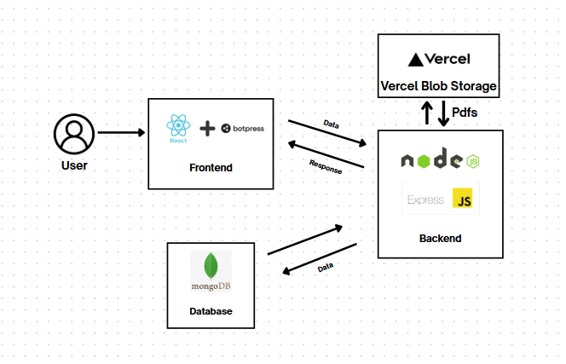

**How It Works**

* The user opens the chatbot from the website and starts the chat with the chatbot
* The chatbot gives a welcome message and shows two options: Create a new policy and view
* existing policies.
* Based on the user selection it starts the process.
* If the user selects create a new policy, it starts to collect the data from the user.
* It collects user-specific and policy details.
* After, user-specific details are collected, it shows the available insurance options: Life and Vehicle
* Insurance
* After collecting all the necessary data, the bot sends an API request to the backend server to
* calculate the premium for the policy
* The bot shows the premium and asks the user whether to proceed.
* If the user agrees, the data is saved with “Active” status, and a PDF policy is generated.
* If not, the data is stored with “Cancelled” status for future uses.
* Finally, Link to the pdf is sent to the user in the chat.

**Premium calculation Logic:**

**Life Insurance:**

- Depends on age, term, and sum assured

- Older age = higher premium

**Vehicle Insurance:**

- Based on vehicle age, type of coverage (comprehensive or third-party), and driver history

- Example: New car with no accidents and comprehensive cover → lower premium

- Old car with accident history → higher premium

**What I Learned**

* How to build an end-to-end MERN application
* Working with real-time chatbots using Bot press
* Creating PDFs dynamically using PDFKit.
* Connecting frontend, backend, and database smoothly

**Output Snapshots**

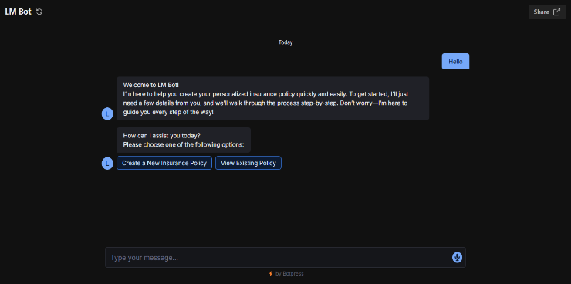 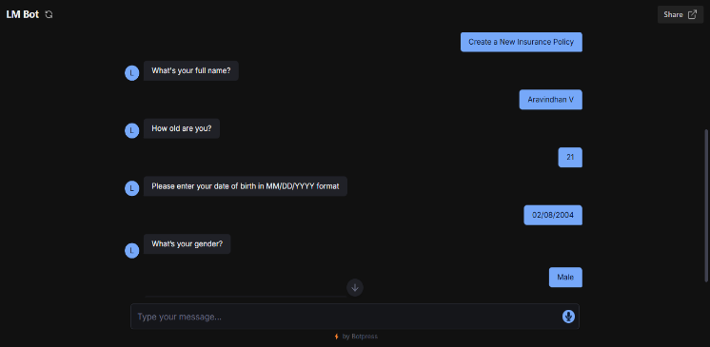

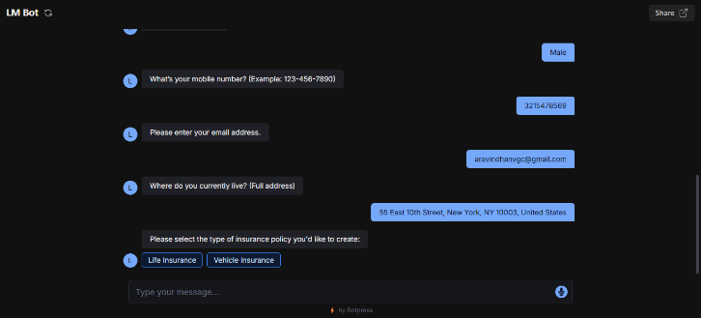 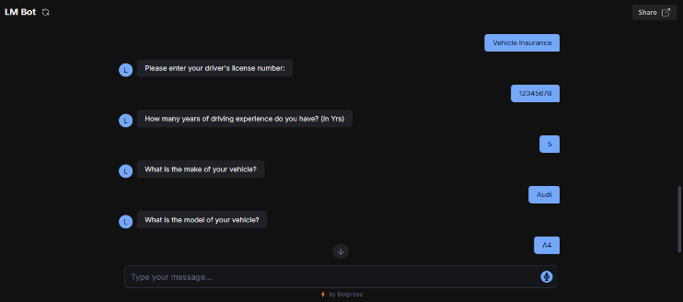

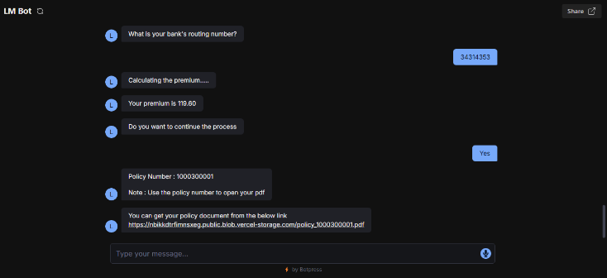 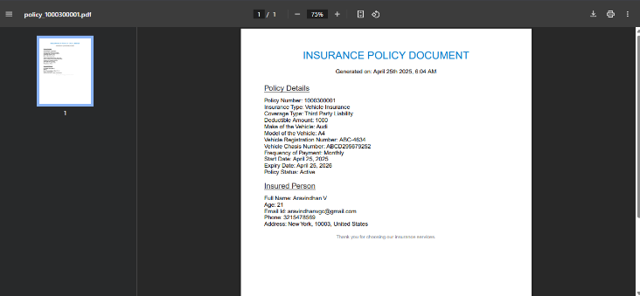

**Challenges Faced**

* Getting the chatbot and React app to sync smoothly
* Connecting the Chatbot and the backend server.
* Creating flexible premium logic for different types

**Future Improvements**

* Add Home Insurance fully
* Create an admin dashboard to manage policies
* Allow users to make payments and get receipts
* Send policy PDF to email or WhatsApp automatically

**Conclusion**

This project helped me understand how to build smart, interactive systems using full stack development. I learned how to connect a chatbot with backend logic and handle real user data. The whole insurance process became simpler and user-friendly through automation.