Algorithm

Algorithm

→ An algorithm is a step-by-step procedure or set of rules to solve a problem .

Algorithm | Programer
→ design | → Implementaion
→ Domain knowledge | → program
→ any language | → prgm language
→ analyze | → Testing

How to Analyze a algorithm

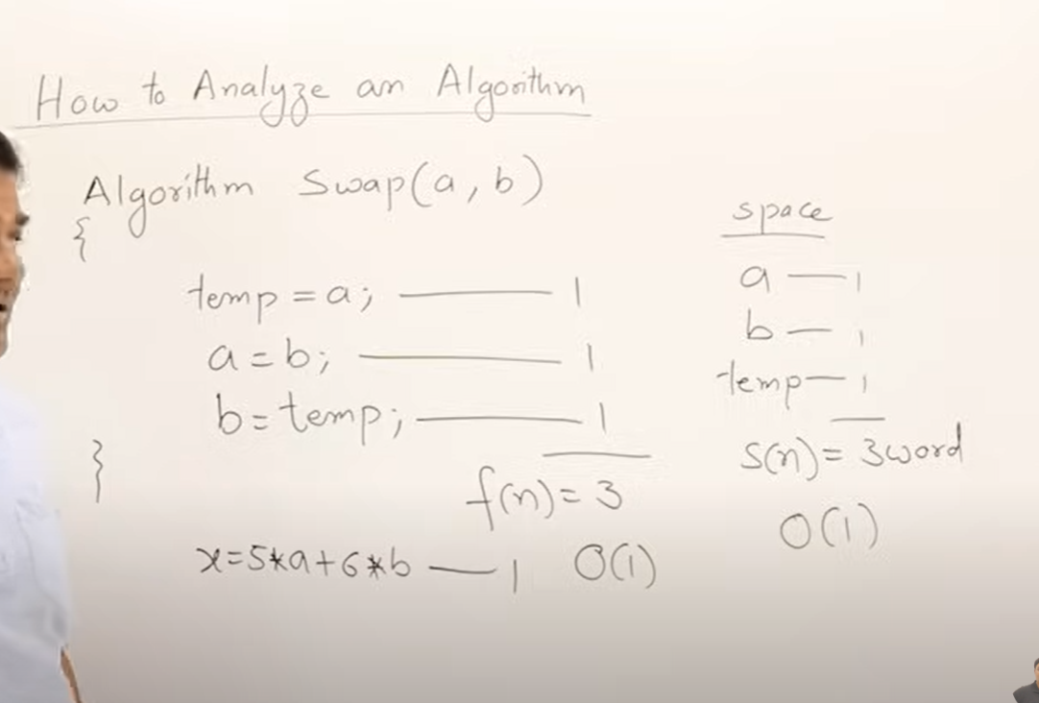
→ Each statement takes an 1 unit of time.
→ Each variable takes an 1 word of space

1.4 frequency count methods
1)
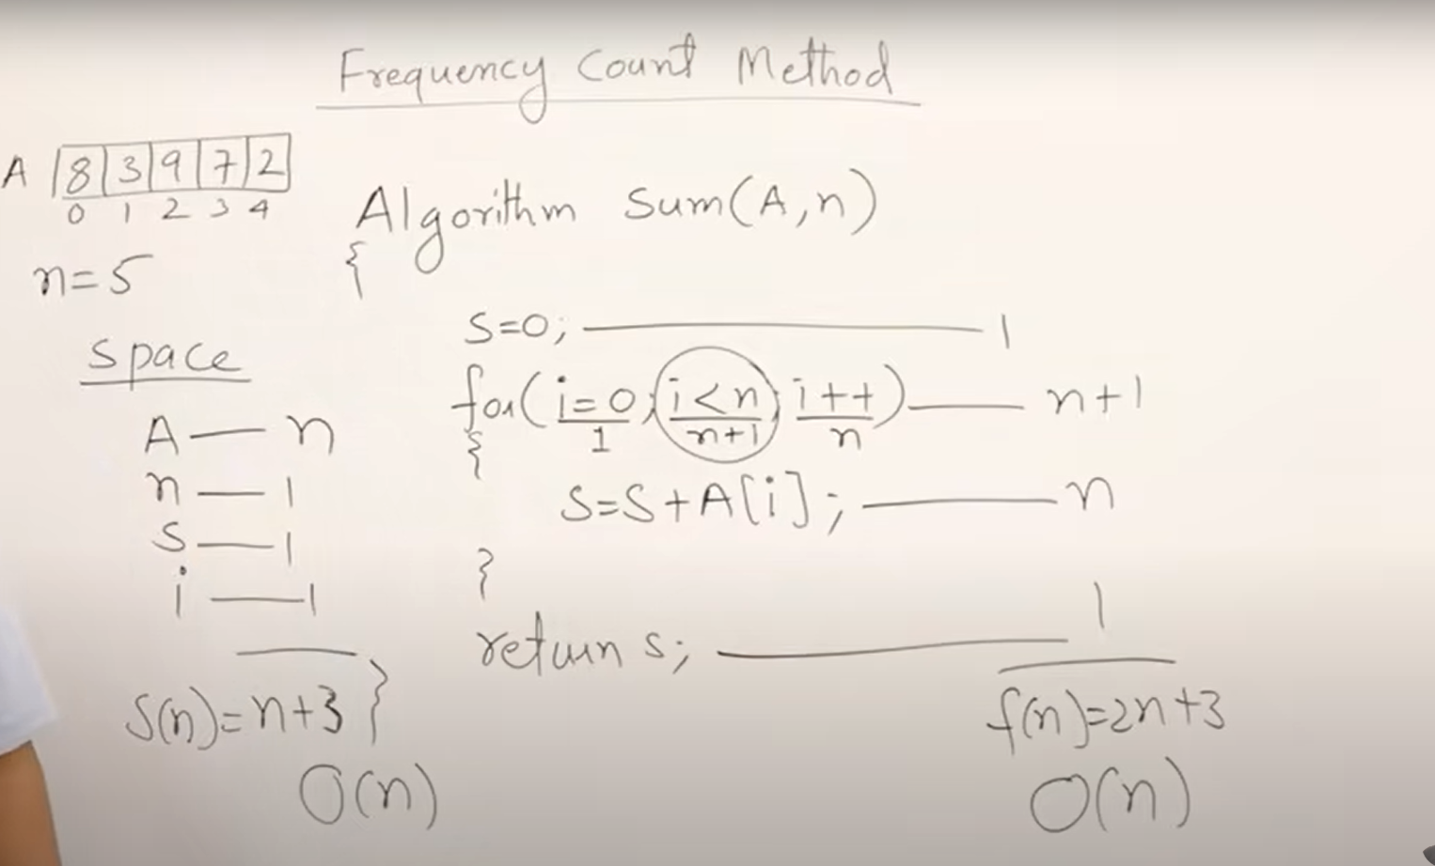

→ in the for loop if n=5 runs but condition checks n+1 times so we take the satement as n+1 ,

2)
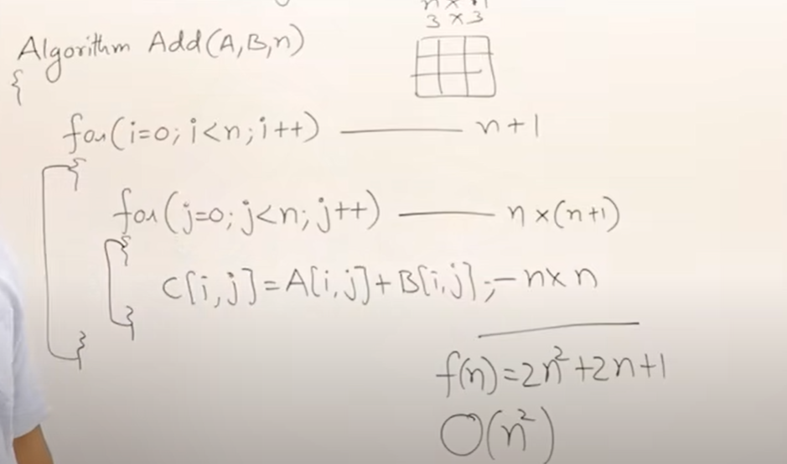
if outer loop n+1 check mean inner loop and assigning has n and n times then same for inner loop
Space complexity

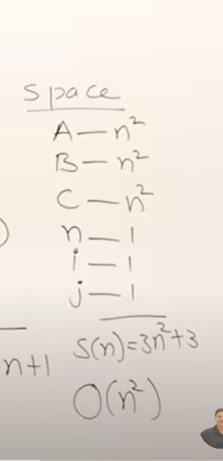

3)

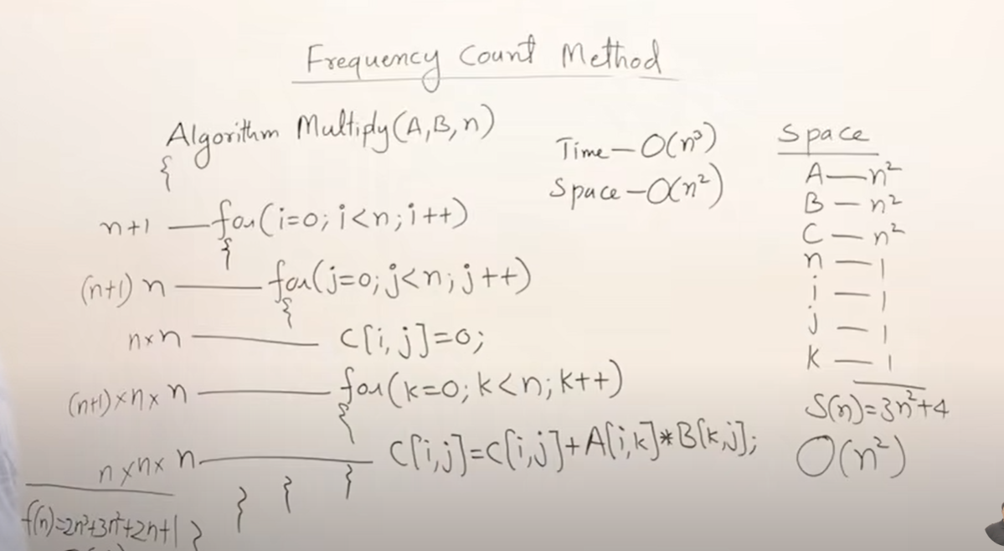
h

Time Complexitty
______________
1)
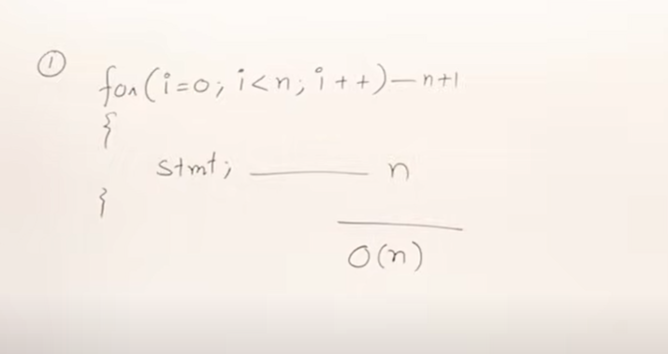
2)
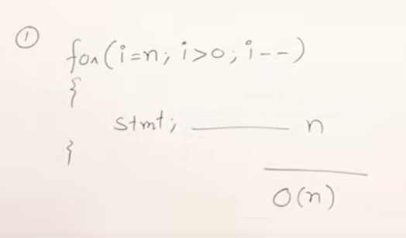
3)

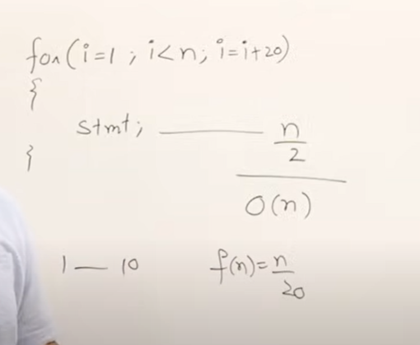
4
4)
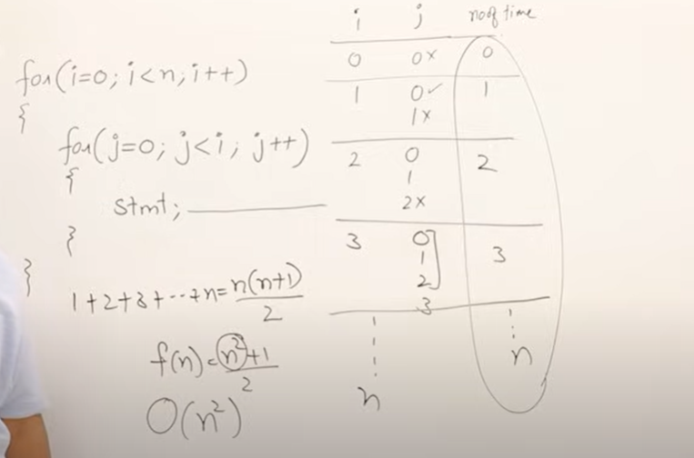
.
5)

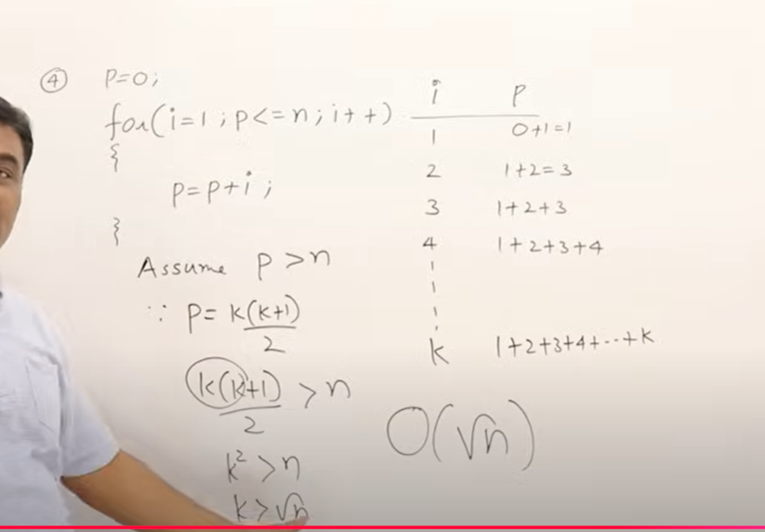
.
6
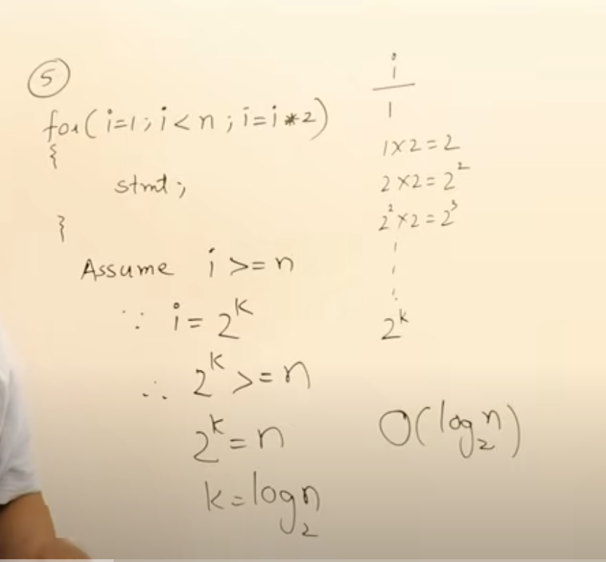
.
other method
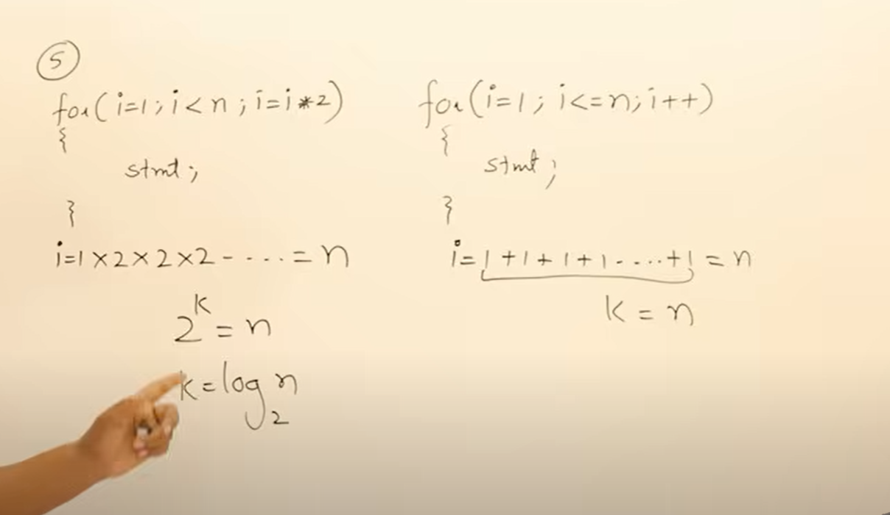
.
7)
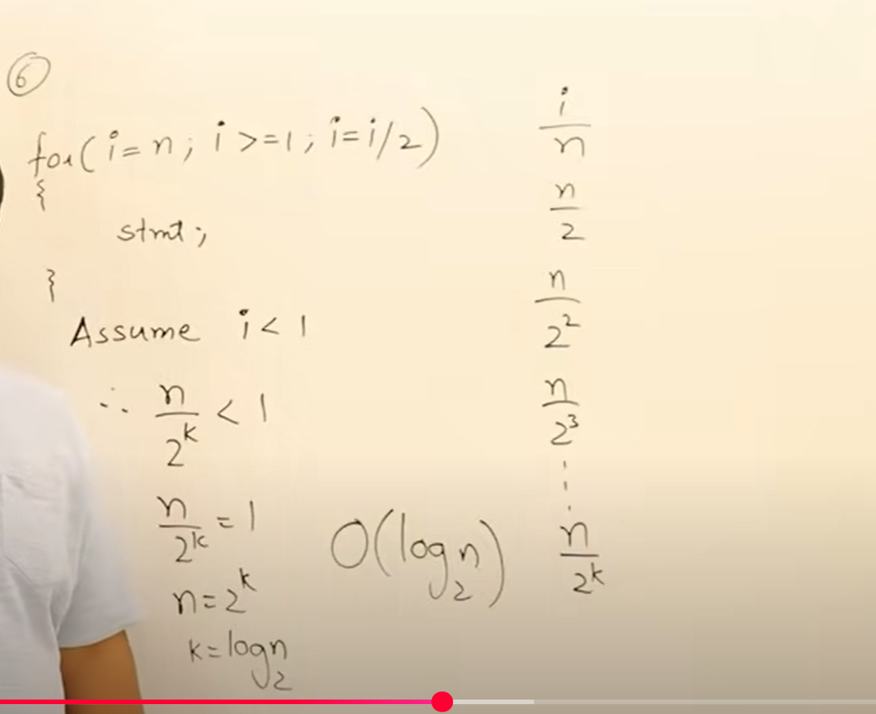
8)

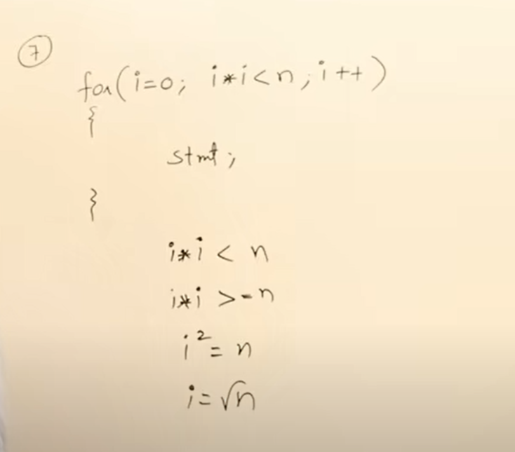
.

9)
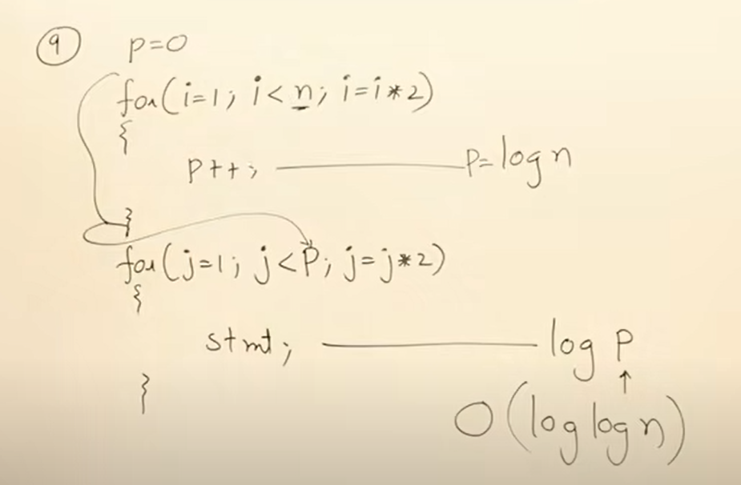
10)
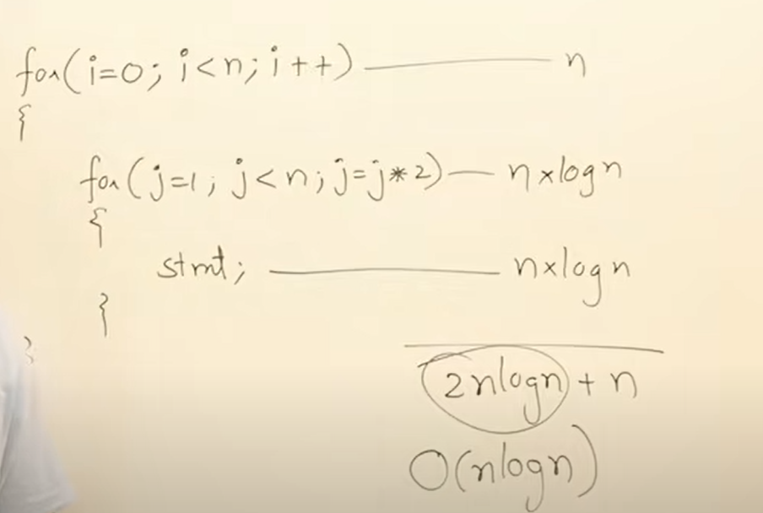
11) Take this like a formula
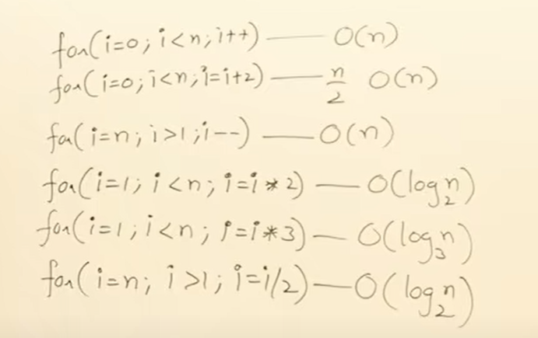
.
Time complexity in while loop
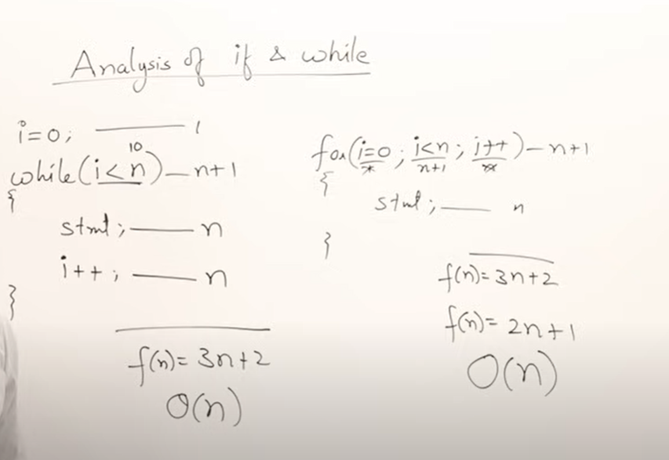
2)
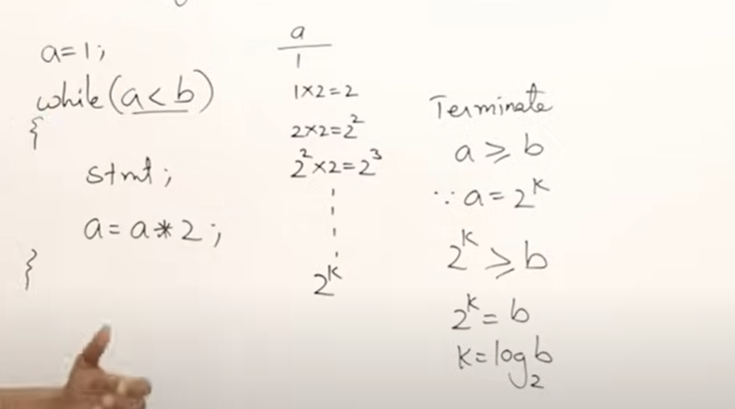
3)
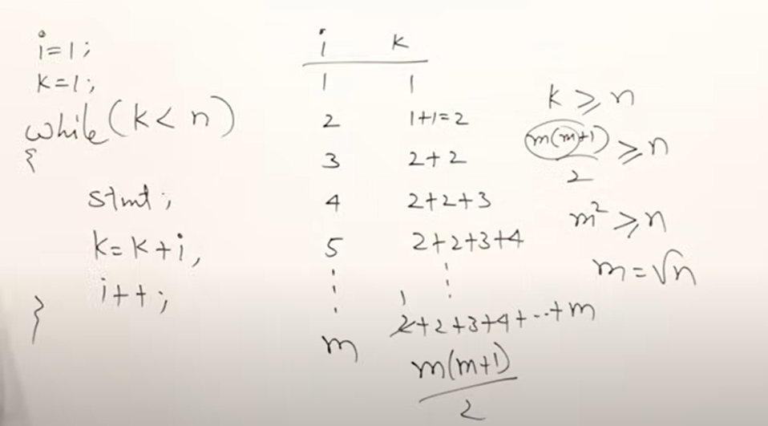
.
4)
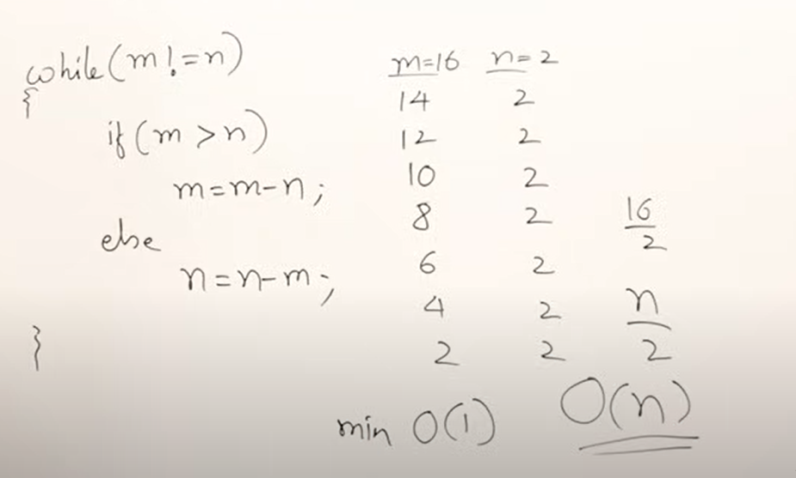
Check all posivblity for finding the maximum time limit.
5)

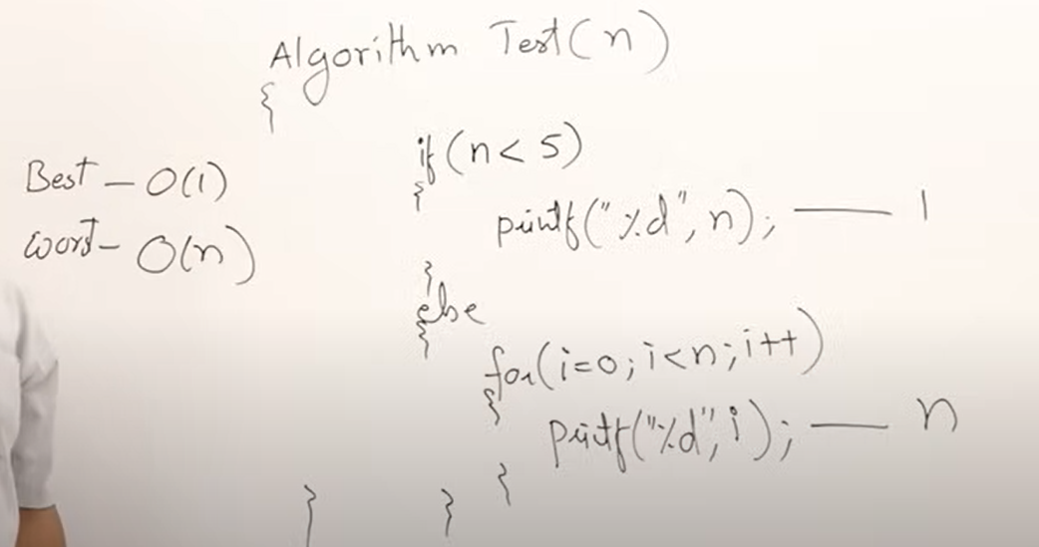
.

1.6 classes Of function
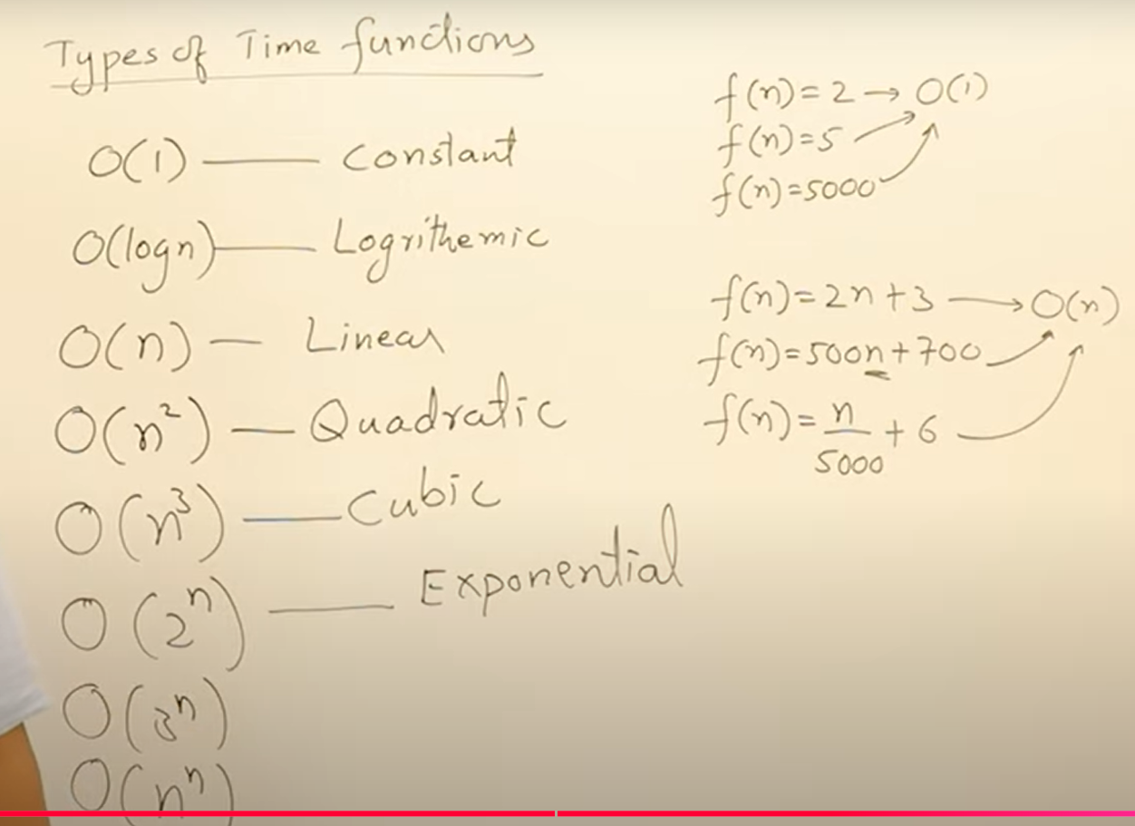
Compare of class Function
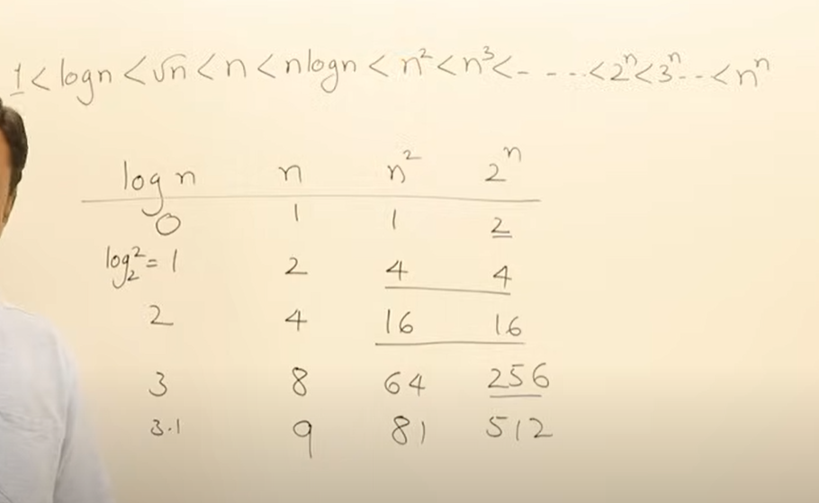

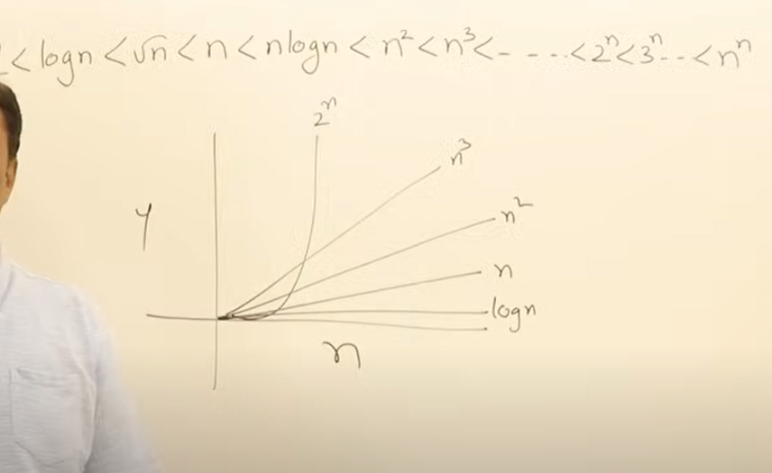
.

Divide and Conquer
→ which is a stragery to solve the problem .
Stratergy = (approach) or (design)
→ if the stratergy is suitable for the problem.
- if the problem is large. divide problem into sub problem
- And solve the sub problem
- And combine the solution for sub problem. To get the answer

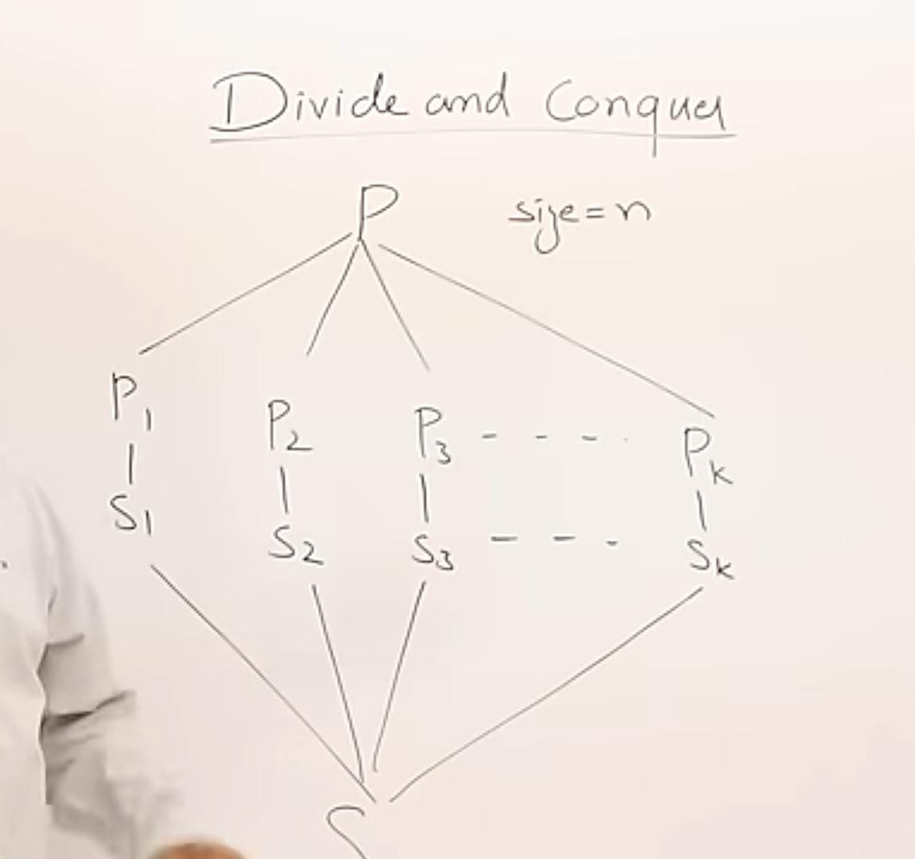
.
* if the sub problem is large do the same

when you use this approach.
→ if a problem we divides it . the sub problem also be the same logic .
eg) sort if a problem is big we divide it the sub problem also we apply the sort.
Use the combine method to get the result.

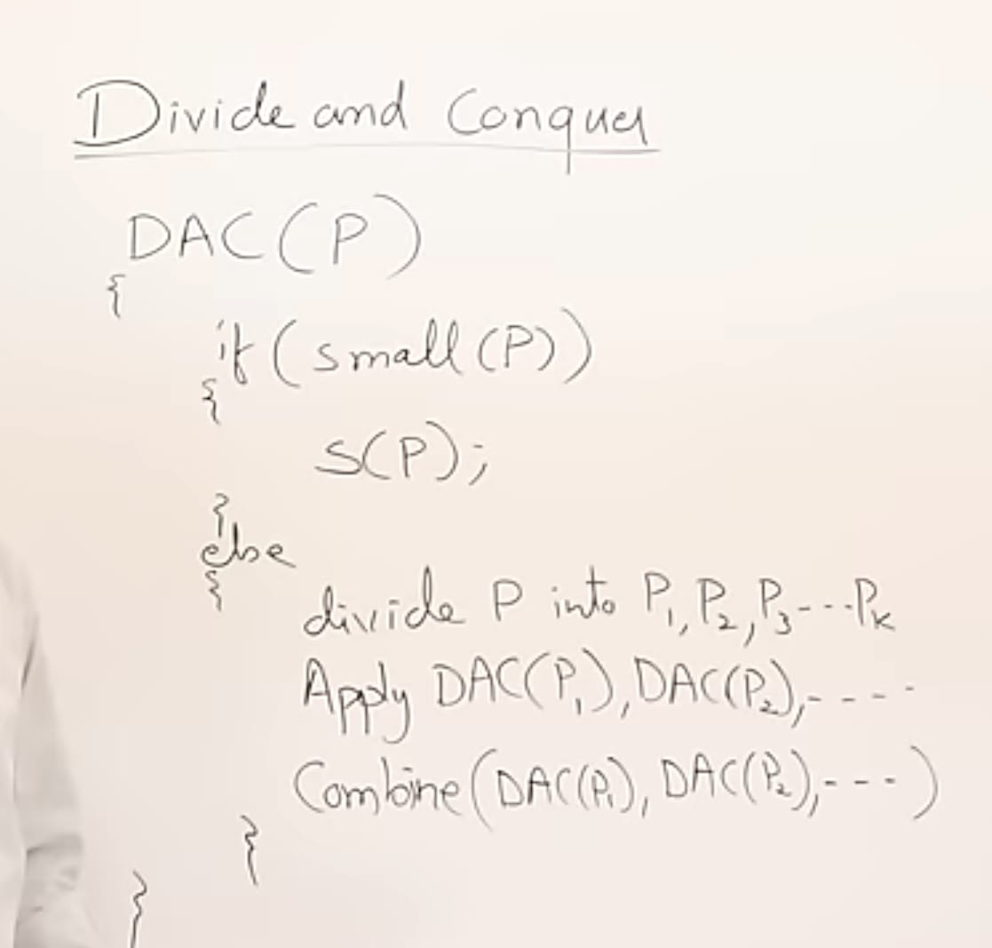
.
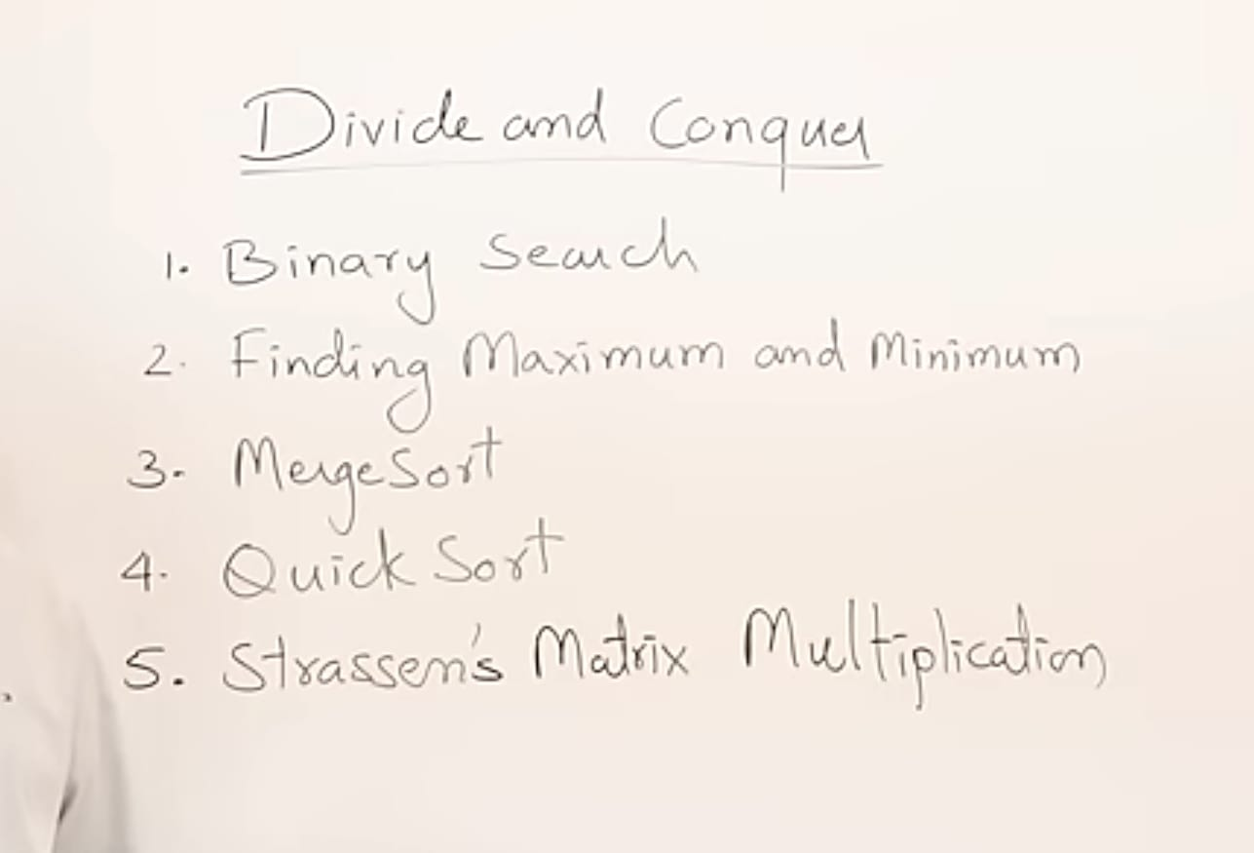
.

2.1.1
Time Complexity
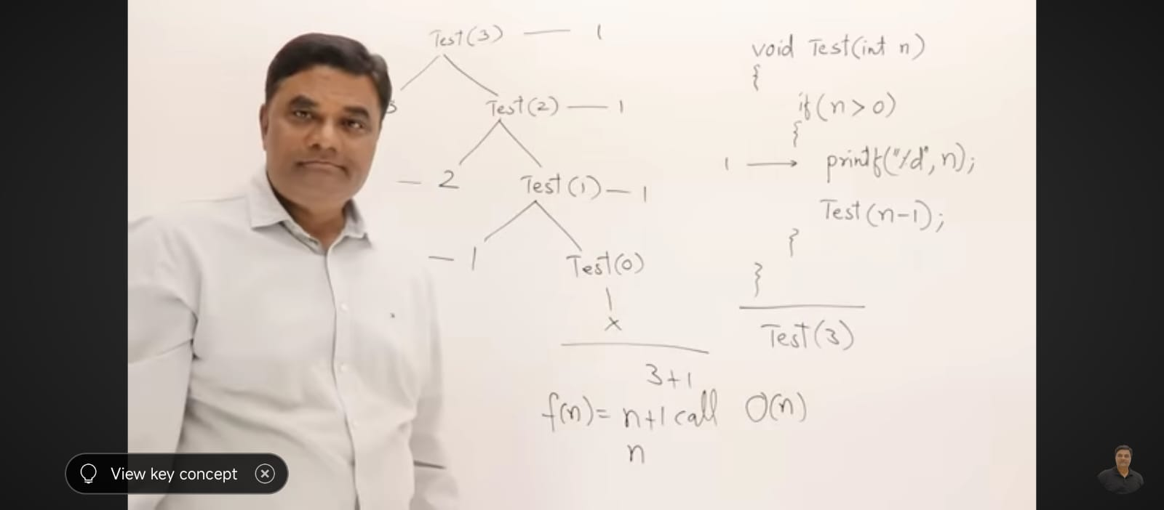
Recursion relation

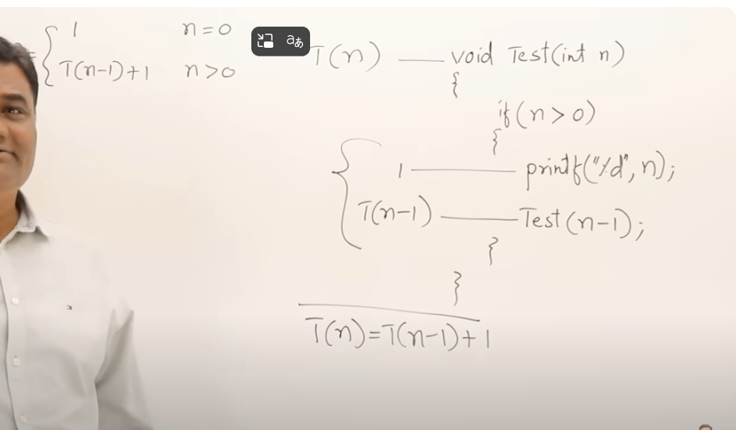
.

RECURSION RELATION SOLVING IN SUBSTITUTION METHOD
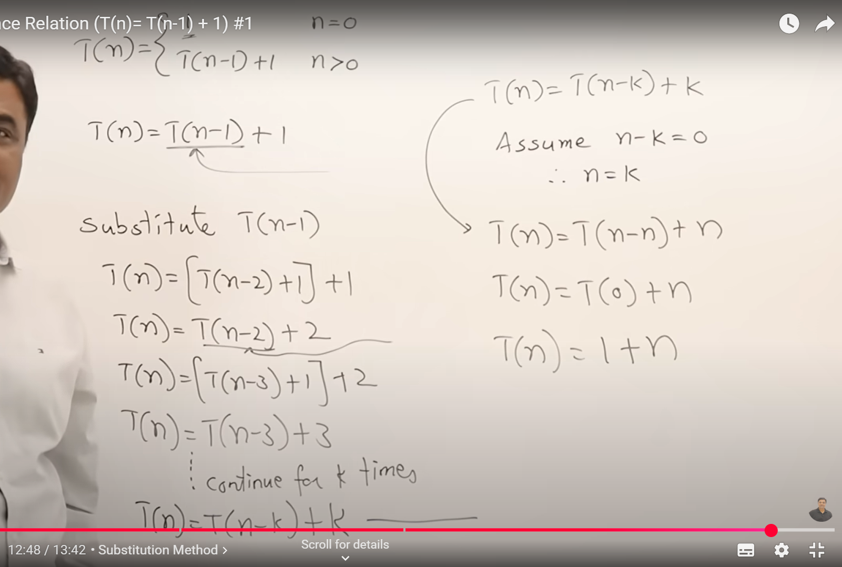
.

2)

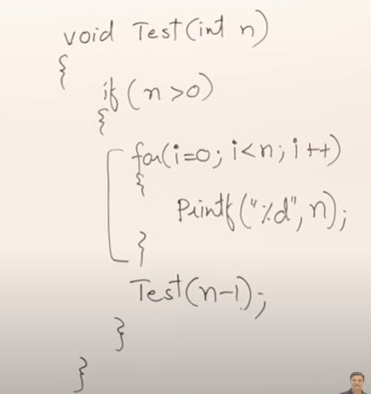

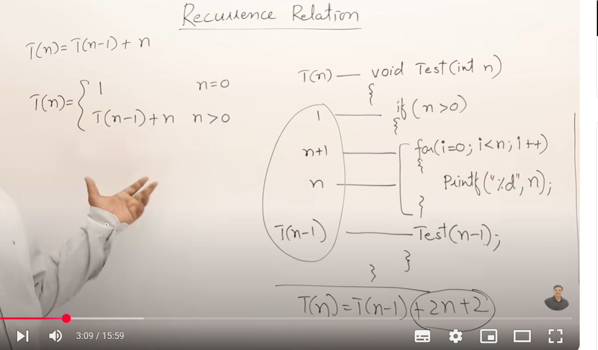

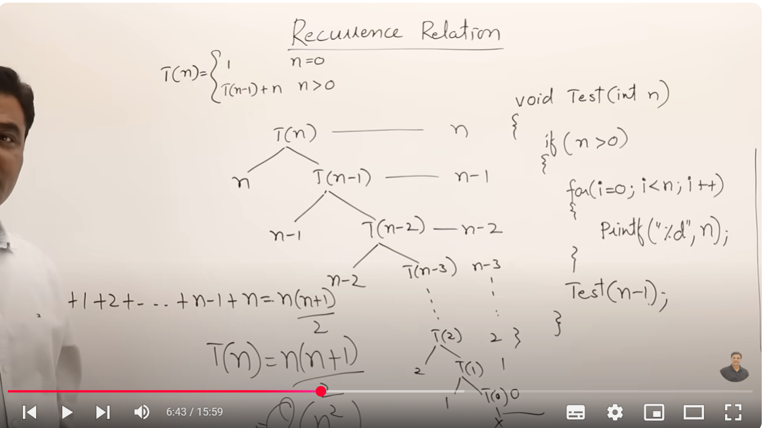
In substitution method.
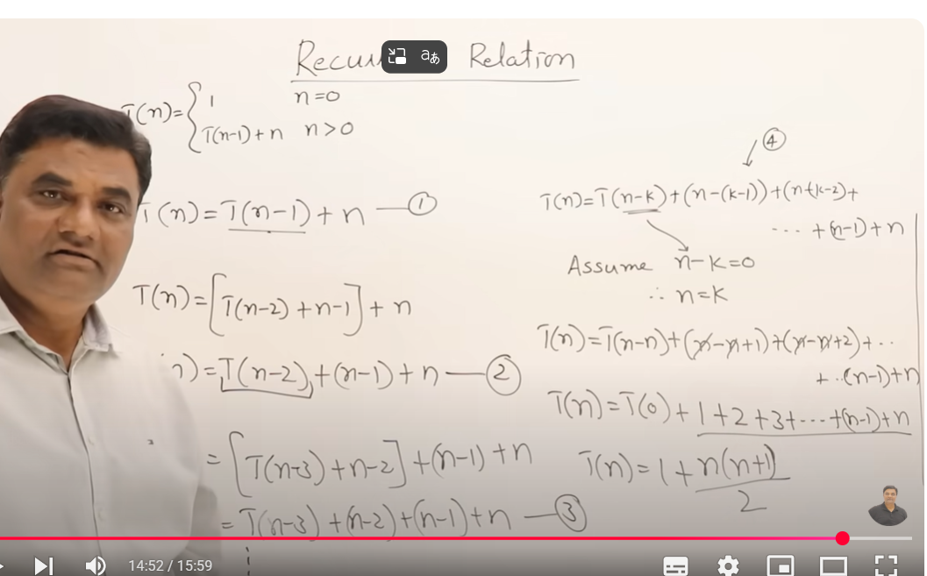
3
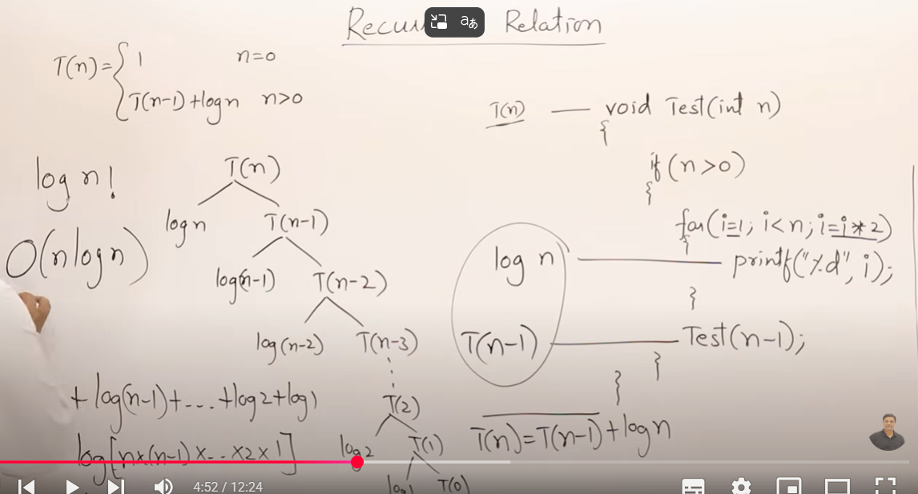
.
General analysis
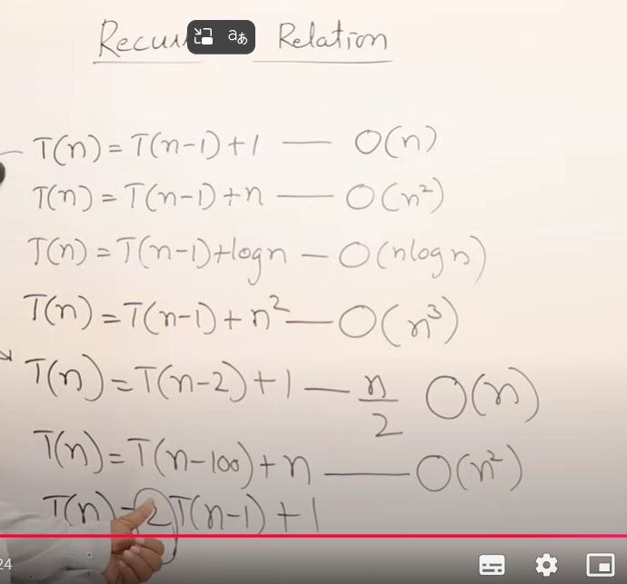

4) T(n) = 2T(n-1) + 1;
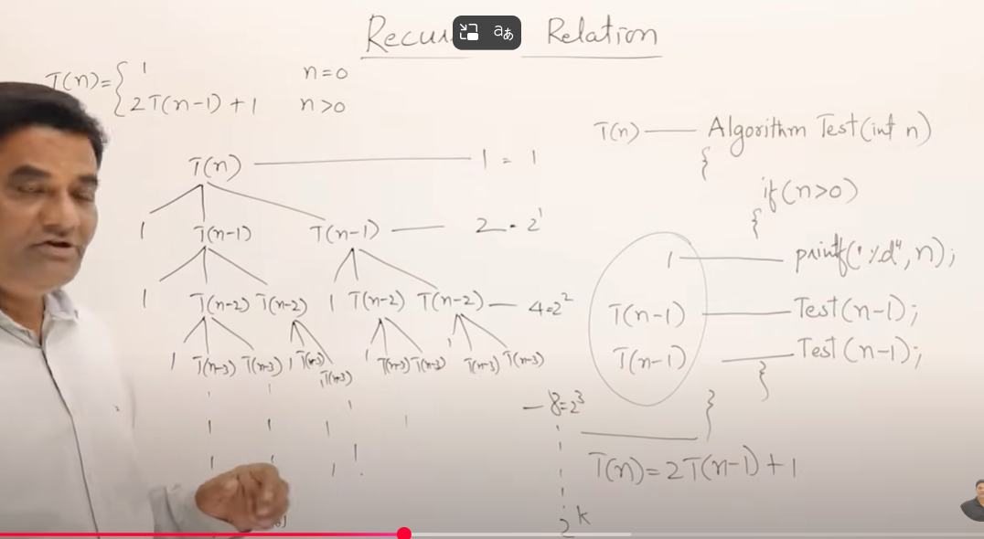
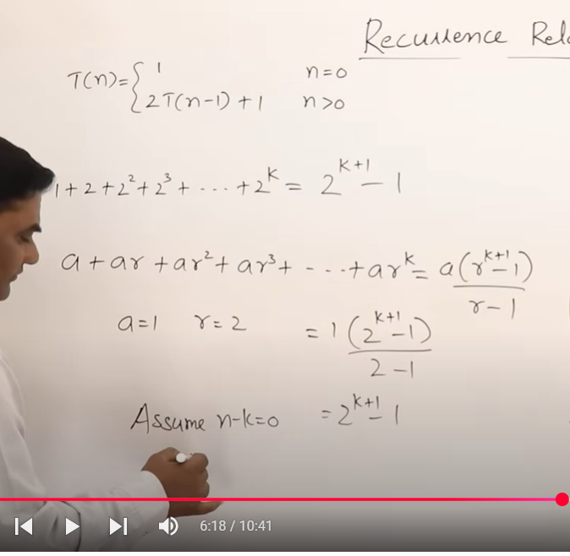
Time complexity = 2^n.

Recursion Relation Deviding Function
1)
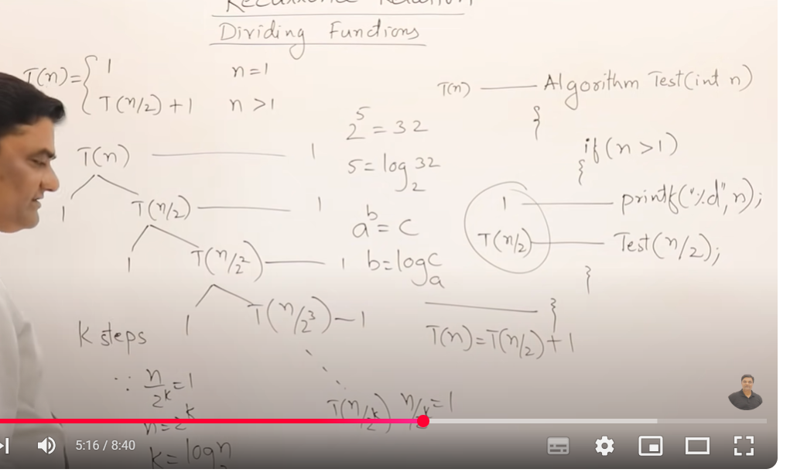
2)
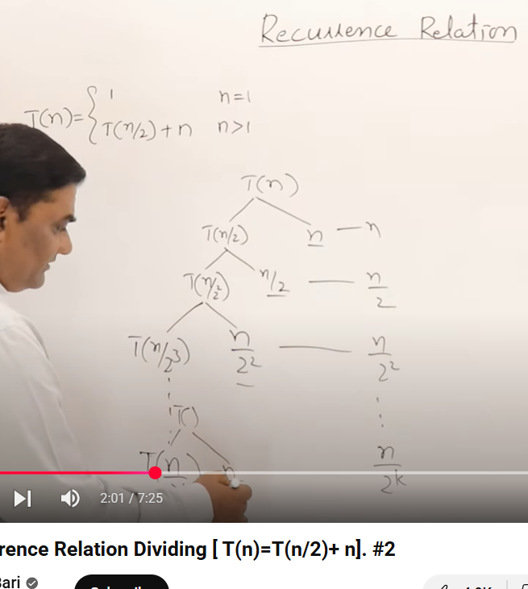

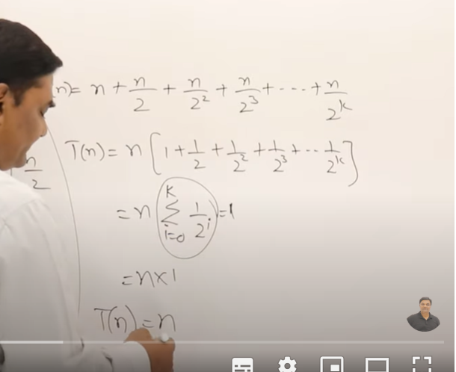
3)

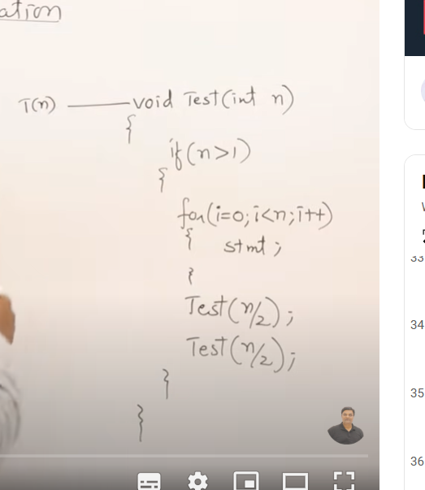

3)
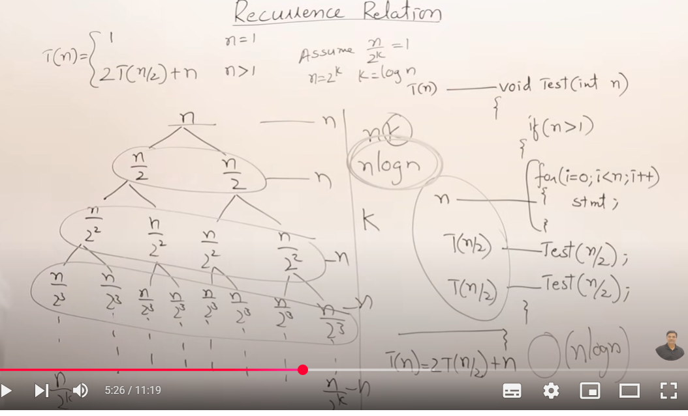
BINARY SEARCH
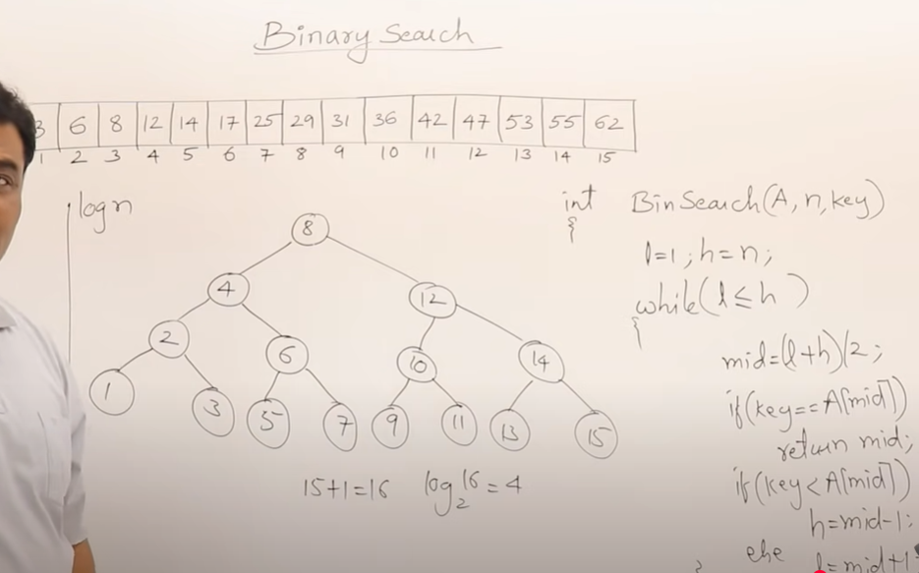
.
MERGE SORT
1) MERGE TW0 SORTED ARRAY
2) M-way merging
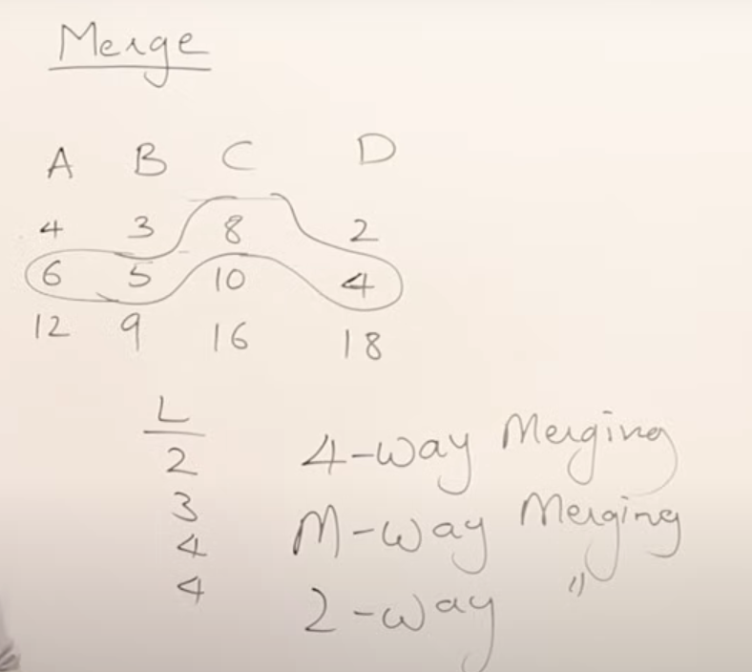
.

Diff way of merging patterns
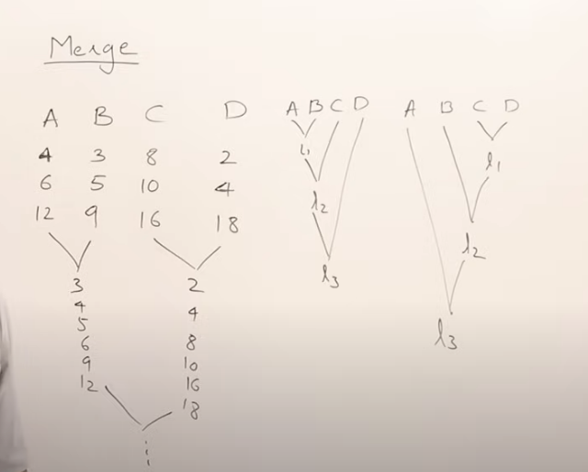
.
MERGE SORT - recursive way
2-Way Merge Sort - iterative way

2 -Way merge sort
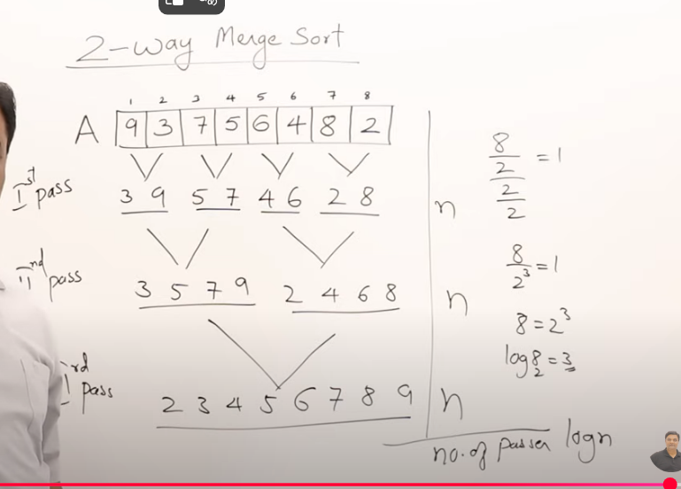
.
Merge Sort
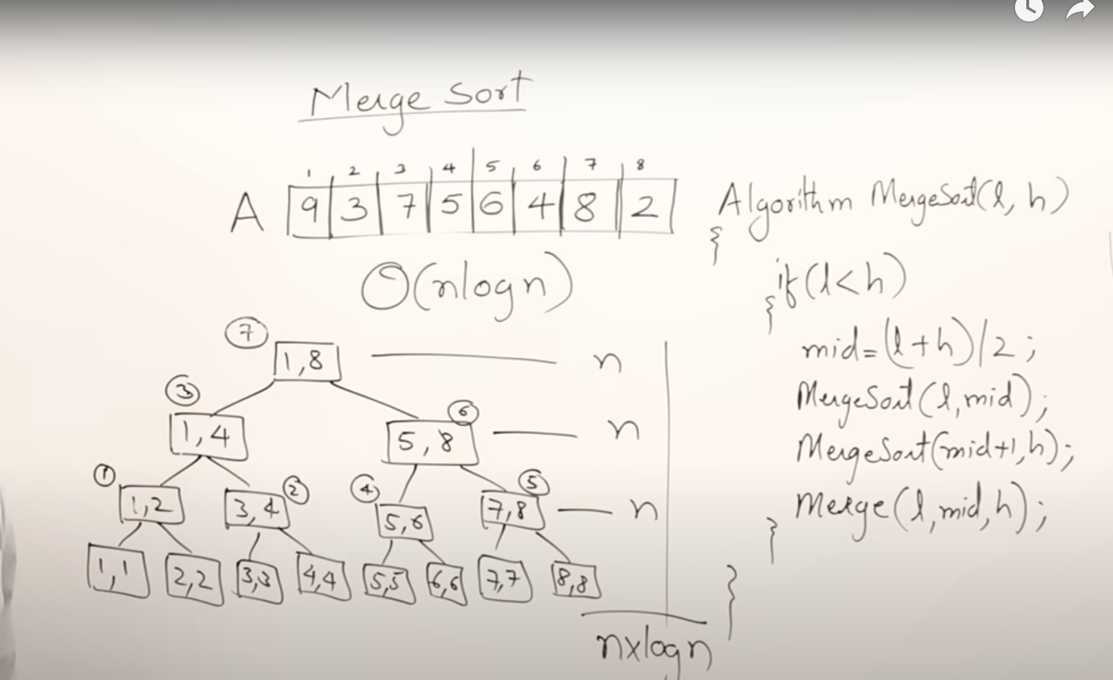
.
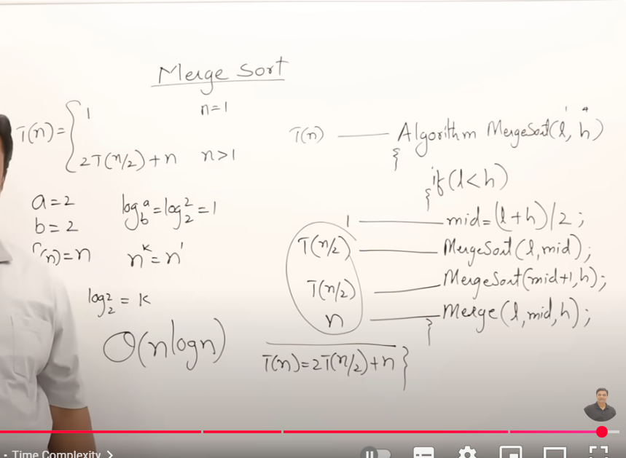
.

pros and Cons Of merge sort
-----------------------------
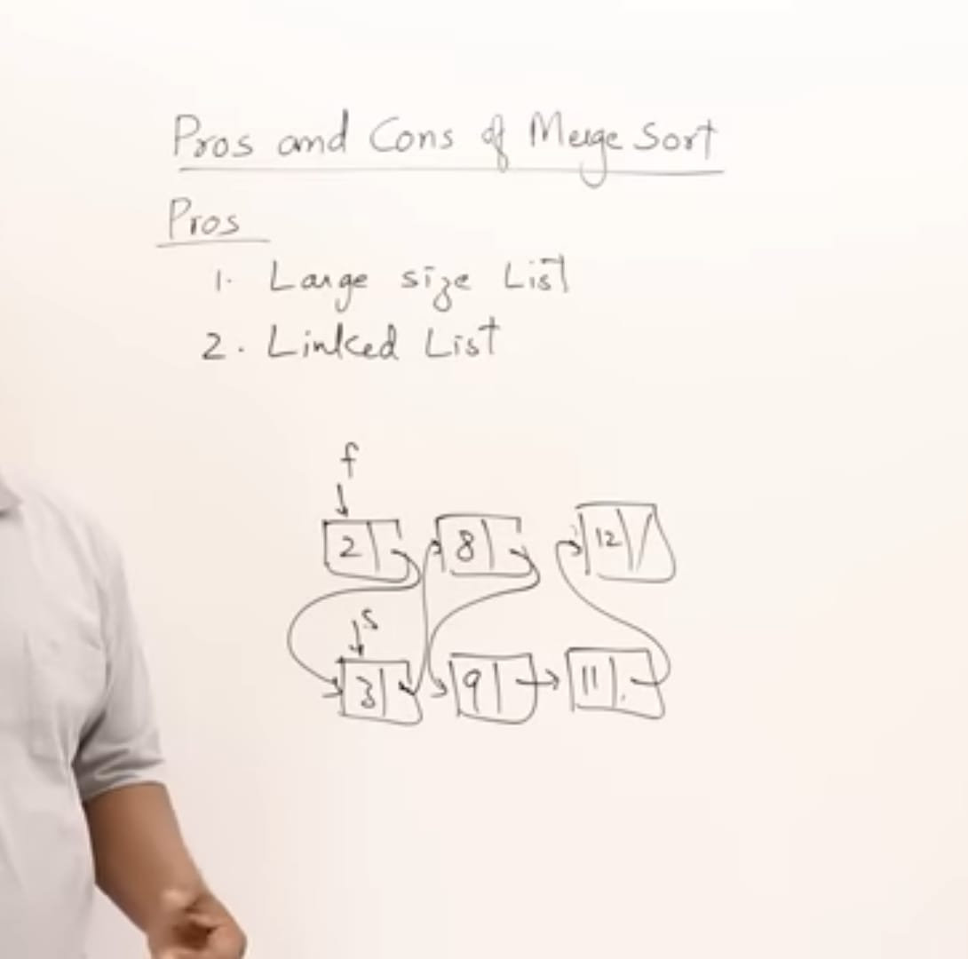
.
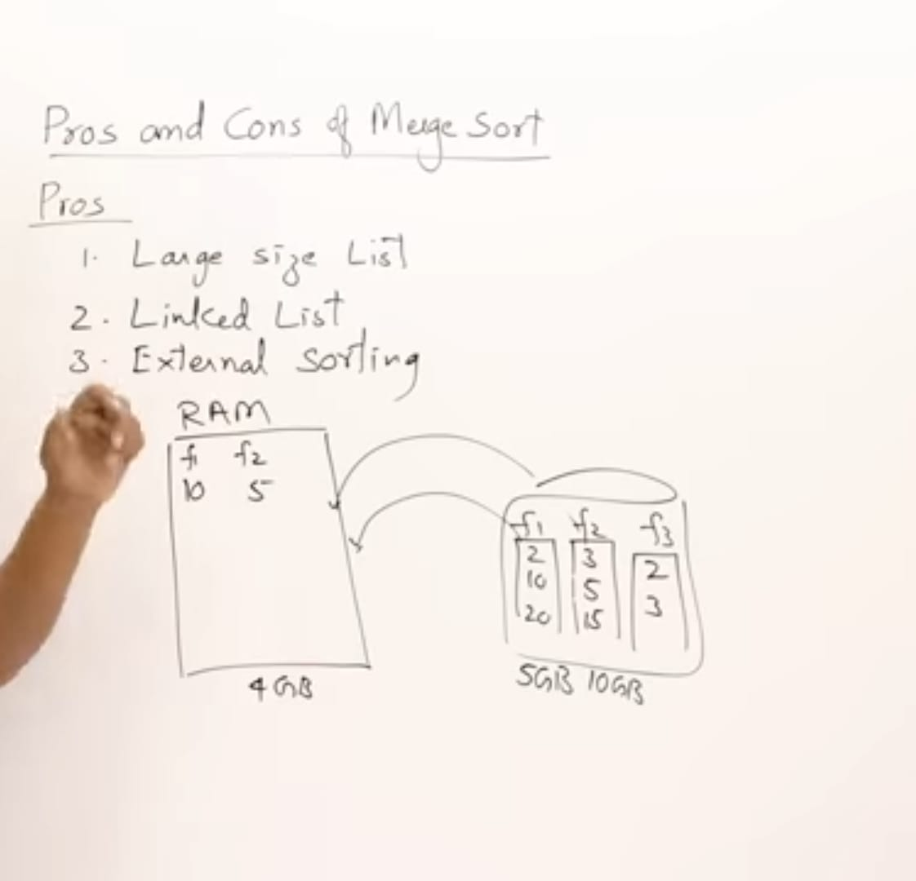
.
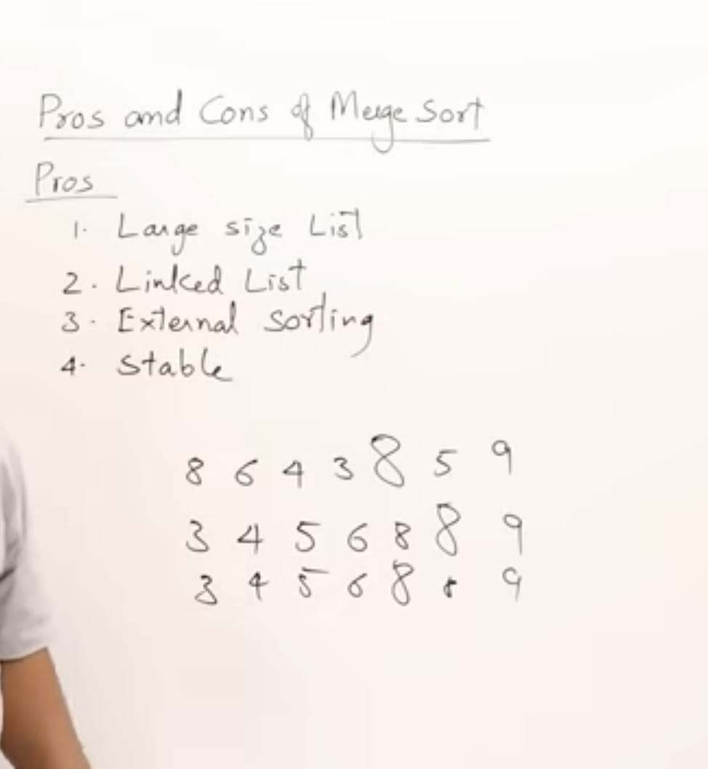
→ Stable plays an important
Consider markslist in maths 2 member are same but different in social
If not stable it be disturb
CONS
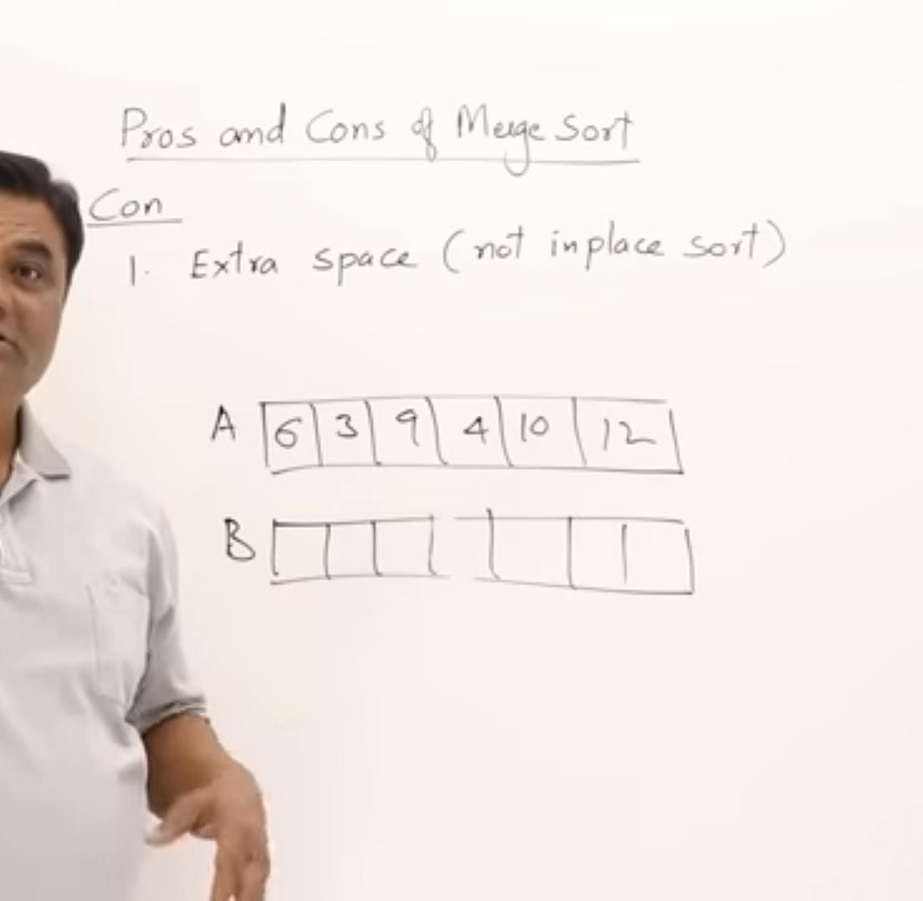
->Merging is not inplace so merge sort is not inplace sort .
→But in linked list it is stable
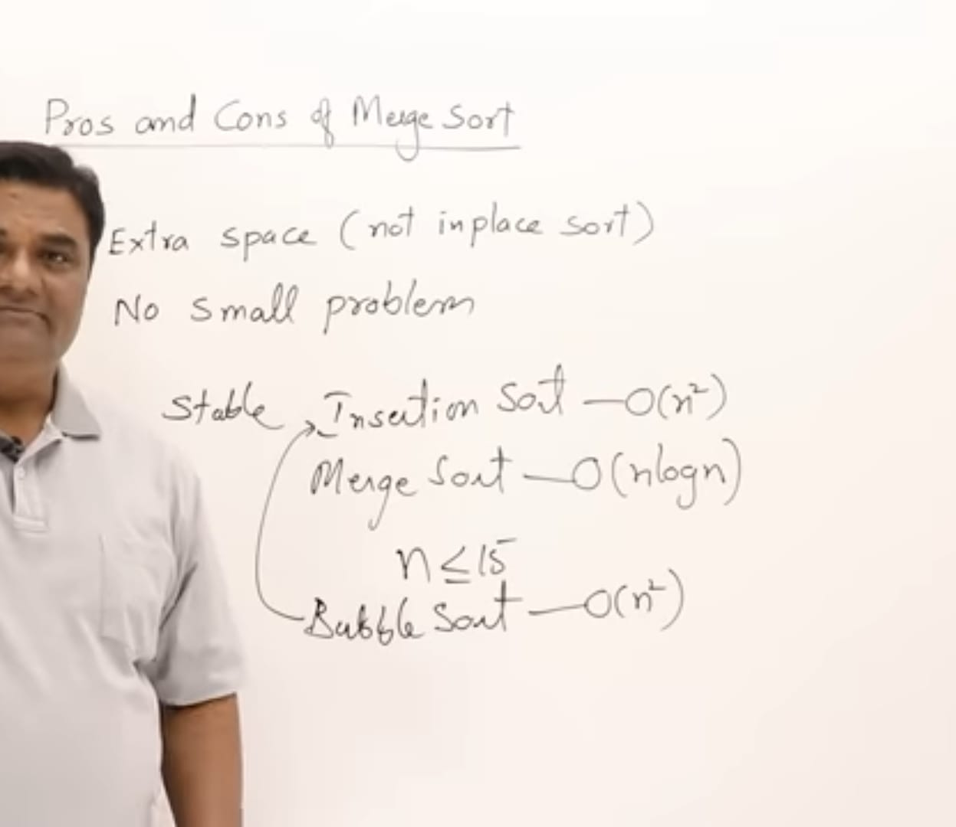
.
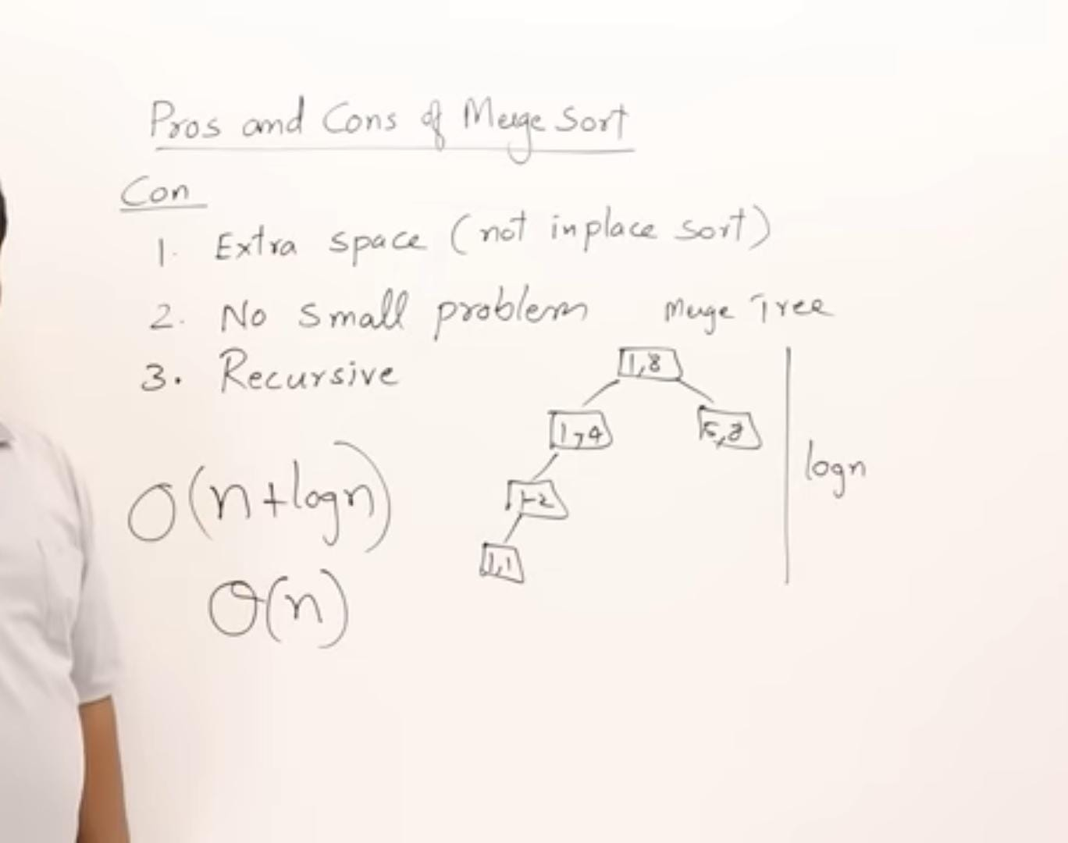
→ It uses stack space as well as auxiliary array space

