Project : Building a Controller

Project Rubric : WRITE UP

1) Provide a Writeup / README that includes all the rubric points and how you addressed each one. You can submit your writeup as markdown or pdf.

This would the documewnt where I explain the rubric points

Project Rubric : Implemented Controller

1)Implemented body rate control in C++.

- The controller is proportional to the error in body rate command.
- The controller takes into account the moments of inertia of the drone when calculating the commanded moments.

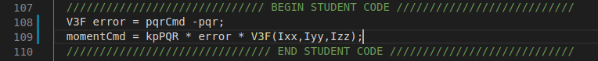

2)Implement roll pitch control in C++.

- The controller uses acceleration and thrust commands.
- The controller uses the rotation matrix to account the non-linear transformation from local accelerations to body rates.

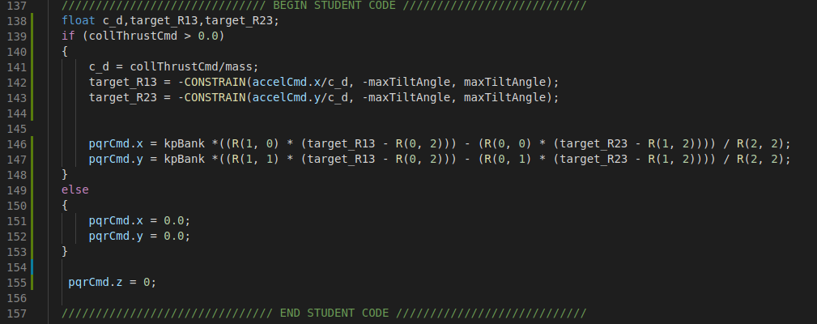
3)Implement altitude controller in C++.

- The controller uses both the down position and the down velocity to command thrust.
- The controller also contains integratedAltitudeError Variable which stores the integrated values over time.
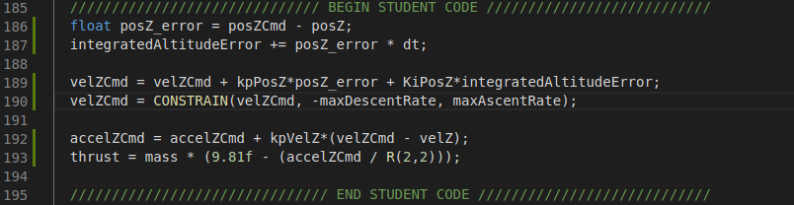

4)Implement lateral position control in C++.

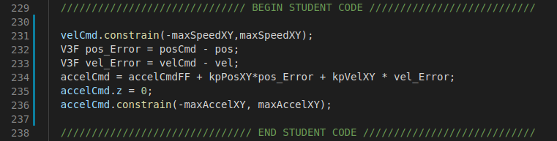

5)Implement yaw control in C++.

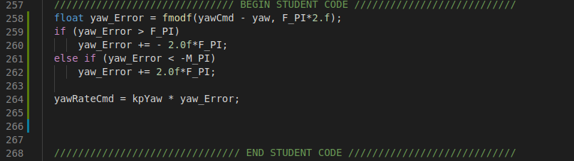

6)Implement calculating the motor commands given commanded thrust and moments in C++.

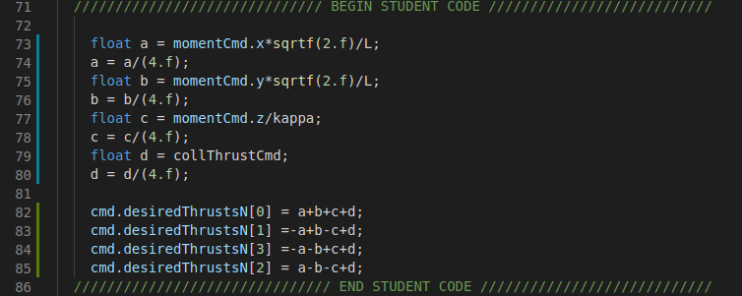

Project Rubric : Flight Evaluation

Test Results of my controller

