**Mukesh Suthar**

**mukesh.suthar@accoliteindia.com**

**1. find all hotels with ratings for cleanliness>=4**

**query:**

select meta().id from `travel-sample` where type="hotel"

or any ratings in reviews satisfies ratings.cleanliness >= 4 end

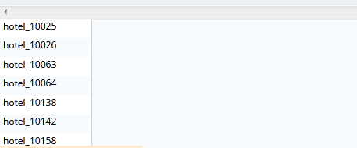

Note : assuming single rating >= 4

**2. find the highest airport in each country.**

**query :**

select * from `travel-sample` a where a.geo.alt in (select raw max(b.geo.alt) from `travel-sample` b where b.type="airport" group by b.country)

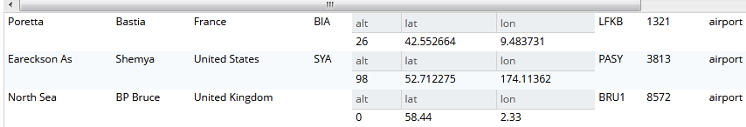

assuming geo.lon as height of airport

**3. find all routes operated by air france from the city of marseille. (use field faa)**

**query :**

select meta(t1).id from `travel-sample` t1 inner join `travel-sample` t2

on t1.sourceairport = t2.faa

where t2.city = "marseille"

