**Mukesh Suthar - mukesh.suthar@accoliteindia.com Maven-assignment**

**A. Install Maven**

1.Send the screenshot of "mvn -version"

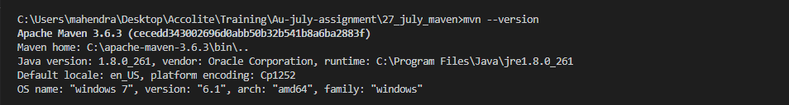

**B. Create a sample maven project**

**1. Using archetype plugin and generate goal.**

**2. Give custom values for groupId, artifactId, version, package and execute "mvn install" and "mvn exec:java -Dexec.mainClass=your-fully-qualified-class-name".**

**3. Share zip of project and screenshot for "mvn install" and "mvn exec:java" command**

**mvn archetype:generate**

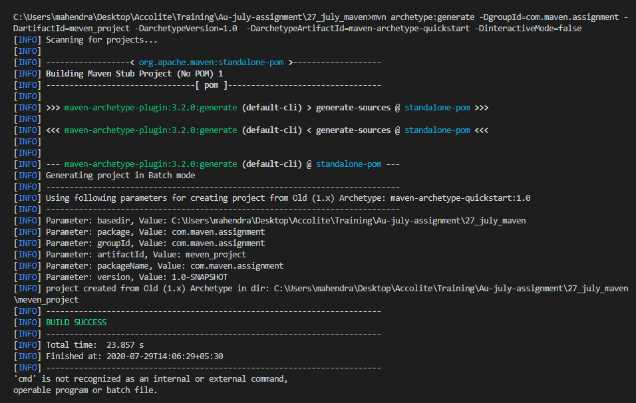

**mvn install**

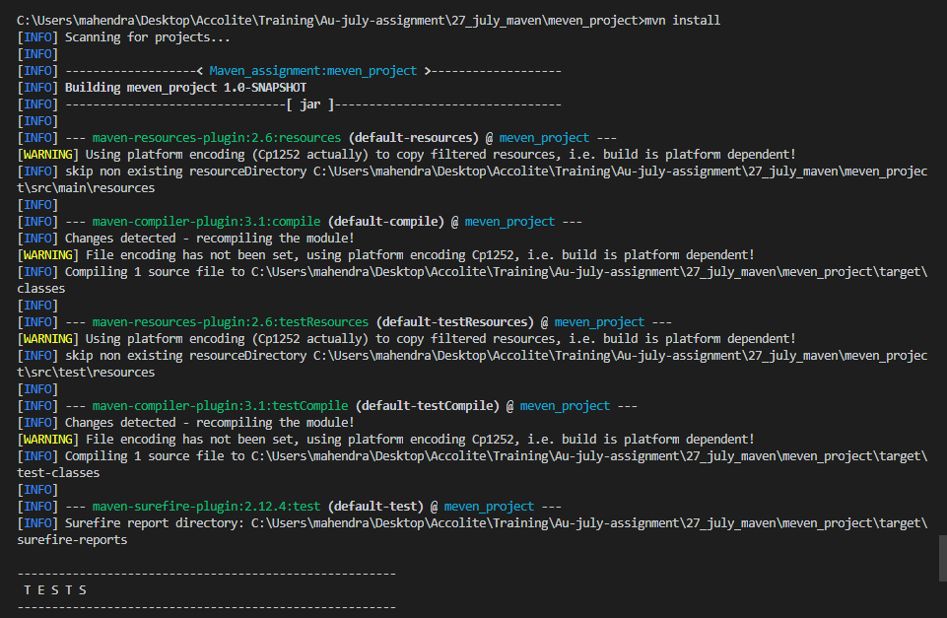

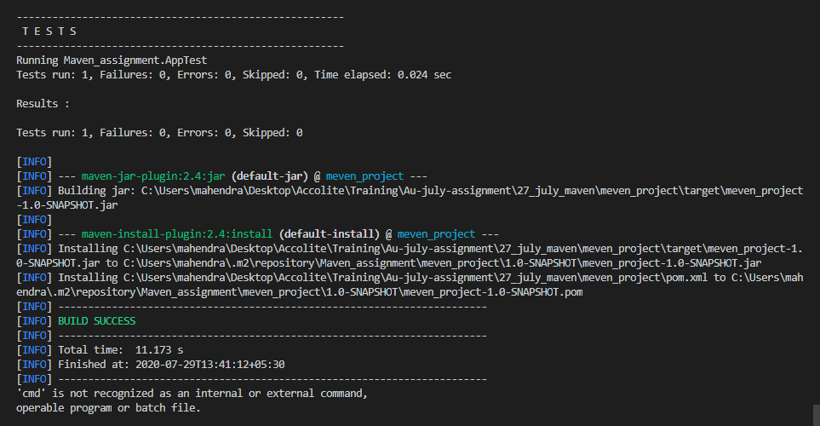

**mvn exec:java -Dexec.mainClass="package.mainclass"**

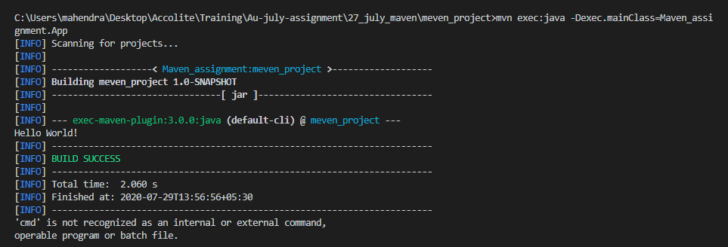

**C. Create a maven web-app project**

**1. Using archetype plugin and generate goal.**

**2. Give custom values for groupId, artifactId, version, package and execute "mvn install" and "mvn exec:java -Dexec.mainClass=your-fully-qualified-class-name".**

**3. Share zip of project and screenshot for "mvn install"**

**mvn archetype:generate -DarchetypeArtifactId="maven-archetype-webapp"**

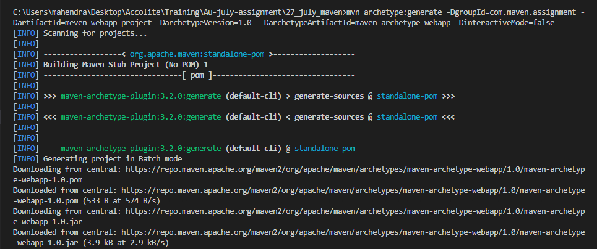

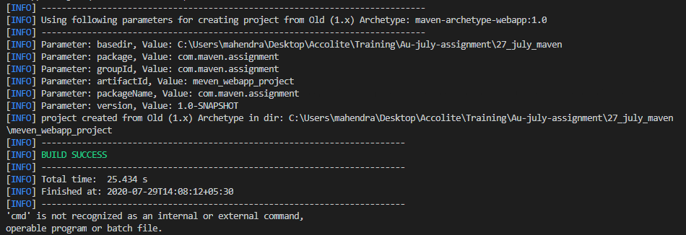

**mvn install**

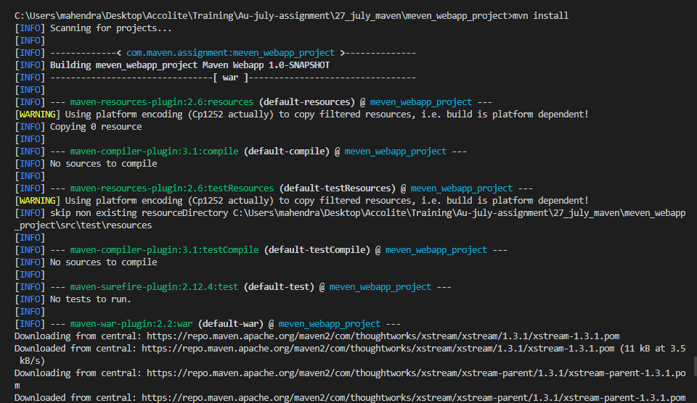

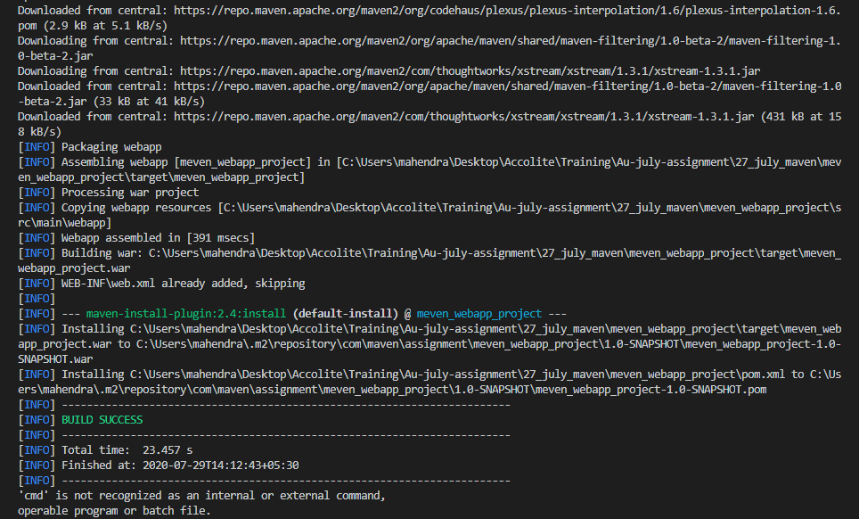

**pom.xml - adding plugin to run on server**

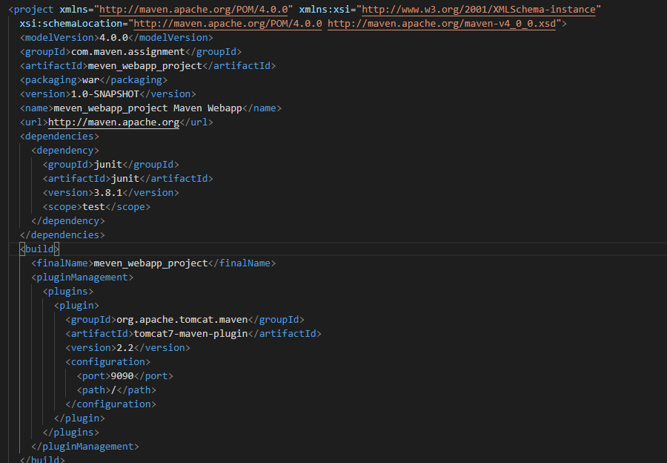

**mvn install**

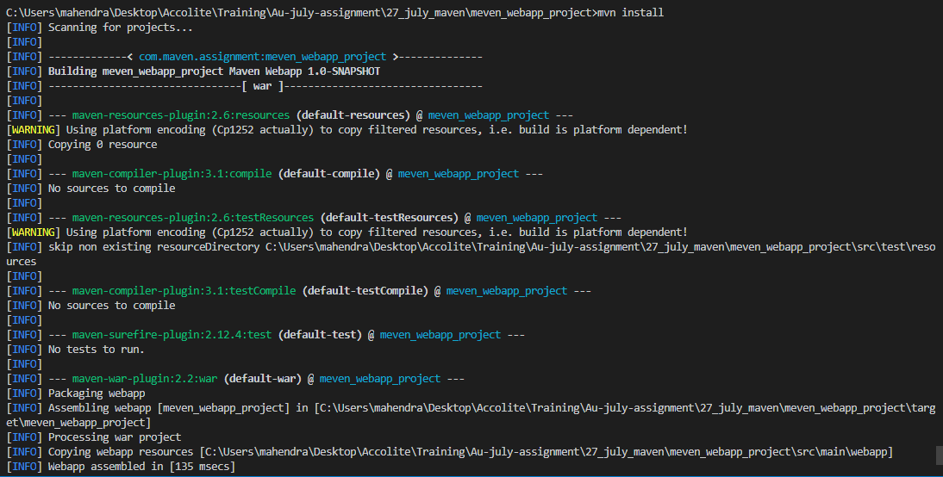

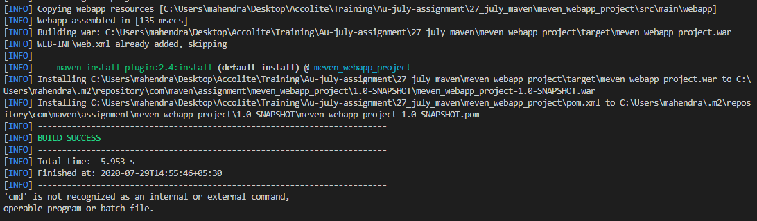

**mvn tomcat7:run**

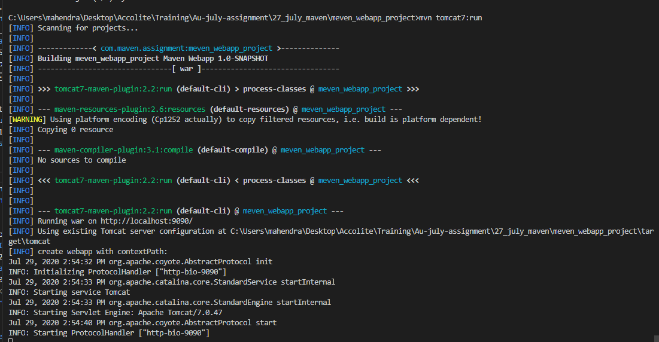

**Output of webapp**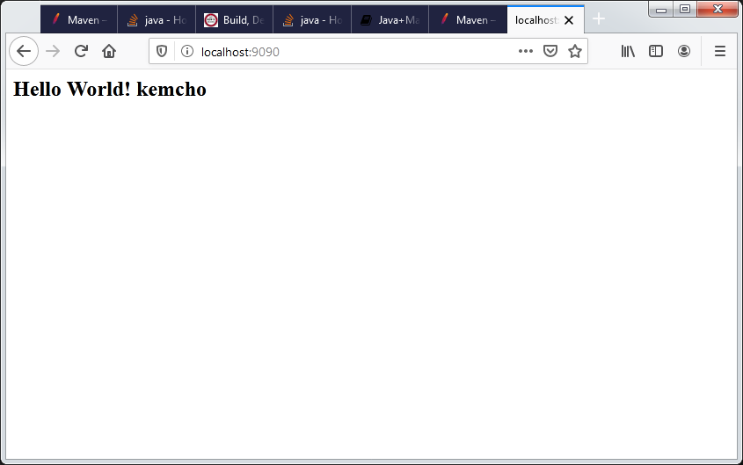

**D. In the above created sample maven project (Step 2) run "mvn install" again but it should now skip the execution of tests.**

**1. Send the screenshot of "mvn install" that should skip the execution of tests.**

**mvn install -Dmaven.test.skip="true"**

