**Mukesh Suthar - mukesh.suthar@accoliteindia.com**

Spring MVC Assignment

Adding Student

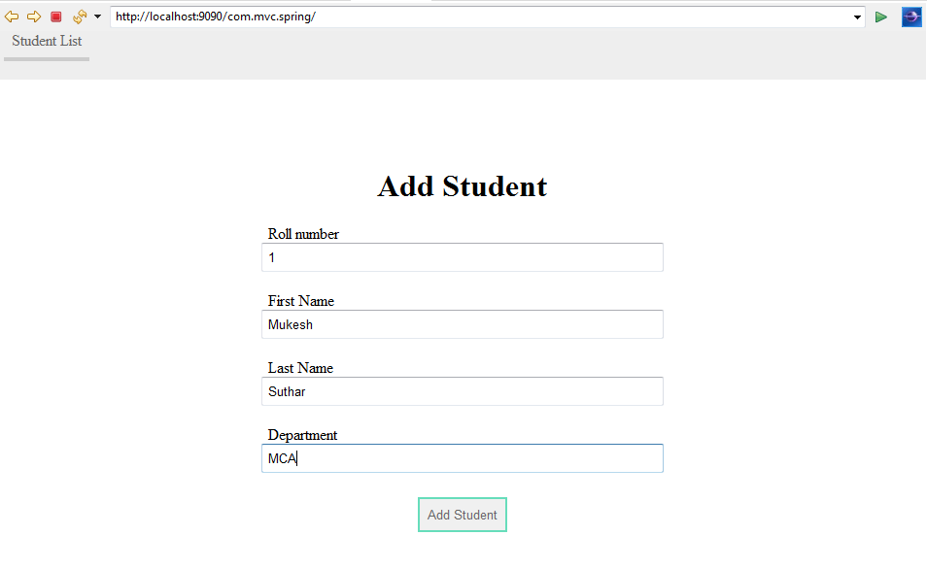

Welcome message after adding into list

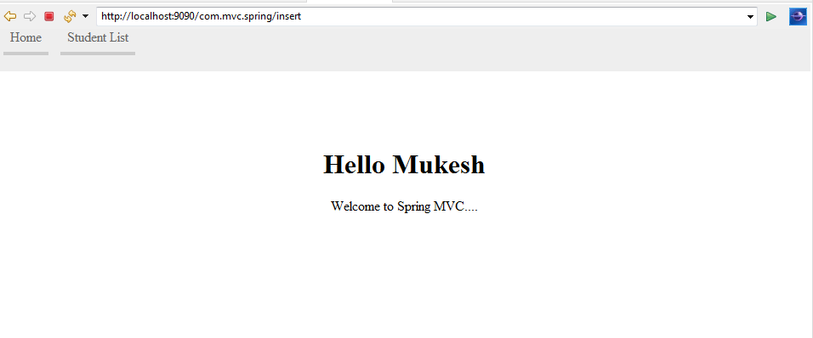

List of the student

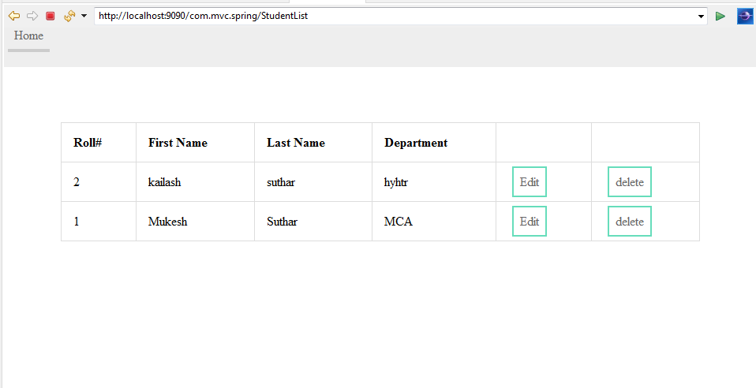

Updating student

Note : Roll number is non updatable

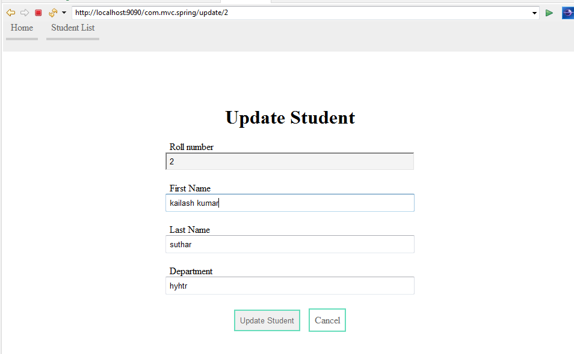

Exception handling (inserting with Same roll number case )

