1) Time taken to count the no of words through iterator:0.17s

2)Time taken to count the no of words using single Thread:0.16S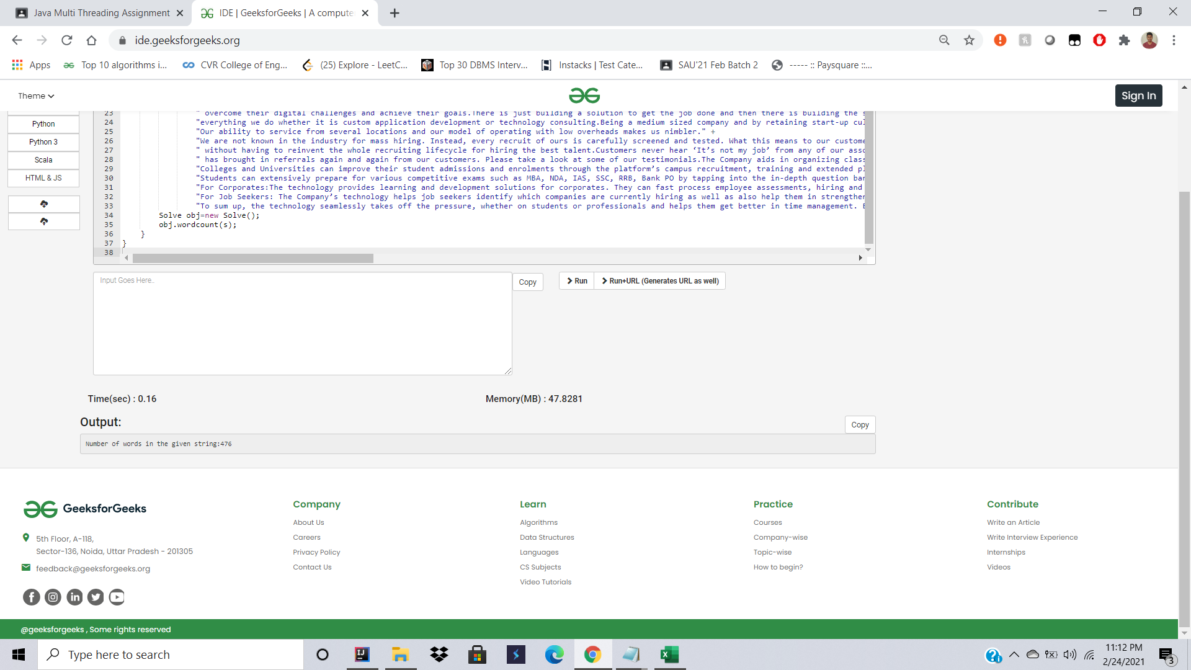

3) Time taken to count the no of words using two Threads

0.14s



Time taken above : twoThreads<oneThread<Iterator

How ever the execution time is not constant and keeps on changing on multiple executions , but the order is

twoThreads<oneThread ~= iterator.(Generalized)