Hamen’s private limited markets and sells different products. The attributes of the product include produce code, product name, and unit price. Products are grouped into categories. A product belongs to one category. A category can have many products. The attributes of category include category code and category name. Sales executives in the company are responsible for marketing and selling products to customers residing in different locations. The attributes of sales executives include sales executive id, name , date born, gender and mobile number. The attributes of the customer include customer id, name, date born, gender, and mobile number. The attributes of location include location code and location name. A location can have many sales executive marketing and selling different categories of products. The products purchased by the customers, date of purchase and number of units purchased have to be kept track.

1. Model an ER diagram for above scenarios

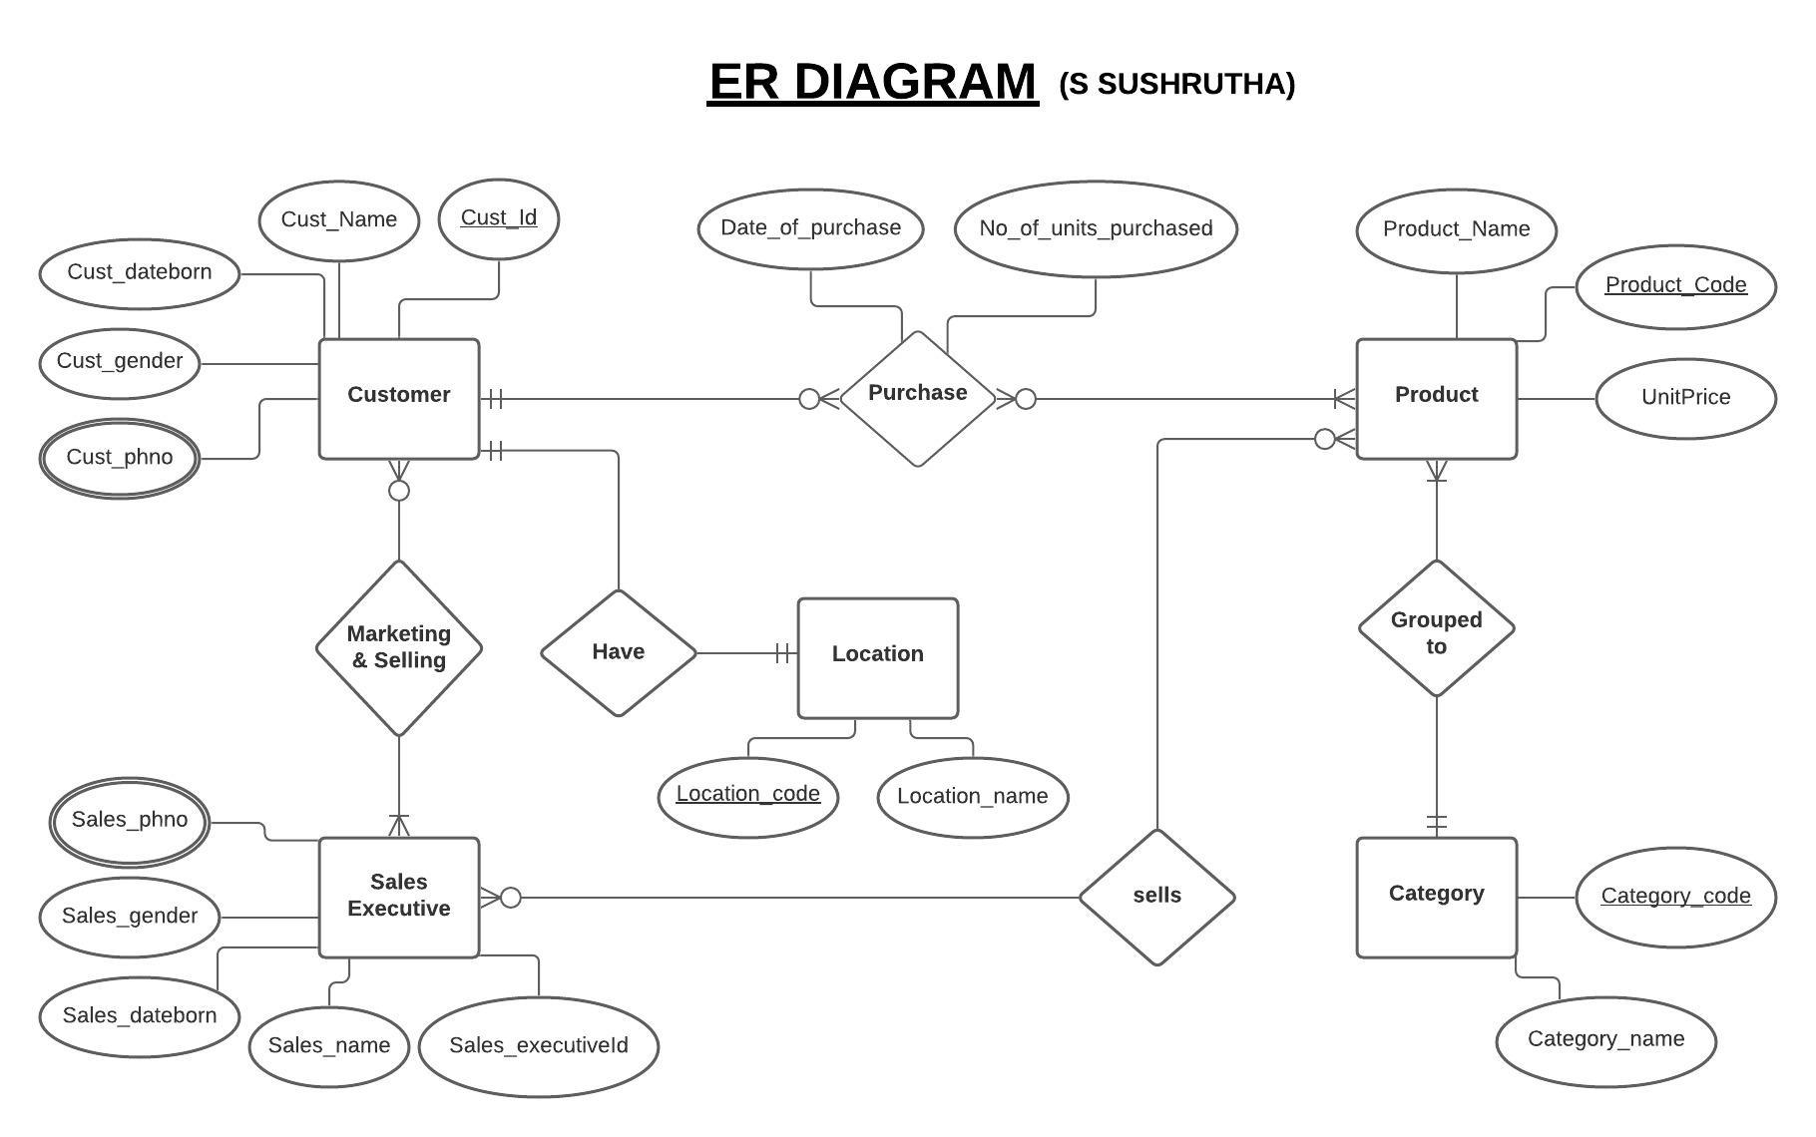

2.Transform the ER diagram to relations (tables) and relations should be normalised as possible.

