Assuming you are ready with the ER Model (from Morning session Assignment), transform it into a Database schema.

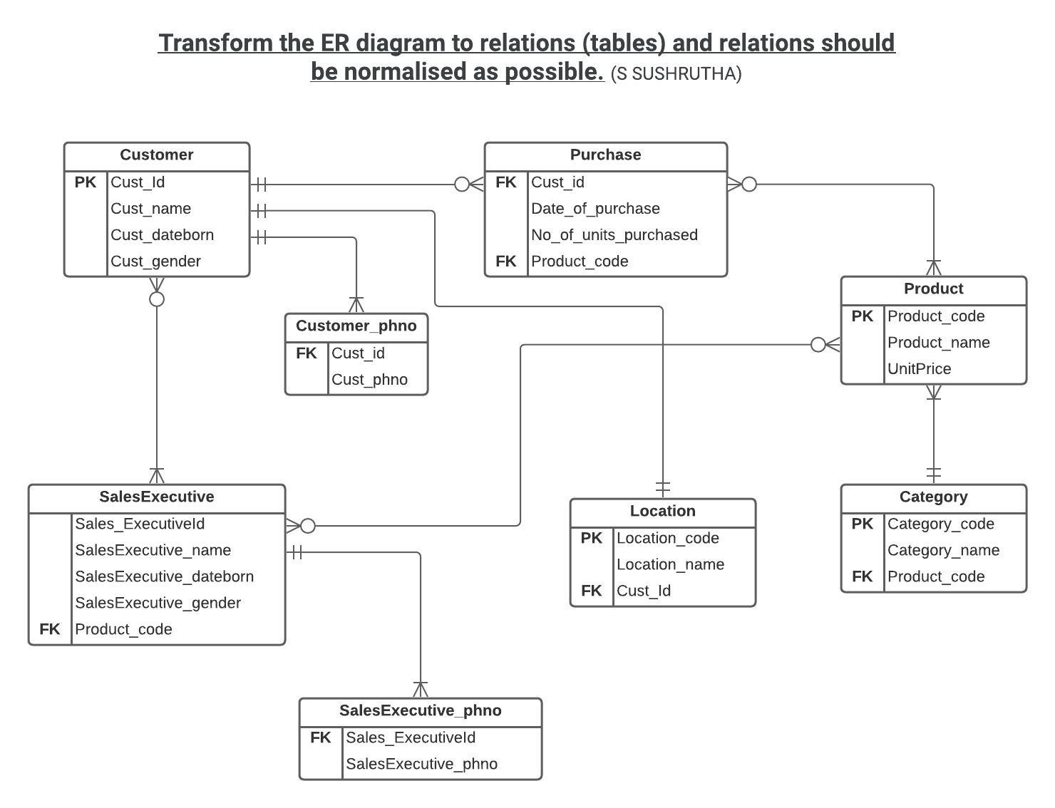

**1. Create tables and keep up the good practices.**(Creating and inserting values into tables)

create table **Customer** (cust_id Int NOT NULL,cust_Name varchar(20),cust_dateborn DATE,cust_gender varchar(10),PRIMARY KEY(cust_id))

insert into Customer values(1,"sushrutha","2000-11-27","Female"),(2,"vishal","1999-11-21","male"),(3,"vineeth","2001-01-11","male"),(4,"xyz","1998-12-01","Female")

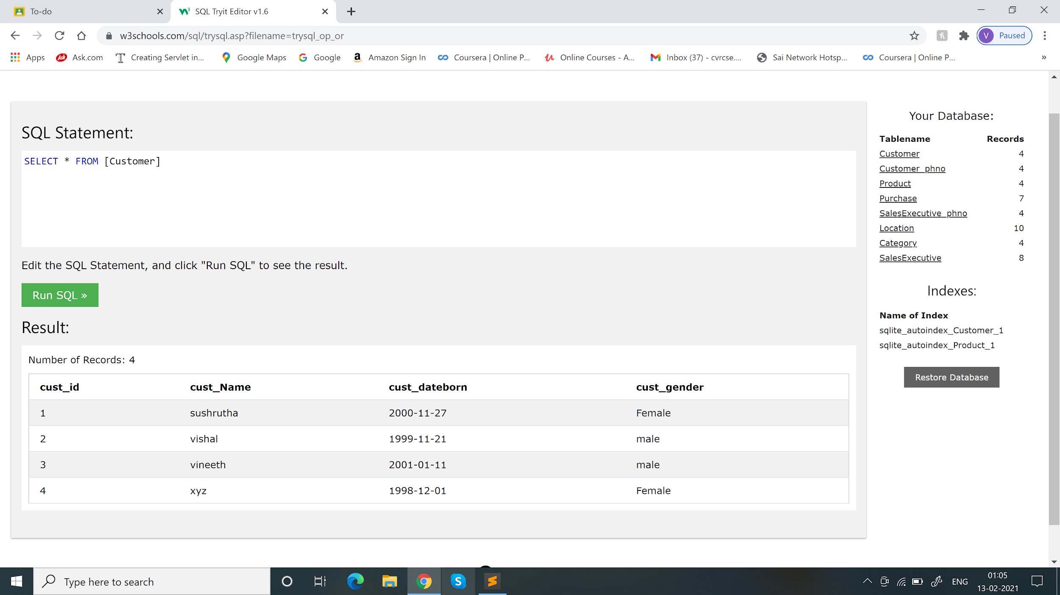

create table **Customer_phno**(Cust_id int,cust_phno int,FOREIGN KEY (Cust_id) REFERENCES Customer(Cust_id))

insert into Customer_phno values(2,"9121324356"),(3,"5678435678"),(1,"1628495847"),(4,"9128364789")

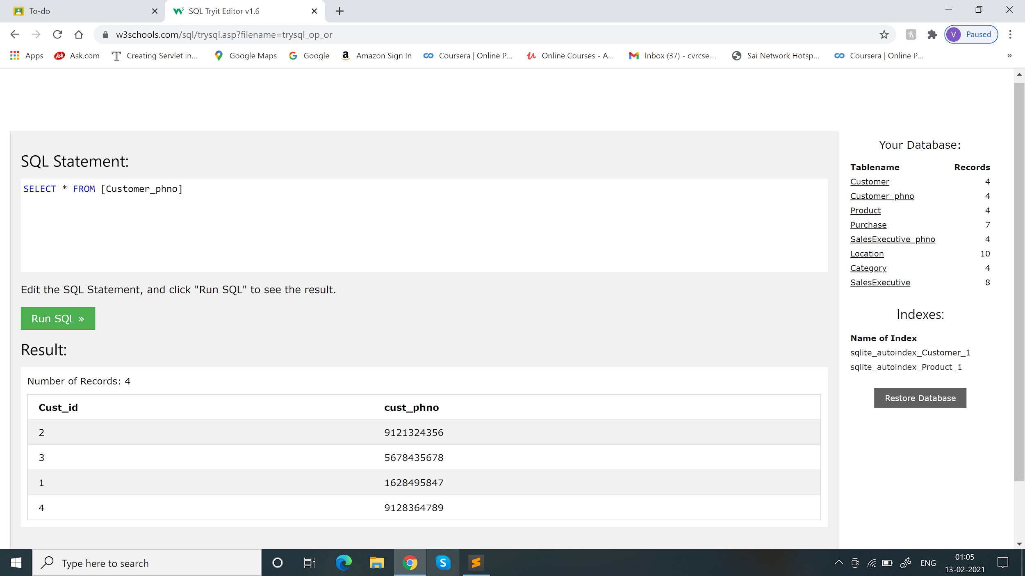

create table **Product**(Product_code varchar(20),Product_name varchar(20),UnitPrice float(6),PRIMARY KEY(Product_code))

insert into Product values("SA2","computers",75000.34),("SA1","MobilePhones",25021.00),("SA4","cameras",176000.53),("SA3","clothing",15000.00)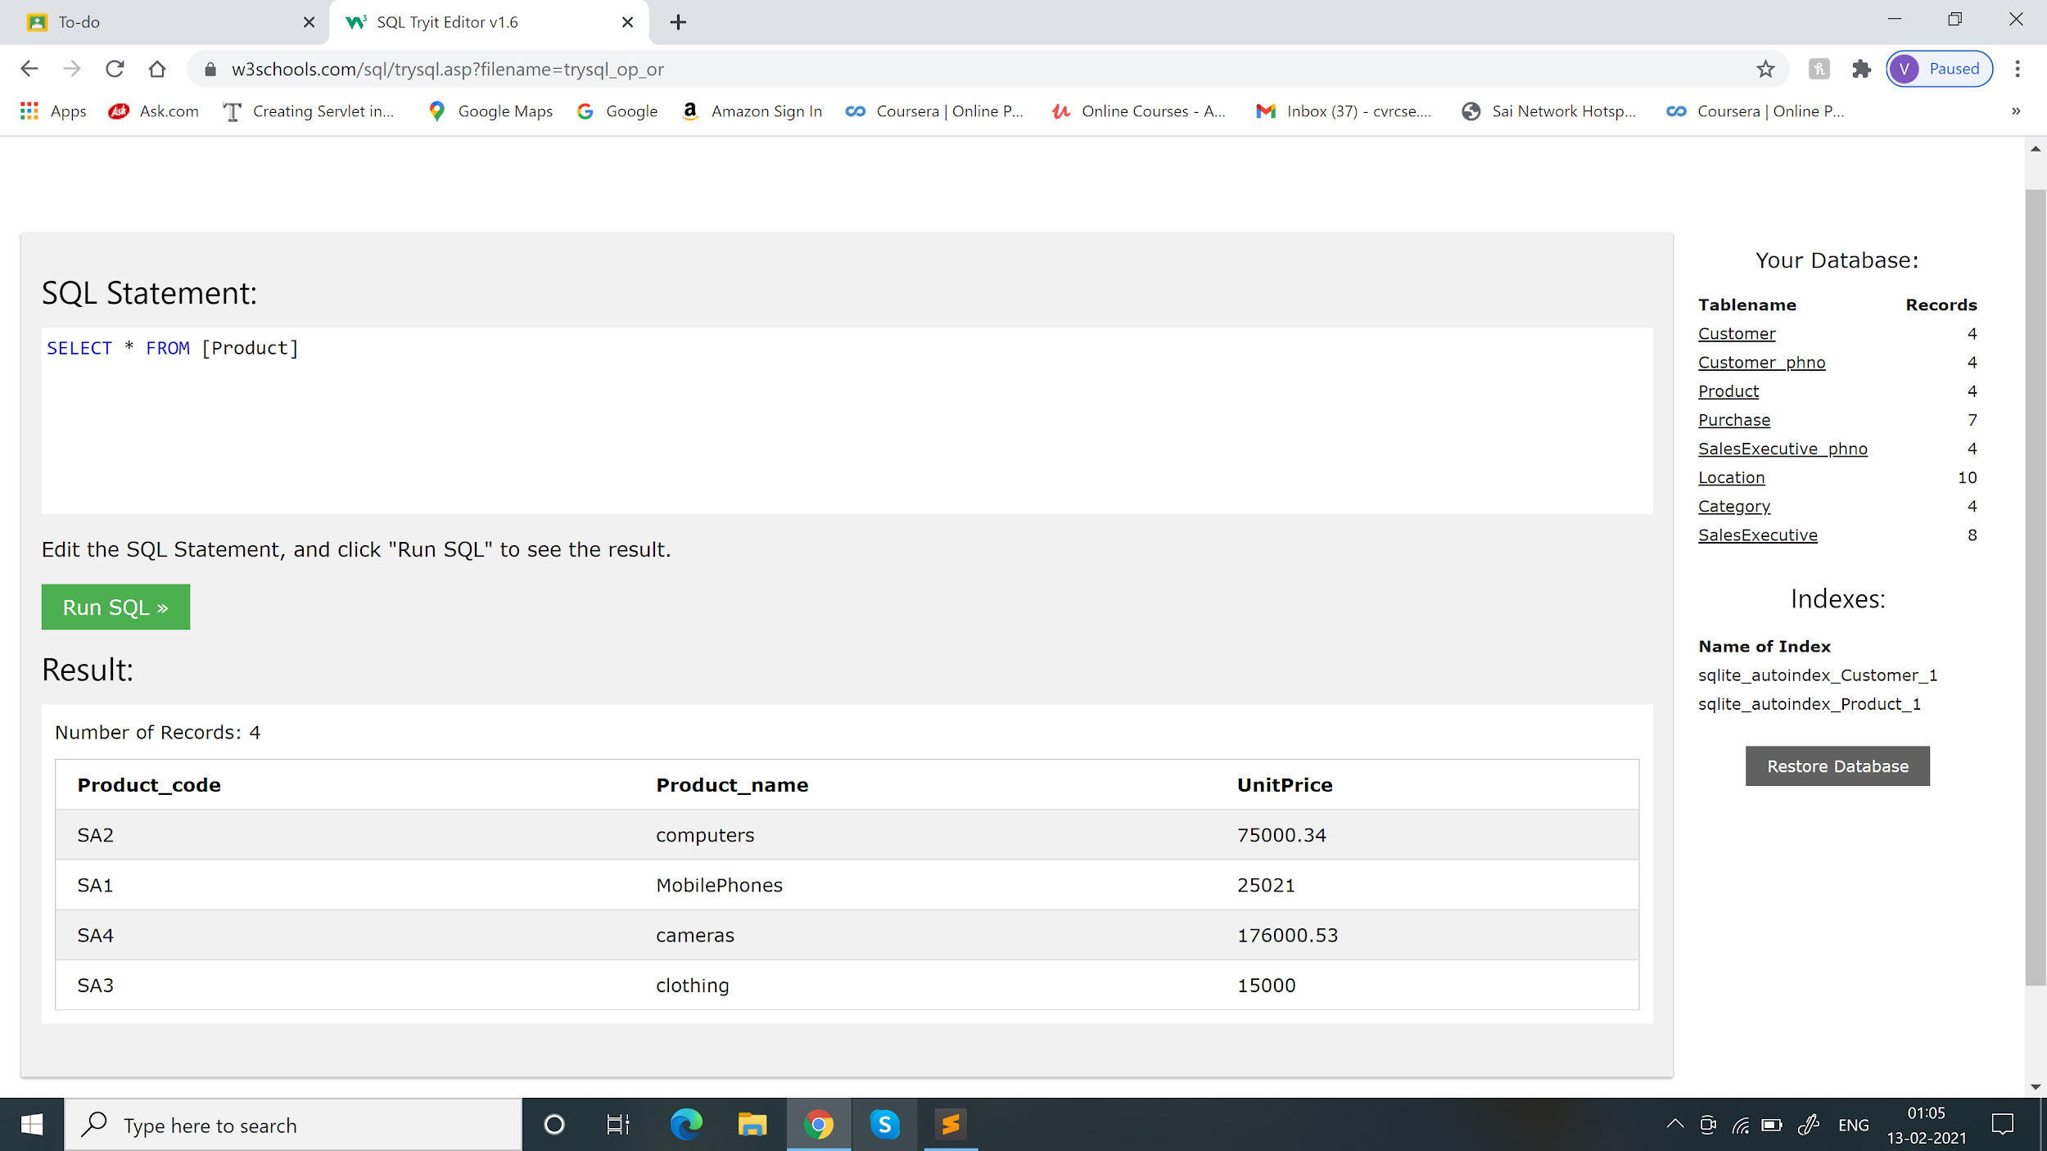

create table **Purchase**(Cust_id int,Date_of_purchase CURRENT_DATE,No_of_units_purchased INT,product_code varchar(20),FOREIGN KEY (Cust_id) REFERENCES Customer(Cust_id),FOREIGN KEY (product_code) REFERENCES Product(product_code))

insert into Purchase values(2,"2020-01-31",2,"SA3"),(3,"2021-02-12",2,"SA4"),(1,"2021-02-21",2,"SA2")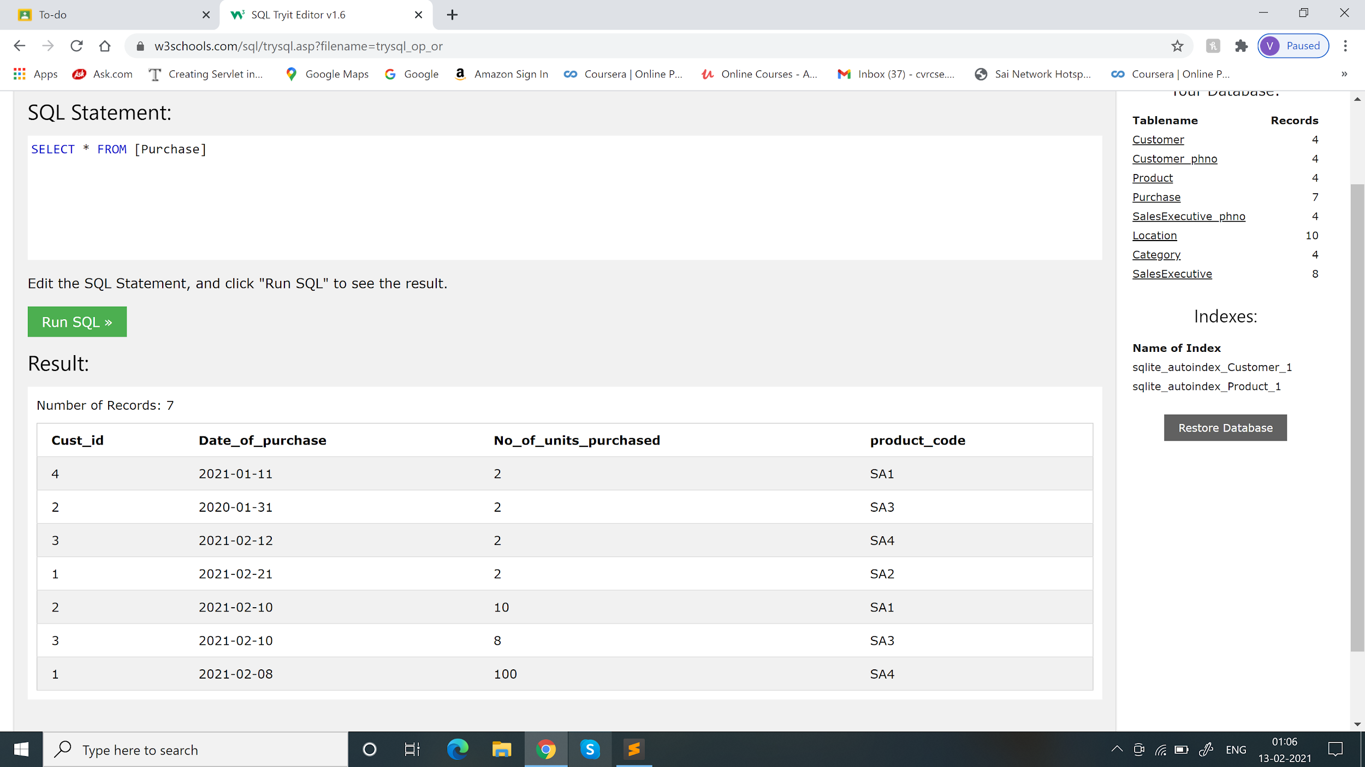

create table **SalesExecutive_phno**(Sales_executiveid int,Sales_phno int,FOREIGN KEY (Sales_executiveid) REFERENCES SalesExecutive(Sales_executiveid))

insert into SalesExecutive_phno values(1011,"9876457867"),(1012,"9876547635"),(1013,"8976543255"),(1014,"7898654356")

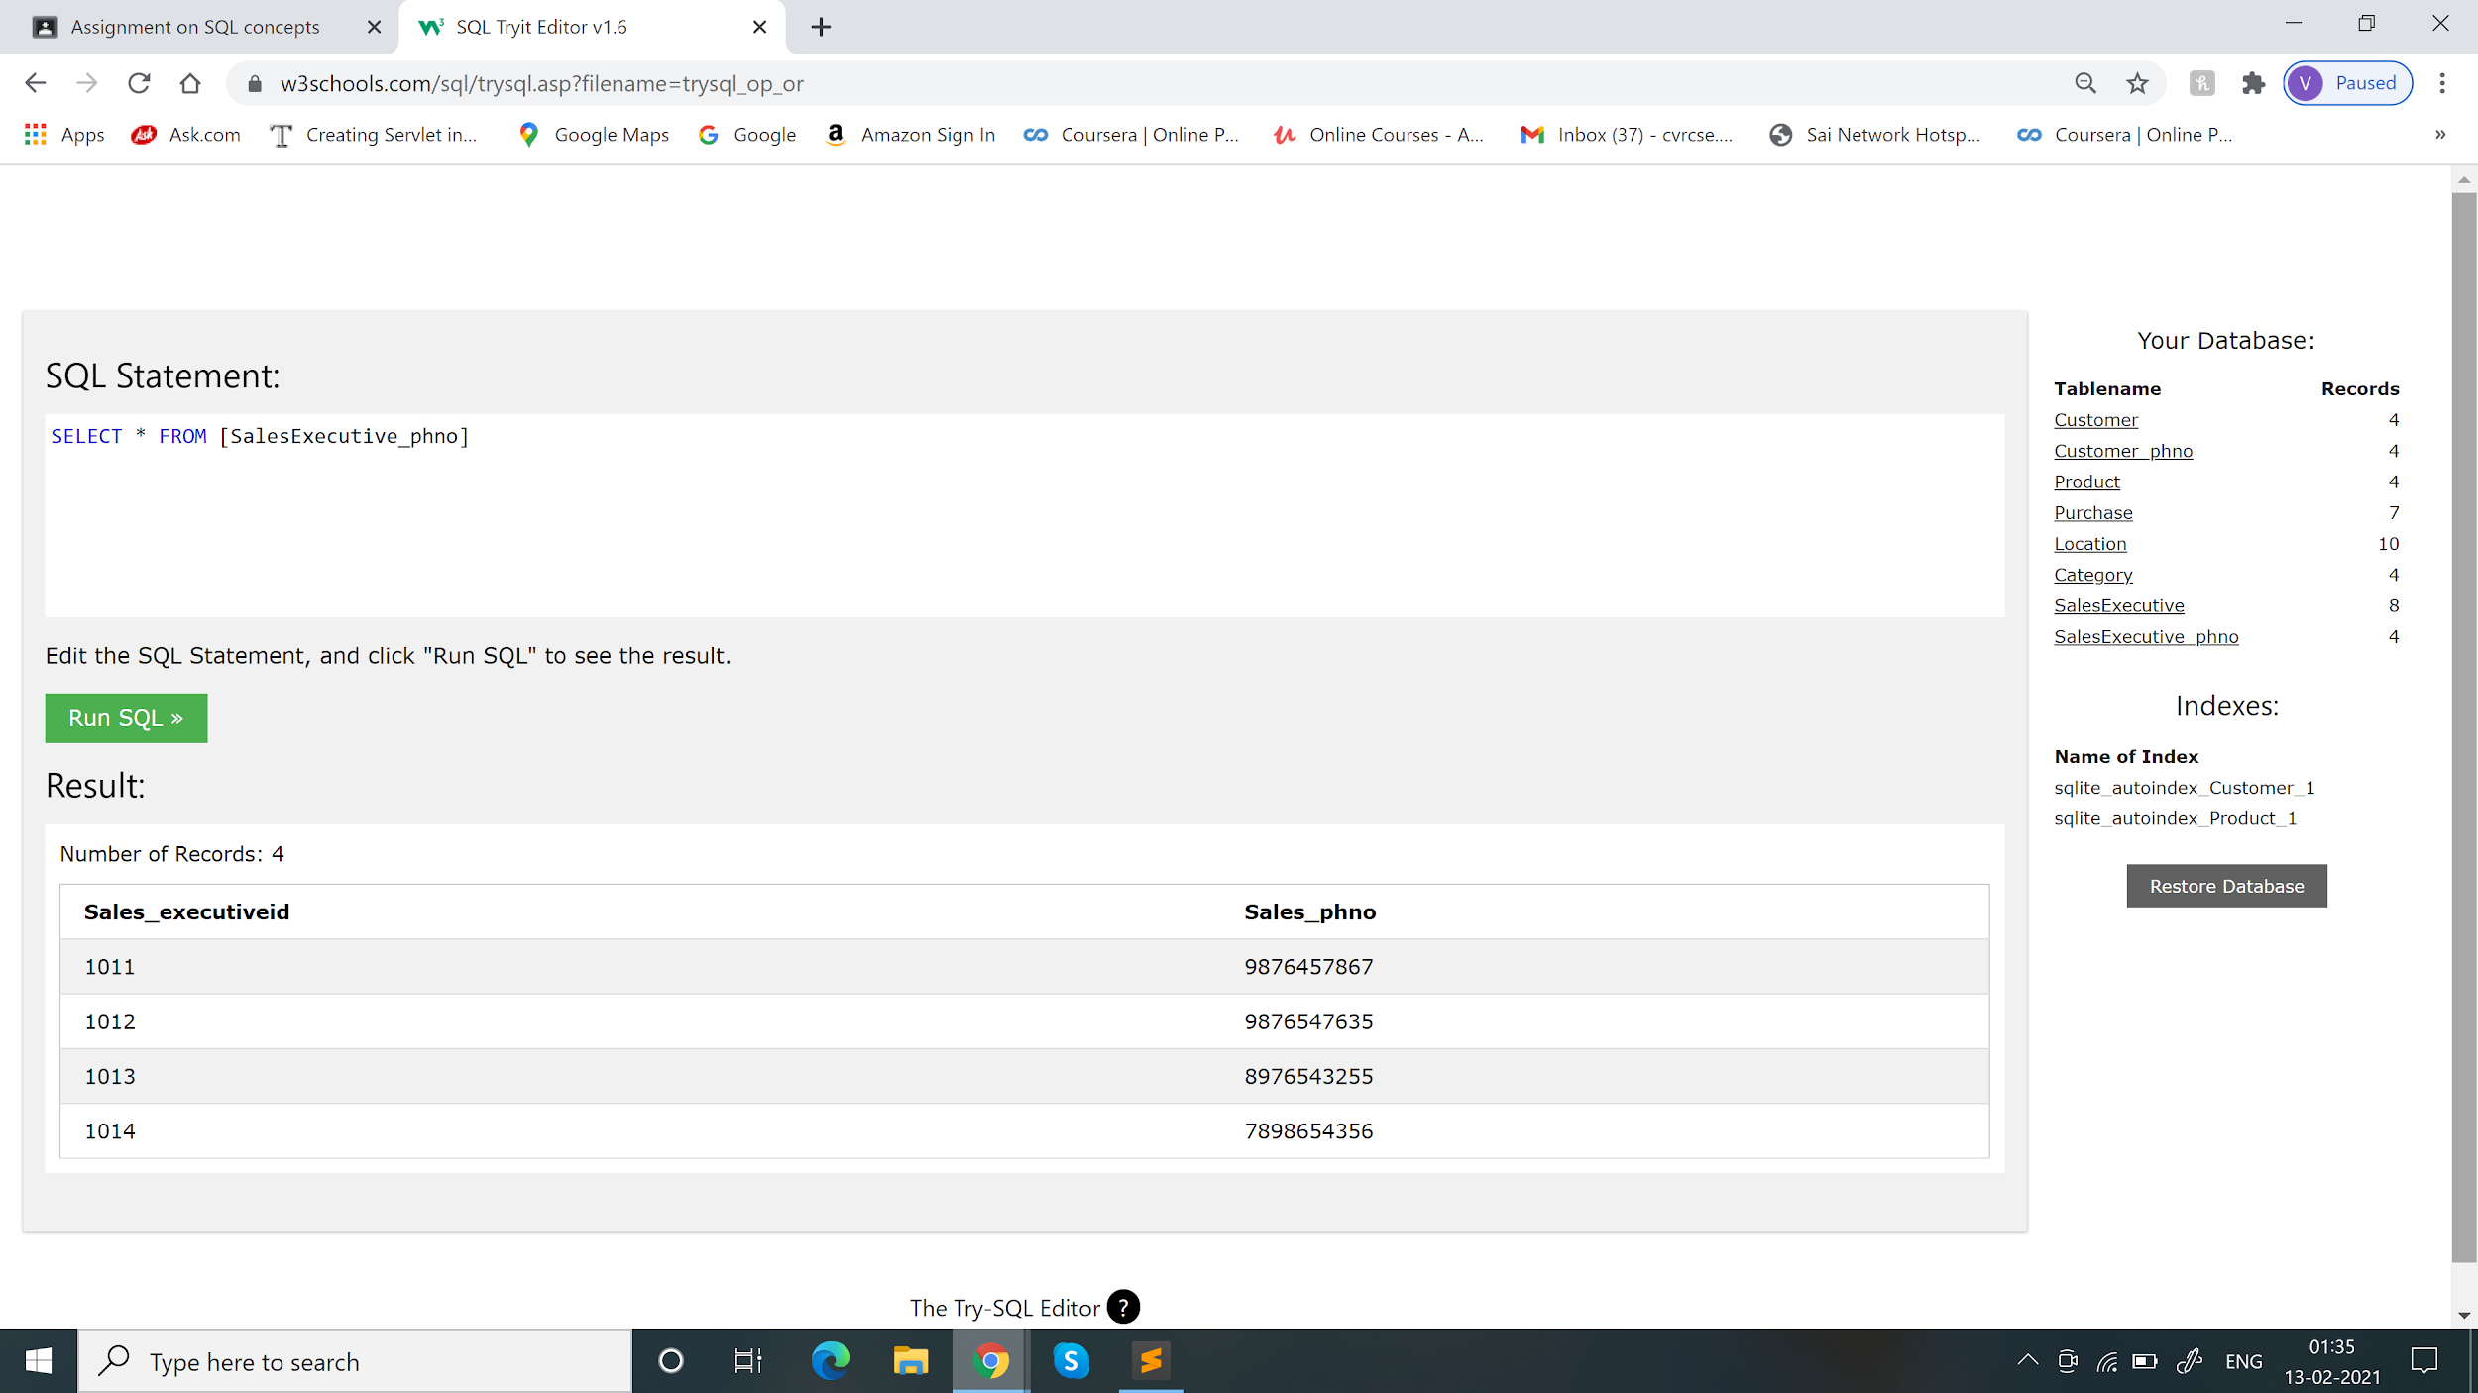

create table **Location**(Location_code int NOT NULL,Location_name varchar(20),Cust_id int,PRIMARY KEY (Location_code),FOREIGN KEY (Cust_id) REFERENCES Customer(Cust_id))

insert into Location values(500079,"Hyd",2),(500077,"Mumbai",4),(500067,"Chennai",1),(712379,"Delhi",3)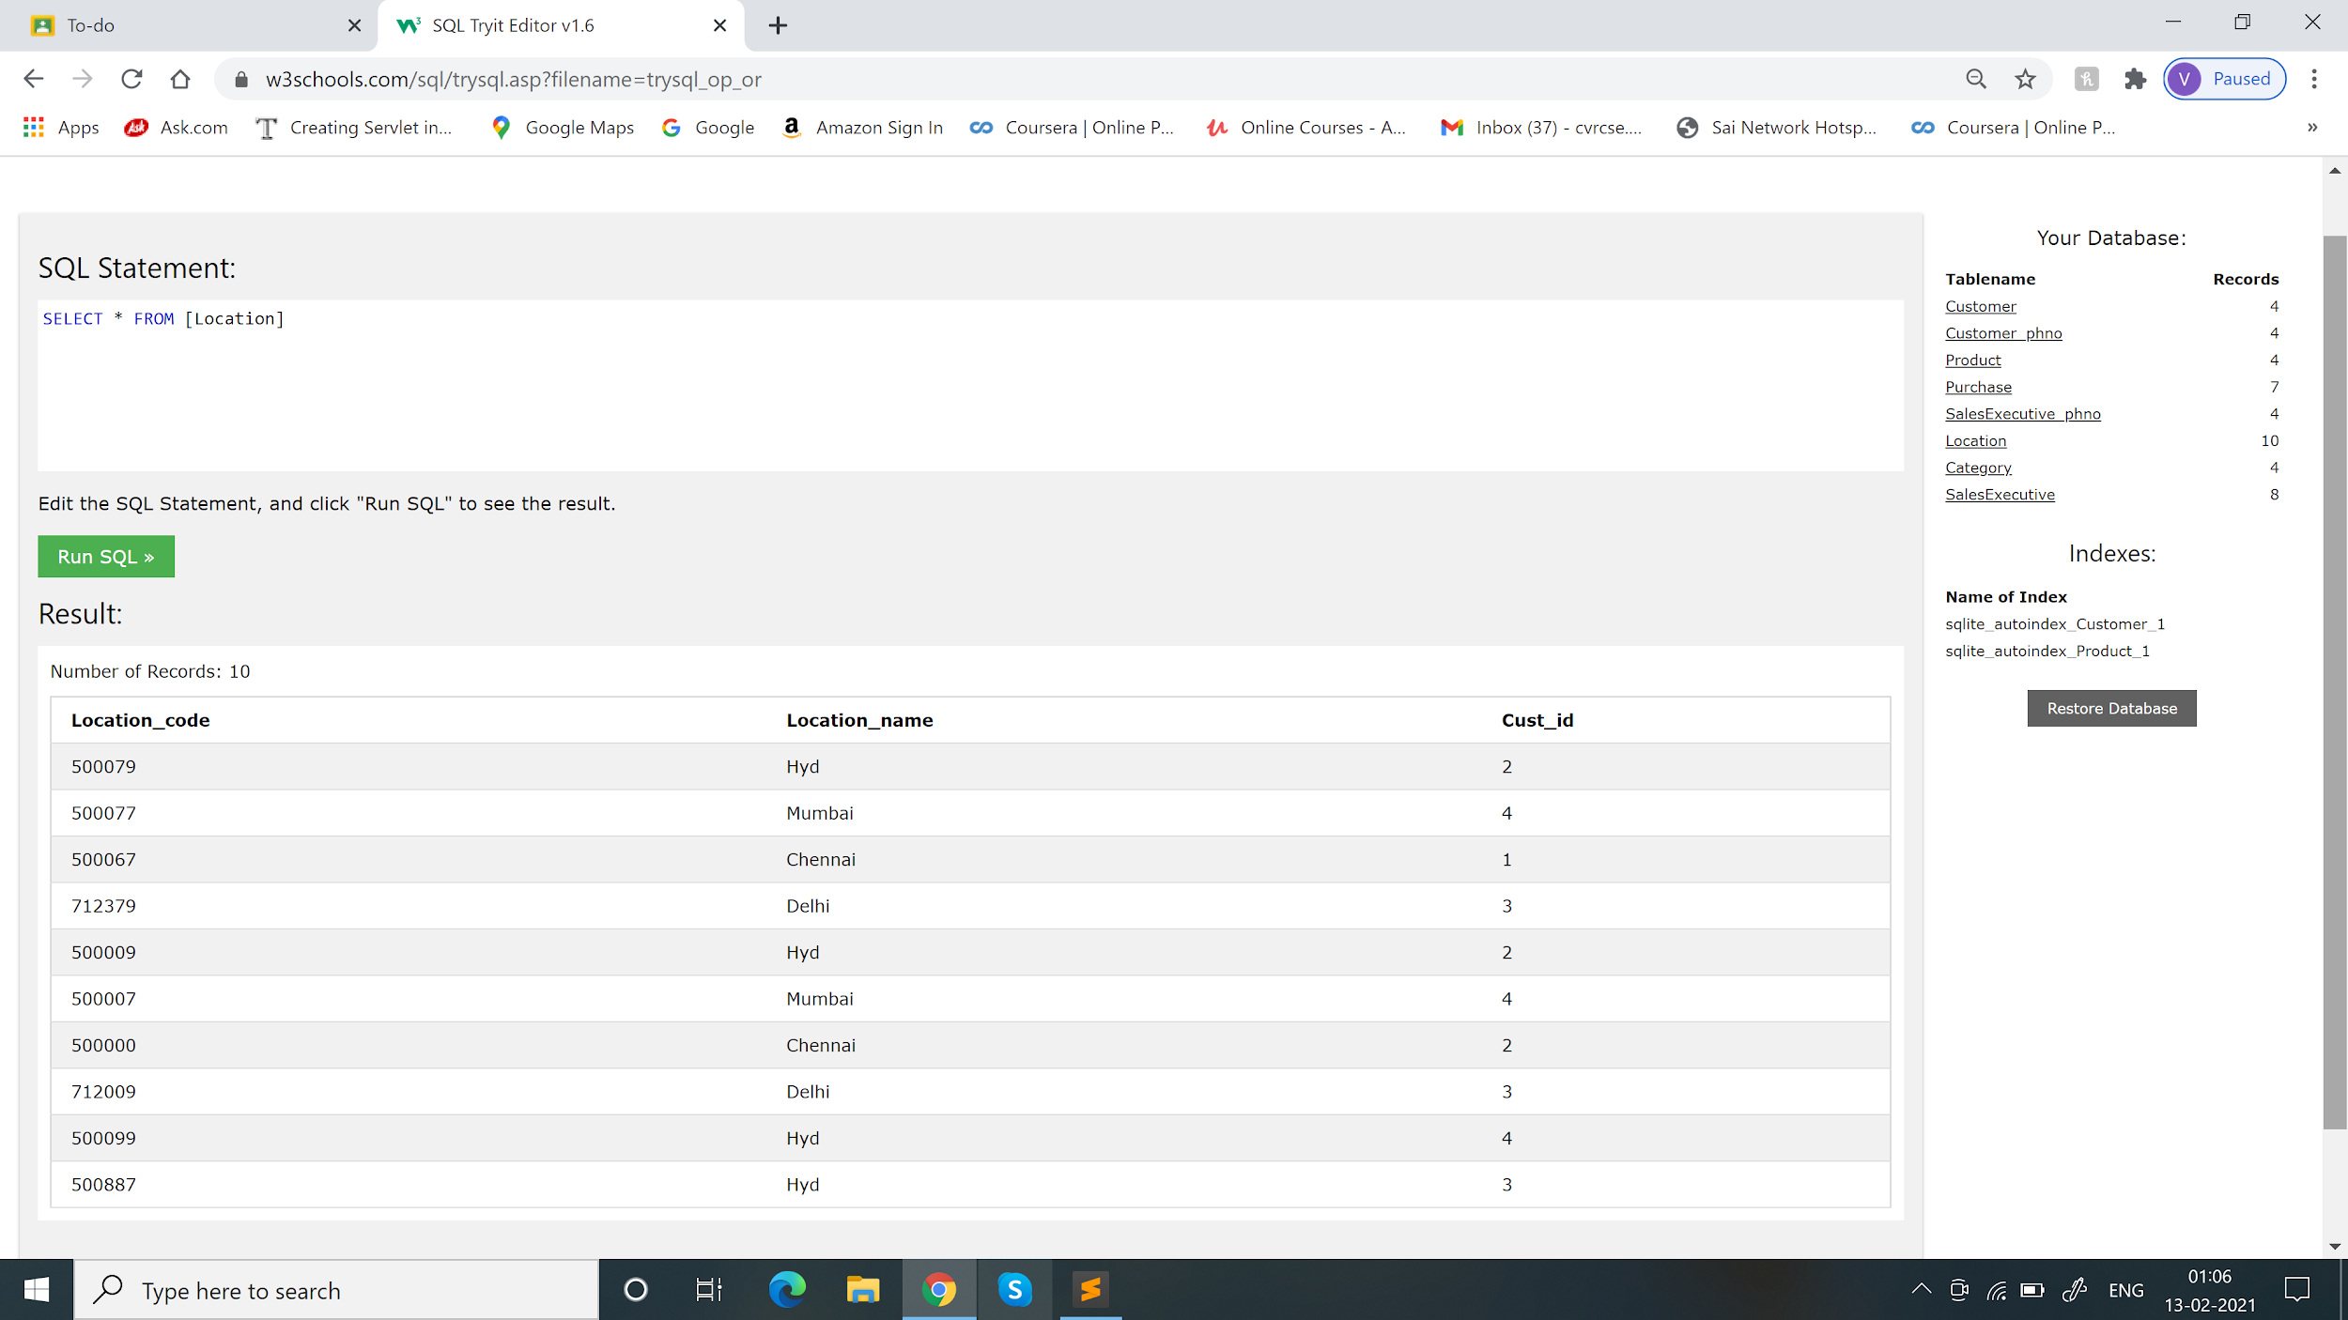

create table **Category** (Category_code varchar(10) not null,Category_name varchar(20),product_code int,FOREIGN KEY (product_code) REFERENCES Product(product_code))

insert into Category values("CA11","CA_name1","SA3"),("CA22","CA_name3","SA2"),("CA44","CA_name4","SA1"),("CA33","CA_name2","SA4")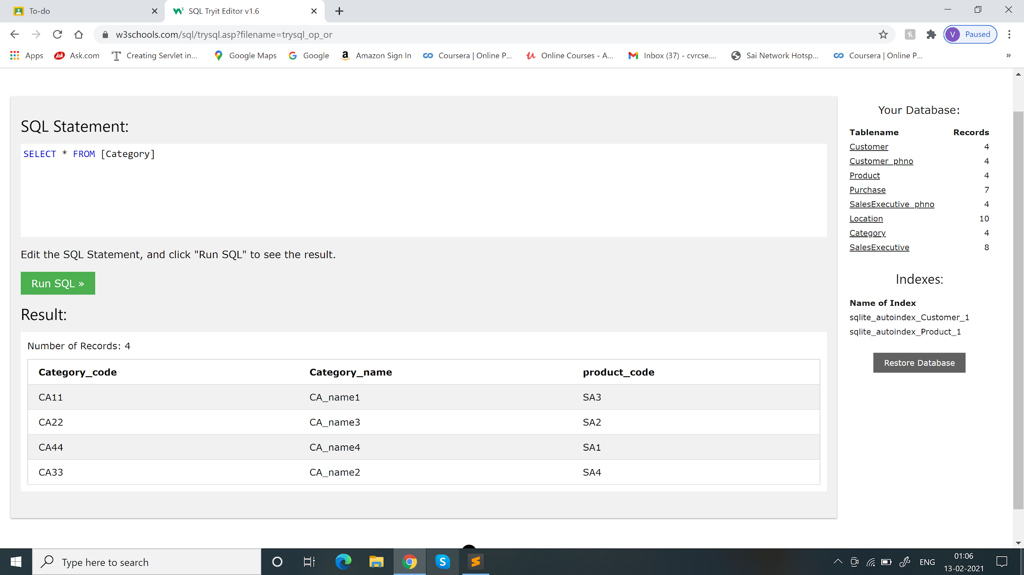

create table **SalesExecutive** (Sales_executiveid int,Sales_name varchar(20),Sales_dateborn DATE,sales_gender varchar(20),product_code varchar(20),FOREIGN KEY(product_code) references Product(product_code))

insert into SalesExecutive values(1011,"se_person","1990-04-01","Female","SA2"),(1012,"se_person1","2000-05-01","male","SA4"),(1013,"se_person4","1880-12-11","Female","SA3"),(1014,"se_person3","2001-09-31","male","SA1")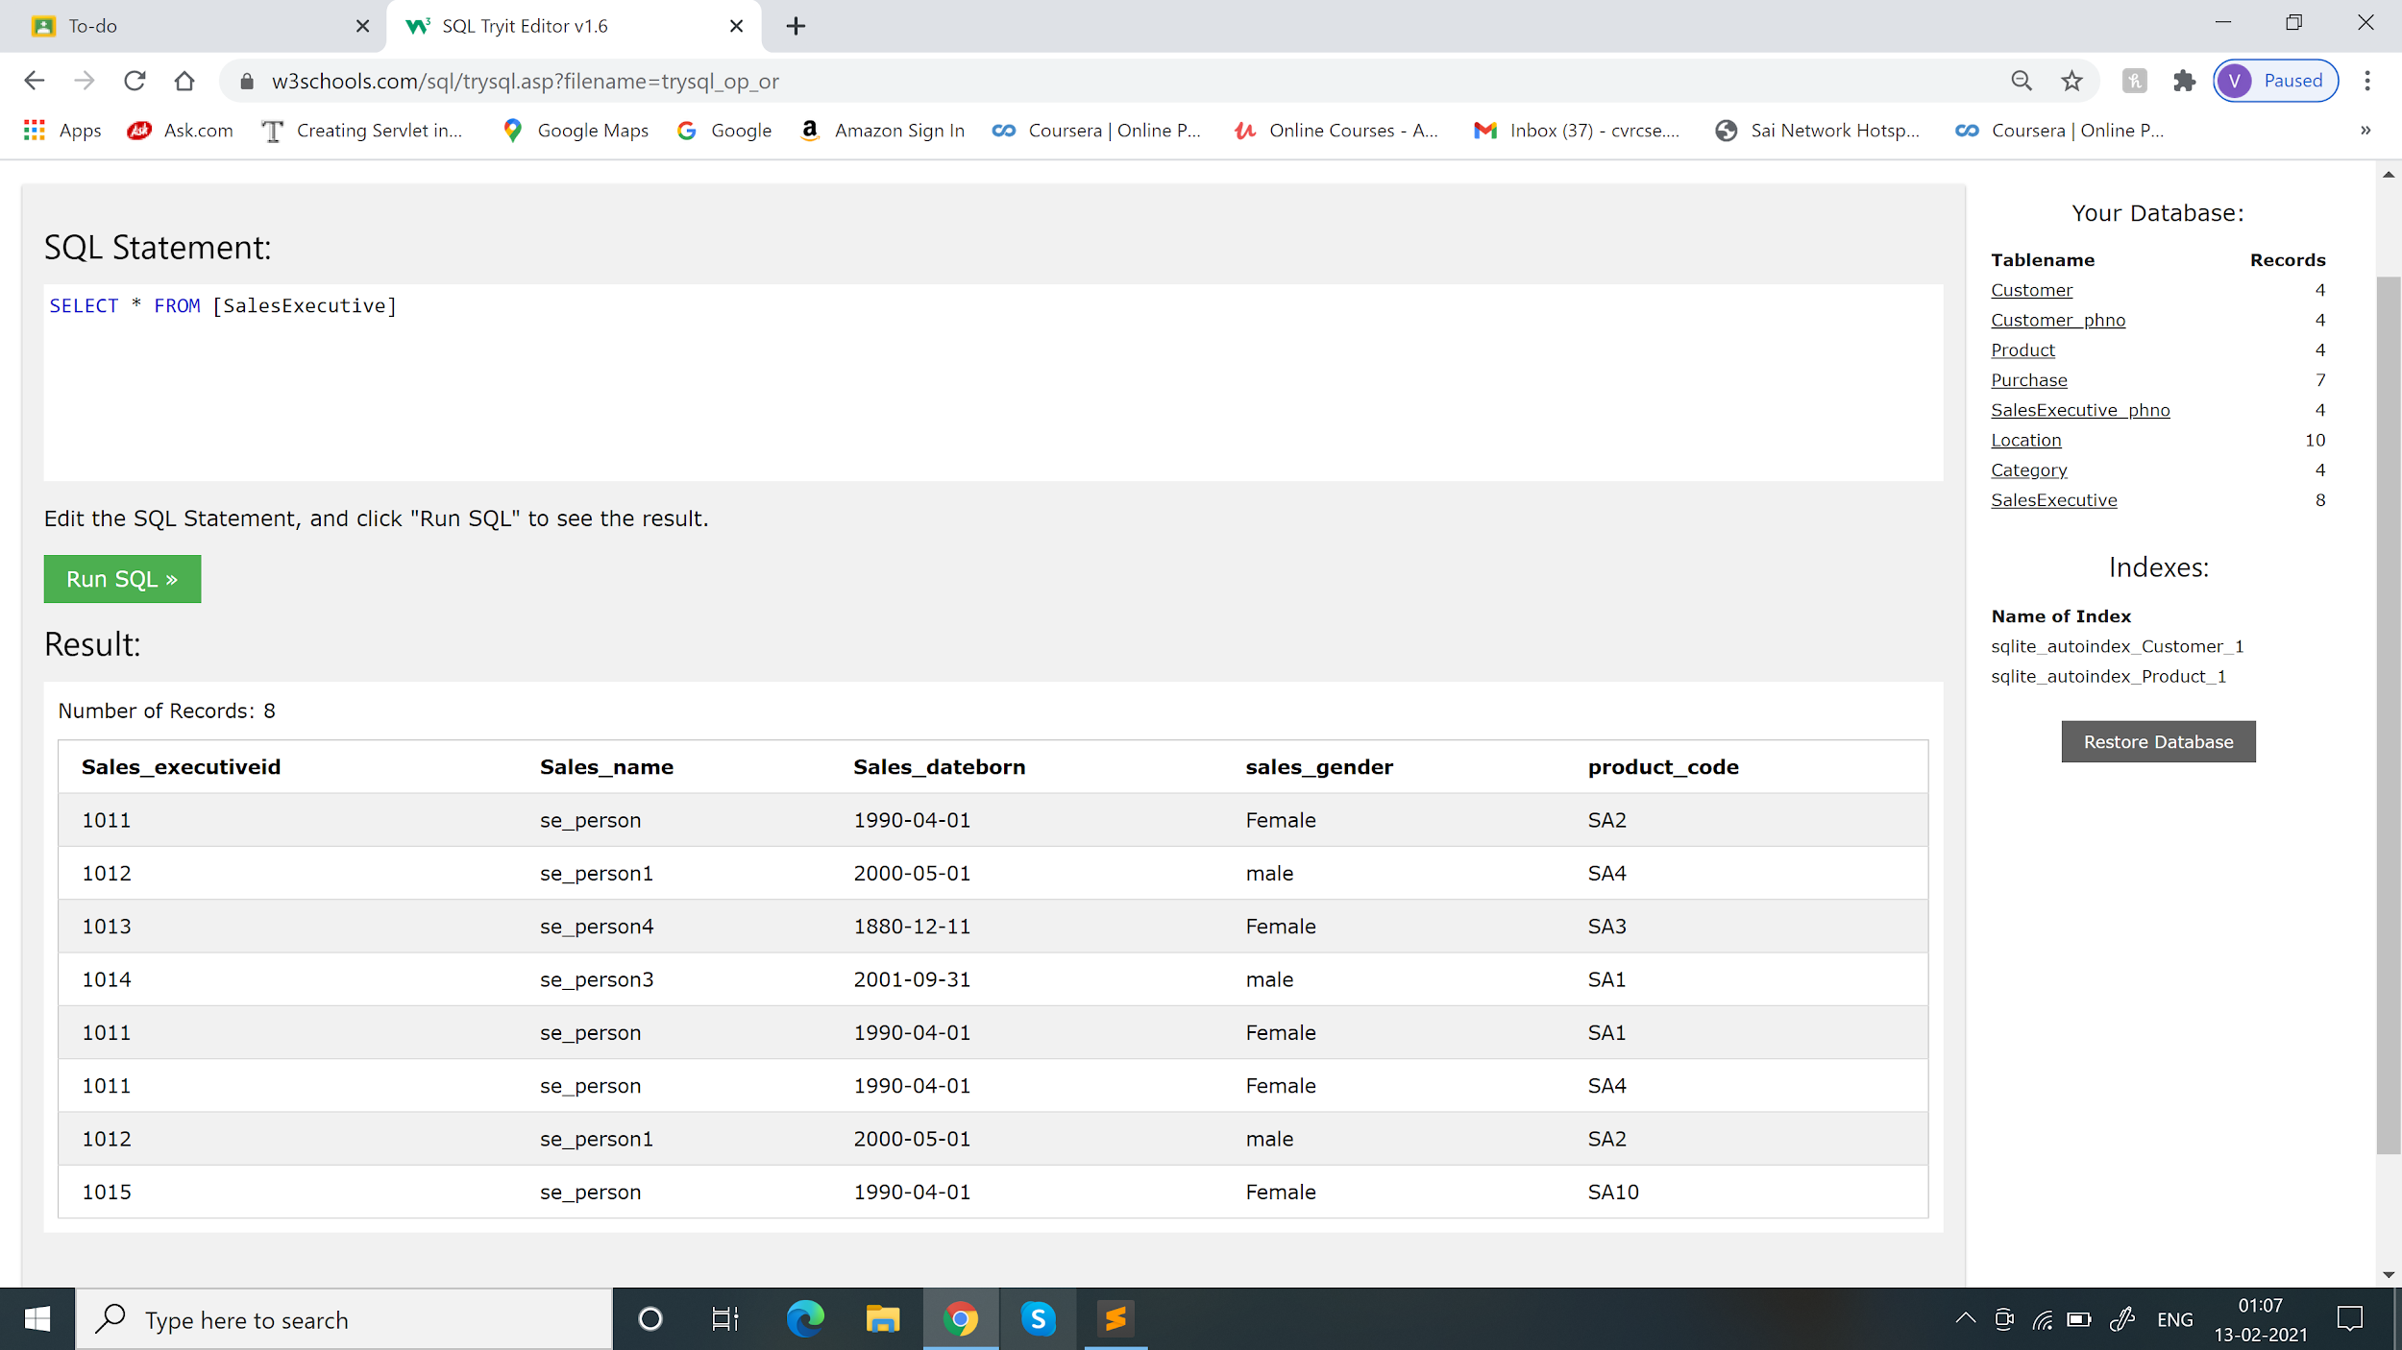

**2. Write a query to retrieve the most sold product per day in a specific location in the last week. You can pick the location of your choice.**

SELECT B.product_code,max(B.No_of_units_purchased) AS total from Location AS A INNER JOIN Purchase AS B ON A.Cust_id=B.Cust_id where A.Location_name="Hyd" and B.Date_of_purchase BETWEEN "2021-02-06" and "2021-02-12"

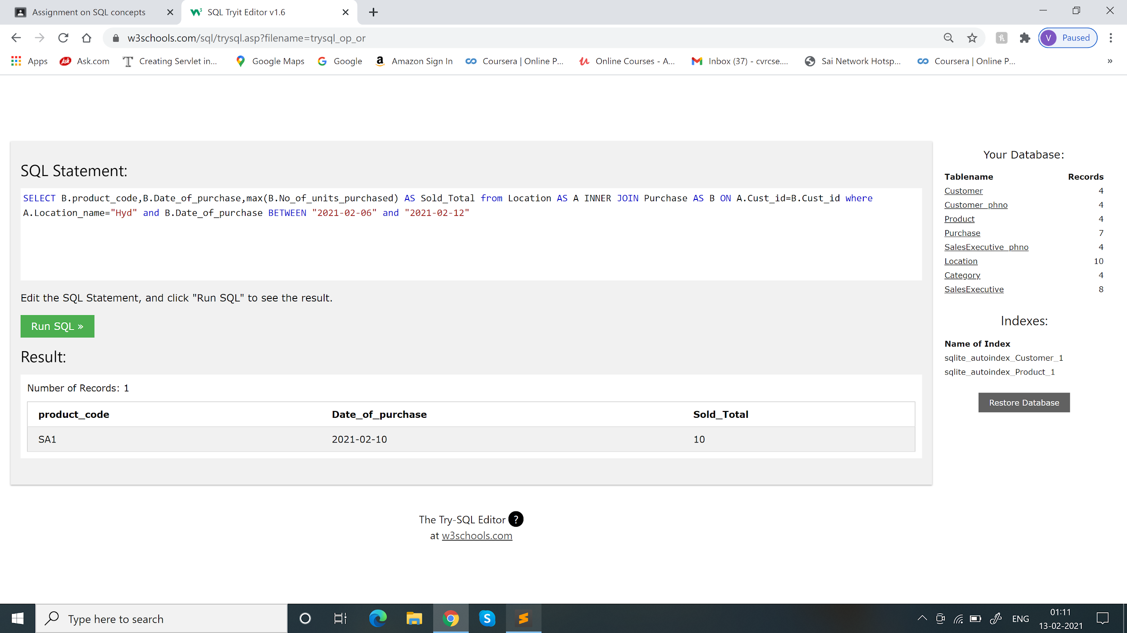

**3. Write a query to list all the salesperson's details along with the count of products sold by them (if any) till the current date.**

SELECT A.Sales_executiveid ,A.Sales_name,count(B.product_code) AS Total from SalesExecutive AS A INNER JOIN Product AS B ON A.product_code=B.product_code Group By A.Sales_executiveid

