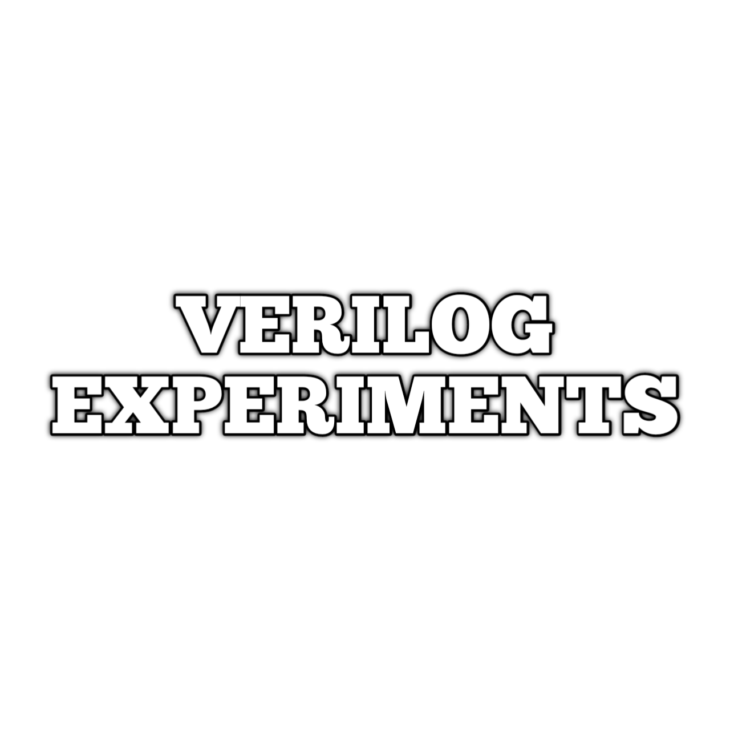

Experiment No. 1
Familiarization of Verilog

Digital systems are highly complex. At their most detailed level, they may consist of millions of elements, such as a collection of logic gates or transistors. Hardware description languages have evolved to aid in the design of systems with this large number of elements and wide range of electronic and logical abstractions. Hardware description languages have been developed for modeling and simulating hardware functions.

Difference between standard programming languages and hardware description languages:
- Standard programming languages: sequential
- HDLs: describe parallel and concurrent behavior
There are two standard HDLs that are supported by IEEE: VHDL and Verilog HDL. The HDL used in our lab will be Verilog.

INTRODUCTION TO VERILOG HDL
Verilog is a Hardware Description Language (HDL) which is used to model electronic systems. It provides the designer entry into the world of large, complex digital systems design. The Verilog language provides the digital system designer with a means of describing a digital system at a wide range of levels of abstraction, and, at the same time, provides access to computer-aided design tools to aid in the design process at these levels. It also fulfils the need for verifying the design for functionality and timing constraints like propagation delay setup and hold times. The components of the target design can be described at different levels with the help of constructs in Verilog.
- Circuit Level/Switch Level: MOS switch is the basic element which can be used to build basic circuits like inverters, logic gates, 1-bit dynamic and static memories.
- Gate Level or structural level: Design is carried out in terms of basic gates. All basic gates are available as ready modules called “primitives”. Primitives can be incorporated into design descriptions directly.
- Data Flow Level: All possible operations on signals and variables are represented in terms of assignments.
- Behavioral Level: This level describes a system by concurrent algorithms and the design description looks like a C program. Compactness and the comprehensive nature of the design description make the development process fast and efficient. Functions, Tasks and always blocks are the main elements.

LANGUAGE CONSTRUCTS AND CONVENTIONS IN VERILOG
Verilog has its own constructs and conventions. Any source file in Verilog is made up of number of ASCII characters. These characters are grouped into sets - referred to as “lexical tokens”. Verilog has 7 types of lexical tokens - operators, keywords, identifiers, white spaces, comments, numbers and strings. Verilog is case sensitive, so all keywords are in lower case.

White Space Characters
Blanks (\b), tabs (\t), newlines (\n) and form feed form the white space characters in Verilog. In any design description the white space characters are included to improve readability. White space characters have significance only when they appear in string.

Comments
Comments are incorporated in two ways.
// begins a single line comment, terminated by a newline.
/* begins a multi-line block comment, terminated by a */.
For Example
Module D_FF (Q, DP, CLK); //This is the design of a D flip-flop.
/* Here Q is the output. DP is the input and CLK is the clock. */

Keywords
The keywords define the language constructs. All keywords in Verilog are in small letters and require to be used as such.
Some of the examples are:
module signifies the beginning of a module definition.
endmodule signifies the end of module definition.
begin signifies the beginning of block of statements.
end signifies the end of a block of statements.
if signifies a conditional activity to be checked.
assign assigns a value or an expression to a net or variable.

Identifiers
Identifiers are user-defined words for variables, function names, module names, block names and instance names. Identifiers begin with a letter or underscore and can include any number of letters, digits and underscores. Identifiers in Verilog are case sensitive.

Numbers
The numbers can be of integer type or real type.
Integer Numbers
Number storage is defined as a number of bits, but values can be specified in binary, octal, decimal or hexadecimal. The representation has three tokens with an optional sign preceding it. Numbers may be sized or unsized. Unsized integers default to at least 32 bits.
Syntax: size’base value

Integer | Stored As |  | Description
1 | 00000000000000000000000000000001 |  | Unsized 32 bits
8’h AA |  | 10101010 |  | Sized hexadecimal
3’b001 |  | 001 |  | 3 bit number
9’o123 |  | 001 010 011 |  | 9 bit octal number
9’h?A |  | zzzzz1010 |  | 5 bit hex number
String
A string is a sequence of characters enclosed by double quotes. It must be contained on a single line. Verilog treats a string as a sequence of ASCII characters.

Logical Values
Verilog uses a 4 value logic system for modelling.
Logical Value Description
0 Zero , low or false
1 One, high or true
Z or z High impedance (tri-state or floating)
X or x Unknown or uninitialized ( don’t care)

Data Types
Verilog has two major data type classes:
1) Net Data type
2) Variable data type

Nets: Net data types are used to make connections between parts of a design. Nets reflect the value and strength level of the drivers of the net or the capacitance of the net, and do not have a value of their own. A net can be specified in different ways.

Wire
A wire (or net) represents a physical wire in a circuit and is used to connect gates or modules. The value of a wire can be read, but not assigned to, in a function or block. A wire does not store its value but must be driven by a continuous assignment statement or by connecting it to the output of a gate or module.
Syntax:wire [msb: lsb] wire_variable_list;
Example
wire c; //declare a wire c

Variable data types
Variable data types are used as temporary storage of programming data. Variables can only be assigned a value from within an initial procedure, an always procedure, a task or a function. Variables can only store logic values; they cannot store logic strength. Variables are un-initialized at the start of simulation, and will contain logic X until a value is assigned. Variables can be declared trough a keyword reg.

Reg
A reg (register) is a data object that holds its value from one procedural assignment to the next. They are used only in functions and procedural blocks. A reg is a Verilog variable type and does not necessarily imply a physical register.
Syntax: reg [msb: lsb] reg_variable_list;
Example
reg a; // single 1-bit register variable
reg [7:0] r_vector; // an 8-bit vector; a bank of 8 registers.
Scalars and Vectors
Entities representing single bits are called “scalars”. Often multiple lines carry signals in a cluster like data bus or address bus. The group of regs is treated as “vector”.

Verilog Module
Verilog language uses a hierarchical, functional unit-based design approach. The whole design consists of several smaller modules. The complexity of the modules is decided by the designer.
Verilog module:
- Definition of the input and output ports
- Definition of the logical relationship between the input and output ports
Port declaration syntax:
<direction> <data_type> <size> <port_name>;
Direction:
- Input port: input
- Output port: output
- Bi‐directional: inout
Verilog language uses a hierarchical, functional unit based design approach:
- The whole design consists of several smaller modules
- The complexity of the modules is decided by the designer
Module Syntax:
module module_name (port_list);
input [msb:lsb] input_port_list;
output [msb:lsb] output_port_list;
inout [msb:lsb] inout_port_list;
... statements ...
Endmodule

Operators

Arithmetic Operators
These perform arithmetic operations.
+ (addition)
- (subtraction)
* (multiplication)
/ (division)
%(modulus)

Relational Operators
Relational operators compare two operands and return a single bit 1or 0. These operators synthesize into comparators.
< (less than)
<= (less than or equal to)
> (greater than)
>= (greater than or equal to)
== (equal to)
!= (not equal to)

Bit-wise Operators
Bit-wise operators do a bit-by-bit comparison between two operands
~ (bitwise NOT) & (bitwise AND)
| (bitwise OR)
^ (bitwise XOR)
~^ or ^~ (bitwise XNOR)

Logical Operators
Logical operators return a single bit 1 or 0. They are the same as bit-wise operators only for single bit operands. They can work on expressions, integers or groups of bits, and treat all values that are nonzero as “1”. Logical operators are typically used in conditional (if ... else) statements since they work with expressions.
! (logical NOT)
&& (logical AND)
|| (logical OR)

Concatenation Operator
The concatenation operator combines two or more operands to form a larger vector.
{} (concatenation)

Experiment No. 2
Basic Gates in Verilog
Aim
To write Verilog descriptions for AND, OR, NOT, NAND, NOR gates.

Programs

AND Gate
Gate Level Modelling
module andgate1(c, a, b);
input a, b;
output c;
and x1(c, a, b);
endmodule

Data Flow Modelling
module andgate1(c, a, b);
input a, b;
output c;
assign c = (a & b);
endmodule

Behavioral Modelling
module andgate1(c, a, b);
input a, b;
output reg c;
always @ (a, b)
c = (a & b);
endmodule

Testbench
module testbencha1;
reg a, b;
wire c;
andgate1 uut(c, a, b);
initial begin
$dumpfile("andgate1.vcd");
$dumpvars();
a=0; b=0; #10
a=0; b=1; #10
a=1; b=0; #10
a=1; b=1; #10
$finish;
end
endmodule

Output
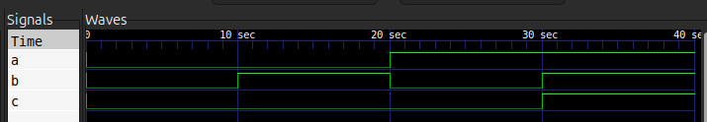

OR Gate
Gate Level Modelling
module orgate1(c, a, b);
input a, b;
output c;
or x1(c, a, b);
endmodule

Data Flow Modelling
module orgate1(c, a, b);
input a, b;
output c;
assign c = (a | b);
endmodule

Behavioral Modelling
module orgate1(c, a, b);
input a, b;
output reg c;
always @ (a, b)
c = (a | b);
endmodule

Testbench
module testbencha1;
reg a, b;
wire c;
orgate1 uut(c, a, b);
initial begin
$dumpfile("orgate1.vcd");
$dumpvars();
a=0; b=0; #10
a=0; b=1; #10
a=1; b=0; #10
a=1; b=1; #10
$finish;
end
endmodule

Output
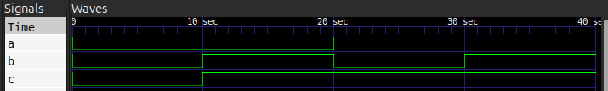

NOT Gate
Gate Level Modelling
module notgate1(c, a);
input a;
output c;
not x1(c, a);
endmodule

Data Flow Modelling
module notgate1(c, a);
input a;
output c;
assign c = ~a;
endmodule

Behavioral Modelling
module notgate1(c, a);
input a;
output reg c;
always @ (a)
c = ~a;
endmodule

Testbench
module testbencha1;
reg a;
wire c;
notgate1 uut(c, a);
initial begin
$dumpfile("notgate1.vcd");
$dumpvars();
a=0; #10
a=1; #10
$finish;
end
endmodule

Output
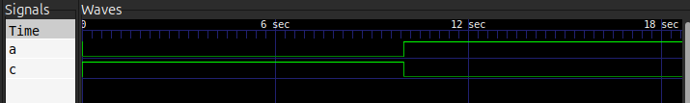

NAND Gate
Gate Level Modelling
module nandgate1(c, a, b);
input a, b;
output c;
nand x1(c, a, b);
endmodule

Data Flow Modelling
module nandgate1(c, a, b);
input a, b;
output c;
assign c = (a ~& b);
endmodule

Behavioral Modelling
module nandgate1(c, a, b);
input a, b;
output reg c;
always @ (a, b)
c = (a ~& b);
endmodule

Testbench
module testbencha1;
reg a, b;
wire c;
nandgate1 uut(c, a, b);
initial begin
$dumpfile("nandgate1.vcd");
$dumpvars();
a=0; b=0; #10
a=0; b=1; #10
a=1; b=0; #10
a=1; b=1; #10
$finish;
end
endmodule

Output
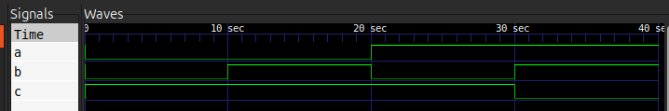

NOR Gate
Gate Level Modelling
module norgate1(c, a, b);
input a, b;
output c;
nor x1(c, a, b);
endmodule

Data Flow Modelling
module norgate1(c, a, b);
input a, b;
output c;
assign c = (a ~| b);
endmodule

Behavioral Modelling
module norgate1(c, a, b);
input a, b;
output reg c;
always @ (a, b)
c = (a ~| b);
endmodule

Testbench
module testbencha1;
reg a, b;
wire c;
norgate1 uut(c, a, b);
initial begin
$dumpfile("norgate1.vcd");
$dumpvars();
a=0; b=0; #10
a=0; b=1; #10
a=1; b=0; #10
a=1; b=1; #10
$finish;
end
endmodule

Output
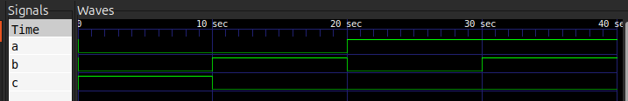

Result
The Verilog descriptions for AND, OR, NOT, NAND, NOR gates have been successfully written and outputs verified.

Experiment No. 3
Adders using Verilog

Aim
To write Verilog descriptions for half adder and full adder.

Programs

Half Adder
Gate Level Modelling
module halfadder(sum, carry, a, b);
input a, b;
output sum, carry;
xor x1(sum, a, b);
and a1(carry, a, b);
endmodule

Data Flow Modelling
module halfadder(sum, carry, a, b);
input a, b;
output sum, carry;
assign sum = (a ^ b);
assign carry = (a & b);
endmodule

Behavioral Modelling
module halfadder(sum, carry, a, b);
input a, b;
output reg sum, carry;
always @ (a, b)
sum = (a ^ b);
always @ (a, b)
carry = (a & b);
endmodule

Testbench
module testbencha1;
reg a, b;
wire sum, carry;
halfadder uut(sum, carry, a, b);
initial begin
$dumpfile("halfadder.vcd");
$dumpvars();
a=0; b=0; #10
a=0; b=1; #10
a=1; b=0; #10
a=1; b=1; #10
$finish;
end
endmodule

Output
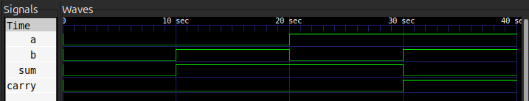

Full Adder
Gate Level Modelling
module fulladder(Sum, Carry, A, B, Cin);
input A, B, Cin;
wire w1, w2, w3;
output Sum, Carry;
xor x1(w1, A, B);
xor x2(Sum, w1, Cin);
and a1(w2, A, B);
and a2(w3, w1, Cin);
or o1(Carry, w2, w3);
endmodule

Data Flow Modelling
module fulladder(Sum, Carry, A, B, Cin);
input A, B, Cin;
output Sum, Carry;
assign Sum = A ^ B ^ Cin;
assign Carry = ((A&B)|(A&Cin)|(B&Cin));
endmodule

Behavioral Modelling
module fulladder(Sum, Carry, A, B, Cin);
input A, B, Cin;
output reg Sum, Carry;
always@(A, B, Cin)
begin
Sum = (A ^ B ^ Cin);
Carry = ((A&B)|(A&Cin)|(B&Cin));
end
endmodule

Testbench
module testbencha1;
reg A, B, Cin;
wire Sum, Carry;
fulladder uut(Sum, Carry, A, B, Cin);
initial begin
$dumpfile("fulladder.vcd");
$dumpvars();
A = 0; B = 0; Cin = 0; #10
A = 0; B = 0; Cin = 1; #10
A = 0; B = 1; Cin = 0; #10
A = 0; B = 1; Cin = 1; #10
A = 1; B = 0; Cin = 0; #10
A = 1; B = 0; Cin = 1; #10
A = 1; B = 1; Cin = 0; #10
A = 1; B = 1; Cin = 1; #10
$finish;
end
endmodule

Output
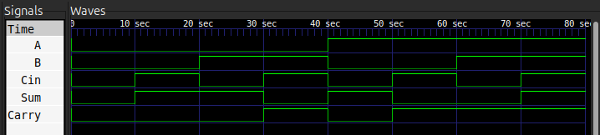

Result
The Verilog descriptions for half adder and full adder have been successfully written and outputs verified.

Experiment No. 4
Subtractors using Verilog
Aim
To write Verilog descriptions for half subtractor and full subtractor.

Programs

Half Subtractor
Gate Level Modelling
module halfsubtractor(difference, borrow, a, b);
input a, b;
wire w1;
output difference, borrow;
xor x1(difference, a, b);
not n1(w1, a);
and a1(borrow, w1, b);
endmodule

Data Flow Modelling
module halfsubtractor(difference, borrow, a, b);
input a, b;
output difference, borrow;
assign difference = a ^ b;
assign borrow = ((~a) & b);
endmodule

Behavioral Modelling
module halfsubtractor(difference, borrow, a, b);
input a, b;
output reg difference, borrow;
always @ (a, b)
begin
difference = a ^ b;
borrow = ((~a) & b);
end
endmodule

Testbench
module testbencha1;
reg a, b;
wire difference, borrow;
halfsubtractor uut(difference, borrow, a, b);
initial begin
$dumpfile("halfsubtractor.vcd");
$dumpvars();
a = 0; b = 0; #10
a = 0; b = 1; #10
a = 1; b = 0; #10
a = 1; b = 1; #10
$finish;
end
endmodule

Output
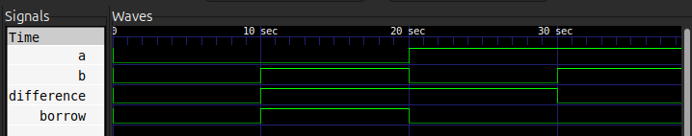

Full Subtractor
Gate Level Modelling
module fullsubtractor(Difference, Borrow, A, B, Bin);
input A, B, Bin;
wire w1, w2, w3, w4, w5;
output Difference, Borrow;
xor x1(w1, A, B);
xor x2(Difference, w1, Bin);
not n1(w2, A);
and a1(w3, w2, B);
not n2(w4, w1);
and a2(w5, w4, Bin);
or o1(Borrow, w3, w5);
endmodule

Data Flow Modelling
module fullsubtractor(Difference,Borrow, A, B, Bin);
input A, B, Bin;
output Difference,Borrow;
assign Difference = A ^ B ^ Bin;
assign Borrow = ((Bin&(~(A ^ B)))|((~A)&B));
endmodule

Behavioral Modelling
module fullsubtractor(Difference, Borrow, A, B, Bin);
input A, B, Bin;
output reg Difference, Borrow;
always@(A, B, Bin)
begin
Difference = (A ^ B ^ Bin);
Borrow = ((Bin&(~(A ^ B)))|((~A)&B));
end
endmodule

Testbench
module testbencha1;
reg A, B, Bin;
wire Difference, Borrow;
fullsubtractor uut(Difference, Borrow, A, B, Bin);
initial begin
$dumpfile("fullsubtractor.vcd");
$dumpvars();
A = 0; B = 0; Bin = 0; #10
A = 0; B = 0; Bin = 1; #10
A = 0; B = 1; Bin = 0; #10
A = 0; B = 1; Bin = 1; #10
A = 1; B = 0; Bin = 0; #10
A = 1; B = 0; Bin = 1; #10
A = 1; B = 1; Bin = 0; #10
A = 1; B = 1; Bin = 1; #10
$finish;
end
endmodule

Output
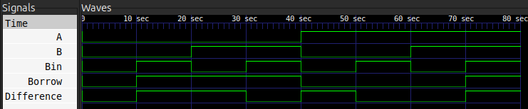

Result
The Verilog descriptions for half subtractor and full subtractor have been successfully written and outputs verified.

Experiment No. 5
Multiplexer using Verilog
Aim
To write Verilog description for 4:1 multiplexer (MUX).

Programs
Gate Level Modelling
module mux(y, i0, i1, i2, i3, s0, s1);
input i0, i1, i2, i3, s0, s1;
output y;
wire n0, n1, a0, a1, a2, a3;
not x1(n0, s0);
not x2(n1, s1);
and x3(a0, n1, n0, i0);
and x4(a1, n1, s0, i1);
and x5(a2, s1, n0, i2);
and x6(a3, s1, s0, i3);
or x7(y, a0, a1, a2, a3);
endmodule

Data Flow Modelling
module mux(y, i0, i1, i2, i3, s0, s1);
input i0, i1, i2, i3, s0, s1;
output y;
assign y = (((~s0)&(~s1)&i0)|(s0&(~s1)&i1)|((~s0)&s1&i2)|(s0&s1&i3));
endmodule

Behavioral Modelling
module mux(y,s0,s1,i0,i1,i2,i3);
input s0,s1,i0,i1,i2,i3;
output reg y;
always @ (s0,s1,i0,i1,i2,i3)
y = (((~s0)&(~s1)&i0)|(s0&(~s1)&i1)|((~s0)&s1&i2)|(s0&s1&i3));
endmodule

Testbench
module testbench;
reg s0, s1, i0, i1, i2, i3;
wire y;
mux uut(y,i0,i1,i2,i3,s0,s1);
initial begin
$dumpfile("mux.vcd");
$dumpvars();
s1 = 0; s0 = 0; i0 = 1; i1 = 0; i2 = 0; i3 = 0; #10
s1 = 0; s0 = 1;i0 = 0; i1 = 1; i2 = 0; i3 = 0; #10
s1 = 1; s0 = 0; i0 = 0; i1 = 0; i2 = 1; i3 = 0; #10
s1 = 1; s0 = 1; i0 = 0; i1 = 0; i2 = 0; i3 = 1; #10
$finish;
end
endmodule

Output
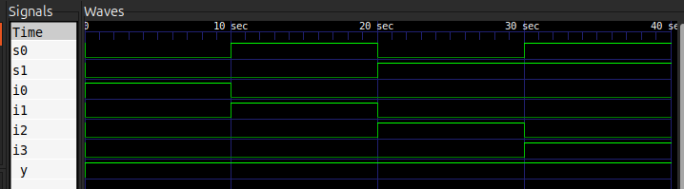

Result
The Verilog descriptions for 4:1 multiplexer (MUX) has been successfully written and outputs verified.

Experiment No. 6
Code Converters using Verilog
Aim
To write Verilog description for 4-bit binary to gray and gray to binary code converters.

Programs

Binary to Gray
Gate Level Modelling
module btog (b1, b2, b3, b0, g1, g2, g3, g0);
input b1, b2, b3, b0;
output g1, g2, g3, g0;
xor (g0, b0, b1);
xor (g1, b1, b2);
xor (g2, b2, b3);
buf(g3, b3);
endmodule

Data Flow Modelling
module btog (b1, b2, b3, b0, g1, g2, g3, g0);
input b1, b2, b3, b0;
output g1, g2, g3, g0;
xor (g0, b0, b1);
xor (g1, b1, b2);
xor (g2, b2, b3);
assign g3 = b3;
endmodule

Behavioral Modelling
module btog (b1, b2, b3, b0, g1, g2, g3, g0);
input b1, b2, b3, b0;
output reg g1, g2, g3, g0;
always @(*)
begin
g0 = b0 ^ b1;
g1 = b1 ^ b2;
g2 = b2 ^ b3;
g3 = b3;
end
endmodule

Testbench
module testbtog;
reg b1, b2, b3, b0;
wire g1, g2, g3, g0;
btog uut(.b0(b0), .b1(b1), .b2(b2), .b3(b3), .g0(g0), .g1(g1), .g2(g2), .g3(g3));
initial begin
$dumpfile("btog.vcd");
$dumpvars();
b3=0; b2=0; b1=0; b0=0; #10;
b3=0; b2=0; b1=0; b0=1; #10;
b3=0; b2=0; b1=1; b0=0; #10;
b3=0; b2=0; b1=1; b0=1; #10;
b3=0; b2=1; b1=0; b0=0; #10;
b3=0; b2=1; b1=0; b0=1; #10;
b3=0; b2=1; b1=1; b0=0; #10;
b3=0; b2=1; b1=1; b0=1; #10;
b3=1; b2=0; b1=0; b0=0; #10;
b3=1; b2=0; b1=0; b0=1; #10;
b3=1; b2=0; b1=1; b0=0; #10;
b3=1; b2=0; b1=1; b0=1; #10;
b3=1; b2=1; b1=0; b0=0; #10;
b3=1; b2=1; b1=0; b0=1; #10;
b3=1; b2=1; b1=1; b0=0; #10;
b3=1; b2=1; b1=1; b0=1; #10;
$finish;
end
endmodule

Output
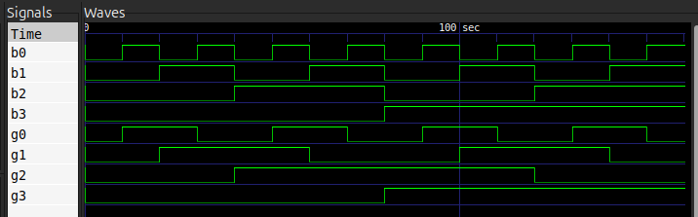

Gray to Binary
Gate Level Modelling
module gtob(g3, g2, g1, g0, b3, b2, b1, b0);
input g3, g2, g1, g0;
output b3, b2, b1, b0;
buf(b3, g3);
xor(b2, g2, b3);
xor(b1, g1, b2);
xor(b0, g0, b1);
endmodule

Data Flow Modelling
module gtob(g3, g2, g1, g0, b0, b1, b2, b3);
input g3, g2, g1, g0;
output b0, b1, b2, b3;
assign b3 = g3;
xor(b2, g2, b3);
xor(b1, b2, g1);
xor(b0, b1, g0);
endmodule

Behavioral Modelling
module gtob(g3, g2, g1, g0, b3, b2, b1, b0);
input g3, g2, g1, g0;
output reg b3, b2, b1, b0;
always @(*)
begin
b3 = g3;
b2 = b3 ^ g2;
b1 = b2 ^ g1;
b0 = b1 ^ g0;
end
endmodule

Testbench
module testgtob;
reg g0, g1, g2, g3;
wire b0, b1, b2, b3;
gtob uut(.g0(g0), .g1(g1), .g2(g2), .g3(g3), .b0(b0), .b1(b1), .b2(b2), .b3(b3));
initial begin
$dumpfile("gtob.vcd");
$dumpvars();
g3 = 0; g2 = 0; g1 = 0; g0 = 0; #10;
g3 = 0; g2 = 0; g1 = 0; g0 = 1; #10;
g3 = 0; g2 = 0; g1 = 1; g0 = 0; #10;
g3 = 0; g2 = 0; g1 = 1; g0 = 1; #10;
g3 = 0; g2 = 1; g1 = 0; g0 = 0; #10;
g3 = 0; g2 = 1; g1 = 0; g0 = 1; #10;
g3 = 0; g2 = 1; g1 = 1; g0 = 0; #10;
g3 = 0; g2 = 1; g1 = 1; g0 = 1; #10;
g3 = 1; g2 = 0; g1 = 0; g0 = 0; #10;
g3 = 1; g2 = 0; g1 = 0; g0 = 1; #10;
g3 = 1; g2 = 0; g1 = 1; g0 = 0; #10;
g3 = 1; g2 = 0; g1 = 1; g0 = 1; #10;
g3 = 1; g2 = 1; g1 = 0; g0 = 0; #10;
g3 = 1; g2 = 1; g1 = 0; g0 = 1; #10;
g3 = 1; g2 = 1; g1 = 1; g0 = 0; #10;
g3 = 1; g2 = 1; g1 = 1; g0 = 1; #10;
$finish;
end
endmodule

Output
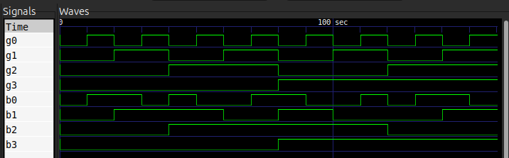

Result
The Verilog descriptions for 4-bit binary to gray and gray to binary code converters have been successfully written and outputs verified.

