**AWS Task-2**

Set up a VPC with an Internet gateway, create a public subnet with 256 IP addresses, a private subnet with 256 IP addresses, make a route table connecting the Internet gateway and the subnets, and launch a Linux EC2 instance by using the above VPC and public subnet.

👉🏼VPC Creation

Search VPC 🡪Select VPC Create 🡪 Select VPC only 🡪 Enter Tag Name 🡪 Default IPv4 🡪 Enter IPv4 CIDR 🡪 Default NO IPv6 🡪 Tenancy Default 🡪 Create VPC

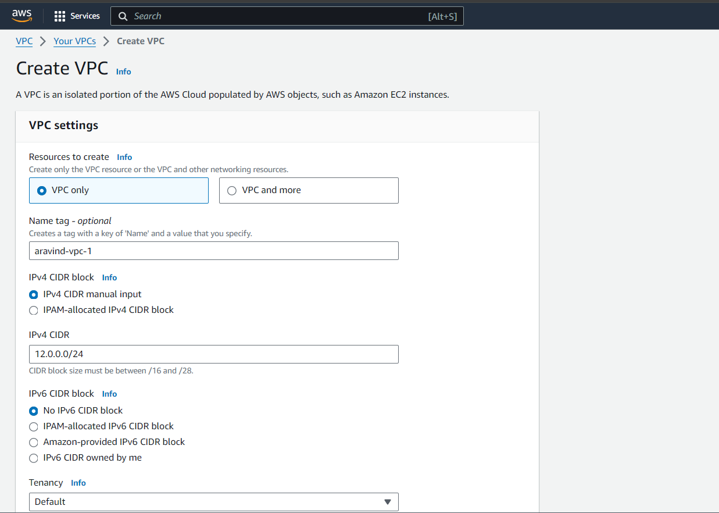

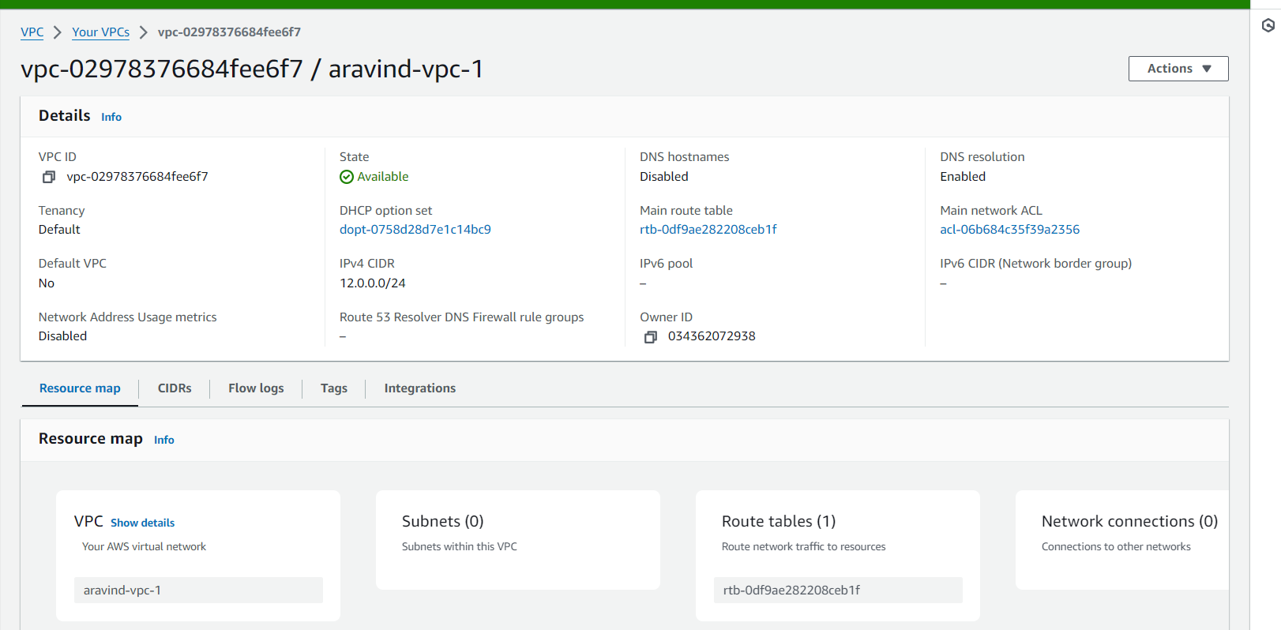

👉🏼Create Internet Gateway and attach it to VPC

Select Internet Gateway 🡪 Enter Name Tag 🡪 Create Internet gateway

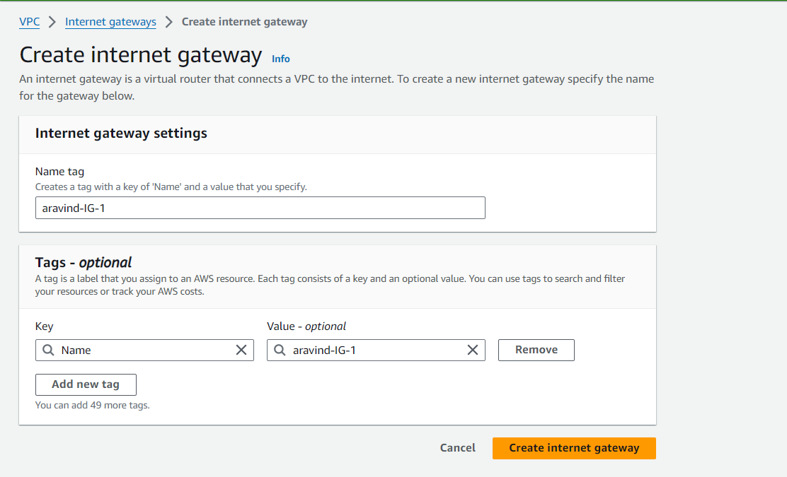

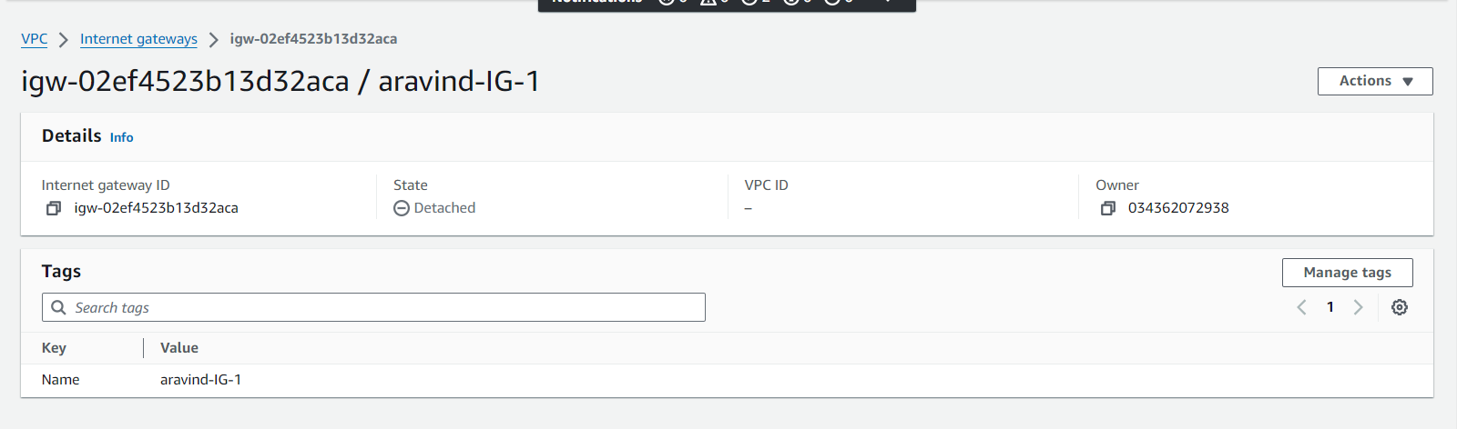

👉🏼Create Public and Private Subnet with 256 IP addresses

Select Subnet 🡪 Create Subnet 🡪 Select VPC from drop down 🡪 Enter Subnet 1 name 🡪 select Available Zone 🡪 Enter Subnet CIDR block for Public Subnet

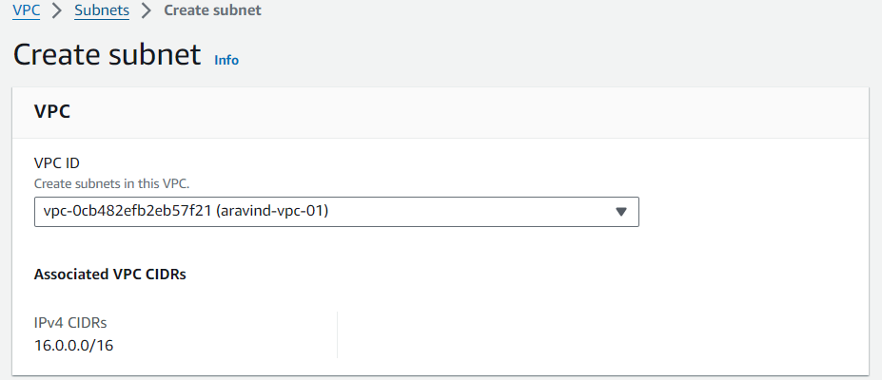

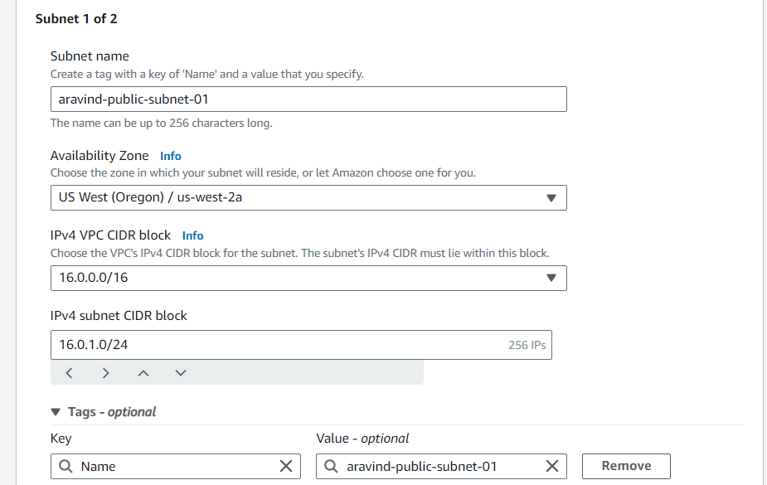

Subnet 2 🡪 Add New Subnet 🡪 select Available Zone 🡪 Enter Subnet CIDR block for Private Subnet

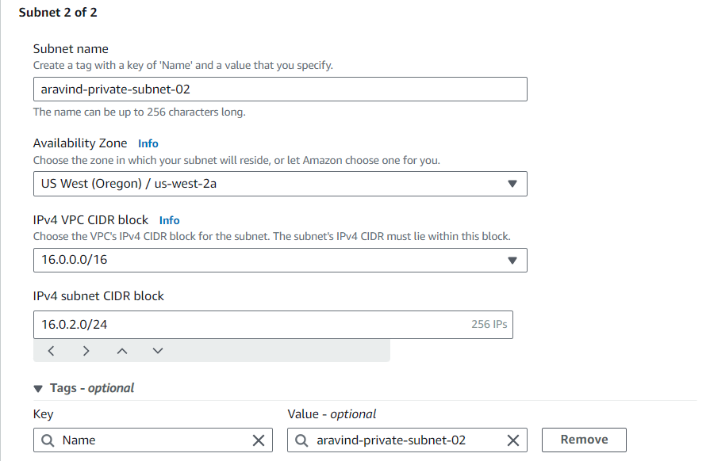

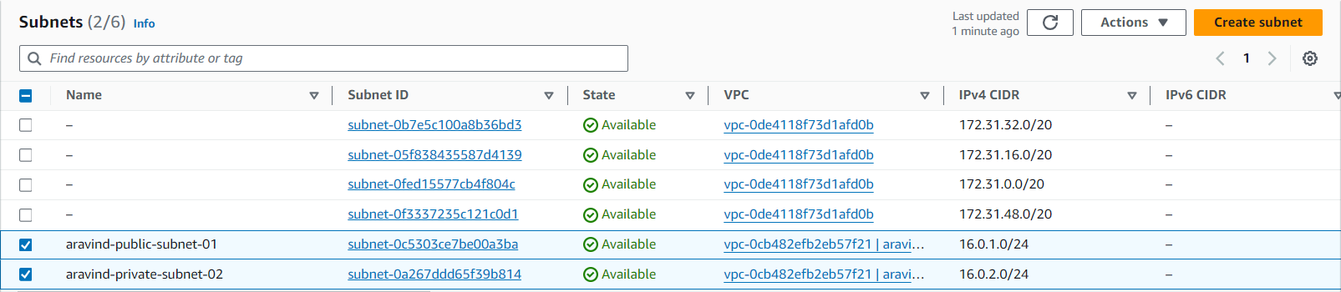

👉🏼Attach Internet Gateway to VPC

Action 🡪 Select VPC from Drop Down 🡪 Attach Internet Gateway

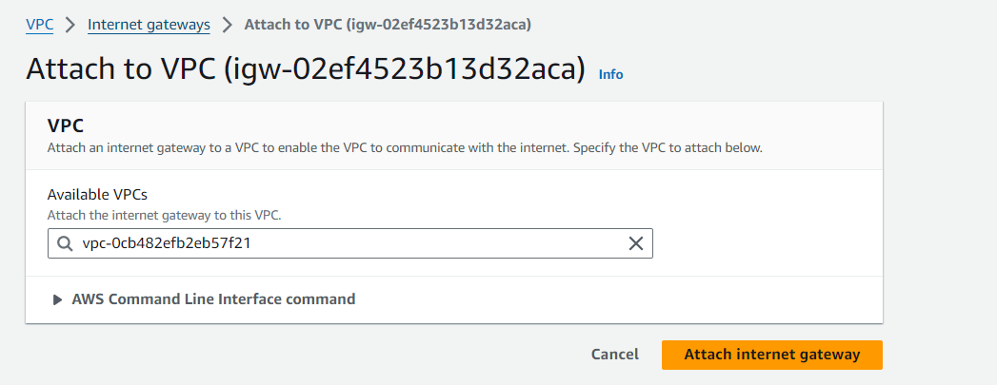

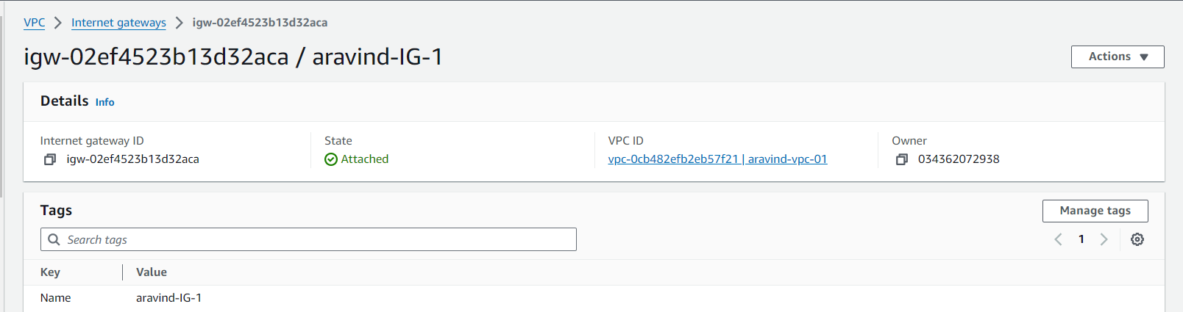

👉🏼Route Table Creation

Select Route Table 🡪 Create Route Table 🡪 Enter Name 🡪 Select VPC from Drop Down 🡪 Create Route Table

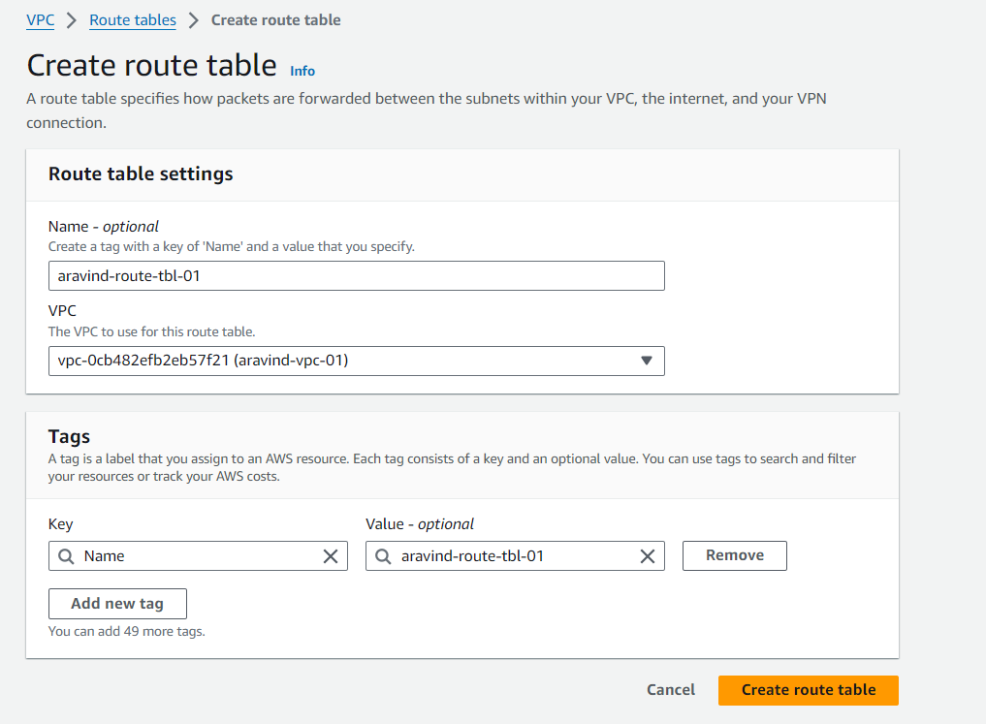

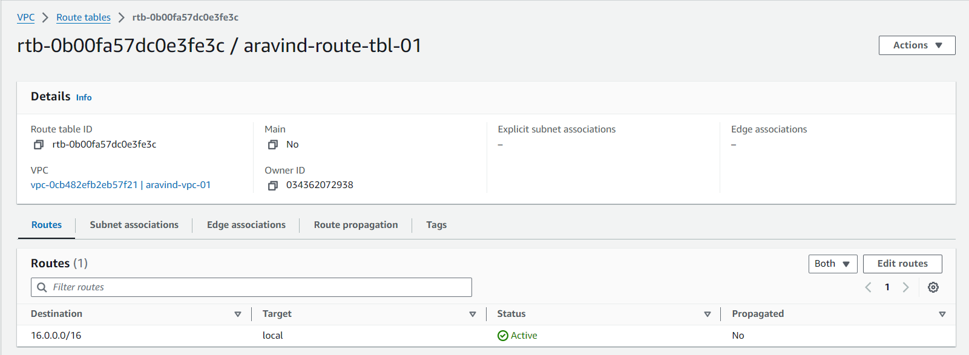

👉🏼Internet Access to Route Table

Edit Route 🡪 Add Route 🡪 Select 0.0.0.0/0 for Destination 🡪 Select Internet gateway 🡪 Save Changes

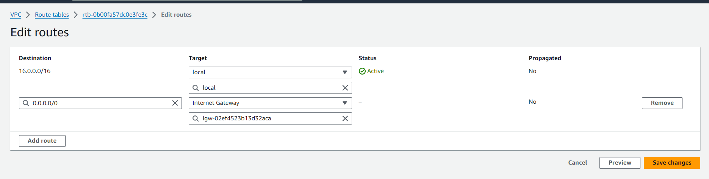

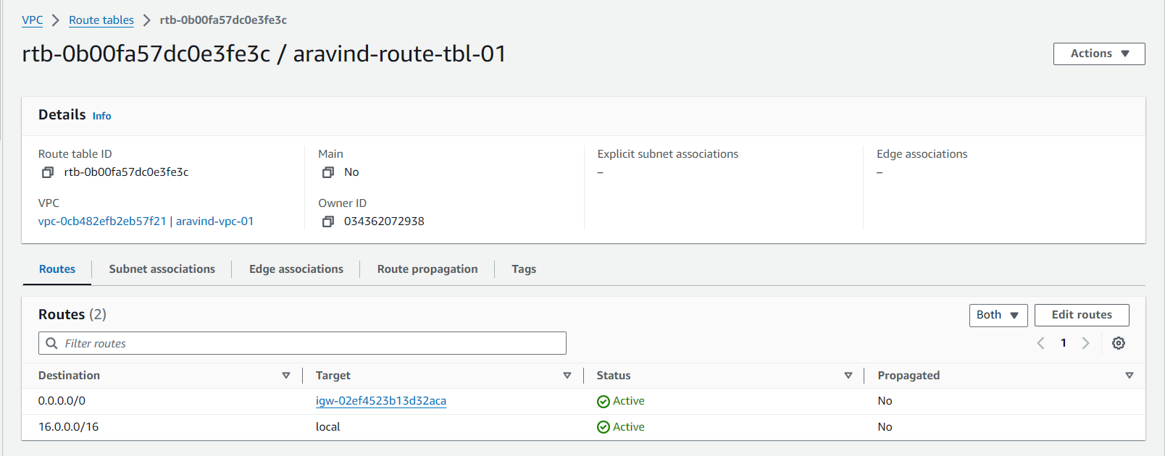

👉🏼Auto Assign Public IP for Public Subnet

Subnets 🡪 Select Public Subnet 🡪 Action 🡪 Edit Subnet Settings 🡪 Enable Auto-assign public IPv4 addresses 🡪 Save

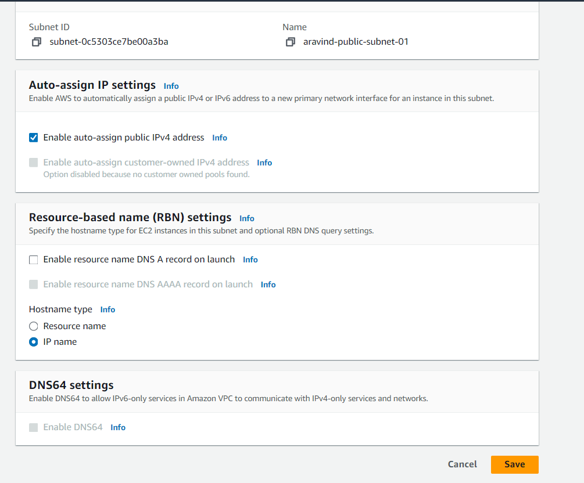

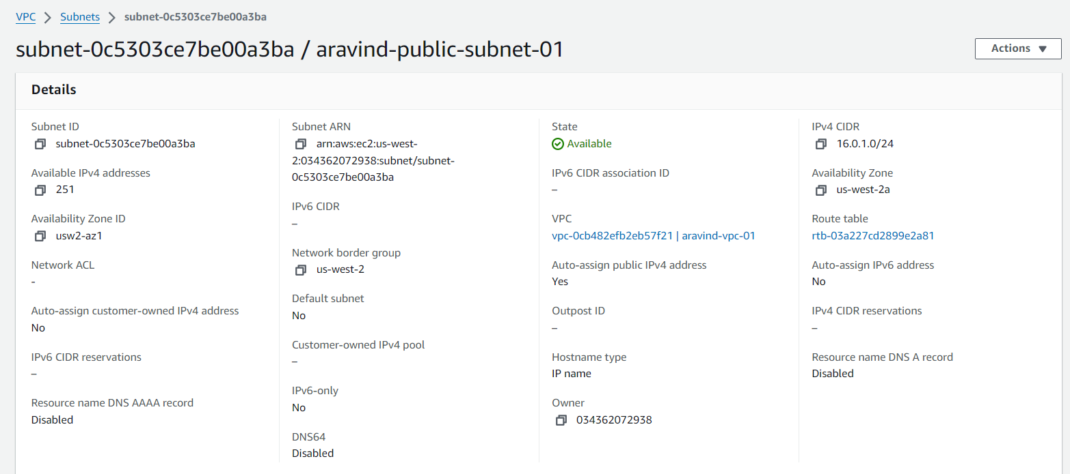

👉🏼Subnet Association for Route Table

Route Table 🡪 select route 🡪 Subnet Association tab 🡪 Edit subnet association 🡪 Select Public subnet 🡪 Save Association

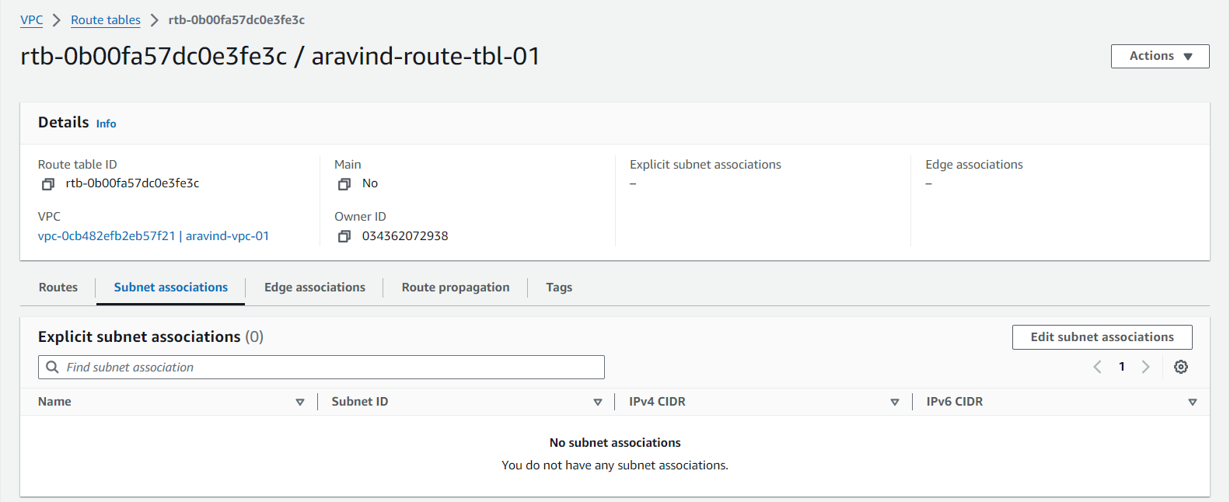

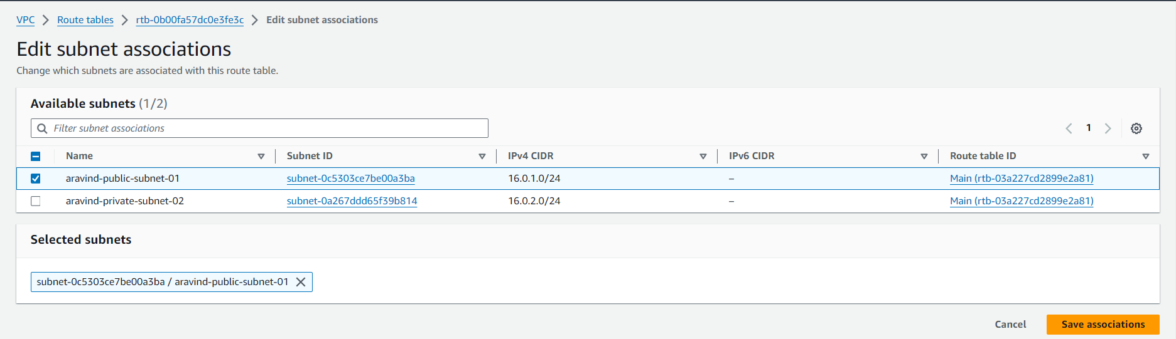

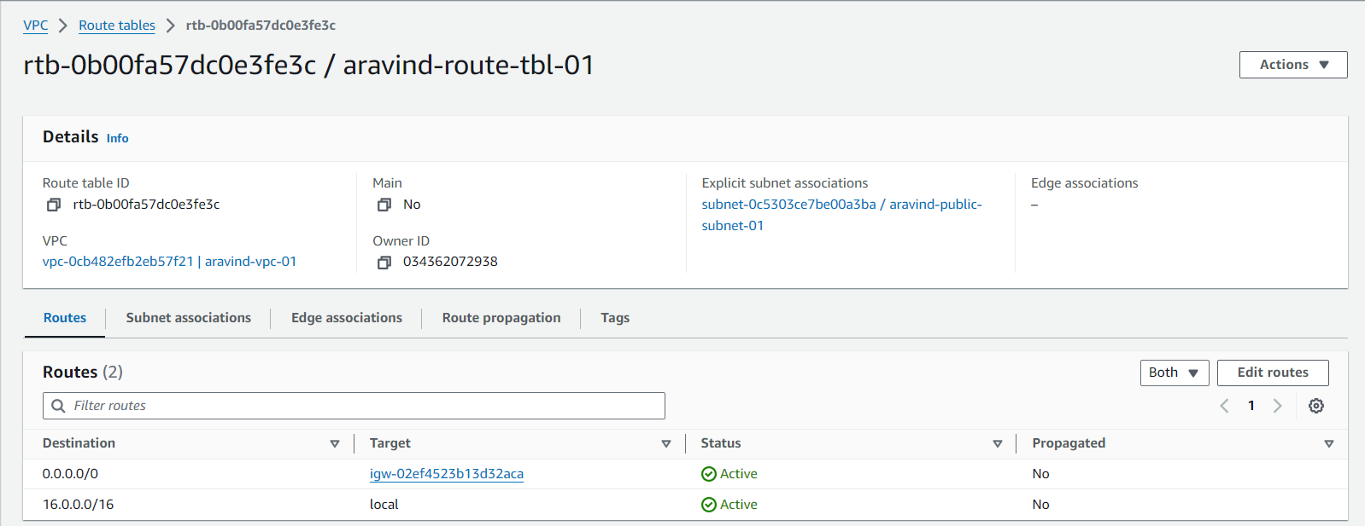

👉🏼EC2 Instance Launch with VPC and Public Subnet

EC2 🡪 Launch Instance 🡪 Enter Name 🡪 Select Amazon Linux 🡪 Select Key pair 🡪 Edit Network Settings 🡪 Select VPC 🡪 Select Public Subnet 🡪 Enable Auto Assign IP 🡪 Add Security Group Rule 🡪 Select Anywhere 🡪 Create Instance

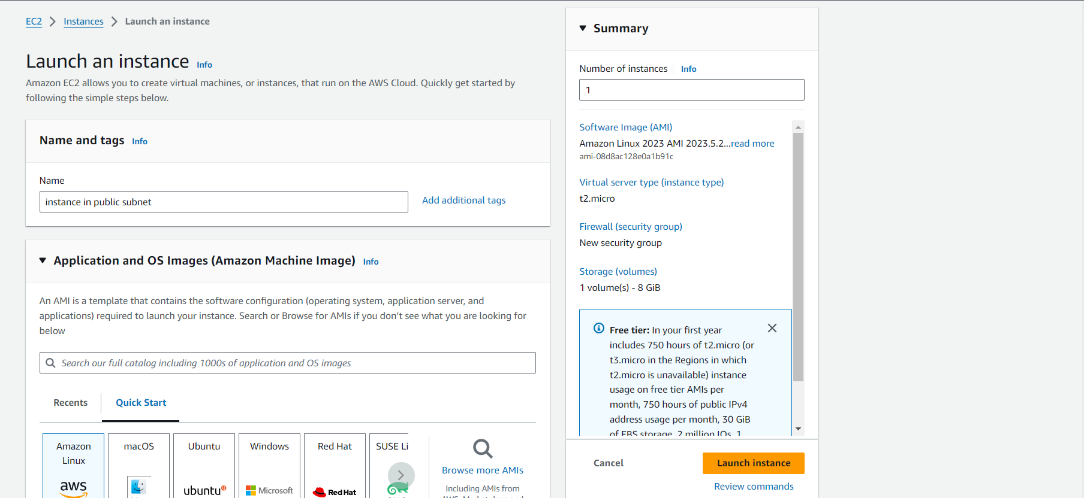

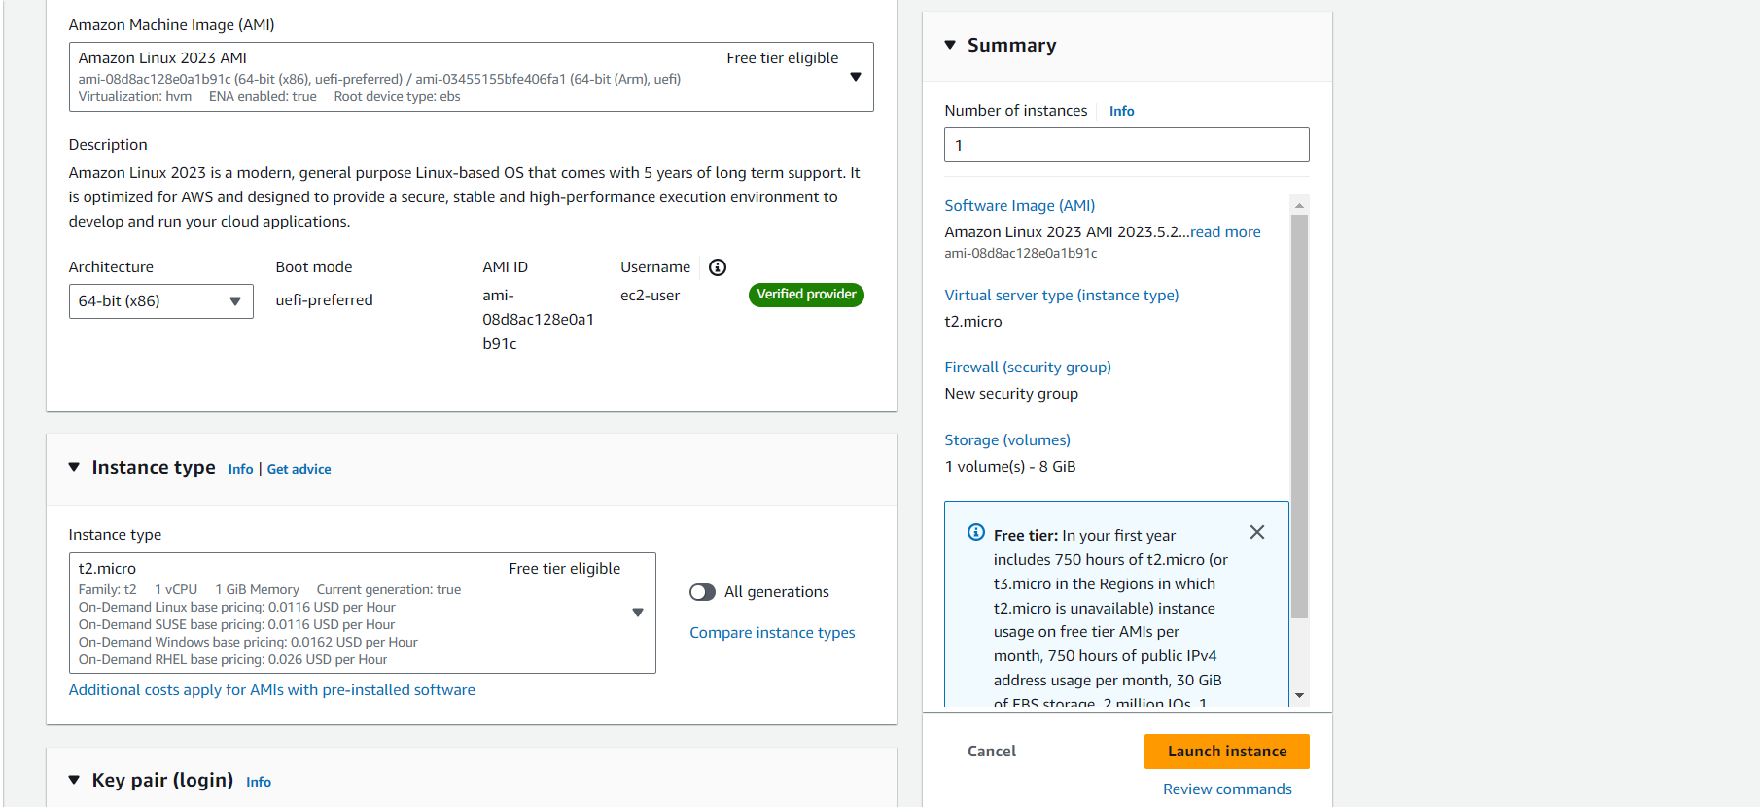

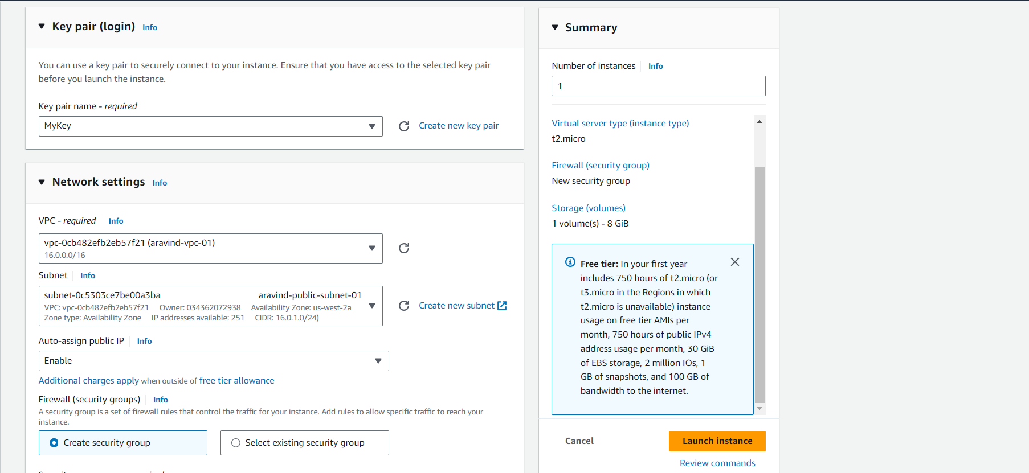

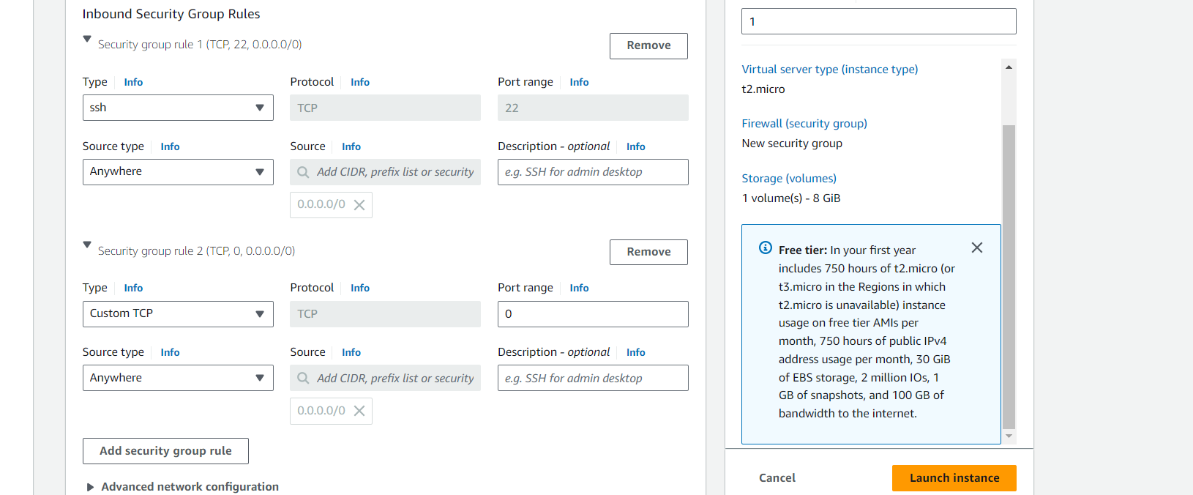

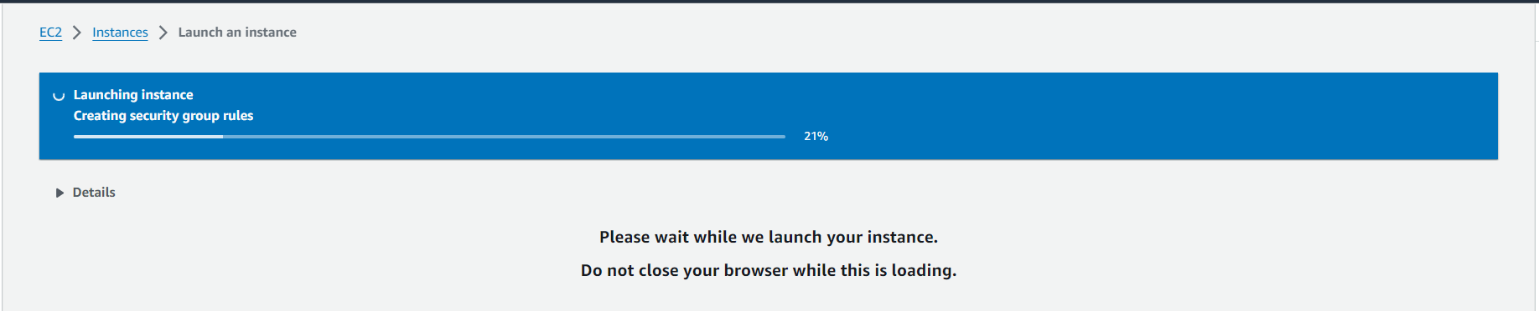

👉🏼EC2 Instance Configuration Details

