**Kubernetes Task-2**

Create the K8s EKS, further you have to do the deployment of the Nginx application and access the application outside the cluster.

Login into AWS and launch a EC2 instance

Install AWS CLI with below command

> curl "https://awscli.amazonaws.com/awscli-exe-linux-x86_64.zip" -o "awscliv2.zip"

> unzip awscliv2.zip

> sudo ./aws/install

> aws –version

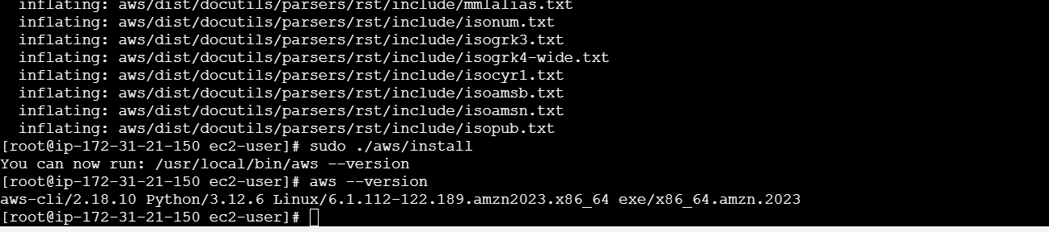

Create a IAM user and enable access key to do aws configure

The key requires for

AWS Access Key ID [None]: YOUR_ACCESS_KEY

AWS Secret Access Key [None]: YOUR_SECRET_KEY

Default region name [None]: us-west-2

Default output format [None]: json

> aws configure

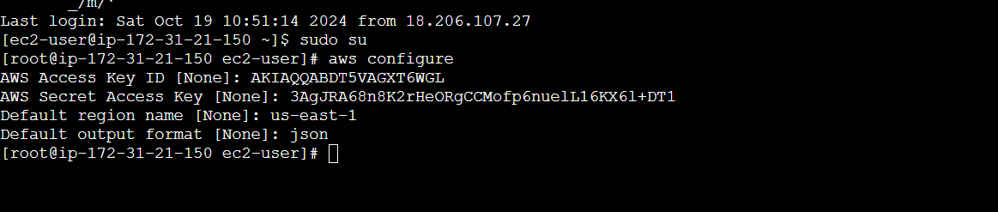

Install eksctl

> curl --location "https://github.com/weaveworks/eksctl/releases/latest/download/eksctl_$(uname -s)_amd64.tar.gz" | tar xz -C /tmp

> sudo mv /tmp/eksctl /usr/local/bin

> eksctl version

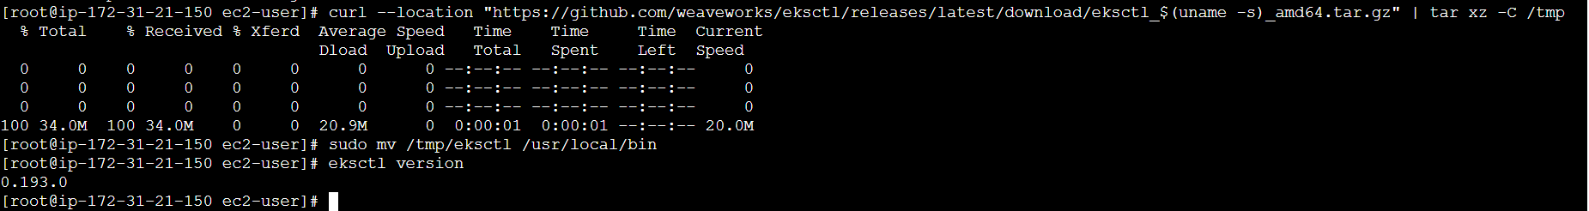

Install kubectl

> curl -LO "https://dl.k8s.io/release/$(curl -L -s https://dl.k8s.io/release/stable.txt)/bin/linux/amd64/kubectl"

chmod +x ./kubectl

> sudo mv ./kubectl /usr/local/bin/kubectl

> kubectl version –client

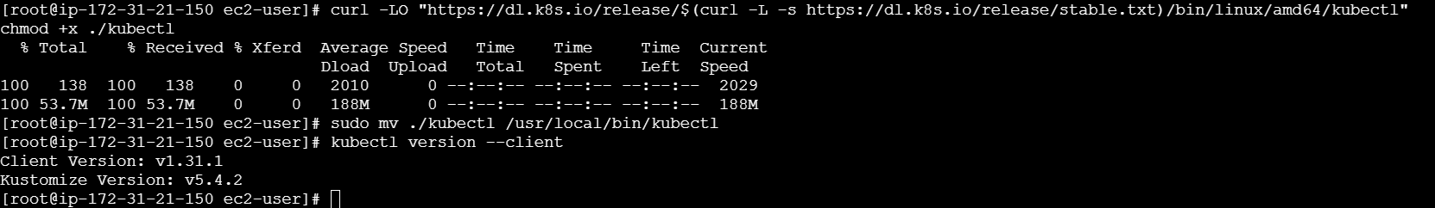

pre-requisites are done, now create a EKS cluster

create EKS Cluster

> eksctl create cluster \

--name new-eks-cluster \

--region us-east-1 \

--nodegroup-name linux-nodes \

--node-type t3.medium \

--nodes 1 \

--nodes-min 1 \

--nodes-max 2 \

--managed

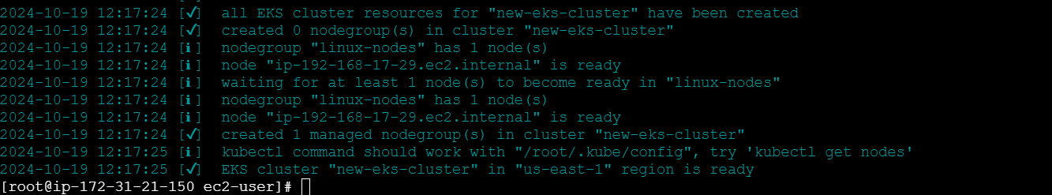

> kubectl get nodes



Verify kubectl eksctl configure kubectl context for the cluster

> kubectl config get-contexts



Cluster is created, now create a yaml configuration for nginx deployment

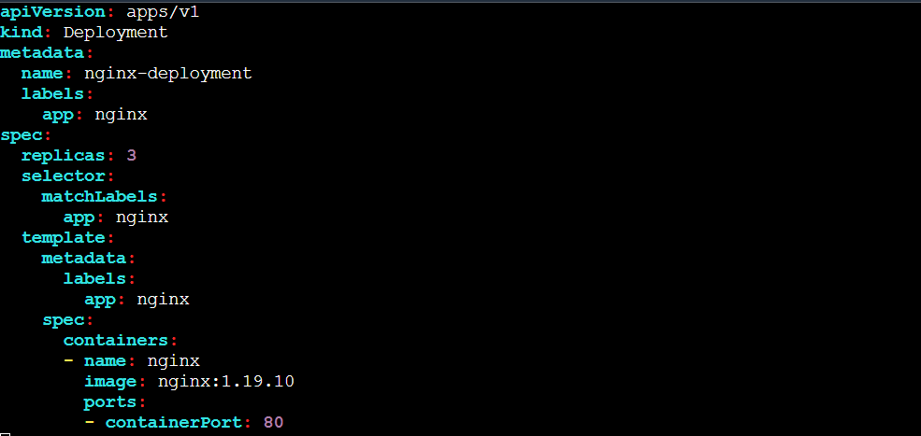

Apply the yaml file

>kubectl apply -f nginx-deployment.yaml

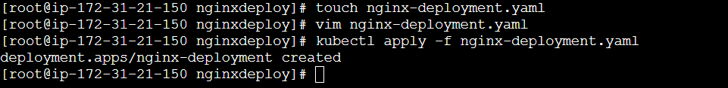

To make nginx accessible externally expose Nginx via load balancer

Create a yaml configuration for expose nginx service

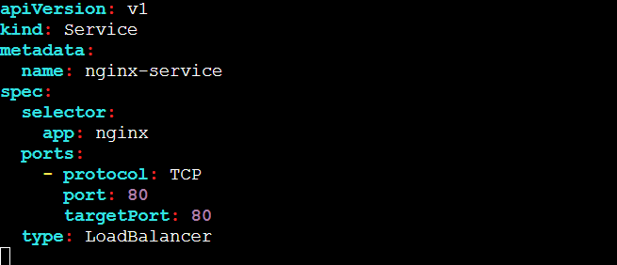

Apply yaml file

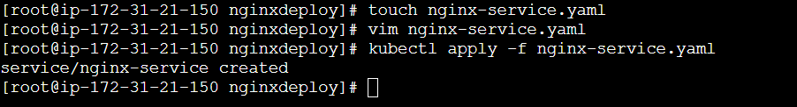

Get external IP address from running below command

>kubectl get svc nginx-service



Access nginx externally

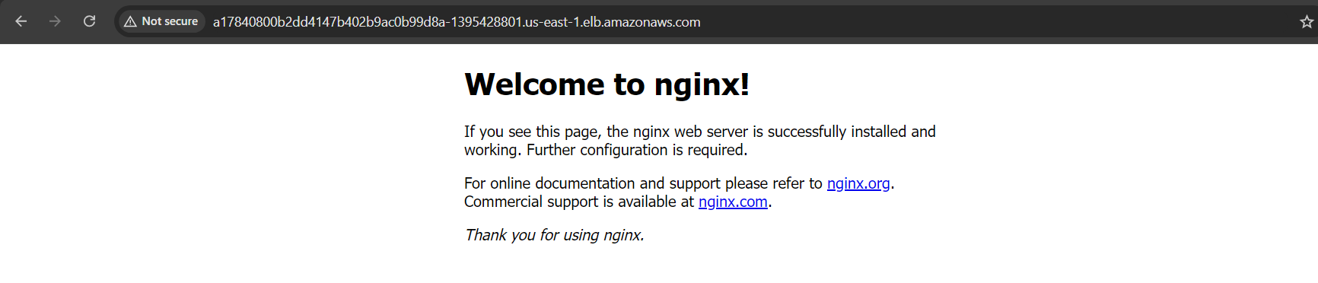

Once your done with the cluster you can clean up with below command, this will clean all the resources related with cluster

> eksctl delete cluster --name new-eks-cluster

