**Terraform Task 1**

Launch Linux EC2 instances in two regions using a single Terraform file.

Install AWS CLI and setup aws configure

Login into AWS account and Create a IAM user and enable access key to do aws configure.

After configuring run

> aws ec2 describe-instances

This will check for the EC2 instance in AWS

Now create main.tf terraform file with provider and resource

Mention the provider as AWS and region as us-east-1 and us-west-1

For resource aws-instance, ami ID, instance type and tags name

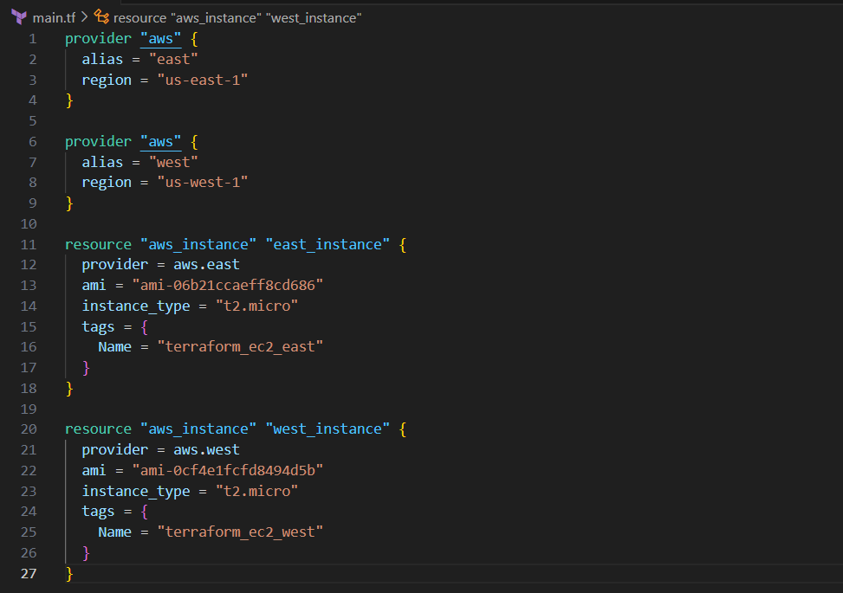

Save the file

Now run the below commands to execute the main.tf file

**> terraform init**

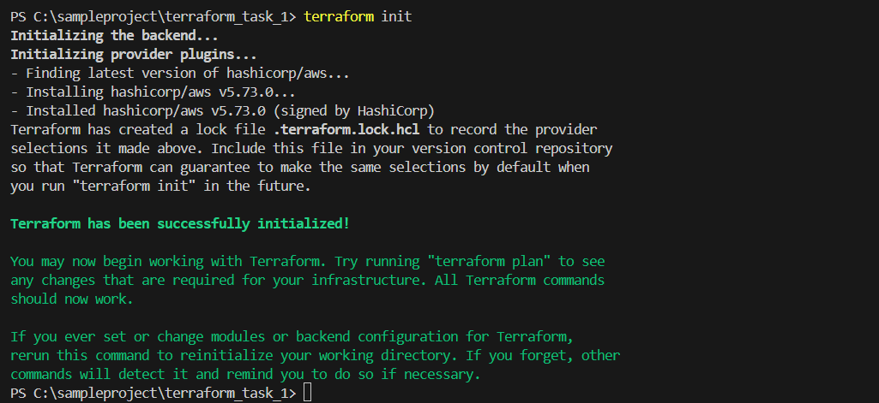

**> terraform plan**

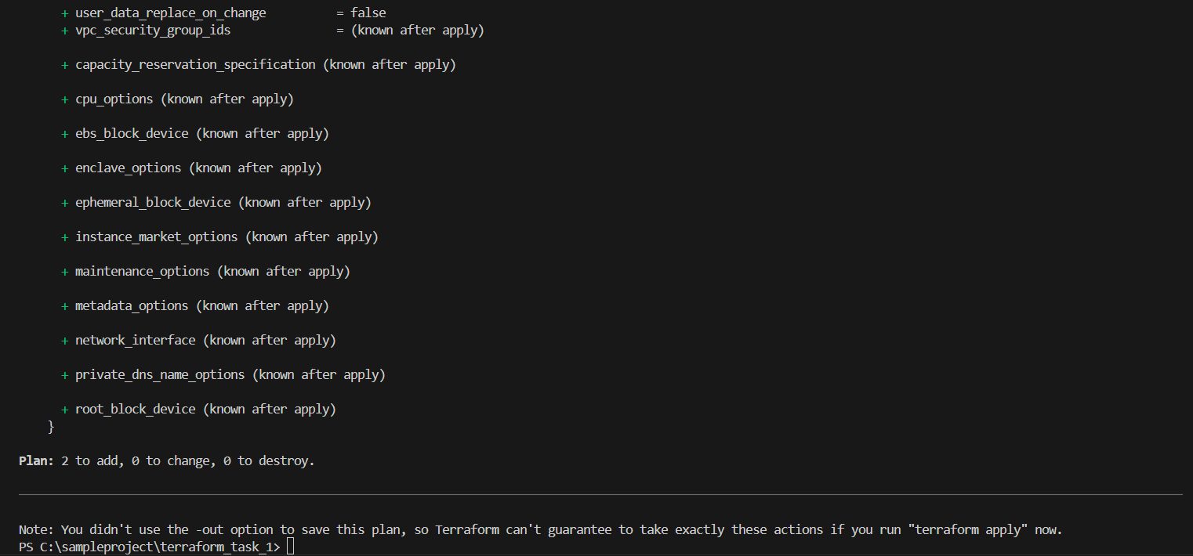

**> terraform apply**

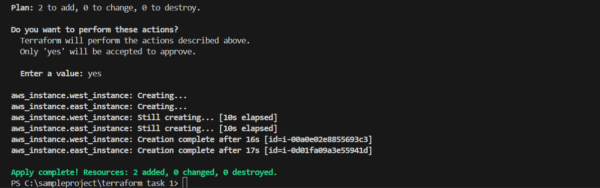

EC2 Instance created on us-east-1 (N. Virginia)

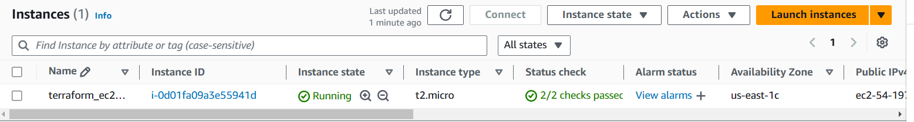

EC2 Instance created on us-west-1 (N. California)

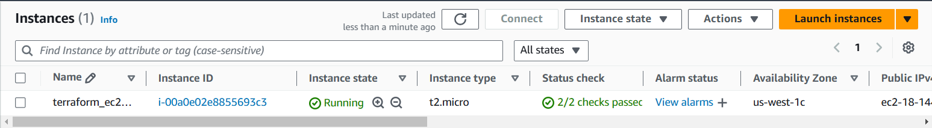

Now run the below command to terminate the EC2 instance created

**> terraform destroy**

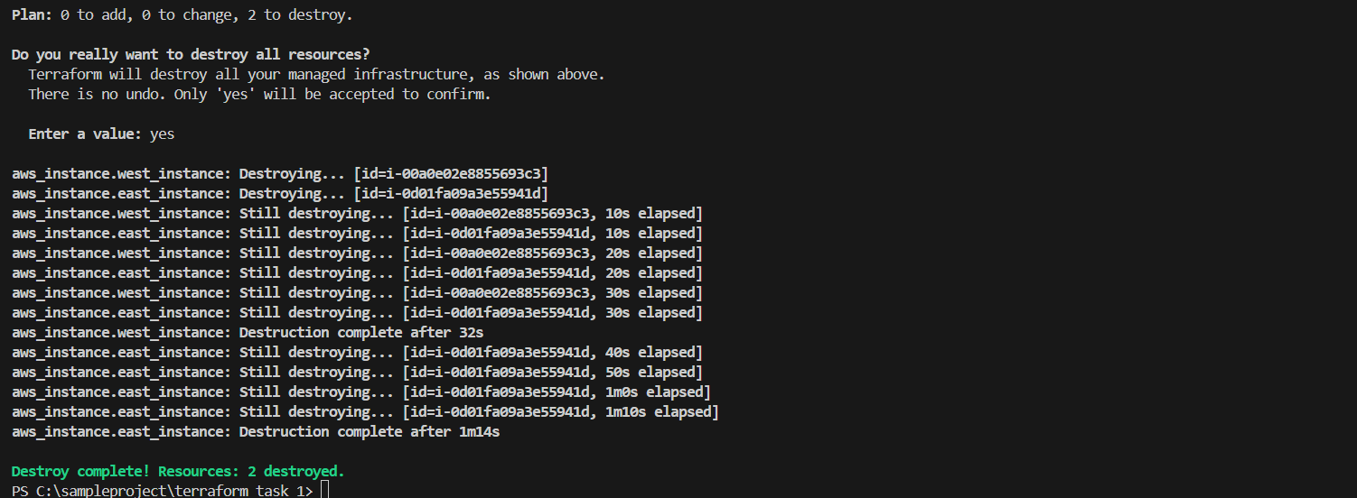

EC2 Instance terminated on us-west-1 (N. California)

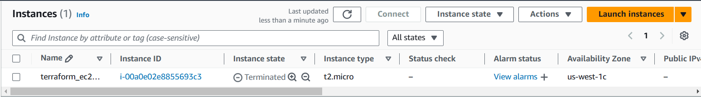

EC2 Instance terminated on us-east-1 (N. Virginia)

