**Terraform Task 2**

Create 2 EC2 instances on 2 different regions and install nginx using terraform script.

Install AWS CLI and setup aws configure

Login into AWS account and Create a IAM user and enable access key to do aws configure.

After configuring run

> aws ec2 describe-instances

This will check for the EC2 instance in AWS

Now create main.tf terraform file with provider and resource

Mention provider as AWS and region as us-east-1 and us-west-1

For resource aws-instance, ami ID, instance type, vpc security group id, user data, tags name

For resource security group, ingress and egress

Here is the terraform code for main.tf

#provider configuration for us-east-1

provider "aws" {

  alias = "east"

  region = "us-east-1"

}

#provider configuration for us-west-1

provider "aws" {

  alias = "west"

  region = "us-west-1"

}

# Security group to allow HTTP traffic (port 80) in us-east-1 region

resource "aws_security_group" "nginx_sg_east" {

  provider = aws.east

  name     = "nginx-sg-east"

  ingress {

    from_port   = 80

    to_port     = 80

    protocol    = "tcp"

    cidr_blocks = ["0.0.0.0/0"]

  }

  egress {

    from_port   = 0

    to_port     = 0

    protocol    = "-1"

    cidr_blocks = ["0.0.0.0/0"]

  }

}

# Security group to allow HTTP traffic (port 80) in us-west-1 region

resource "aws_security_group" "nginx_sg_west" {

  provider = aws.west

  name     = "nginx-sg-east"

  ingress {

    from_port   = 80

    to_port     = 80

    protocol    = "tcp"

    cidr_blocks = ["0.0.0.0/0"]

  }

  egress {

    from_port   = 0

    to_port     = 0

    protocol    = "-1"

    cidr_blocks = ["0.0.0.0/0"]

  }

}

#EC2 instance in us-east-1 with nginx Installation

resource "aws_instance" "east_instance" {

  provider = aws.east

  ami = "ami-06b21ccaeff8cd686"

  instance_type = "t2.micro"

  vpc_security_group_ids = [aws_security_group.nginx_sg_east.id]

  user_data = <<-EOF

              #!/bin/bash

              sudo yum update -y

              sudo yum install -y nginx

              sudo systemctl start nginx.service

              sudo systemctl enable nginx.service

            EOF

  tags = {

    Name = "east_nginx"

  }

}

#EC2 instance in us-west-1 with nginx Installation

resource "aws_instance" "west_instance" {

  provider = aws.west

  ami = "ami-0cf4e1fcfd8494d5b"

  instance_type = "t2.micro"

  vpc_security_group_ids = [aws_security_group.nginx_sg_west.id]

  user_data = <<-EOF

              #!/bin/bash

              sudo yum update -y

              sudo yum install -y nginx

              sudo systemctl start nginx.service

              sudo systemctl enable nginx.service

            EOF

  tags = {

    Name = "west_nginx"

  }

}

Now start running the terraform commands

> terraform init

By running the terraform init command “.terraform” file is created with all the dependencies and packages.

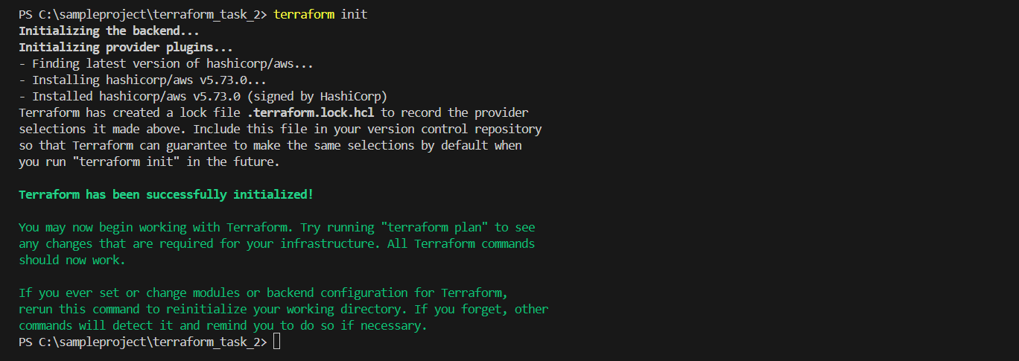

> terraform plan

By running the terraform plan command, number of resources should be added to EC2 instances will be displayed

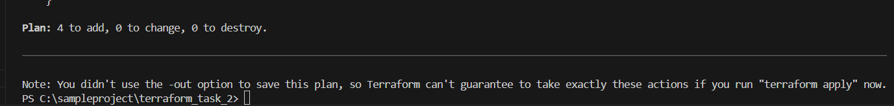

> terraform apply

By running the terraform apply, terraform state and terraform state backup file will be created and resources will be created in AWS

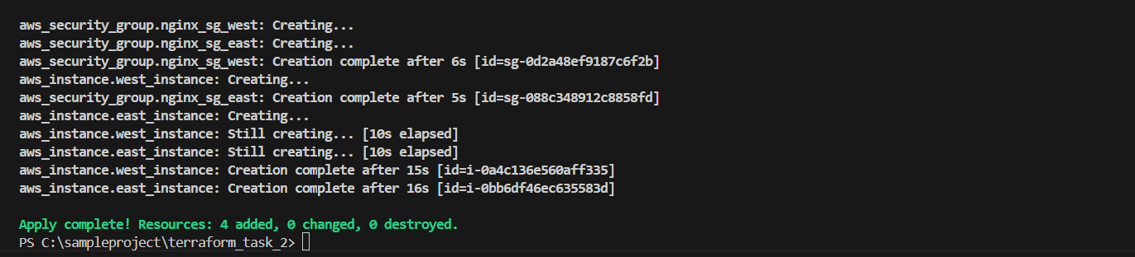

EC2 Instance created on us-east-1

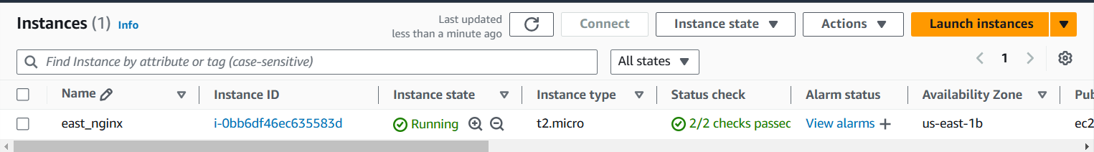

EC2 Instance created on us-west-1

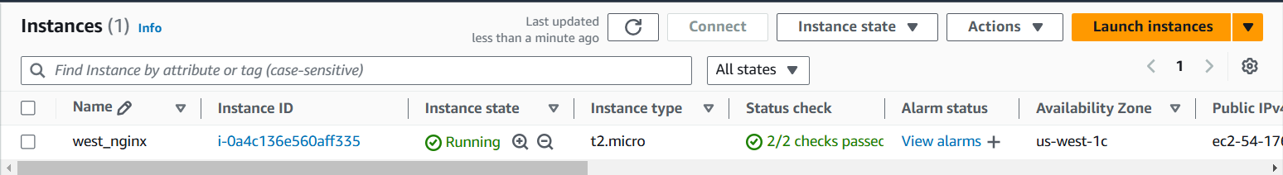

Nginx server on EC2 Instance us-east-1 region

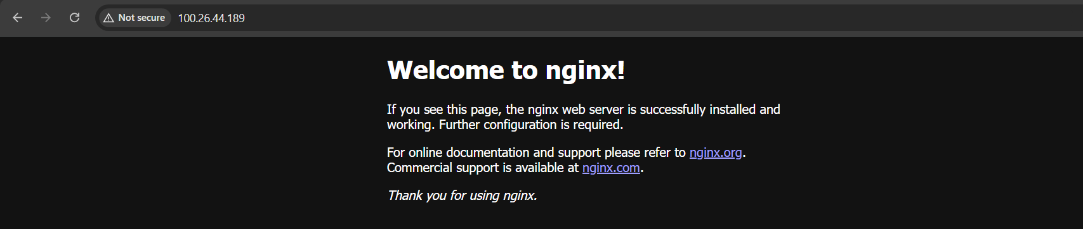

Nginx server on EC2 Instance us-west-1 region

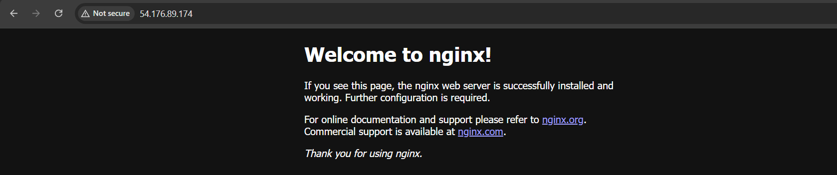

> terraform destroy

By running the terraform destroy command user deletes all the resources created from terraform.

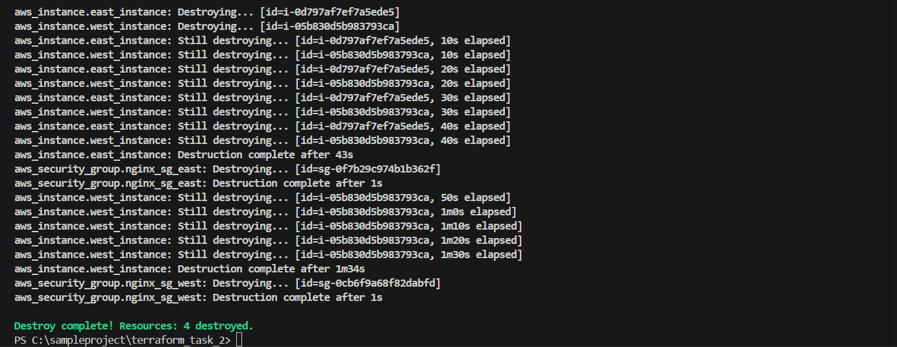

EC2 Instance terminated on us-east-1

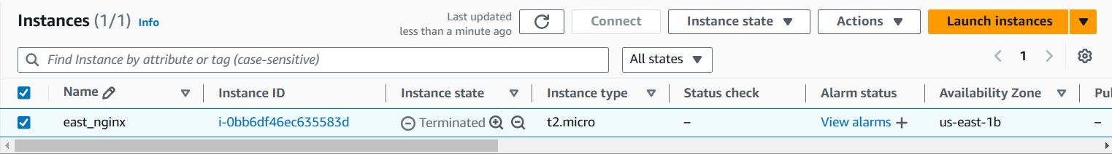

EC2 Instance terminated on us-west-1

