Introduction To MYSQL
SQL is built by ‘Database’. To communicate the Database by “MySQL”.” Oracle”, etc., “MySQL” is the base language. MySQL is stored in Structured of “Rows” and “Columns” like a Table.
General Database Structure
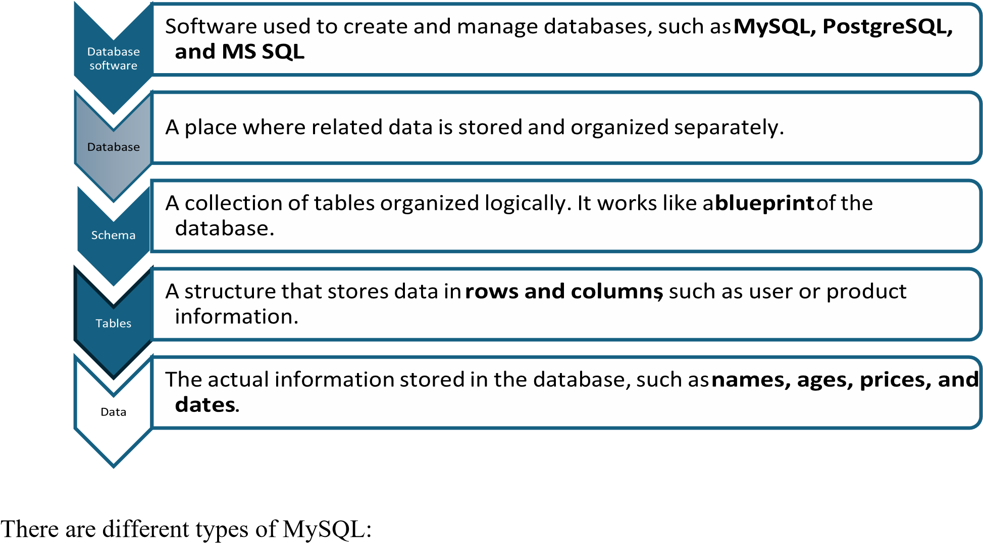
DDL (Data definition language)
Purpose: Defines, modifies, and alters the actual structure or schema of the database.
Core Commands:
- CREATE (makes new tables)
- ALTER (modifies table structures)
- DROP (deletes an entire table permanently)
- TRUNCATE (removes all records but keeps the structure) DML (Data Manipulation language)
Purpose: Manages and modifies the actual data rows stored inside the existing tables.
Core Commands:
- INSERT (adds new rows)
- UPDATE (edits existing data)
- DELETE (removes specific records).
TCL (Transaction Control Language)
Purpose: Manages transactions to group multiple tasks together, ensuring database integrity.
Core Commands:
- COMMIT (saves changes permanently)
- ROLLBACK (undoes changes if an error occurs)
Datatypes of SQL:
NUMERIC-----------------------------DATE AND TIME------------------------------------------STRING
int date and time(“Y:M:D”) varchar bigint timestamp (change in universal time) char
float
Movie Database Management and Analytical Reporting Case Study:
#Create a database and use the database
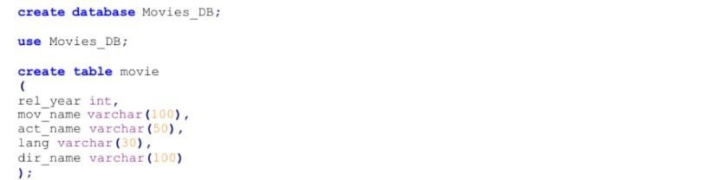
#Insert the data’s
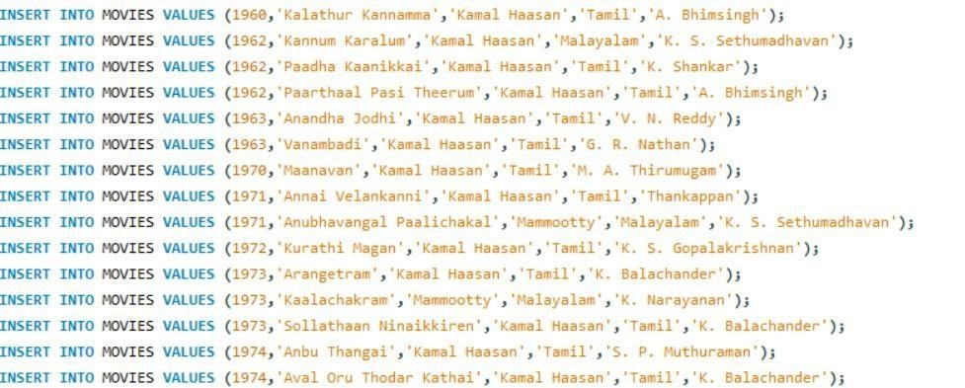
1.Retrieve all details from the movie table.
Solution:
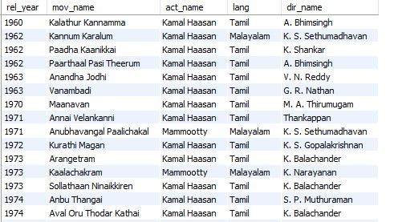

2.Display only movie names and actor names.

Solution:
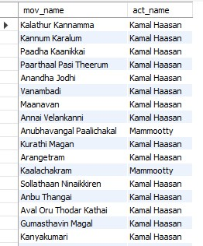

2.

3.Display distinct movie languages.
Solution:
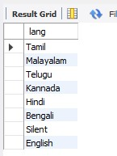

4.Retrieve unique actor names.
Solution:
