E-commerce Delivery & Logistics
Performance Analysis
Revised Final Project Report
Dataset: Olist Brazilian E-Commerce Public Dataset

1. Executive Summary
This project evaluates e-commerce delivery performance using the public Olist Brazilian e-commerce dataset. The workflow included data inspection, cleaning and eligibility checks, exploratory data analysis (EDA), KPI calculation, segment comparisons, and Power BI dashboard development. Among 96,470 delivered orders with valid actual and estimated delivery timestamps, 6,534 were late (6.77%). Average purchase-to-customer delivery duration was 12.56 days, with a median of 10.22 days. Late deliveries were associated with substantially lower average review scores. The findings are descriptive: they identify areas for operational investigation but do not prove causes.

2. Project Objectives
- Inspect the dataset structure, completeness, duplicates, and timestamp quality.
- Prepare a validated subset of delivered orders for delivery-timeliness analysis.
- Calculate and define delivery KPIs consistently.
- Explore delivery duration and late-delivery patterns by month, product category, seller, and customer review score.
- Create a Power BI dashboard and document checks that align dashboard figures with analysis outputs.
- Recommend measurable operational follow-up actions.

3. Dataset and Scope
The project uses the Olist Brazilian E-Commerce Public Dataset, distributed as multiple CSV files for orders and related entities. The initial orders table contained 99,441 rows and 8 columns. The main delivery-timeliness analysis uses 96,470 delivered orders with usable actual and estimated delivery dates. Metrics may use different eligible populations where the required fields differ.
The available data used in this analysis did not include a usable carrier identifier/name or a direct delivery-distance measure. Therefore, carrier-by-carrier and distance-band comparisons are outside the scope of the current findings.

4. Data Cleaning and Quality Checks
- Checked order IDs for duplicates; no duplicate order IDs were found in the initial orders table.
- Reviewed missing timestamps, including approval and customer-delivery timestamps.
- Excluded records without required actual and estimated delivery dates from the core delivery KPI calculation.
- Reviewed negative durations and timestamp-order anomalies; invalid intervals were excluded from interval-specific summaries.
- Kept the denominator explicit for each KPI and segment so rates are interpreted against the appropriate eligible population.
Data-quality caveat: missing timestamps and timestamp-order anomalies exist in the source data. The results should be read with the eligibility rules above in mind rather than as measures of every row in the source dataset.

5. Week 1 Exploratory Data Analysis (EDA)
The initial EDA established the dataset scale and the status/timestamp fields needed for delivery analysis. It also helped identify which records could support delivery-duration calculations and which needed to be excluded from specific metrics.
- Order population: 99,441 order records were present in the initial orders table.
- Delivery eligibility: 96,470 delivered orders had usable actual and estimated delivery timestamps for the core late-rate calculation.
- Status/cancellation context: 625 orders were cancelled, corresponding to 0.63% of all 99,441 orders.
- Duration distribution: average delivery duration (12.56 days) exceeded the median (10.22 days), suggesting a right-skewed distribution where a smaller number of long deliveries raise the mean.
- Outcome distribution: 93.23% of eligible deliveries arrived on or before the estimated date, while 6.77% arrived after it.

5.1 EDA Chart: Delivery Duration Distribution
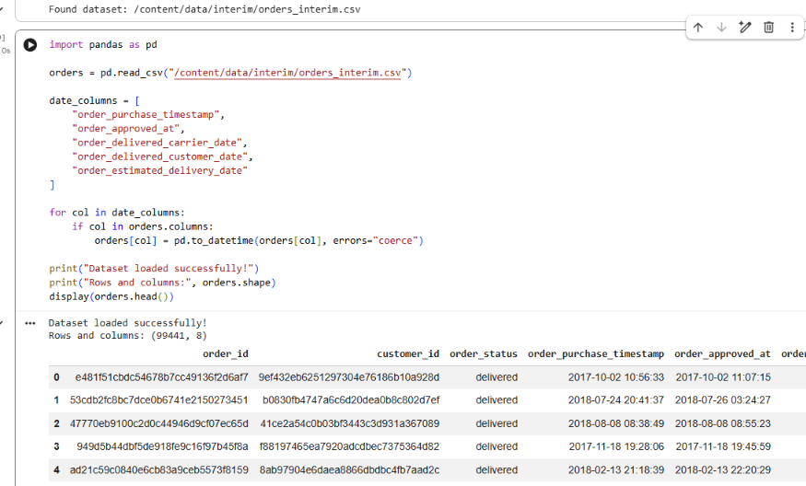
Figure 1. Screenshot from the project analysis workflow related to delivery-duration exploration. Use the notebook-exported distribution chart here if available for a cleaner final publication.
Interpretation: the mean of 12.56 days and median of 10.22 days indicate that delivery duration is not perfectly symmetric. The median is a useful typical-duration measure, while the mean reflects the effect of unusually long deliveries.

5.2 EDA Chart: Delivery Outcomes Over Time
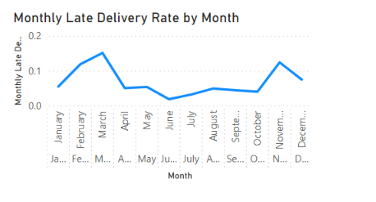
Figure 2. Power BI monthly late-delivery-rate chart captured during dashboard development.
The monthly view shows that delivery performance varies over time rather than remaining constant. March 2018 had the highest observed late-delivery rate among months with at least 100 eligible orders: 18.96% (1,328 late orders out of 7,003). February 2018 was 14.13% (926/6,555), and November 2017 was 12.40% (904/7,288). These are investigation signals, not proof that seasonality or any single operational factor caused the increase.

6. KPI Definitions and Results
KPI | Result | Definition / denominator
Eligible delivered orders | 96,470 | Delivered orders with usable actual and estimated delivery timestamps
Late deliveries | 6,534 | Eligible orders delivered after the estimated date
Late-delivery rate | 6.77% | 6,534 ÷ 96,470
On-time or early rate | 93.23% | Eligible orders delivered on or before the estimated date
Average delivery duration | 12.56 days | Mean purchase-to-customer delivery duration
Median delivery duration | 10.22 days | Median purchase-to-customer delivery duration
Cancellation rate | 0.63% | 625 cancelled orders ÷ 99,441 total orders
Average purchase-to-carrier handover | 3.23 days | 96,304 valid non-negative intervals; mean
Average carrier-to-customer transit | 9.33 days | 96,446 valid non-negative intervals; mean

7. Deeper Analysis and Findings

7.1 Processing Proxy vs. Transit Time
The purchase-to-carrier handover interval averaged 3.23 days (median 2.21), while carrier handover to customer averaged 9.33 days (median 7.10). The transit interval represents the larger share of elapsed time in these summaries. This supports prioritizing further analysis of destination/route and delivery execution, while still monitoring seller preparation and handover.

7.2 Product-Category Differences
Among categories reviewed with at least 100 eligible orders, audio had an 11.78% late-delivery rate (41/348), casa conforto had 9.44% (37/392), and fashion underwear/beachwear had 9.40% (11/117). Differences may reflect seller mix, destination mix, handling requirements, or small sample sizes. These categories should be investigated rather than automatically treated as causes.
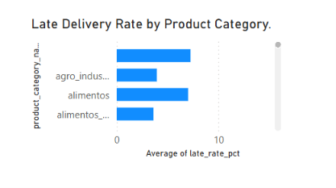
Figure 3. Power BI comparison of late-delivery rates by product category.

7.3 Seller-Level Variation
The highest observed seller late-delivery rate in the reviewed output was 30.14% for a seller with 73 eligible orders (22 late orders). Other examples included 23.44% for a seller with 64 eligible orders and 21.88% for a seller with 96 eligible orders. Seller rates should be reviewed alongside order counts and destination mix; small samples can make rates unstable.
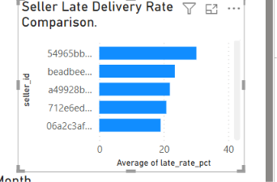
Figure 4. Power BI seller-level late-delivery-rate comparison.

7.4 Customer Review Scores
Mean review score was 4.29 for orders delivered on time or early (89,443 matched reviews) and 2.27 for late deliveries (6,381 matched reviews), a 2.02-point difference. This is a strong descriptive association, but it does not establish that delivery lateness alone caused lower scores; product quality, communication, and other factors may also affect reviews.

8. Cancellation Analysis and Interpretation
There were 625 cancelled orders out of 99,441 total orders, giving a cancellation rate of 0.63%. This rate is relatively small compared with the delivered-order population, but cancellations still represent lost fulfilment opportunities and potential customer friction. Cancellation should be analyzed separately from late delivery because cancelled orders do not have a completed customer-delivery timestamp and should not be included in the delivered-order late-rate denominator.
Recommended next analysis: break cancellations down by order month, order status, seller, and payment/approval timing where fields are available. Check whether cancellation counts cluster around particular sellers or periods before recommending interventions. Do not infer a cancellation cause from the overall rate alone.

9. Power BI Dashboard and Visual Validation
The Power BI report contains three headline KPI cards—eligible delivered orders, late-delivery rate, and average delivery duration—plus a monthly late-delivery-rate trend, product-category comparison, and seller late-delivery-rate comparison.
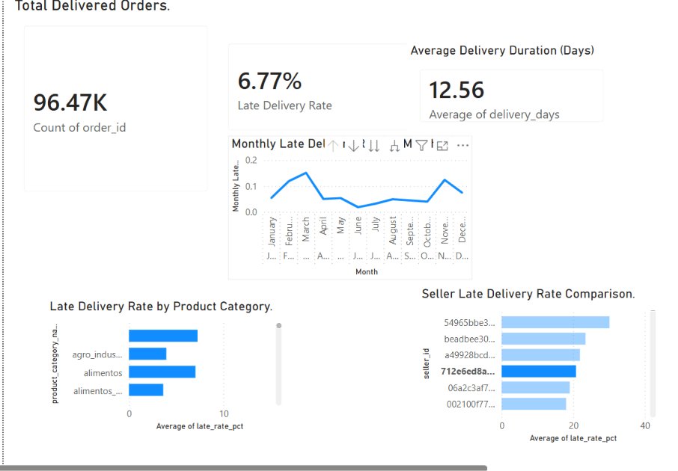
Figure 5. Power BI dashboard screenshot captured during project development.

9.1 KPI Reconciliation Checklist
Dashboard measure | Analysis output | Dashboard display | Validation note
Eligible delivered orders | 96,470 | 96.47K | Consistent at displayed precision; verify exact underlying count in Power BI.
Late-delivery rate | 6.77% | 6.77% | Displayed value matches the analysis summary.
Average delivery duration | 12.56 days | 12.56 | Displayed value matches the analysis summary; ensure the measure uses the same eligible population.
Monthly late-delivery rate | March 2018: 18.96% | Trend chart shown | Check March point and all monthly denominators against the monthly CSV.
Category and seller rates | Rates from segment analysis | Comparison charts shown | Confirm each source row is one segment and aggregation is Average or a correctly calculated measure—not a sum of rates.
Validation status: the visible KPI cards agree with the reported headline values at the precision displayed. Exact underlying values, month-by-month points, and segment calculations should be confirmed by comparing Power BI measures with the exported analysis CSVs. The screenshots alone do not prove that every underlying row or filter context has been reconciled.

10. Measurable Follow-up Actions and Tracking Metrics
The following are proposed management actions and monitoring targets, not measured outcomes from this historical dataset. A baseline should be captured first, and targets should be agreed with the project/business owner before implementation.
Action | Operational follow-up | Metrics to track | Proposed trigger/target
1. Investigate transit delays | Compare destination/route groups and review handover-to-customer duration. | Median transit days; 90th-percentile transit days; late-delivery rate by destination/route. | Establish a 4-week baseline, then aim for a 10% reduction in median transit time over the next quarter, if operationally feasible.
2. Review high-delay periods | Compare monthly rates, eligible volumes, seller preparation time, and operational context. | Monthly late rate; late-order count; eligible order count; purchase-to-carrier days. | Trigger a review when monthly late rate exceeds the agreed baseline by 3 percentage points or more.
3. Support high-risk sellers | Review sellers with elevated late rates and sufficient volume; validate destination mix before action. | Seller late rate; eligible orders; late-order count; seller processing days. | Review sellers with at least 50 eligible orders and late rate above 10%; agree a corrective plan and reassess monthly.
4. Review category patterns | Check seller mix, handling needs, and delivery outcomes for categories with elevated rates. | Category late rate; eligible orders; average delivery days. | Review categories with at least 100 eligible orders and late rate above the overall 6.77% baseline.
5. Protect customer experience | Pair delivery metrics with review scores and customer complaints where available. | Mean review score for late/on-time orders; share of late orders; complaint/contact rate if available. | Track monthly; investigate a fall of 0.2 points or more in mean review score against the established baseline.
6. Monitor cancellations | Segment cancelled orders by month and seller and inspect available approval/payment fields. | Cancellation rate; cancelled-order count; cancellation rate by seller/month. | Review any seller/month segment that exceeds the overall 0.63% baseline materially, after checking sample size.

11. Limitations
- The analysis is descriptive and does not establish causation.
- Some records have missing timestamps or timestamp-order anomalies.
- Different metrics use different eligible populations because required fields vary.
- Carrier identity and a direct delivery-distance measure were unavailable for the comparisons performed.
- Category and seller rates can be affected by sample size, destination mix, and unobserved operational factors.
- The proposed targets are recommendations for future monitoring, not results achieved in this project.
- Dashboard screenshots confirm displayed values only; full reconciliation requires checking exact underlying measures and source exports.

12. Conclusion
The analysis established a structured workflow for examining delivery performance and communicating it in Power BI. In the main eligible set of 96,470 delivered orders, 6.77% were late and average delivery duration was 12.56 days. The analysis identified variation across months, categories, and sellers, and a 2.02-point difference in mean customer review score between late and on-time/early deliveries. The next step is to reconcile all dashboard measures to the analysis exports and track operational metrics over time to determine whether targeted actions improve reliability.

13. Suggested GitHub Repository Contents
- data/README.md — dataset source, licensing/usage note, and instructions; avoid committing large raw data files if repository rules or dataset terms advise against it.
- notebooks/ — data quality checks, Week 1 EDA, KPI calculations, and deeper analysis.
- reports/ — this report and supporting CSV summaries.
- figures/ — exported charts used in the report and README.
- dashboard/ — the Power BI .pbix file and dashboard screenshot.
- README.md — project overview, workflow, key findings, setup steps, and links to the dashboard/report.
- requirements.txt — Python packages needed to reproduce the analysis.

