**KENDRIYA VIDYALAYA NO-2, SVN**

**CCA COLOURING COMPETITION (2014-15**)

Name of the student: _____________________ Class & Sec: _______ House: ____________

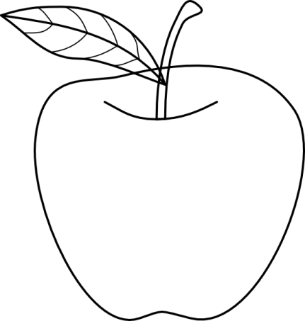 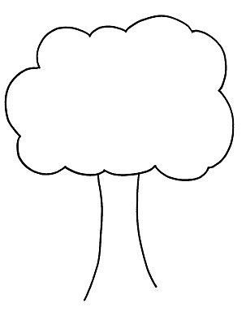

**KENDRIYA VIDYALAYA NO-2, SVN**

**CCA COLOURING COMPETITION (2014-15**)

Name of the student: _____________________ Class & Sec: _______ House: ____________

 