**Exercise 1: Implementing the Singleton Pattern**

**1.Logger.java**

public class Logger {

private static Logger instance;

private Logger() {

System.out.println("Logger initialized.");

}

public static Logger getInstance() {

if (instance == null) {

instance = new Logger();

}

return instance;

}

// Utility method for logging

public void log(String message) {

System.out.println("LOG: " + message);

}

}

**2.Main.java**

public class SingletonPatternTest {

public static void main(String[] args)

{

Logger logger1 = Logger.getInstance();

logger1.log("First log message");

Logger logger2 = Logger.getInstance();

logger2.log("Second log message");

if (logger1 == logger2) {

System.out.println("Both logger instances are the same.");

} else {

System.out.println("Different logger instances!");

}

}

}

**Output:**

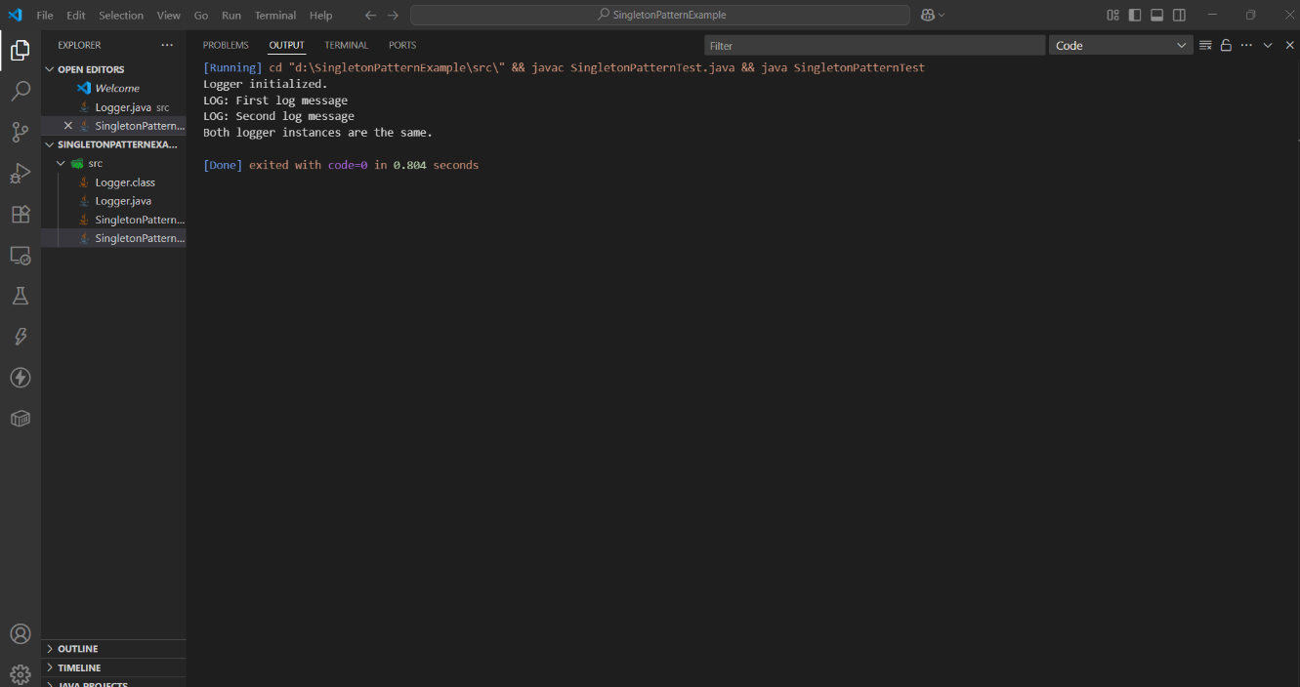

**Exercise 2: Implementing the Factory Method Pattern**

**1. Document.java**

package factory;

public interface Document {

void open();

}

**2. WordDocument.java**

package factory;  
  
public class WordDocument implements Document {  
 public void open() {  
 System.out.println("Opening Word document.");  
 }  
}

**3. PdfDocument.java**

package factory;  
  
public class PdfDocument implements Document {  
 public void open() {  
 System.out.println("Opening PDF document.");  
 }  
}

**4. ExcelDocument.java**

package factory;  
  
public class ExcelDocument implements Document {  
 public void open() {  
 System.out.println("Opening Excel document.");  
 }  
}

**5. DocumentFactory.java**

package factory;  
  
public abstract class DocumentFactory {  
 public abstract Document createDocument();  
}

**6. WordDocumentFactory.java**

package factory;  
  
public class WordDocumentFactory extends DocumentFactory {  
 public Document createDocument() {  
 return new WordDocument();  
 }  
}

**7. PdfDocumentFactory.java**

package factory;  
  
public class PdfDocumentFactory extends DocumentFactory {  
 public Document createDocument() {  
 return new PdfDocument();  
 }  
}

**8. ExcelDocumentFactory.java**

package factory;  
  
public class ExcelDocumentFactory extends DocumentFactory {  
 public Document createDocument() {  
 return new ExcelDocument();  
 }  
}

**9. Main.java**

package factory;  
  
public class Main {  
 public static void main(String[] args) {  
 // Word Document  
 DocumentFactory wordFactory = new WordDocumentFactory();  
 Document word = wordFactory.createDocument();  
 word.open();  
  
 // PDF Document  
 DocumentFactory pdfFactory = new PdfDocumentFactory();  
 Document pdf = pdfFactory.createDocument();  
 pdf.open();  
  
 // Excel Document  
 DocumentFactory excelFactory = new ExcelDocumentFactory();  
 Document excel = excelFactory.createDocument();  
 excel.open();  
 }  
}

**Output:**

