**Create a Spring Web Project using Maven**

**Pom.xml:**

<dependencies>

<dependency>

<groupId>org.springframework.boot</groupId>

<artifactId>spring-boot-starter-web</artifactId>

</dependency>

<dependency>

<groupId>org.springframework.boot</groupId>

<artifactId>spring-boot-devtools</artifactId>

<scope>runtime</scope>

<optional>true</optional>

</dependency>

<dependency>

<groupId>org.springframework.boot</groupId>

<artifactId>spring-boot-starter-test</artifactId>

<scope>test</scope>

</dependency>

</dependencies>

**SpringLearnApplication.java:**

**package** com.cognizant.spring_learn;

**import** org.springframework.boot.SpringApplication;

**import** org.springframework.boot.autoconfigure.SpringBootApplication;

@SpringBootApplication

**public** **class** SpringLearnApplication {

**public** **static** **void** main(String[] args) {

System.***out***.println("SpringLearnApplication started...");

SpringApplication.*run*(SpringLearnApplication.**class**, args);

}

}

**Application.properties:**

spring.application.name=spring-learn

server.port=7071

**index.html:**

<!DOCTYPE html>

<html>

<head>

<title>Spring Learn</title>

</head>

<body>

<h1>Welcome to Spring Learn Home Page!</h1>

</body>

</html>

**Output:**

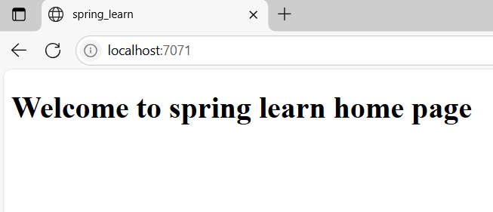

**Hans-on-> 2:**

**Spring Core – Load Country from Spring Configuration XML**

**Pom.xml:**

<dependencies>

<dependency>

<groupId>org.springframework</groupId>

<artifactId>spring-context</artifactId>

<version>5.3.34</version>

</dependency>

<dependency>

<groupId>org.slf4j</groupId>

<artifactId>slf4j-api</artifactId>

<version>1.7.36</version>

</dependency>

<dependency>

<groupId>org.slf4j</groupId>

<artifactId>slf4j-simple</artifactId>

<version>1.7.36</version>

</dependency>

<dependency>

<groupId>org.junit.jupiter</groupId>

<artifactId>junit-jupiter</artifactId>

<version>5.10.0</version>

<scope>test</scope></dependency>

**Country.java:**

**package** com.cognizant.spring_learn;

**import** org.slf4j.Logger;

**import** org.slf4j.LoggerFactory;

**public** **class** Country {

**private** String code;

**private** String name;

**private** **static** **final** Logger ***LOGGER*** = LoggerFactory.*getLogger*(Country.**class**);

**public** Country() {

***LOGGER***.debug("Inside Country Constructor.");

}

**public** String getCode() {

***LOGGER***.debug("Inside getCode()");

**return** code;

}

**public** **void** setCode(String code) {

***LOGGER***.debug("Inside setCode()");

**this**.code = code;

}

**public** String getName() {

***LOGGER***.debug("Inside getName()");

**return** name;

}

**public** **void** setName(String name) {

***LOGGER***.debug("Inside setName()");

**this**.name = name;

}

@Override

**public** String toString() {

**return** "Country [code=" + code + ", name=" + name + "]";

}

}

**SpringLearnApplication.java:**

**package** com.cognizant.spring_learn;

**import** org.slf4j.Logger;

**import** org.slf4j.LoggerFactory;

**import** org.springframework.context.ApplicationContext;

**import** org.springframework.context.support.ClassPathXmlApplicationContext;

**public** **class** SpringLearnApplication {

**private** **static** **final** Logger ***LOGGER*** = LoggerFactory.*getLogger*(SpringLearnApplication.**class**);

**public** **static** **void** main(String[] args) {

System.***out***.println("Main started");

*displayCountry*();

}

**public** **static** **void** displayCountry() {

***LOGGER***.debug("Start displayCountry()");

ApplicationContext context = **new** ClassPathXmlApplicationContext("country.xml");

Country country = context.getBean("country", Country.**class**);

***LOGGER***.debug("Country : {}", country.toString());

***LOGGER***.debug("End displayCountry()");}}

**Country.xml:**

<?xml version="1.0" encoding="UTF-8"?>

<beans xmlns="http://www.springframework.org/schema/beans"

xmlns:xsi="http://www.w3.org/2001/XMLSchema-instance"

xsi:schemaLocation="

http://www.springframework.org/schema/beans

http://www.springframework.org/schema/beans/spring-beans.xsd">

<bean id="country" class="com.cognizant.spring_learn.Country">

<property name="code" value="IN"/>

<property name="name" value="India"/>

</bean>

</beans>

**SpringLearnApplicationTests.java:**

**package** com.cognizant.spring_learn;

**import** **static** org.junit.jupiter.api.Assertions.*;

**import** org.junit.jupiter.api.Test;

**import** org.springframework.context.ApplicationContext;

**import** org.springframework.context.support.ClassPathXmlApplicationContext;

**public** **class** SpringLearnApplicationTests {

@Test

**public** **void** testCountryBeanLoaded() {

ApplicationContext context= **new** ClassPathXmlApplicationContext("country.xml");

Country country = context.getBean("country", Country.**class**);

*assertNotNull*(country, "Country bean should not be null");

*assertEquals*("IN", country.getCode(), "Code should be IN");

*assertEquals*("India", country.getName(), "Name should be India");

}

@Test

**public** **void** testToStringFormat() {

Country country = **new** Country();

country.setCode("JP");

country.setName("Japan");

String expected = "Country [code=JP, name=Japan]";

*assertEquals*(expected, country.toString());

}

}

**OUTPUT:**

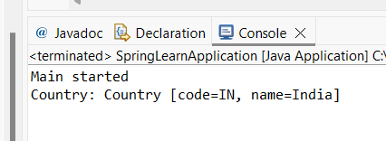

**Hands-on:3**

**Hello World RESTful Web Service**

**SpringLearnApplication.java:**

**package** com.cognizant.spring_learn;

**import** org.springframework.boot.SpringApplication;

**import** org.springframework.boot.autoconfigure.SpringBootApplication;

@SpringBootApplication

**public** **class** SpringLearnApplication {

**public** **static** **void** main(String[] args) {

SpringApplication.*run*(SpringLearnApplication.**class**, args);

}

}

**HelloController.java:**

**package** com.cognizant.spring_learn.controller;

**import** org.slf4j.Logger;

**import** org.slf4j.LoggerFactory;

**import** org.springframework.web.bind.annotation.*;

@RestController

**public** **class** HelloController {

**private** **static** **final** Logger ***LOGGER*** = LoggerFactory.*getLogger*(HelloController.**class**);

@GetMapping("/hello")

**public** String sayHello() {

***LOGGER***.info("START: sayHello()");

String message = "Hello World!!";

***LOGGER***.info("END: sayHello()");

**return** message;

}

}

**Application.properties:**

spring.application.name=spring-learn

server.port=7073

**OUTPUT:**

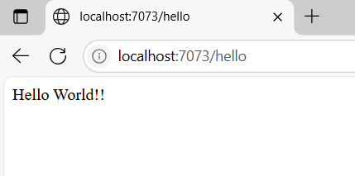

**Hands-on:4**

**REST - Country Web Service**

**SpringLearnApplication.java:**

**package** com.cognizant.spring_learn;

**import** org.springframework.boot.SpringApplication;

**import** org.springframework.boot.autoconfigure.SpringBootApplication;

@SpringBootApplication

**public** **class** SpringLearnApplication {

**public** **static** **void** main(String[] args) {

SpringApplication.*run*(SpringLearnApplication.**class**, args);

}

}

**CountryController.java:**

**package** com.cognizant.spring_learn.controller;

**import** com.cognizant.spring_learn.model.Country;

**import** org.slf4j.Logger;

**import** org.slf4j.LoggerFactory;

**import** org.springframework.context.ApplicationContext;

**import** org.springframework.context.support.ClassPathXmlApplicationContext;

**import** org.springframework.web.bind.annotation.*;

@RestController

**public** **class** CountryController {

**private** **static** **final** Logger ***LOGGER*** = LoggerFactory.*getLogger*(CountryController.**class**);

@RequestMapping("/country")

**public** Country getCountryIndia() {

***LOGGER***.info("START: getCountryIndia()");

**try** (ClassPathXmlApplicationContext context = **new** ClassPathXmlApplicationContext("country.xml")) {

Country country = (Country) context.getBean("in");

***LOGGER***.info("END: getCountryIndia()");

**return** country;

}}}

**Country.java:**

**package** com.cognizant.spring_learn.model;

**public** **class** Country {

**private** String code;

**private** String name;

**public** Country() {}

**public** Country(String code, String name) {

**this**.code = code;

**this**.name = name;

}

**public** String getCode() {

**return** code;

}

**public** **void** setCode(String code) {

**this**.code = code;

}

**public** String getName() {

**return** name;

}

**public** **void** setName(String name) {

**this**.name = name;

}

}

**Country.xml:**

<?xml version="1.0" encoding="UTF-8"?>

<beans xmlns="http://www.springframework.org/schema/beans"

xmlns:xsi="http://www.w3.org/2001/XMLSchema-instance"

xsi:schemaLocation="http://www.springframework.org/schema/beans

http://www.springframework.org/schema/beans/spring-beans.xsd">

<bean id="in" class="com.cognizant.spring_learn.model.Country">

<property name="code" value="IN" />

<property name="name" value="India" />

</bean>

</beans>

**OUTPUT:**

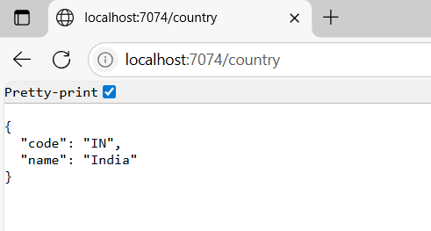

**Hands-on:5**

**REST - Get country based on country code**

**Country.java:**

package com.cognizant.spring_learn.model;

public class Country {

private String code;

private String name;

public Country() {}

public Country(String code, String name) {

this.code = code;

this.name = name;

}

public String getCode() { return code; }

public void setCode(String code) { this.code = code; }

public String getName() { return name; }

public void setName(String name) { this.name = name; }

}

**country.xml:**

<?xml version="1.0" encoding="UTF-8"?>

<beans xmlns="http://www.springframework.org/schema/beans"

xmlns:xsi="http://www.w3.org/2001/XMLSchema-instance"

xsi:schemaLocation="http://www.springframework.org/schema/beans

http://www.springframework.org/schema/beans/spring-beans.xsd">

<bean id="countryList" class="java.util.ArrayList">

<constructor-arg>

<list>

<bean class="com.cognizant.spring_learn.model.Country">

<property name="code" value="IN"/>

<property name="name" value="India"/>

</bean>

<bean class="com.cognizant.spring_learn.model.Country">

<property name="code" value="US"/>

<property name="name" value="United States"/>

</bean>

<bean class="com.cognizant.spring_learn.model.Country">

<property name="code" value="JP"/>

<property name="name" value="Japan"/>

</bean>

</list>

</constructor-arg>

</bean>

</beans>

**CountryService.java:**

package com.cognizant.spring_learn.service;

import com.cognizant.spring_learn.model.Country;

public interface CountryService {

Country getCountry(String code);

}

**CountryServiceImpl.java:**

package com.cognizant.spring_learn.service;

import com.cognizant.spring_learn.model.Country;

import org.springframework.context.support.ClassPathXmlApplicationContext;

import org.springframework.stereotype.Service;

import java.util.List;

@Service

public class CountryServiceImpl implements CountryService {

@Override

public Country getCountry(String code) {

try (ClassPathXmlApplicationContext context = new ClassPathXmlApplicationContext("country.xml")) {

List<Country> countryList = (List<Country>) context.getBean("countryList");

return countryList.stream()

.filter(c -> c.getCode().equalsIgnoreCase(code))

.findFirst()

.orElse(null);

}

}

}

**CountryController.java;**

package com.cognizant.spring_learn.controller;

import com.cognizant.spring_learn.model.Country;

import com.cognizant.spring_learn.service.CountryService;

import org.slf4j.Logger;

import org.slf4j.LoggerFactory;

import org.springframework.beans.factory.annotation.Autowired;

import org.springframework.web.bind.annotation.*;

@RestController

public class CountryController {

private static final Logger LOGGER = LoggerFactory.getLogger(CountryController.class);

@Autowired

private CountryService countryService;

@GetMapping("/countries/{code}")

public Country getCountry(@PathVariable String code) {

LOGGER.info("START: getCountry() with code={}", code);

Country country = countryService.getCountry(code);

LOGGER.info("END: getCountry()");

return country;

}

}

**SpringLearnApplication.java:**

package com.cognizant.spring_learn;

import org.springframework.boot.SpringApplication;

import org.springframework.boot.autoconfigure.SpringBootApplication;

import org.springframework.context.annotation.ImportResource;

@SpringBootApplication

@ImportResource("classpath:country.xml") // This allows loading XML-based beans

public class SpringLearnApplication {

public static void main(String[] args) {

SpringApplication.run(SpringLearnApplication.class, args);

}

}

**OUTPUT:**

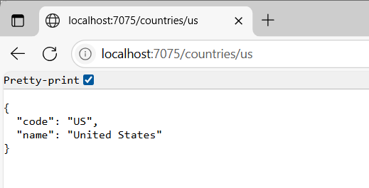

**Hands-on:6**

**Create authentication service that returns JWT**

**Pom.xml**

<dependencies>

<!-- Spring Boot Web -->

<dependency>

<groupId>org.springframework.boot</groupId>

<artifactId>spring-boot-starter-web</artifactId>

</dependency>

<!-- Spring Boot Security -->

<dependency>

<groupId>org.springframework.boot</groupId>

<artifactId>spring-boot-starter-security</artifactId>

</dependency>

<!-- JWT Dependencies (modularized 0.11.5) -->

<dependency>

<groupId>io.jsonwebtoken</groupId>

<artifactId>jjwt-api</artifactId>

<version>0.11.5</version>

</dependency>

<dependency>

<groupId>io.jsonwebtoken</groupId>

<artifactId>jjwt-impl</artifactId>

<version>0.11.5</version>

<scope>runtime</scope>

</dependency>

<dependency>

<groupId>io.jsonwebtoken</groupId>

<artifactId>jjwt-jackson</artifactId>

<version>0.11.5</version>

<scope>runtime</scope>

</dependency>

<!-- Lombok (optional) -->

<dependency>

<groupId>org.projectlombok</groupId>

<artifactId>lombok</artifactId>

<optional>true</optional>

</dependency>

<!-- Testing -->

<dependency>

<groupId>org.springframework.boot</groupId>

<artifactId>spring-boot-starter-test</artifactId>

<scope>test</scope>

</dependency>

<dependency>

<groupId>org.springframework.security</groupId>

<artifactId>spring-security-test</artifactId>

<scope>test</scope>

</dependency>

</dependencies>

**JwtAuthServiceApplication.java:**

**package** com.example.jwtauth;

**import** org.springframework.boot.SpringApplication;

**import** org.springframework.boot.autoconfigure.SpringBootApplication;

@SpringBootApplication

**public** **class** JwtAuthServiceApplication {

**public** **static** **void** main(String[] args) {

SpringApplication.*run*(JwtAuthServiceApplication.**class**, args);

}

}

**SecurityConfig.java:**

**package** com.example.jwtauth.config;

**import** org.springframework.context.annotation.Bean;

**import** org.springframework.context.annotation.Configuration;

**import** org.springframework.security.config.annotation.web.configuration.EnableWebSecurity;

**import** org.springframework.security.core.userdetails.User;

**import** org.springframework.security.core.userdetails.UserDetailsService;

**import** org.springframework.security.provisioning.InMemoryUserDetailsManager;

**import** org.springframework.security.web.SecurityFilterChain;

**import** org.springframework.security.config.annotation.web.builders.HttpSecurity;

@Configuration

@EnableWebSecurity

**public** **class** SecurityConfig {

@Bean

**public** SecurityFilterChain securityFilterChain(HttpSecurity http) **throws** Exception {

http

.csrf(csrf -> csrf.disable())

.authorizeHttpRequests(auth -> auth

.requestMatchers("/authenticate").authenticated()

.anyRequest().permitAll()

)

.httpBasic(); // enable Basic Auth

**return** http.build();

}

@Bean

**public** UserDetailsService userDetailsService() {

**return** **new** InMemoryUserDetailsManager(

User.withDefaultPasswordEncoder()

.username("user")

.password("pwd")

.roles("USER")

.build()

);

}

}

**AuthenticationController.java:**

**package** com.example.jwtauth.controller;

**import** com.example.jwtauth.util.JwtUtil;

**import** org.springframework.beans.factory.annotation.Autowired;

**import** org.springframework.security.core.annotation.AuthenticationPrincipal;

**import** org.springframework.security.core.userdetails.UserDetails;

**import** org.springframework.web.bind.annotation.*;

**import** java.util.Collections;

**import** java.util.Map;

@RestController

**public** **class** AuthenticationController {

@Autowired

**private** JwtUtil jwtUtil;

@GetMapping("/authenticate")

**public** Map<String, String> authenticate(@AuthenticationPrincipal UserDetails user) {

String token = jwtUtil.generateToken(user.getUsername());

**return** Collections.*singletonMap*("token", token);

}

}

**JwtUtil.java:**

**package** com.example.jwtauth.util;

**import** io.jsonwebtoken.Jwts;

**import** io.jsonwebtoken.SignatureAlgorithm;

**import** io.jsonwebtoken.security.Keys;

**import** org.springframework.stereotype.Component;

**import** java.security.Key;

**import** java.util.Date;

@Component

**public** **class** JwtUtil {

**private** **final** String SECRET_KEY = "MySuperSecretKeyForJWTThatIsLongEnough123!"; // >= 32 bytes

**private** **final** Key key = Keys.*hmacShaKeyFor*(SECRET_KEY.getBytes());

**public** String generateToken(String username) {

**return** Jwts.*builder*()

.setSubject(username)

.setIssuedAt(**new** Date())

.setExpiration(**new** Date(System.*currentTimeMillis*() + 1000 * 60 * 10)) // 10 minutes

.signWith(key, SignatureAlgorithm.***HS256***)

.compact();

}

}

**OUTPUT:**

