Week 6 -Hands-on

**Hands-on:1**

Create a new React Application with the name “myfirstreact”, Run the application to print “welcome to the first session of React” as heading of that page.

1. npm install -g create-react-app
2. npx create-react-app myfirstreact
3. cd myfirstreact

**App.js:**

import React from 'react';

function App() {

return (

<div>

<h1>Welcome to the first session of React</h1>

</div>

);

}

export default App;

**OUTPUT:**

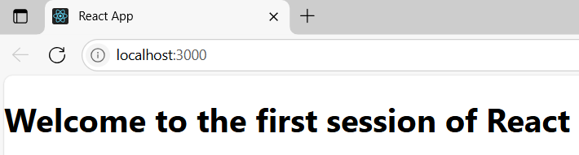

**Hands-on:2**

Create a react app for Student Management Portal named StudentApp

**src/Components/Home.js:**

import React from 'react';

function Home() {

return (

<div>

<h2>Welcome to the Home page of Student Management Portal</h2>

</div>

);

}

export default Home;

**src/Components/About.js;**

import React from 'react';

function About() {

return (

<div>

<h2>Welcome to the About page of the Student Management Portal</h2>

</div>

);

}

export default About;

**src/Components/Contact.js:**

import React from 'react';

function Contact() {

return (

<div>

<h2>Welcome to the Contact page of the Student Management Portal</h2>

</div>

);

}

export default Contact;

**src/App.js:**

import React from 'react';

import Home from './Components/Home';

import About from './Components/About';

import Contact from './Components/Contact';

function App() {

return (

<div className="App">

<h1>Student Management Portal</h1>

<Home />

<About />

<Contact />

</div>

);

}

export default App;

**OUTPUT:**

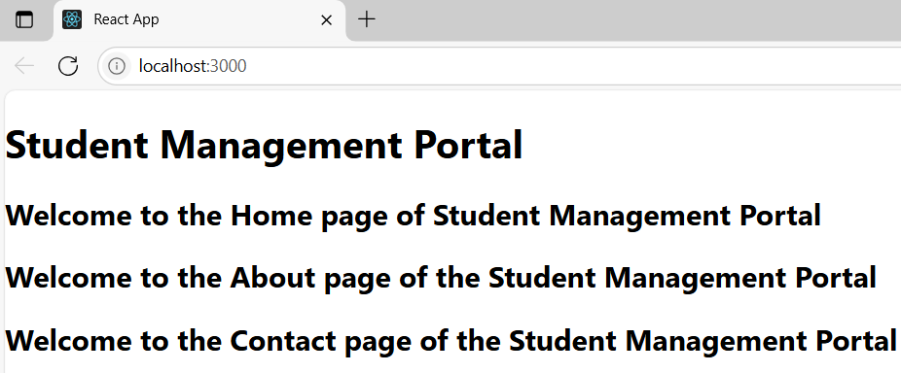

**hands-on:3**

Create a react app for Student Management Portal named scorecalculatorapp

**CalculateScore.js:**

import React from 'react';

import '../Stylesheets/mystyle.css';

function CalculateScore(props) {

const { name, school, total, goal } = props;

const average = total / goal;

return (

<div className="score-card">

<h2>Student Score Summary</h2>

<p><strong>Name:</strong> {name}</p>

<p><strong>School:</strong> {school}</p>

<p><strong>Total Marks:</strong> {total}</p>

<p><strong>Subjects:</strong> {goal}</p>

<p><strong>Average Score:</strong> {average.toFixed(2)}</p>

</div>

);

}

export default CalculateScore;

**src/Stylesheets/mystyle.css:**

.score-card {

border: 2px solid #4CAF50;

padding: 20px;

margin: 30px auto;

width: 60%;

background-color: #f9f9f9;

box-shadow: 0 4px 8px rgba(0, 0, 0, 0.2);

font-family: Arial, sans-serif;

}

.score-card h2 {

color: #4CAF50;

text-align: center;

}

**App.js:**

import React from 'react';

import './App.css';

import CalculateScore from './Components/CalculateScore';

function App() {

return (

<div className="App">

<h1>Score Calculator App</h1>

<CalculateScore name="Arun" school="Greenwood High" total={480} goal={6} />

</div>

);

}

export default App;

**OUTPUT:**

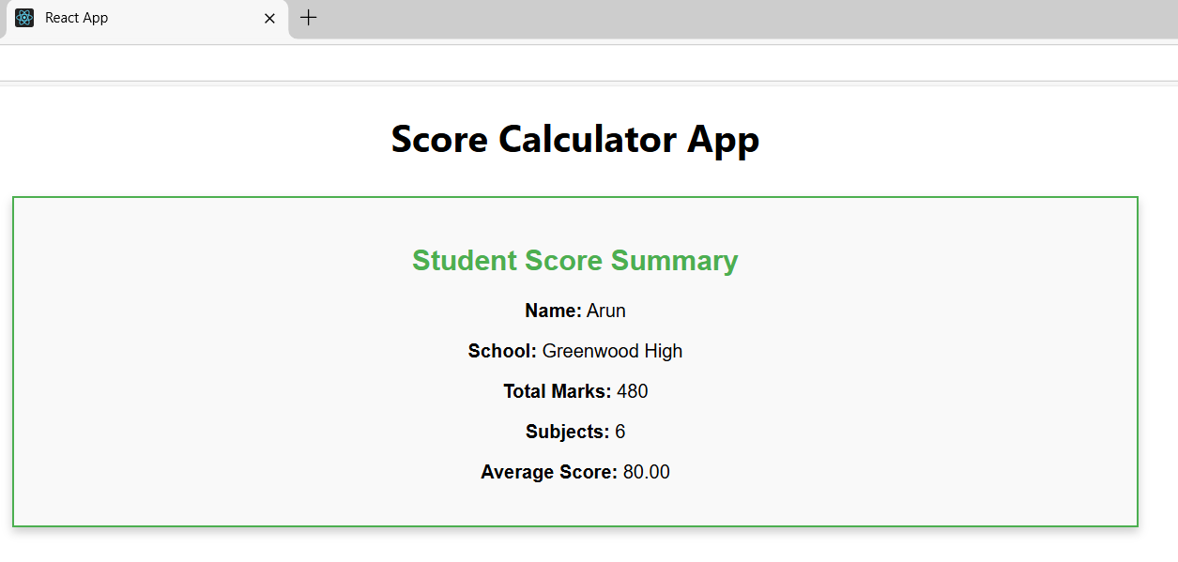

**Hands-on:4**

Create a new react application using create-react-app tool with the name as “blogapp”.

**npx create-react-app blogapp**

**cd blogapp**

**src/Post.js:**

import React from 'react';

class Post extends React.Component {

render() {

return (

<div style={{ border: '1px solid gray', margin: '10px', padding: '10px' }}>

<h3>{this.props.title}</h3>

<p>{this.props.body}</p>

</div>

);

}

}

export default Post;

**src/Posts.js:**

import React from 'react';

import Post from './Post';

class Posts extends React.Component {

constructor(props) {

super(props);

this.state = {

posts: [],

error: null,

};

}

loadPosts = () => {

fetch('https://jsonplaceholder.typicode.com/posts')

.then((response) => {

if (!response.ok) {

throw new Error("Something went wrong while fetching posts.");

}

return response.json();

})

.then((data) => this.setState({ posts: data }))

.catch((err) => this.setState({ error: err.message }));

};

componentDidMount() {

this.loadPosts();

}

componentDidCatch(error, info) {

alert("An error occurred: " + error);

console.error("Error caught in componentDidCatch:", error, info);

}

render() {

const { posts, error } = this.state;

if (error) {

return <h2>Error: {error}</h2>;

}

return (

<div>

<h1>Blog Posts</h1>

{posts.map((post) => (

<Post key={post.id} title={post.title} body={post.body} />

))}

</div>

);

}

}

export default Posts;

**App.js:**

import React from 'react';

import './App.css';

import Posts from './Posts';

function App() {

return (

<div className="App">

<Posts />

</div>

);

}

export default App;

**OUTPUT:**

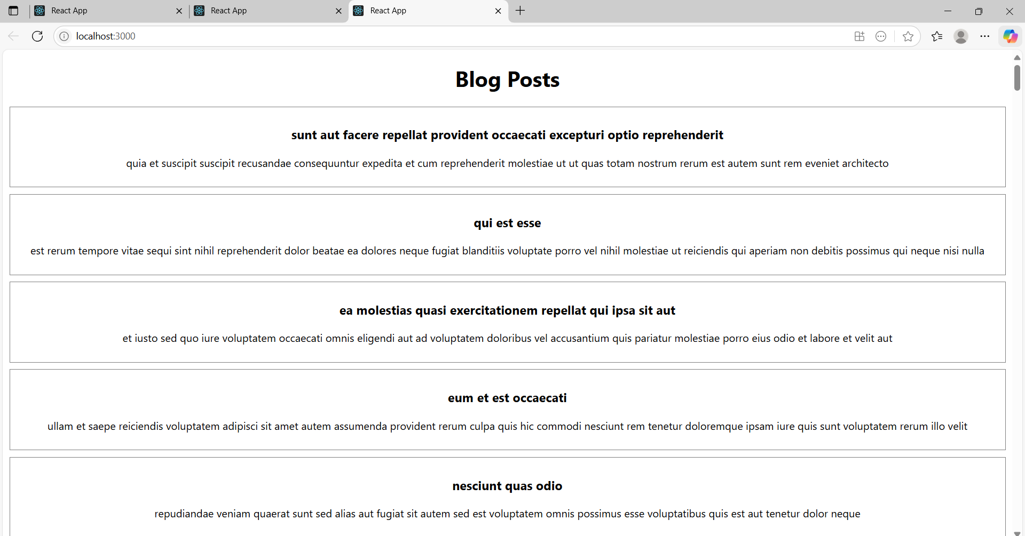

**Hands-on:5:**

My Academy team at Cognizant want to create a dashboard containing the details of ongoing and completed cohorts

**CohortDetails.module.css:**

.box {

width: 300px;

display: inline-block;

margin: 10px;

padding: 10px 20px;

border: 1px solid black;

border-radius: 10px;

}

dt {

font-weight: 500; }

**CohortDetails.js:**

import React from 'react';

import styles from './CohortDetails.module.css';

function CohortDetails({ name, status, startDate, endDate }) {

const statusStyle = {

color: status.toLowerCase() === 'ongoing' ? 'green' : 'blue'

};

return (

<div className={styles.box}>

<h3 style={statusStyle}>{name}</h3>

<dl>

<dt>Status:</dt>

<dd>{status}</dd>

<dt>Start Date:</dt>

<dd>{startDate}</dd>

<dt>End Date:</dt>

<dd>{endDate}</dd>

</dl>

</div>

);

}

export default CohortDetails;

**App.js:**

import React from 'react';

import CohortDetails from './components/CohortDetails';

function App() {

return (

<div className="App">

<CohortDetails

name="React Training"

status="Ongoing"

startDate="2025-07-01"

endDate="2025-07-31"

/>

<CohortDetails

name="Angular Training"

status="Completed"

startDate="2025-06-01"

endDate="2025-06-30"

/>

</div>

);

}

export default App;

**OUTPUT:**

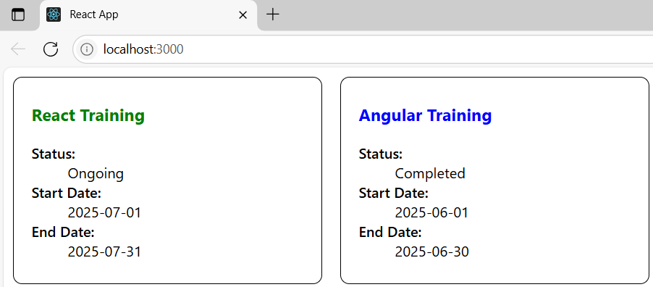

**Addition**

**HANDS-ON:6:**

Create a new React app using create-react-app tool with the as “TrainersApp”

**src/Trainer.js:**

class Trainer {

constructor(id, name, phone, email, stream, skills) {

this.trainerId = id;

this.name = name;

this.phone = phone;

this.email = email;

this.stream = stream;

this.skills = skills;

}

}

export default Trainer;

**src/TrainersMock.js:**

import Trainer from "./Trainer";

const trainers = [

new Trainer(1, "Arun Kumar", "9876543210", "arun.kumar@cognizant.com", "React", ["JS", "HTML", "React"]),

new Trainer(2, "Priya Sharma", "9876543211", "priya.sharma@cognizant.com", "Java", ["OOP", "Spring", "Hibernate"]),

new Trainer(3, "Rahul Dev", "9876543212", "rahul.dev@cognizant.com", "Python", ["Flask", "Django", "Pandas"]),

];

export default trainers;

**src/TrainerList.js:**

import React from 'react';

import { Link } from 'react-router-dom';

function TrainerList({ trainers }) {

return (

<div>

<h2>Trainer List</h2>

<ul>

{trainers.map((trainer) => (

<li key={trainer.trainerId}>

<Link to={`/trainer/${trainer.trainerId}`}>{trainer.name}</Link>

</li>

))}

</ul>

</div>

);

}

export default TrainerList;

**src/Home.js**

import React from 'react';

function Home() {

return (

<div>

<h1>Welcome to Cognizant Academy</h1>

<p>This portal provides details about the trainers.</p>

</div>

);

}

export default Home;

**src/App.js**

import React from 'react';

import { BrowserRouter as Router, Routes, Route, Link } from 'react-router-dom';

import Home from './Home';

import TrainerList from './TrainerList';

import TrainerDetail from './TrainerDetail';

import trainers from './TrainersMock';

function App() {

return (

<Router>

<div>

<h1>Cognizant Academy - Trainer Portal</h1>

<nav>

<Link to="/">Home</Link> | <Link to="/trainers">Trainers</Link>

</nav>

<hr />

<Routes>

<Route path="/" element={<Home />} />

<Route path="/trainers" element={<TrainerList trainers={trainers} />} />

<Route path="/trainer/:id" element={<TrainerDetail />} />

</Routes>

</div>

</Router>

);

}

export default App;

**src/TrainerDetail.js:**

import React from 'react';

import { useParams } from 'react-router-dom';

import trainers from './TrainersMock';

function TrainerDetail() {

const { id } = useParams();

const trainer = trainers.find(t => t.trainerId === parseInt(id));

if (!trainer) {

return <h2>Trainer Not Found</h2>;

}

return (

<div>

<h2>{trainer.name}'s Details</h2>

<p><strong>Phone:</strong> {trainer.phone}</p>

<p><strong>Email:</strong> {trainer.email}</p>

<p><strong>Technology:</strong> {trainer.stream}</p>

<p><strong>Skills:</strong> {trainer.skills.join(', ')}</p>

</div>

);

}

export default TrainerDetail;

**OUTPUT:**

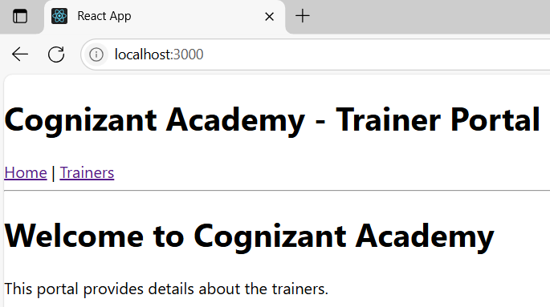

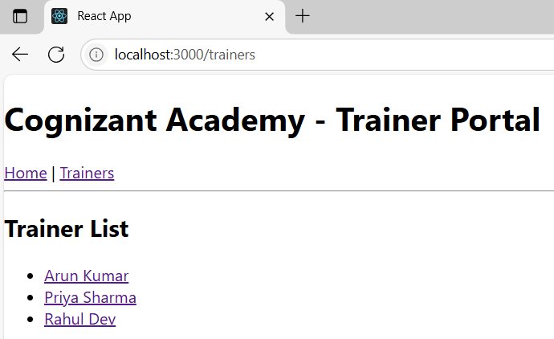

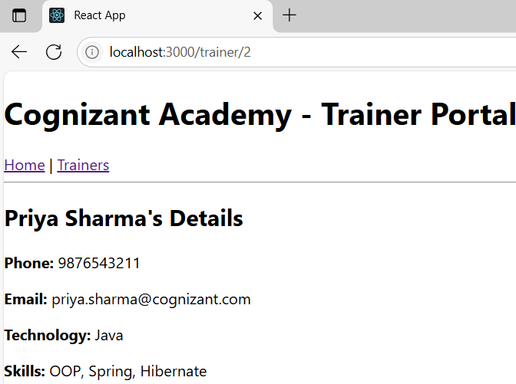

HANDS-ON:7:

Create a React Application named “shoppingapp” with a class component named “OnlineShopping” and “Cart”.

**Cart.js:**

// src/Cart.js

import React from 'react';

class Cart extends React.Component {

render() {

return (

<div style={{ border: '1px solid black', margin: '10px', padding: '10px' }}>

<h3>Item: {this.props.itemname}</h3>

<p>Price: ₹{this.props.price}</p>

</div>

);

}

}

// Default Props

Cart.defaultProps = {

itemname: 'Unknown Item',

price: 0

};

export default Cart;

**OnlineShopping.js:**

// src/OnlineShopping.js

import React from 'react';

import Cart from './Cart';

class OnlineShopping extends React.Component {

constructor(props) {

super(props);

this.cartItems = [

{ itemname: 'Laptop', price: 55000 },

{ itemname: 'Smartphone', price: 20000 },

{ itemname: 'Headphones', price: 1500 },

{ itemname: 'Smartwatch', price: 3000 },

{ itemname: 'Backpack', price: 1000 }

];

}

render() {

return (

<div>

<h2>🛒 My Shopping Cart</h2>

{

this.cartItems.map((item, index) => (

<Cart key={index} itemname={item.itemname} price={item.price} />

))

}

</div>

);

}

}

export default OnlineShopping;

**App.js:**

import React from 'react';

import OnlineShopping from './OnlineShopping';

function App() {

return (

<div className="App">

<OnlineShopping />

</div>

);

}

export default App;

**index.js:**

// src/index.js

import React from 'react';

import ReactDOM from 'react-dom/client';

import App from './App';

const root = ReactDOM.createRoot(document.getElementById('root'));

// Using reactDOM.render() for older versions OR createRoot for v18+

root.render(<App />);

**OUTPUT:**

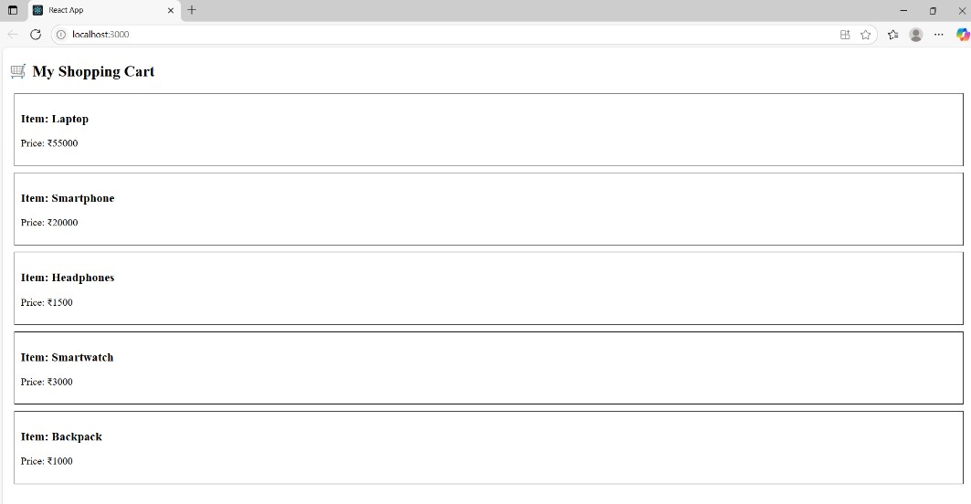

**Hands-on:8**

Create a React App “counterapp” which will have a component named “CountPeople” which will have 2 methods.

**App.js:**

import React from 'react';

import CountPeople from './CountPeople';

function App() {

return (

<div className="App">

<CountPeople />

</div>

);

}

export default App;

**CountPeople.js:**

import React from 'react';

class CountPeople extends React.Component {

constructor(props) {

super(props);

// Initialize state

this.state = {

entryCount: 0,

exitCount: 0

};

}

// Method to update entry count

UpdateEntry = () => {

this.setState(prevState => ({

entryCount: prevState.entryCount + 1

}));

};

// Method to update exit count

UpdateExit = () => {

this.setState(prevState => ({

exitCount: prevState.exitCount + 1

}));

};

render() {

return (

<div style={{ padding: '20px', textAlign: 'center' }}>

<h2>🛍️ Mall Entry Counter</h2>

<p><strong>People Entered:</strong> {this.state.entryCount}</p>

<p><strong>People Exited:</strong> {this.state.exitCount}</p>

<button onClick={this.UpdateEntry} style={{ margin: '10px', padding: '10px' }}>

Login

</button>

<button onClick={this.UpdateExit} style={{ margin: '10px', padding: '10px' }}>

Exit

</button>

</div>

);

}

}

export default CountPeople;

**index.js:**

import React from 'react';

import ReactDOM from 'react-dom/client';

import App from './App';

const root = ReactDOM.createRoot(document.getElementById('root'));

root.render(<App />);

**OUTPUT:**

