Week 8 Hands-ON

Hands-on:1

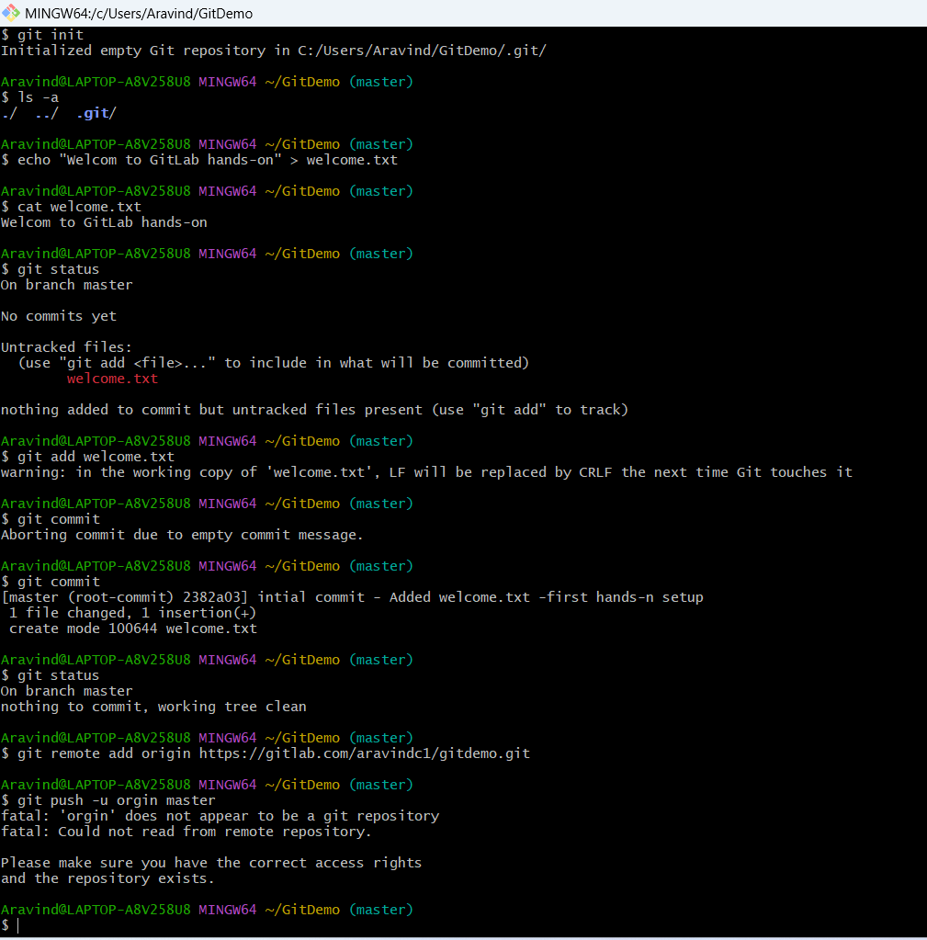

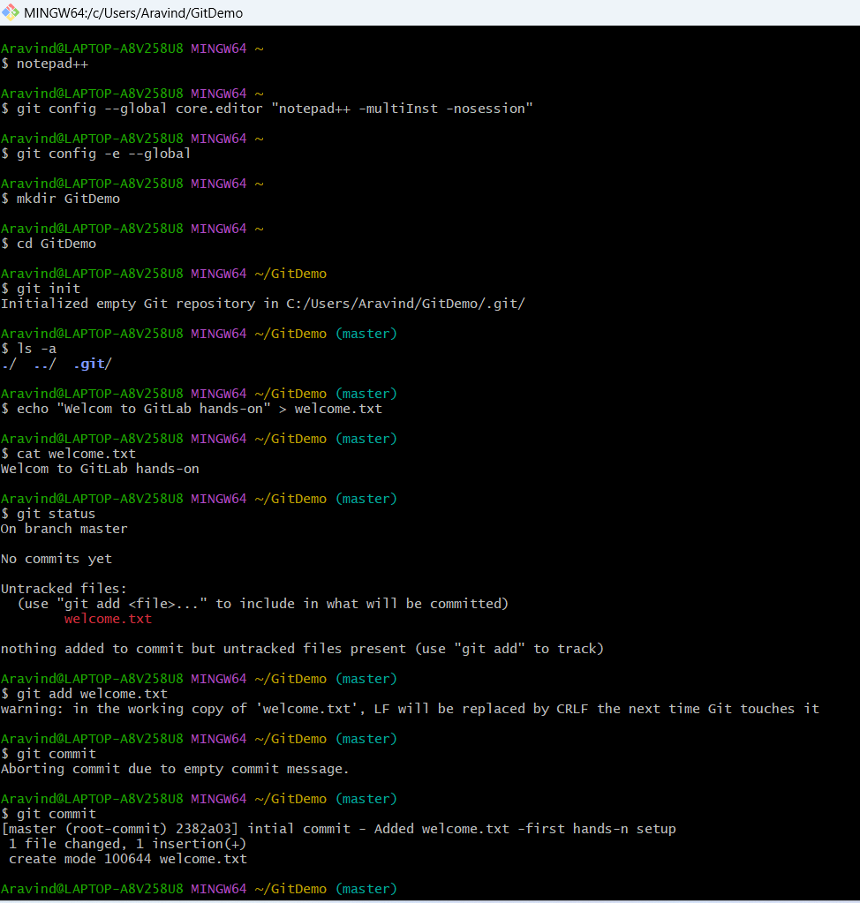

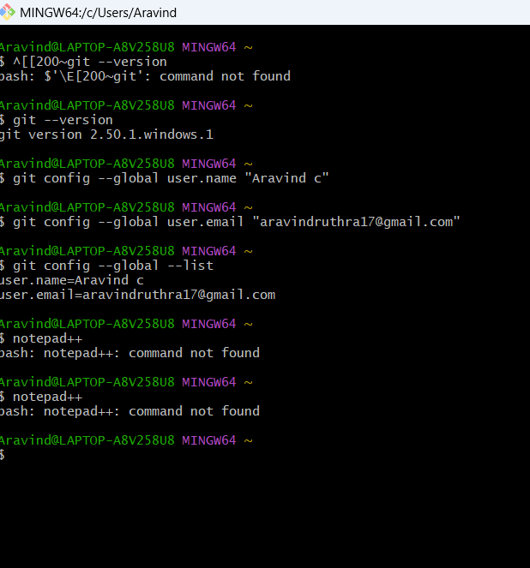

**Ouput:**

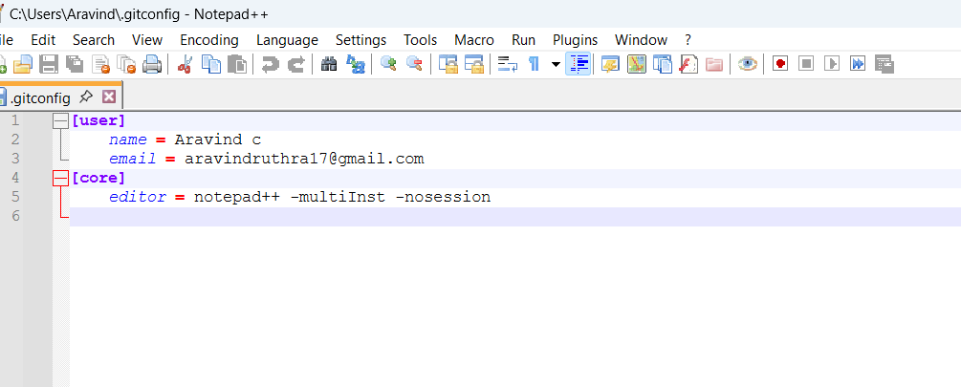

**Hands-on:2**

cd /path/to/repo

echo "sample log" > app.log

mkdir -p log

echo "server log" > log/server.log

# add ignore rules

printf "%s\n" "*.log" "log/" > .gitignore

# check what git sees

git status --short

git check-ignore -v app.log

git ls-files --others -i --exclude-standard

# if previously tracked

git rm --cached app.log || true

git rm -r --cached log || true

git add .gitignore

git commit -m "Add .gitignore to ignore .log files and log/ directory"

git status

OUTPUT:

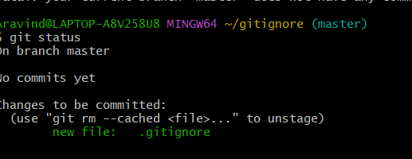

**HANDS-ON:3**

git checkout -b GitNewBranch

git branch -a

echo "This is a sample file in GitNewBranch" > sample.txt

git add sample.txt

git commit -m "Added sample.txt in GitNewBranch"

git status

git checkout master

git diff master..GitNewBranch

git difftool master..GitNewBranch

git merge GitNewBranch

git log --oneline --graph --decorate

git branch -d GitNewBranch

git status

OUTPUT:

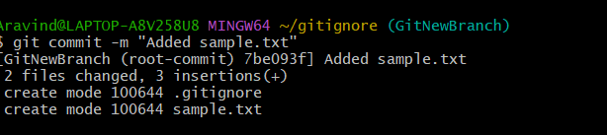

HANDS-ON:4

git checkout master

git status

git checkout -b GitWork

echo "<message>Hello from GitWork branch</message>" > hello.xml

git add hello.xml

git commit -m "Added hello.xml in GitWork branch"

echo "<message>Updated content in GitWork branch</message>" > hello.xml

git status

git add hello.xml

git commit -m "Updated hello.xml in GitWork branch"

git checkout master

echo "<message>Hello from master branch</message>" > hello.xml

git add hello.xml

git commit -m "Added hello.xml in master branch"

git log --oneline --graph --decorate --all

git diff master..GitWork

git difftool master..GitWork

git merge GitWork

git mergetool

git add hello.xml

git commit -m "Merged GitWork into master with conflict resolution"

echo "*.orig" >> .gitignore

git add .gitignore

git commit -m "Added merge tool backup files to .gitignore"

git branch -a

git branch -d GitWork

git log --oneline --graph –decorate

OUTPUT:

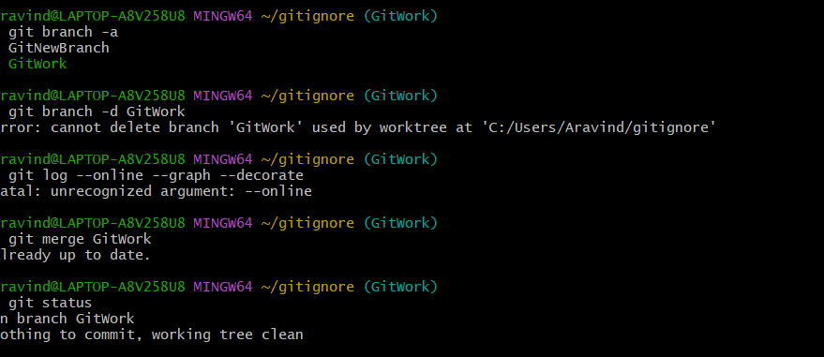

HANDS-ON:5

git checkout master

git status

git branch -a

git pull origin master

git push origin master

git log --oneline --decorate --graph origin/master

git status

git branch -a

git pull origin master

git push origin master

OUTPUT:

