**Voting Code:**

**package** test;

**public** **class** InsufficientAgeException **extends** NumberFormatException{

**public** InsufficientAgeException() {

**super**("Ur age is not suuficient to vote");

}

**public** **class** InvalidAgeException **extends** NumberFormatException {

InvalidAgeException(){

**super**("Ur age is not valid for voting");

}

**import** java.util.Scanner;

**public** **class** Voting {

**public** **void** testAge() **throws** InvalidAgeException,InsufficientAgeException{

Scanner sc=**new** Scanner(System.***in***);

System.***out***.println("Enter ur age");

**int** age=sc.nextInt();

**if**(age<0)

**throw** **new** InvalidAgeException();

**else** **if**(age<18)

**throw** **new** InsufficientAgeException();

**else** **if**(age>=18 && age<=100)

System.***out***.println("U are eligible to vote");

**else**

System.***out***.println("Please enter age in number only.....");

}

}

**public** **class** TestVoting {

**public** **static** **void** main(String[] args) {

// **TODO** Auto-generated method stub

Voting vt=**new** Voting();

**try**{

vt.testAge();

}

**catch**(InsufficientAgeException ife) {

System.***out***.println(ife);

}

**catch**(InvalidAgeException iae) {

System.***out***.println(iae);

}

}

}

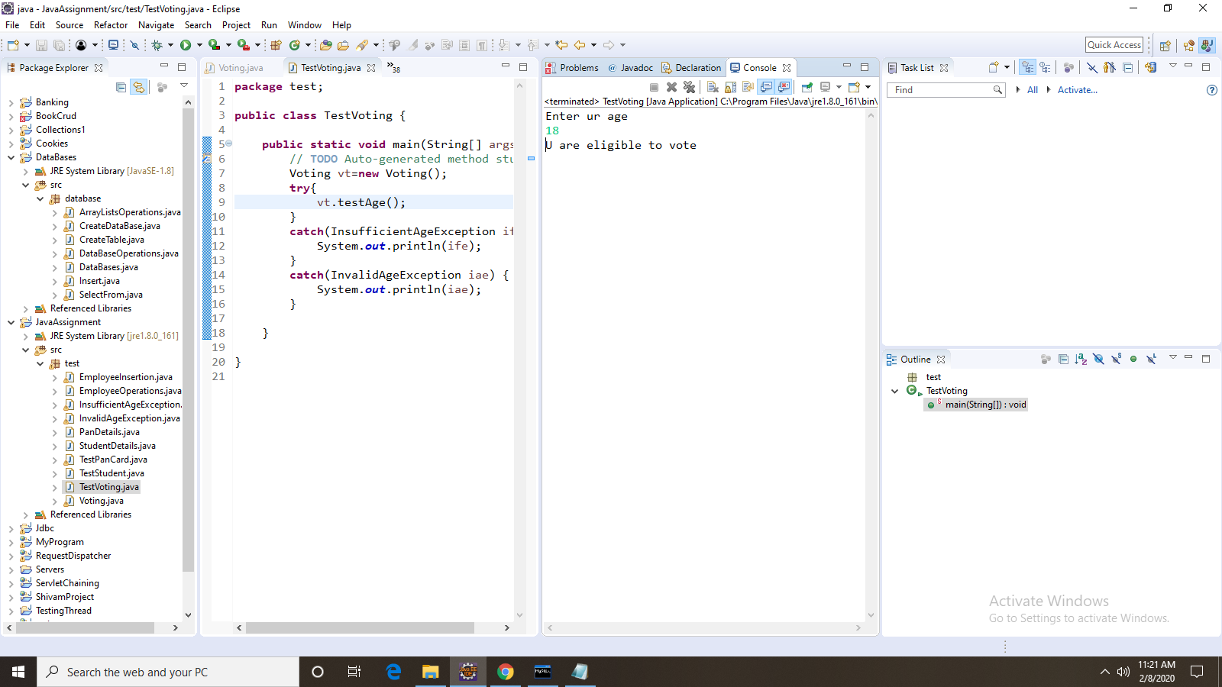

**Pan Card Code:**

**public** **class** PanDetails {

**public** **static** **int** panValidating(String str) {

**int** count=0;

**if**(str.length()==10) {

**if**(str.matches("[A-Z]{5}[0-9]{4}[A-Z]{1}"))

count++;

}

**return** count;

}

}

**import** java.util.Scanner;

**public** **class** TestPanCard {

**public** **static** **void** main(String[] args) {

// **TODO** Auto-generated method stub

PanDetails pdt=**new** PanDetails();

Scanner sc = **new** Scanner(System.***in***);

System.***out***.println("Enter the pancard number");

String str=sc.next();

**int** count=pdt.*panValidating*(str);

**if**(count==1)

System.***out***.println("valid pan card");

**else**

System.***out***.println("Not valid pan card");

}

}

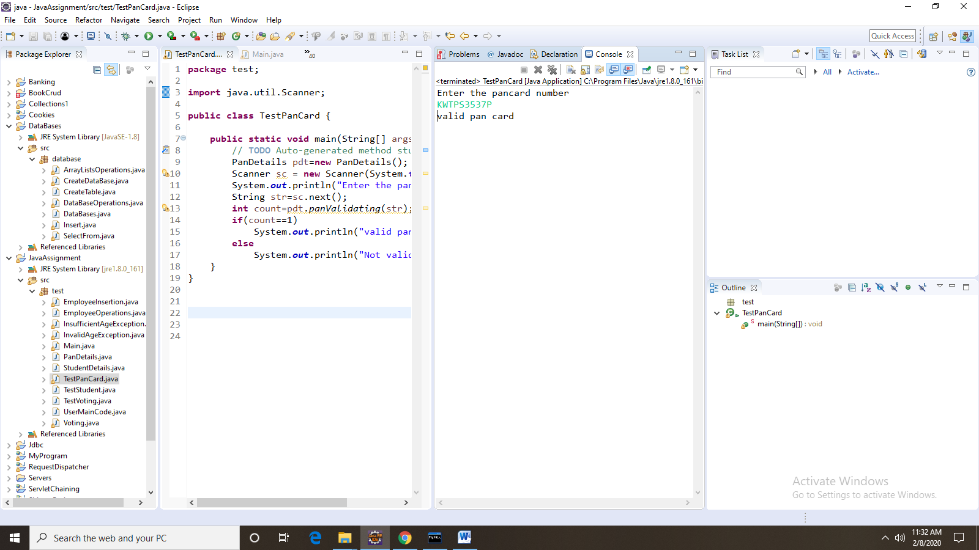

**StudentMarks Code:**

**public** **class** StudentDetails {

String name;

**int** marks;

StudentDetails(String name,**int** marks){

**this**.name=name;

**this**.marks=marks;

}

}

**import** java.util.ArrayList;

**import** java.util.function.Consumer;

**import** java.util.function.Function;

**import** java.util.function.Predicate;

**public** **class** TestStudent {

**public** **static** **void** main(String[] args) {

// **TODO** Auto-generated method stub

ArrayList<StudentDetails>list=**new** ArrayList<StudentDetails>();

StudentDetails s1=**new** StudentDetails("Aravind",90);

StudentDetails s2=**new** StudentDetails("venkat",85);

StudentDetails s3=**new** StudentDetails("dinesh",80);

StudentDetails s4=**new** StudentDetails("chandu",95);

StudentDetails s5=**new** StudentDetails("dheeraj",88);

list.add(s1);

list.add(s2);

list.add(s3);

list.add(s4);

list.add(s5);

System.***out***.println("students who are passed:");

Predicate<StudentDetails>p=s->s.marks>=40;

Function<StudentDetails,String>f=stud->{

**int** m=stud.marks;

**if**(m>=80)

**return** "Distinction";

**else** **if**(m>=60 && m<=79)

**return** "FirsT Class";

**else** **if**(m>=40 && m<=50)

**return** "Second class";

**else**

**return** "fail";

};

Consumer<StudentDetails>c=std->{

System.***out***.print(std.name+" ");

System.***out***.println(f.apply(std));

};

**for**(StudentDetails std:list) {

**if**(p.test(std))

{

c.accept(std);

}

}

}

}

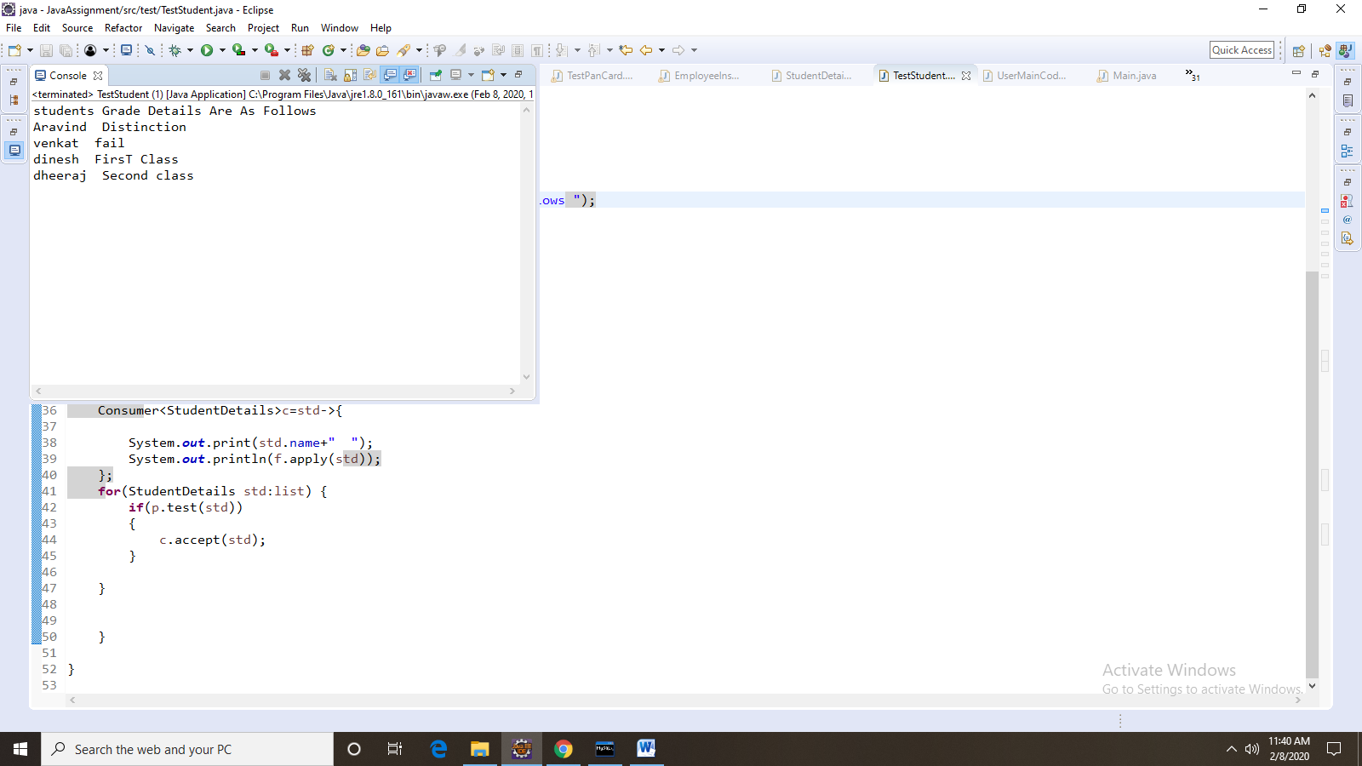

**ArrayListCode(Ex:4)**

**import** java.util.ArrayList;

**import** java.util.Scanner;

**public** **class** ArrayListExample {

**public** **static** ArrayList<Integer> performSetOperations(ArrayList<Integer> arr1,ArrayList<Integer> arr2, **char** c)

{

ArrayList<Integer> arl1 = **new** ArrayList<Integer>();

**int** k = 0;

**switch** (c)

{

**case** '+':

arr1.removeAll(arr2);

arr1.addAll(arr2);

arl1 = arr1;

**break**;

**case** '*':

arr1.retainAll(arr2);

arl1 = arr1;

**break**;

**case** '-':

**for** (**int** i = 0; i < arr1.size(); i++)

{

k = 0;

**for** (**int** j = 0; j < arr2.size(); j++)

{

**if** (arr1.get(i) == arr2.get(j))

k = 1;

}

**if** (k == 0)

arl1.add(arr1.get(i));

}

**break**;

}

**return** arl1;

}

**public** **static** **void** main(String[] args) {

// **TODO** Auto-generated method stub

ArrayListExample axe=**new** ArrayListExample();

Scanner sc = **new** Scanner(System.***in***);

System.***out***.println("Enter Size of an ArrayList");

**int** n = Integer.*parseInt*(sc.nextLine());

ArrayList<Integer> ar1 = **new** ArrayList<Integer>();

ArrayList<Integer> ar2 = **new** ArrayList<Integer>();

System.***out***.println("Enter Elements in First ArrayList");

**for** (**int** i = 0; i < 2*n; i++)

{

ar1.add(Integer.*parseInt*(sc.nextLine()));

}

System.***out***.println("Enter Elements in Second ArrayList");

**for** (**int** i = 0; i < 2*n; i++)

{

ar2.add(Integer.*parseInt*(sc.nextLine()));

}

System.***out***.println("Enter your choice : '+' for SET-UNION, '*' for SET-INTERSECTION, '-' for SET-DIFFERENCE ");

**char** c = sc.nextLine().charAt(0);

System.***out***.println("Resultant Arraylist : "+axe.*performSetOperations*(ar1,ar2,c));

}

}

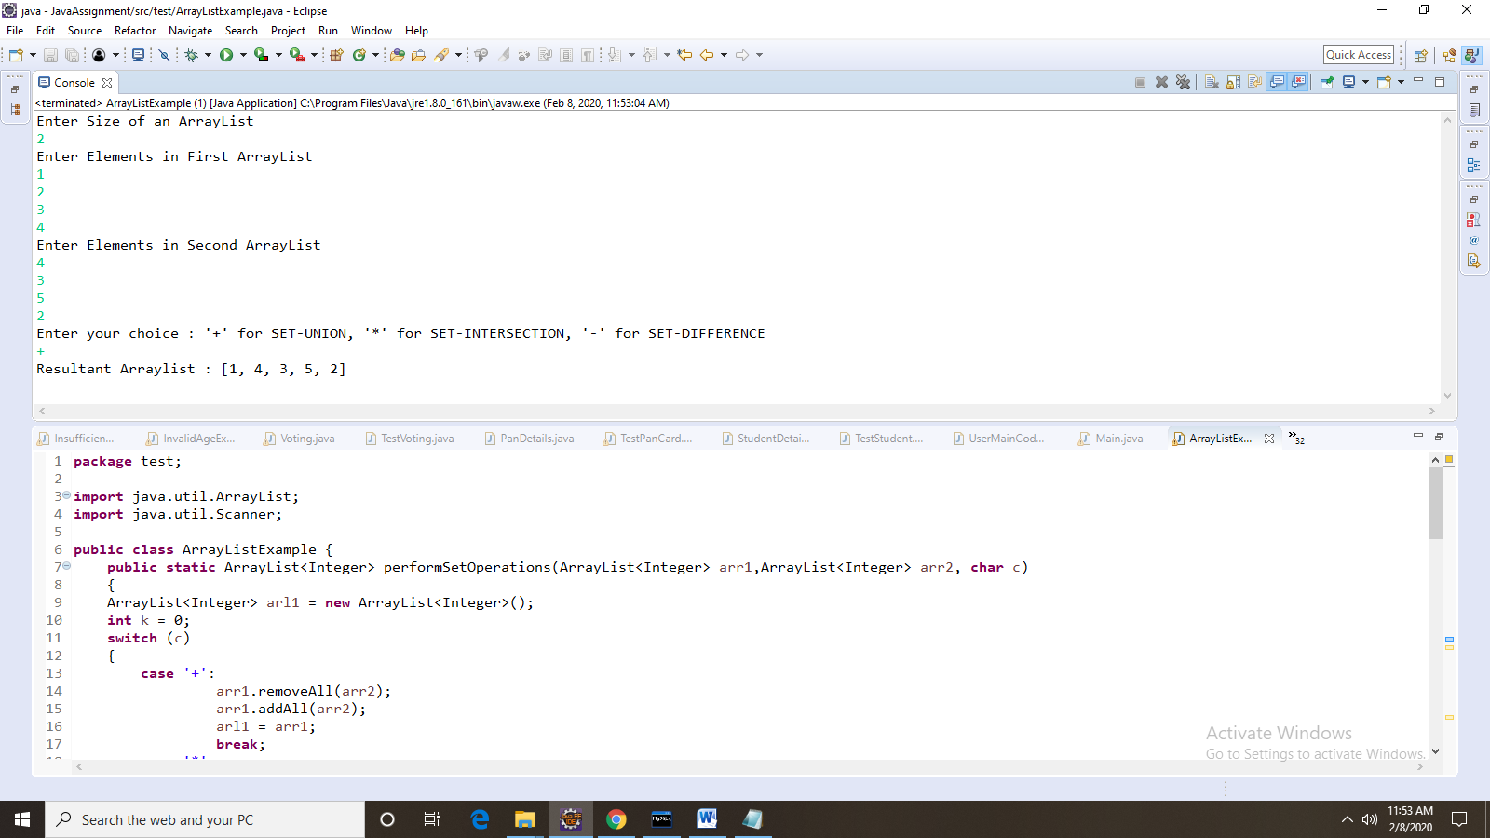

**Employee Table Operations(Ex5):**

**Creating table:**

**import** java.sql.Connection;

**import** java.sql.DriverManager;

**import** java.sql.SQLException;

**import** java.sql.Statement;

**public** **class** EmployeeOperations {

**public** **static** **void** main(String[] args)**throws** SQLException {

// **TODO** Auto-generated method stub

DriverManager.*registerDriver*(**new** com.mysql.cj.jdbc.Driver());

Connection connection=DriverManager.*getConnection*("jdbc:mysql://localhost:3306/aravind","root","root");

Statement statement=connection.createStatement();

String query="create table IF NOT EXISTS Employee(name varchar(20),id int(10),dept varchar(20),desg varchar(20),company varchar(20),emailid varchar(15))";

**int** count=statement.executeUpdate(query);

System.***out***.println(count+"table created");

statement.close();

connection.close();

}

}

**Insertion Operations:**

**import** java.sql.Connection;

**import** java.sql.DriverManager;

**import** java.sql.PreparedStatement;

**import** java.sql.SQLException;

**import** java.sql.Statement;

**import** java.util.Scanner;

**public** **class** EmployeeInsertion {

**public** **static** **void** main(String[] args)**throws** SQLException {

// **TODO** Auto-generated method stub

DriverManager.*registerDriver*(**new** com.mysql.cj.jdbc.Driver());

Connection connection=DriverManager.*getConnection*("jdbc:mysql://localhost:3306/aravind","root","root");

String query="insert into Employee values(?,?,?,?,?)";

PreparedStatement pst=connection.prepareStatement(query);

Scanner sc=**new** Scanner(System.***in***);

System.***out***.println("Enter name");

String name=sc.next();

System.***out***.println("Enter id ");

**int** id=sc.nextInt();

System.***out***.println("Enter department");

String dept=sc.next();

System.***out***.println("Enter desgination");

String desg=sc.next();

System.***out***.println("Enter companyname");

String cmpny=sc.next();

System.***out***.println("Enter emailid");

String email=sc.next();

pst.setString(1, name);

pst.setInt(2,id);

pst.setString(3, dept);

pst.setString(4, desg);

pst.setString(5, cmpny);

pst.setString(6, email);

**int** x=pst.executeUpdate();

System.***out***.println(x+ " "+ " Record inserted");

}

}

**Table Created:**

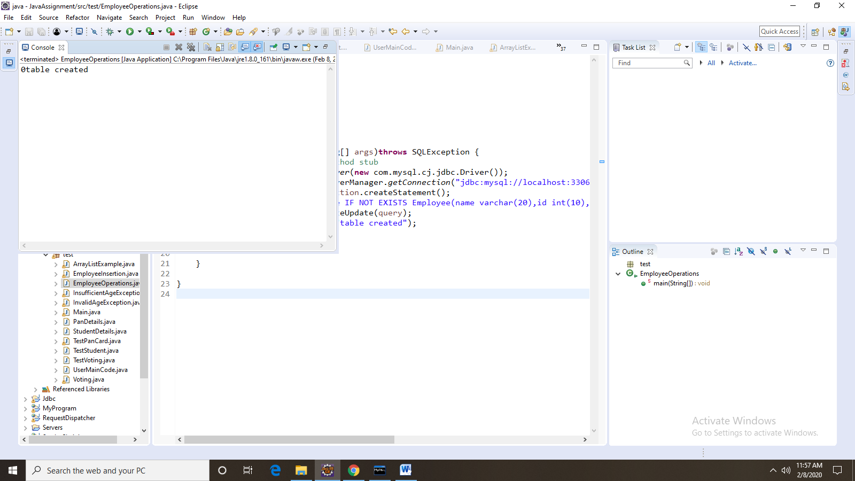

**Record Inserted:**

