**Group Project no 13 – Police gun shooting (2000-2019)**

Segment – 1

/* Explored the time series signal components for complete data from 2000 – 2019 */

**Trend, Seasonality and Cycle charts**

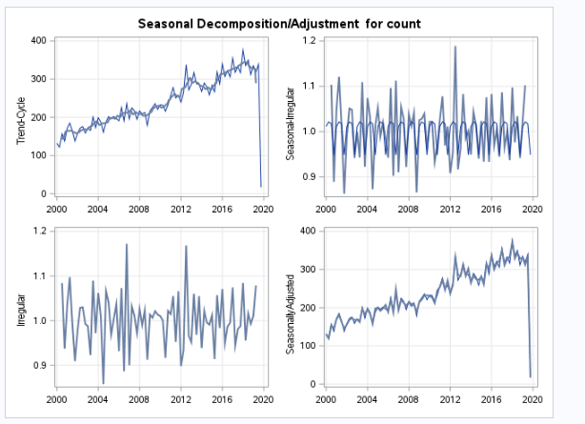

**Simple Forecast based on the available data – 12 months forecast**

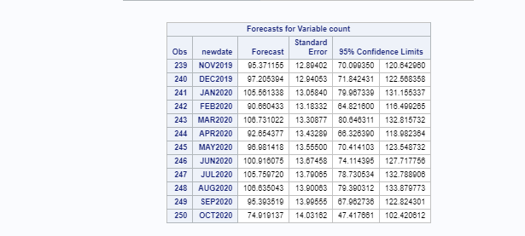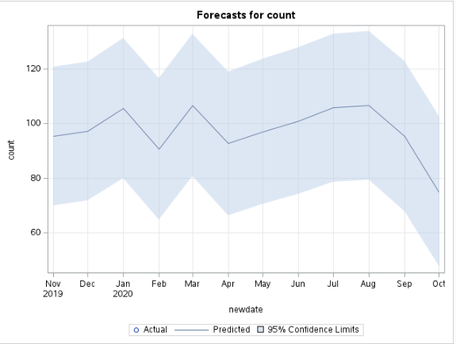

Things to do this week - To create fit and holdout sample and understand the differences in output between models like ARIM, ARIMAX and Exponential smoothing

Segment 2

/* Created age groups to see the various signal components like Trend, seasonality and cycle */

Age below 19 are categorized as agegroup1 and created 9 groups to analyze based on age and forecast the expected incidents for next 12 months

Number of incidents based on Age group

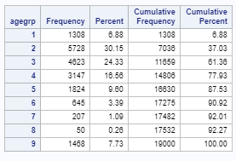

**Trend, Seasonality and Cycle charts for group 2 and 3 which has high number of incidents**

***Age group - 2***

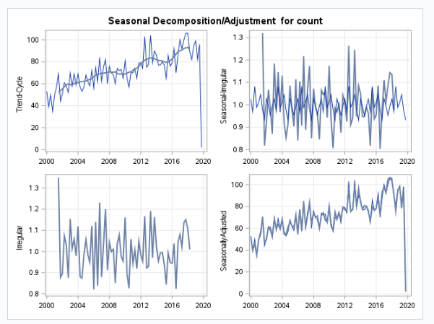

***Age group - 3***

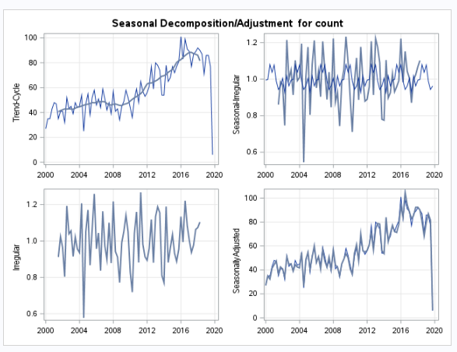

**Forecast based on the age group data (Group 2 and 3) - 12 months forecast**

***Age group -2***

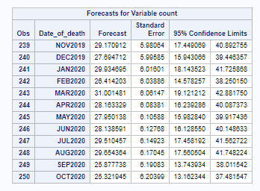

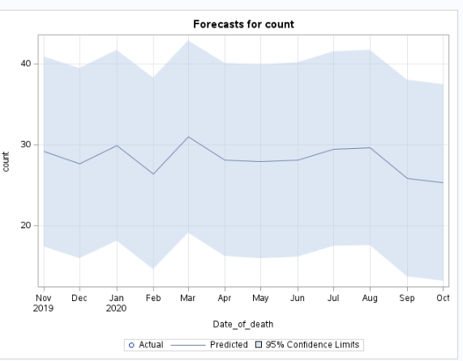

***Age group – 3***

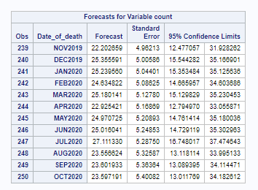

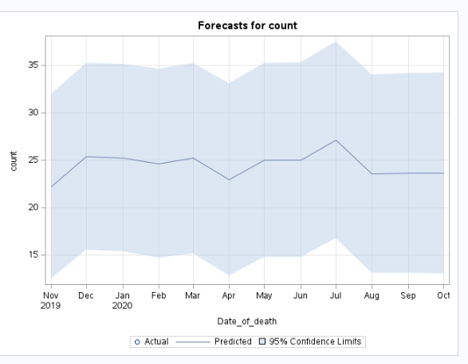

Things to do this week - To create fit and holdout sample and understand the differences in output between models like ARIM, ARIMAX and Exponential smoothing

Segment 3

/* Explored the data based on gender to see the various signal components like Trend, seasonality and cycle */

***Gender – Female***

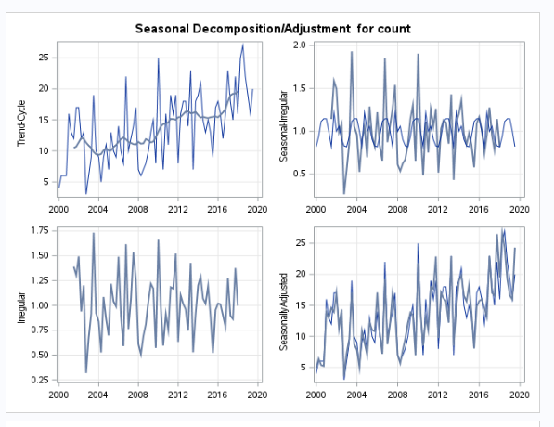

***Gender – Male***

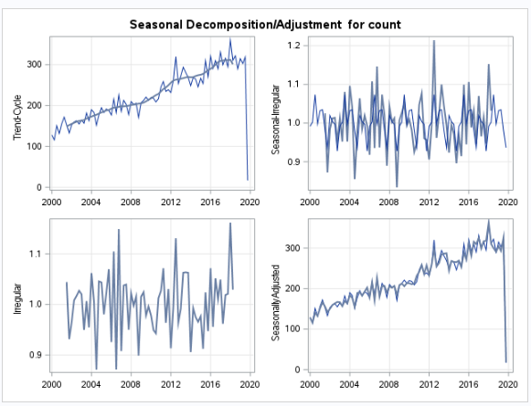

**Forecast based on the gender - 12 month forecast**

***Gender – Female***

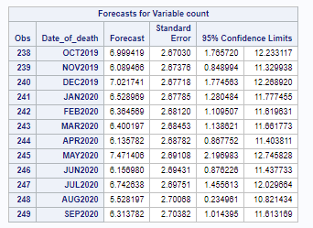

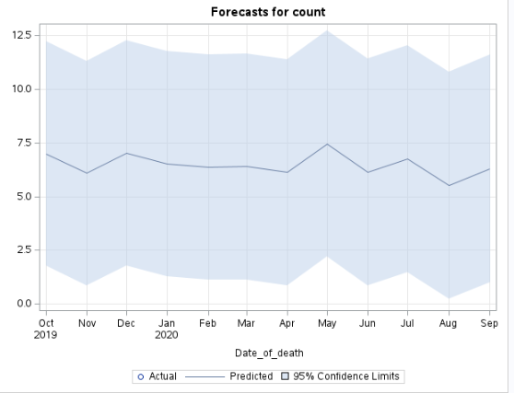

***Gender – Male***

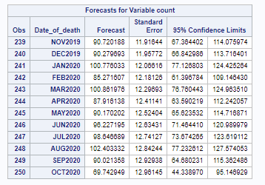

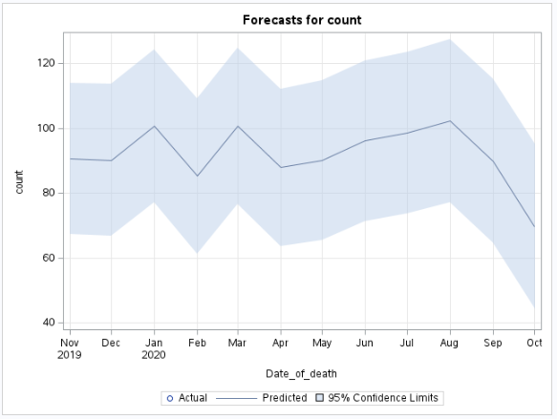

**Things to be done:**

* To create fit and holdout sample and understand the differences in output between models like ARIM, ARIMAX and Exponential smoothing
* Results of the Text analysis on the description part must be channelized with the output of final forecasts

**Team: tasks to be completed by this week**

1. **Alex** – Analysis on state and county wise proportion to forecast incidents across counties
2. **Aravind** – Forecast the Segment 1,2,3 across different models (ARIMA, ARIMAX) and to forecast the final model across the top counties with maximum incidents
3. **Mason** – Analysis on the age group and census data to channelize with the output of the final forecasts

Decision tree

