Install IBM App Connect Operator using Helm with the following steps.
Add this commands:

helm repo add ibm-helm https://raw.githubusercontent.com/IBM/charts/master/repo/ibm-helm

helm repo update

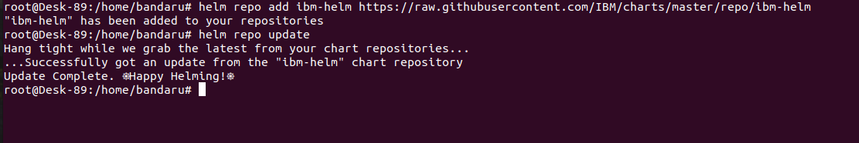
kubectl create namespace appconnecter

kubectl config set-context --current --namespace=appconnecter
kubectl get ns
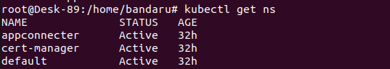
Add the entitlement key for accessing ibm operators installation in aks cluster.
kubectl create secret docker-registry ibm-entitlement-key \
--docker-server=cp.icr.io \
--docker-username=cp \
--docker-password=<IBM_ENTITLEMENT_KEY>

kubectl get secrets
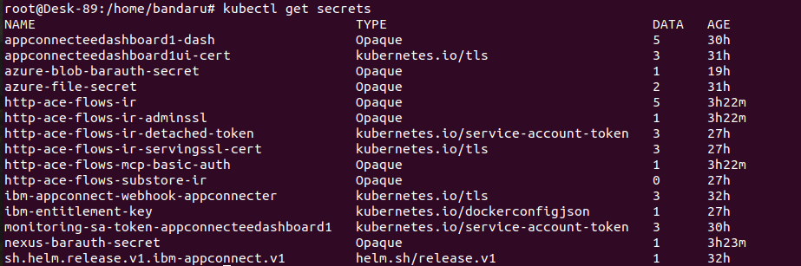
To install ibm connect operator use following command:

helm install ibm-appconnect ibm-helm/ibm-appconnect-operator \
-n appconnecter \
--set namespace=appconnecter \
--set operator.installMode=AllNamespaces

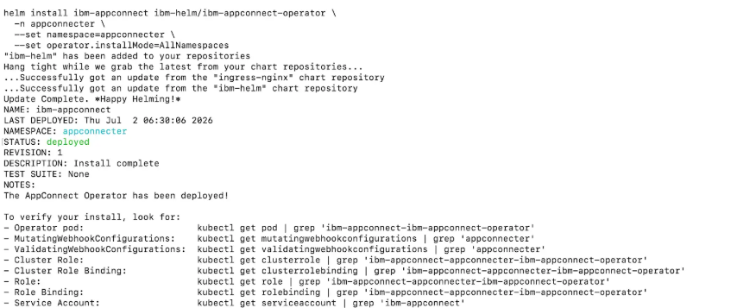
To verify installation use following command
Helm ls
kubectl get pods -n appconnecter

Create the NGINX Controller for external access to the cluster resources

Kubectl create namespace ingress-nginx
kubectl config set-context --current --namespace=ingress-nginx

kubectl apply -f https://raw.githubusercontent.com/kubernetes/ingress-nginx/controller-v1.3.0/deploy/static/provider/cloud/deploy.yaml

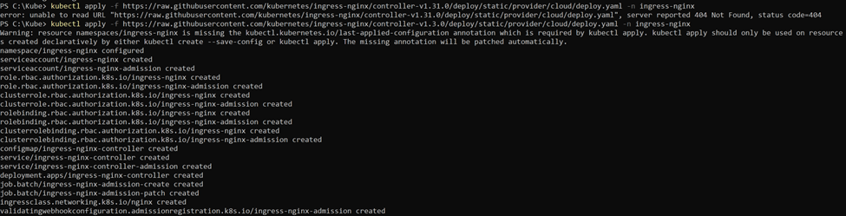
Verify the ingress controller
kubectl get svc -n ingress-nginx

Storage Architecture

Azure Storage Account
(acestorage2345)
▼
Azure File Share
(acefileshare)
▼
Persistent Volume (PV)
ace-dashboard-pv
▼
Persistent Volume Claim (PVC)
appconnecteedashboard1-content
▼
App Connect Dashboard Pod
appconnecteedashboard1-dash

Create azure storage account for pv and pvc we can do it manually through portal with following details

Name of storage account :
Acestorage2345
Performance standard
location:East us 2
Redundancy: Local redundant storage
Blob storage choose hot tier
Public network access :enabled

Give unique name to storage account containing letters and numbers.
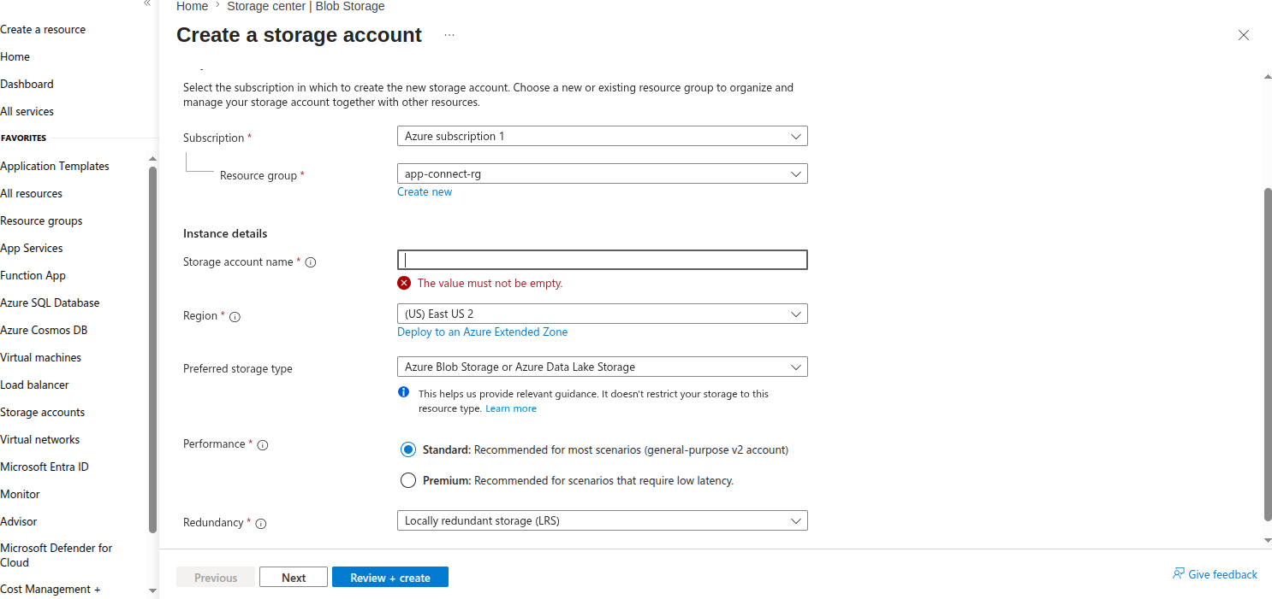

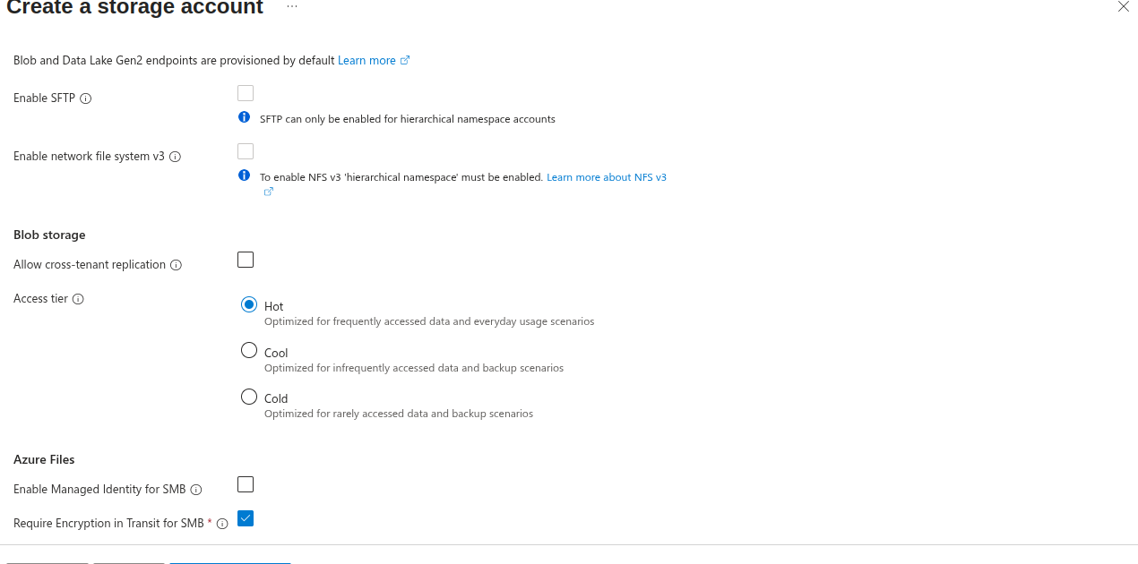
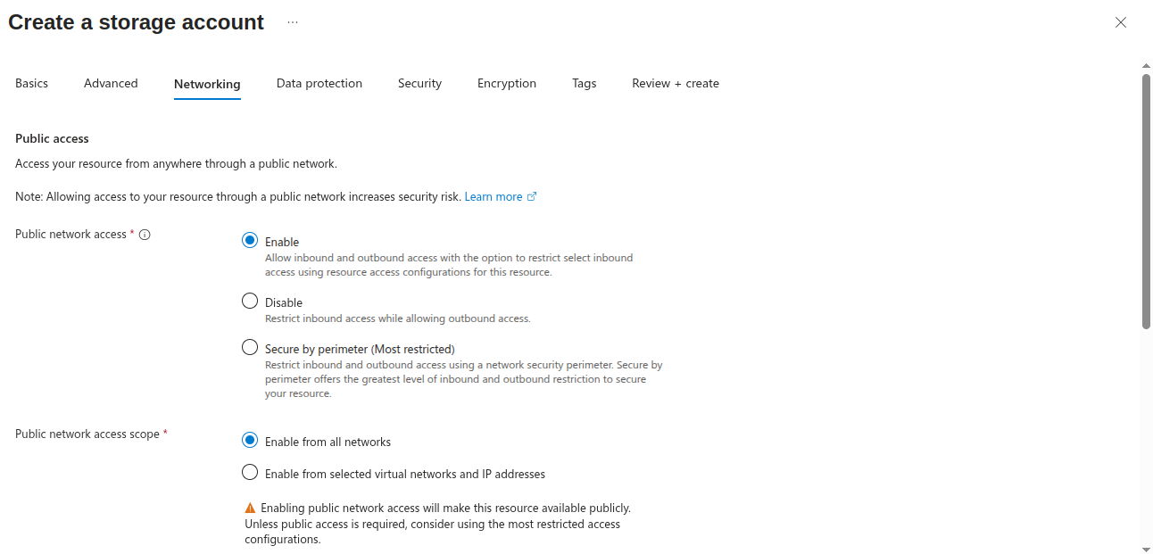
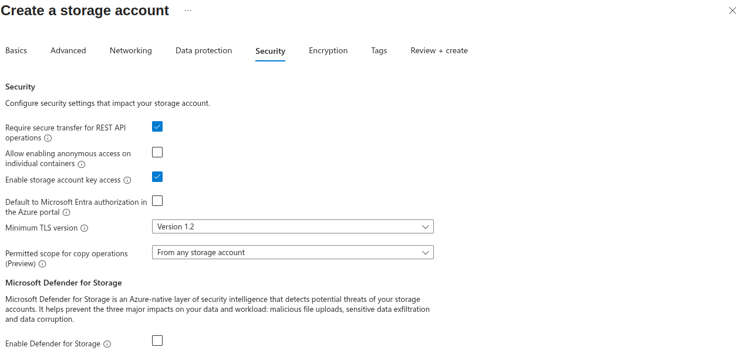

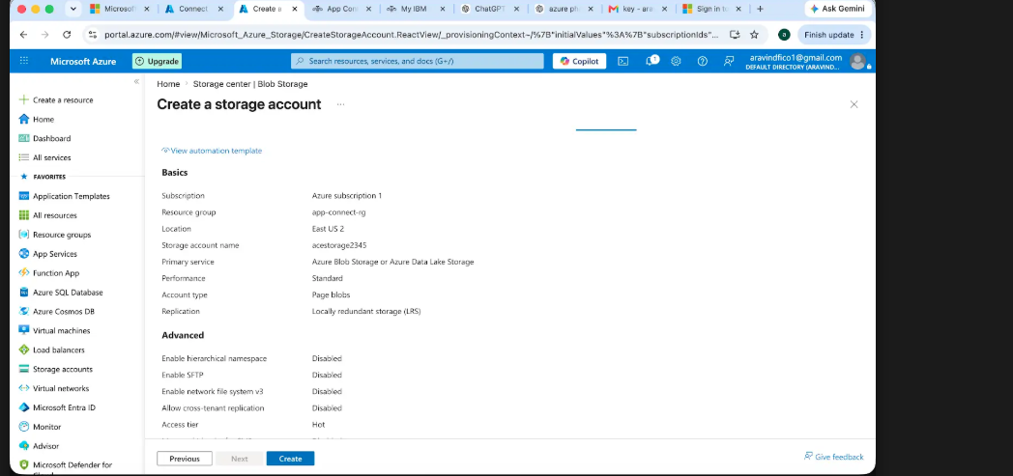
Go to storage account click on classic fileshares and create fileshare
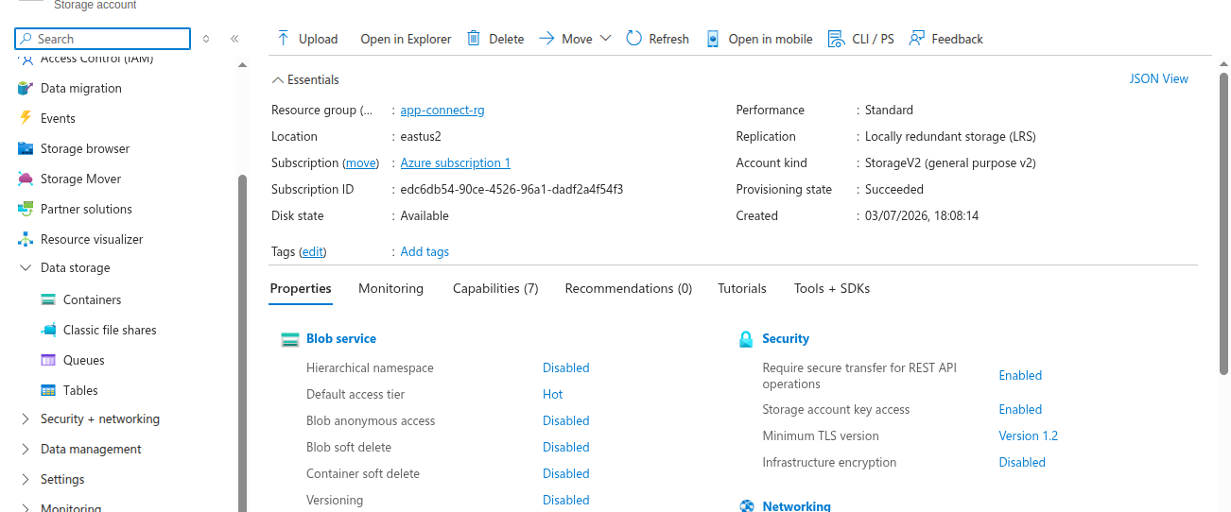

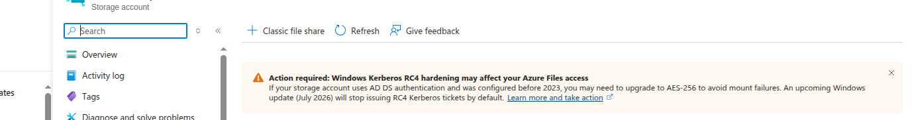
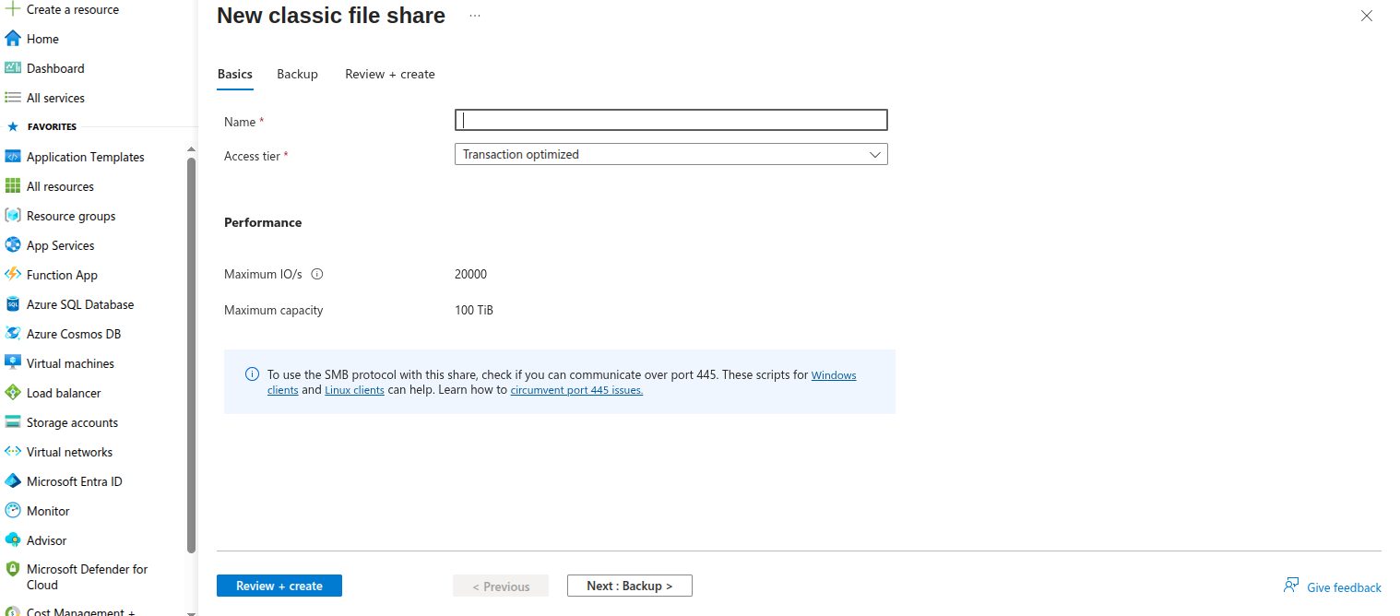
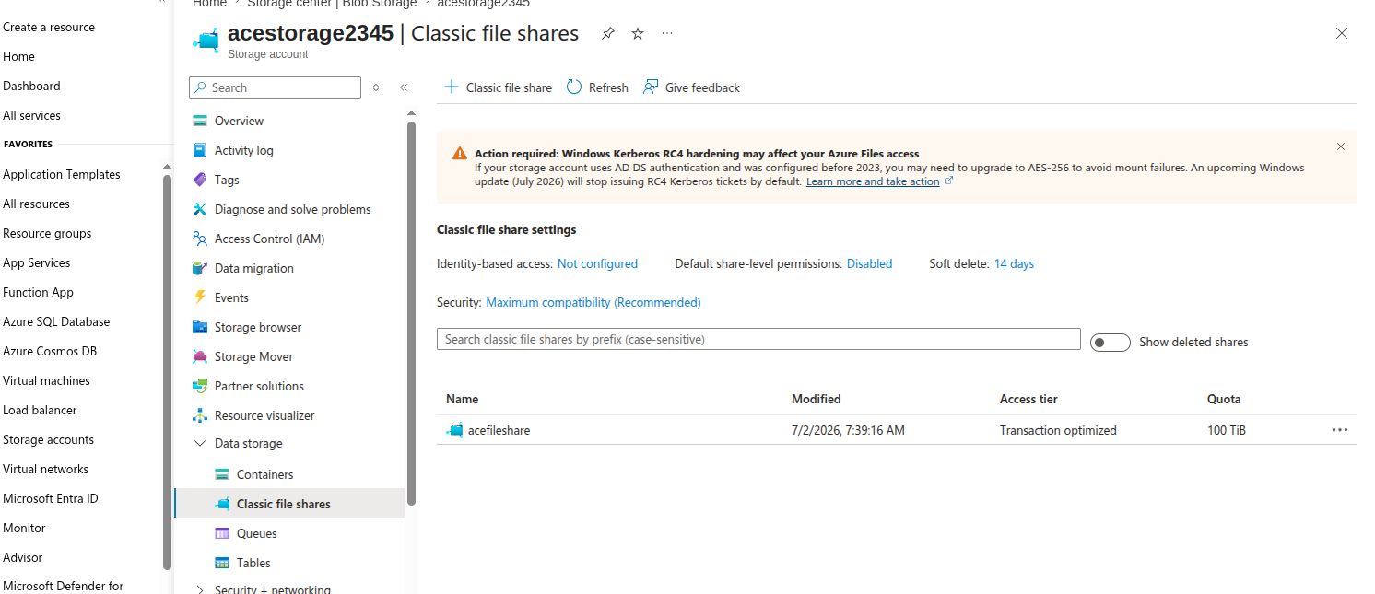
Next we need to create Azure file secret Without the Azure File secret, Kubernetes cannot authenticate to your Azure Storage Account, so it cannot mount the Azure File Share. The PV would fail to mount.
Here we need access so that storage account is connected externally by using access keys While generating secret

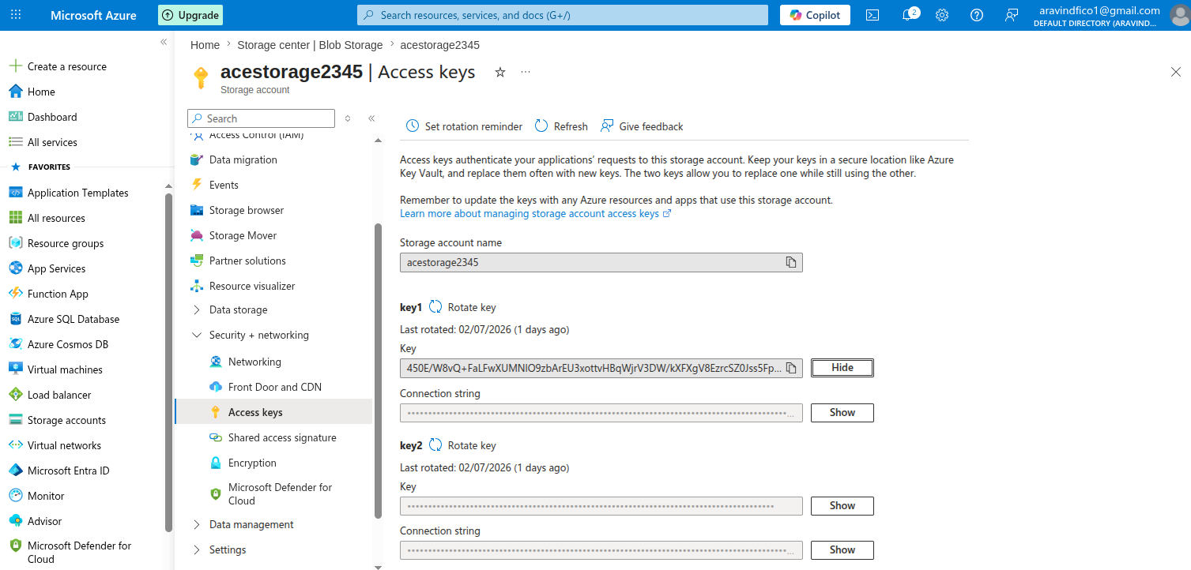

kubectl create secret generic azure-file-secret \
--from-literal=azurestorageaccountname=acestorage2345 \
--from-literal=azurestorageaccountkey="PASTE_THE_KEY_HERE" \
-n appconnecter

kubectl get secret -n appconnecter
kubectl describe secret azure-file-secret -n appconnecter
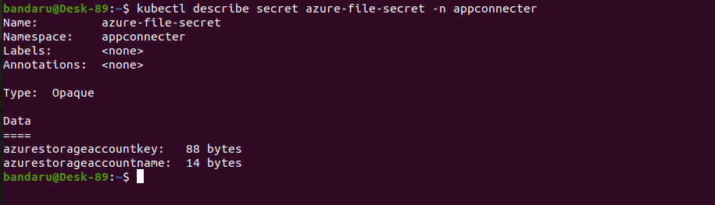
The secret which we are generated is used in persistent volume(pv).

The flow would be like this
Azure Storage Account (acestorage2345)
▼
Access Key (Key1 or Key2)
▼
Kubernetes Secret
(azure-file-secret)
▼
Persistent Volume (PV)
▼
Persistent Volume Claim (PVC)
▼
App Connect Dashboard Pod

nano ace-dashboard-pv.yaml
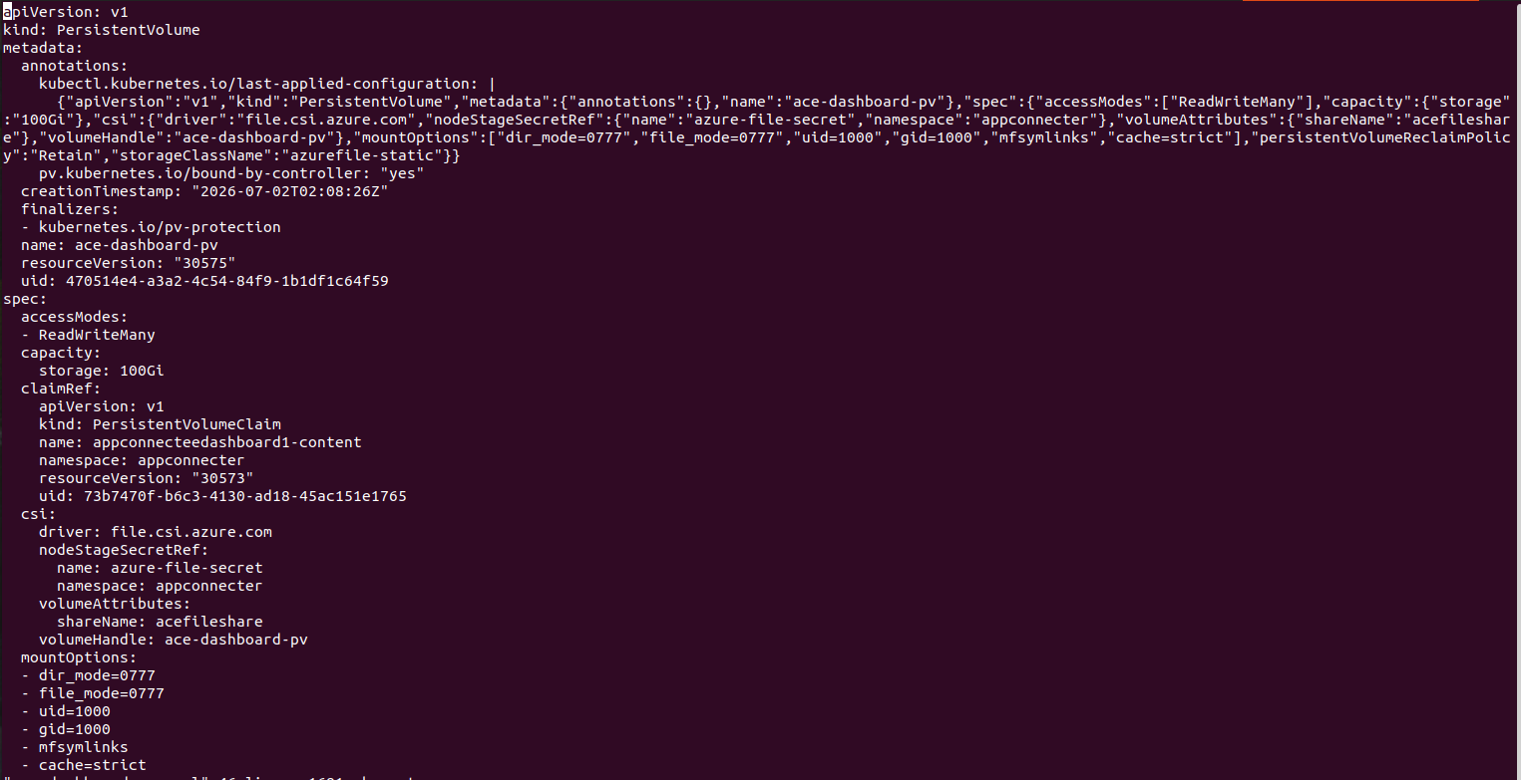

apiVersion: v1
kind: PersistentVolume
metadata:
annotations:
kubectl.kubernetes.io/last-applied-configuration: |
{"apiVersion":"v1",
"kind":"PersistentVolume",
"Metadata":{"annotations":{},"name":"ace-dashboard-pv"},
"spec":{"accessModes":["ReadWriteMany"],
"capacity":{"storage":"100Gi"},
"csi":{"driver":"file.csi.azure.com",
"nodeStageSecretRef":{"name":"azure-file-secret","namespace":"appconnecter"},
"volumeAttributes":{"shareName":"acefileshare"},
"volumeHandle":"ace-dashboard-pv"},
"mountOptions":["dir_mode=0777","file_mode=0777","uid=1000","gid=1000","mfsymlinks","cache=strict"],
"persistentVolumeReclaimPolicy":"Retain","storageClassName":"azurefile-static"}}
pv.kubernetes.io/bound-by-controller: "yes"
creationTimestamp: "2026-07-02T02:08:26Z"
finalizers:
- kubernetes.io/pv-protection
name: ace-dashboard-pv
spec:
accessModes:
- ReadWriteMany
capacity:
storage: 100Gi
claimRef:
apiVersion: v1
kind: PersistentVolumeClaim
name: appconnecteedashboard1-content
namespace: appconnecter
csi:
driver: file.csi.azure.com
nodeStageSecretRef:
name: azure-file-secret
namespace: appconnecter
volumeAttributes:
shareName: acefileshare
volumeHandle: ace-dashboard-pv
mountOptions:
- dir_mode=0777
- file_mode=0777
- uid=1000
- gid=1000
- mfsymlinks
- cache=strict
"ace-dashboard-pv.yaml" 46 lines, 1681 characters

Kubectl apply -f ace-dashboard-pv.yaml

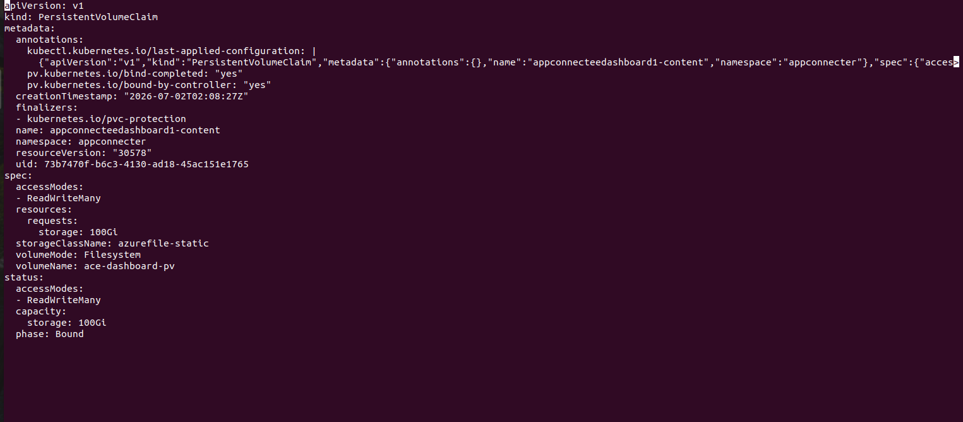
Kubectl apply -f dashboard-pvc.yaml

apiVersion: v1
kind: PersistentVolumeClaim
metadata:
annotations:
kubectl.kubernetes.io/last-applied-configuration: |
{"apiVersion":"v1",
"kind":"PersistentVolumeClaim",
"Metadata":{"annotations":{},"name":"appconnecteedashboard1-content",
"namespace":"appconnecter"},
"spec":{"acces>
pv.kubernetes.io/bind-completed: "yes"
pv.kubernetes.io/bound-by-controller: "yes"
creationTimestamp: "2026-07-02T02:08:27Z"
finalizers:
- kubernetes.io/pvc-protection
name: appconnecteedashboard1-content
namespace: appconnecter
spec:
accessModes:
- ReadWriteMany
resources:
requests:
storage: 100Gi
storageClassName: azurefile-static
volumeMode: Filesystem
volumeName: ace-dashboard-pv
status:
accessModes:
- ReadWriteMany
capacity:
storage: 100Gi
phase: Bound

Creating the App Connect Dashboard

Vi my-azurefile-csi-premium.yaml
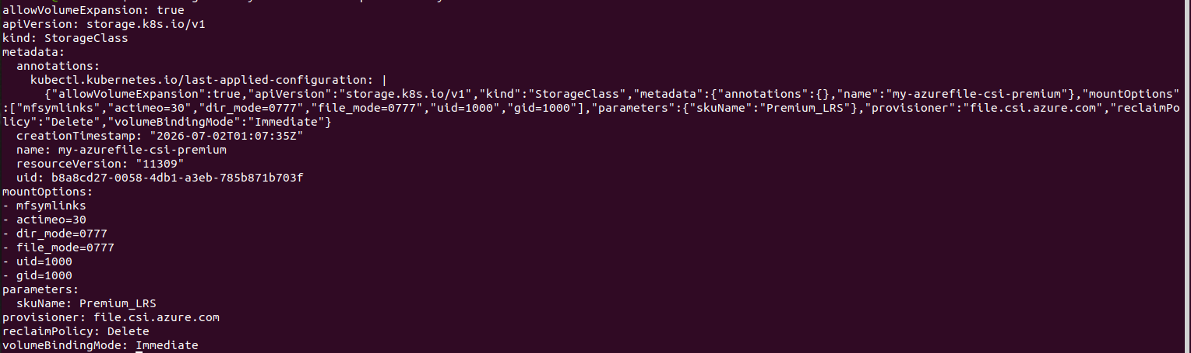

allowVolumeExpansion: true
apiVersion: storage.k8s.io/v1
kind: StorageClass
metadata:
annotations:
kubectl.kubernetes.io/last-applied-configuration: |
{"allowVolumeExpansion":true,
"apiVersion":"storage.k8s.io/v1",
"kind":"StorageClass",
"Metadata":{"annotations":{},"name":"my-azurefile-csi-premium"},
"mountOptions":["mfsymlinks","actimeo=30","dir_mode=0777",
"file_mode=0777","uid=1000","gid=1000"],
"parameters":{"skuName":"Premium_LRS"},
"provisioner":"file.csi.azure.com",
"reclaimPolicy":"Delete",
"volumeBindingMode":"Immediate"}
mountOptions:
- mfsymlinks
- actimeo=30
- dir_mode=0777
- file_mode=0777
- uid=1000
- gid=1000
parameters:
skuName: Premium_LRS
provisioner: file.csi.azure.com
reclaimPolicy: Delete
volumeBindingMode: Immediate

kubectl apply -f my-azurefile-csi-premium.yaml -n appconnecter

Create the appconnected dashboard using following command

vi appconnecteedashboard1.yaml

apiVersion: appconnect.ibm.com/v1beta1
kind: Dashboard
metadata:
name: appconnecteedashboard1
namespace: appconnecter
spec:
license:
accept: true
license: L-RJGW-BUAA2R
use: AppConnectEnterpriseNonProductionFREE
authentication:
integrationKeycloak:
enabled: false
authorization:
integrationKeycloak:
enabled: false
ingress:
domain: 57.165.29.23.nip.io
api:
enabled: true
storage:
claimName: appconnecteedashboard1-content
type: persistent-claim
displayMode: IntegrationRuntimes
replicas: 1
version: 13.0.8.0-r1

kubectl get dashboard -n appconnecter

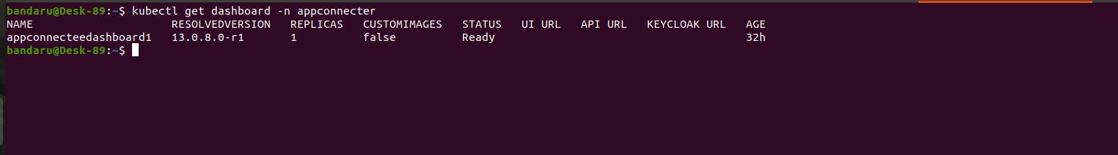
kubectl get pods -n appconnecter

kubectl get svc -n appconnecter

Create the ingress resource for the dashboard
Copy the following text to create the appconnecteedashboard1-ui.yaml file.

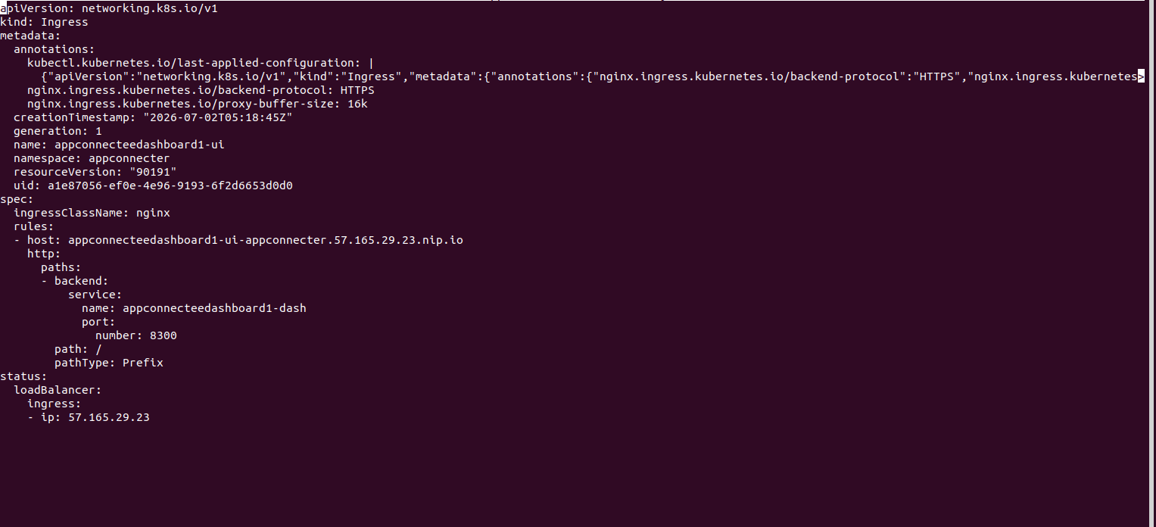

apiVersion: networking.k8s.io/v1
kind: Ingress

metadata:
name: appconnecteedashboard1-ui
namespace: appconnecter
annotations:
nginx.ingress.kubernetes.io/backend-protocol: HTTPS
nginx.ingress.kubernetes.io/proxy-buffer-size: 16k

spec:
ingressClassName: nginx
rules:
- host: appconnecteedashboard1-ui-appconnecter.57.165.29.23.nip.io
http:
paths:
- path: /
pathType: Prefix
backend:
service:
name: appconnecteedashboard1-dash
port:
number: 8300

kubectl apply -f appconnecteedashboard1-ui.yaml

Access the dashboard
Open your web browser and go the following URL:

https://appconnecteedashboard1-ui-appconnecter.57.165.29.23.nip.io

You should see the App Connect EE dashboard UI.
