Cyclist Project Report

Abstract
This project analyzes Cyclistic's 2025 bike-share trip data to identify behavioral differences between annual members and casual riders using Python, MySQL, and Power BI. The insights generated from ride patterns, duration, and usage trends help support data-driven marketing strategies aimed at converting casual riders into annual members.

Introduction
Cyclistic operates a bike-sharing service that offers both annual memberships and casual ride options to its customers. This project analyzes 12 months of trip data to understand the differences in riding behavior between annual members and casual riders, providing insights that can support targeted marketing strategies and increase membership conversions.

Problem Statement
Cyclistic aims to increase the number of annual memberships, as annual members are more profitable than casual riders. The challenge is to understand how annual members and casual riders use the bike-sharing service differently and identify behavioral patterns that can help develop effective marketing strategies to convert casual riders into annual members..

Objectives

- To analyze 12 months of Cyclistic bike-share trip data and understand customer riding behavior.

- To compare ride patterns between annual members and casual riders based on ride frequency and duration.

- To identify trends in bike usage across different days, months, and hours of the year.

- To uncover key behavioral differences that influence membership and casual ride usage.

- To provide data-driven insights and recommendations that can help Cyclistic convert casual riders into annual members.

- Build an interactive Power BI dashboard.

Dataset Description

The Cyclistic bike-share trip data for all 12 months of 2025 was downloaded and imported into Python using the Pandas and Glob libraries. The individual monthly datasets were combined into a single dataframe to create a consolidated dataset for analysis.

Tools & Technologies

- Python (Pandas, NumPy) – Data Cleaning

- SQL – Business Query Analysis

- Power BI – Dashboard Visualization

- Jupyter Notebook – Development Environment

Data Collection and Preparation

- Imported all 12 monthly Cyclistic trip datasets using the Pandas and Glob libraries.
- Used Glob to automatically locate and load multiple CSV files from a folder.
- Combined the monthly datasets into a single dataframe to create a unified dataset for analysis.
- This ensured that all trips from the entire year were available for comprehensive analysis.
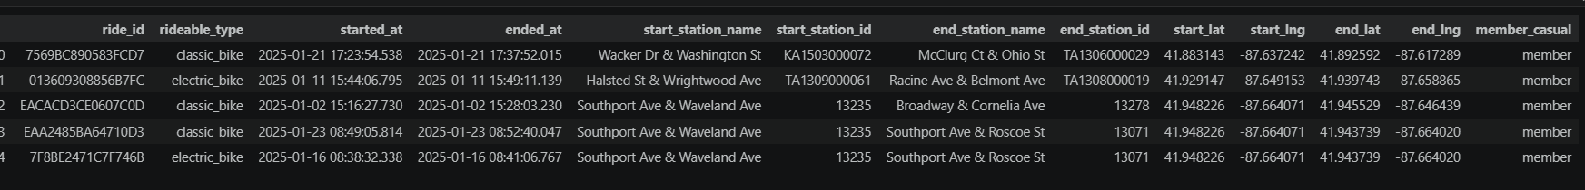
- Used merged_df.describe() to analyze statistical summaries such as mean, median, minimum, maximum, and standard deviation.
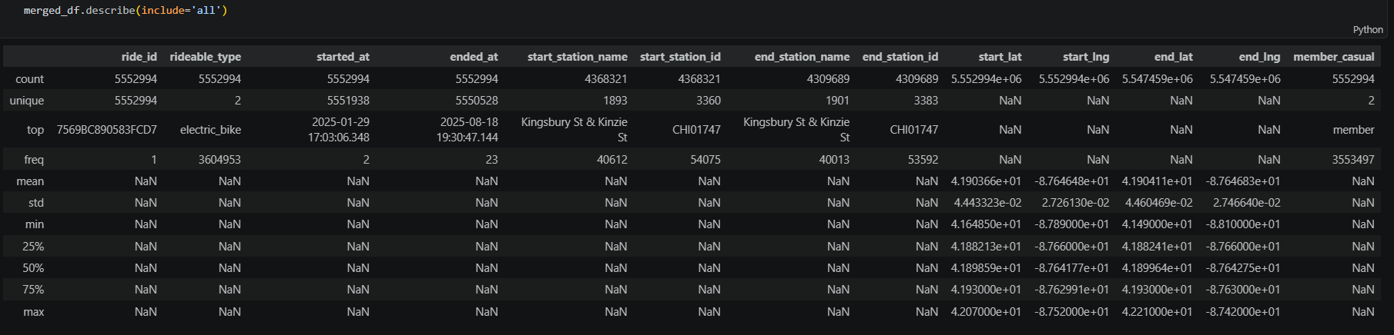

- Checked for missing/null values using df.isnull().sum() And
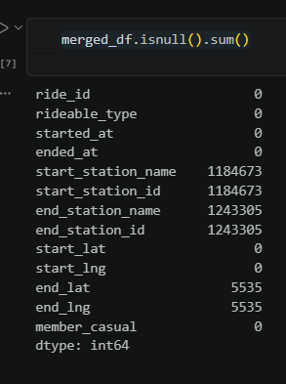
- Replaced missing values in station name and station ID columns with "Unknown".
- This approach preserved ride records while clearly identifying unavailable station information.
- Standardized column names by converting them to lowercase and replacing spaces with underscores for better consistency and easier querying.
- Prevented unnecessary data loss during the cleaning process.
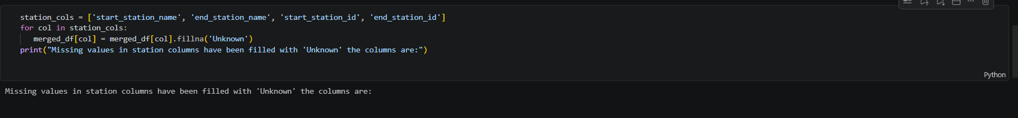
- Removed records containing missing ending latitude and longitude values.
- Geographic coordinates are important location attributes and cannot be accurately replaced.
- Removing incomplete records improved data reliability.

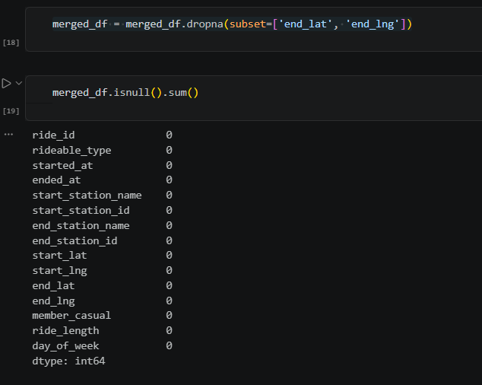

- Converted the started_at and ended_at columns into datetime format.
- Enabled accurate time-based calculations and feature extraction.
- Datetime conversion is required for calculating trip durations and temporal analysis.

- Created a new column called ride_length.
- Calculated ride duration by subtracting trip start time from trip end time.
- This metric serves as one of the most important variables in the analysis.
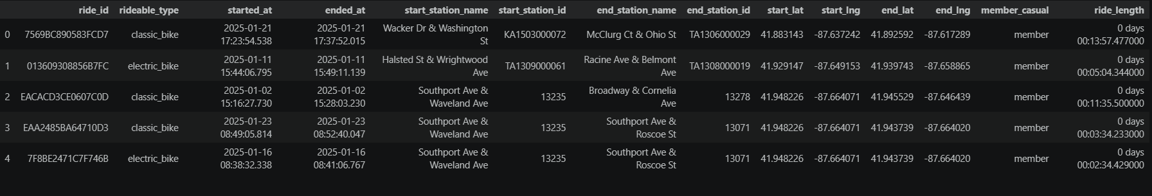
- Extracted the day of the week from the ride start timestamp.
- Enabled analysis of riding behavior across weekdays and weekends.
- Helped identify commuting and leisure usage patterns.
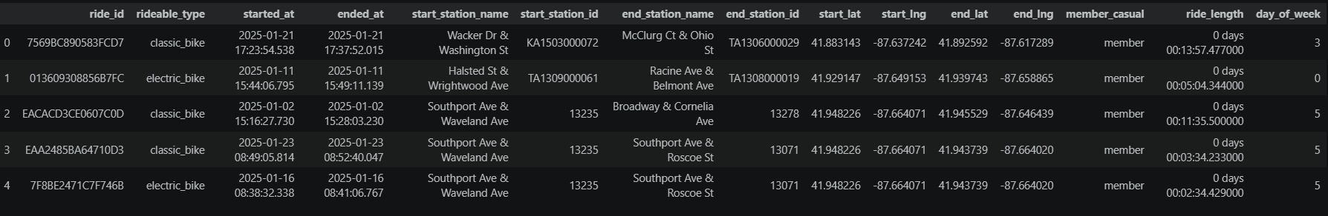
- Removed rides lasting less than one minute.
- Such records are likely caused by accidental unlocks, test rides, or system errors.
- Removing unrealistic trips improved analytical accuracy.
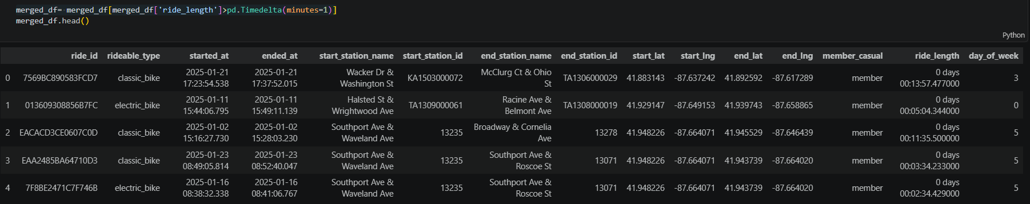

- Checked for duplicate rides using the unique ride_id field.
- Removed duplicate entries to prevent double-counting trips.
- Ensured each ride was represented only once in the dataset.
- Converted ride duration into seconds and minutes.
- These numerical measures simplify aggregation and statistical calculations.
- Ride duration metrics were later used for user behavior comparison.
- Extracted month and hour from ride start timestamps.
- Enabled monthly trend analysis and hourly usage pattern analysis.
- These features help identify seasonal and daily riding behavior.
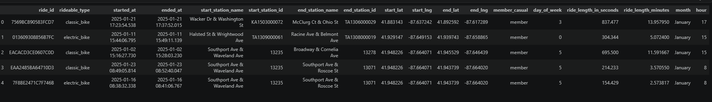

- Exported the cleaned dataset into a MySQL database using SQLAlchemy.
- Stored data in a structured format for efficient querying.
- Enabled SQL-based business analysis.

SQL Analysis
Business Questions
- Which user type uses bikes more?
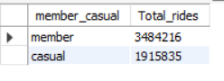
- Which user type rides longer?
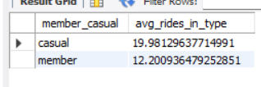

- What days do users ride most?
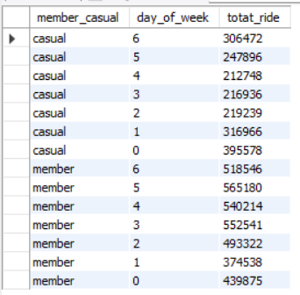
- What hours are busiest?
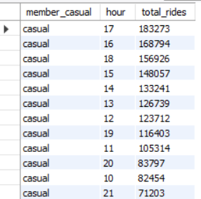
- Which months have highest usage?
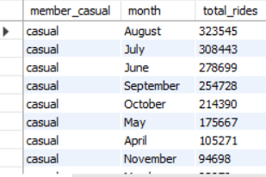
- Which bike types are preferred?
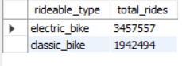
- Average ride duration by weekday
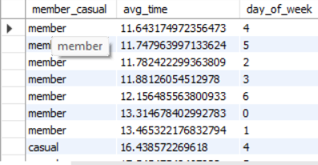

Dashboard Development

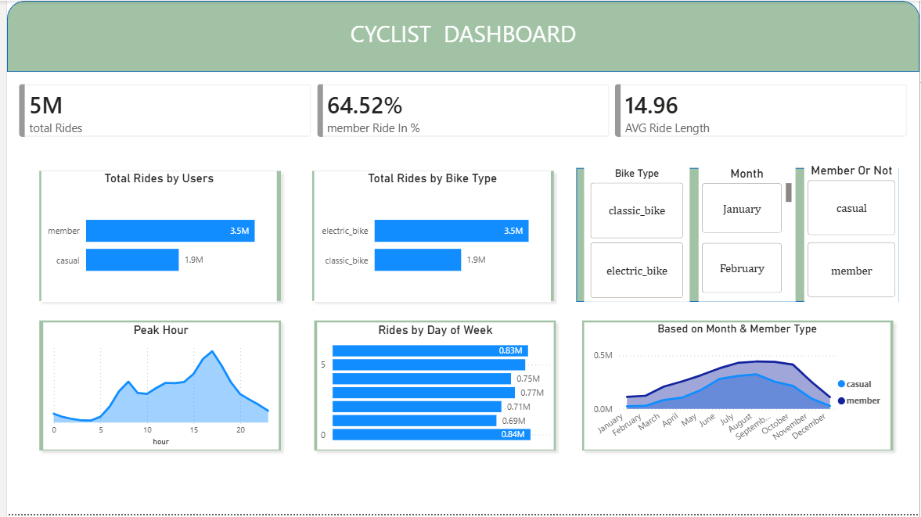

The Power BI dashboard includes:

- Dashboard Overview
- An interactive Power BI dashboard was developed to visualize key performance indicators and riding behavior patterns of Cyclistic users.
- The dashboard enables comparison between annual members and casual riders through various metrics and trend analyses.
- Key Performance Indicators (KPIs)
- Total rides recorded during the analysis period reached approximately 5 million trips.
- Annual members accounted for 64.52% of total rides, indicating higher engagement compared to casual riders.
- The average ride duration was approximately 14.96 minutes.
- User Type Analysis
- Annual members generated significantly more rides than casual riders.
- This suggests that members use the bike-sharing service more frequently, likely for regular commuting and daily transportation needs.
- Bike Type Analysis
- Electric bikes were the most frequently used bike type among riders.
- The popularity of electric bikes indicates a preference for convenience and reduced riding effort.
Peak Hour Analysis
- Ride activity increased during daytime hours and peaked during the late afternoon and evening period.
- This pattern suggests that many users utilize the service for commuting and daily travel purposes.
- Day of Week Analysis
- Ride activity varied across the week, with certain days experiencing higher usage than others.
- Understanding these patterns helps identify customer behavior during weekdays and weekends.
- Monthly Trend Analysis
- Both annual members and casual riders showed increased activity during warmer months.
- Ride volume peaked during the summer season and declined toward the winter months.
- Annual members consistently recorded higher ride counts throughout the year compared to casual riders.
- Dashboard Filters
- Interactive filters were implemented for bike type, month, and rider category.
- These filters allow users to explore specific segments and perform detailed analysis based on business requirements.
- Business Value
- The dashboard provides a clear understanding of customer usage patterns.
- The insights generated can support marketing decisions aimed at increasing annual memberships and improving customer engagement.

Key Findings

- Annual members contribute the majority of rides
- Electric bikes are the most preferred bike type.
- Ride activity peaks during afternoon and evening hours.
- Usage increases significantly during summer months.
- Members consistently use the service more frequently than casual riders.

Recommendations

- Offer targeted membership discounts to frequent casual riders to increase annual subscriptions.
- Launch seasonal marketing campaigns during high-demand summer months.
- Promote membership benefits through personalized email and app notifications.
- Increase customer engagement using social media and digital marketing channels.
- Focus promotional efforts during peak riding hours and high-usage periods.

Conclusion

The Cyclistic bike-share analysis successfully identified key differences between annual members and casual riders by examining ride frequency, duration, bike preferences, and usage patterns across different times of the year. The findings indicate that annual members use the service more consistently, while casual riders show stronger seasonal and recreational usage patterns. These insights can help Cyclistic develop targeted marketing strategies to convert casual riders into annual members and support long-term business growth.

