**ARAVINDH.M**

**ASSIGNMENT-9**

**TOPIC: RECOMMENDATION SYSTEM**

**QUESTION:**

**Recommend a best book based on the ratings.**

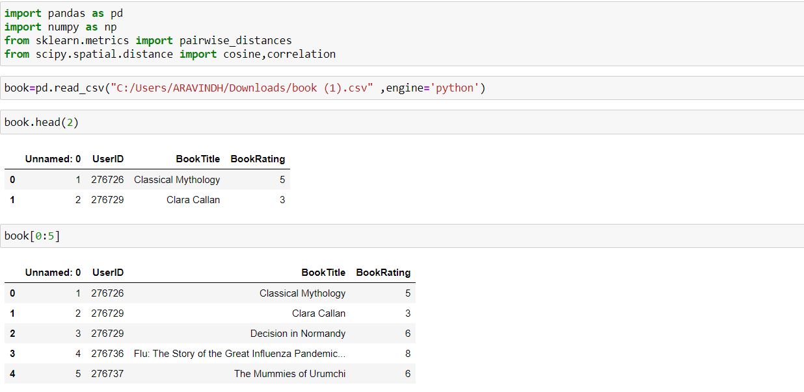

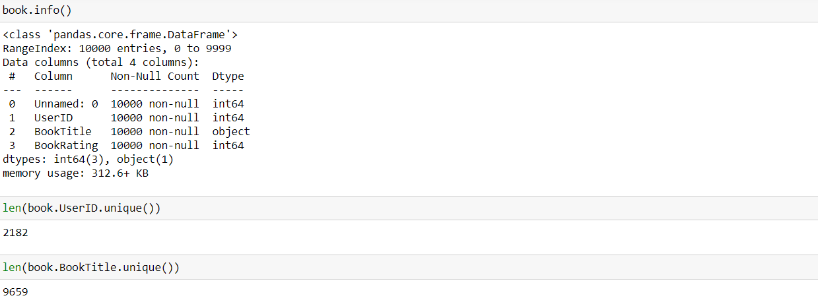

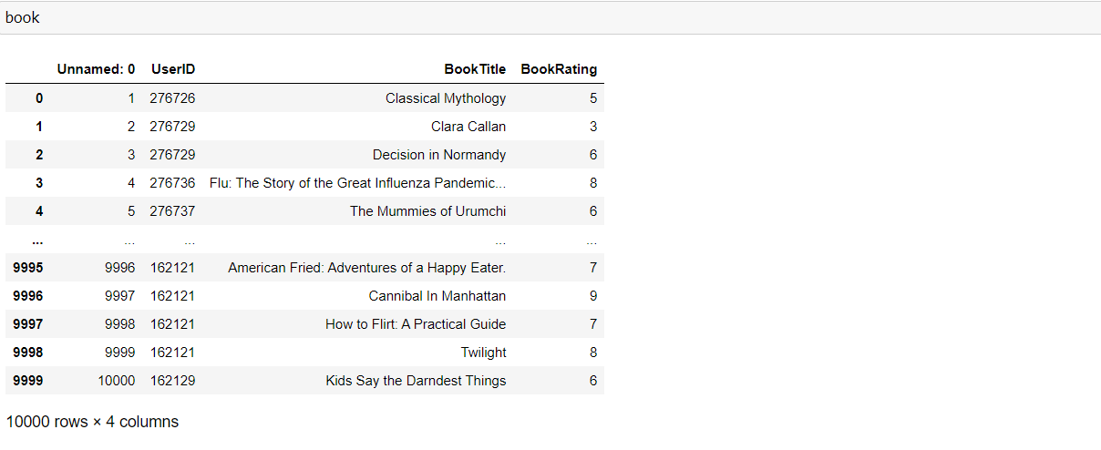

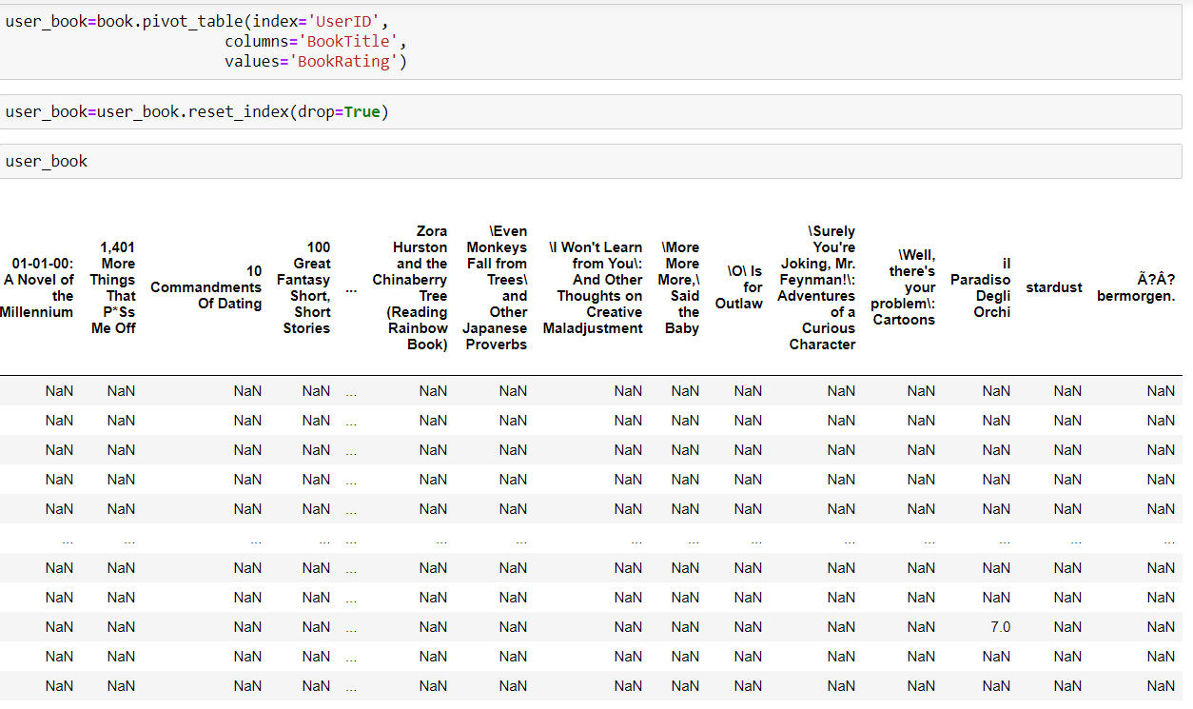

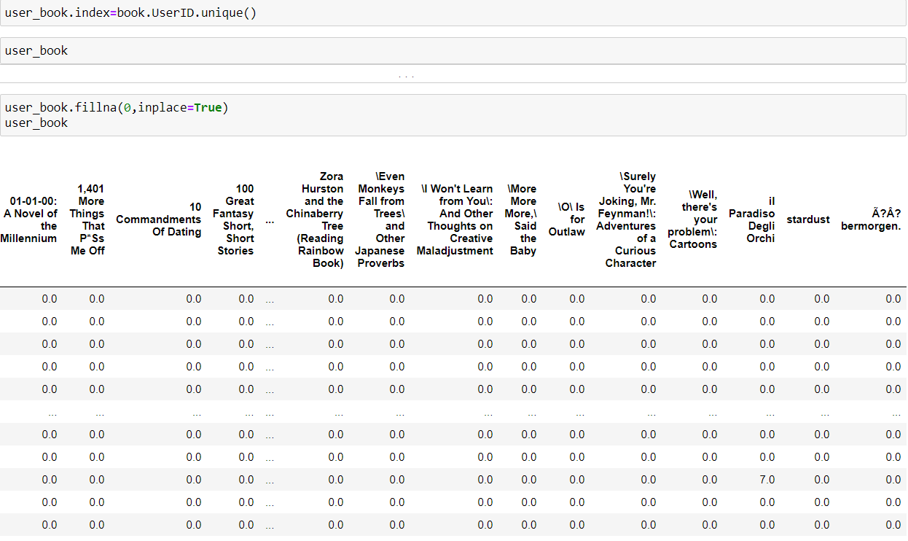

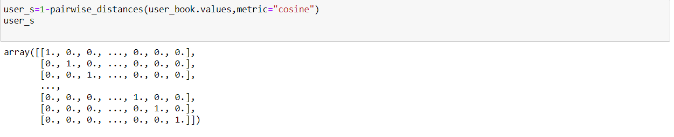

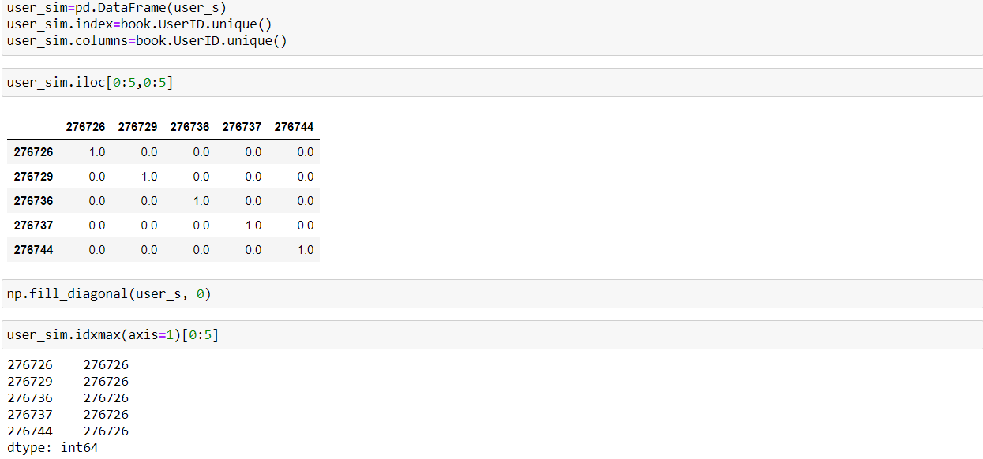

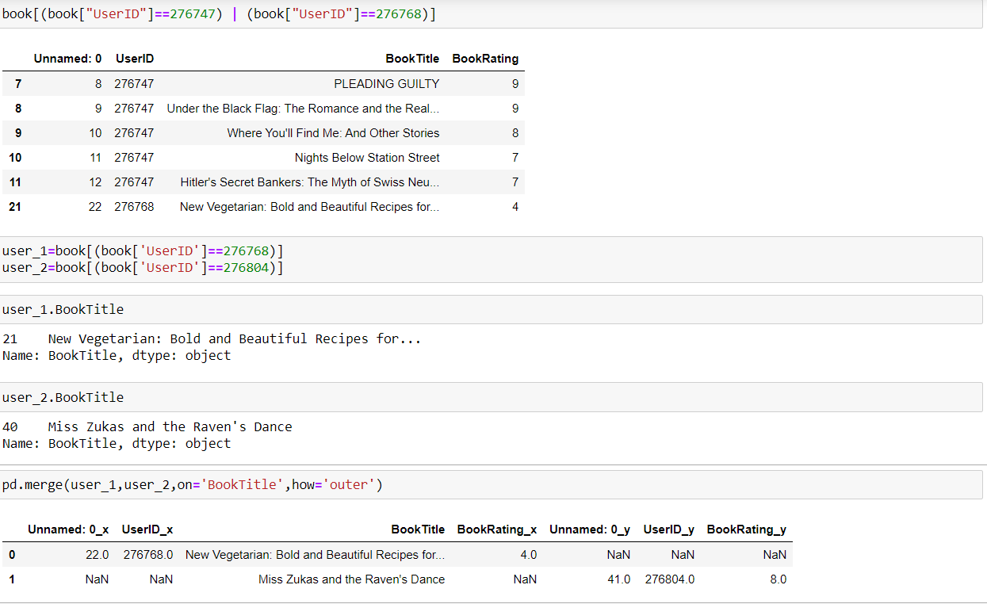

Here user id=276768 and user id=276804 have simlilarity.so we Recommend books based on these similarity.