**ARAVINDH.M**

**ASSIGNMENT-13**

**TOPIC: K NEAREST NEIGHBOURS(KNN)**

**QUESTIONS:**

**Prepare a model for glass classification using KNN**

**DATASET: glass**

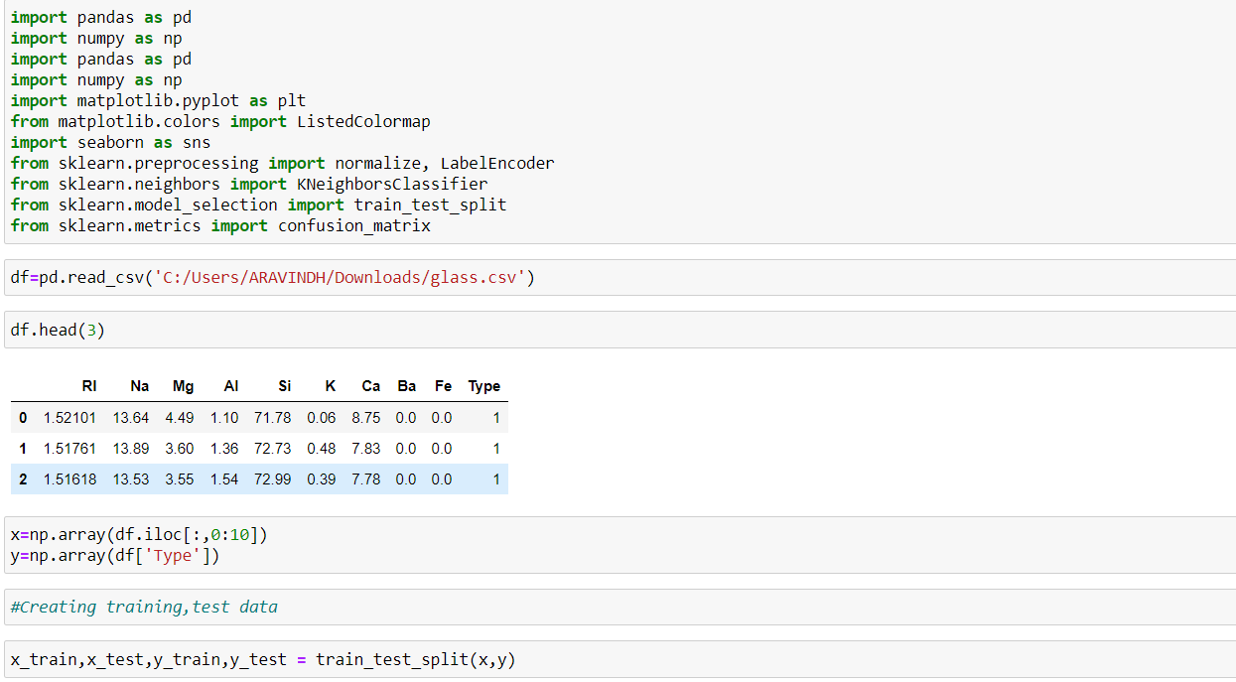

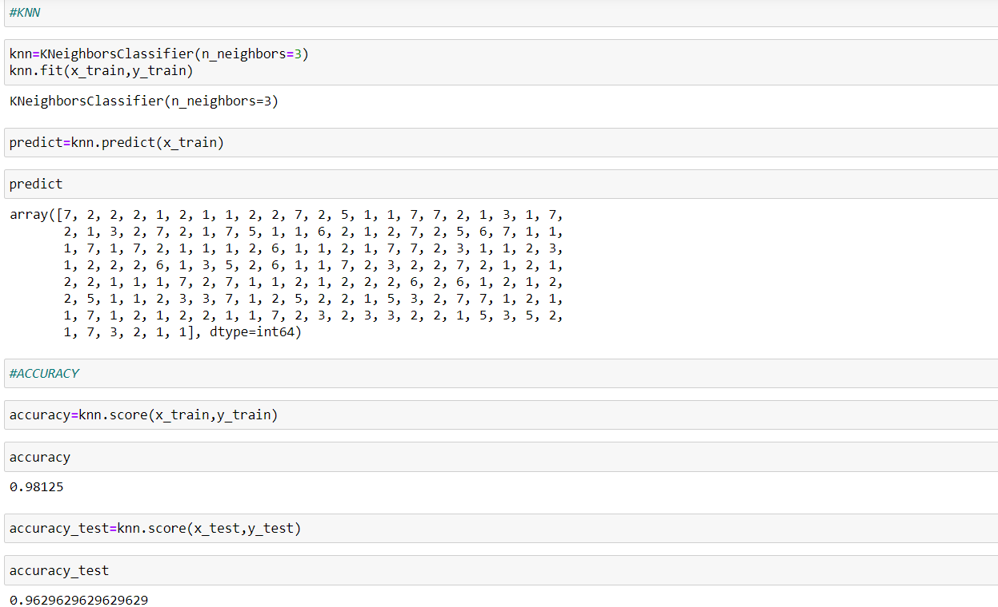

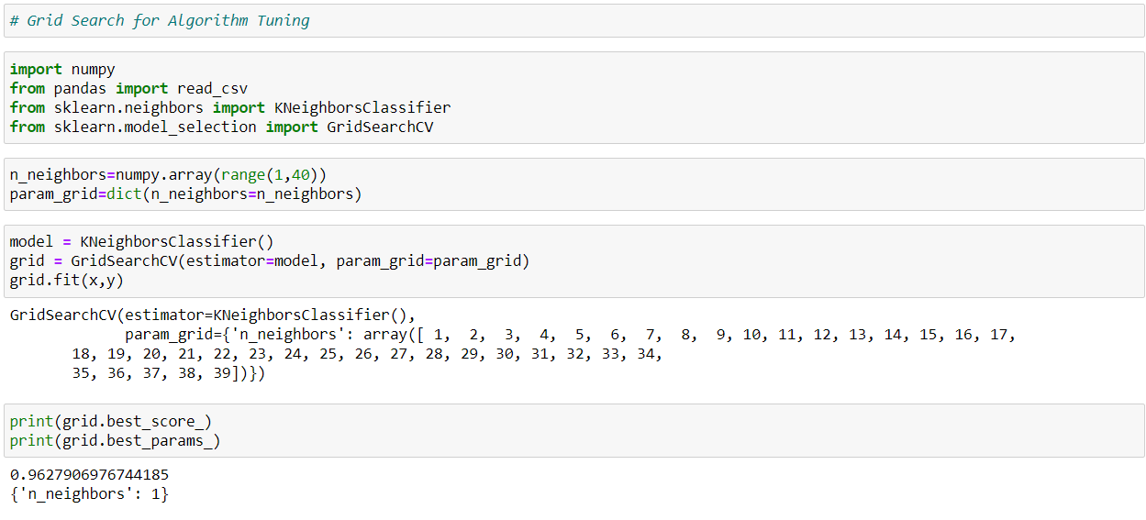

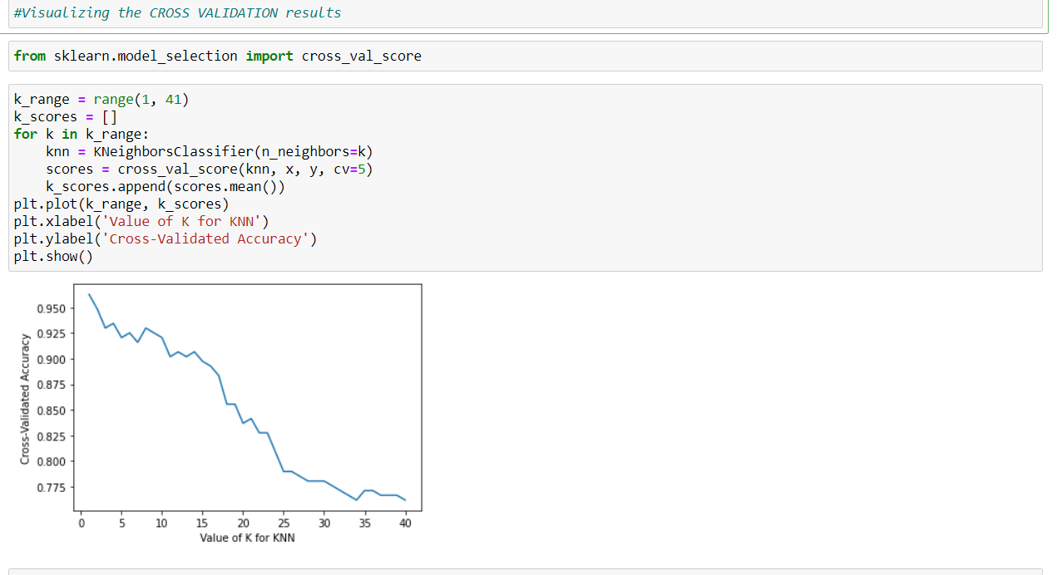

**Question:**

**Implement a KNN model to classify the animals in to categories**

**DATASET: zoo**

