**ARAVINDH.M**

**ASSIGNMENT-14**

**TOPIC: DECISION TREE**

**QUESTIONS:**

**DATA SET – Iris**

**Perform the following activity in R: → Build a decision tree for the ‘iris’ data with function ‘ctree()’ in package “party”.**

**CTREE:**

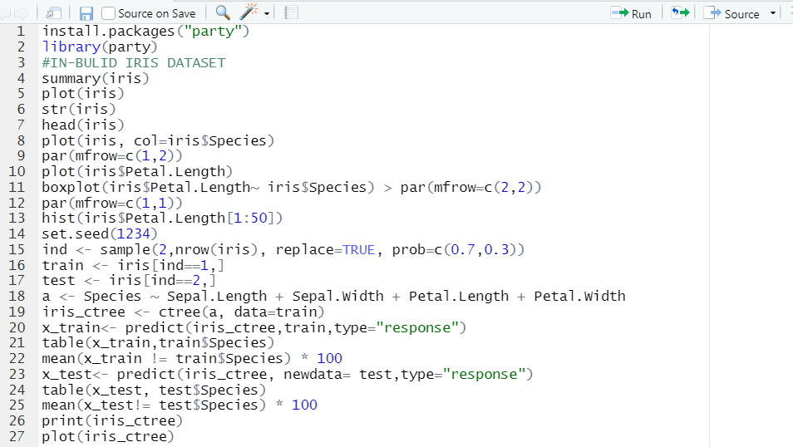

**RPART:**

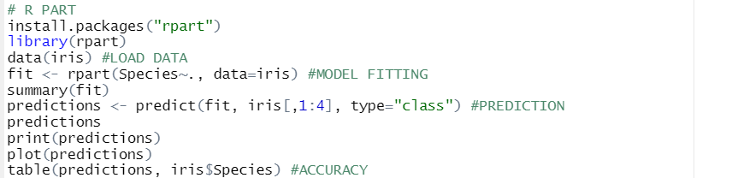

**C 5.0:**

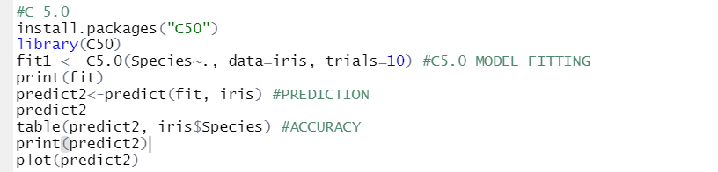

**OUTPUTS:**

**Summary of dataset:**

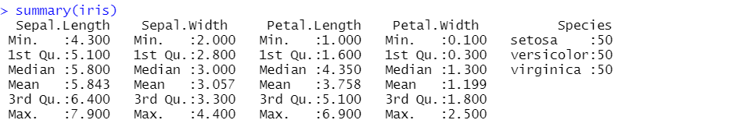

**Plot:**

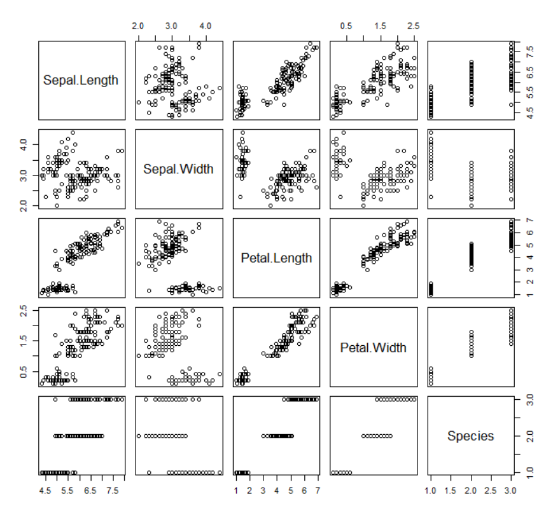

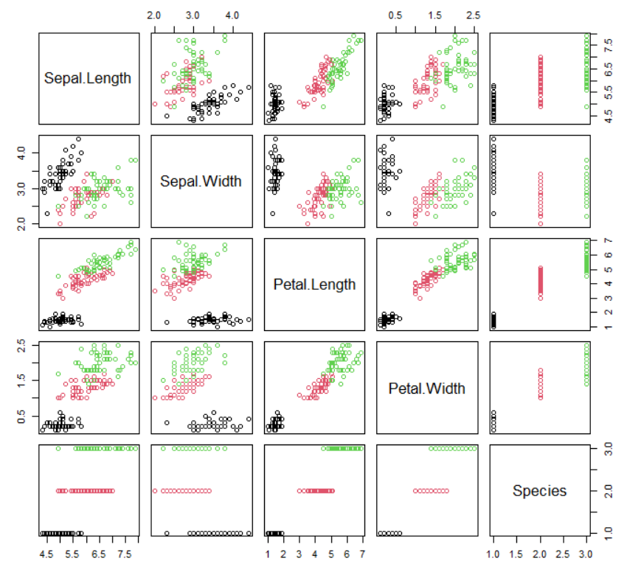

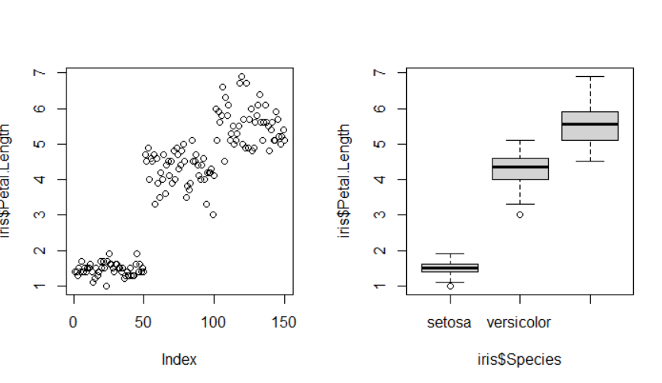

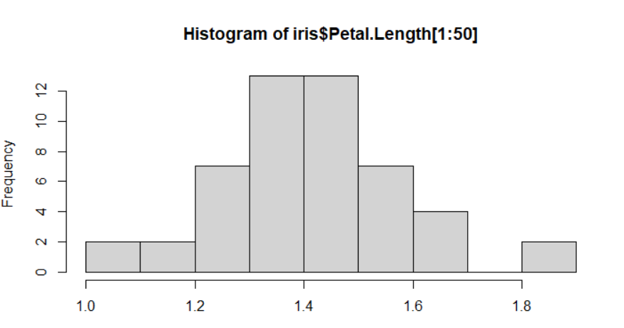

**Ctree:**

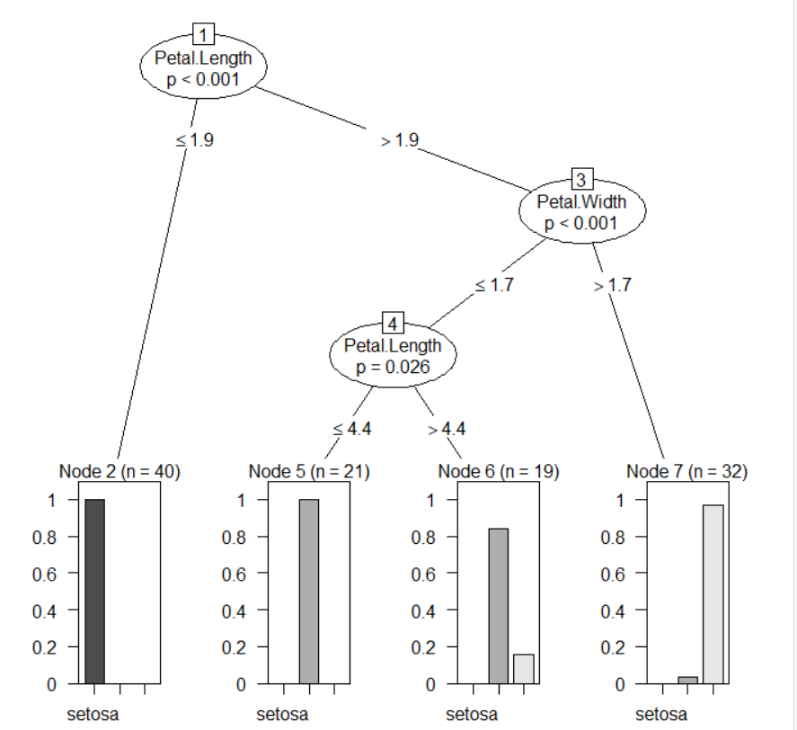

**Rpart:**

