ARAVINDH.M

ASSIGNMENT 3

HYPOTHESIS ASSIGNMENT

**1) A F&B manager wants to determine whether there is any significant difference in the diameter of the cutlet between two units. A randomly selected sample of cutlets was collected from both units and measured? Analyze the data and draw inferences at 5% significance level. Please state the assumptions and tests that you carried out to check validity of the assumptions.**

**DataSets : Cutlets.mtw**

Test: Two-sample t-test

NULL HYPOTHESIS:

There is no significant difference between two units

ALTERNATIVE HYPOTHESIS:

There is a significant difference between two units

In python:

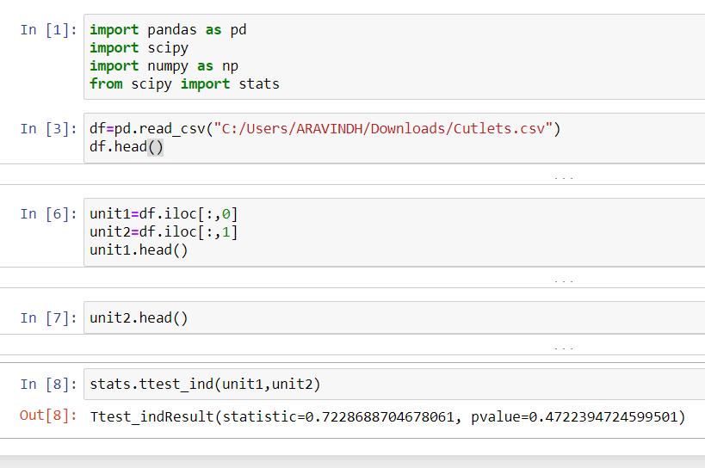

0.472=P value>0.05 so, accept Null hypothesis

Therefore, there is no significant difference between two units

**2)A hospital wants to determine whether there is any difference in the average Turn Around Time (TAT) of reports of the laboratories on their preferred list. They collected a random sample and recorded TAT for reports of 4 laboratories. TAT is defined as sample collected to report dispatch. Analyze the data and determine whether there is any difference in average TAT among the different laboratories at 5% significance level.**

Minitab File: **LabTAT.mtw**

Test:ANOVA test

NULL HYPOTHESIS:

There is no difference in average TAT among the different laboratories

ALTERNATIVE HYPOTHESIS:

There is a difference in average TAT among the different laboratories

In python:

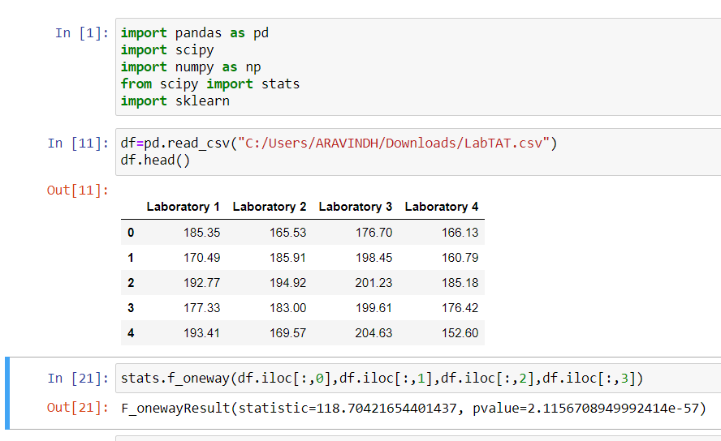

Here, p <0.05 which is 2.115*e-57. So Reject NULL Hypothesis.

Therefore, there is a difference in average TAT among the different laboratories

**3)Sales of products in four different regions is tabulated for males and females. Find if male-female buyer rations are similar across regions.**

**DATASETS:Buyerratio.csv**

TEST: 2 sample test

NULL HYPOTHESIS:

There is no significant difference between male and female buyer.

ALTERNATIVE HYPOTHESIS:

There is significant difference between male and female buyer.

In python:

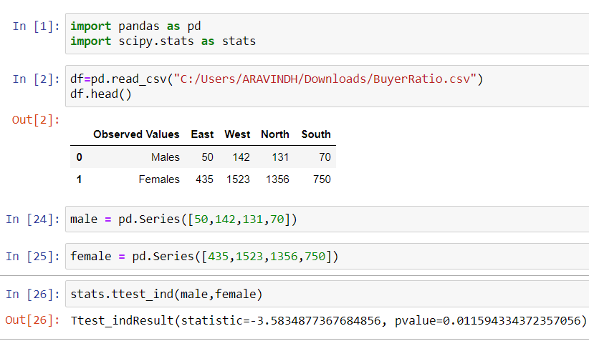

Here, P value which is 0.01159 is lesser than 0.05.So Reject null hypothesis.

Therefore,there is significant difference between male and female buyer.

**4)TeleCall uses 4 centers around the globe to process customer order forms. They audit a certain % of the customer order forms. Any error in order form renders it defective and has to be reworked before processing. The manager wants to check whether the defective % varies by centre. Please analyze the data at *5%* significance level and help the manager draw appropriate inferences**

**DATASETS: CustomerOrderForm.mtw**

TEST: chi-square test

NULL HYPOTHESIS:

There is a significant difference on Defective percentages.

ALTERNATIVE HYPOTHESIS:

There is no significant difference on Defective percentages.

IN R STUDIO:

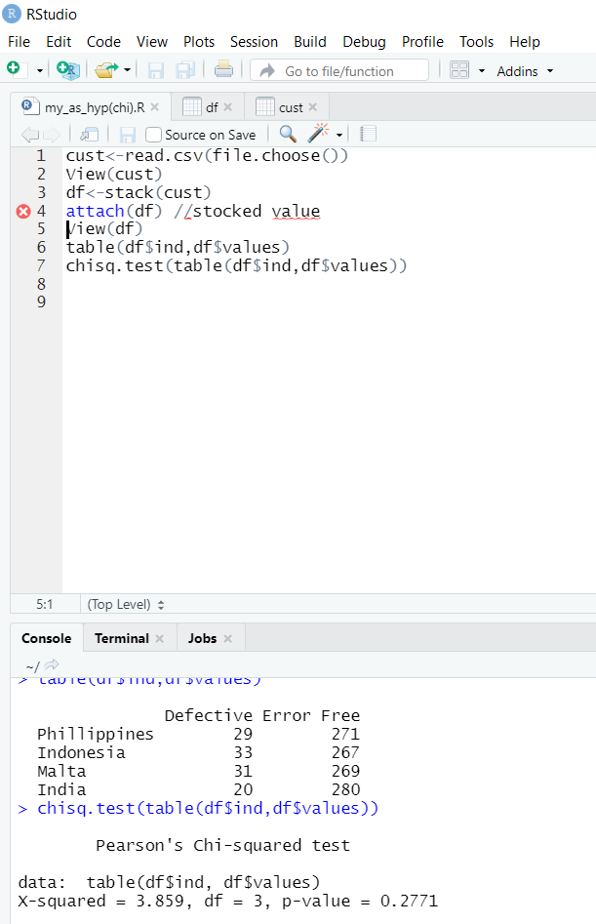

Here, p >0.05 which is 0.2771. So Accept NULL Hypothesis.

Therefore, there is a significant difference on defective percentages.

**5) Fantaloons Sales managers commented that *%* of males versus females walking in to the store differ based on day of the week. Analyze the data and determine whether there is evidence at *5 %* significance level to support this hypothesis.**

Minitab File: **Fantaloons.mtw**

Test: Proportion test

NULL HYPOTHESIS:

There is no significant difference between percentage of male and female.

ALTERNATIVE HYPOTHESIS:

There is significant difference between percentage of male and female.

IN R STUDIO:

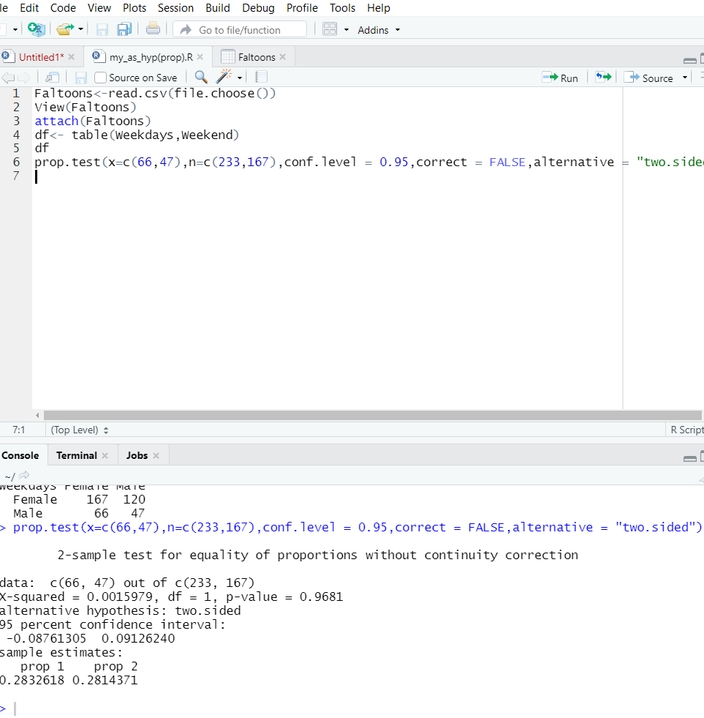

Here, p>0.05 which is 0.9681.So accept null hypothesis.

Therefore, there is no significant difference between percentage of male and female.