**3)Sales of products in four different regions is tabulated for males and females. Find if male-female buyer rations are similar across regions.**

**DATASETS:Buyerratio.csv**

TEST: CHI-square test

NULL HYPOTHESIS:

There is no significant difference between male and female buyer across region.

ALTERNATIVE HYPOTHESIS:

There is significant difference between male and female buyer across region.

In R STUDIO:

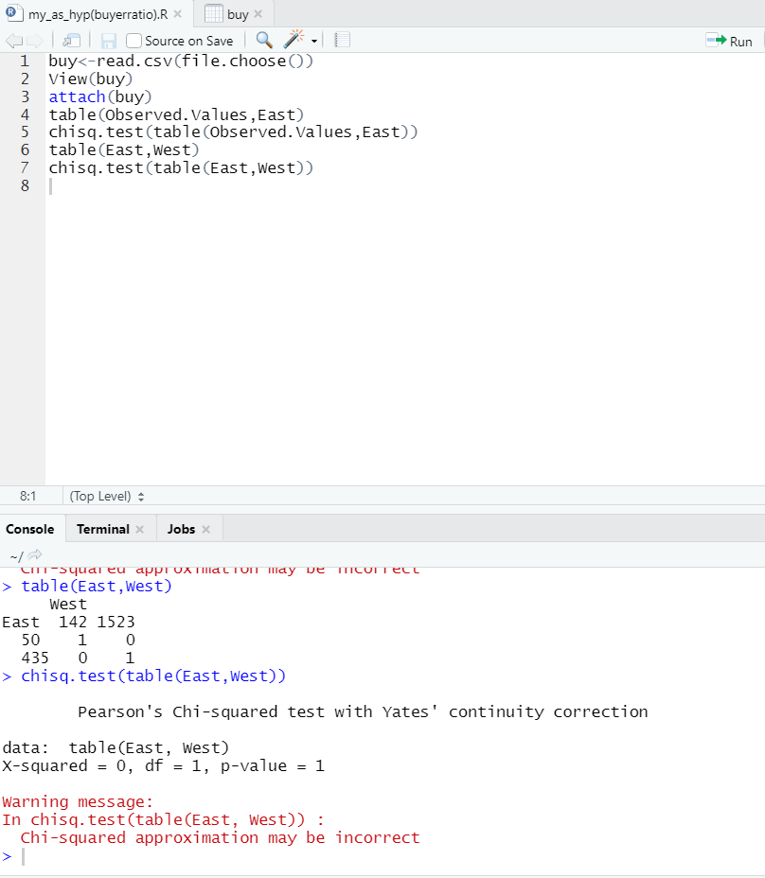

Here, P value which is 1 is greater than 0.05.So accept null hypothesis.

Therefore,there is no significant difference between male and female buyer across region.