**ARAVINDH.M**

**ASSIGNMENT 7**

**TOPIC: HIERARICAL CLUSTERING AND K-MEANS CLUSTERING**

**QUESTION:**

**Perform clustering (Both hierarchical and K means clustering) for the airlines data to obtain optimum number of clusters. Draw the inferences from the clusters obtained.**

**HIERARICAL CLUSTERING:**

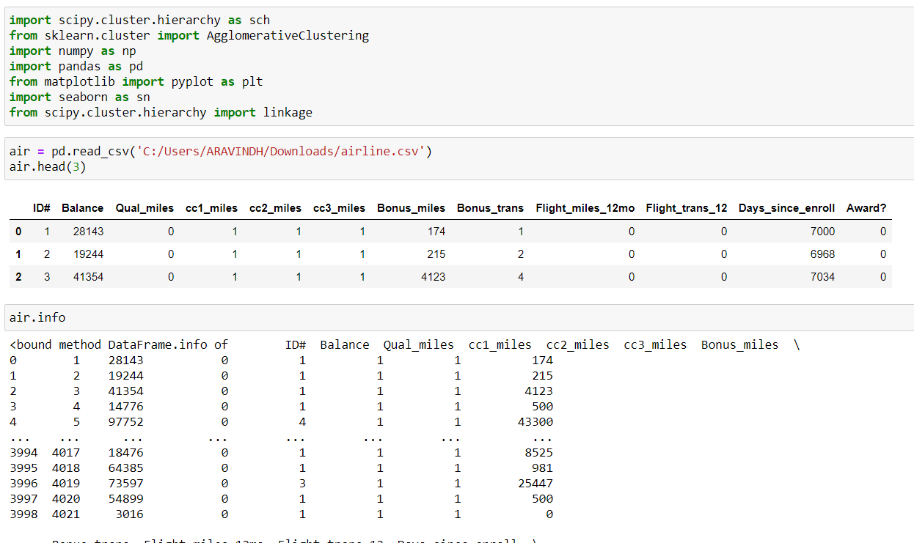

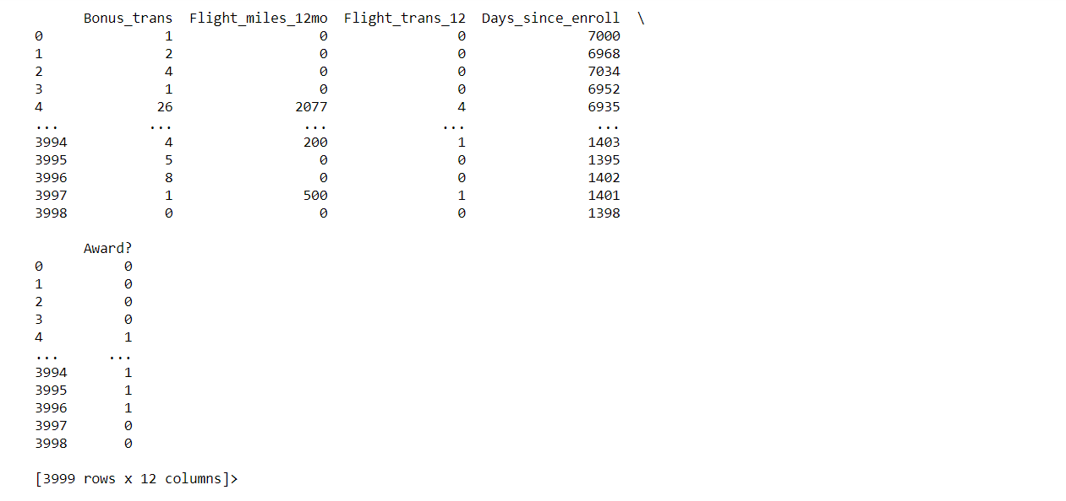

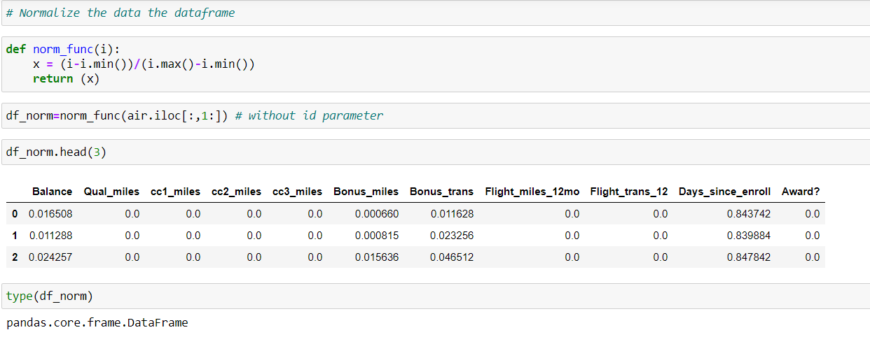

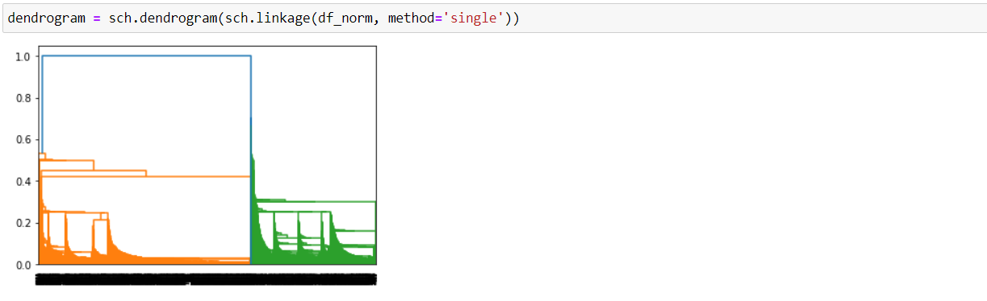

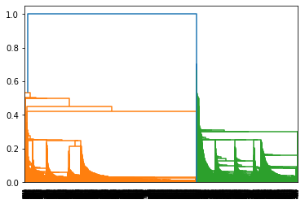

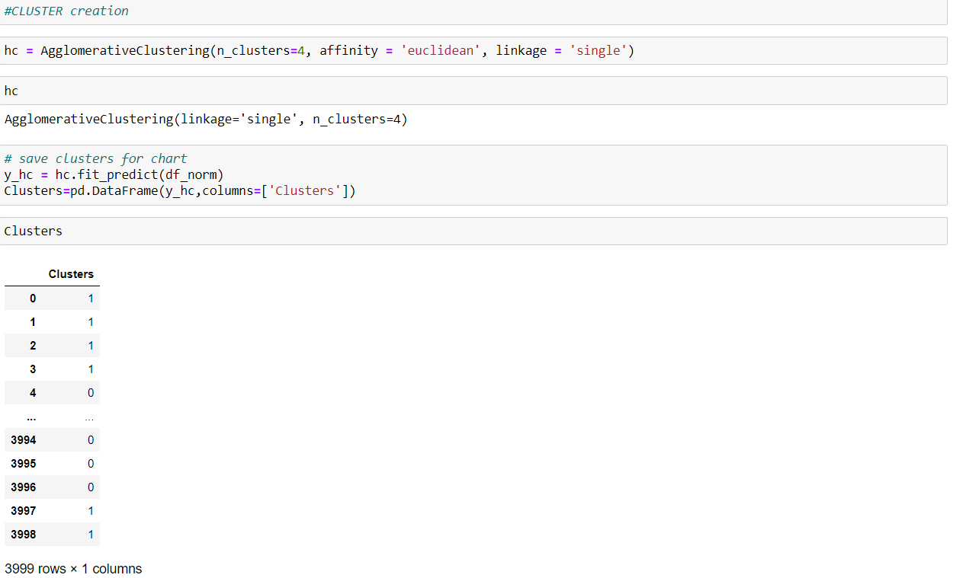

* Here we cannot make good inferences by using dendrogram graph because this dataset size is large.
* For larger data hierarchical clustering is not good method.so we use another clustering called k-means clustering.
* In this assignment we are going to use Rstudio for K-means for visualization.

**K-MEANS:**

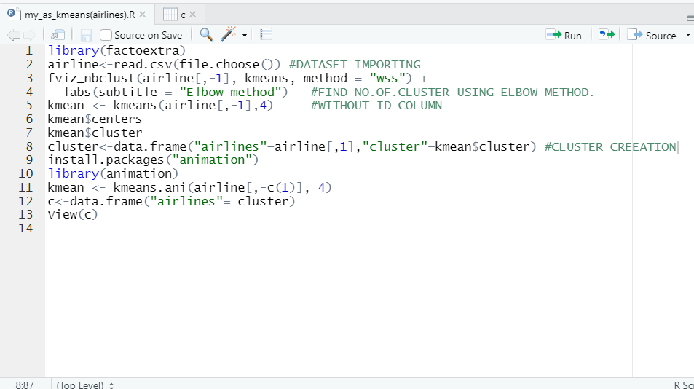

**FINDING NUMBER OF CLUSTER USING ELBOW METHOD:**

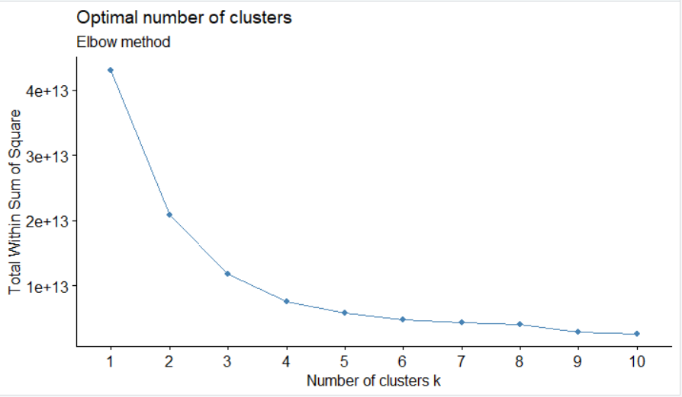

**According to above elbow curve number of cluster(k)=4**

**PLOT:**

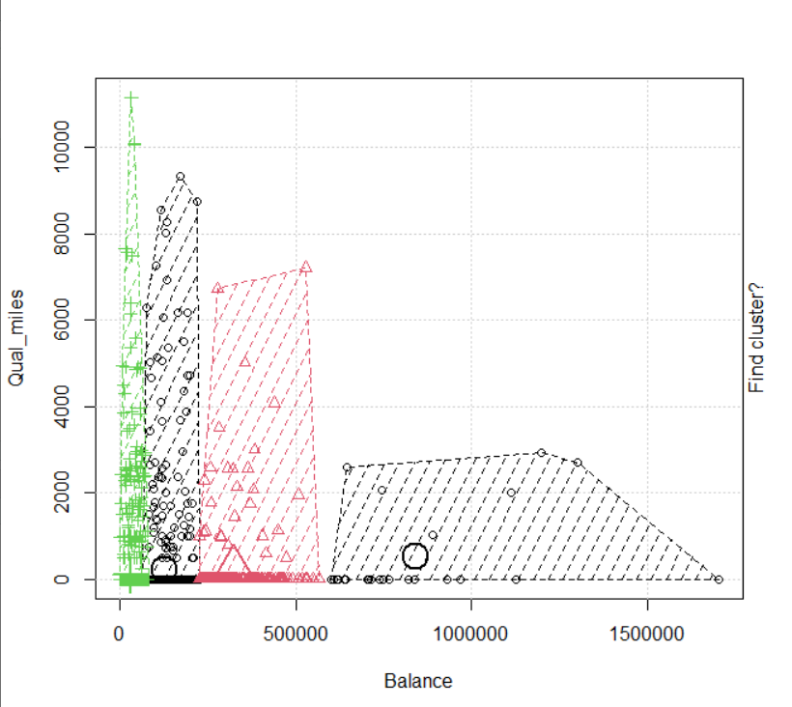

**CLUSTER:**

