**ARAVINDH.M**

**ASSIGNMENT 7**

**TOPIC: CLUSTERING**

**QUESTION:**

**Perform Clustering for the crime data and identify the number of clusters formed and draw inferences.**

**HIERARICAL CLUSTERING**

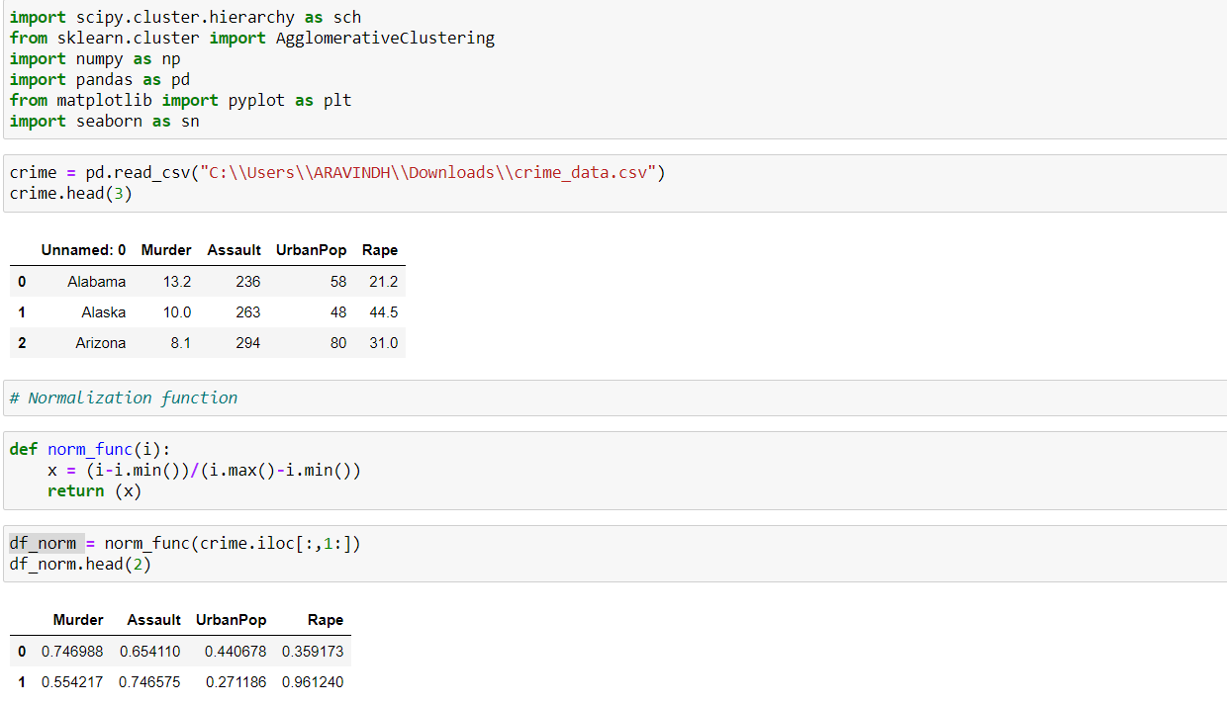

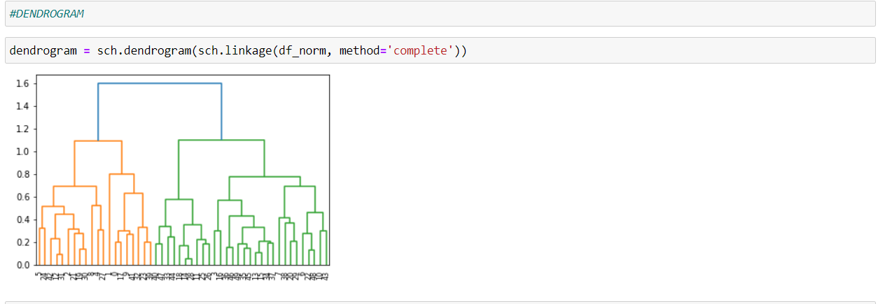

**Clear image of DENDROGRAM:**

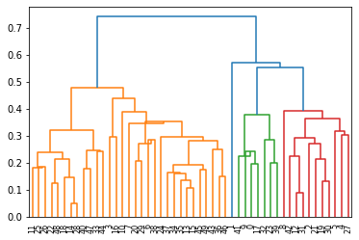

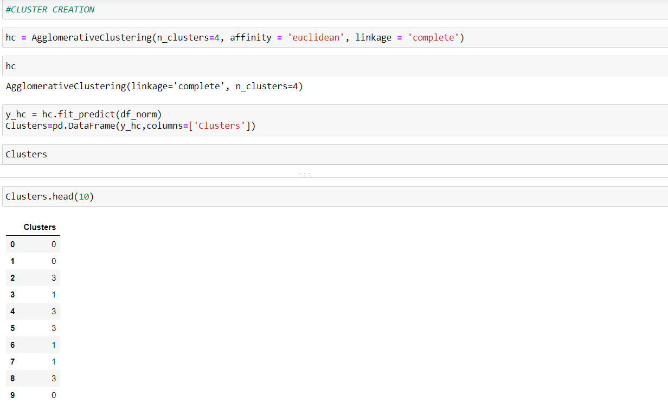

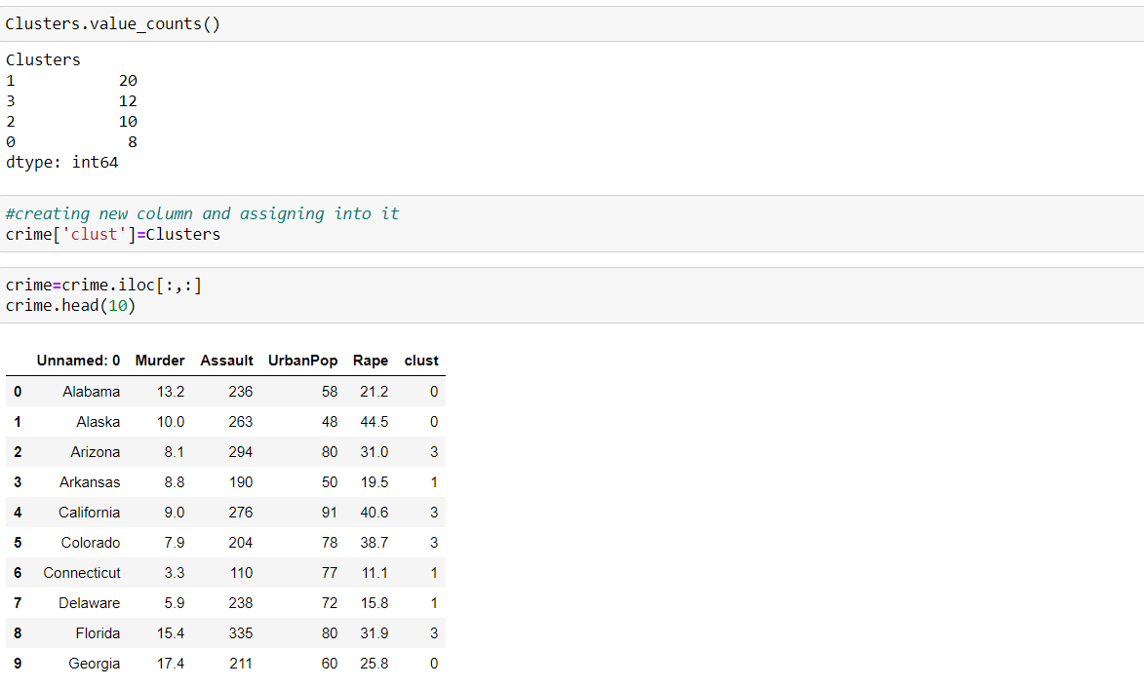

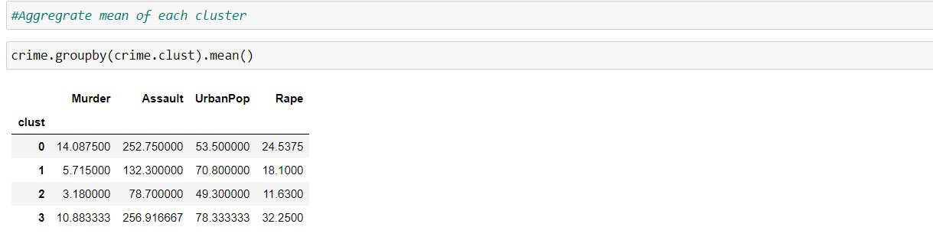

**K-MEANS:(code in same python file)**

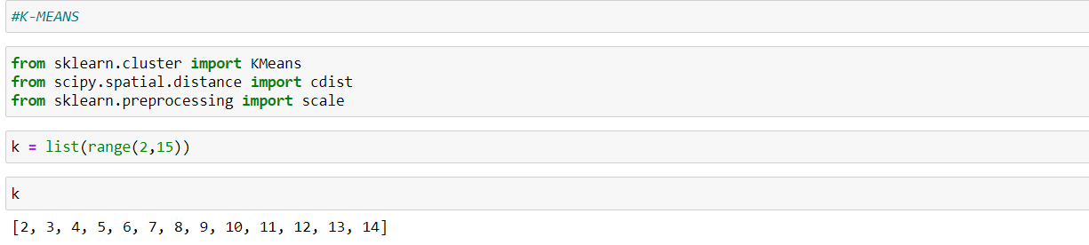

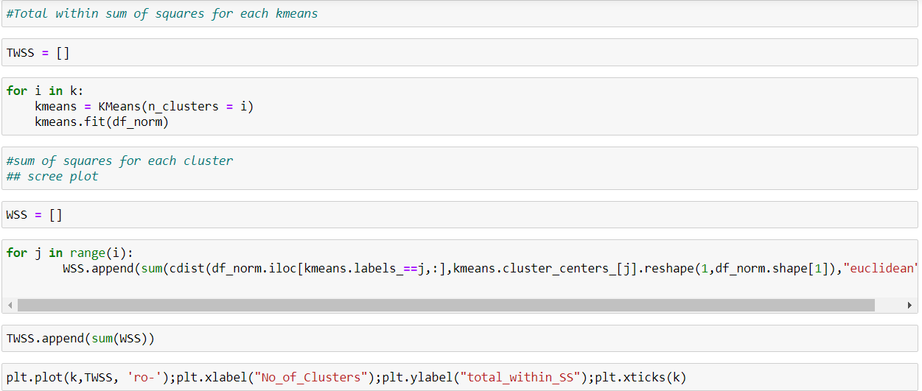

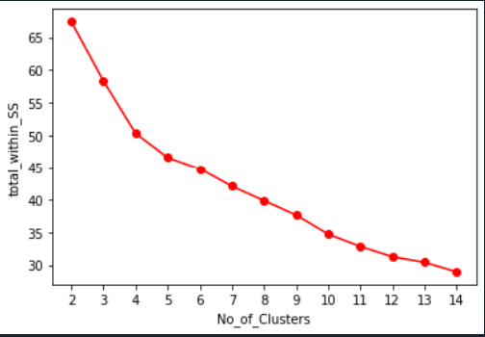

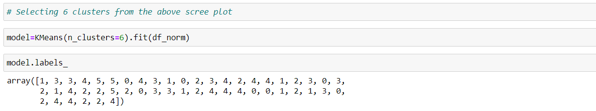

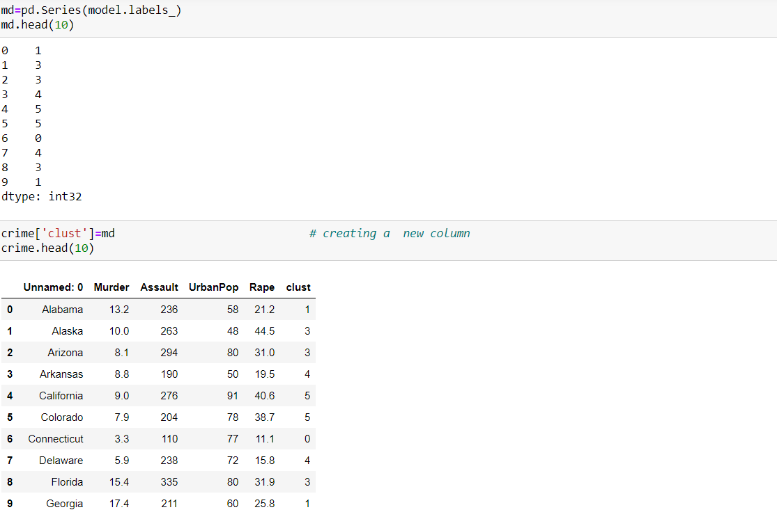

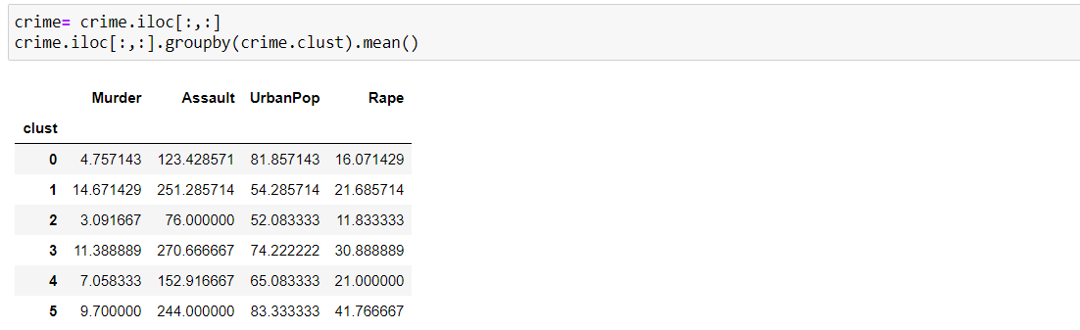

Here crime data set size is small.so,we can use both hierarchical and k-means clustering.