**ARAVINDH.M**

**ASSIGNMENT-14**

**TOPIC: DECISION TREE**

**QUESTIONS:**

**DATA SET – Fraud_check**

**Use decision trees to prepare a model on fraud data treating those who have taxable_income <= 30000 as "Risky" and others are "Good"**

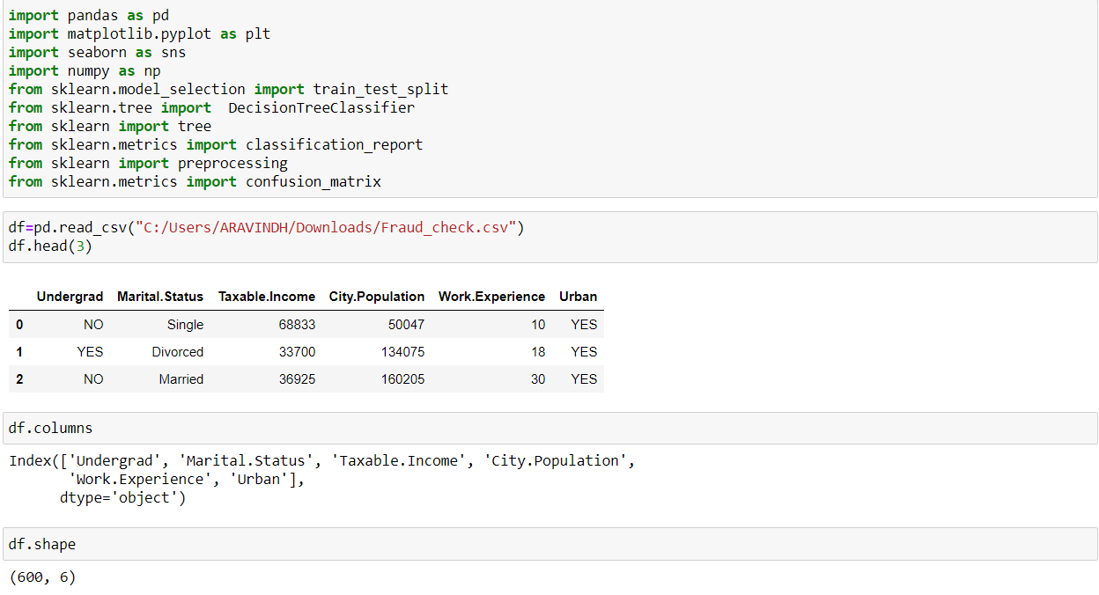

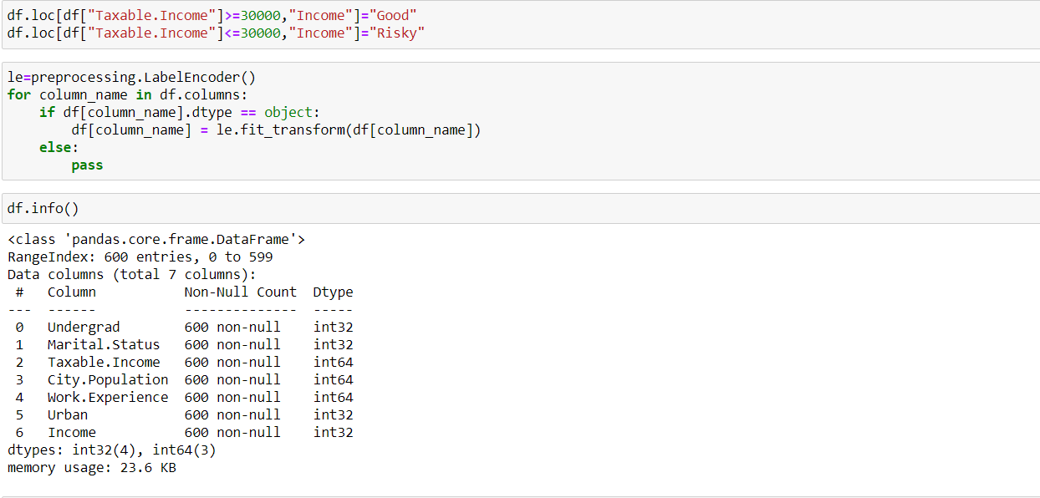

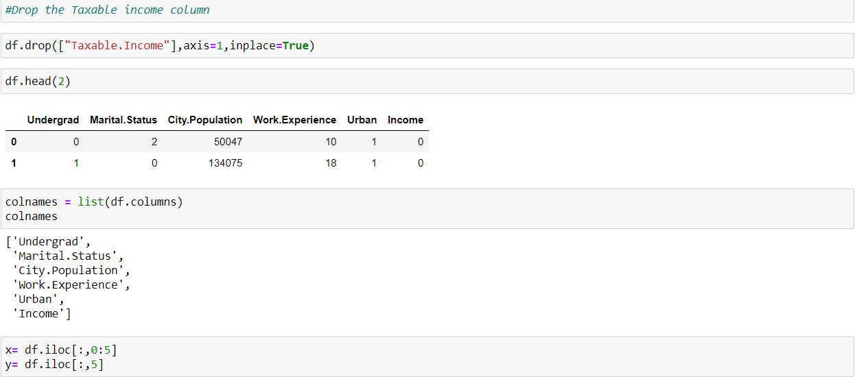

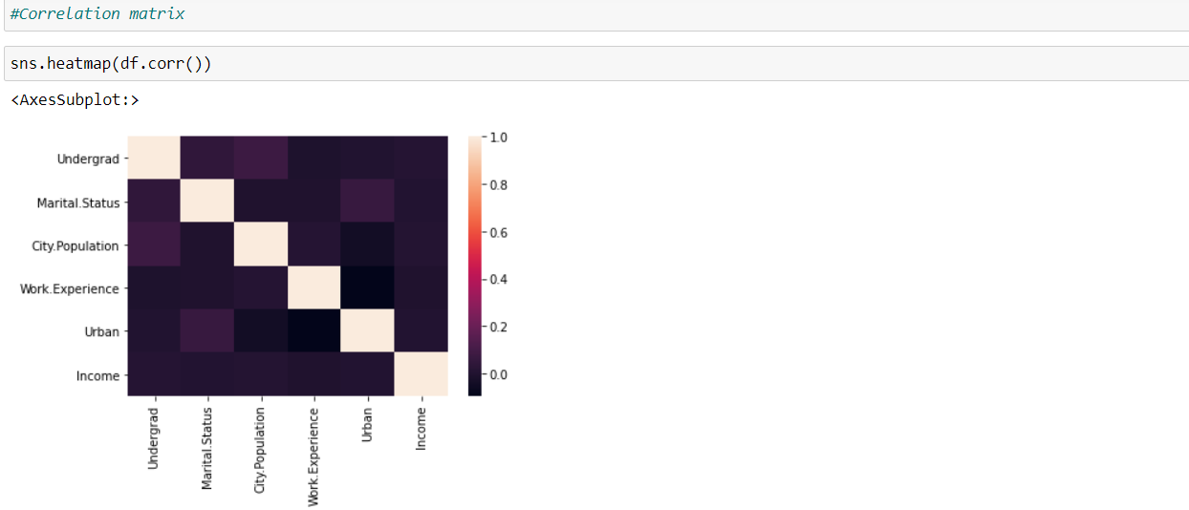

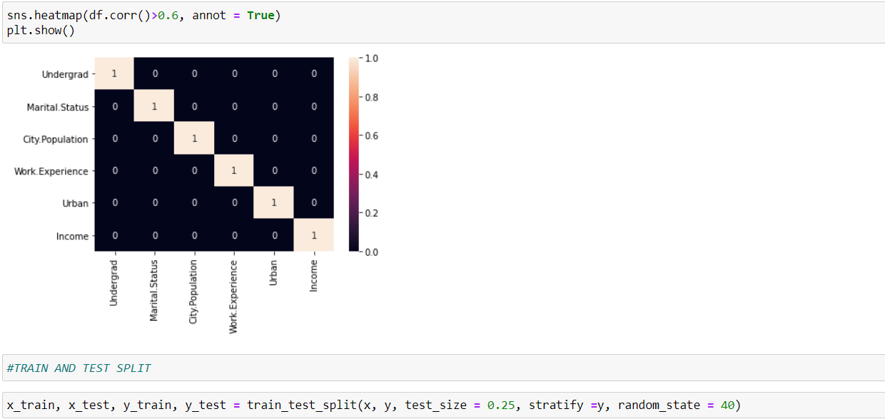

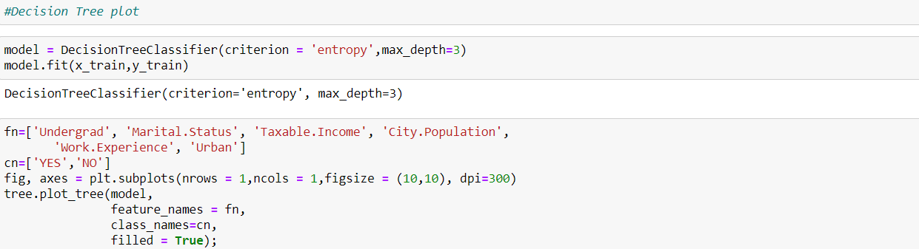

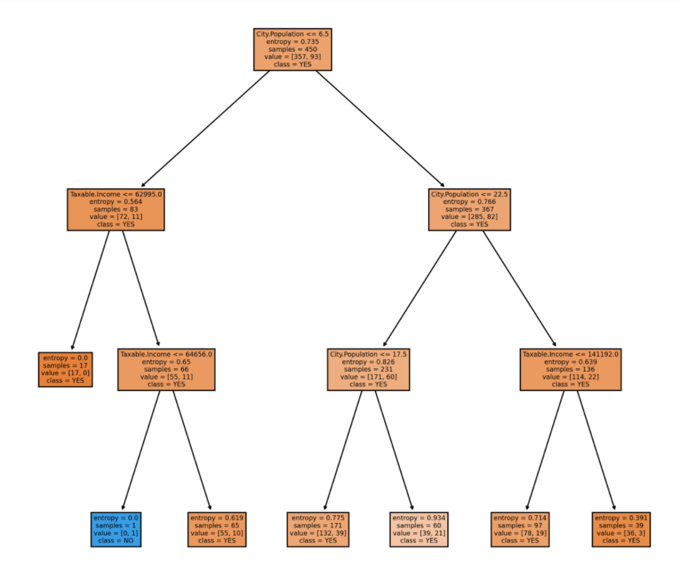

**Accuracy:**

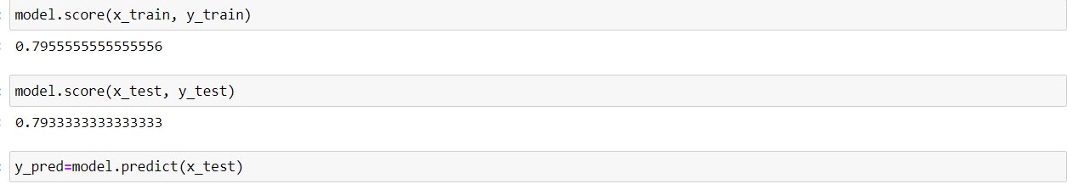

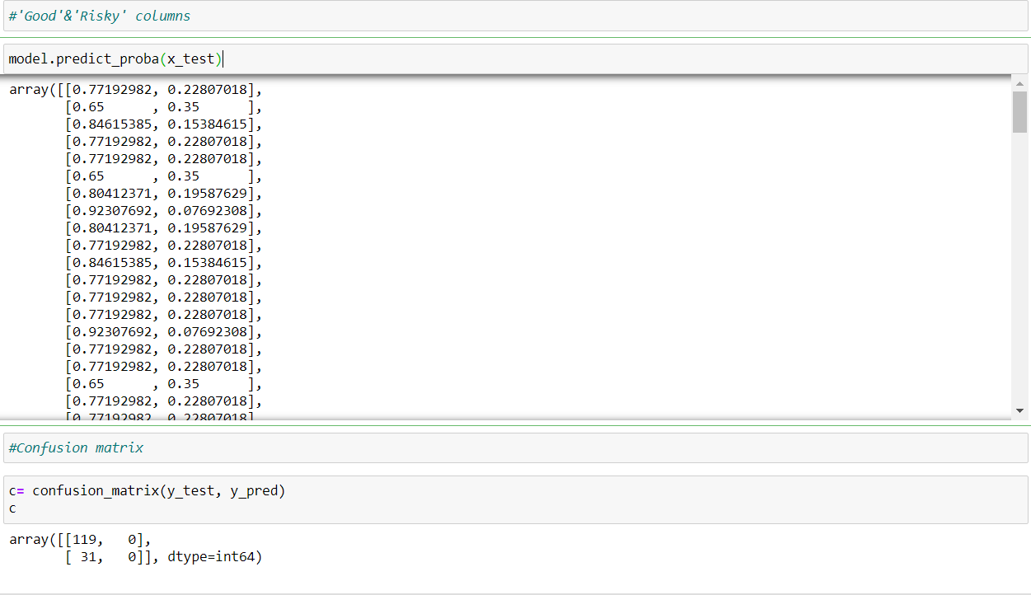

**DATA SET – Company_Data**

**A cloth manufacturing company is interested to know about the segment or attributes causes high sale.**

