

**Web Application Development**

**(Meglerfront)**

**Requirements Document**

Version 0.2

|  |  |
| --- | --- |
| Business Leads |  |
| IT Project Manager |  |
| IT Business Analyst |  |
| Primary Department |  |

Version History

|  |  |  |  |
| --- | --- | --- | --- |
| **Date** | **Version** | **Contributor** | **Description** |
| 15/02/2019 | 0.1 | Thirumurugan | Initial Draft |
| 29/04/2019 | 0.2 | Thirumurugan | Updated |

**Table of Contents**

1. INTRODUCTION 3

1.1 Purpose of the Document 3

1.2 Intended Audience 3

2. OVERVIEW 3

2.1 Background 3

2.2 Scope 3

3. BUSINESS REQUIREMENTS 3

3.1 High Level Business Requirements 3

3.2 Requirements 4

4. User Navigation Flow 5

5. Sample Web Pages 6

5.1 Login Page 6

5.2 Login Page with Error 6

5.3 Home Page (Search) 7

5.4 Home Page (Search) with Error 7

5.5 Customer Page 8

6. Data Sheet 9

7. Data Integrity Diagram 9

# INTRODUCTION

## Purpose of the Document

This document describes in detail the business and functional requirements specification for the Web application.

## Intended Audience

* Business Users

# 

# OVERVIEW

## Background

DNB would like to decommission the SharePoint server and other relevant infrastructure as the Meglarfront application is not in direct use since this functionality is integrated in the new core solution.

## Scope

To optimize the cost in maintaining and ease of use to extract the relevant data with minimum user access by means of web application.  This is required as per regulatory requirements of Norway (Data to be made available for 10 years from the date of creation).

# BUSINESS REQUIREMENTS

## High Level Business Requirements

| **ID** | **Requirement Definition** |
| --- | --- |
|  | Login Page – User should login into application with their credentials |
|  | Home Page – User can search customer details with valid input |
|  | Customer Page – User can export the customer details to excel sheet and navigate to new search / logout from the application. |
|  | Schedule Job – To delete the older records of the customer |

## Requirements

| **ID** | **BR reference** | **Description** |
| --- | --- | --- |
|  | BR1 | User can enter their credentials in login page and should have ability to login to the web application. |
|  | BR1 | **Post Form Submission**  Authentication will be done from the DNB AD. If authentication success, then Search page will be shown otherwise, error message will be shown in login page. |
|  | BR2 | User can enter First name or Last Name or Phone Mobile or Phone Home or Email and click on Search button. |
|  | BR2 | **Post Form Submission**  Customer details will be populated in the Customer Page if the customer found otherwise, error message will be shown. |
|  | BR2 | Search page will have logout functionality |
|  | BR3 | Export to Excel –  Customer details can be exported to excel and prompted for excel file name. |
|  | BR3 | New Search - This will leads the user to home page. |
|  | BR4 | SQL Batch Job to Delete record  Scheduled job will execute once in a day to delete the Accommodation records which are older than 10 years |

# User Navigation Flow

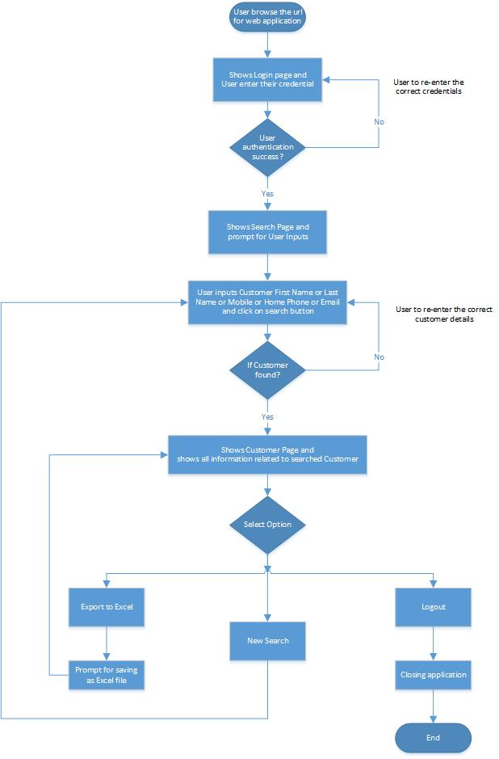

# Sample Web Pages

## Login Page



## Login Page with Error



## Home Page (Search)

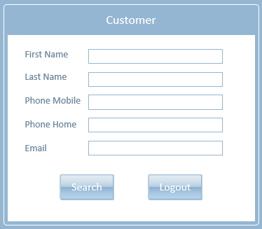

## Home Page (Search) with Error

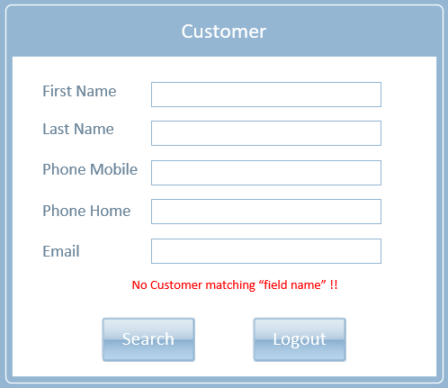

## Customer Page

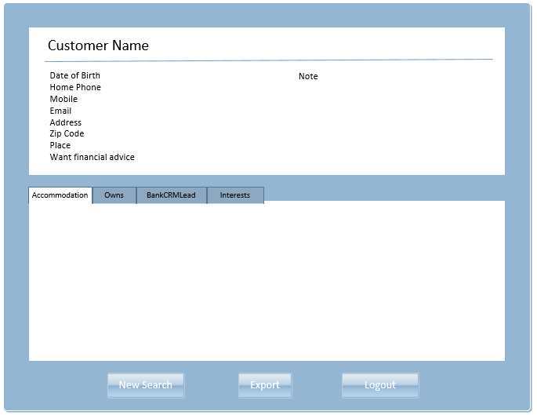

# Data Sheet



# Data Integrity Diagram

