# Chatbot for ESAIP -- High level design document

***For***



***By,***

Aravindh JAWAHAR  
Saravana Kumar JAISHANKAR

Siddharth RAMESH

MSS September 2021

***Guided***

***by,***

MOUTYMBO Charles-Alexis

***For course,***

Application Project

Semester III

MSS September 2021

**Index**

**Contents**

A . Introduction 3

B . Goals of the proposed system 3

C . Proposed system

C. A. High level operational requirements 4

C. B. High level architecture 4

**Table of Figures**

Figure 1. High level architecture diagram4

**A . Introduction**

The project is to build the chatbot for ESAIP website. The chatbot removes the person of receptionist where the machine is trained to answer the queries related to the related to college such as admission procedures, requirements for the course to join and the follow-up during the process which is needed for the candidate undergoing the admission process. These user requirements can be converted to user experience with the efficient way by making the system to learn the frequently asked questions and also with the Natural language processing to make the model learn with the questions asked by the users to respond it relevant to the query. The knowledge base has been maintained in order to store the questions queried by the user of the chatbot and if the query has been initiated it should refer the knowledge to check whether the query has already been asked by any other user if so the knowledge base return the answer for the query. If the user needs to be contacted by the person from ESAIP then he can ad the contact details in order to get contacted.

The model will be trained to answer with NLP API methods which implements machine learning methods to learn by itself and make updated the knowledge base. Each time the model will be updated with the new questions by the user. At the end, the expected result for the user will be reached whenever queried (24/7).

**B . Goals of the proposed system**

The goal of the system is to develop the anonymous working chatbot which answers the user queries for frequently asked questions or newly asked question will be answered.

Benefits of this system:

* Available 24 * 7
* Cuts down operational costs
* Offers personalised experience
* Give better insights
* Automates repetitive tasks
* Time management for the organization

With covering all the above benefits in the organisation, chatbot increases the performance of the user experience. As it is proven that the performance of chatbot is many a times higher than the traditional service using the customer support. The proposed system is profitable for the organisation as it satisfies the following for the organisation:

* Time
* Money
* Manpower

**C . Proposed system**

**C . A. High level operational requirements**

High level operational requirements for the chatbot are as follow:

* User can query for the information about ESAIP for education admission
* Conversational AI bot can answer the question which is about the ESAIP in terms of organization or academic
* Information about the user such as email, contact etc can be sent to ESAIP
* Query regarding the admission process can be accessed for specific courses
* Course content can be retrieved for the user

**C . B. High level architecture**

The high-level architecture diagram is as follows, which explains the different components in the chatbot system on its execution as a whole in relationship with its other sub-components.

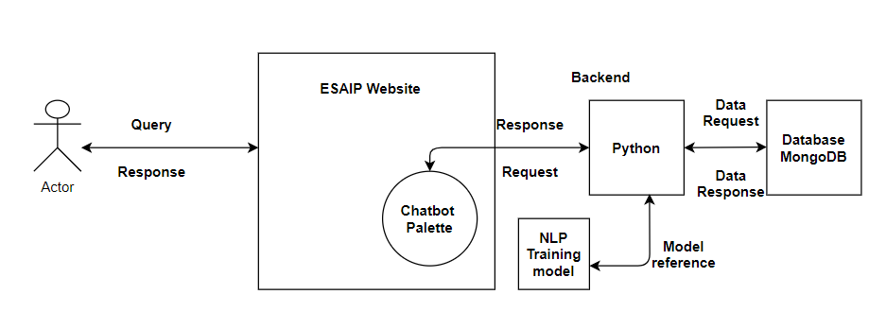

**Fig 1. High level architecture diagram**

User will open the chatbot and ask for the questions on the website using the chatbot palette at the bottom of the webpage. If any query has been asked the backend python will check whether the Knowledge base (database) contains the same question as the FAQ if so the answer will be retrieved from the previous one available. In the case when the question is new the chatbot use the trained model of NLP from the machine learning service and form the response from the website data if any information related to that and then respond to the user asking the question by adding the new question to the knowledge base for future reference.