# Chatbot for ESAIP – Project report

***For***



***By,***

Aravindh JAWAHAR  
Saravana Kumar JAISHANKAR

Siddharth RAMESH

MSS September 2021

***Guided***

***by,***

MOUTYMBO Charles-Alexis

***For course,***

Application Project

Semester III

MSS September 2021

**Index**

1. Abstract 3
2. Introduction 3
3. Requirements Collection 6
4. Feasibility study for bot 10
5. Design of bot 12
6. Development of the chatbot 13
7. Challenges during the project 19
8. Project execution and management 20
9. Finance part 23
10. Course knowledge mapping with the project 24

**Appendix**

References 26

**A . Abstract**

ESAIP engineer school has the website which requires the chatbot application for the institution to answer the query of the new students approaching for the admission or to know about the courses available and its campus life among with the details requiring the admission process to join and to proceed on.

This application will have the machine learning algorithm undergoing the training on **Natural language processing** (NLP) and using the inference the system will answer the question/query given by any individual on the website with the chatbot. The chatbot will infer with the knowledge base and some **Frequently asked questions** (FAQ’s) inputted over the database along with its response.

Chatbot is completely based on a text-based user interface and it allows the user to type the commands and receives the text as well as. Chatbots are usually stateful services, remembering previous commands in order to provide the functionalities.

The knowledge base will be trained to give response with NLP and stores the questions if it is new to the base. The ‘To be contacted’ portal will be enabled on the chatbot if in case the individual enquiring the chatbot about the academics needed discussion with the panel of admission members.

**B . Introduction**

Focus on creating a chatbot to be used by student to get their queries responded easily by the college website. The Chatbot is an **artificial intelligence** (AI) that stimulates a conversation with a user in Natural language through messaging application, websites, mobile apps, or desktop. It works on the algorithm called **Natural processing language** (NLP).

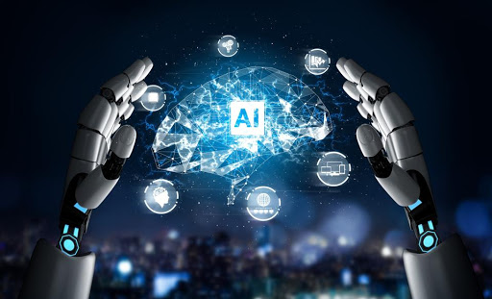

Figure 1 Artificial Intelligence Figure 2 Natural language processing

The user must be very specific while asking the questions so that bot can answer the questions easily. This Chatbot provides certain bits of information like how to apply for the college and

application deadlines and how to apply for housing. With the help of artificial intelligence, the system will **answer the query** asked by the users. Chatbot system retrieves the query from the database which will be stored in the cloud.

The chatbot system uses specific keyword to retrieve the query from the database. The users can ask for any query that is related to college activities through the system. The system replies to a user with the graphical user interface which implies the real person is talking to a student. The **front-end** of the project is designed using HTML, CSS, and JavaScript.

**Aim and Objective**

The aim of this project is to contribute the solutions of the problem of **direct communication** between users and the university. The goal of the system is to develop the **anonymous** working chatbot which answers the user queries for frequently asked questions or newly asked question will be answered.

**Goals of the proposed systems**

The goal of the system is to develop the anonymous working chatbot which answers the user queries for frequently asked questions or newly asked question will be answered.

Benefits of this system:

* Available 24 * 7
* Cuts down operational costs
* Offers personalised experience
* Give better insights
* Automates repetitive tasks
* Time management for the organization

With covering all the above benefits in the organisation, chatbot increases the performance of the user experience. As it is proven that the performance of chatbot is many a times higher than the traditional service using the customer support. The proposed system is profitable for the organisation as it satisfies the following for the organisation:

* Time
* Money
* Manpower

**Service need of the project**

The chatbot is build in order to replace the human intervention in place of support for assisting the students finding the information related to the college admission process.

**Chatbot varieties and ideas**

There are numerous varieties of chatbot types available for specific purposes, this section of the document explains about the types and its usages over the websites for specific business.

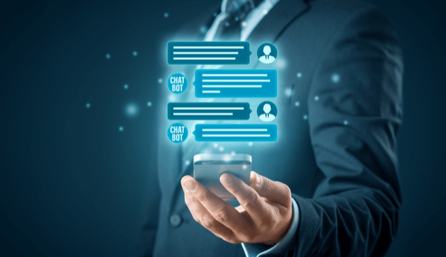

Figure 3 Chatbot

Chatbot has more **benefits** as compared to the traditional service with the support having the person behind. The model has been trained with the Natural Language Processing (NLP) along with the knowledge base with FAQ’s. This model will learn itself using the machine learning algorithm on usage and add it to knowledge base by learning . These learned inferences will be used as insights on usage or chat with any individuals.

**Types of Chatbot[1]:**

* Support chatbots
* Skill chatbots
* Assistant chatbots

**Support Chatbots:**

It is built with mastering of single domain, for instance about the organization or company. It should have context awareness. It should be able to walk a user through any business process

and answer a wide range of FAQ’s. It should ensure that it can execute the actions like selling cards to the persons.

**Skill chatbots:**

This type of chatbots are typically more single-turn-type bots that do not require a lot of contextual awareness. They set commands that are intended to do business perfect. Users can multi-task while engaging a bot. It doesn’t need to worry too much about contextual awareness unless you want to design a particularly advanced one. Its important to focus on integration especially when controlling with personalized objects.

**Assistant chatbots:**

It is the middle ground between the two bots above. They work best when they know a little about the variety of topics. Many people Many people envision these bots will someday become navigators of all other bots that are out there now. Assistant chatbots should be conversational and react to pretty much anything, while at the same time being just about as engaging as could be expected. When assembling a partner chatbot, it is essential to make it however clear as conceivable how the bot may be prepared. The scope of inquiries a client may pose is huge, so ensuring you have satisfactory inclusion will be the most troublesome factor. Much of the time, when individuals don't have the foggiest idea what they ought to ask, they won't ask anything by any means. Furthermore, in the event that you miss the couple of points, they at first will attempt, they won't return for additional.

No matter what type of bot you decide to build, it is important give bot some life and personality to make it useful. The possibilities are endless.

**C . Requirements collection**

**User requirements**

* First the users can get the information from the chatbot like how to apply for the college, admission procedure and how to apply for housing.
* Users can ask from the chatbot what kind of courses are available for their qualification.
* The users can ask for the eligibility criteria for applying these courses and whether the IELTS is mandatory or not.
* The student from other country who wants to do masters or bachelor in this college can ask for the visa procedure.
* The users can ask whether the college will help to open a bank account.
* In which language is courses are taught.
* The users can ask whether the college helps to find a internship or they allocate any job fairs.
* The user can ask for the exact location of college and is there any public transport available for travelling from home to college.
* This chatbot will be working for 24/7 and users can get their information regarding the college.

**High level operational requirements**

High level operational requirements for the chatbot are as follow:

* User can query for the information about ESAIP for education admission
* Conversational AI bot can answer the question which is about the ESAIP in terms of organization or academic
* Information about the user such as email, contact etc can be sent to ESAIP
* Query regarding the admission process can be accessed for specific courses
* Course content can be retrieved for the user

**Technical requirements**

**Choice – I**

The chatbot chosen for implementation is **Skilled chatbot**. It will be specialised in one domain, in or instance we train our model about the school and its admission process corresponding its requirements to apply. The Notification will be added if in case the enquired person from the chatbot needed to be contacted by the person for admission process or regarding the business query if in case the individual needed to collaborate their organization for business integration with subject to conditions.

The implementation details for the development will be as follows:

**Front-end :** HTML CSS JavaScript

**Back-End :** Python and its libraries

**Knowledge Base :** MongoDB

**Machine learning :** Natural Language Processing

This model has been elected because the possibility of changing the bot’s in accordance with any constraints this model will be under ease of use for developers to change the motive if needed. The cost[2] of implementing is free of cost as the dedicated database for the chatbot has been used in order to support the application with knowledge base. In the technical view the front-end module of the chatbot will be added to html script of the ESAIP school website as it is written in HTML CSS. The back-end integration will be added to the servers for supporting the chatbot on the website to answer the queries and for knowledge base learning.

The below diagram represents the architecture of the implementation using the 3-tier Model:

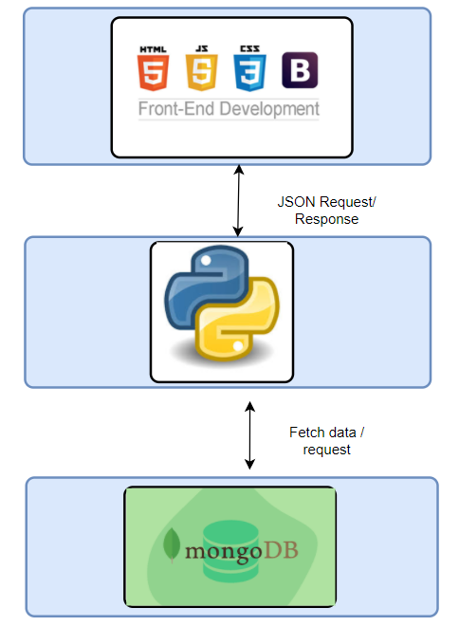

**Tier – 1 User-Interface**

User-Interface of the system will have the support of website which holds as palette in the right bottom of the screen and will have the pop-up supporting the system based on the queries from the user.

**Tier – 2 Middleware**

UI will communicate to the middleware-layer which is written I python to extract the data from the database MongoDB. The python middleware layer has high quality code in backend which helps out the UI to find the best possible answers for the queries to pull out the answers from the stored data.

**Tier – 3 Data-storage**

The database at the end will act as knowledge base for storing the data as well as the data warehouse which learns automatically using the questions asked by the user if it is not found in the knowledge base.

**Choice – II**

Choice two will be using cloud in order to execute the chatbot services to assist the users enquiring about the ESAIP for information or deals to be followed up.

The cloud under choice is Amazon web service and IBM Watson.

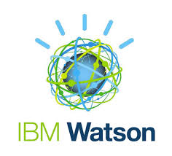 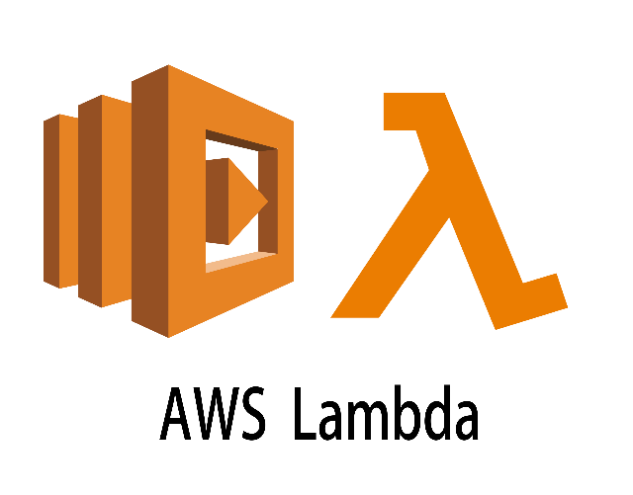

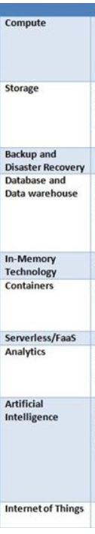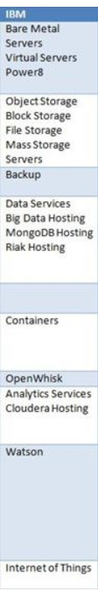

**D . Feasibility study of requirements**

The certainty of the project with respect to the requirements have been discussed to find the apt development methods to proceed with development.

The choices are :

* **Building** infra with UI and Database to answer the questions
* Use the services of cloud such as **AWS** Lambda or **IBM** Watson to deliver the bot service

Comparison have been made to find out the apt method and certain method to proceed the development.

By using the method of development and building infra-structure everything should be made by initiating the development in terms of infra for the database, so it is difficult to handle in future too.

So, while undergoing the advantages of cloud such as AWS and IBM the infra is taken over by the service provider so that the maintenance problem has been solved. The security of the cloud has been handed by the service provider and only the credentials should be safe guarded from the attackers or the external users/ persons.

Now under the choice -II on cloud bot we have two cloud IBM and AWS under consideration. So we made the comparison on both the clouds as listed below,

|  |  |  |
| --- | --- | --- |
| **Features** | **AWS** | **IBM** |
| Serverless computing | AWS Lambda | Open Whisk |
| Supported Languages | Python, Java, JavaScript | Python, JavaScript |
| File storage | AWS Elastic File System | Bluemix File Storage |
| Object storage | Simple storage services | IBM cloud object storage |
| Relational database management | AWS RDS, AWS Aurora | Dash database for transaction SQL database, IBM database on cloud |
| Non-Relational database management | AWS Dynamo database | NoSQL database |
| Machine Learning | AWS Machine Learning | IBM Watson Machine Learning |
| Virtual personal assistance | Alexa skills kits | Virtual Personal Assistance |
| Network security & Firewall | AWS Web application firewall | Hardware Firewall |
| API Management | AWS API gateway | API connect |
| Big data processing | Elastic MapReduce | IBM open platform |
| Scalability | AWS Auto Scaling | Auto Scaling |
| Database Migration | Database Migration Services | Lift |
| Caching | Elastic cache | Compose for Redis |
| Dedicated network | Direct connect | Direct Link |
| Backend process logic | AWS Step Functions | IBM cloud Functions |

**Why IBM Watson is better than AWS**

On the above table shows the comparison between the cloud platforms AWS and IBM Watson by comparing some parameters in that some of them are services, Storage services, Database services A.I build-in, Programming language, etc. By using IBM Watson, we don’t need to do backend coding and it is so simple. The IBM Watson assistant has multiple use cases to deploy

any sequences. It has a multi-language feature that allows the system to automatically change whenever the conversation is going between the bot and user.

**Advantages of IBM Watson:**

* Visual recognition security
* Automated predicted analysis
* Flexible deployment
* Easy to train a bot to handle the questions and queries
* Language translator
* The scalability of the IBM Watson is good

After the comparison we are under discussion IBM is highly under development for the bot to be highly secured and flexible for usage as API by collaborating with the other services as efficiently.So we develop the bot using the IBM services **“IBM Watson assistant”.**

**E . Design of bot**

**High-level architecture**

Bot services under IBM is Watson as undergoes following architecture to be as development in order to deliver as services.

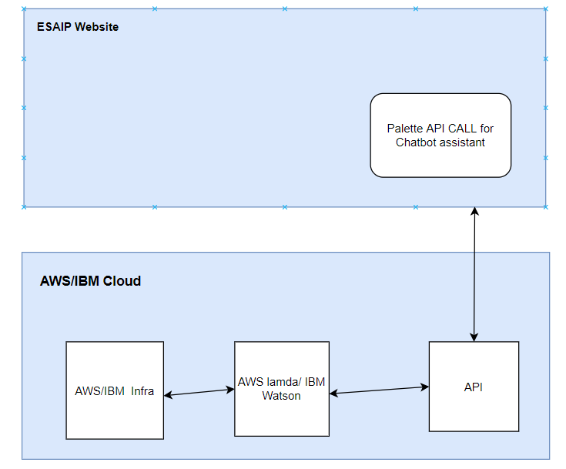

Figure High-level Architecture

The high-level architecture diagram is as follows, which explains the different components in the chatbot system on its execution as a whole in relationship with its other sub-components. User will open the chatbot and ask for the questions on the website using the chatbot palette at the bottom of the webpage. If any query has been asked the backend python will check whether the Knowledge base (database) contains the same question as the FAQ if so, the answer will be retrieved from the previous one available. In the case when the question is new the chatbot use the trained model of NLP from the machine learning service and form the response from the website data if any information related to that and then respond to the user asking the question by adding the new question to the knowledge base for future reference.

**High level operational requirements**

High level operational requirements for the chatbot are as follow:

* User can query for the information about ESAIP for education admission
* Conversational AI bot can answer the question which is about the ESAIP in terms of organization or academic
* Information about the user such as email, contact etc can be sent to ESAIP
* Query regarding the admission process can be accessed for specific courses
* Course content can be retrieved for the user

**F . Development of the bot**

Resource list has been mentioned in the cloud where we add the IBM Watson assistant .The future services will be added on the resources list as sections mentioned below:

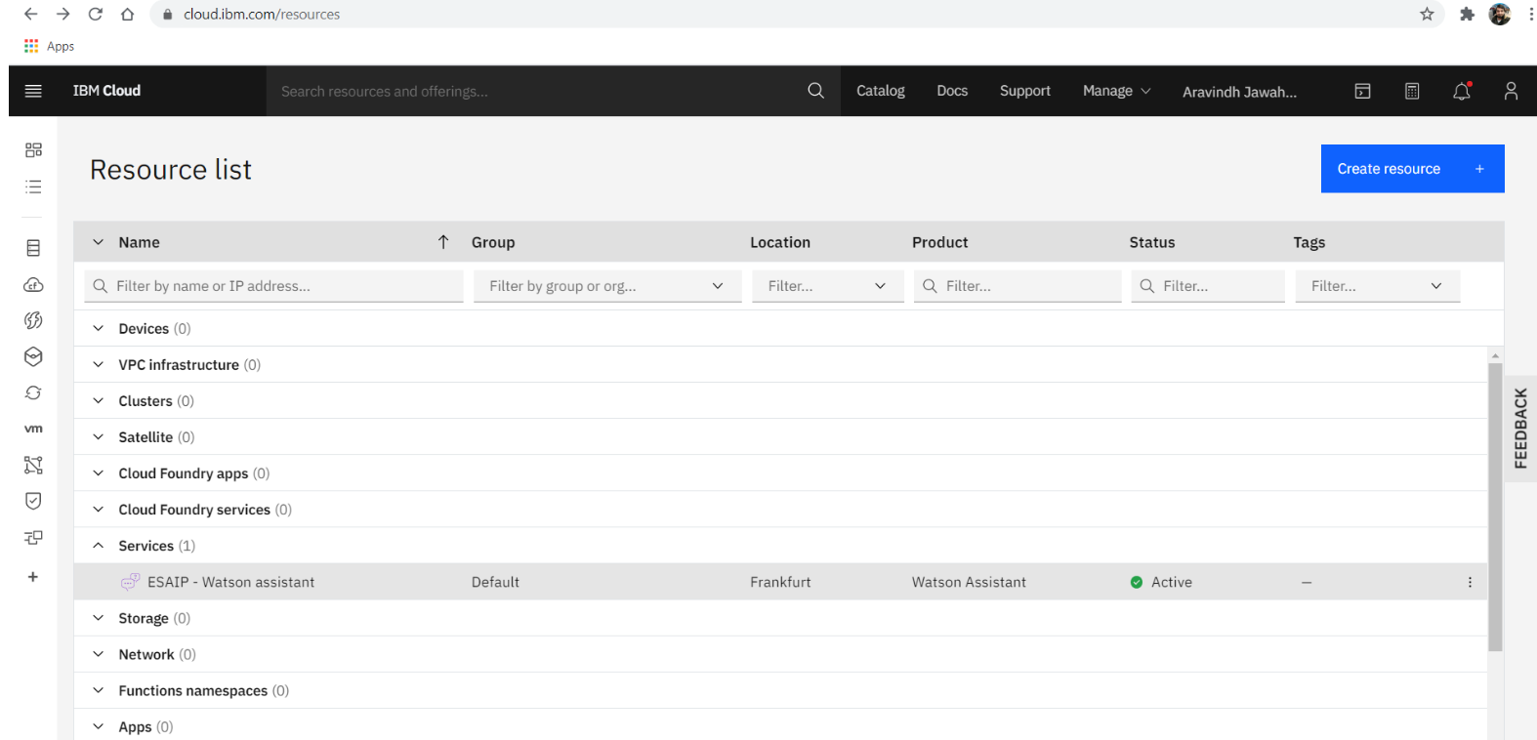

After clicking on the Watson assistant, we have API-key along with the credentials. The services trained over the cloud will be used with the API calls on the UI platform over the service applications.

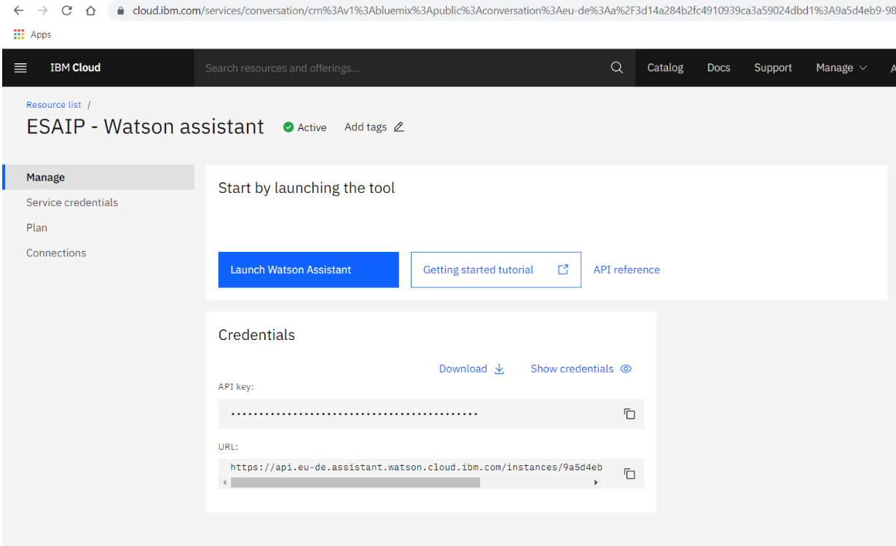

After clicking on the launch assistant on the above page chatbot assistant will be created. The assistant integration module will have virtual assistant demo along with the demo module.

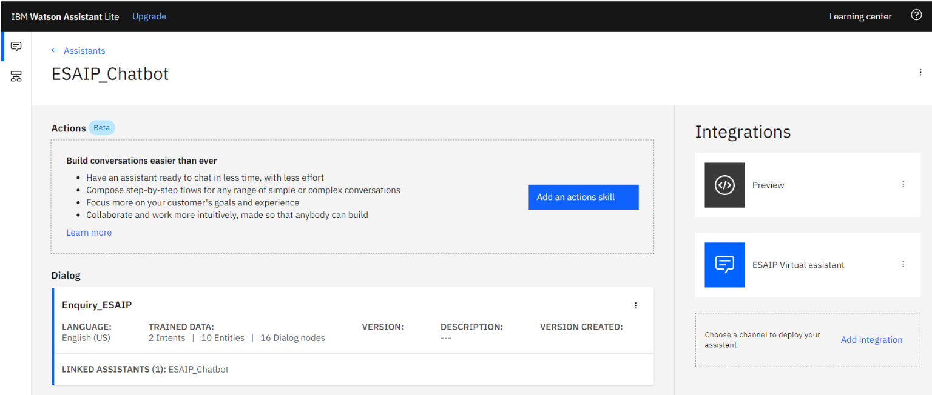

Now we have preview of the virtual bot interface on two types such as:

* Web / chat preview
* Development assistant using the on demo training

The following looks like the interface chat preview over the web along with the link and API call key credentials over which can be used in the application for the service.

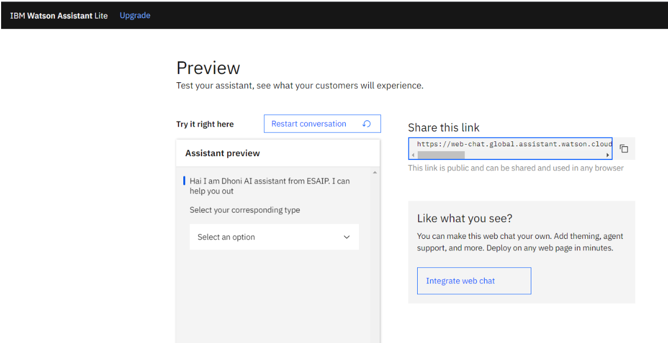

The entity will be created as like the variables in programming, where the variables will hold the values for the chat response over the bot with the user. These can be used on the dialog creation of chat by @ variables.

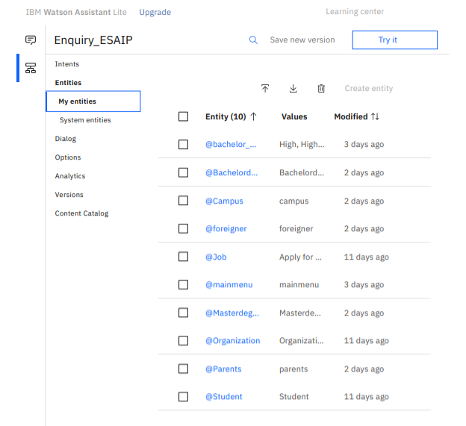

The response on the chatbot can be stored as intents where it has values or the dialog framed to responded to the user on information request by using # at front of variable on the dialog creatin window.

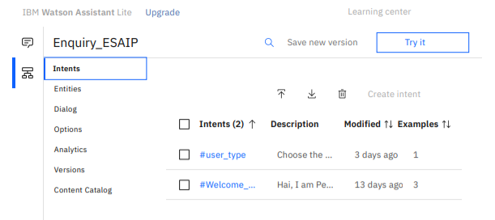

**Dialog** tab is used in order to add dialog on the sequential manner and also the tree structure for the questions framed over the algorithm of **Tree data structure**.

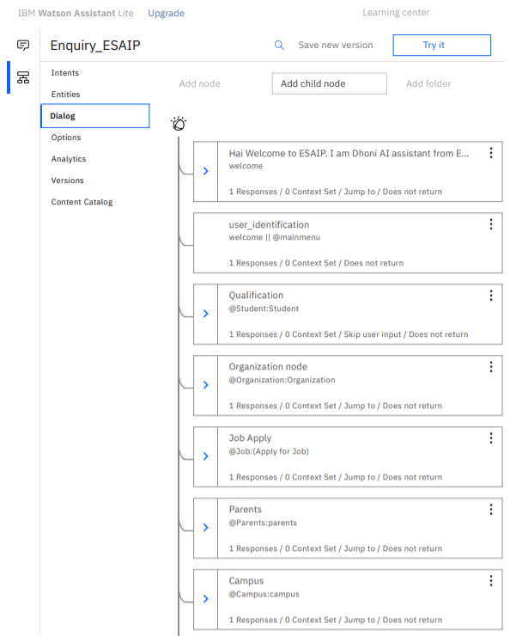

**Identity access management of IBM Watson services**

Free IBM Watson service is used which has limit of **10000** API calls per month which is of lighter version. At present now I had above **9000**+ free calls. It is followed by **entity based** AI assistant.

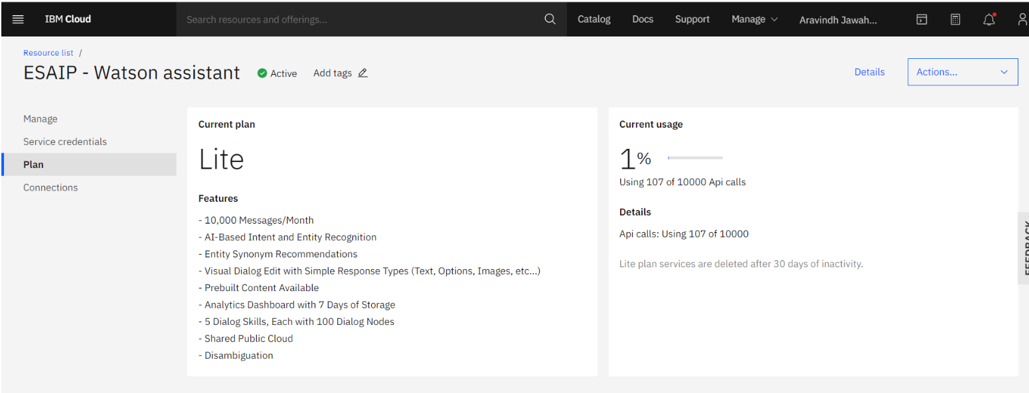

**IAM Users**

The **users** allowed for integration or usage is **1** user as of free usage in future it can be added as many or finite numbers according to the usage of the organization.

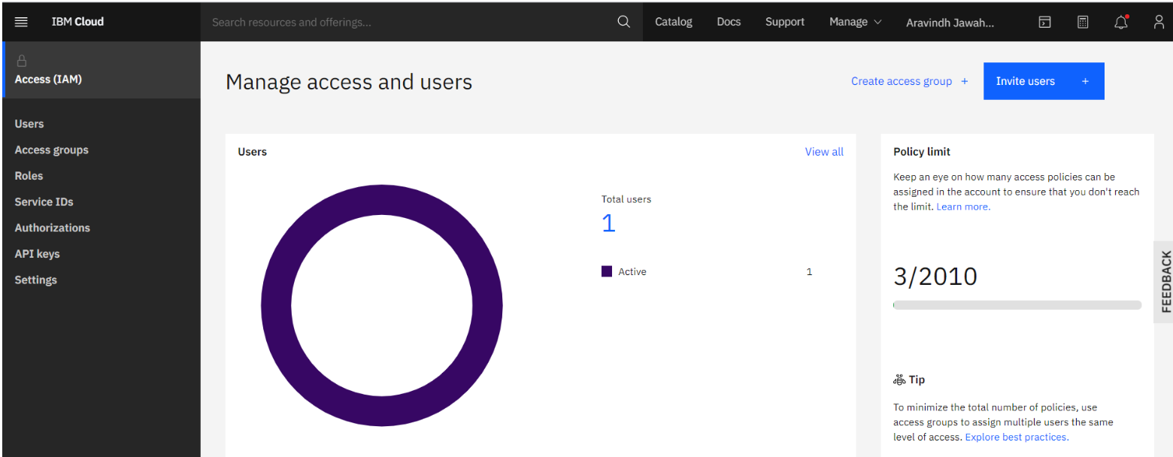

The service used as API can be accessed as **API** key along with its **credentials**. These keys can be generated on period over which it can be changed ad synchronised to protect with the security purpose.

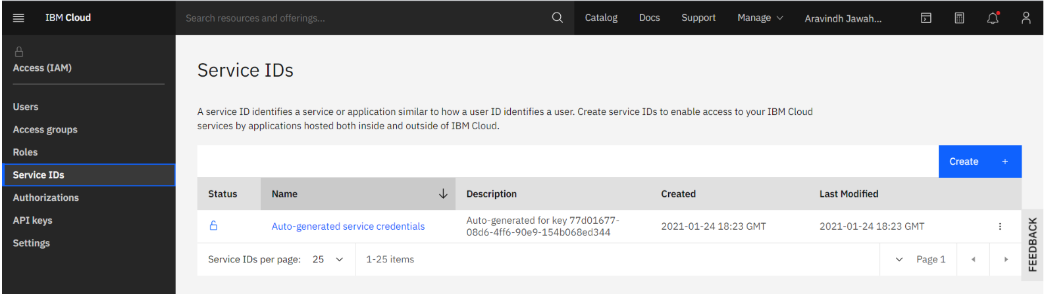

**Multifactor authentication** along with the **public access group** can be added. Public access group can be used to add the users who can be use the API to make use of the AI services trained over the IBM cloud.

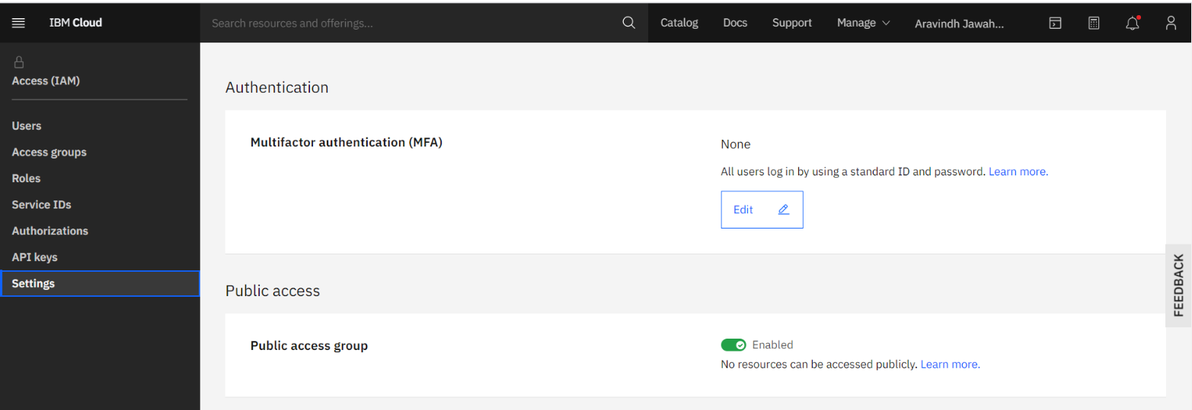

The User-interface of the bot service looks like as follows:

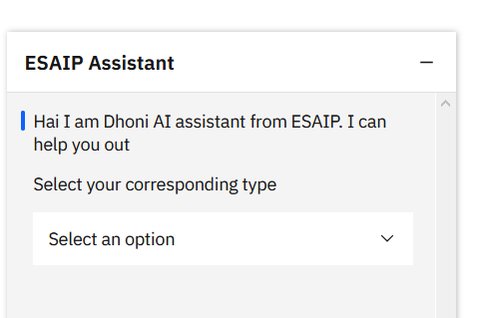

The UI is developed using the HTML CSS and JavaScript which calls the API trained over the IBM cloud as Watson service. JavaScript calls the API and receives the request by making the mandatory calls by requesting upon the design and restriction to ask the question by the user.

**G . Challenges during the project**

In this section, we focus on the challenges undergone during the project and the tackles followed up to recover from the project drop fall.

The list of challenges during the project are:

* Python coding for NLP modelling
* Training the model using the data sets

The above-mentioned tasks are late tasks as it is undone in the development life cycle. The representation is:

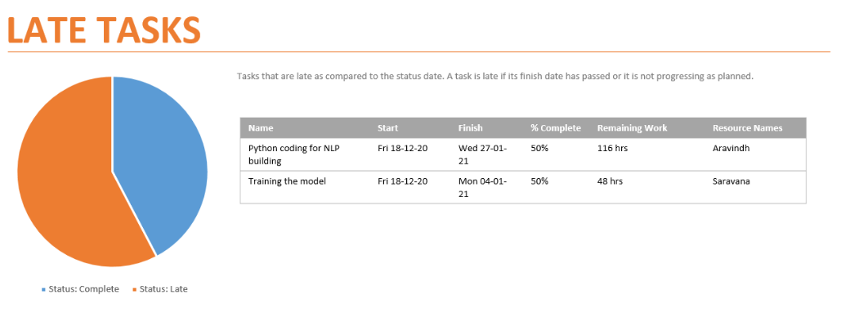

The task came up late and had more challenges. The development task in python had numerous issues that are listed below:

* More complex algorithmic design
* Complex data structures usage for storing the data in live variable usage
* Accuracy and efficiency building in algorithm
* Database handling dataset with different category of data
* Required high learning related to machine learning algorithms

Some specific problems in Training the model for usage are:

* Algorithm with high complexity in terms of efficiency
* Non-proper datasets
* Proper and knowledge in Machine learning

These problems are handled with critical trial and error method for approaching towards the solution building. But unfortunately, many of the problems in the path are not solved properly due to the lack of attention and insufficient time for contribution where the project challenges required high involvement as full time. In future the project unbuild part for algorithm development will be developed for usage with own NLP knowledge base server.

The motive of the NLP server is to develop NLP processing server which learns itself for answering the academic related questions using the chatbot interface.

**H . Project plan and execution**

Project has been planned to go with flow as **Agile driven methodology**. The weekly meetings have been assigned in order to review the tasks and to validate the flow which has been followed up in the execution of the project. Series of task has been updated in each sprint to focus on the valid execution to deliver the services of chatbot under the application.

Project has been tracked and managed using **MS-Project** tracking tool for tracking the task flow and planning of the projects on regard of the phases.

**Task list**

The task has been divided based on the following criteria:

* Based on the phase segregation
* Based on the task flow and to the resource knowledge

The task corresponding to each phases and sprints are divided based on the experience of the resource in the project and the reflection of knowledge over the technology. There are three resources used in the project (Siddharth, Aravindh and Saravana).

The following are the list of tasks that are bounded with the deadline corresponding the tracking and allowing the Manager to track their progress over MS-Project tool. The task listed below:

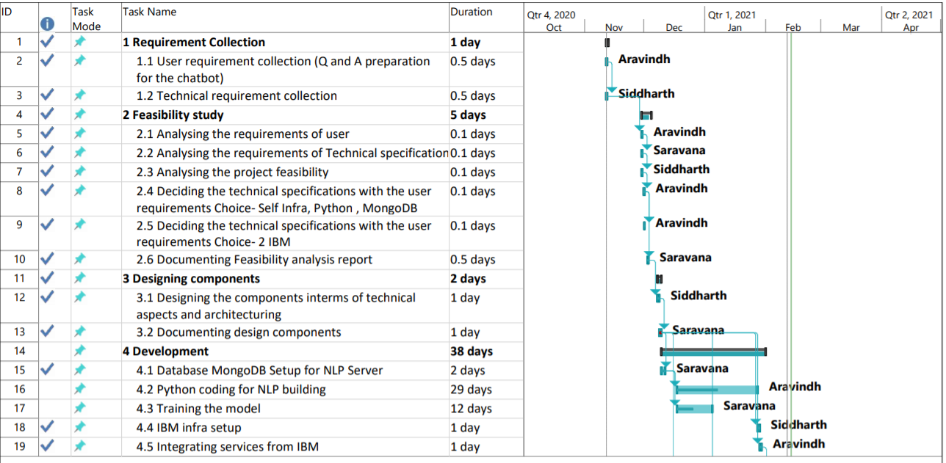

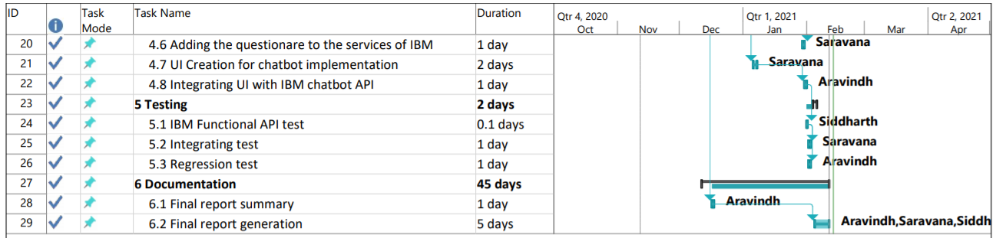

Figure Task list

**Gantt chart**

The Chatbot developed has undergone some critical phases to deliver as services. These critical phases have been put in place to be careful without making sure the task is late or which should not be late to affect the end date of the project finish. Critical path of the project ha undergone in the development and design phase here the actual delivering of service is built so that it can be used as applications. These critical path on the development and design has strong time frame during the API development in IBM platform and designing the components based on the flow planned. The late task for Bot self-learning algorithm is not complete and the alternate temporary solution has been found.

**Resource overview**

The task allocation of the project to the resources has put up in the following dividend ratio among each other.

Roles:

* Aravindh - Project manager and developer
* Siddharth - Developer
* Saravana - Application developer

Figure Resource allocation

**Task time fall back tackling**

The tasks allocated has delayed in some task of development phase where the task of UI design and development and IBM dialog design for chatbot along with the adding of questionaries are delayed. These delayed tasks are tackled without affecting the end date of the project so that the final date of finish is not delayed. During the task delay the time slot allocated had exceeded over the time frame of one day and it has been managed to finish within the start of other dependent tasks as the other successor task has time interval to start.

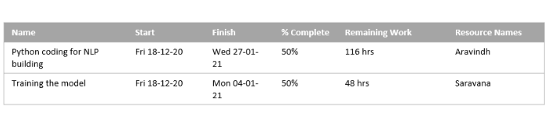

Figure Late tasks

**H . Finance section**

In this section, we will present the financial aspect related to our project. First, we will discuss the estimation of an implementation on a single application and the total cost of the applications I have implemented.

**Implementation of the project**

To estimate the average cost of implementation, you should have several elements. We need to separate the various phases of the project and we need to have the following elements: the stakeholders, the length of time performed by its stakeholders. Then we can calculate the total cost in adding up the costs of each phase.

|  |  |  |
| --- | --- | --- |
| **Phase** | **Designation** | **Cost** |
| Requirements | Business Analyst | 50 Euros |
| Design | Software designer | 100 Euros |
| Development | Back-end Developer | 250 Euros |
| Testing | Developer | 50 Euros |

**SDLC Cost**

The SDLC phases has been divided and each is carried out by the individuals with specific designation and specialisation. The duration of the task for the project and their estimation relates to the cost which expresses the weightage of the task and its mission.

Certain resources will be working on the different phases with multiples designation so that the resources can be handled with accuracy and low cost.

The total cost of the project in terms of the development process in the software development life cycle is **500 Euros.**

**Real time implementation**

* The migration includes the storage of the code repository while the usage of code on running the application
* Keeping the repository active for the users while making it available for 24/7-time bar
* The migration process involves costs such as pay for use for IBM services

|  |  |
| --- | --- |
| **Operation** | **Cost** |
| SDLC | 500 Euros |
| IBM Services | 120 $ |

**J . Project and Course Knowledge Mapping**

The courses in **ESAIP** which helps us to implement this project without any difficulties. Some of the courses are listed below which will give the brief explanation about the knowledge mapping.

Courses in academic helped to do project:

* Artificial Intelligence
* Cloud Computing - Azure
* Web technologies
* Project Management

The knowledge extraction from each of the module from the academics are:

**Artificial Intelligence**

Artificial intelligence is a smart machine which can perform a task like human intelligence. The subset of the artificial intelligence is machine learning which will perform the concept of the computer program that automatically learn and adapt to new data without human intelligence.

* Solving knowledge intensive tasks
* Creating the virtual personal assistant
* Focus on structuring and functioning of a simple A.I System
* Algorithms to manipulate the data particularly
* Containing right structure of mark-up languages
* Reduce number repetitive manual task

**Azure**

In our academic study we have learned about the Microsoft Azure and how to implement that technology into the project. Then we decided to use the IBM Watson Cloud because it is same as the azure. with the help of an IBM Watson Assistant, we can be able to create a chatbot by following ways:

* Cognitive services to build an intelligent application
* Natural language processing
* Delivers personalized and proactive customer services
* No coding required
* IDE to develop the chatbot and the cloud platform has its own build-in IDE

**Web Development**

Web development helped in the project for UI development of the chatbot for the user usage in an efficient manner. The following are the technologies for web used for the development for the front-end interface of the application from the course module are:

* HTML
* CSS
* Bootstrap
* JavaScript

The abilities earned from the course module are:

* Efficient development of web UI
* Design a complete set of conversational UI assets
* Efficient coding standard
* Depth understanding of the background working of the technologies helped to develop the project better
* Efficient handling of resources

**Project Management**

* Task Allocation to resources
* Task dividing
* Task Planning
* Crisis Handling in the project
* Management tools usage for planning, maintaining, and handling
* Tools: MS Project
* Gantt Chart to identify the critical path of the development process

The managerial skills acquired from the course to act well in the project are:

* Decision making
* Leadership Qualities
* Crisis Management
* Usage of Development methodologies to do the process
* Documentation abilities to track

**Appendix**

**References**

1. <https://www.ibm.com/blogs/watson/2017/12/3-types-of-business-chatbots-you-can-build/>
2. https://www.mongodb.com/pricing