Vehicle Energy Dataset (VED) Analysis & Machine Learning Summary
Table of contents

- Objective: To analyze real-world driving data from the Vehicle Energy Dataset (VED) comprising diverse vehicle types (ICE, HEV, PHEV, EV) in Ann Arbor, Michigan.
- Goal: Develop and evaluate machine learning models to predict Fuel Consumption Rate (FCR) for internal combustion/hybrid vehicles and HV Battery Power for electric vehicles.
- Challenge: Integrating static vehicle specifications with large-scale, high-frequency dynamic driving data, handling missing sensor data, and deriving physics-based features to estimate energy usage accurately.

1. Static Data Load
import warnings
warnings.filterwarnings('ignore')
import os
print(os.getcwd())
g:\DIYguru\Data-Science-and-Engineering-Analytics\Projects\Main_Project_ML
'''
Created a function 'load_data_excel' to load excel into python
'''
import pandas as pd
import numpy as np
import os
def load_data_excel(file_path):
"""
Load data from an Excel file and return a DataFrame.
"""
if not os.path.exists(file_path):
raise FileNotFoundError(f"The file {file_path} does not exist.")
df = pd.read_excel(file_path)
return df
'''
Loaded VED_Static_Data_ICE&HEV into dataframe df_ICE_HEV using the above function
Loaded VED_Static_Data_PHEV&EV into dataframe df_PHEV_EV using the above function
'''
df_ICE_HEV = load_data_excel(r"G:\DIYguru\Data-Science-and-Engineering-Analytics\Assignments\other_source_files\VED_Static_Data_ICE&HEV.xlsx")
df_PHEV_EV = load_data_excel(r"G:\DIYguru\Data-Science-and-Engineering-Analytics\Assignments\other_source_files\VED_Static_Data_PHEV&EV.xlsx")
'''
# Import required libraries for Google Drive authentication
from pydrive.auth import GoogleAuth
from pydrive.drive import GoogleDrive
def authenticate_drive():
"""
Authenticate and return a GoogleDrive instance.
This function handles Google Drive authentication using PyDrive.
It opens a browser window for user login and returns an authenticated
GoogleDrive instance that can be used to access files on Google Drive.
Returns:
GoogleDrive: An authenticated GoogleDrive instance
"""
# Initialize GoogleAuth object for authentication
gauth = GoogleAuth()
# Perform local webserver authentication - opens browser for login
gauth.LocalWebserverAuth()
# Return authenticated GoogleDrive instance
return GoogleDrive(gauth)
'''
'''
This cell defines a function to read Excel files from Google Drive.
The function takes an authenticated GoogleDrive instance and a file_id as parameters.
It downloads the Excel file to a temporary location and reads it into a pandas DataFrame.
This enables accessing Excel files stored in Google Drive programmatically.
import pandas as pd
def read_excel_from_drive(drive, file_id):
"""
Reads an Excel file from Google Drive using its file_id.
Args:
drive: Authenticated GoogleDrive instance
file_id: File ID of the Excel file in Google Drive
Returns:
DataFrame containing the Excel data
"""
file = drive.CreateFile({'id': file_id})
file.GetContentFile('temp_excel_file.xlsx')
df = pd.read_excel('temp_excel_file.xlsx')
return df
'''
'''
This cell loads AWS credentials from a .env file using python-dotenv,
creates a boto3 S3 client with those credentials,
and lists all S3 buckets in the account.
'''
import os
from dotenv import load_dotenv
import boto3
# Load environment variables from .env
load_dotenv()
# Create boto3 client using loaded environment variables
s3 = boto3.client("s3",
aws_access_key_id=os.getenv("AWS_ACCESS_KEY_ID"),
aws_secret_access_key=os.getenv("AWS_SECRET_ACCESS_KEY"),
region_name=os.getenv("AWS_DEFAULT_REGION")
)
# Example: list buckets
buckets = s3.list_buckets()
print("Your S3 Buckets:")
for bucket in buckets['Buckets']:
print(f" - {bucket['Name']}")
Your S3 Buckets:
- s3aravindh973515031797
'''
import pandas as pd
from io import BytesIO
def read_excel_from_s3(bucket_name, object_key):
"""
Reads an Excel file from an AWS S3 bucket using the global s3 client.
Args:
bucket_name: Name of the S3 bucket.
object_key: Key (path) to the Excel file in the S3 bucket.
Returns:
DataFrame containing the Excel data.
"""
response = s3.get_object(Bucket=bucket_name, Key=object_key)
file_content = response['Body'].read()
df = pd.read_excel(BytesIO(file_content))
return df
'''
'''
# Step 1: Authenticate
drive = authenticate_drive()
# Step 2: Provide File and Folder IDs
ICE_HEV = '1nIVzW4czIBAOczy9DExM3VEVyYGBXNJe' # Replace with your Excel file ID
PHEV_EV = '1L-rPZ-OrASQDw4m-onNPZFSTNAkbEe8H' # Replace with your Excel file ID
# Step 3: Read Excel
df_ICE_HEV = read_excel_from_drive(drive, ICE_HEV)
print("Excel File Contents:\n", df_ICE_HEV.head())
df_PHEV_EV = read_excel_from_drive(drive, PHEV_EV)
print("Excel File Contents:\n", df_PHEV_EV.head())
'''
bucket_name = 's3aravindh973515031797'
response = s3.list_objects_v2(Bucket=bucket_name)
for item in response.get("Contents", []):
print(item["Key"])
Cleaned up VED Source Data/
Cleaned up VED Source Data/df_ICE_HEV.parquet
Cleaned up VED Source Data/df_PHEV_EV.parquet
Cleaned up VED Source Data/df_VED.parquet
Cleaned up VED Source Data/df_combined.parquet
Cleaned up VED Source Data/df_dynamic_sample.parquet
Cleaned up VED Source Data/df_static.parquet
DIYguru ML Source Data/
DIYguru ML Source Data/Other sample source files/
DIYguru ML Source Data/Other sample source files/DACIA SPRING/20230418_DACIA_ANDOAIN_AZPEITIA_011.csv
DIYguru ML Source Data/Other sample source files/DACIA SPRING/20230418_DACIA_AZPEITIA_DONOSTIA_012.csv
DIYguru ML Source Data/Other sample source files/DACIA SPRING/20230418_DACIA_DONOSTIA_HERNANI_001.csv
DIYguru ML Source Data/Other sample source files/DACIA SPRING/20230418_DACIA_DONOSTIA_IRUN_009.csv
DIYguru ML Source Data/Other sample source files/DACIA SPRING/20230418_DACIA_HERNANI_TOLOSA_002.csv
DIYguru ML Source Data/Other sample source files/DACIA SPRING/20230418_DACIA_IRUN_ANDOAIN_010.csv
DIYguru ML Source Data/Other sample source files/DACIA SPRING/20230418_DACIA_TOLOSA_ZARAUTZ_003.csv
DIYguru ML Source Data/Other sample source files/DACIA SPRING/20230418_DACIA_ZARAUTZ_DONOSTIA_004.csv
DIYguru ML Source Data/Other sample source files/DACIA SPRING/20230419_DACIA_ANDOAIN_AZPEITIA_027.csv
DIYguru ML Source Data/Other sample source files/DACIA SPRING/20230419_DACIA_AZPEITIA_DONOSTIA_028.csv
DIYguru ML Source Data/Other sample source files/DACIA SPRING/20230419_DACIA_DONOSTIA_HERNANI_017.csv
DIYguru ML Source Data/Other sample source files/DACIA SPRING/20230419_DACIA_DONOSTIA_IRUN_025.csv
DIYguru ML Source Data/Other sample source files/DACIA SPRING/20230419_DACIA_DONOSTIA_TOLOSA_033.csv
DIYguru ML Source Data/Other sample source files/DACIA SPRING/20230419_DACIA_HERNANI_TOLOSA_018.csv
DIYguru ML Source Data/Other sample source files/DACIA SPRING/20230419_DACIA_IRUN_ANDOAIN_026.csv
DIYguru ML Source Data/Other sample source files/DACIA SPRING/20230419_DACIA_TOLOSA_DONOSTIA_034.csv
DIYguru ML Source Data/Other sample source files/DACIA SPRING/20230419_DACIA_TOLOSA_ZARAUTZ_019.csv
DIYguru ML Source Data/Other sample source files/DACIA SPRING/20230419_DACIA_ZARAUTZ_DONOSTIA_020.csv
DIYguru ML Source Data/Other sample source files/DACIA SPRING/20230420_DACIA_BILBAO_EIBAR_051.csv
DIYguru ML Source Data/Other sample source files/DACIA SPRING/20230420_DACIA_DONOSTIA_HERNANI_037.csv
DIYguru ML Source Data/Other sample source files/DACIA SPRING/20230420_DACIA_DONOSTIA_HERNANI_045.csv
DIYguru ML Source Data/Other sample source files/DACIA SPRING/20230420_DACIA_EIBAR_BILBAO_049.csv
DIYguru ML Source Data/Other sample source files/DACIA SPRING/20230420_DACIA_EIBAR_DONOSTIA_053.csv
DIYguru ML Source Data/Other sample source files/DACIA SPRING/20230420_DACIA_HERNANI_EIBAR_047.csv
DIYguru ML Source Data/Other sample source files/DACIA SPRING/20230420_DACIA_HERNANI_TOLOSA_038.csv
DIYguru ML Source Data/Other sample source files/DACIA SPRING/20230420_DACIA_TOLOSA_ZARAUTZ_039.csv
DIYguru ML Source Data/Other sample source files/DACIA SPRING/20230420_DACIA_ZARAUTZ_DONOSTIA_040.csv
DIYguru ML Source Data/Other sample source files/DACIA SPRING/20230421_DACIA_DONOSTIA_ULIA_055.csv
DIYguru ML Source Data/Other sample source files/DACIA SPRING/20230421_DACIA_ULIA_HERNANI_057.csv
DIYguru ML Source Data/Other sample source files/Diabetes Missing Data.csv
DIYguru ML Source Data/Other sample source files/NISSAN LEAF/20230418_NISSAN_ANDOAIN_AZPEITIA_015.csv
DIYguru ML Source Data/Other sample source files/NISSAN LEAF/20230418_NISSAN_AZPEITIA_DONOSTIA_016.csv
DIYguru ML Source Data/Other sample source files/NISSAN LEAF/20230418_NISSAN_DONOSTIA_HERNANI_005.csv
DIYguru ML Source Data/Other sample source files/NISSAN LEAF/20230418_NISSAN_DONOSTIA_IRUN_013.csv
DIYguru ML Source Data/Other sample source files/NISSAN LEAF/20230418_NISSAN_HERNANI_TOLOSA_006.csv
DIYguru ML Source Data/Other sample source files/NISSAN LEAF/20230418_NISSAN_IRUN_ANDOAIN_014.csv
DIYguru ML Source Data/Other sample source files/NISSAN LEAF/20230418_NISSAN_TOLOSA_ZARAUTZ_007.csv
DIYguru ML Source Data/Other sample source files/NISSAN LEAF/20230418_NISSAN_ZARAUTZ_DONOSTIA_008.csv
DIYguru ML Source Data/Other sample source files/NISSAN LEAF/20230419_NISSAN_ANDOAIN_AZPEITIA_031.csv
DIYguru ML Source Data/Other sample source files/NISSAN LEAF/20230419_NISSAN_AZPEITIA_DONOSTIA_032.csv
DIYguru ML Source Data/Other sample source files/NISSAN LEAF/20230419_NISSAN_DONOSTIA_HERNANI_021.csv
DIYguru ML Source Data/Other sample source files/NISSAN LEAF/20230419_NISSAN_DONOSTIA_IRUN_029.csv
DIYguru ML Source Data/Other sample source files/NISSAN LEAF/20230419_NISSAN_DONOSTIA_TOLOSA_035.csv
DIYguru ML Source Data/Other sample source files/NISSAN LEAF/20230419_NISSAN_HERNANI_TOLOSA_022.csv
DIYguru ML Source Data/Other sample source files/NISSAN LEAF/20230419_NISSAN_IRUN_ANDOAIN_030.csv
DIYguru ML Source Data/Other sample source files/NISSAN LEAF/20230419_NISSAN_TOLOSA_DONOSTIA_036.csv
DIYguru ML Source Data/Other sample source files/NISSAN LEAF/20230419_NISSAN_TOLOSA_ZARAUTZ_023.csv
DIYguru ML Source Data/Other sample source files/NISSAN LEAF/20230419_NISSAN_ZARAUTZ_DONOSTIA_024.csv
DIYguru ML Source Data/Other sample source files/NISSAN LEAF/20230420_NISSAN_BILBAO_EIBAR_052.csv
DIYguru ML Source Data/Other sample source files/NISSAN LEAF/20230420_NISSAN_DONOSTIA_HERNANI_041.csv
DIYguru ML Source Data/Other sample source files/NISSAN LEAF/20230420_NISSAN_DONOSTIA_HERNANI_046.csv
DIYguru ML Source Data/Other sample source files/NISSAN LEAF/20230420_NISSAN_EIBAR_BILBAO_050.csv
DIYguru ML Source Data/Other sample source files/NISSAN LEAF/20230420_NISSAN_EIBAR_DONOSTIA_054.csv
DIYguru ML Source Data/Other sample source files/NISSAN LEAF/20230420_NISSAN_HERNANI_EIBAR_048.csv
DIYguru ML Source Data/Other sample source files/NISSAN LEAF/20230420_NISSAN_HERNANI_TOLOSA_042.csv
DIYguru ML Source Data/Other sample source files/NISSAN LEAF/20230420_NISSAN_TOLOSA_ZARAUTZ_043.csv
DIYguru ML Source Data/Other sample source files/NISSAN LEAF/20230420_NISSAN_ZARAUTZ_DONOSTIA_044.csv
DIYguru ML Source Data/Other sample source files/NISSAN LEAF/20230421_NISSAN_DONOSTIA_ULIA_056.csv
DIYguru ML Source Data/Other sample source files/NISSAN LEAF/20230421_NISSAN_ULIA_HERNANI_058.csv
DIYguru ML Source Data/Other sample source files/mnist_test.csv
DIYguru ML Source Data/Other sample source files/olympics.csv
DIYguru ML Source Data/Other sample source files/results.csv
DIYguru ML Source Data/Other sample source files/sample_olympics_data.csv
DIYguru ML Source Data/Other sample source files/sample_olympics_data_updated.csv
DIYguru ML Source Data/Other sample source files/sample_olympics_data_with_population.csv
DIYguru ML Source Data/Other sample source files/sensor_health_monitoring_advanced.csv
DIYguru ML Source Data/VED_DynamicData_Part1/VED_171101_week.csv
DIYguru ML Source Data/VED_DynamicData_Part1/VED_171108_week.csv
DIYguru ML Source Data/VED_DynamicData_Part1/VED_171115_week.csv
DIYguru ML Source Data/VED_DynamicData_Part1/VED_171122_week.csv
DIYguru ML Source Data/VED_DynamicData_Part1/VED_171129_week.csv
DIYguru ML Source Data/VED_DynamicData_Part1/VED_171206_week.csv
DIYguru ML Source Data/VED_DynamicData_Part1/VED_171213_week.csv
DIYguru ML Source Data/VED_DynamicData_Part1/VED_171220_week.csv
DIYguru ML Source Data/VED_DynamicData_Part1/VED_171227_week.csv
DIYguru ML Source Data/VED_DynamicData_Part1/VED_180103_week.csv
DIYguru ML Source Data/VED_DynamicData_Part1/VED_180110_week.csv
DIYguru ML Source Data/VED_DynamicData_Part1/VED_180117_week.csv
DIYguru ML Source Data/VED_DynamicData_Part1/VED_180124_week.csv
DIYguru ML Source Data/VED_DynamicData_Part1/VED_180131_week.csv
DIYguru ML Source Data/VED_DynamicData_Part1/VED_180207_week.csv
DIYguru ML Source Data/VED_DynamicData_Part1/VED_180214_week.csv
DIYguru ML Source Data/VED_DynamicData_Part1/VED_180221_week.csv
DIYguru ML Source Data/VED_DynamicData_Part1/VED_180228_week.csv
DIYguru ML Source Data/VED_DynamicData_Part1/VED_180307_week.csv
DIYguru ML Source Data/VED_DynamicData_Part1/VED_180314_week.csv
DIYguru ML Source Data/VED_DynamicData_Part1/VED_180321_week.csv
DIYguru ML Source Data/VED_DynamicData_Part1/VED_180328_week.csv
DIYguru ML Source Data/VED_DynamicData_Part2/VED_180404_week.csv
DIYguru ML Source Data/VED_DynamicData_Part2/VED_180411_week.csv
DIYguru ML Source Data/VED_DynamicData_Part2/VED_180418_week.csv
DIYguru ML Source Data/VED_DynamicData_Part2/VED_180425_week.csv
DIYguru ML Source Data/VED_DynamicData_Part2/VED_180502_week.csv
DIYguru ML Source Data/VED_DynamicData_Part2/VED_180509_week.csv
DIYguru ML Source Data/VED_DynamicData_Part2/VED_180516_week.csv
DIYguru ML Source Data/VED_DynamicData_Part2/VED_180523_week.csv
DIYguru ML Source Data/VED_DynamicData_Part2/VED_180530_week.csv
DIYguru ML Source Data/VED_DynamicData_Part2/VED_180606_week.csv
DIYguru ML Source Data/VED_DynamicData_Part2/VED_180613_week.csv
DIYguru ML Source Data/VED_DynamicData_Part2/VED_180620_week.csv
DIYguru ML Source Data/VED_DynamicData_Part2/VED_180627_week.csv
DIYguru ML Source Data/VED_DynamicData_Part2/VED_180704_week.csv
DIYguru ML Source Data/VED_DynamicData_Part2/VED_180711_week.csv
DIYguru ML Source Data/VED_DynamicData_Part2/VED_180718_week.csv
DIYguru ML Source Data/VED_DynamicData_Part2/VED_180725_week.csv
DIYguru ML Source Data/VED_DynamicData_Part2/VED_180801_week.csv
DIYguru ML Source Data/VED_DynamicData_Part2/VED_180808_week.csv
DIYguru ML Source Data/VED_DynamicData_Part2/VED_180815_week.csv
DIYguru ML Source Data/VED_DynamicData_Part2/VED_180822_week.csv
DIYguru ML Source Data/VED_DynamicData_Part2/VED_180829_week.csv
DIYguru ML Source Data/VED_DynamicData_Part2/VED_180905_week.csv
DIYguru ML Source Data/VED_DynamicData_Part2/VED_180912_week.csv
DIYguru ML Source Data/VED_DynamicData_Part2/VED_180919_week.csv
DIYguru ML Source Data/VED_DynamicData_Part2/VED_180926_week.csv
DIYguru ML Source Data/VED_DynamicData_Part2/VED_181003_week.csv
DIYguru ML Source Data/VED_DynamicData_Part2/VED_181010_week.csv
DIYguru ML Source Data/VED_DynamicData_Part2/VED_181017_week.csv
DIYguru ML Source Data/VED_DynamicData_Part2/VED_181024_week.csv
DIYguru ML Source Data/VED_DynamicData_Part2/VED_181031_week.csv
DIYguru ML Source Data/VED_DynamicData_Part2/VED_181107_week.csv
DIYguru ML Source Data/VED_Static_Data_ICE&HEV.xlsx
DIYguru ML Source Data/VED_Static_Data_PHEV&EV.xlsx
EV Charging Station/
EV Charging Station/Charging_data.parquet
EV_Battery_Health_Source/
EV_Battery_Health_Source/EV_Battery_Health_Source.parquet
ML_DL_Models/
ML_DL_Models/gru_soh_model.h5
ML_DL_Models/gru_soh_model.keras
ML_DL_Models/lstm_soh_model.h5
ML_DL_Models/lstm_soh_model.keras
ML_DL_Models/rf_soh_model.joblib
ML_DL_Models/soh_scaler.joblib
ML_DL_Models/xgb_model.joblib
NISSAN LEAF/NISSAN_LEAF.parquet
'''
ICE_HEV = 'DIYguru ML Source Data/VED_Static_Data_ICE&HEV.xlsx'
PHEV_EV = 'DIYguru ML Source Data/VED_Static_Data_PHEV&EV.xlsx'
df_ICE_HEV = read_excel_from_s3(bucket_name, ICE_HEV)
print("Excel File Contents:\n", df_ICE_HEV.head())
df_PHEV_EV = read_excel_from_s3(bucket_name, PHEV_EV)
print("Excel File Contents:\n", df_PHEV_EV.head())
'''
'''
Checked unique values in both the dataframe
'''
for i in df_ICE_HEV.columns:
print(f"Unique values in column '{i}':")
print(df_ICE_HEV[i].unique())
for i in df_PHEV_EV.columns:
print(f"Unique values in column '{i}':")
print(df_PHEV_EV[i].unique())
import pandas as pd
import numpy as np
import os
'''
Replaced 'NO DATA' with nan
'''
df_ICE_HEV.replace('NO DATA', np.nan, inplace=True)
df_PHEV_EV.replace('NO DATA', np.nan, inplace=True)
'''
Handle data type changes and column renames to concatenate two dataframes
'''
df_ICE_HEV['Drive Wheels'] = df_ICE_HEV['Drive Wheels'].astype('object')
df_PHEV_EV.rename(columns={'EngineType': 'Vehicle Type'}, inplace=True)
'''
Created new df_static by concatenating df_ICE_HEV and df_PHEV_EV
'''
df_static = pd.concat([df_ICE_HEV, df_PHEV_EV], ignore_index=True)
'''
Checked duplicates
'''
duplicates = df_static.duplicated()
if duplicates.any():
print("Duplicates found in the DataFrame:")
print(df_static[duplicates])
'''
def push_df_to_s3(df, object_key):
"""
Pushes a pandas DataFrame to a predefined S3 bucket as a CSV file.
Args:
df (pd.DataFrame): DataFrame to upload.
object_key (str): S3 object key (path/filename.csv).
"""
from io import BytesIO
csv_buffer = BytesIO()
df.to_csv(csv_buffer, index=False)
csv_buffer.seek(0)
s3.upload_fileobj(csv_buffer, bucket_name, object_key)
print(f"DataFrame uploaded to s3://{bucket_name}/{object_key}")
# Example usage:
# push_df_to_s3(df_static, 'path/to/df_static.csv')
'''
'''
push_df_to_s3(df_static, 'Cleaned up VED Source Data/df_static.csv')
'''
def push_df_to_s3_parquet(df, object_key):
"""
Pushes a pandas DataFrame to a predefined S3 bucket as a Parquet file.
Args:
df (pd.DataFrame): DataFrame to upload.
object_key (str): S3 object key (path/filename.parquet).
"""
from io import BytesIO
parquet_buffer = BytesIO()
df.to_parquet(parquet_buffer, index=False)
parquet_buffer.seek(0)
s3.upload_fileobj(parquet_buffer, bucket_name, object_key)
print(f"DataFrame uploaded to s3://{bucket_name}/{object_key}")
# Example usage:
# push_df_to_s3_parquet(df_static, 'path/to/df_static.parquet')
push_df_to_s3_parquet(df_ICE_HEV, 'Cleaned up VED Source Data/df_ICE_HEV.parquet')
push_df_to_s3_parquet(df_PHEV_EV, 'Cleaned up VED Source Data/df_PHEV_EV.parquet')
push_df_to_s3_parquet(df_static, 'Cleaned up VED Source Data/df_static.parquet')
DataFrame uploaded to s3://s3aravindh973515031797/Cleaned up VED Source Data/df_ICE_HEV.parquet
DataFrame uploaded to s3://s3aravindh973515031797/Cleaned up VED Source Data/df_PHEV_EV.parquet
DataFrame uploaded to s3://s3aravindh973515031797/Cleaned up VED Source Data/df_static.parquet
df_static.info()
<class 'pandas.core.frame.DataFrame'>
RangeIndex: 384 entries, 0 to 383
Data columns (total 7 columns):
# Column Non-Null Count Dtype
--- ------ -------------- -----
0 VehId 384 non-null int64
1 Vehicle Type 384 non-null object
2 Vehicle Class 32 non-null object
3 Engine Configuration & Displacement 384 non-null object
4 Transmission 95 non-null object
5 Drive Wheels 27 non-null object
6 Generalized_Weight 368 non-null float64
dtypes: float64(1), int64(1), object(5)
memory usage: 21.1+ KB
'''
Checked unique and number of unique values in the new df_static
'''
for i in df_static.columns:
print(f"\nUnique values in column '{i}':")
print(f"Number of unique values: {df_static[i].nunique()}")
print(df_static[i].unique())
print(df_static[i].value_counts())
df_static.describe(include='all')
 | VehId | Vehicle Type | Vehicle Class | Engine Configuration & Displacement | Transmission | Drive Wheels | Generalized_Weight
count | 384.000000 | 384 | 32 | 384 | 95 | 27 | 368.000000
unique | NaN | 4 | 2 | 74 | 17 | 1 | NaN
top | NaN | ICE | Car | 4-FI 2.4L | CVT | FWD | NaN
freq | NaN | 264 | 31 | 48 | 27 | 27 | NaN
mean | 360.867188 | NaN | NaN | NaN | NaN | NaN | 3483.695652
std | 153.293829 | NaN | NaN | NaN | NaN | NaN | 697.215509
min | 2.000000 | NaN | NaN | NaN | NaN | NaN | 2000.000000
25% | 236.500000 | NaN | NaN | NaN | NaN | NaN | 3000.000000
50% | 369.500000 | NaN | NaN | NaN | NaN | NaN | 3500.000000
75% | 485.250000 | NaN | NaN | NaN | NaN | NaN | 4000.000000
max | 630.000000 | NaN | NaN | NaN | NaN | NaN | 6500.000000

2. Dynamic Data Load
'''
Loads all CSV files from a specified directory, randomly samples 50% of them, reads each sampled file into a DataFrame, and concatenates them into a single DataFrame.
'''
def load_csv_files_from_directory(directory):
"""
Load all CSV files from a specified directory and return a concatenated DataFrame.
"""
all_files = [f for f in os.listdir(directory) if f.endswith('.csv')]
np.random.seed(42)
sampled_files = np.random.choice(all_files, size=int(len(all_files) * 0.5), replace=False)
df_list = []
for file in sampled_files:
file_path = os.path.join(directory, file)
df = pd.read_csv(file_path)
df_list.append(df)
return pd.concat(df_list, ignore_index=True)
'''
Loaded VED_DynamicData_Part1 into dataframe df_part1 using the above function
Loaded VED_DynamicData_Part2 into dataframe df_part2 using the above function
'''
df_part1 = load_csv_files_from_directory(r"G:\DIYguru\Data-Science-and-Engineering-Analytics\Assignments\VED_DynamicData_Part1")
#df_part2 = load_csv_files_from_directory("G:\\DIYguru\\Notes and Sample Data\\VED-master\\Data\\VED_DynamicData_Part2")
'''
import random
import pandas as pd
from io import StringIO
def read_and_concat_random_csvs_from_drive_folder(drive, folder_id, sample_frac=0.5):
"""
Reads a random fraction of CSV files directly from a Google Drive folder
and concatenates them into a single DataFrame.
Args:
drive: Authenticated GoogleDrive instance
folder_id: Folder ID in Google Drive
sample_frac: Fraction of CSV files to read (default is 0.5)
Returns:
A single pandas DataFrame combining all sampled CSV files
"""
file_list = drive.ListFile({'q': f"'{folder_id}' in parents and trashed=false"}).GetList()
csv_files = [file for file in file_list if file['title'].endswith('.csv')]
if not csv_files:
return pd.DataFrame() # Return empty DataFrame if no CSVs found
sample_size = max(1, int(len(csv_files) * sample_frac))
sampled_files = random.sample(csv_files, sample_size)
dataframes = []
for file in sampled_files:
file_content = file.GetContentString()
df = pd.read_csv(StringIO(file_content))
df['source_file'] = file['title'] # Optional: add filename for tracking
dataframes.append(df)
combined_df = pd.concat(dataframes, ignore_index=True)
return combined_df
'''
'''
import random
import pandas as pd
import boto3
from io import StringIO
def read_and_concat_random_csvs_from_s3(bucket_name, folder_key, sample_frac=0.5):
"""
Reads a random fraction of CSV files directly from an AWS S3 bucket folder
and concatenates them into a single DataFrame.
Args:
bucket_name: Name of the S3 bucket
folder_key: S3 folder key (prefix) where CSV files are stored
sample_frac: Fraction of CSV files to read (default is 0.5)
Returns:
A single pandas DataFrame combining all sampled CSV files
"""
# Assume s3 variable is a boto3 S3 client or resource, already authenticated
# Example: s3 = boto3.client('s3') or s3 = boto3.resource('s3')
# Here, we use s3 as a boto3 client
global s3 # s3 should be defined elsewhere in the notebook/environment
random.seed(42)
# List all objects in the specified S3 folder
response = s3.list_objects_v2(Bucket=bucket_name, Prefix=folder_key)
if 'Contents' not in response:
return pd.DataFrame() # Return empty DataFrame if no files found
# Filter for CSV files
csv_files = [obj['Key'] for obj in response['Contents'] if obj['Key'].endswith('.csv')]
if not csv_files:
return pd.DataFrame() # Return empty DataFrame if no CSVs found
sample_size = max(1, int(len(csv_files) * sample_frac))
sampled_files = random.sample(csv_files, sample_size)
dataframes = []
for key in sampled_files:
obj = s3.get_object(Bucket=bucket_name, Key=key)
file_content = obj['Body'].read().decode('utf-8')
df = pd.read_csv(StringIO(file_content))
df['source_file'] = key # Optional: add filename for tracking
dataframes.append(df)
combined_df = pd.concat(dataframes, ignore_index=True)
return combined_df
'''
# Recursively list all folders and subfolders in the S3 bucket
def list_all_s3_folders(bucket_name, prefix=''):
"""
Recursively lists all folders and subfolders in an S3 bucket.
Returns a list of folder prefixes.
"""
folders = []
paginator = s3.get_paginator('list_objects_v2')
for page in paginator.paginate(Bucket=bucket_name, Prefix=prefix, Delimiter='/'):
if 'CommonPrefixes' in page:
for cp in page['CommonPrefixes']:
folder_prefix = cp['Prefix']
folders.append(folder_prefix)
# Recursively get subfolders
folders.extend(list_all_s3_folders(bucket_name, prefix=folder_prefix))
return folders
all_folders = list_all_s3_folders(bucket_name)
if all_folders:
print("📁 All folders and subfolders:")
for folder in all_folders:
print(f" - {folder}")
else:
print("No folders found.")
📁 All folders and subfolders:
- Cleaned up VED Source Data/
- DIYguru ML Source Data/
- DIYguru ML Source Data/Other sample source files/
- DIYguru ML Source Data/Other sample source files/DACIA SPRING/
- DIYguru ML Source Data/Other sample source files/NISSAN LEAF/
- DIYguru ML Source Data/VED_DynamicData_Part1/
- DIYguru ML Source Data/VED_DynamicData_Part2/
- EV Charging Station/
- EV_Battery_Health_Source/
- ML_DL_Models/
- NISSAN LEAF/
'''
part1 = 'DIYguru ML Source Data/VED_DynamicData_Part1/'
df_part1 = read_and_concat_random_csvs_from_s3(bucket_name, part1, sample_frac=0.5)
# Print each file name and first few rows
for filename, df in df_part1.items():
print(f"\n--- {filename} ---\n", df.head())
'''
'''
part1 = '13K9WanXU7lOd-nWzztKoCF4kH7LC5789' # Replace with your folder ID
# Step 4: Read Random Sample of CSVs
df_part1 = read_and_concat_random_csvs_from_drive_folder(drive, part1)
# Print each file name and first few rows
for filename, df in df_part1.items():
print(f"\n--- {filename} ---\n", df.head())
'''
df_part1.columns
Index(['DayNum', 'VehId', 'Trip', 'Timestamp(ms)', 'Latitude[deg]',
'Longitude[deg]', 'Vehicle Speed[km/h]', 'MAF[g/sec]',
'Engine RPM[RPM]', 'Absolute Load[%]', 'OAT[DegC]', 'Fuel Rate[L/hr]',
'Air Conditioning Power[kW]', 'Air Conditioning Power[Watts]',
'Heater Power[Watts]', 'HV Battery Current[A]', 'HV Battery SOC[%]',
'HV Battery Voltage[V]', 'Short Term Fuel Trim Bank 1[%]',
'Short Term Fuel Trim Bank 2[%]', 'Long Term Fuel Trim Bank 1[%]',
'Long Term Fuel Trim Bank 2[%]'],
dtype='object')
df_part1.info()
#df_part2.info()
<class 'pandas.core.frame.DataFrame'>
RangeIndex: 5131987 entries, 0 to 5131986
Data columns (total 22 columns):
# Column Dtype
--- ------ -----
0 DayNum float64
1 VehId int64
2 Trip int64
3 Timestamp(ms) int64
4 Latitude[deg] float64
5 Longitude[deg] float64
6 Vehicle Speed[km/h] float64
7 MAF[g/sec] float64
8 Engine RPM[RPM] float64
9 Absolute Load[%] float64
10 OAT[DegC] float64
11 Fuel Rate[L/hr] float64
12 Air Conditioning Power[kW] float64
13 Air Conditioning Power[Watts] float64
14 Heater Power[Watts] float64
15 HV Battery Current[A] float64
16 HV Battery SOC[%] float64
17 HV Battery Voltage[V] float64
18 Short Term Fuel Trim Bank 1[%] float64
19 Short Term Fuel Trim Bank 2[%] float64
20 Long Term Fuel Trim Bank 1[%] float64
21 Long Term Fuel Trim Bank 2[%] float64
dtypes: float64(19), int64(3)
memory usage: 861.4 MB
'''
Checked unique values in both the dataframe
'''
for i in df_part1.columns:
print(f"Unique values in column '{i}':")
print(df_part1[i].unique())
'''
for i in df_part2.columns:
print(f"Unique values in column '{i}':")
print(df_part2[i].unique())
'''
'''
Created new df_dynamic by concatenating df_part1 and df_part2
'''
#df_dynamic = pd.concat([df_part1, df_part2], ignore_index=True)
#df_dynamic.info()
'''
Checked unique and number of unique values in the new df_dynamic
for i in df_dynamic.columns:
print(f"\nUnique values in column '{i}':")
print(f"Number of unique values: {df_dynamic[i].nunique()}")
print(df_dynamic[i].unique())
print(df_dynamic[i].value_counts())
'''
#df_dynamic.head()
'''
Checked duplicates
duplicates = df_dynamic.duplicated()
if duplicates.any():
print("Duplicates found in the DataFrame:")
print(df_dynamic[duplicates])
'''
'''
Checked duplicates
'''
duplicates = df_part1.duplicated()
if duplicates.any():
print("Duplicates found in the DataFrame:")
print(df_part1[duplicates])
df_static.columns
Index(['VehId', 'Vehicle Type', 'Vehicle Class',
'Engine Configuration & Displacement', 'Transmission', 'Drive Wheels',
'Generalized_Weight'],
dtype='object')
#df_dynamic.columns

3. Join Static and Dynamic dataframes
'''
Dynamic has 22436808 records and so was not able to join because of RAM size
'''
#print(df_dynamic['VehId'].nunique(), len(df_dynamic))
print(df_static['VehId'].nunique(), len(df_static))
384 384
'''
Even the sample of 50% df_dynamic didnt work, so pulled 50% sample from df_part1 instead of df_dynamic which has 5118478 records
It is handled in the load_csv_files_from_directory function.
'''
df_dynamic_sample = df_part1
len(df_dynamic_sample)
5131987
'''
push_df_to_s3(df_dynamic_sample, 'Cleaned up VED Source Data/df_dynamic_sample.csv')
'''
push_df_to_s3_parquet(df_dynamic_sample, 'Cleaned up VED Source Data/df_dynamic_sample.parquet')
DataFrame uploaded to s3://s3aravindh973515031797/Cleaned up VED Source Data/df_dynamic_sample.parquet
'''
Joined dataframe df with 5118478 entries is created.
'''
df = df_dynamic_sample.merge(df_static, on='VehId', how='left')
#22436808
df.info()
<class 'pandas.core.frame.DataFrame'>
RangeIndex: 5131987 entries, 0 to 5131986
Data columns (total 28 columns):
# Column Dtype
--- ------ -----
0 DayNum float64
1 VehId int64
2 Trip int64
3 Timestamp(ms) int64
4 Latitude[deg] float64
5 Longitude[deg] float64
6 Vehicle Speed[km/h] float64
7 MAF[g/sec] float64
8 Engine RPM[RPM] float64
9 Absolute Load[%] float64
10 OAT[DegC] float64
11 Fuel Rate[L/hr] float64
12 Air Conditioning Power[kW] float64
13 Air Conditioning Power[Watts] float64
14 Heater Power[Watts] float64
15 HV Battery Current[A] float64
16 HV Battery SOC[%] float64
17 HV Battery Voltage[V] float64
18 Short Term Fuel Trim Bank 1[%] float64
19 Short Term Fuel Trim Bank 2[%] float64
20 Long Term Fuel Trim Bank 1[%] float64
21 Long Term Fuel Trim Bank 2[%] float64
22 Vehicle Type object
23 Vehicle Class object
24 Engine Configuration & Displacement object
25 Transmission object
26 Drive Wheels object
27 Generalized_Weight float64
dtypes: float64(20), int64(3), object(5)
memory usage: 1.1+ GB

4. Data Engineering & Preprocessing
- Integration: Successfully merged static vehicle data (weight, engine type) with dynamic time-series data (speed, GPS, timestamps).
- Feature Extraction:
  - Derived Distance from speed and time deltas.
  - Calculated Fuel Consumption Rate (FCR) using the VED paper’s algorithm (utilizing MAF, Absolute Load, and Fuel Trims).
  - Categorized Outside Air Temperature (OAT) to analyze weather impacts.
- Data Cleaning: Handled missing values (NO DATA $→$ NaN) and performed imputation (e.g., using means for specific vehicle types) to prepare datasets for regression.
'''
Checked for duplicates
'''
duplicates = df.duplicated()
if duplicates.any():
print("Duplicates found in the DataFrame:")
print(df[duplicates])
else:
print("No Duplicates found in the DataFrame:")
No Duplicates found in the DataFrame:
'''
Checked unique and number of unique values in the new df_dynamic
'''
for i in df.columns:
print(f"\nUnique values in column '{i}':")
print(f"Number of unique values: {df[i].nunique()}")
print(df[i].unique())
print(df[i].value_counts())
df.head().to_dict()
'''
Mapped these values to OAT[DegC] values and create a new column 'OAT_Category' (< -20 'Extremely Cold' , -20 to 0 'Cold', 0 to 10 'Cool', 10 to 20 'Mild', 20 to 30 'Warm', > 30 'Hot')
'''
def categorize_oat(value):
if value < -20:
return 'Extremely Cold'
elif -20 <= value < 0:
return 'Cold'
elif 0 <= value < 10:
return 'Cool'
elif 10 <= value < 20:
return 'Mild'
elif 20 <= value < 30:
return 'Warm'
elif value >= 30:
return 'Hot'
else:
return np.nan
df['OAT_Category'] = df['OAT[DegC]'].apply(categorize_oat)
df['OAT_Category'].unique()
array([nan, 'Cool', 'Mild', 'Warm', 'Hot', 'Cold', 'Extremely Cold'],
dtype=object)
df.info()
<class 'pandas.core.frame.DataFrame'>
RangeIndex: 5131987 entries, 0 to 5131986
Data columns (total 29 columns):
# Column Dtype
--- ------ -----
0 DayNum float64
1 VehId int64
2 Trip int64
3 Timestamp(ms) int64
4 Latitude[deg] float64
5 Longitude[deg] float64
6 Vehicle Speed[km/h] float64
7 MAF[g/sec] float64
8 Engine RPM[RPM] float64
9 Absolute Load[%] float64
10 OAT[DegC] float64
11 Fuel Rate[L/hr] float64
12 Air Conditioning Power[kW] float64
13 Air Conditioning Power[Watts] float64
14 Heater Power[Watts] float64
15 HV Battery Current[A] float64
16 HV Battery SOC[%] float64
17 HV Battery Voltage[V] float64
18 Short Term Fuel Trim Bank 1[%] float64
19 Short Term Fuel Trim Bank 2[%] float64
20 Long Term Fuel Trim Bank 1[%] float64
21 Long Term Fuel Trim Bank 2[%] float64
22 Vehicle Type object
23 Vehicle Class object
24 Engine Configuration & Displacement object
25 Transmission object
26 Drive Wheels object
27 Generalized_Weight float64
28 OAT_Category object
dtypes: float64(20), int64(3), object(6)
memory usage: 1.1+ GB
'''
Converted DayNum to timestamp using vectorized timedelta to create separate columns for df['DateTime'], df['Date'] and df['Time']
'''
import pandas as pd
from datetime import datetime, timedelta
# Reference datetime for DayNum = 1
reference_date = datetime(2017, 11, 1)
# Convert DayNum to timestamp using vectorized timedelta
df['DateTime'] = pd.to_timedelta(df['DayNum'] - 1, unit='D') + reference_date
# Create separate columns for date and time
df['Date'] = df['DateTime'].dt.date
# Create a time column with proper formatting
df['Time'] = df['DateTime'].dt.time
'''
Calculated distance travelled in km using Vehicle Speed[km/h] and Timestamp(ms) - df['Distance[km]'] : df['Distance[km]'] = df['Vehicle Speed[km/h]'] * (df['Timestamp(ms)'] / 3600000)
'''
df['Distance[km]'] = df['Vehicle Speed[km/h]'] * (df['Timestamp(ms)'] / 3600000)
'''
Calculated FCR based on the Algorithm in IEEE paper - [the VED paper](https://arxiv.org/abs/1905.02081)
Algorithm 1: Estimation of Fuel Consumption Rate (FCR)
Input : FuelRate, MAF, AbsLoad, Displacementeng,
RPMeng, ST FT, LT FT, AFR, ρair
Output: FCR
1 correction = (1 + ST FT/100 + LT FT/100)/AFR
2 if FuelRate is available then
3 return FuelRate
4 else if MAF is available then
5 return MAF * correction
6 else if AbsLoad and RPMeng are available then
7 MAF =
AbsLoad/100*ρair*Displacementeng*RPMeng/120
8 return MAF * correction
9 else
10 return NaN
'''
import pandas as pd
import numpy as np
# Constants
AFR = 14.7 # typical AFR for gasoline engines
ρ_air = 1.184 # air density in kg/m³
def compute_fcr(df):
# Parse displacement in liters from 'Engine Configuration & Displacement' if format like "I4 2.0L"
def extract_displacement(val):
try:
return float(val.split()[-1].replace("L", ""))
except:
return np.nan
df['Displacement_L'] = df['Engine Configuration & Displacement'].apply(extract_displacement)
# Compute correction factor
df['correction'] = (1 + df['Short Term Fuel Trim Bank 1[%]']/100 + df['Long Term Fuel Trim Bank 1[%]']/100) / AFR
# Step 1: Use FuelRate if available
df['FCR'] = np.where(
~df['Fuel Rate[L/hr]'].isna(),
df['Fuel Rate[L/hr]'],
np.nan
)
# Step 2: Else if MAF is available
maf_condition = df['FCR'].isna() & ~df['MAF[g/sec]'].isna()
df.loc[maf_condition, 'FCR'] = df.loc[maf_condition, 'MAF[g/sec]'] * df.loc[maf_condition, 'correction']
# Step 3: Else if AbsLoad and RPMeng are available
derived_condition = df['FCR'].isna() & ~df['Absolute Load[%]'].isna() & ~df['Engine RPM[RPM]'].isna() & ~df['Displacement_L'].isna()
maf_derived = (df['Absolute Load[%]'] / 100) * ρ_air * df['Displacement_L'] * df['Engine RPM[RPM]'] / 120
df.loc[derived_condition, 'FCR'] = maf_derived[derived_condition] * df.loc[derived_condition, 'correction']
return df
df = compute_fcr(df)
'''
Calculated Power using Voltage and Current: df['HV Battery Power[Watts]'] = df['HV Battery Voltage[V]'] * df['HV Battery Current[A]']
'''
df['HV Battery Power[Watts]'] = df['HV Battery Voltage[V]'] * df['HV Battery Current[A]']
df.columns
Index(['DayNum', 'VehId', 'Trip', 'Timestamp(ms)', 'Latitude[deg]',
'Longitude[deg]', 'Vehicle Speed[km/h]', 'MAF[g/sec]',
'Engine RPM[RPM]', 'Absolute Load[%]', 'OAT[DegC]', 'Fuel Rate[L/hr]',
'Air Conditioning Power[kW]', 'Air Conditioning Power[Watts]',
'Heater Power[Watts]', 'HV Battery Current[A]', 'HV Battery SOC[%]',
'HV Battery Voltage[V]', 'Short Term Fuel Trim Bank 1[%]',
'Short Term Fuel Trim Bank 2[%]', 'Long Term Fuel Trim Bank 1[%]',
'Long Term Fuel Trim Bank 2[%]', 'Vehicle Type', 'Vehicle Class',
'Engine Configuration & Displacement', 'Transmission', 'Drive Wheels',
'Generalized_Weight', 'OAT_Category', 'DateTime', 'Date', 'Time',
'Distance[km]', 'Displacement_L', 'correction', 'FCR',
'HV Battery Power[Watts]'],
dtype='object')
'''
push_df_to_s3(df, 'Cleaned up VED Source Data/df_VED.csv')
'''

5. Sample plots
'''
Calculate and display the average distance travelled for each vehicle type.
This is done by grouping the DataFrame by 'Vehicle Type' and computing the mean of 'Distance[km]'.
The result is then sorted in descending order of mean distance.
'''
df_distance = df.groupby(['Vehicle Type'])['Distance[km]'].mean().reset_index().sort_values(by='Distance[km]', ascending=False)
df_distance
 | Vehicle Type | Distance[km]
3 | PHEV | 5.900412
1 | HEV | 4.959184
2 | ICE | 4.428779
0 | EV | 4.351690
'''
Plot a bar chart showing the average distance travelled by each vehicle type.
- Uses matplotlib to create a bar plot of mean distance per vehicle type.
- Sets figure size, axis labels, and title.
- Limits y-axis to 10% above the maximum mean distance.
- Annotates each bar with its value.
- Displays the plot.
'''
import matplotlib.pyplot as plt
plt.figure(figsize=(5, 3))
plt.bar(df_distance['Vehicle Type'], df_distance['Distance[km]'], alpha=0.7, color='blue')
plt.title('Average Distance Travelled by Vehicle Types')
plt.xlabel('Vehicle Type')
plt.ylabel('Mean Distance (km)')
plt.ylim(0, df_distance['Distance[km]'].max() * 1.1) # Set y-axis limit to 10% above max distance
# Add text labels on top of the bars
for index, value in enumerate(df_distance['Distance[km]']):
plt.text(index, value, f"{value:.2f}", ha='center', va='bottom')
plt.tight_layout()
plt.show()
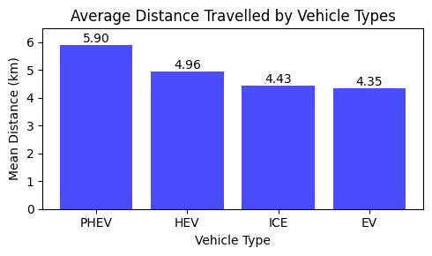
"""
Calculate the average HV Battery Voltage for each day:
- Convert the 'Date' column to datetime format.
- Group the DataFrame by day and compute the mean of 'HV Battery Voltage[V]'.
- Reset the index and convert the period index back to timestamps.
- Sort the resulting DataFrame by date.
"""
df['Date'] = pd.to_datetime(df['Date'])
df_eot = df.groupby(df['Date'].dt.to_period('D'))['HV Battery Voltage[V]'].mean().reset_index()
df_eot['Date'] = df_eot['Date'].dt.to_timestamp()
df_eot = df_eot.sort_values(by='Date')
df_eot
'''
Plot the average HV Battery Voltage over time:
- Uses matplotlib to create a line plot of mean HV Battery Voltage per day.
- Sets figure size, axis labels, and title.
- Displays the plot.
'''
import matplotlib.pyplot as plt
plt.figure(figsize=(5, 3))
plt.plot(df_eot['Date'], df_eot['HV Battery Voltage[V]'], marker='o', linestyle='-', color='blue', alpha=0.7)
plt.title('Average HV Battery Voltage Over Time')
plt.xlabel('Date')
plt.ylabel('Mean HV Battery Voltage (V)')
plt.tight_layout()
plt.show()
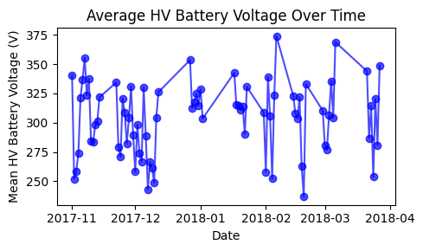
"""
Calculate the average Fuel Consumption Rate (FCR) for each day:
- Ensure the 'Date' column is in datetime format.
- Group the DataFrame by day and compute the mean of 'FCR'.
- Reset the index and convert the period index back to timestamps.
- Sort the resulting DataFrame by date.
"""
df['Date'] = pd.to_datetime(df['Date'])
df_eof = df.groupby(df['Date'].dt.to_period('D'))['FCR'].mean().reset_index()
df_eof['Date'] = df_eof['Date'].dt.to_timestamp()
df_eof = df_eof.sort_values(by='Date')
df_eof = df_eof[df_eof['Date'] != df_eof['Date'].min()] # Starting Date with FCR 0 is filtered out
df_eof
'''
Plot the average Fuel Consumption Rate (FCR) over time:
- Uses matplotlib to create a line plot of mean FCR per day.
- Sets figure size, axis labels, and title.
- Displays the plot.
'''
import matplotlib.pyplot as plt
plt.figure(figsize=(5, 3))
plt.plot(df_eof['Date'], df_eof['FCR'], marker='o', linestyle='-', color='blue', alpha=0.7)
plt.title('Average Fuel Rate Over Time')
plt.xlabel('Date')
plt.ylabel('Mean Fuel Rate (L/hr)')
plt.tight_layout()
plt.show()
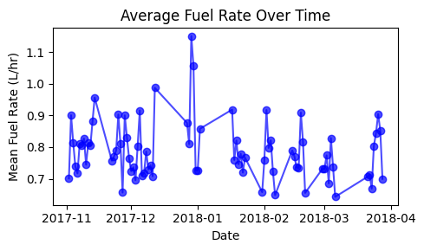
'''
Average Trip Count by Location (Heat Map)
'''
df_map = df.groupby(['Latitude[deg]', 'Longitude[deg]','Vehicle Type'])['Trip'].mean().reset_index()
df_map
df_map.head()
 | Latitude[deg] | Longitude[deg] | Vehicle Type | Trip
0 | 42.220305 | -83.760323 | ICE | 1661.0
1 | 42.220306 | -83.767207 | HEV | 1502.0
2 | 42.220316 | -83.734527 | ICE | 1955.0
3 | 42.220316 | -83.760919 | ICE | 1399.0
4 | 42.220321 | -83.796176 | ICE | 506.0
'''
The code visualized the average trip count by location for each vehicle type using a scatter plot on subplots.
It iterated over unique vehicle types, filtered the data for each type, and plotted longitude and latitude with color representing the logarithm of the average trip count.
It set subplot titles and axis labels, and added a colorbar for each subplot.
Finally, it adjusted the layout and displayed the figure.
'''
import matplotlib.pyplot as plt
vehicle_types = df_map['Vehicle Type'].unique()
fig, axes = plt.subplots(2, 2, figsize=(14, 10), sharex=True, sharey=True)
axes = axes.flatten()
for idx, vtype in enumerate(vehicle_types):
ax = axes[idx]
data = df_map[df_map['Vehicle Type'] == vtype]
sc = ax.scatter(
data['Longitude[deg]'],
data['Latitude[deg]'],
c=np.log(data['Trip']),
marker='o',
s=10,
cmap='RdYlGn_r'
)
ax.set_title(f'Average Trip Count: {vtype}')
ax.set_xlabel('Longitude (deg)')
ax.set_ylabel('Latitude (deg)')
plt.colorbar(sc, ax=ax, label='Log(Average Trip Count)')
plt.tight_layout()
plt.show()
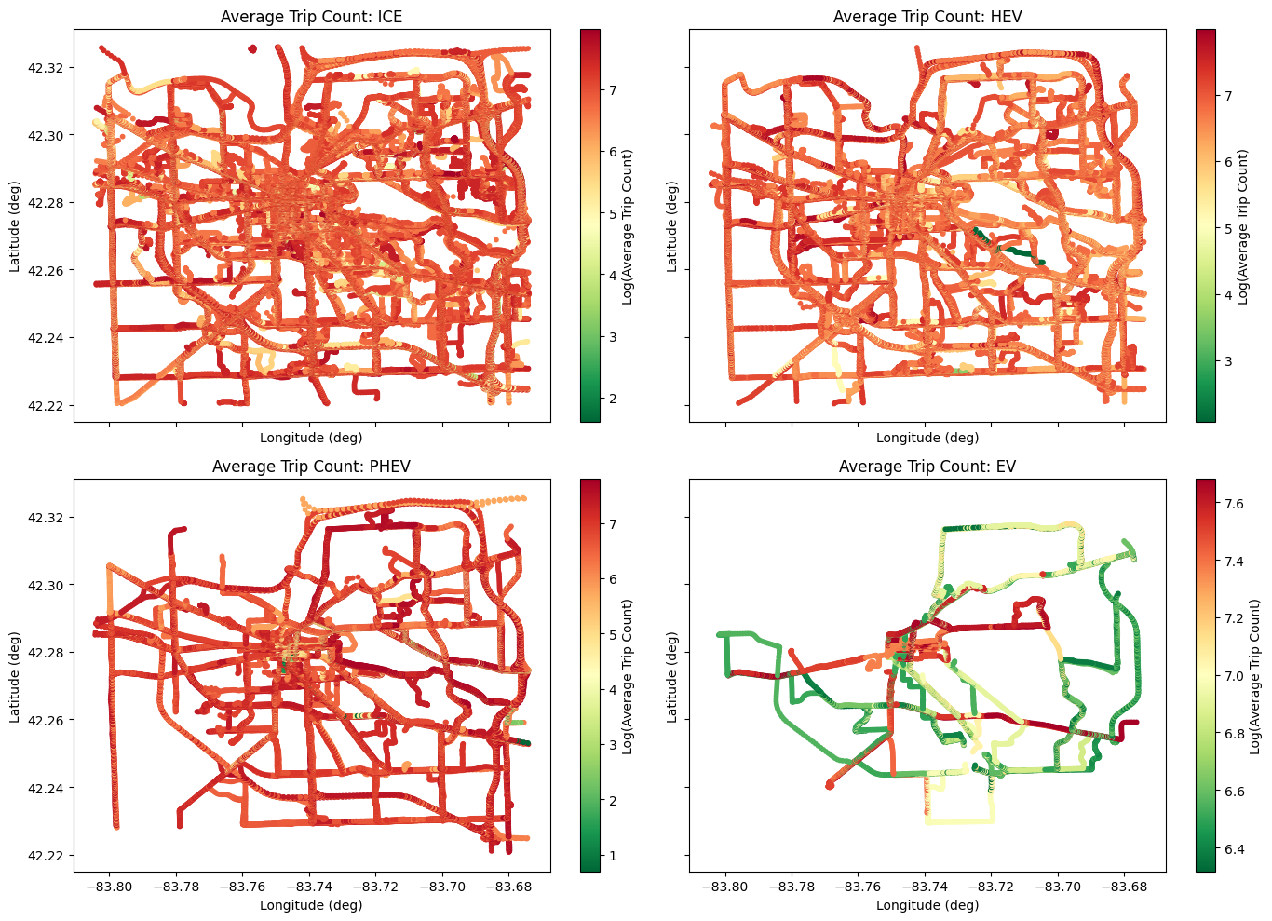
'''
Average Trips Over Time
'''
# Ensure 'Date' column is datetime type
df['Date'] = pd.to_datetime(df['Date'])
# Group by month and calculate average trips per month
df_trip = df.groupby(df['Date'].dt.to_period('M'))['Trip'].mean().reset_index()
df_trip['Date'] = df_trip['Date'].dt.to_timestamp()
df_trip = df_trip.sort_values(by='Date')
df_trip
 | Date | Trip
0 | 2017-11-01 | 810.211164
1 | 2017-12-01 | 889.058995
2 | 2018-01-01 | 1042.154448
3 | 2018-02-01 | 1164.122802
4 | 2018-03-01 | 1278.197673
'''
Plot the average number of trips over time using a line plot.
Set figure size, plot the data with markers and lines, set the title and axis labels, adjust layout, and display the plot.
'''
import matplotlib.pyplot as plt
plt.figure(figsize=(10, 3))
plt.plot(df_trip['Date'], df_trip['Trip'], marker='o', linestyle='-', color='blue', alpha=0.7)
plt.title('Average Trips Over Time')
plt.xlabel('Date')
plt.ylabel('Average Trips')
plt.tight_layout()
plt.show()
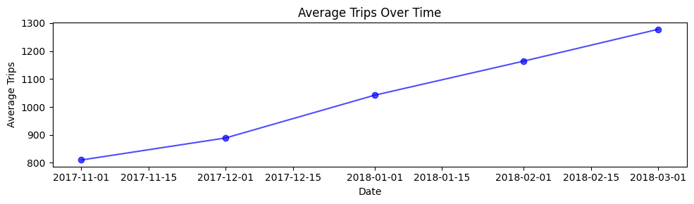
push_df_to_s3_parquet(df, 'Cleaned up VED Source Data/df_VED.parquet')
DataFrame uploaded to s3://s3aravindh973515031797/Cleaned up VED Source Data/df_VED.parquet

6. Exploratory Data Analysis
- Correlations: Identified strong relationships between energy consumption and dynamic variables like Vehicle Speed, Engine RPM, and Absolute Load.
- Visualizations: Mapped trip density via heatmaps and analyzed trends in battery voltage and fuel rates over time.
'''
Data exploration of Battery Power, Fuel Consumption Rate (FCR) and Battery SOC using the features Battery Power, AC Power, Heater Power with respect to OAT_Category and Vehicle Type
'''
df_SOC = df.groupby(['OAT_Category', 'Vehicle Type'])[
['HV Battery Power[Watts]', 'Air Conditioning Power[Watts]', 'Heater Power[Watts]','HV Battery SOC[%]','FCR']
].mean().reset_index().sort_values(by='HV Battery SOC[%]', ascending=False)
df_SOC
'''
Data exploration of Battery Power, Fuel Consumption Rate (FCR) using the features below with respect to Trip and Vehicle Type
'''
df_EC_trip = df.groupby(['Trip','Vehicle Type'])[
['Latitude[deg]',
'Longitude[deg]',
'Air Conditioning Power[Watts]',
'Heater Power[Watts]',
'Vehicle Speed[km/h]',
'Distance[km]',
'Engine RPM[RPM]',
'OAT[DegC]',
'Generalized_Weight',
'FCR',
'HV Battery Power[Watts]',
'MAF[g/sec]',
'Absolute Load[%]',
'Short Term Fuel Trim Bank 1[%]',
'Short Term Fuel Trim Bank 2[%]',
'Long Term Fuel Trim Bank 1[%]',
'Long Term Fuel Trim Bank 2[%]'
]
].mean().reset_index().sort_values(by=['FCR','HV Battery Power[Watts]'], ascending=False)
df_EC_trip
'''
Data exploration of Battery Power, Fuel Consumption Rate (FCR) using the features below with respect to Date (Month) and Vehicle Type
'''
df_EC_time = df.groupby([df['Date'].dt.to_period('M'), 'Vehicle Type'])[
['Latitude[deg]',
'Longitude[deg]',
'Air Conditioning Power[Watts]',
'Heater Power[Watts]',
'Vehicle Speed[km/h]',
'Distance[km]',
'Engine RPM[RPM]',
'OAT[DegC]',
'Generalized_Weight',
'FCR',
'HV Battery Power[Watts]',
'MAF[g/sec]',
'Absolute Load[%]',
'Short Term Fuel Trim Bank 1[%]',
'Short Term Fuel Trim Bank 2[%]',
'Long Term Fuel Trim Bank 1[%]',
'Long Term Fuel Trim Bank 2[%]']
].mean().reset_index().sort_values(
by=['Date', 'FCR', 'HV Battery Power[Watts]'],
)
df_EC_time
'''
Data exploration of Battery Power, Fuel Consumption Rate (FCR) using the features below with respect to Date and Vehicle Type
'''
df_EC_time = df.groupby([df['Date'].dt.to_period('D'), 'Vehicle Type'])[
['Latitude[deg]',
'Longitude[deg]',
'Air Conditioning Power[Watts]',
'Heater Power[Watts]',
'Vehicle Speed[km/h]',
'Distance[km]',
'Engine RPM[RPM]',
'OAT[DegC]',
'Generalized_Weight',
'FCR',
'HV Battery Power[Watts]',
'MAF[g/sec]',
'Absolute Load[%]',
'Short Term Fuel Trim Bank 1[%]',
'Short Term Fuel Trim Bank 2[%]',
'Long Term Fuel Trim Bank 1[%]',
'Long Term Fuel Trim Bank 2[%]']
].mean().reset_index().sort_values(
by=['Date', 'FCR', 'HV Battery Power[Watts]'],
)
df_EC_time
'''
Data exploration of Battery Power, Fuel Consumption Rate (FCR) using the features Speed, Absolute Load[%], Engine RPM, OAT, Generalized_Weight with respect to Latitude, Longitude and Vehicle Type
'''
df_la_lo = df.groupby(['Latitude[deg]','Longitude[deg]','Vehicle Type'])[
['Vehicle Speed[km/h]', 'Absolute Load[%]','Engine RPM[RPM]','OAT[DegC]','Generalized_Weight','FCR','HV Battery Power[Watts]']
].mean().reset_index().sort_values(by=['FCR','HV Battery Power[Watts]'], ascending=False)
df_la_lo
'''
ICE, HEV, EV and PHEV Analysis (Distance vs FCR and HV Battery Power[Watts]
'''
df_EC_trip_ICE_HEV = df_EC_trip[df_EC_trip['Vehicle Type'].isin(['ICE','HEV'])]
df_EC_trip_EV_PHEV = df_EC_trip[df_EC_trip['Vehicle Type'].isin(['EV','PHEV'])]
df_EC_time_ICE_HEV = df_EC_time[df_EC_time['Vehicle Type'].isin(['ICE','HEV'])]
df_EC_time_EV_PHEV = df_EC_time[df_EC_time['Vehicle Type'].isin(['EV','PHEV'])]
for i in df_EC_trip_ICE_HEV.columns:
print(f"Unique values in column '{i}':")
print(df_EC_trip_ICE_HEV[i].unique())
print(df_EC_trip_ICE_HEV[i].value_counts())
for i in df_EC_trip_EV_PHEV.columns:
print(f"Unique values in column '{i}':")
print(df_EC_trip_EV_PHEV[i].unique())
print(df_EC_trip_EV_PHEV[i].value_counts())
'''
Created Scatter plots to show Energy Consumption Comparison by Vehicle Type by Trip
Distance vs FCR for ICE and HEV
Distance vs HV Battery Power[Watts] for EV and PHEV
'''
import matplotlib.pyplot as plt
# Create a 1x2 subplot
fig, axes = plt.subplots(1, 2, figsize=(11, 5), sharex=False)
# ---------- Subplot 1: ICE vs HEV ----------
ax1 = axes[0]
ax1.scatter(
df_EC_trip_ICE_HEV[df_EC_trip_ICE_HEV['Vehicle Type'] == 'ICE']['Distance[km]'],
df_EC_trip_ICE_HEV[df_EC_trip_ICE_HEV['Vehicle Type'] == 'ICE']['FCR'],
alpha=0.5,
c='blue',
label='ICE'
)
ax1.scatter(
df_EC_trip_ICE_HEV[df_EC_trip_ICE_HEV['Vehicle Type'] == 'HEV']['Distance[km]'],
df_EC_trip_ICE_HEV[df_EC_trip_ICE_HEV['Vehicle Type'] == 'HEV']['FCR'],
alpha=0.5,
c='green',
label='HEV'
)
ax1.set_xlabel('Distance (km)')
ax1.set_ylabel('Fuel Consumption Rate (L/hr)')
ax1.set_title('ICE vs HEV')
ax1.legend()
ax1.grid(True)
# ---------- Subplot 2: EV vs PHEV ----------
ax2 = axes[1]
ax2.scatter(
df_EC_trip_EV_PHEV[df_EC_trip_EV_PHEV['Vehicle Type'] == 'PHEV']['Distance[km]'],
df_EC_trip_EV_PHEV[df_EC_trip_EV_PHEV['Vehicle Type'] == 'PHEV']['HV Battery Power[Watts]'],
alpha=0.5,
c='red',
label='PHEV'
)
ax2.scatter(
df_EC_trip_EV_PHEV[df_EC_trip_EV_PHEV['Vehicle Type'] == 'EV']['Distance[km]'],
df_EC_trip_EV_PHEV[df_EC_trip_EV_PHEV['Vehicle Type'] == 'EV']['HV Battery Power[Watts]'],
alpha=0.5,
c='orange',
label='EV'
)
ax2.set_xlabel('Distance (km)')
ax2.set_ylabel('HV Battery Power (Watts)')
ax2.set_title('EV vs PHEV')
ax2.legend()
ax2.grid(True)
# ---------- Shared Title ----------
fig.suptitle('Energy Consumption Comparison by Vehicle Type over Trip', fontsize=14, fontweight='bold')
plt.tight_layout(rect=[0, 0, 1, 1]) # Leave space for suptitle
plt.show()
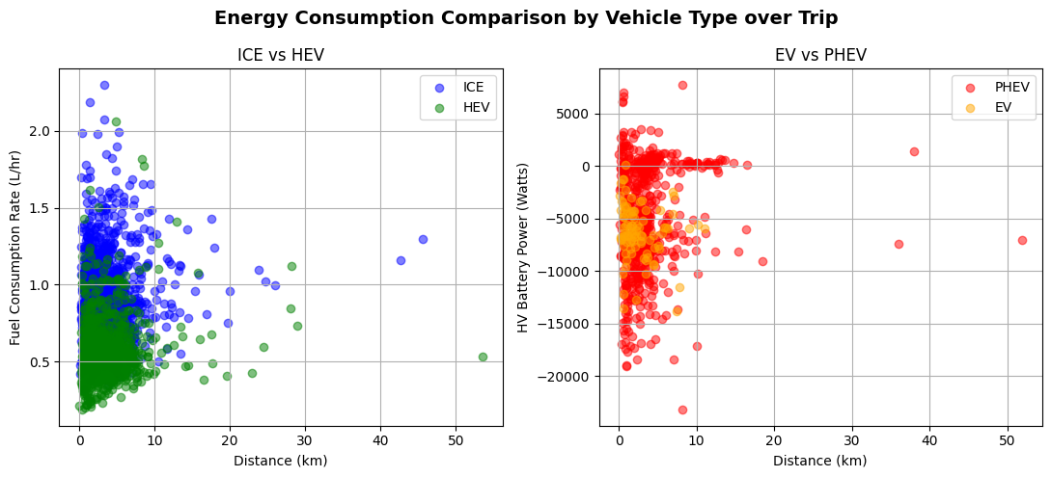
'''
Created Scatter plots to show Energy Consumption Comparison by Vehicle Type over Time
Distance vs FCR for ICE and HEV
Distance vs HV Battery Power[Watts] for EV and PHEV
'''
import matplotlib.pyplot as plt
# Create a 1x2 subplot
fig, axes = plt.subplots(1, 2, figsize=(11, 5), sharex=False)
# ---------- Subplot 1: ICE vs HEV ----------
ax1 = axes[0]
ax1.scatter(
df_EC_time_ICE_HEV[df_EC_time_ICE_HEV['Vehicle Type'] == 'ICE']['Distance[km]'],
df_EC_time_ICE_HEV[df_EC_time_ICE_HEV['Vehicle Type'] == 'ICE']['FCR'],
alpha=0.5,
c='blue',
label='ICE'
)
ax1.scatter(
df_EC_time_ICE_HEV[df_EC_time_ICE_HEV['Vehicle Type'] == 'HEV']['Distance[km]'],
df_EC_time_ICE_HEV[df_EC_time_ICE_HEV['Vehicle Type'] == 'HEV']['FCR'],
alpha=0.5,
c='green',
label='HEV'
)
ax1.set_xlabel('Distance (km)')
ax1.set_ylabel('Fuel Consumption Rate (L/hr)')
ax1.set_title('ICE vs HEV')
ax1.legend()
ax1.grid(True)
# ---------- Subplot 2: EV vs PHEV ----------
ax2 = axes[1]
ax2.scatter(
df_EC_time_EV_PHEV[df_EC_time_EV_PHEV['Vehicle Type'] == 'PHEV']['Distance[km]'],
df_EC_time_EV_PHEV[df_EC_time_EV_PHEV['Vehicle Type'] == 'PHEV']['HV Battery Power[Watts]'],
alpha=0.5,
c='red',
label='PHEV'
)
ax2.scatter(
df_EC_time_EV_PHEV[df_EC_time_EV_PHEV['Vehicle Type'] == 'EV']['Distance[km]'],
df_EC_time_EV_PHEV[df_EC_time_EV_PHEV['Vehicle Type'] == 'EV']['HV Battery Power[Watts]'],
alpha=0.5,
c='orange',
label='EV'
)
ax2.set_xlabel('Distance (km)')
ax2.set_ylabel('HV Battery Power (Watts)')
ax2.set_title('EV vs PHEV')
ax2.legend()
ax2.grid(True)
# ---------- Shared Title ----------
fig.suptitle('Energy Consumption Comparison by Vehicle Type over Time', fontsize=14, fontweight='bold')
plt.tight_layout(rect=[0, 0, 1, 1]) # Leave space for suptitle
plt.show()
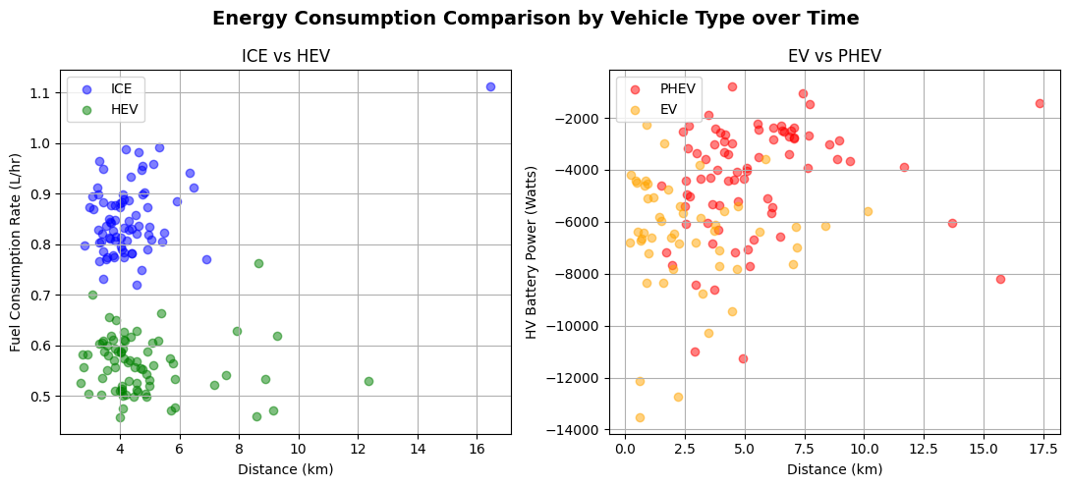
'''
Individual Vehicle Type analysis by Trip: df_ICE, df_HEV, df_EV, df_PHEV
'''
# Run for trip
df_ICE = df_EC_trip_ICE_HEV[df_EC_trip_ICE_HEV['Vehicle Type'] == 'ICE']
df_HEV = df_EC_trip_ICE_HEV[df_EC_trip_ICE_HEV['Vehicle Type'] == 'HEV']
df_EV = df_EC_trip_EV_PHEV[df_EC_trip_EV_PHEV['Vehicle Type'] == 'EV']
df_PHEV = df_EC_trip_EV_PHEV[df_EC_trip_EV_PHEV['Vehicle Type'] == 'PHEV']
'''
Individual Vehicle Type analysis by Time: df_ICE, df_HEV, df_EV, df_PHEV
# Run for time
df_ICE = df_EC_time_ICE_HEV[df_EC_time_ICE_HEV['Vehicle Type'] == 'ICE']
df_HEV = df_EC_time_ICE_HEV[df_EC_time_ICE_HEV['Vehicle Type'] == 'HEV']
df_EV = df_EC_time_EV_PHEV[df_EC_time_EV_PHEV['Vehicle Type'] == 'EV']
df_PHEV = df_EC_time_EV_PHEV[df_EC_time_EV_PHEV['Vehicle Type'] == 'PHEV']
'''
"\nIndividual Vehicle Type analysis by Time: df_ICE, df_HEV, df_EV, df_PHEV\n\n# Run for time\ndf_ICE = df_EC_time_ICE_HEV[df_EC_time_ICE_HEV['Vehicle Type'] == 'ICE']\ndf_HEV = df_EC_time_ICE_HEV[df_EC_time_ICE_HEV['Vehicle Type'] == 'HEV']\ndf_EV = df_EC_time_EV_PHEV[df_EC_time_EV_PHEV['Vehicle Type'] == 'EV']\ndf_PHEV = df_EC_time_EV_PHEV[df_EC_time_EV_PHEV['Vehicle Type'] == 'PHEV']\n\n"
'''
Handled Missing values as it is required during Regression
'''
# show the columns with missing values in df_ICE and df_HEV
missing_values = df_ICE.isnull().sum()
print("\nMissing values in ICE Vehicles:")
print(missing_values[missing_values > 0])
missing_values = df_HEV.isnull().sum()
print("\nMissing values in HEV Vehicles:")
print(missing_values[missing_values > 0])
missing_values = df_EV.isnull().sum()
print("\nMissing values in EV Vehicles:")
print(missing_values[missing_values > 0])
missing_values = df_PHEV.isnull().sum()
print("\nMissing values in PHEV Vehicles:")
print(missing_values[missing_values > 0])
Missing values in ICE Vehicles:
Air Conditioning Power[Watts] 1850
Heater Power[Watts] 1850
Vehicle Speed[km/h] 2
Distance[km] 2
Engine RPM[RPM] 2
OAT[DegC] 1148
Generalized_Weight 92
FCR 212
HV Battery Power[Watts] 1850
MAF[g/sec] 207
Absolute Load[%] 156
Short Term Fuel Trim Bank 1[%] 80
Short Term Fuel Trim Bank 2[%] 833
Long Term Fuel Trim Bank 1[%] 87
Long Term Fuel Trim Bank 2[%] 852
dtype: int64
Missing values in HEV Vehicles:
Air Conditioning Power[Watts] 1164
Heater Power[Watts] 1164
Vehicle Speed[km/h] 1
Distance[km] 1
Engine RPM[RPM] 1
OAT[DegC] 631
FCR 82
HV Battery Power[Watts] 1164
MAF[g/sec] 7
Absolute Load[%] 6
Short Term Fuel Trim Bank 1[%] 74
Short Term Fuel Trim Bank 2[%] 1068
Long Term Fuel Trim Bank 1[%] 78
Long Term Fuel Trim Bank 2[%] 1079
dtype: int64
Missing values in EV Vehicles:
Engine RPM[RPM] 95
FCR 95
MAF[g/sec] 95
Absolute Load[%] 95
Short Term Fuel Trim Bank 1[%] 95
Short Term Fuel Trim Bank 2[%] 95
Long Term Fuel Trim Bank 1[%] 95
Long Term Fuel Trim Bank 2[%] 95
dtype: int64
Missing values in PHEV Vehicles:
Air Conditioning Power[Watts] 184
Heater Power[Watts] 618
FCR 390
MAF[g/sec] 184
Absolute Load[%] 618
Short Term Fuel Trim Bank 1[%] 618
Short Term Fuel Trim Bank 2[%] 618
Long Term Fuel Trim Bank 1[%] 618
Long Term Fuel Trim Bank 2[%] 618
dtype: int64
# Handle missing values
df_ICE.fillna({
'OAT[DegC]': 15,
'Generalized_Weight': df_ICE['Generalized_Weight'].mean(),
'FCR': df_ICE['FCR'].mean(),
'HV Battery Power[Watts]': 0.0, # ICE vehicles typically do not have HV Battery Power
'Air Conditioning Power[Watts]' : 0,
'Heater Power[Watts]': df_ICE['Heater Power[Watts]'].mean(),
'MAF[g/sec]': df_ICE['MAF[g/sec]'].mean(),
'Absolute Load[%]': df_ICE['Absolute Load[%]'].mean(),
'Short Term Fuel Trim Bank 1[%]': df_ICE['Short Term Fuel Trim Bank 1[%]'].mean(),
'Short Term Fuel Trim Bank 2[%]': df_ICE['Short Term Fuel Trim Bank 2[%]'].mean(),
'Long Term Fuel Trim Bank 1[%]': df_ICE['Long Term Fuel Trim Bank 1[%]'].mean(),
'Long Term Fuel Trim Bank 2[%]': df_ICE['Long Term Fuel Trim Bank 2[%]'].mean(),
'Vehicle Speed[km/h]': df_ICE['Vehicle Speed[km/h]'].mean(),
'Distance[km]': df_ICE['Distance[km]'].mean(),
'Engine RPM[RPM]': df_ICE['Engine RPM[RPM]'].mean()
}, inplace=True)
df_HEV.fillna({
'OAT[DegC]': 15,
'FCR': df_HEV['FCR'].mean(),
'HV Battery Power[Watts]': 0,
'Air Conditioning Power[Watts]': 0,
'Heater Power[Watts]': 0,
'MAF[g/sec]': df_HEV['MAF[g/sec]'].mean(),
'Absolute Load[%]': df_HEV['Absolute Load[%]'].mean(),
'Short Term Fuel Trim Bank 1[%]': df_HEV['Short Term Fuel Trim Bank 1[%]'].mean(),
'Short Term Fuel Trim Bank 2[%]': df_HEV['Short Term Fuel Trim Bank 2[%]'].mean(),
'Long Term Fuel Trim Bank 1[%]': df_HEV['Long Term Fuel Trim Bank 1[%]'].mean(),
'Long Term Fuel Trim Bank 2[%]': df_HEV['Long Term Fuel Trim Bank 2[%]'].mean(),'Vehicle Speed[km/h]': df_ICE['Vehicle Speed[km/h]'].mean(),
'Distance[km]': df_HEV['Distance[km]'].mean(),
'Engine RPM[RPM]': df_HEV['Engine RPM[RPM]'].mean()
}, inplace=True)
df_EV.fillna({
'Engine RPM[RPM]': 0, # EVs typically do not have engine RPM
'FCR': 0, # EVs typically do not have fuel consumption rate
'MAF[g/sec]': 0,
'Absolute Load[%]': 0,
'Short Term Fuel Trim Bank 1[%]': 0,
'Short Term Fuel Trim Bank 2[%]': 0,
'Long Term Fuel Trim Bank 1[%]': 0,
'Long Term Fuel Trim Bank 2[%]': 0
}, inplace=True)
df_PHEV.fillna({
'OAT[DegC]': 15,
'FCR': df_PHEV['FCR'].mean(),
'HV Battery Power[Watts]': 0.0, # PHEVs typically do not have HV Battery Power
'Air Conditioning Power[Watts]': 0,
'Heater Power[Watts]': 0,
'MAF[g/sec]': df_PHEV['MAF[g/sec]'].mean(),
'Absolute Load[%]': df_PHEV['Absolute Load[%]'].mean(),
'Short Term Fuel Trim Bank 1[%]': df_PHEV['Short Term Fuel Trim Bank 1[%]'].mean(),
'Short Term Fuel Trim Bank 2[%]': 0,
'Long Term Fuel Trim Bank 1[%]': df_PHEV['Long Term Fuel Trim Bank 1[%]'].mean(),
'Long Term Fuel Trim Bank 2[%]': 0
}, inplace=True)
df_ICE.describe()
 | Trip | Latitude[deg] | Longitude[deg] | Air Conditioning Power[Watts] | Heater Power[Watts] | Vehicle Speed[km/h] | Distance[km] | Engine RPM[RPM] | OAT[DegC] | Generalized_Weight | FCR | HV Battery Power[Watts] | MAF[g/sec] | Absolute Load[%] | Short Term Fuel Trim Bank 1[%] | Short Term Fuel Trim Bank 2[%] | Long Term Fuel Trim Bank 1[%] | Long Term Fuel Trim Bank 2[%]
count | 1850.000000 | 1850.000000 | 1850.000000 | 1850.0 | 0.0 | 1850.000000 | 1850.000000 | 1850.000000 | 1850.000000 | 1850.000000 | 1850.000000 | 1850.0 | 1850.000000 | 1850.000000 | 1850.000000 | 1850.000000 | 1850.000000 | 1850.000000
mean | 1104.844865 | 42.270912 | -83.730017 | 0.0 | NaN | 39.015194 | 3.309058 | 1419.302311 | 9.775714 | 3493.050820 | 0.873750 | 0.0 | 12.391077 | 31.495418 | 0.417175 | -0.025516 | 1.531788 | 1.545437
std | 630.409547 | 0.014450 | 0.024162 | 0.0 | NaN | 11.758976 | 2.884161 | 211.698176 | 7.752689 | 554.956111 | 0.228333 | 0.0 | 3.437400 | 4.730420 | 2.115002 | 3.133955 | 3.710839 | 3.170008
min | 5.000000 | 42.228167 | -83.799060 | 0.0 | NaN | 2.315187 | 0.138885 | 672.498164 | -37.615797 | 2500.000000 | 0.320519 | 0.0 | 4.235972 | 17.194966 | -7.173713 | -82.059717 | -16.385135 | -10.732110
25% | 597.250000 | 42.261734 | -83.743438 | 0.0 | NaN | 32.237114 | 1.779731 | 1294.994079 | 3.455565 | 3097.581051 | 0.731963 | 0.0 | 10.277281 | 28.595927 | -0.581242 | -0.398955 | -0.506914 | 0.789335
50% | 1066.500000 | 42.271157 | -83.729257 | 0.0 | NaN | 37.594433 | 2.759217 | 1394.228477 | 15.000000 | 3500.000000 | 0.867654 | 0.0 | 12.151134 | 31.495418 | 0.099822 | -0.025516 | 1.510724 | 1.545437
75% | 1560.750000 | 42.280541 | -83.714530 | 0.0 | NaN | 44.196954 | 4.063893 | 1510.973719 | 15.000000 | 3746.313644 | 0.954025 | 0.0 | 13.496370 | 33.783841 | 0.926757 | -0.025516 | 3.590080 | 1.621051
max | 2898.000000 | 42.317667 | -83.676301 | 0.0 | NaN | 104.139269 | 45.644997 | 2696.845238 | 23.299127 | 6000.000000 | 2.298379 | 0.0 | 31.219119 | 65.068105 | 17.910560 | 27.945243 | 23.878614 | 24.087992

df_HEV.describe()
 | Trip | Latitude[deg] | Longitude[deg] | Air Conditioning Power[Watts] | Heater Power[Watts] | Vehicle Speed[km/h] | Distance[km] | Engine RPM[RPM] | OAT[DegC] | Generalized_Weight | FCR | HV Battery Power[Watts] | MAF[g/sec] | Absolute Load[%] | Short Term Fuel Trim Bank 1[%] | Short Term Fuel Trim Bank 2[%] | Long Term Fuel Trim Bank 1[%] | Long Term Fuel Trim Bank 2[%]
count | 1164.000000 | 1164.000000 | 1164.000000 | 1164.0 | 1164.0 | 1164.000000 | 1164.000000 | 1164.000000 | 1164.000000 | 1164.000000 | 1164.000000 | 1164.0 | 1164.000000 | 1164.000000 | 1164.000000 | 1164.000000 | 1164.000000 | 1164.000000
mean | 983.212199 | 42.271584 | -83.732861 | 0.0 | 0.0 | 44.398181 | 3.449325 | 1090.477207 | 8.854155 | 3236.013017 | 0.566654 | 0.0 | 8.335685 | 27.302309 | -0.671801 | 0.032357 | -0.127626 | -1.331489
std | 515.772796 | 0.017908 | 0.027968 | 0.0 | 0.0 | 11.139853 | 3.189938 | 262.692593 | 7.583781 | 401.061570 | 0.182241 | 0.0 | 2.696189 | 8.164484 | 1.263061 | 0.387498 | 2.166047 | 0.532416
min | 8.000000 | 42.228755 | -83.799822 | 0.0 | 0.0 | 0.000000 | 0.000000 | 265.103448 | -13.000000 | 2000.000000 | 0.188280 | 0.0 | 2.775069 | 8.867478 | -7.945980 | -3.556068 | -7.110596 | -6.281250
25% | 603.750000 | 42.260316 | -83.751087 | 0.0 | 0.0 | 37.914713 | 1.616139 | 915.507061 | 2.092175 | 3000.000000 | 0.463180 | 0.0 | 6.784858 | 23.384086 | -1.157698 | 0.032357 | -1.487380 | -1.331489
50% | 939.500000 | 42.273864 | -83.730601 | 0.0 | 0.0 | 43.209330 | 2.870381 | 1071.343876 | 15.000000 | 3090.897992 | 0.543431 | 0.0 | 7.835598 | 26.880582 | -0.557701 | 0.032357 | -0.127626 | -1.331489
75% | 1289.500000 | 42.283531 | -83.711190 | 0.0 | 0.0 | 49.451699 | 4.346975 | 1253.673305 | 15.000000 | 3500.000000 | 0.617360 | 0.0 | 9.159218 | 30.394540 | -0.075793 | 0.032357 | 1.175747 | -1.331489
max | 2932.000000 | 42.316757 | -83.679435 | 0.0 | 0.0 | 96.011730 | 53.547970 | 2546.437500 | 17.314754 | 5000.000000 | 2.062937 | 0.0 | 29.435711 | 154.924407 | 7.597805 | 4.540215 | 9.791153 | 3.458137

df_PHEV.describe()
 | Trip | Latitude[deg] | Longitude[deg] | Air Conditioning Power[Watts] | Heater Power[Watts] | Vehicle Speed[km/h] | Distance[km] | Engine RPM[RPM] | OAT[DegC] | Generalized_Weight | FCR | HV Battery Power[Watts] | MAF[g/sec] | Absolute Load[%] | Short Term Fuel Trim Bank 1[%] | Short Term Fuel Trim Bank 2[%] | Long Term Fuel Trim Bank 1[%] | Long Term Fuel Trim Bank 2[%]
count | 618.000000 | 618.000000 | 618.000000 | 618.000000 | 618.0 | 618.000000 | 618.000000 | 618.000000 | 618.000000 | 618.000000 | 618.000000 | 618.000000 | 618.000000 | 0.0 | 0.0 | 618.0 | 0.0 | 618.0
mean | 1027.393204 | 42.273889 | -83.723610 | 27.315283 | 0.0 | 42.794632 | 3.630850 | 452.272555 | 1.400766 | 3800.047327 | 1.310643 | -5064.759049 | 4.287581 | NaN | NaN | 0.0 | NaN | 0.0
std | 579.918702 | 0.019057 | 0.025063 | 165.769118 | 0.0 | 12.024760 | 3.956138 | 482.111349 | 6.943586 | 366.069026 | 1.188460 | 5028.038070 | 3.193834 | NaN | NaN | 0.0 | NaN | 0.0
min | 2.000000 | 42.229778 | -83.799610 | 0.000000 | 0.0 | 14.977123 | 0.045077 | 0.000000 | -20.775568 | 3000.000000 | 0.000000 | -23172.896785 | 0.170000 | NaN | NaN | 0.0 | NaN | 0.0
25% | 590.000000 | 42.259793 | -83.739610 | 0.000000 | 0.0 | 35.673644 | 1.383368 | 0.000000 | -3.000000 | 3806.372686 | 1.191592 | -8178.594596 | 1.419221 | NaN | NaN | 0.0 | NaN | 0.0
50% | 955.500000 | 42.277656 | -83.719121 | 0.000000 | 0.0 | 41.934884 | 2.855270 | 346.214084 | 2.500000 | 4000.000000 | 1.310643 | -5249.647151 | 4.287581 | NaN | NaN | 0.0 | NaN | 0.0
75% | 1457.750000 | 42.286126 | -83.707332 | 0.000000 | 0.0 | 47.761296 | 4.189252 | 783.824850 | 6.237949 | 4000.000000 | 1.310643 | -287.400366 | 5.717953 | NaN | NaN | 0.0 | NaN | 0.0
max | 2432.000000 | 42.319032 | -83.678096 | 2008.721360 | 0.0 | 101.025354 | 51.932325 | 3360.000000 | 26.144342 | 4000.000000 | 7.870564 | 7689.712572 | 40.230000 | NaN | NaN | 0.0 | NaN | 0.0

df_EV.describe()
 | Trip | Latitude[deg] | Longitude[deg] | Air Conditioning Power[Watts] | Heater Power[Watts] | Vehicle Speed[km/h] | Distance[km] | Engine RPM[RPM] | OAT[DegC] | Generalized_Weight | FCR | HV Battery Power[Watts] | MAF[g/sec] | Absolute Load[%] | Short Term Fuel Trim Bank 1[%] | Short Term Fuel Trim Bank 2[%] | Long Term Fuel Trim Bank 1[%] | Long Term Fuel Trim Bank 2[%]
count | 95.000000 | 95.000000 | 95.000000 | 95.000000 | 95.000000 | 95.000000 | 95.000000 | 95.0 | 95.000000 | 95.0 | 95.0 | 95.000000 | 95.0 | 95.0 | 95.0 | 95.0 | 95.0 | 95.0
mean | 1274.105263 | 42.271297 | -83.735505 | 451.206427 | 595.948098 | 38.120463 | 2.529701 | 0.0 | 2.758068 | 3500.0 | 0.0 | -6257.533768 | 0.0 | 0.0 | 0.0 | 0.0 | 0.0 | 0.0
std | 533.419428 | 0.017869 | 0.023455 | 389.532228 | 766.175778 | 12.568234 | 2.356622 | 0.0 | 6.301469 | 0.0 | 0.0 | 2555.379815 | 0.0 | 0.0 | 0.0 | 0.0 | 0.0 | 0.0
min | 554.000000 | 42.231394 | -83.792418 | 0.000000 | 0.000000 | 3.490542 | 0.174693 | 0.0 | -13.153201 | 3500.0 | 0.0 | -13857.507261 | 0.0 | 0.0 | 0.0 | 0.0 | 0.0 | 0.0
25% | 737.000000 | 42.260824 | -83.749556 | 79.973193 | 0.000000 | 30.045382 | 0.879309 | 0.0 | -2.118267 | 3500.0 | 0.0 | -7292.243492 | 0.0 | 0.0 | 0.0 | 0.0 | 0.0 | 0.0
50% | 1149.000000 | 42.272546 | -83.736166 | 370.610687 | 307.565789 | 39.347546 | 1.704800 | 0.0 | 2.894870 | 3500.0 | 0.0 | -6377.998333 | 0.0 | 0.0 | 0.0 | 0.0 | 0.0 | 0.0
75% | 1806.000000 | 42.284664 | -83.723986 | 785.391036 | 852.601621 | 45.667038 | 3.458791 | 0.0 | 7.279737 | 3500.0 | 0.0 | -4515.746667 | 0.0 | 0.0 | 0.0 | 0.0 | 0.0 | 0.0
max | 2165.000000 | 42.307465 | -83.682248 | 1224.153166 | 3545.282369 | 67.570289 | 11.031075 | 0.0 | 15.156609 | 3500.0 | 0.0 | 73.835938 | 0.0 | 0.0 | 0.0 | 0.0 | 0.0 | 0.0
"""
Created a function to Perform linear regression using given features and target.
Prints model coefficients, regression equation, and evaluation metrics.
Returns:
model: Trained linear regression model.
X_test, y_test: Test data for further analysis.
y_pred: Predictions on test set.
regression_line_model: Model for plotting Actual vs Predicted regression line.
"""
from sklearn.model_selection import train_test_split
from sklearn.linear_model import LinearRegression
from sklearn.metrics import r2_score, mean_absolute_error, mean_squared_error
import numpy as np
def linear_regression_analysis(features, target, X, y):
# Split data
X_train, X_test, y_train, y_test = train_test_split(
X, y, test_size=0.2, random_state=42
)
# Fit linear model
model = LinearRegression()
model.fit(X_train, y_train)
y_pred = model.predict(X_test)
# Print model coefficients
print("Model Coefficients:")
for feature, coef in zip(features, model.coef_):
print(f" {feature}: {coef:.4f}")
# Print regression equation
equation = " + ".join([f"{coef:.4f}*{feature}" for feature, coef in zip(features, model.coef_)])
print(f"\nRegression Equation:")
print(f" Slope of the regression line: {model.coef_}")
print(f" Intercept: {model.intercept_:.4f}")
print(f" Target Variable: {target}")
print(f" {target} = {equation} + {model.intercept_:.4f}\n")
# Evaluation metrics
r2 = r2_score(y_test, y_pred)
mae = mean_absolute_error(y_test, y_pred)
mse = mean_squared_error(y_test, y_pred)
rmse = np.sqrt(mse)
print("Evaluation Metrics:")
print(f" R² Score : {r2:.4f}")
print(f" MAE : {mae:.4f}")
print(f" MSE : {mse:.4f}")
print(f" RMSE : {rmse:.4f}\n")
# Regression line for plotting (optional)
regression_line_model = LinearRegression()
regression_line_model.fit(y_test.values.reshape(-1, 1), y_pred)
return model, X_test, y_test, y_pred, regression_line_model

7. Linear Regression to Predict Energy Consumption in ICE, HEV, EV and PHEV Vehicles
"""
Scenario 1 for ICE
Performed linear regression analysis to predict FCR for ICE vehicles using 'Vehicle Speed[km/h]' and 'Distance[km]' as features.
Trained the model and obtained predictions on the test set.
Plotted Actual vs Predicted FCR values and the regression line.
Displayed evaluation metrics (R², MAE, MSE, RMSE) on the plot.
"""
#features = ['Vehicle Speed[km/h]','Distance[km]', 'Engine RPM[RPM]']
features = ['Vehicle Speed[km/h]','Distance[km]']
target = 'FCR'
X = df_ICE[features]
y = df_ICE[target]
model, X_test, y_test, y_pred, regression_line_model = linear_regression_analysis(features, target, X, y)
# plotting the results
import numpy as np
import matplotlib.pyplot as plt
from sklearn.metrics import r2_score, mean_absolute_error, mean_squared_error
y_test_sorted = np.sort(y_test)
y_line = regression_line_model.predict(y_test_sorted.reshape(-1, 1))
plt.figure(figsize=(6, 3))
plt.scatter(y_test, y_pred, alpha=0.5, color='blue')
# Plotted the regression line
plt.plot(y_test_sorted, y_line, color='red', linestyle='--', linewidth=2, label='Regression Line')
plt.title('Actual vs Predicted FCR for ICE Vehicles')
plt.xlabel('Actual FCR (L/hr)')
plt.ylabel('Predicted FCR (L/hr)')
plt.text(1.20, 0.5, f'R²: {r2_score(y_test, y_pred):.4f}\nMAE: {mean_absolute_error(y_test, y_pred):.4f}\nMSE: {mean_squared_error(y_test, y_pred):.4f}\nRMSE: {np.sqrt(mean_squared_error(y_test, y_pred)):.4f}',
fontsize=10, ha='center', va='center', transform=plt.gca().transAxes, bbox=dict(facecolor='white', alpha=0.5))
plt.grid(True)
plt.tight_layout()
plt.show()
Model Coefficients:
Vehicle Speed[km/h]: 0.0095
Distance[km]: 0.0003
Regression Equation:
Slope of the regression line: [0.00948307 0.0002586 ]
Intercept: 0.5035
Target Variable: FCR
FCR = 0.0095*Vehicle Speed[km/h] + 0.0003*Distance[km] + 0.5035
Evaluation Metrics:
R² Score : 0.1874
MAE : 0.1436
MSE : 0.0345
RMSE : 0.1858
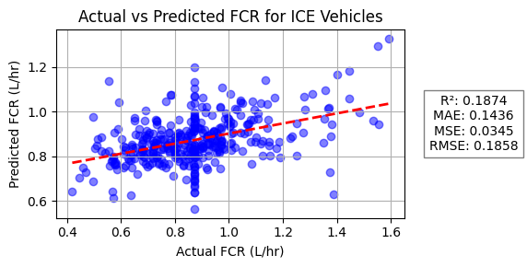
X = df_ICE[features]
print(X.head())
y = df_ICE[target]
print(y.head())
param = [model, X_test, y_test, y_pred, regression_line_model, y_test_sorted, y_line]
# print the value of the param variable using for loop
for i, value in enumerate(param):
print(f"Parameter {i}: {value}")
print() # Add a newline for better readability
"""
Scenario 2 for ICE
Performed linear regression analysis using selected features to predict FCR for ICE vehicles.
Plotted Actual vs Predicted FCR values and regression line.
Displayed evaluation metrics: R², MAE, MSE, and RMSE on the plot.
"""
features = ['Latitude[deg]','Longitude[deg]','Vehicle Speed[km/h]','Distance[km]', 'Engine RPM[RPM]', 'OAT[DegC]', 'Generalized_Weight']
target = 'FCR'
X = df_ICE[features]
y = df_ICE[target]
model, X_test, y_test, y_pred, regression_line_model = linear_regression_analysis(features, target, X, y)
# plotting the results
import numpy as np
import matplotlib.pyplot as plt
from sklearn.metrics import r2_score, mean_absolute_error, mean_squared_error
y_test_sorted = np.sort(y_test)
y_line = regression_line_model.predict(y_test_sorted.reshape(-1, 1))
plt.figure(figsize=(6, 3))
plt.scatter(y_test, y_pred, alpha=0.5, color='blue')
# Plotted the regression line
plt.plot(y_test_sorted, y_line, color='red', linestyle='--', linewidth=2, label='Regression Line')
plt.title('Actual vs Predicted FCR for ICE Vehicles')
plt.xlabel('Actual FCR (L/hr)')
plt.ylabel('Predicted FCR (L/hr)')
plt.text(1.20, 0.5, f'R²: {r2_score(y_test, y_pred):.4f}\nMAE: {mean_absolute_error(y_test, y_pred):.4f}\nMSE: {mean_squared_error(y_test, y_pred):.4f}\nRMSE: {np.sqrt(mean_squared_error(y_test, y_pred)):.4f}',
fontsize=10, ha='center', va='center', transform=plt.gca().transAxes, bbox=dict(facecolor='white', alpha=0.5))
plt.grid(True)
plt.tight_layout()
plt.show()
Model Coefficients:
Latitude[deg]: 0.0605
Longitude[deg]: 0.1722
Vehicle Speed[km/h]: 0.0074
Distance[km]: -0.0015
Engine RPM[RPM]: 0.0002
OAT[DegC]: 0.0011
Generalized_Weight: 0.0002
Regression Equation:
Slope of the regression line: [ 0.06045161 0.17222124 0.00735495 -0.00152155 0.00022506 0.00105238
0.00020136]
Intercept: 11.4261
Target Variable: FCR
FCR = 0.0605*Latitude[deg] + 0.1722*Longitude[deg] + 0.0074*Vehicle Speed[km/h] + -0.0015*Distance[km] + 0.0002*Engine RPM[RPM] + 0.0011*OAT[DegC] + 0.0002*Generalized_Weight + 11.4261
Evaluation Metrics:
R² Score : 0.3866
MAE : 0.1205
MSE : 0.0261
RMSE : 0.1614
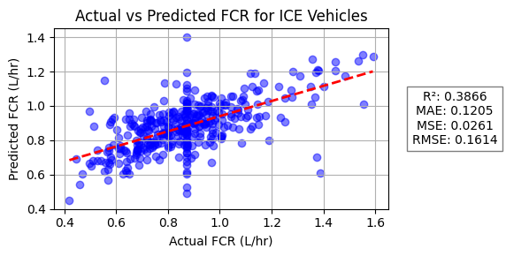
"""
Scenario 3 for ICE
Performed linear regression analysis using selected features to predict FCR for ICE vehicles.
Plotted Actual vs Predicted FCR values and regression line.
Displayed evaluation metrics: R², MAE, MSE, and RMSE on the plot.
"""
features = ['Vehicle Speed[km/h]', 'Distance[km]', 'Engine RPM[RPM]', 'OAT[DegC]', 'Generalized_Weight']
#features = ['Vehicle Speed[km/h]', 'Distance[km]', 'Engine RPM[RPM]', 'OAT[DegC]']
target = 'FCR'
X = df_ICE[features]
y = df_ICE[target]
model, X_test, y_test, y_pred, regression_line_model = linear_regression_analysis(features, target, X, y)
# plotting the results
import numpy as np
import matplotlib.pyplot as plt
from sklearn.metrics import r2_score, mean_absolute_error, mean_squared_error
y_test_sorted = np.sort(y_test)
y_line = regression_line_model.predict(y_test_sorted.reshape(-1, 1))
plt.figure(figsize=(6, 3))
plt.scatter(y_test, y_pred, alpha=0.5, color='blue')
# Plotted the regression line
plt.plot(y_test_sorted, y_line, color='red', linestyle='--', linewidth=2, label='Regression Line')
plt.title('Actual vs Predicted FCR for ICE Vehicles')
plt.xlabel('Actual FCR (L/hr)')
plt.ylabel('Predicted FCR (L/hr)')
plt.text(1.20, 0.5, f'R²: {r2_score(y_test, y_pred):.4f}\nMAE: {mean_absolute_error(y_test, y_pred):.4f}\nMSE: {mean_squared_error(y_test, y_pred):.4f}\nRMSE: {np.sqrt(mean_squared_error(y_test, y_pred)):.4f}',
fontsize=10, ha='center', va='center', transform=plt.gca().transAxes, bbox=dict(facecolor='white', alpha=0.5))
plt.grid(True)
plt.tight_layout()
plt.show()
Model Coefficients:
Vehicle Speed[km/h]: 0.0074
Distance[km]: -0.0014
Engine RPM[RPM]: 0.0002
OAT[DegC]: 0.0010
Generalized_Weight: 0.0002
Regression Equation:
Slope of the regression line: [ 0.00735636 -0.00137758 0.0002257 0.00104617 0.0002006 ]
Intercept: -0.4373
Target Variable: FCR
FCR = 0.0074*Vehicle Speed[km/h] + -0.0014*Distance[km] + 0.0002*Engine RPM[RPM] + 0.0010*OAT[DegC] + 0.0002*Generalized_Weight + -0.4373
Evaluation Metrics:
R² Score : 0.3841
MAE : 0.1206
MSE : 0.0262
RMSE : 0.1618
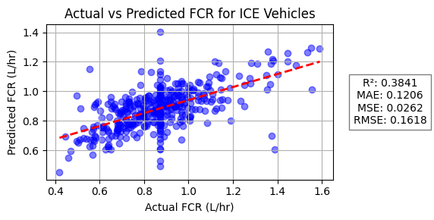
"""
Scenario 4 for ICE
Performed linear regression analysis using selected features to predict FCR for ICE vehicles.
Used features: Vehicle Speed[km/h], Distance[km], Generalized_Weight, MAF[g/sec], Absolute Load[%], Short Term Fuel Trim Bank 1[%], Short Term Fuel Trim Bank 2[%], Long Term Fuel Trim Bank 1[%], Long Term Fuel Trim Bank 2[%].
Plotted Actual vs Predicted FCR values and regression line.
Displayed evaluation metrics: R², MAE, MSE, and RMSE on the plot.
"""
#features = ['Vehicle Speed[km/h]', 'Distance[km]', 'Engine RPM[RPM]', 'OAT[DegC]', 'Generalized_Weight','MAF[g/sec]',
# 'Absolute Load[%]', 'Short Term Fuel Trim Bank 1[%]',
# 'Short Term Fuel Trim Bank 2[%]', 'Long Term Fuel Trim Bank 1[%]',
# 'Long Term Fuel Trim Bank 2[%]']
features = ['Vehicle Speed[km/h]', 'Distance[km]', 'Generalized_Weight','MAF[g/sec]',
'Absolute Load[%]', 'Short Term Fuel Trim Bank 1[%]',
'Short Term Fuel Trim Bank 2[%]', 'Long Term Fuel Trim Bank 1[%]',
'Long Term Fuel Trim Bank 2[%]']
target = 'FCR'
X = df_ICE[features]
y = df_ICE[target]
model, X_test, y_test, y_pred, regression_line_model = linear_regression_analysis(features, target, X, y)
# plotting the results
import numpy as np
import matplotlib.pyplot as plt
from sklearn.metrics import r2_score, mean_absolute_error, mean_squared_error
y_test_sorted = np.sort(y_test)
y_line = regression_line_model.predict(y_test_sorted.reshape(-1, 1))
plt.figure(figsize=(6, 3))
plt.scatter(y_test, y_pred, alpha=0.5, color='blue')
# Plotted the regression line
plt.plot(y_test_sorted, y_line, color='red', linestyle='--', linewidth=2, label='Regression Line')
plt.title('Actual vs Predicted FCR for ICE Vehicles')
plt.xlabel('Actual FCR (L/hr)')
plt.ylabel('Predicted FCR (L/hr)')
plt.text(1.20, 0.5, f'R²: {r2_score(y_test, y_pred):.4f}\nMAE: {mean_absolute_error(y_test, y_pred):.4f}\nMSE: {mean_squared_error(y_test, y_pred):.4f}\nRMSE: {np.sqrt(mean_squared_error(y_test, y_pred)):.4f}',
fontsize=10, ha='center', va='center', transform=plt.gca().transAxes, bbox=dict(facecolor='white', alpha=0.5))
plt.grid(True)
plt.tight_layout()
plt.show()
Model Coefficients:
Vehicle Speed[km/h]: 0.0035
Distance[km]: 0.0002
Generalized_Weight: 0.0001
MAF[g/sec]: 0.0372
Absolute Load[%]: 0.0066
Short Term Fuel Trim Bank 1[%]: -0.0004
Short Term Fuel Trim Bank 2[%]: 0.0029
Long Term Fuel Trim Bank 1[%]: 0.0076
Long Term Fuel Trim Bank 2[%]: 0.0005
Regression Equation:
Slope of the regression line: [ 3.51771144e-03 1.54859609e-04 8.60672719e-05 3.72308331e-02
6.57019976e-03 -3.68340265e-04 2.92205509e-03 7.63933480e-03
4.79373945e-04]
Intercept: -0.2424
Target Variable: FCR
FCR = 0.0035*Vehicle Speed[km/h] + 0.0002*Distance[km] + 0.0001*Generalized_Weight + 0.0372*MAF[g/sec] + 0.0066*Absolute Load[%] + -0.0004*Short Term Fuel Trim Bank 1[%] + 0.0029*Short Term Fuel Trim Bank 2[%] + 0.0076*Long Term Fuel Trim Bank 1[%] + 0.0005*Long Term Fuel Trim Bank 2[%] + -0.2424
Evaluation Metrics:
R² Score : 0.6887
MAE : 0.0770
MSE : 0.0132
RMSE : 0.1150
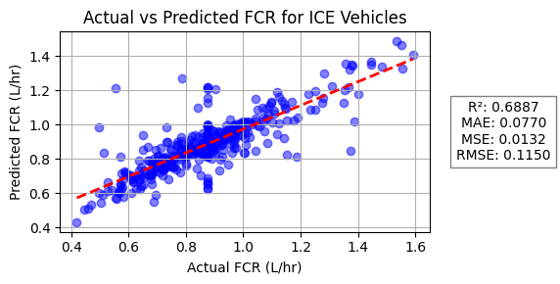
"""
Scenario 1 for HEV
Performed linear regression analysis for HEV vehicles using 'MAF[g/sec]' as the feature and 'FCR' as the target.
Trained the model and generated predictions on the test set.
Plotted Actual vs Predicted FCR values and the regression line.
Displayed evaluation metrics: R², MAE, MSE, and RMSE on the plot.
"""
'''
features = ['Vehicle Speed[km/h]',
'Distance[km]',
'Engine RPM[RPM]',
'OAT[DegC]',
'Generalized_Weight',
'HV Battery Power[Watts]',
'MAF[g/sec]',
'Absolute Load[%]', 'Short Term Fuel Trim Bank 1[%]',
'Short Term Fuel Trim Bank 2[%]', 'Long Term Fuel Trim Bank 1[%]',
'Long Term Fuel Trim Bank 2[%]'
]
'''
'''
features = ['Vehicle Speed[km/h]',
'Distance[km]',
'Generalized_Weight',
'MAF[g/sec]',
'Absolute Load[%]', 'Short Term Fuel Trim Bank 1[%]',
'Long Term Fuel Trim Bank 1[%]'
]
'''
features = [
'MAF[g/sec]'
]
target = 'FCR'
X = df_HEV[features]
y = df_HEV[target]
model, X_test, y_test, y_pred, regression_line_model = linear_regression_analysis(features, target, X, y)
import numpy as np
import matplotlib.pyplot as plt
from sklearn.metrics import r2_score, mean_absolute_error, mean_squared_error
y_test_sorted = np.sort(y_test)
y_line = regression_line_model.predict(y_test_sorted.reshape(-1, 1))
plt.figure(figsize=(6, 3))
plt.scatter(y_test, y_pred, alpha=0.5, color='blue')
plt.plot(y_test_sorted, y_line, color='red', linestyle='--', linewidth=2, label='Regression Line')
plt.title('Actual vs Predicted FCR for HEV Vehicles')
plt.xlabel('Actual FCR (L/hr)')
plt.ylabel('Predicted FCR (L/hr)')
plt.text(1.20, 0.5, f'R²: {r2_score(y_test, y_pred):.4f}\nMAE: {mean_absolute_error(y_test, y_pred):.4f}\nMSE: {mean_squared_error(y_test, y_pred):.4f}\nRMSE: {np.sqrt(mean_squared_error(y_test, y_pred)):.4f}',
fontsize=10, ha='center', va='center', transform=plt.gca().transAxes, bbox=dict(facecolor='white', alpha=0.5))
plt.grid(True)
plt.tight_layout()
plt.show()
Model Coefficients:
MAF[g/sec]: 0.0629
Regression Equation:
Slope of the regression line: [0.06293091]
Intercept: 0.0413
Target Variable: FCR
FCR = 0.0629*MAF[g/sec] + 0.0413
Evaluation Metrics:
R² Score : 0.9440
MAE : 0.0216
MSE : 0.0013
RMSE : 0.0359
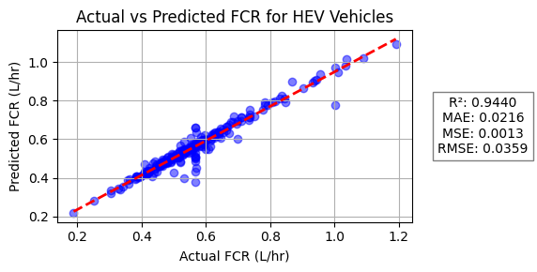
'''
Created a function to handle outliers using IQR
'''
def handle_outliers_iqr(df, columns, method='cap'):
"""
Detects and handles outliers in specified columns using the IQR method.
Adds boolean columns for outlier flags and modifies outliers in place.
method: 'cap' (default) replaces outliers with nearest bound, 'remove' drops outlier rows.
Returns the modified DataFrame.
"""
df = df.copy()
for col in columns:
Q1 = df[col].quantile(0.25)
Q3 = df[col].quantile(0.75)
IQR = Q3 - Q1
lower = Q1 - 1.5 * IQR
upper = Q3 + 1.5 * IQR
outlier_flag = (df[col] < lower) | (df[col] > upper)
df[f'{col}_outlier'] = outlier_flag
if method == 'cap':
df.loc[df[col] < lower, col] = lower
df.loc[df[col] > upper, col] = upper
elif method == 'remove':
df = df[~outlier_flag]
return df
# Example usage for EV outliers (capping outliers)
outlier_columns = ['Air Conditioning Power[Watts]','Heater Power[Watts]','Vehicle Speed[km/h]','HV Battery Power[Watts]']
df_EV_clean = handle_outliers_iqr(df_EV, outlier_columns, method='cap')
df_EV_clean.head()
 | Trip | Vehicle Type | Latitude[deg] | Longitude[deg] | Air Conditioning Power[Watts] | Heater Power[Watts] | Vehicle Speed[km/h] | Distance[km] | Engine RPM[RPM] | OAT[DegC] | ... | MAF[g/sec] | Absolute Load[%] | Short Term Fuel Trim Bank 1[%] | Short Term Fuel Trim Bank 2[%] | Long Term Fuel Trim Bank 1[%] | Long Term Fuel Trim Bank 2[%] | Air Conditioning Power[Watts]_outlier | Heater Power[Watts]_outlier | Vehicle Speed[km/h]_outlier | HV Battery Power[Watts]_outlier
822 | 554 | EV | 42.244071 | -83.736644 | 95.625000 | 182.812500 | 46.201749 | 0.881169 | 0.0 | 11.500000 | ... | 0.0 | 0.0 | 0.0 | 0.0 | 0.0 | 0.0 | False | False | False | True
2172 | 1143 | EV | 42.244397 | -83.731922 | 0.000000 | 0.000000 | 54.838408 | 0.557468 | 0.0 | 15.000000 | ... | 0.0 | 0.0 | 0.0 | 0.0 | 0.0 | 0.0 | False | False | False | False
842 | 565 | EV | 42.243102 | -83.721478 | 0.000000 | 0.000000 | 51.888828 | 0.495307 | 0.0 | 10.000000 | ... | 0.0 | 0.0 | 0.0 | 0.0 | 0.0 | 0.0 | False | False | False | False
2250 | 1175 | EV | 42.254800 | -83.725075 | 465.562249 | 489.457831 | 6.612898 | 0.212290 | 0.0 | 2.767068 | ... | 0.0 | 0.0 | 0.0 | 0.0 | 0.0 | 0.0 | False | False | True | False
1098 | 678 | EV | 42.272546 | -83.749215 | 0.000000 | 0.000000 | 31.160595 | 0.896625 | 0.0 | 15.072848 | ... | 0.0 | 0.0 | 0.0 | 0.0 | 0.0 | 0.0 | False | False | False | False

df_EV.describe()
 | Trip | Latitude[deg] | Longitude[deg] | Air Conditioning Power[Watts] | Heater Power[Watts] | Vehicle Speed[km/h] | Distance[km] | Engine RPM[RPM] | OAT[DegC] | Generalized_Weight | FCR | HV Battery Power[Watts] | MAF[g/sec] | Absolute Load[%] | Short Term Fuel Trim Bank 1[%] | Short Term Fuel Trim Bank 2[%] | Long Term Fuel Trim Bank 1[%] | Long Term Fuel Trim Bank 2[%]
count | 95.000000 | 95.000000 | 95.000000 | 95.000000 | 95.000000 | 95.000000 | 95.000000 | 95.0 | 95.000000 | 95.0 | 95.0 | 95.000000 | 95.0 | 95.0 | 95.0 | 95.0 | 95.0 | 95.0
mean | 1274.105263 | 42.271297 | -83.735505 | 451.206427 | 595.948098 | 38.120463 | 2.529701 | 0.0 | 2.758068 | 3500.0 | 0.0 | -6257.533768 | 0.0 | 0.0 | 0.0 | 0.0 | 0.0 | 0.0
std | 533.419428 | 0.017869 | 0.023455 | 389.532228 | 766.175778 | 12.568234 | 2.356622 | 0.0 | 6.301469 | 0.0 | 0.0 | 2555.379815 | 0.0 | 0.0 | 0.0 | 0.0 | 0.0 | 0.0
min | 554.000000 | 42.231394 | -83.792418 | 0.000000 | 0.000000 | 3.490542 | 0.174693 | 0.0 | -13.153201 | 3500.0 | 0.0 | -13857.507261 | 0.0 | 0.0 | 0.0 | 0.0 | 0.0 | 0.0
25% | 737.000000 | 42.260824 | -83.749556 | 79.973193 | 0.000000 | 30.045382 | 0.879309 | 0.0 | -2.118267 | 3500.0 | 0.0 | -7292.243492 | 0.0 | 0.0 | 0.0 | 0.0 | 0.0 | 0.0
50% | 1149.000000 | 42.272546 | -83.736166 | 370.610687 | 307.565789 | 39.347546 | 1.704800 | 0.0 | 2.894870 | 3500.0 | 0.0 | -6377.998333 | 0.0 | 0.0 | 0.0 | 0.0 | 0.0 | 0.0
75% | 1806.000000 | 42.284664 | -83.723986 | 785.391036 | 852.601621 | 45.667038 | 3.458791 | 0.0 | 7.279737 | 3500.0 | 0.0 | -4515.746667 | 0.0 | 0.0 | 0.0 | 0.0 | 0.0 | 0.0
max | 2165.000000 | 42.307465 | -83.682248 | 1224.153166 | 3545.282369 | 67.570289 | 11.031075 | 0.0 | 15.156609 | 3500.0 | 0.0 | 73.835938 | 0.0 | 0.0 | 0.0 | 0.0 | 0.0 | 0.0
'''
Scenario 1 for EV
Selected features for linear regression analysis to predict HV Battery Power for EVs.
Performed linear regression using the selected features and target.
Plotted Actual vs Predicted Power for EV vehicles, including regression line and evaluation metrics (R², MAE, MSE, RMSE).
'''
'''
features = ['Latitude[deg]',
'Longitude[deg]',
'Air Conditioning Power[Watts]',
'Heater Power[Watts]',
'Vehicle Speed[km/h]',
'Distance[km]',
'OAT[DegC]',
'Generalized_Weight']
'''
'''
features = [
'Air Conditioning Power[Watts]',
'Heater Power[Watts]',
'Vehicle Speed[km/h]',
'Distance[km]',
'OAT[DegC]']
'''
features = [
'Air Conditioning Power[Watts]',
'Heater Power[Watts]',
'Vehicle Speed[km/h]',
]
target = 'HV Battery Power[Watts]'
X = df_EV[features]
y = df_EV[target]
model, X_test, y_test, y_pred, regression_line_model = linear_regression_analysis(features, target, X, y)
import numpy as np
import matplotlib.pyplot as plt
from sklearn.metrics import r2_score, mean_absolute_error, mean_squared_error
y_test_sorted = np.sort(y_test)
y_line = regression_line_model.predict(y_test_sorted.reshape(-1, 1))
plt.figure(figsize=(7, 3))
plt.scatter(y_test, y_pred, alpha=0.5, color='blue')
plt.plot(y_test_sorted, y_line, color='red', linestyle='--', linewidth=2, label='Regression Line')
plt.title('Actual vs Predicted Power for EV Vehicles')
plt.xlabel('Actual Power (Watts)')
plt.ylabel('Predicted Power (Watts)')
plt.text(
1.20, 0.5,
f'R²: {r2_score(y_test, y_pred):.4f}\nMAE: {mean_absolute_error(y_test, y_pred):.4f}\nMSE: {mean_squared_error(y_test, y_pred):.4f}\nRMSE: {np.sqrt(mean_squared_error(y_test, y_pred)):.4f}',
fontsize=10, ha='center', va='center', transform=plt.gca().transAxes,
bbox=dict(facecolor='white', alpha=0.5)
)
plt.grid(True)
plt.tight_layout()
plt.show()
Model Coefficients:
Air Conditioning Power[Watts]: -2.5853
Heater Power[Watts]: -1.2364
Vehicle Speed[km/h]: -112.8938
Regression Equation:
Slope of the regression line: [ -2.58530326 -1.23642892 -112.89382874]
Intercept: -271.2544
Target Variable: HV Battery Power[Watts]
HV Battery Power[Watts] = -2.5853*Air Conditioning Power[Watts] + -1.2364*Heater Power[Watts] + -112.8938*Vehicle Speed[km/h] + -271.2544
Evaluation Metrics:
R² Score : -0.1497
MAE : 1752.7312
MSE : 5513130.9951
RMSE : 2348.0057
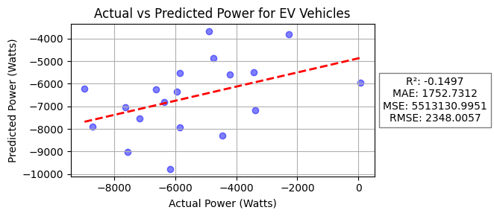
'''
Scenario 2 for EV without outliers
'''
'''
features = ['Latitude[deg]',
'Longitude[deg]',
'Air Conditioning Power[Watts]',
'Heater Power[Watts]',
'Vehicle Speed[km/h]',
'Distance[km]',
'OAT[DegC]',
'Generalized_Weight']
'''
'''
features = [
'Air Conditioning Power[Watts]',
'Heater Power[Watts]',
'Vehicle Speed[km/h]',
'Distance[km]',
'OAT[DegC]']
'''
features = [
'Air Conditioning Power[Watts]',
'Heater Power[Watts]',
'Vehicle Speed[km/h]',
]
target = 'HV Battery Power[Watts]'
X = df_EV_clean[features]
y = df_EV_clean[target]
model, X_test, y_test, y_pred, regression_line_model = linear_regression_analysis(features, target, X, y)
# plotting the results
import numpy as np
import matplotlib.pyplot as plt
from sklearn.metrics import r2_score, mean_absolute_error, mean_squared_error
y_test_sorted = np.sort(y_test)
y_line = regression_line_model.predict(y_test_sorted.reshape(-1, 1))
plt.figure(figsize=(7, 3))
plt.scatter(y_test, y_pred, alpha=0.5, color='blue')
#plot the regression line
plt.plot(y_test_sorted, y_line, color='red', linestyle='--', linewidth=2, label='Regression Line')
plt.title('Actual vs Predicted Power for EV Vehicles')
plt.xlabel('Actual Power (Watts)')
plt.ylabel('Predicted Power (Watts)')
plt.text(1.20, 0.5, f'R²: {r2_score(y_test, y_pred):.4f}\nMAE: {mean_absolute_error(y_test, y_pred):.4f}\nMSE: {mean_squared_error(y_test, y_pred):.4f}\nRMSE: {np.sqrt(mean_squared_error(y_test, y_pred)):.4f}',
fontsize=10, ha='center', va='center', transform=plt.gca().transAxes, bbox=dict(facecolor='white', alpha=0.5))
plt.grid(True)
plt.tight_layout()
plt.show()
Model Coefficients:
Air Conditioning Power[Watts]: -2.0558
Heater Power[Watts]: -1.3454
Vehicle Speed[km/h]: -103.8481
Regression Equation:
Slope of the regression line: [ -2.05582262 -1.34538495 -103.8481054 ]
Intercept: -764.9562
Target Variable: HV Battery Power[Watts]
HV Battery Power[Watts] = -2.0558*Air Conditioning Power[Watts] + -1.3454*Heater Power[Watts] + -103.8481*Vehicle Speed[km/h] + -764.9562
Evaluation Metrics:
R² Score : -0.0733
MAE : 1695.1069
MSE : 4889657.5024
RMSE : 2211.2570
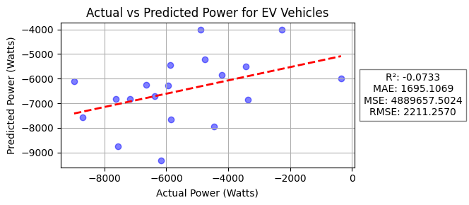
df_EV.describe()
 | Trip | Latitude[deg] | Longitude[deg] | Air Conditioning Power[Watts] | Heater Power[Watts] | Vehicle Speed[km/h] | Distance[km] | Engine RPM[RPM] | OAT[DegC] | Generalized_Weight | FCR | HV Battery Power[Watts] | MAF[g/sec] | Absolute Load[%] | Short Term Fuel Trim Bank 1[%] | Short Term Fuel Trim Bank 2[%] | Long Term Fuel Trim Bank 1[%] | Long Term Fuel Trim Bank 2[%]
count | 95.000000 | 95.000000 | 95.000000 | 95.000000 | 95.000000 | 95.000000 | 95.000000 | 95.0 | 95.000000 | 95.0 | 95.0 | 95.000000 | 95.0 | 95.0 | 95.0 | 95.0 | 95.0 | 95.0
mean | 1274.105263 | 42.271297 | -83.735505 | 451.206427 | 595.948098 | 38.120463 | 2.529701 | 0.0 | 2.758068 | 3500.0 | 0.0 | -6257.533768 | 0.0 | 0.0 | 0.0 | 0.0 | 0.0 | 0.0
std | 533.419428 | 0.017869 | 0.023455 | 389.532228 | 766.175778 | 12.568234 | 2.356622 | 0.0 | 6.301469 | 0.0 | 0.0 | 2555.379815 | 0.0 | 0.0 | 0.0 | 0.0 | 0.0 | 0.0
min | 554.000000 | 42.231394 | -83.792418 | 0.000000 | 0.000000 | 3.490542 | 0.174693 | 0.0 | -13.153201 | 3500.0 | 0.0 | -13857.507261 | 0.0 | 0.0 | 0.0 | 0.0 | 0.0 | 0.0
25% | 737.000000 | 42.260824 | -83.749556 | 79.973193 | 0.000000 | 30.045382 | 0.879309 | 0.0 | -2.118267 | 3500.0 | 0.0 | -7292.243492 | 0.0 | 0.0 | 0.0 | 0.0 | 0.0 | 0.0
50% | 1149.000000 | 42.272546 | -83.736166 | 370.610687 | 307.565789 | 39.347546 | 1.704800 | 0.0 | 2.894870 | 3500.0 | 0.0 | -6377.998333 | 0.0 | 0.0 | 0.0 | 0.0 | 0.0 | 0.0
75% | 1806.000000 | 42.284664 | -83.723986 | 785.391036 | 852.601621 | 45.667038 | 3.458791 | 0.0 | 7.279737 | 3500.0 | 0.0 | -4515.746667 | 0.0 | 0.0 | 0.0 | 0.0 | 0.0 | 0.0
max | 2165.000000 | 42.307465 | -83.682248 | 1224.153166 | 3545.282369 | 67.570289 | 11.031075 | 0.0 | 15.156609 | 3500.0 | 0.0 | 73.835938 | 0.0 | 0.0 | 0.0 | 0.0 | 0.0 | 0.0

df_PHEV.describe()
 | Trip | Latitude[deg] | Longitude[deg] | Air Conditioning Power[Watts] | Heater Power[Watts] | Vehicle Speed[km/h] | Distance[km] | Engine RPM[RPM] | OAT[DegC] | Generalized_Weight | FCR | HV Battery Power[Watts] | MAF[g/sec] | Absolute Load[%] | Short Term Fuel Trim Bank 1[%] | Short Term Fuel Trim Bank 2[%] | Long Term Fuel Trim Bank 1[%] | Long Term Fuel Trim Bank 2[%]
count | 618.000000 | 618.000000 | 618.000000 | 618.000000 | 618.0 | 618.000000 | 618.000000 | 618.000000 | 618.000000 | 618.000000 | 618.000000 | 618.000000 | 618.000000 | 0.0 | 0.0 | 618.0 | 0.0 | 618.0
mean | 1027.393204 | 42.273889 | -83.723610 | 27.315283 | 0.0 | 42.794632 | 3.630850 | 452.272555 | 1.400766 | 3800.047327 | 1.310643 | -5064.759049 | 4.287581 | NaN | NaN | 0.0 | NaN | 0.0
std | 579.918702 | 0.019057 | 0.025063 | 165.769118 | 0.0 | 12.024760 | 3.956138 | 482.111349 | 6.943586 | 366.069026 | 1.188460 | 5028.038070 | 3.193834 | NaN | NaN | 0.0 | NaN | 0.0
min | 2.000000 | 42.229778 | -83.799610 | 0.000000 | 0.0 | 14.977123 | 0.045077 | 0.000000 | -20.775568 | 3000.000000 | 0.000000 | -23172.896785 | 0.170000 | NaN | NaN | 0.0 | NaN | 0.0
25% | 590.000000 | 42.259793 | -83.739610 | 0.000000 | 0.0 | 35.673644 | 1.383368 | 0.000000 | -3.000000 | 3806.372686 | 1.191592 | -8178.594596 | 1.419221 | NaN | NaN | 0.0 | NaN | 0.0
50% | 955.500000 | 42.277656 | -83.719121 | 0.000000 | 0.0 | 41.934884 | 2.855270 | 346.214084 | 2.500000 | 4000.000000 | 1.310643 | -5249.647151 | 4.287581 | NaN | NaN | 0.0 | NaN | 0.0
75% | 1457.750000 | 42.286126 | -83.707332 | 0.000000 | 0.0 | 47.761296 | 4.189252 | 783.824850 | 6.237949 | 4000.000000 | 1.310643 | -287.400366 | 5.717953 | NaN | NaN | 0.0 | NaN | 0.0
max | 2432.000000 | 42.319032 | -83.678096 | 2008.721360 | 0.0 | 101.025354 | 51.932325 | 3360.000000 | 26.144342 | 4000.000000 | 7.870564 | 7689.712572 | 40.230000 | NaN | NaN | 0.0 | NaN | 0.0
'''
Scenario 1 for PHEV
Selected features and target for linear regression analysis on PHEV data.
Performed linear regression using the selected features to predict HV Battery Power.
Plotted Actual vs Predicted Power for PHEV vehicles, including regression line and evaluation metrics (R², MAE, MSE, RMSE).
'''
'''
features = ['Latitude[deg]',
'Longitude[deg]',
'Engine RPM[RPM]',
'Air Conditioning Power[Watts]',
'Heater Power[Watts]',
'Vehicle Speed[km/h]',
'Distance[km]',
'OAT[DegC]',
'Generalized_Weight',
]
'''
features = [
'Engine RPM[RPM]',
'Air Conditioning Power[Watts]',
'Vehicle Speed[km/h]',
'OAT[DegC]',
]
target = 'HV Battery Power[Watts]'
X = df_PHEV[features]
y = df_PHEV[target]
model, X_test, y_test, y_pred, regression_line_model = linear_regression_analysis(features, target, X, y)
import numpy as np
import matplotlib.pyplot as plt
from sklearn.metrics import r2_score, mean_absolute_error, mean_squared_error
y_test_sorted = np.sort(y_test)
y_line = regression_line_model.predict(y_test_sorted.reshape(-1, 1))
plt.figure(figsize=(8, 3))
plt.scatter(y_test, y_pred, alpha=0.5, color='blue')
plt.plot(y_test_sorted, y_line, color='red', linestyle='--', linewidth=2, label='Regression Line')
plt.title('Actual vs Predicted Power for PHEV Vehicles')
plt.xlabel('Actual Power (Watts)')
plt.ylabel('Predicted Power (Watts)')
plt.text(
1.20, 0.5,
f'R²: {r2_score(y_test, y_pred):.4f}\nMAE: {mean_absolute_error(y_test, y_pred):.4f}\nMSE: {mean_squared_error(y_test, y_pred):.4f}\nRMSE: {np.sqrt(mean_squared_error(y_test, y_pred)):.4f}',
fontsize=10, ha='center', va='center', transform=plt.gca().transAxes,
bbox=dict(facecolor='white', alpha=0.5)
)
plt.grid(True)
plt.tight_layout()
plt.show()
Model Coefficients:
Engine RPM[RPM]: 8.1661
Air Conditioning Power[Watts]: -0.9029
Vehicle Speed[km/h]: -203.6183
OAT[DegC]: 144.2664
Regression Equation:
Slope of the regression line: [ 8.166065 -0.90289333 -203.61834751 144.26640201]
Intercept: -277.2092
Target Variable: HV Battery Power[Watts]
HV Battery Power[Watts] = 8.1661*Engine RPM[RPM] + -0.9029*Air Conditioning Power[Watts] + -203.6183*Vehicle Speed[km/h] + 144.2664*OAT[DegC] + -277.2092
Evaluation Metrics:
R² Score : 0.7122
MAE : 2184.4709
MSE : 8073354.4590
RMSE : 2841.3649
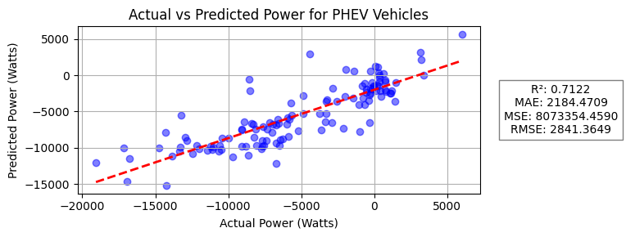
df_ICE.info()
<class 'pandas.core.frame.DataFrame'>
Index: 1850 entries, 3086 to 3723
Data columns (total 19 columns):
# Column Non-Null Count Dtype
--- ------ -------------- -----
0 Trip 1850 non-null int64
1 Vehicle Type 1850 non-null object
2 Latitude[deg] 1850 non-null float64
3 Longitude[deg] 1850 non-null float64
4 Air Conditioning Power[Watts] 1850 non-null float64
5 Heater Power[Watts] 0 non-null float64
6 Vehicle Speed[km/h] 1850 non-null float64
7 Distance[km] 1850 non-null float64
8 Engine RPM[RPM] 1850 non-null float64
9 OAT[DegC] 1850 non-null float64
10 Generalized_Weight 1850 non-null float64
11 FCR 1850 non-null float64
12 HV Battery Power[Watts] 1850 non-null float64
13 MAF[g/sec] 1850 non-null float64
14 Absolute Load[%] 1850 non-null float64
15 Short Term Fuel Trim Bank 1[%] 1850 non-null float64
16 Short Term Fuel Trim Bank 2[%] 1850 non-null float64
17 Long Term Fuel Trim Bank 1[%] 1850 non-null float64
18 Long Term Fuel Trim Bank 2[%] 1850 non-null float64
dtypes: float64(17), int64(1), object(1)
memory usage: 289.1+ KB
'''
This cell performs SHAP (SHapley Additive exPlanations) analysis on a linear regression model for HEV vehicles:
1. Imports required libraries for SHAP analysis, linear regression, and data preprocessing
2. Defines features including vehicle performance metrics, environmental conditions, and fuel system parameters
3. Sets FCR (Fuel Consumption Rate) as the target variable for HEV vehicles
4. Standardizes features using StandardScaler to improve SHAP analysis with linear models
5. Splits data into training and testing sets (80/20 split)
6. Trains a LinearRegression model on the standardized training data
7. Creates a SHAP explainer for the linear model using training data
8. Generates SHAP values for test data to understand feature importance
9. Visualizes SHAP analysis through:
- Bar plot showing overall feature importance
- Beeswarm plot showing feature effects distribution
- Waterfall plot for individual prediction explanation
10. Creates a DataFrame of SHAP values for further analysis
'''
import pandas as pd
import numpy as np
import shap
import matplotlib.pyplot as plt
from sklearn.linear_model import LinearRegression
from sklearn.model_selection import train_test_split
from sklearn.preprocessing import StandardScaler
# Example features and target
features = ['Vehicle Speed[km/h]',
'Distance[km]',
'Engine RPM[RPM]',
'OAT[DegC]',
'Generalized_Weight',
'HV Battery Power[Watts]',
'MAF[g/sec]',
'Absolute Load[%]', 'Short Term Fuel Trim Bank 1[%]',
'Short Term Fuel Trim Bank 2[%]', 'Long Term Fuel Trim Bank 1[%]',
'Long Term Fuel Trim Bank 2[%]'
]
target = 'FCR'
X = df_HEV[features]
y = df_HEV[target]
# Standardize features (optional but helps SHAP with linear models)
scaler = StandardScaler()
X_scaled = scaler.fit_transform(X)
# Train-test split
X_train, X_test, y_train, y_test = train_test_split(X_scaled, y, test_size=0.2, random_state=42)
model = LinearRegression()
model.fit(X_train, y_train)
explainer = shap.Explainer(model, X_train) # uses LinearExplainer
shap_values = explainer(X_test)
shap.plots.bar(shap_values)
shap.plots.beeswarm(shap_values)
shap.plots.waterfall(shap_values[0])
shap_df = pd.DataFrame(shap_values.values, columns=features)
shap_df.head()
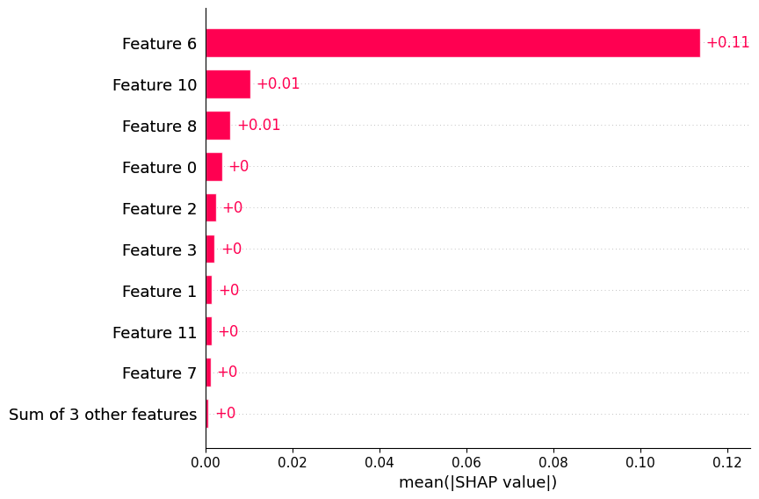
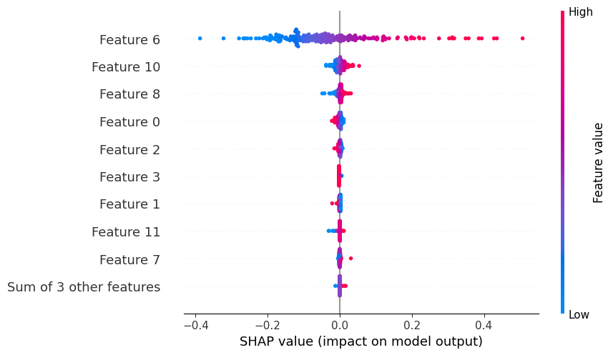
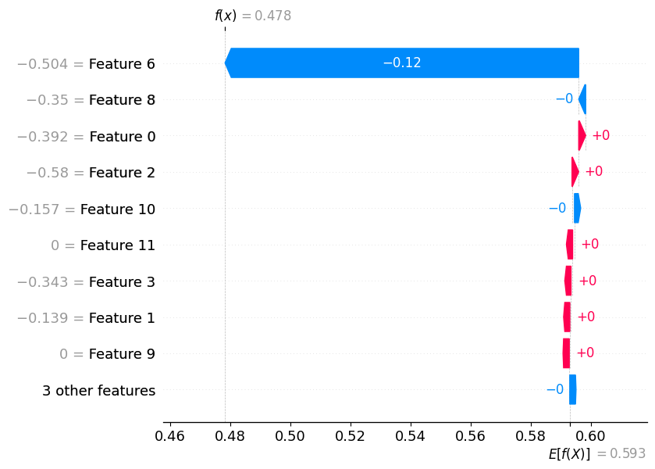
 | Vehicle Speed[km/h] | Distance[km] | Engine RPM[RPM] | OAT[DegC] | Generalized_Weight | HV Battery Power[Watts] | MAF[g/sec] | Absolute Load[%] | Short Term Fuel Trim Bank 1[%] | Short Term Fuel Trim Bank 2[%] | Long Term Fuel Trim Bank 1[%] | Long Term Fuel Trim Bank 2[%]
0 | 0.002323 | 0.000396 | 0.002229 | 0.000534 | -0.000119 | -0.0 | -0.117554 | -0.000057 | -0.002329 | 0.000192 | -0.000825 | 0.000613
1 | -0.004610 | 0.000477 | 0.000417 | 0.002119 | 0.000116 | -0.0 | 0.185491 | 0.000156 | 0.005444 | 0.000192 | -0.010098 | 0.000613
2 | 0.006633 | -0.000043 | -0.000759 | -0.001930 | -0.000119 | -0.0 | -0.109387 | 0.000487 | -0.010127 | 0.000192 | -0.006545 | 0.000613
3 | -0.001457 | -0.000090 | 0.001661 | 0.000494 | -0.000119 | -0.0 | -0.104673 | -0.000157 | 0.003040 | 0.000192 | 0.015050 | 0.000613
4 | 0.000815 | 0.000157 | 0.000368 | -0.001640 | -0.000119 | -0.0 | -0.120312 | -0.000818 | -0.000773 | 0.000192 | 0.004881 | 0.000613

8. Predictive Modeling Performance
- Hybrid Electric Vehicles (HEV): Achieved the highest predictive accuracy.
  - Trip-based Split: $R^{2}≈0.92$
  - Time-based Split: $R^{2}≈0.98$
- Plug-in Hybrid (PHEV): Strong performance in predicting battery power.
  - Trip-based Split: $R^{2}≈0.82$
  - Time-based Split: $R^{2}≈0.84$
- Internal Combustion (ICE): Performance relied heavily on feature selection.
  - Basic features (Speed, RPM): $R^{2}≈0.31$
  - Advanced features (MAF, Fuel Trims, Load): $R^{2}$ improved to 0.62 (Trip) and 0.86 (Time).
- Electric Vehicles (EV): Proved most difficult to model linearly.
  - Trip-based Split: $R^{2}≈0.32$
  - Time-based Split: $R^{2}≈0.54$

9. K means Clustering Classification models to categorize vehicle type
df_combined = pd.concat([df_ICE, df_HEV, df_PHEV, df_EV], ignore_index=True)
push_df_to_s3_parquet(df_combined, 'Cleaned up VED Source Data/df_combined.parquet')
DataFrame uploaded to s3://s3aravindh973515031797/Cleaned up VED Source Data/df_combined.parquet
df_combined_k = df_combined[['Trip','FCR']]
df_combined_sf = df_combined[['Vehicle Speed[km/h]','FCR']]
df_combined_sb = df_combined[['Vehicle Speed[km/h]','HV Battery Power[Watts]']]
df_combined_of = df_combined[['OAT[DegC]','FCR']]
df_combined_ob = df_combined[['OAT[DegC]','HV Battery Power[Watts]']]
'''
This cell:
- Imports necessary libraries: numpy, matplotlib.pyplot, and KMeans from sklearn.
- Defines a function `plot_kmeans_elbow` that:
- Computes KMeans clustering inertia for cluster counts from 1 to 4.
- Calculates the difference in inertia to suggest an optimal number of clusters (elbow point).
- Prints the suggested optimal K.
- Plots the inertia values (elbow curve) to visually assist in selecting the optimal number of clusters.
'''
import numpy as np
import matplotlib.pyplot as plt
from sklearn.cluster import KMeans
def plot_kmeans_elbow(df):
"""
Plots the elbow curve for KMeans clustering to help select the optimal number of clusters.
Args:
df (pd.DataFrame): DataFrame containing the features for clustering.
"""
inertia = []
for i in range(1, 5):
kmeans = KMeans(n_clusters=i, init='random', random_state=42)
kmeans.fit(df)
inertia.append(kmeans.inertia_)
# Find elbow point (simple method: where the decrease in inertia slows down the most)
diff = np.diff(inertia)
elbow_k = np.argmin(diff) + 2 # +2 because diff is one less and we start from k=1
print("Suggested optimal K:", elbow_k)
# Plot the elbow curve
plt.figure(figsize=(5, 3))
plt.plot(range(1, 5), inertia, 'bo-')
plt.xlabel('Number of Clusters (K)')
plt.ylabel('Inertia')
plt.title('Elbow Method for Optimal K Selection')
plt.grid(True)
plt.show()
plot_kmeans_elbow(df_combined_k)
Suggested optimal K: 2
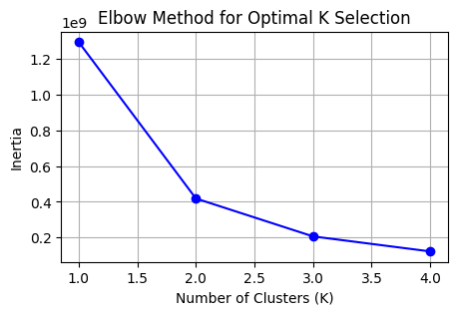
'''
This cell:
- Imports KMeans from sklearn.
- Defines a function `fit_predict_kmeans` that:
- Fits KMeans clustering to the input DataFrame with a specified number of clusters.
- Predicts cluster labels for the input data.
- Adds a new 'Cluster' column to the DataFrame with the assigned cluster labels.
- Returns the modified DataFrame, the predicted cluster labels, and the fitted KMeans object.
'''
from sklearn.cluster import KMeans
def fit_predict_kmeans(df, n_clusters, random_state=42):
"""
Fits KMeans clustering on the given DataFrame and returns a copy with a new 'Cluster' column.
Parameters:
df (pd.DataFrame): The input DataFrame (features only, no target).
n_clusters (int): Number of clusters to use.
random_state (int): Random state for reproducibility.
Returns:
pd.DataFrame: A copy of the input DataFrame with an added 'Cluster' column.
np.ndarray: The predicted cluster labels.
KMeans: The fitted KMeans object.
"""
kmeans = KMeans(n_clusters=n_clusters, random_state=random_state)
kmeans.fit(df)
pred = kmeans.predict(df)
df['Cluster'] = kmeans.labels_
return df, pred, kmeans
# Example usage:
# df_with_clusters, cluster_labels, kmeans_model = fit_predict_kmeans(df, elbow_k)
fit_predict_kmeans(df_combined_k, 4)
( Trip FCR Cluster
0 1637 2.298379 3
1 293 2.188477 0
2 340 2.076016 0
3 1455 1.994577 3
4 2016 1.984249 1
... ... ... ...
3722 658 0.000000 2
3723 728 0.000000 2
3724 1674 0.000000 3
3725 1026 0.000000 2
3726 596 0.000000 0
[3727 rows x 3 columns],
array([3, 0, 0, ..., 3, 2, 0], shape=(3727,), dtype=int32),
KMeans(n_clusters=4, random_state=42))
'''
This cell:
- Creates a scatter plot of 'Trip' vs 'FCR' from df_combined_k.
- Colors the points by their assigned KMeans cluster using the 'Cluster' column.
- Sets axis labels and a title.
- Adds a legend for the clusters.
- Displays the plot.
'''
plt.figure(figsize=(6, 3))
scatter = plt.scatter(
df_combined_k['Trip'],
df_combined_k['FCR'],
c=df_combined_k['Cluster'],
cmap='viridis',
s=50
)
plt.xlabel('Trip Counts')
plt.ylabel('FCR')
plt.title('KMeans Clusters: Trip Counts vs FCR')
handles, labels = scatter.legend_elements(prop="colors")
plt.legend(handles, [f"Cluster {i}" for i in range(len(handles))])
plt.show()
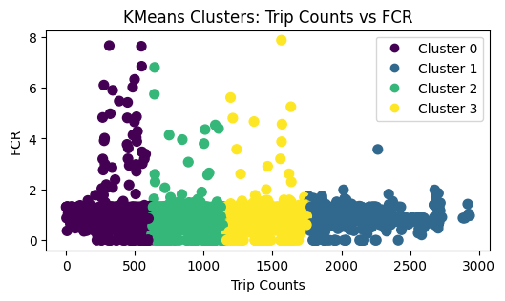
plot_kmeans_elbow(df_combined_sf)
Suggested optimal K: 2
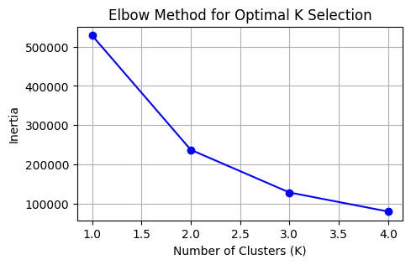
fit_predict_kmeans(df_combined_sf,4)
( Vehicle Speed[km/h] FCR Cluster
0 71.199588 2.298379 1
1 55.280435 2.188477 3
2 55.131579 2.076016 3
3 78.166852 1.994577 1
4 36.728477 1.984249 0
... ... ... ...
3722 65.420500 0.000000 1
3723 64.908588 0.000000 1
3724 36.466653 0.000000 0
3725 58.251157 0.000000 3
3726 65.121893 0.000000 1
[3727 rows x 3 columns],
array([1, 3, 3, ..., 0, 3, 1], shape=(3727,), dtype=int32),
KMeans(n_clusters=4, random_state=42))
'''
This cell:
- Creates a scatter plot of 'Vehicle Speed[km/h]' vs 'FCR' from df_combined_sf.
- Colors the points by their assigned KMeans cluster using the 'Cluster' column.
- Sets axis labels and a title.
- Adds a legend for the clusters.
- Displays the plot.
'''
plt.figure(figsize=(6, 3))
scatter = plt.scatter(
df_combined_sf['Vehicle Speed[km/h]'],
df_combined_sf['FCR'],
c=df_combined_sf['Cluster'],
cmap='viridis',
s=50
)
plt.xlabel('Speed')
plt.ylabel('FCR')
plt.title('KMeans Clusters: Speed vs FCR')
handles, labels = scatter.legend_elements(prop="colors")
plt.legend(handles, [f"Cluster {i}" for i in range(len(handles))])
plt.show()
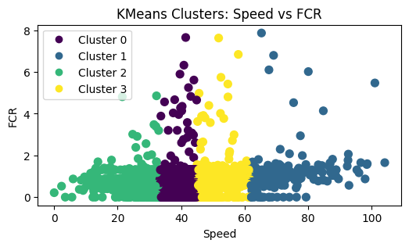
df_combined_sf = df_combined[['Vehicle Type','Vehicle Speed[km/h]','FCR']]
df_combined_sf.head()
 | Vehicle Type | Vehicle Speed[km/h] | FCR
0 | ICE | 71.199588 | 2.298379
1 | ICE | 55.280435 | 2.188477
2 | ICE | 55.131579 | 2.076016
3 | ICE | 78.166852 | 1.994577
4 | ICE | 36.728477 | 1.984249
'''
This cell:
- Maps the 'Vehicle Type' column in df_combined_sf from string labels ('ICE', 'HEV', 'EV', 'PHEV')
to numeric codes (0, 1, 2, 3) for further analysis or modeling.
'''
df_combined_sf['Vehicle Type'] = df_combined_sf['Vehicle Type'].map({'ICE': 0, 'HEV': 1, 'EV': 2, 'PHEV': 3})
plot_kmeans_elbow(df_combined_sf)
Suggested optimal K: 2
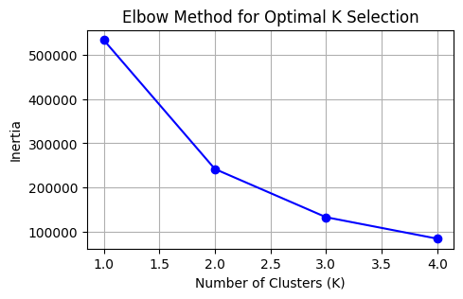
fit_predict_kmeans(df_combined_sf,3)
( Vehicle Type Vehicle Speed[km/h] FCR Cluster
0 0 71.199588 2.298379 1
1 0 55.280435 2.188477 1
2 0 55.131579 2.076016 1
3 0 78.166852 1.994577 1
4 0 36.728477 1.984249 2
... ... ... ... ...
3722 2 65.420500 0.000000 1
3723 2 64.908588 0.000000 1
3724 2 36.466653 0.000000 2
3725 2 58.251157 0.000000 1
3726 2 65.121893 0.000000 1
[3727 rows x 4 columns],
array([1, 1, 1, ..., 2, 1, 1], shape=(3727,), dtype=int32),
KMeans(n_clusters=3, random_state=42))
'''
This code:
- Imports matplotlib for plotting.
- Gets the unique vehicle types from the dataframe.
- Creates a 2x2 grid of subplots for visualizing each vehicle type.
- Iterates over each vehicle type, filtering the dataframe for that type.
- Plots a scatter plot of Speed vs FCR for each vehicle type, colored by cluster.
- Maps numeric vehicle type codes back to string labels for subplot titles.
- Sets axis labels and adds a legend for clusters in each subplot.
- Sets a common title for the figure and adjusts layout.
- Displays the plot.
'''
import matplotlib.pyplot as plt
vehicle_types = df_combined_sf['Vehicle Type'].unique()
fig, axes = plt.subplots(2, 2, figsize=(10, 6), sharey=True)
axes = axes.flatten()
for i, vtype in enumerate(vehicle_types):
ax = axes[i]
subset = df_combined_sf[df_combined_sf['Vehicle Type'] == vtype]
scatter = ax.scatter(
subset['Vehicle Speed[km/h]'],
subset['FCR'],
c=subset['Cluster'],
cmap='viridis',
s=50
)
# Map numeric vehicle type back to string for title
vtype_str = {0: "ICE", 1: "HEV", 2: "EV", 3: "PHEV"}.get(vtype, str(vtype))
ax.set_title(f'Vehicle Type: {vtype_str}')
ax.set_xlabel('Speed')
ax.set_ylabel('FCR')
handles, labels = scatter.legend_elements(prop="colors")
ax.legend(handles, [f"Cluster {i}" for i in range(len(handles))])
fig.suptitle('KMeans Clusters: Speed vs FCR by Vehicle Type', fontsize=16)
plt.tight_layout()
plt.show()
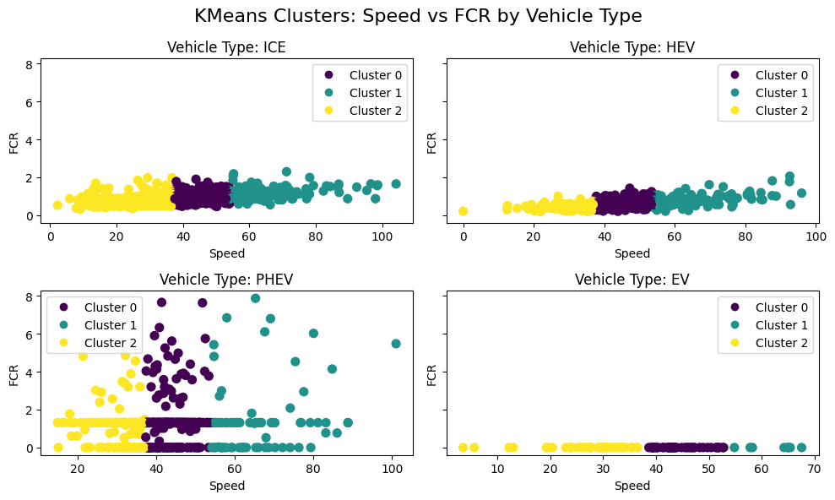
plot_kmeans_elbow(df_combined_sb)
Suggested optimal K: 2
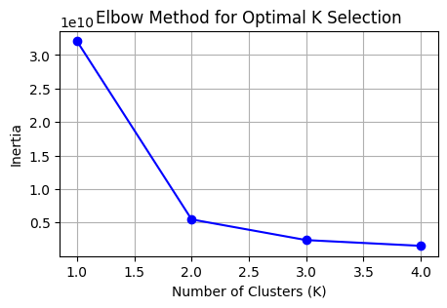
fit_predict_kmeans(df_combined_sb,3)
( Vehicle Speed[km/h] HV Battery Power[Watts] Cluster
0 71.199588 0.000000 0
1 55.280435 0.000000 0
2 55.131579 0.000000 0
3 78.166852 0.000000 0
4 36.728477 0.000000 0
... ... ... ...
3722 65.420500 -11560.435733 1
3723 64.908588 -12142.036859 1
3724 36.466653 -12732.903288 1
3725 58.251157 -13526.524390 1
3726 65.121893 -13857.507261 1
[3727 rows x 3 columns],
array([0, 0, 0, ..., 1, 1, 1], shape=(3727,), dtype=int32),
KMeans(n_clusters=3, random_state=42))
'''
- Creates a scatter plot of Vehicle Speed vs HV Battery Power, colored by KMeans cluster assignment.
- Sets axis labels and plot title.
- Adds a legend for the clusters.
- Displays the plot.
'''
plt.figure(figsize=(6, 3))
scatter = plt.scatter(
df_combined_sb['Vehicle Speed[km/h]'],
df_combined_sb['HV Battery Power[Watts]'],
c=df_combined_sb['Cluster'],
cmap='viridis',
s=50
)
plt.xlabel('Speed')
plt.ylabel('Battery Power')
plt.title('KMeans Clusters: Speed vs Battery Power')
handles, labels = scatter.legend_elements(prop="colors")
plt.legend(handles, [f"Cluster {i}" for i in range(len(handles))])
plt.show()
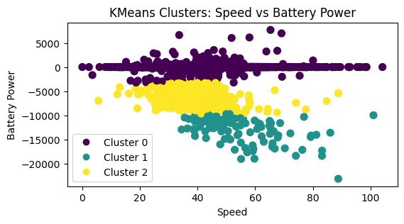
'''
This code calculates the silhouette score for KMeans clustering on the features
'Vehicle Speed[km/h]' and 'HV Battery Power[Watts]' from the dataframe df_combined_sb.
- It iterates over a range of cluster numbers (2 to 10).
- For each number of clusters, it fits a KMeans model and computes the silhouette score.
- The silhouette score measures how well each data point fits within its cluster (higher is better).
- Finally, it plots the silhouette scores against the number of clusters to help select the optimal cluster count.
'''
# Calculate silhouette score for each cluster
from sklearn.metrics import silhouette_score
from sklearn.cluster import KMeans
# Calculate silhouette score for each cluster
silhouette_scores = []
for n_clusters in range(2, 5):
kmeans = KMeans(n_clusters=n_clusters, random_state=42)
kmeans.fit(df_combined_sb[['Vehicle Speed[km/h]', 'HV Battery Power[Watts]']])
labels = kmeans.labels_
score = silhouette_score(df_combined_sb[['Vehicle Speed[km/h]', 'HV Battery Power[Watts]']], labels)
silhouette_scores.append((n_clusters, score))
# Plot silhouette scores
plt.figure(figsize=(5, 3))
plt.plot([score[0] for score in silhouette_scores], [score[1] for score in silhouette_scores], marker='o')
plt.xlabel('Number of Clusters')
plt.ylabel('Silhouette Score')
plt.title('Silhouette Scores for KMeans Clustering')
plt.show()
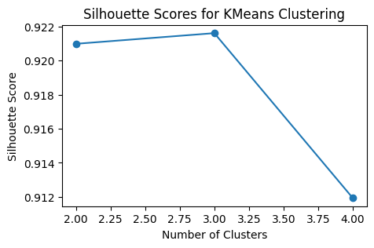
df_combined_sb = df_combined[['Vehicle Type','Vehicle Speed[km/h]','HV Battery Power[Watts]']]
# map vehicle type to 0,1,2,3
df_combined_sb['Vehicle Type'] = df_combined_sb['Vehicle Type'].map({'ICE': 0, 'HEV': 1, 'EV': 2, 'PHEV': 3})
df_combined_sb.head()
 | Vehicle Type | Vehicle Speed[km/h] | HV Battery Power[Watts]
0 | 0 | 71.199588 | 0.0
1 | 0 | 55.280435 | 0.0
2 | 0 | 55.131579 | 0.0
3 | 0 | 78.166852 | 0.0
4 | 0 | 36.728477 | 0.0
plot_kmeans_elbow(df_combined_sb)
fit_predict_kmeans(df_combined_sb,3)
Suggested optimal K: 2
( Vehicle Type Vehicle Speed[km/h] HV Battery Power[Watts] Cluster
0 0 71.199588 0.000000 0
1 0 55.280435 0.000000 0
2 0 55.131579 0.000000 0
3 0 78.166852 0.000000 0
4 0 36.728477 0.000000 0
... ... ... ... ...
3722 2 65.420500 -11560.435733 1
3723 2 64.908588 -12142.036859 1
3724 2 36.466653 -12732.903288 1
3725 2 58.251157 -13526.524390 1
3726 2 65.121893 -13857.507261 1
[3727 rows x 4 columns],
array([0, 0, 0, ..., 1, 1, 1], shape=(3727,), dtype=int32),
KMeans(n_clusters=3, random_state=42))
'''
This code creates a 2x2 grid of scatter plots, one for each vehicle type, showing the relationship between 'Vehicle Speed[km/h]' and 'HV Battery Power[Watts]' for each type.
- It iterates over unique vehicle types, selects the corresponding subset of data, and plots the points colored by their KMeans cluster assignment.
- The numeric vehicle type is mapped back to a string for the plot title.
- Each subplot includes a legend for the clusters.
- The overall figure is titled and laid out neatly.
'''
import matplotlib.pyplot as plt
vehicle_types = df_combined_sf['Vehicle Type'].unique()
fig, axes = plt.subplots(2, 2, figsize=(10, 6), sharey=True)
axes = axes.flatten()
for i, vtype in enumerate(vehicle_types):
ax = axes[i]
subset = df_combined_sb[df_combined_sb['Vehicle Type'] == vtype]
scatter = ax.scatter(
subset['Vehicle Speed[km/h]'],
subset['HV Battery Power[Watts]'],
c=subset['Cluster'],
cmap='viridis',
s=50
)
# Map numeric vehicle type back to string for title
vtype_str = {0: "ICE", 1: "HEV", 2: "EV", 3: "PHEV"}.get(vtype, str(vtype))
ax.set_title(f'Vehicle Type: {vtype_str}')
ax.set_xlabel('Speed')
ax.set_ylabel('Battery Power')
handles, labels = scatter.legend_elements(prop="colors")
ax.legend(handles, [f"Cluster {i}" for i in range(len(handles))])
fig.suptitle('KMeans Clusters: Speed vs Battery Power by Vehicle Type', fontsize=16)
plt.tight_layout()
plt.show()
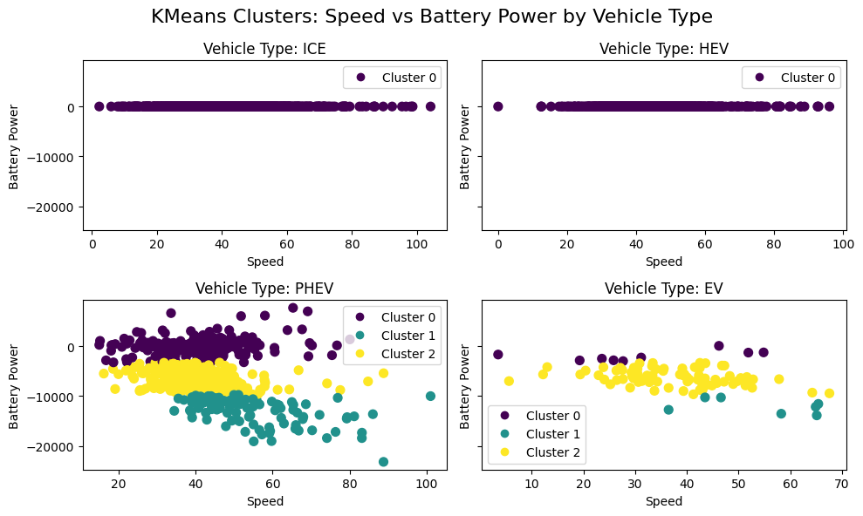
df_combined_sb
 | Vehicle Type | Vehicle Speed[km/h] | HV Battery Power[Watts] | Cluster
0 | 0 | 71.199588 | 0.000000 | 0
1 | 0 | 55.280435 | 0.000000 | 0
2 | 0 | 55.131579 | 0.000000 | 0
3 | 0 | 78.166852 | 0.000000 | 0
4 | 0 | 36.728477 | 0.000000 | 0
... | ... | ... | ... | ...
3722 | 2 | 65.420500 | -11560.435733 | 1
3723 | 2 | 64.908588 | -12142.036859 | 1
3724 | 2 | 36.466653 | -12732.903288 | 1
3725 | 2 | 58.251157 | -13526.524390 | 1
3726 | 2 | 65.121893 | -13857.507261 | 1
plot_kmeans_elbow(df_combined_of)
fit_predict_kmeans(df_combined_of,5)
Suggested optimal K: 2
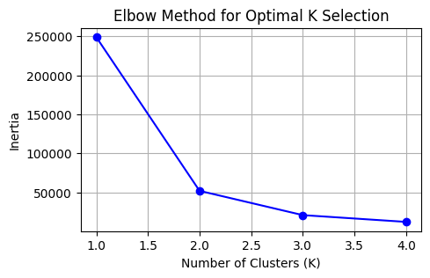
( OAT[DegC] FCR Cluster
0 15.000000 2.298379 0
1 -4.954545 2.188477 1
2 6.611650 2.076016 2
3 15.000000 1.994577 0
4 15.000000 1.984249 0
... ... ... ...
3722 2.673522 0.000000 3
3723 6.500000 0.000000 2
3724 1.240812 0.000000 3
3725 -2.682927 0.000000 1
3726 -5.061386 0.000000 1
[3727 rows x 3 columns],
array([0, 1, 2, ..., 3, 1, 1], shape=(3727,), dtype=int32),
KMeans(n_clusters=5, random_state=42))
'''
This code creates a scatter plot to visualize KMeans clustering results.
- It plots 'OAT[DegC]' (Outside Air Temperature) vs 'FCR', coloring points by their cluster assignment.
- The color map 'viridis' is used for cluster coloring.
- The plot includes axis labels, a title, and a legend indicating cluster numbers.
'''
plt.figure(figsize=(6, 3))
scatter = plt.scatter(
df_combined_of['OAT[DegC]'],
df_combined_of['FCR'],
c=df_combined_of['Cluster'],
cmap='viridis',
s=50
)
plt.xlabel('Outside Air Temperature')
plt.ylabel('FCR')
plt.title('KMeans Clusters: Outside Air Temperature vs FCR')
handles, labels = scatter.legend_elements(prop="colors")
plt.legend(handles, [f"Cluster {i}" for i in range(len(handles))])
plt.show()
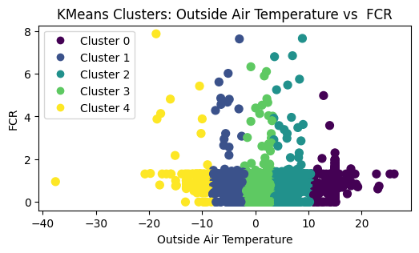
plot_kmeans_elbow(df_combined_ob)
fit_predict_kmeans(df_combined_ob,5)
Suggested optimal K: 2
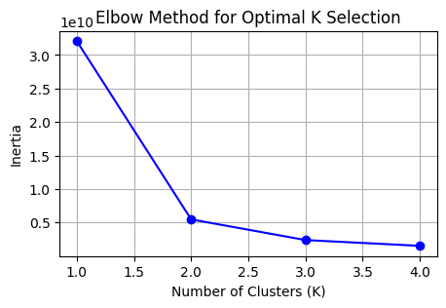
( OAT[DegC] HV Battery Power[Watts] Cluster
0 15.000000 0.000000 0
1 -4.954545 0.000000 0
2 6.611650 0.000000 0
3 15.000000 0.000000 0
4 15.000000 0.000000 0
... ... ... ...
3722 2.673522 -11560.435733 1
3723 6.500000 -12142.036859 1
3724 1.240812 -12732.903288 1
3725 -2.682927 -13526.524390 1
3726 -5.061386 -13857.507261 3
[3727 rows x 3 columns],
array([0, 0, 0, ..., 1, 1, 3], shape=(3727,), dtype=int32),
KMeans(n_clusters=5, random_state=42))
'''
This code creates a scatter plot to visualize KMeans clustering results.
- It plots 'OAT[DegC]' (Outside Air Temperature) vs 'HV Battery Power[Watts]', coloring points by their cluster assignment.
- The color map 'viridis' is used for cluster coloring.
- The plot includes axis labels, a title, and a legend indicating cluster numbers.
'''
plt.figure(figsize=(6, 3))
scatter = plt.scatter(
df_combined_ob['OAT[DegC]'],
df_combined_ob['HV Battery Power[Watts]'],
c=df_combined_ob['Cluster'],
cmap='viridis',
s=50
)
plt.xlabel('Outside Air Temperature')
plt.ylabel('Battery Power')
plt.title('KMeans Clusters: Outside Air Temperature vs Battery Power')
handles, labels = scatter.legend_elements(prop="colors")
plt.legend(handles, [f"Cluster {i}" for i in range(len(handles))])
plt.show()
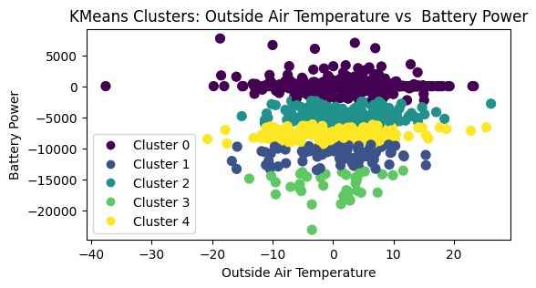

10. Final Verdict
- Feasibility: Predicting energy consumption using standard OBD-II data is highly feasible for Hybrid and ICE vehicles, provided that engine load and fuel trim data are available.
- Model Robustness: HEV models were the most robust, likely due to the consistent interplay between the engine and battery systems captured in the data.
- Feature Importance: Mass Air Flow (MAF) and Absolute Load are the most critical predictors for fuel consumption. For EVs, simple kinematic variables (Speed, Distance) are insufficient for high-accuracy power prediction, suggesting the need for road gradient or auxiliary load data.
- Methodology: Time-based data splitting yielded superior metrics compared to random trip splitting, highlighting the importance of temporal continuity in driving data analysis.

