RETAIL SALES DATA PROCESSING AND BUSINESS INSIGHTS GENERATION

An End-to-End Data Engineering Pipeline and Power BI Analytics Solution for Retail Business Intelligence

Submission from:
ARAVIND J S
ST Joseph’s University
7510886497
Aravindjs10@gmail.com

Table of Contents

Sl No. | Title
1 | Executive Summary
2 | Problem Statement
3 | Solution Overview
4 | Architecture Diagram
5 | Data Flow Diagram
6 | Data Model
7 | Data Ingestion Strategy
8 | Data Cleaning Strategy
9 | Data Transformation Logic
10 | Storage and Structured Dataset
11 | Power BI Dashboard
12 | Conclusion

Section 1

EXECUTIVE SUMMARY
ABC Retail Solutions operates through multiple retail channels across several cities and processes thousands of daily transactions from both online and offline sales systems. However, inconsistencies in retail transaction data, including duplicate records, missing values, inconsistent product names, invalid quantities, and varying date formats, hinder accurate business reporting and decision-making.
To address these challenges, a complete end-to-end retail data engineering pipeline was designed and implemented. The solution ingests transactional retail data from multiple source systems, performs extensive cleaning and transformation, enriches transaction records using standardized product metadata, and generates business-ready datasets suitable for reporting and analytics.
The transformed data is modeled using a dimensional schema and visualized through an interactive Power BI dashboard. The dashboard provides insights into total revenue, product performance, category trends, transaction behavior, and regional sales performance.
The solution enables ABC Retail Solutions to improve reporting accuracy, enhance operational efficiency, and make data-driven strategic business decisions.

Section 2

PROBLEM STATEMENT
ABC Retail Solutions collects transactional retail data from multiple operational systems. Due to inconsistencies such as duplicate transactions, missing product information, inconsistent naming conventions, invalid quantity values, and varying date formats, generating reliable business insights becomes challenging.
The organization lacks a standardized and scalable data processing framework capable of cleansing, transforming, and analyzing retail sales information efficiently.
Without a reliable data engineering pipeline, management faces difficulties in:
- Monitoring overall business revenue.
- Identifying top-performing products.
- Analyzing category-wise sales performance.
- Understanding customer purchasing trends.
- Evaluating regional business performance.
- Making strategic business decisions based on accurate data.
becomes difficult.

Section 3

SOLUTION OVERVIEW
To address the challenges faced by ABC Retail Solutions, a complete retail analytics solution was developed using modern data engineering principles and Power BI.
The solution automates the ingestion, validation, cleaning, transformation, and visualization of retail transaction data.

1. Data Ingestion
Retail transaction data from multiple source systems is ingested into the processing environment.
Datasets include:
- Retail Transaction Dataset 1
- Retail Transaction Dataset 2
- Product Dimension Dataset
The ingestion process validates:
- Schema consistency
- Data type accuracy
- Missing records
- Invalid values

2. Data Cleaning and Transformation
The raw datasets undergo extensive preprocessing.
Activities include:
- Duplicate transaction removal
- Missing value treatment
- Standardization of product names
- Standardization of category names
- Date format normalization
- Invalid quantity correction
- Data validation
Personally Identifiable Information (PII) such as:
- Customer Email
- Phone Number
are masked to ensure privacy compliance.

3. Data Enrichment
Transaction records are enriched using the Product Dimension table.
Additional attributes include:
- Product Category
- Standard Product Price
- Product Metadata
This enrichment improves analytical capabilities and reporting accuracy.

4. Business KPI Generation
Several business metrics are calculated:
- Total Revenue
- Revenue by Category
- Revenue by Product
- Revenue by Month
- Revenue by Quarter
- Revenue by Region
- Total Transactions
- Average Order Value
- Total Quantity Sold
- Discount Impact Analysis

5. Visualization and Reporting
A fully interactive Power BI dashboard is developed.
Dashboard sections include:
- Executive Summary
- Revenue Analysis
- Product Performance
- Category Trends
- Regional Insights
Interactive slicers allow filtering by:
- Year
- Month
- Quarter
- Category
- Product
- City

Section 4

ARCHITECTURE DIAGRAM

Figure 4.1 End-to-End Retail Sales Analytics Architecture
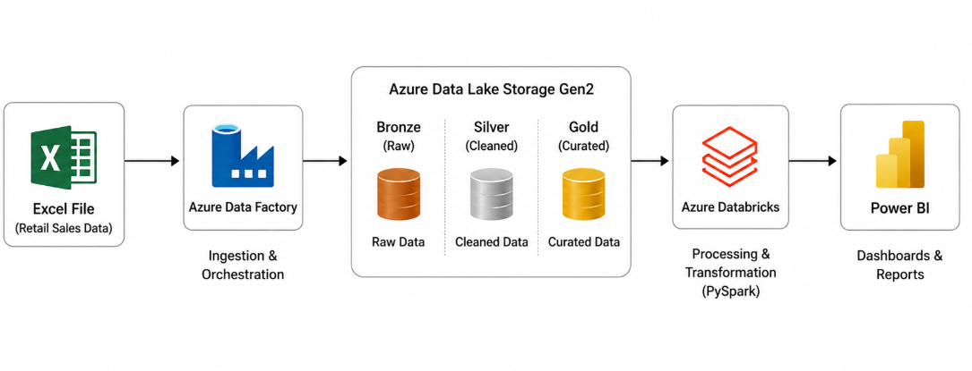
The retail analytics solution follows the Medallion Architecture pattern consisting of Bronze, Silver, and Gold layers.

1. BRONZE LAYER – RAW DATA INGESTION
The Bronze layer stores retail transaction datasets in their original format after ingestion from source systems.
Datasets:
- retail_data1.csv
- retail_data2.csv
- product_dimension.csv
The primary objective of this layer is to preserve raw data for auditing and recovery purposes.

2. SILVER LAYER – DATA STANDARDIZATION
The Silver layer performs cleansing and standardization operations.
Activities performed:
- Rename columns
- Standardize product names
- Convert data types
- Date format standardization
- Handle null values
- Remove duplicate records
- Schema validation
- Convert CSV files into Parquet format
The Silver layer ensures consistent and analytics-ready datasets.

3. GOLD LAYER – BUSINESS TRANSFORMATION
The Gold layer performs business-level transformations.
Activities performed:
- Read Silver datasets
- Union Retail_Data1 and Retail_Data2
- Advanced deduplication
- Missing price correction
- Invalid transaction detection
- Revenue calculations
- Date dimension generation
- Aggregation table creation
- Star schema preparation
The Gold layer contains the final curated datasets optimized for reporting and analytics.

4. POWER BI REPORTING LAYER
The curated Gold datasets are loaded into Power BI.
The dashboard provides:
- Revenue Analysis
- Product Performance
- Category Trends
- Regional Insights
- Executive KPI Monitoring
The reporting layer enables business users to make informed decisions based on real-time sales insights.

Section 5

DATA FLOW DIAGRAM

Figure 5.1 Retail Sales Data Flow

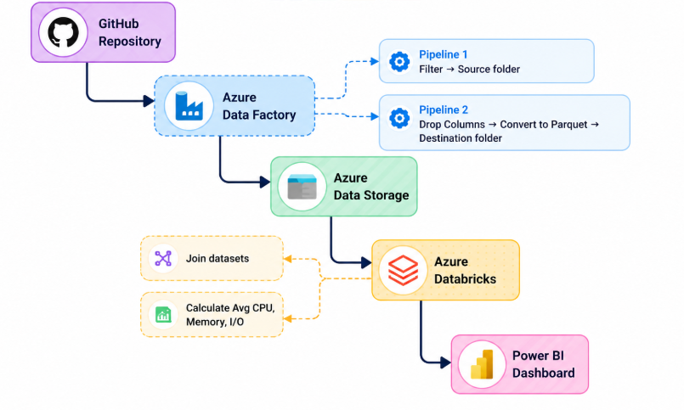

Data Flow Stages

Data Sources
The system receives data from:
- Retail Transaction Source 1
- Retail Transaction Source 2
- Product Metadata Source

Ingestion Layer
Azure Data Factory pipelines retrieve source files and load them into Azure Storage.

Silver Layer
Data quality improvements are applied through standardization and cleansing operations.

Gold Layer
Business logic transformations are applied to generate revenue metrics and analytical datasets.

Visualization Layer
Power BI consumes the final curated datasets and generates business dashboards.

Section 6

DATA MODEL
The data model serves as the foundation for business analytics and reporting. It organizes retail transaction data and supporting dimensions to enable efficient querying, aggregation, and visualization in Power BI.
After the cleaning, transformation, and enrichment stages, the final dataset is structured using a Star Schema design. This schema improves analytical performance, simplifies report development, and supports drill-down analysis.

Model Type

Star Schema
The model consists of:
- One central Fact Table containing transactional sales data.
- Supporting Dimension Tables containing descriptive attributes used for filtering and reporting.
This structure improves query performance and dashboard responsiveness.

Key Tables

1. Fact_Sales (Fact Table)
The Fact_Sales table stores retail transactions and business metrics generated during the Gold Layer transformation process.

Key Attributes
Column Name | Description
transaction_id | Unique transaction identifier
transaction_date | Date of transaction
product_id | Product reference key
quantity | Number of units sold
unit_price | Selling price per unit
gross_revenue | Revenue before discounts
discount_amount | Total discount applied
net_revenue | Revenue after discounts

This table serves as the primary source for sales and revenue analytics.

2. Dim_Product (Dimension Table)
The Product Dimension table contains standardized product information used to enrich retail transactions.

Key Attributes
Column Name | Description
product_id | Unique product identifier
product_name | Product name
category | Product category
standard_price | Standard product price
This dimension supports product-level and category-level analysis.

3. Dim_Date (Dimension Table)
The Date Dimension table was created during the Gold Layer transformation stage and supports time-based reporting.

Key Attributes
Column Name | Description
date | Calendar date
year | Year
quarter | Quarter
month | Month name
month_number | Month sequence
day_name | Day of week

This dimension enables monthly, quarterly, and yearly analysis.

Relationships
The model uses one-to-many relationships between dimension tables and the fact table.

Relationship 1
Dim_Product.product_id
|
V
Fact_Sales.product_id
Relationship Type: One-to-Many (1:*)

Relationship 2
Dim_Date.date
|
V
Fact_Sales.transaction_date
Relationship Type: One-to-Many (1:*)

Star Schema Representation
Dim_Product
|
|
V
Fact_Sales
^
|
|
Dim_Date
The Star Schema provides an optimized structure for KPI calculations, filtering, and Power BI reporting.
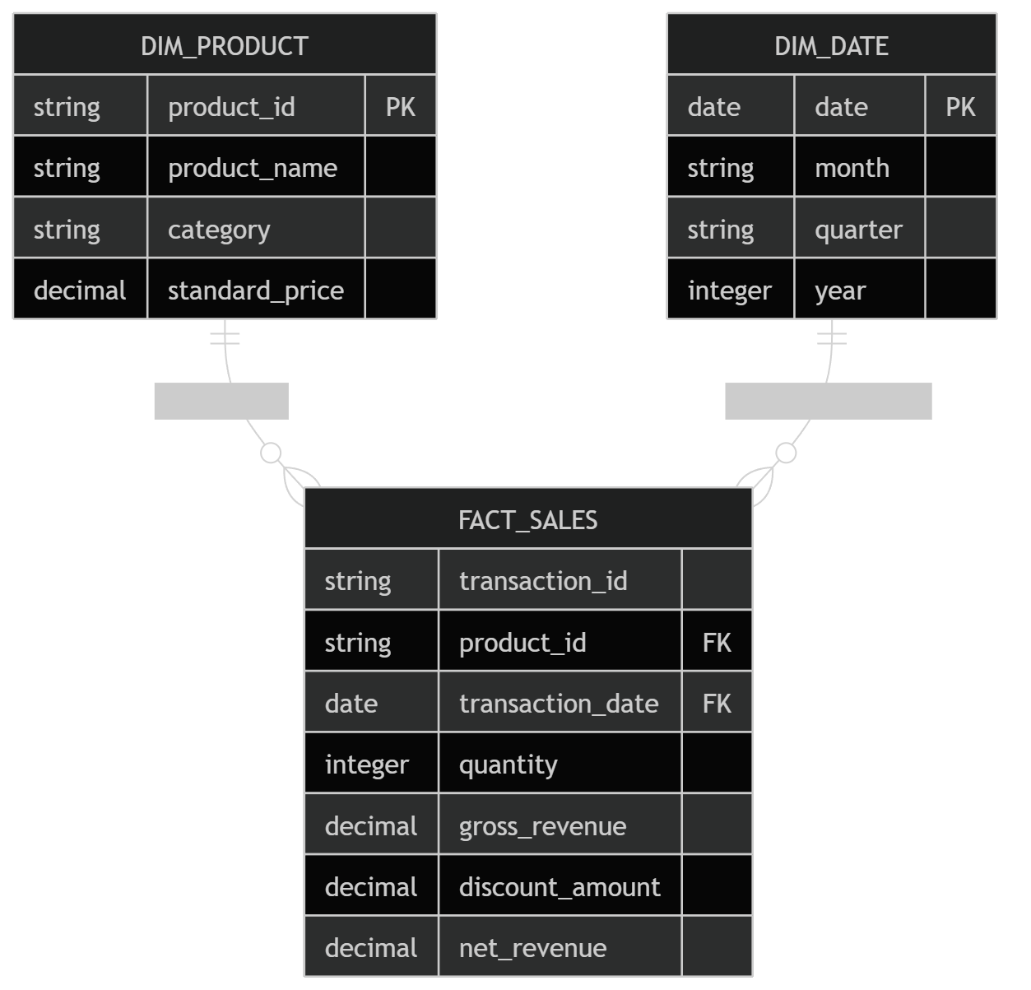

Section 7

DATA INGESTION STRATEGY
To ingest retail transaction data into the analytics platform, Azure Data Factory (ADF) was used as the primary orchestration and ingestion service.
The ingestion framework automates data retrieval, validation, and loading while ensuring high data quality and consistency.
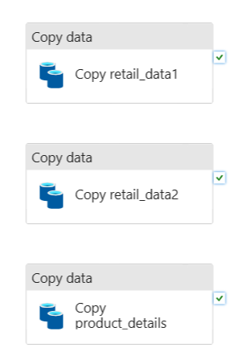

Source Datasets
The following source datasets were used:

Retail_Data1.csv
Contains retail transactions collected from the first transactional system.

Retail_Data2.csv
Contains retail transactions collected from the second transactional system.

Product_Dimension.csv
Contains standardized product metadata used for data enrichment.

Bronze Layer Architecture
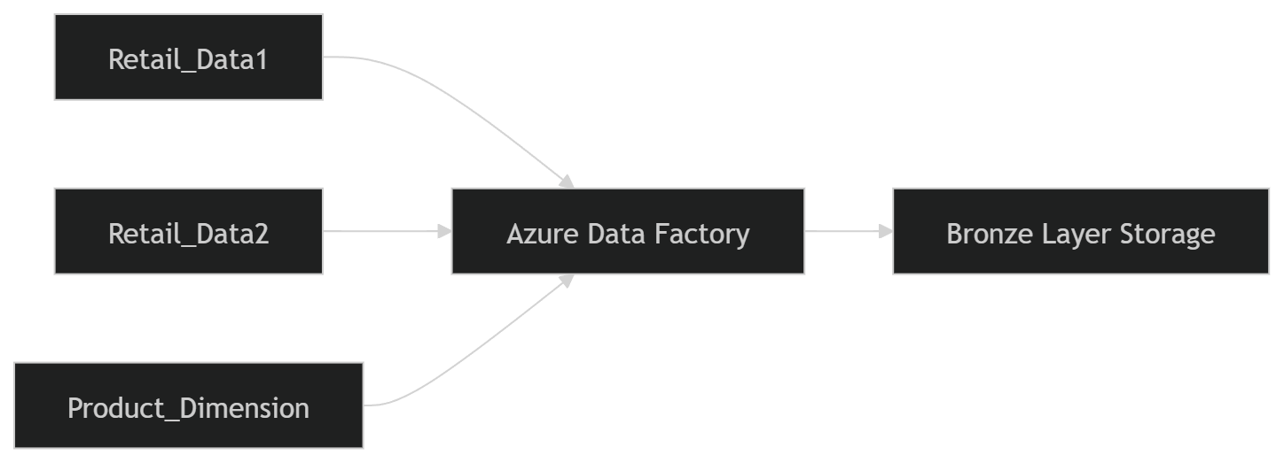

Section 8

DATA CLEANING STRATEGY
To ensure high-quality business reporting, extensive cleaning operations were performed in the Silver Layer.
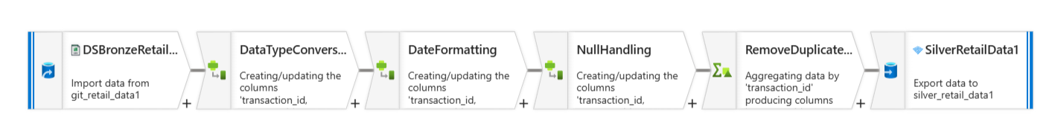
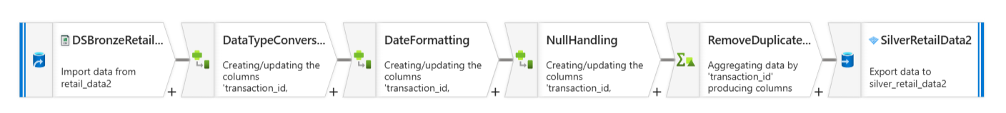
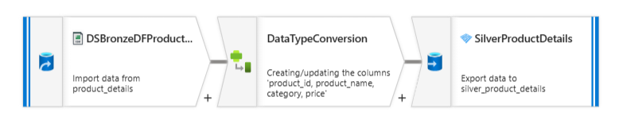

Initial Data Assessment
The retail datasets were profiled to identify:
- Missing values
- Duplicate transactions
- Invalid quantities
- Incorrect product names
- Schema inconsistencies

Column Standardization
Columns from multiple source systems were renamed to maintain consistent naming conventions.
Examples:
Source Column | Standardized Column
Product_Name | product_name
ProductID | product_id
SaleDate | transaction_date

Data Type Conversion
The following conversions were applied:
Column | Original Type | Converted Type
transaction_date | String | Date
quantity | String | Integer
unit_price | String | Decimal

Date Standardization
Different date formats were converted into a unified standard:
YYYY-MM-DD

Null Handling
Missing values were handled using:
- Mean imputation
- Product master lookup
- Business rules
Critical records with insufficient information were removed.

Duplicate Removal
Duplicate transactions were identified using:
- Transaction ID
- Product ID
- Transaction Date
Duplicate records were removed before further processing.

CSV to Parquet Conversion
After cleaning, datasets were converted from CSV format into Parquet format to improve:
- Storage efficiency
- Query performance
- Scalability

Section 9

DATA TRANSFORMATION LOGIC
The Gold Layer contains advanced business transformations that convert cleaned retail data into analytical datasets.

Major Transformation Steps

Step 1: Read Silver Layer Datasets
The cleaned Parquet datasets were loaded into the transformation environment.
Datasets:
- Silver_Retail_Data1
- Silver_Retail_Data2
- Silver_Product_Dimension

Step 2: Union Retail Datasets
Both retail transaction datasets were merged into a unified transaction dataset.
Retail_Data1
UNION ALL
Retail_Data2

Step 3: Advanced Deduplication
Duplicate records across both datasets were identified and removed using composite business keys.
Deduplication Keys:
- transaction_id
- product_id
- transaction_date

Step 4: Missing Price Resolution
Missing prices were corrected using Product Dimension reference data.
If Unit Price IS NULL
→ Retrieve Standard Price from Product Dimension

Step 5: Invalid Transaction Detection
The following invalid transactions were identified:
- Negative quantities
- Negative prices
- Zero-value sales
- Invalid dates
Such records were logged and removed.

Step 6: Revenue Metric Creation
The following business metrics were generated:

Gross Revenue
Gross Revenue = Quantity × Unit Price

Discount Amount
Discount Amount = Gross Revenue × Discount %

Net Revenue
Net Revenue = Gross Revenue − Discount Amount

Step 7: Date Dimension Creation

A dedicated Date Dimension was created containing:

Field
Date
Year
Quarter
Month
Month Number
Day Name

Step 8: Aggregation Tables
Business aggregation tables were generated.
Examples:
- Revenue by Product
- Revenue by Category
- Revenue by City
- Revenue by Month
- Revenue by Quarter
These aggregation tables improve dashboard performance and reduce query execution time.

Step 9: Star Schema Creation
The final model consists of:
Fact Table:
- Fact_Sales
Dimension Tables:
- Dim_Product
- Dim_Date
This schema provides optimized Power BI performance.

Section 10

STORAGE AND STRUCTURED DATASET
The storage layer plays a vital role in managing retail sales data throughout the processing lifecycle. Azure Data Lake Storage was used to store and organize datasets across the Medallion Architecture, ensuring reliable, scalable, and efficient data access for analytics and reporting.
The storage structure is organized into three primary layers:

Bronze Layer – Raw Data Storage
The Bronze Layer stores source datasets in their original format immediately after ingestion.
Datasets stored:
- Retail_Data1.csv
- Retail_Data2.csv
- Product_Dimension.csv
This layer acts as the system of record and supports auditability, traceability, and data recovery.

Silver Layer – Cleaned and Standardized Data
The Silver Layer contains datasets that have undergone cleansing and standardization.

Key Activities Performed
- Column renaming
- Data type conversion
- Date standardization
- Null value handling
- Duplicate removal
- Schema validation
The cleaned datasets are stored in Parquet format to improve storage efficiency and query performance.

Gold Layer – Business-Ready Data
The Gold Layer contains transformed and enriched datasets optimized for analytics and reporting.

Key Outputs
- Fact_Sales
- Dim_Product
- Dim_Date
- Revenue Aggregation Tables
- Category Performance Tables
- Monthly Sales Summary Tables
These datasets serve as the primary source for Power BI dashboards and business reporting.

Storage Benefits
The Medallion Architecture provides:
- Improved data governance
- Faster query performance
- Reduced storage consumption
- Better scalability
- Simplified maintenance
This layered approach ensures a structured flow of data from raw ingestion to business-ready analytical datasets.

Section 11

POWER BI DASHBOARD
The final Gold Layer datasets were imported into Power BI to create an interactive business intelligence dashboard. The dashboard provides a comprehensive view of retail sales performance and supports data-driven decision-making.
The report is organized into multiple analytical sections to enable easy business interpretation.
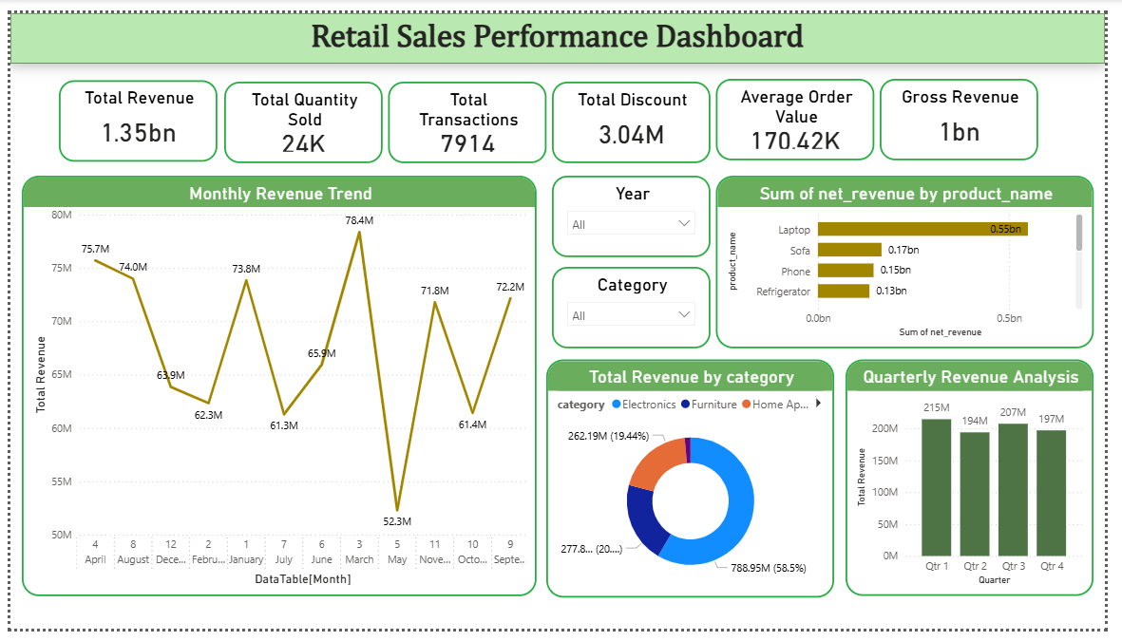

KPI Cards
The dashboard displays key performance indicators including:
- Total Revenue
- Gross Revenue
- Net Revenue
- Total Quantity Sold
- Total Transactions
- Average Order Value
These KPI cards provide instant visibility into the organization's overall sales performance.
Visualizations include:
- Monthly Revenue Trend (Line Chart)
- Quarterly Revenue Analysis (Column Chart)
- Revenue Distribution by Category (Donut Chart)
This page helps identify seasonal trends and revenue growth patterns.

Slicers
- Year
- Category

Section 12

CONCLUSION
This project successfully demonstrates the design and implementation of an end-to-end Retail Sales Analytics Platform using Azure Data Engineering services and Power BI.
The solution addresses critical data quality challenges by implementing automated ingestion, cleansing, transformation, enrichment, and reporting processes. Through the Medallion Architecture approach, raw retail transaction data is systematically transformed into reliable and business-ready datasets.
The implementation of Silver Layer standardization and Gold Layer business transformations enabled the creation of accurate sales metrics such as Gross Revenue, Discount Amount, Net Revenue, Product Performance, Category Analysis, and Revenue Trends.
The final Power BI dashboard provides interactive and real-time insights through KPI cards, revenue analysis, product performance monitoring, category trend evaluation, and regional sales reporting. These visualizations empower stakeholders to make informed business decisions based on reliable data.
Overall, the solution improves reporting accuracy, enhances operational efficiency, and establishes a scalable foundation for future retail analytics initiatives. The architecture can be further extended to support advanced analytics, forecasting, and enterprise-scale business intelligence requirements, making it a robust and future-ready retail data platform.

