Aravind krishnan

task 11

· Go to Azure Portal.

· Sign in with your Azure account

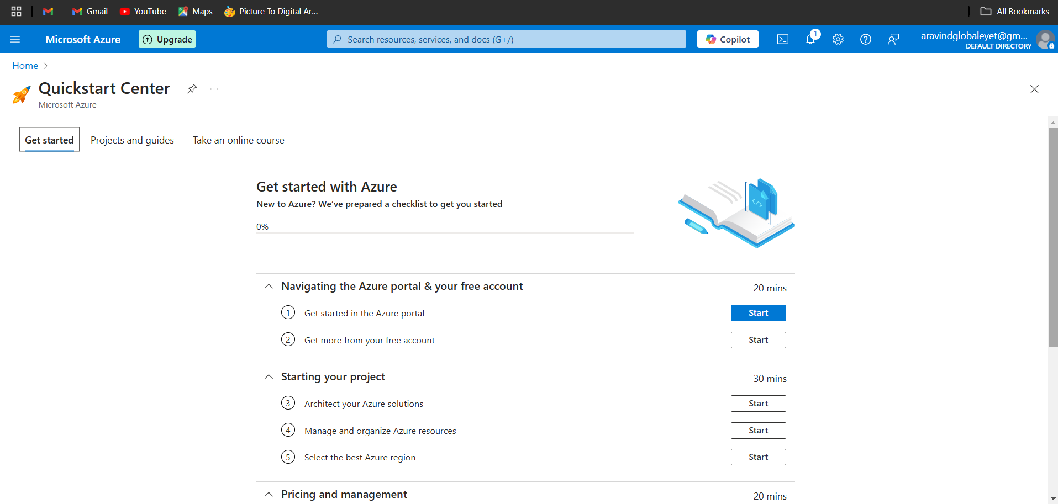

· Navigate to Virtual Machines from the Azure dashboard.

· Click Create Azure Virtual Machine

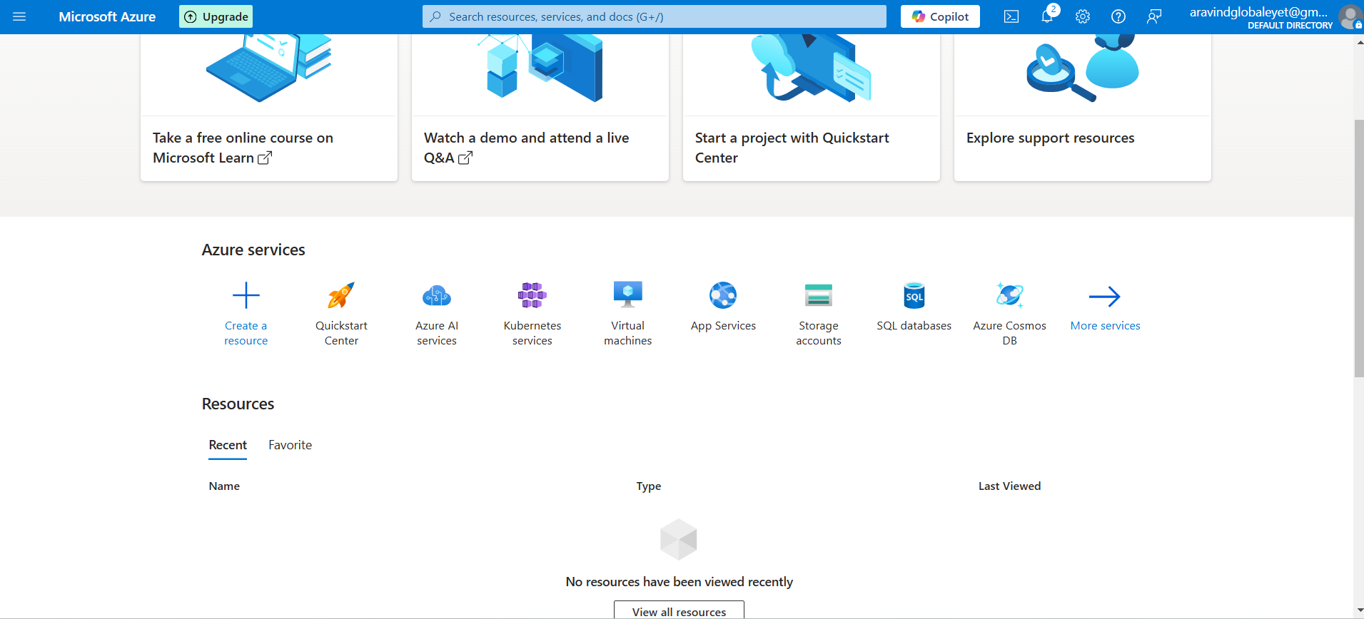

Select an available free-tier VM, such as Ubuntu Server 24.04 LTS Gen2

· Choose a resource group (or create a new one)

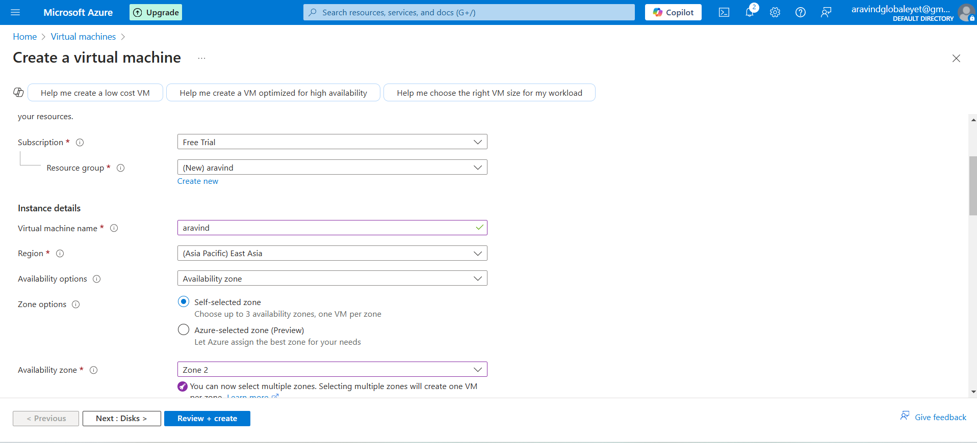

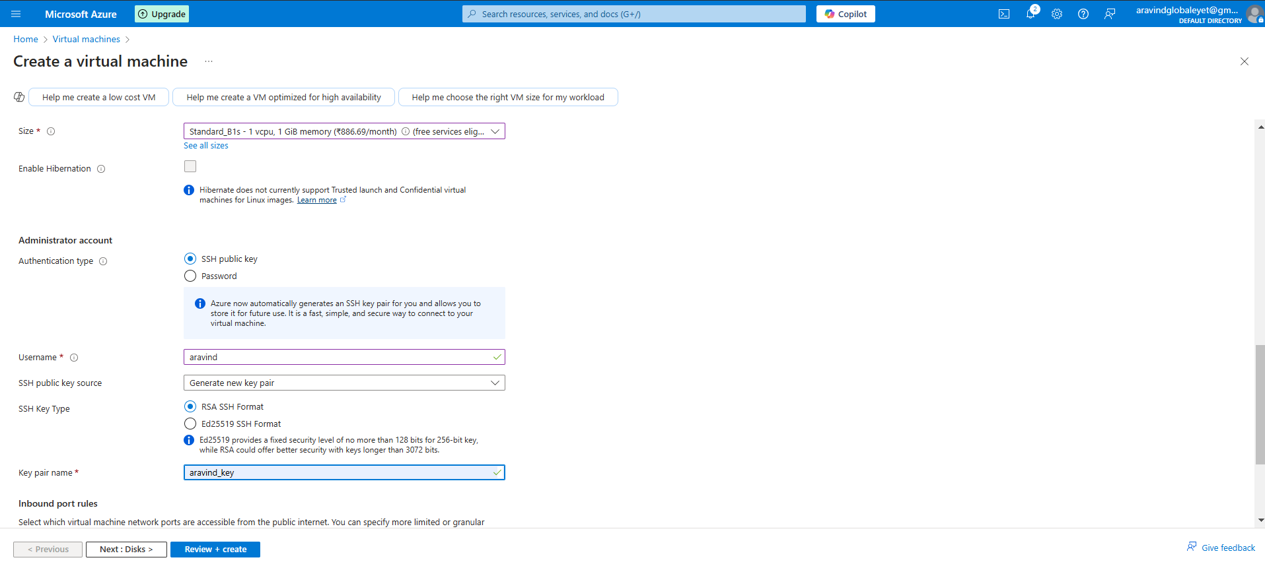

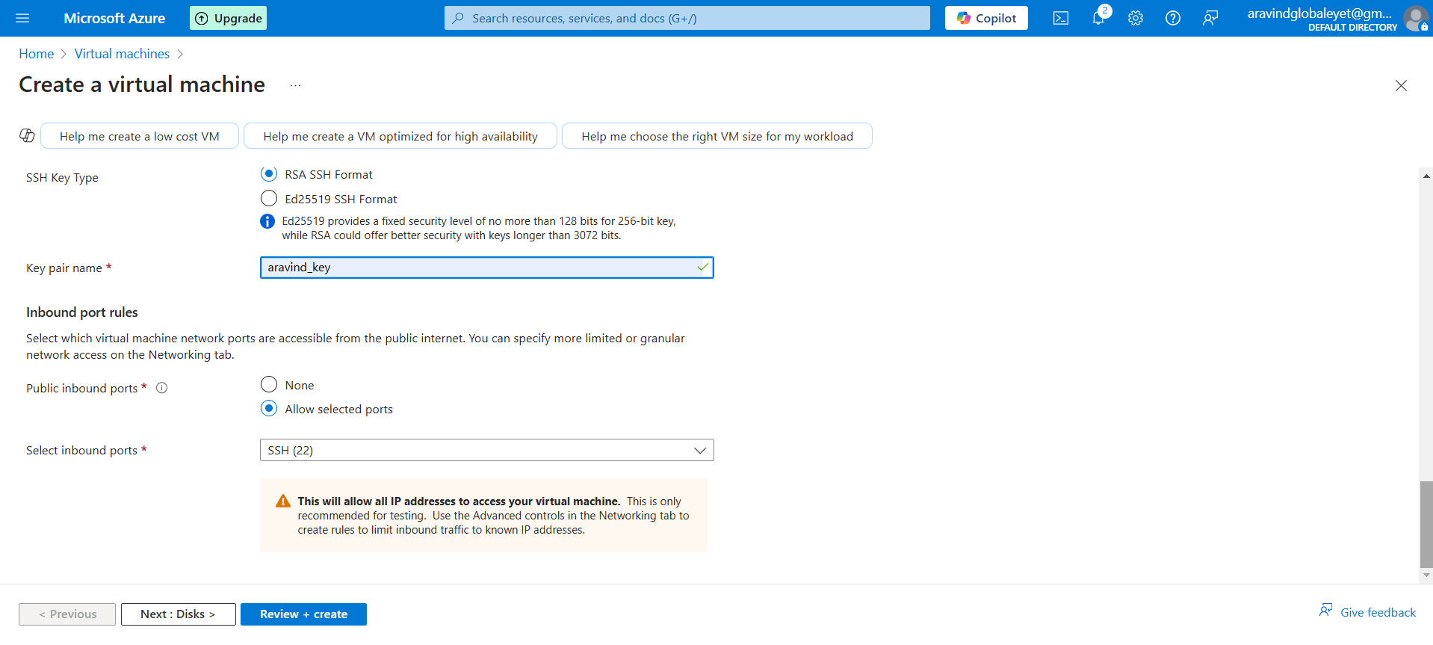

Ensure Allow SSH (port 22) is enabled under Networking.

· Click Review + Create and then Create.

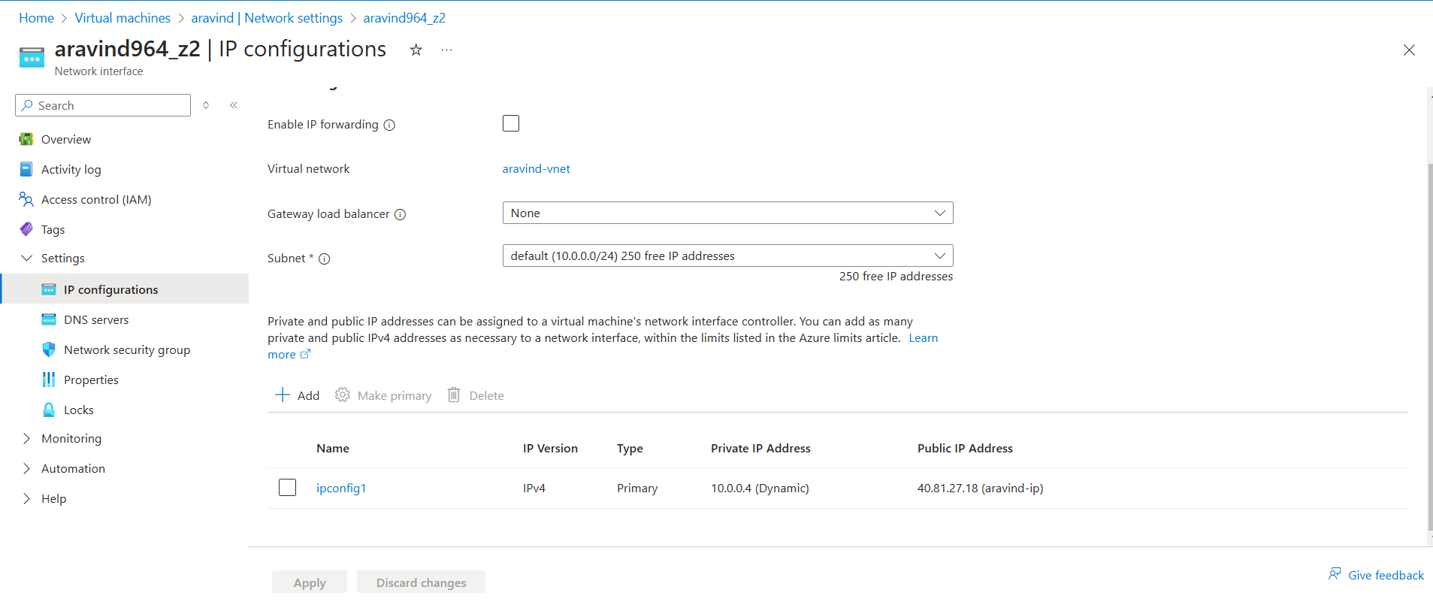

ping -c 4 <ip>

· If the ping fails, check Azure’s Networking > Inbound Rules:

1. Ensure an inbound rule exists for ICMP (ping) requests.

2. If not, create a new rule allowing ICMP from anywhere.

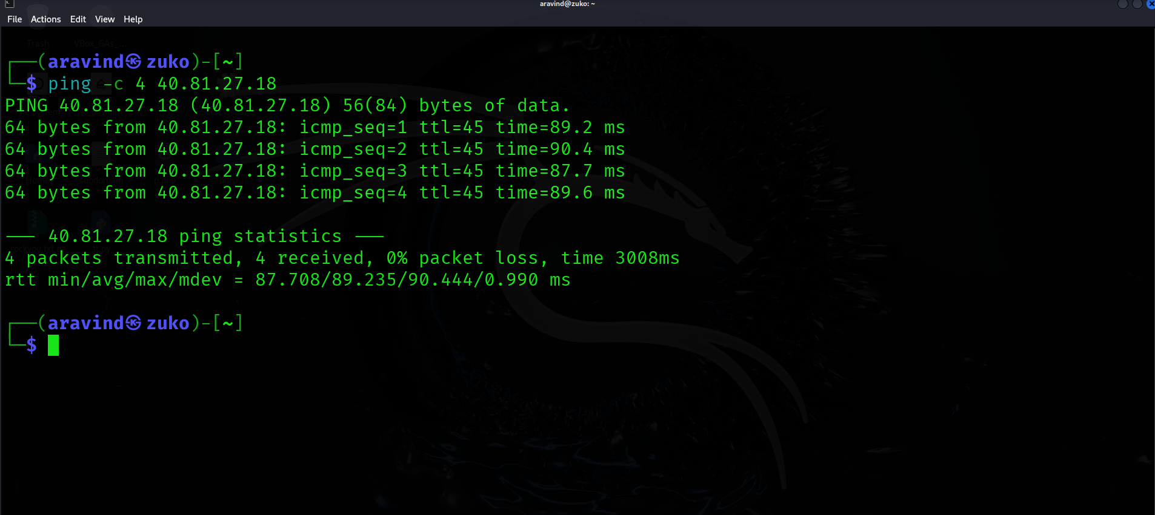

**Login via ssh**

ssh -i /home/aravind/Desktop/aravind_key.pem [azureuser@104.214.179.253](mailto:azureuser@104.214.179.253)

run: ip a

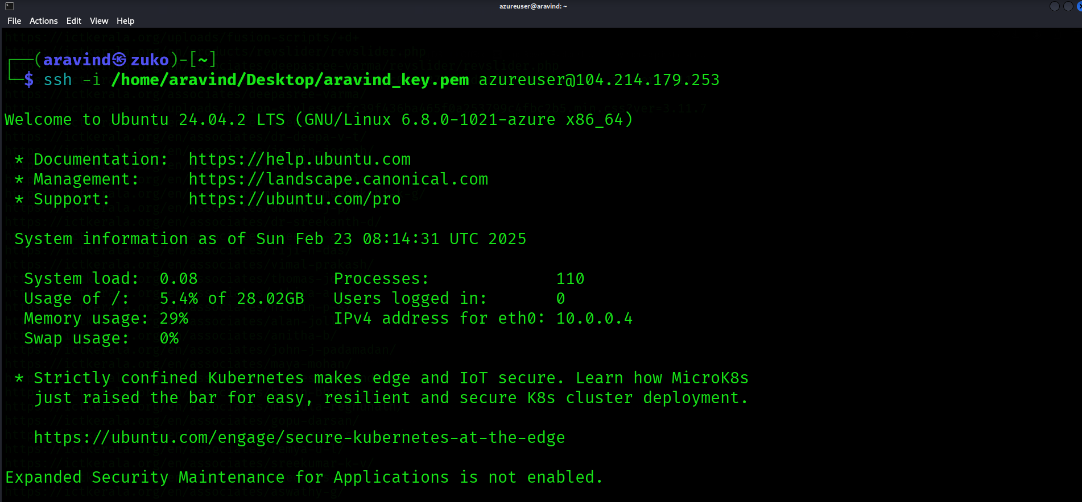

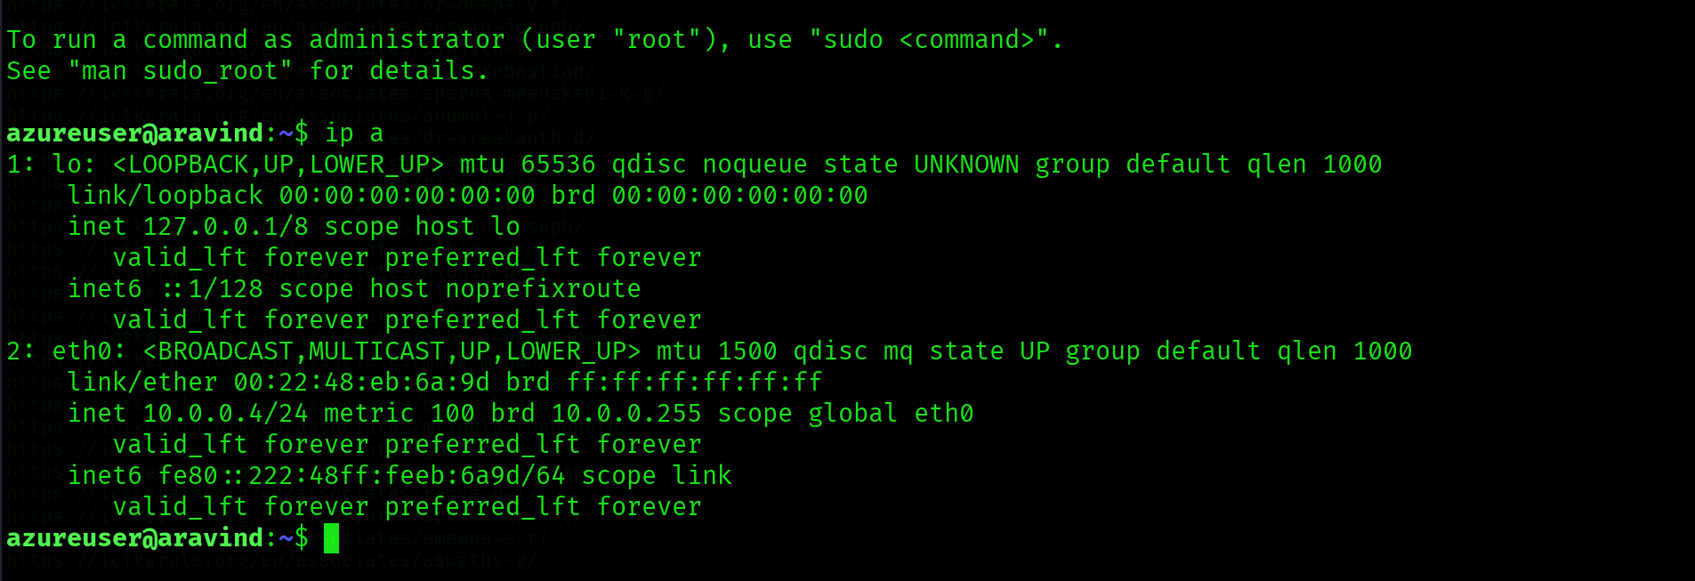

Find your public ip



try pinging it from the Azure VM

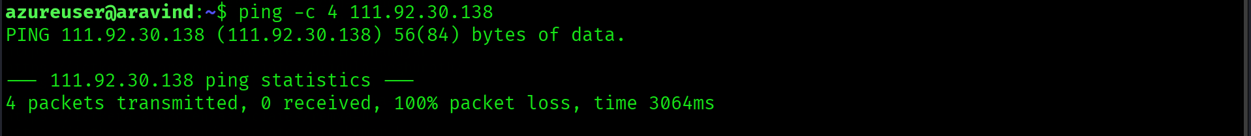

While try pinging the public IP from cloud VM, no packets are transmitted. It might be because of ISP restriction as there is no internal fire wall blockage

Shut down the VM safely:

sudo shutdown -h now

Step 6: Destroy/Terminate the VM

1. Go to Azure Portal > Virtual Machines.

2. Select your VM and click Delete.

3. Delete the associated resource group to remove all dependencies.