Ticket-booking-portal

Steps to run:

1. git clone https://github.com/aravindkumar01/ticket-booking.git

2. open the project path using cd ticket-booking

3. Run the fllowing commands

a.mvn clean install

b.mvn spring-boot:run -Dspring-boot.run.arguments=--username=admin@gmail.com (if you want to given your name as a admin login)

the username and password are same.

login Page

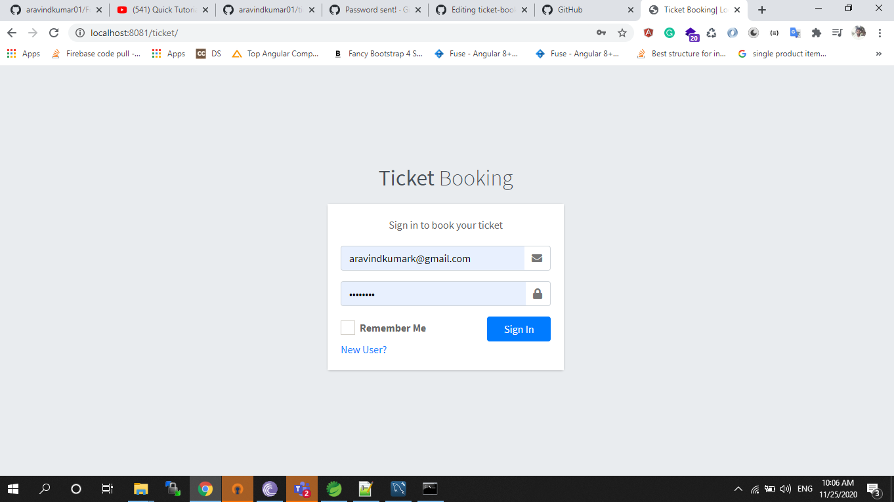

Admin Page

Admin only view the booking details for all customers and also change the personal information for user account page.

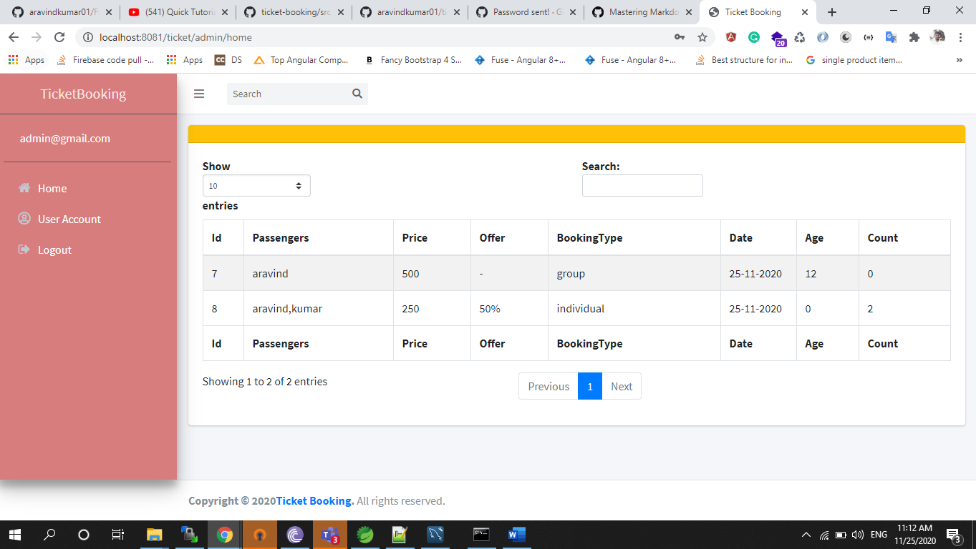

Registration page

The user registers the portal for the mentioned details in screenshot.

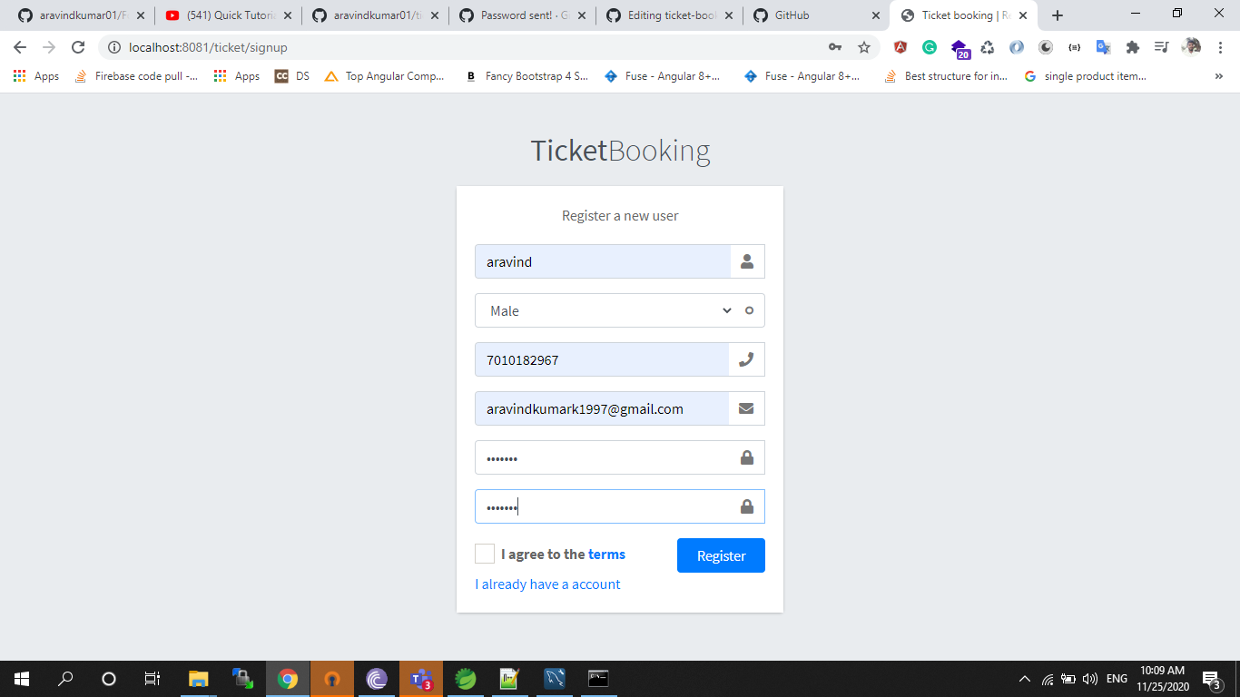

Booking page

User able to book a ticket group and individual.

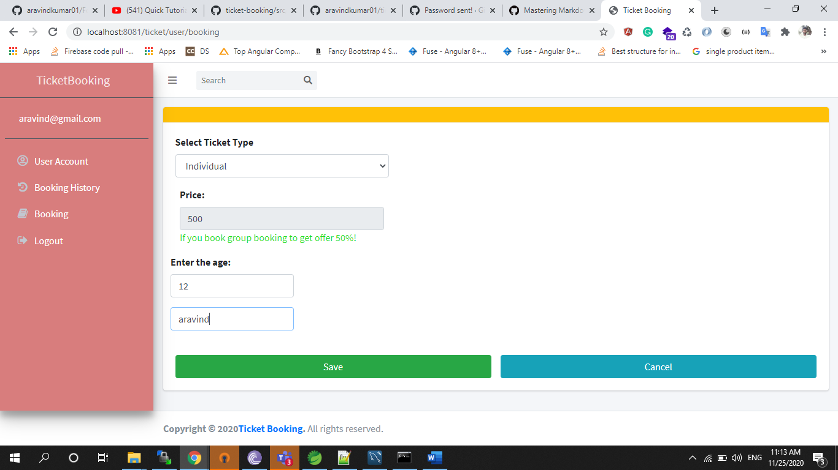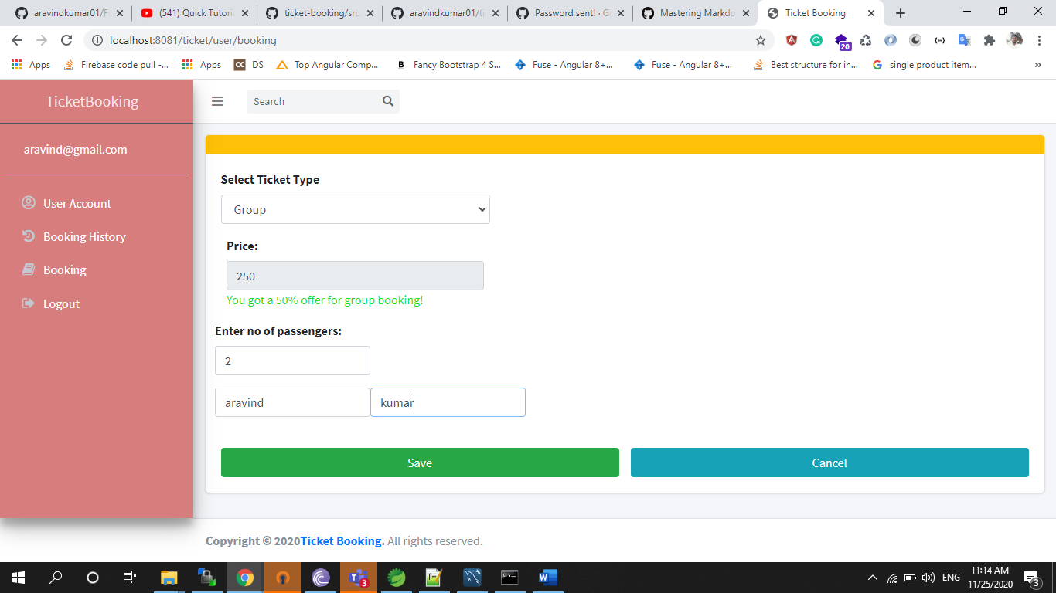

# Booking History

The user able to view the booking history as well

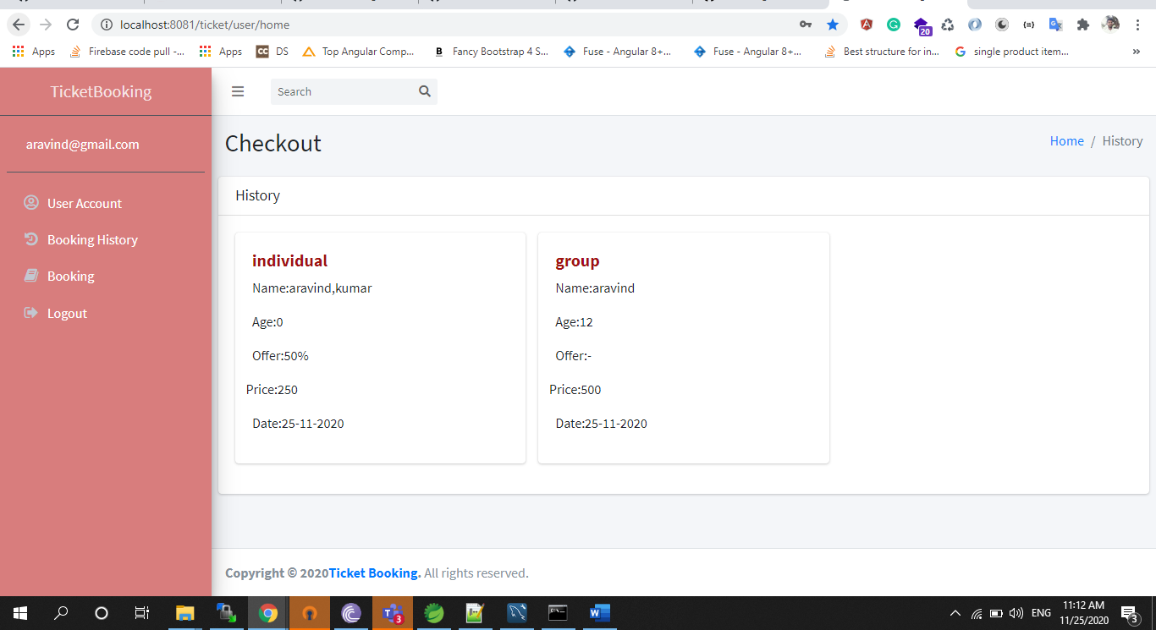

User account

Both users able to change the personal details

