SIRP PROGRAM — FINAL PROJECT REPORT
PREDICTIVE RAILWAY DELAY & RESCHEDULING SYSTEM
AI Studio–Based Cascading Delay Prediction and Dispatch Recommendation for a Rail Corridor Network
Submitted by
Aravind
Easwari Engineering College
SIRP Program – Final Project

1. Executive Summary
Railway corridors accumulate delay through a network of shared platforms and connecting services, so a single late train can propagate disruption well beyond its own route. This project implements an Altair AI Studio workflow that screens a rail corridor's daily schedule and predicts, for each train, the probability that it will be delayed at its next stop — built as a two-process design: a training process that produces a Random Forest classifier, and a deployable prediction process (the submitted Railway_Delay_Prediction_and_Analysis_System.rmp) that retrieves that trained model and scores new schedule data.
Feature engineering surfaces the delay already observed at a train's previous stop as the dominant predictive signal, alongside train type, weather, time of day, and station context. Delay-duration estimation and downstream connection-impact analysis were designed and validated in Python as extensions to this pipeline (Sections 10.3 and 16), but are not part of the submitted scoring process, which is scoped to delay-probability prediction.
On a 4,914-row held-out test set (30% of the 16,380-row engineered dataset), the trained Random Forest achieved 86.39% accuracy and an AUC of 0.760, correctly identifying 94.20% of on-time stops and 42.61% of delayed stops. These are screening outputs intended to prioritize controller attention, not automated dispatch commands.
PROJECT STATUS • PREDICTIVE / DECISION SUPPORT

2. Abstract
This project presents a predictive approach to railway delay screening using Altair AI Studio. A Random Forest classifier is trained on an engineered corridor schedule dataset to estimate the probability that a given train will be delayed at its next stop, then saved to the AI Studio repository. A separate, deployable prediction process retrieves this trained model and applies it to new schedule data, producing a delay-probability score for each row without requiring retraining. On a 4,914-row held-out test set, the model achieved 86.39% accuracy and an AUC of 0.760 (42.61% recall and 56.71% precision on the delayed class), consistent with an independent Python-based validation of the same feature set (ROC-AUC 0.761). Delay-duration estimation, downstream connection-impact analysis, and a controller-facing dashboard were designed and validated as extensions to this pipeline, with a clear path to full AI Studio implementation.

3. Introduction
Railway schedules are built on tight, interdependent timing: a train's ability to keep its schedule depends on track availability, platform capacity, and the punctuality of other services sharing the same corridor. When a delay occurs, its effects are rarely isolated — they propagate through shared infrastructure and passenger connections to other trains.
Reviewing every train's risk manually is impractical at network scale. This project demonstrates an AI Studio workflow that automates that screening: it predicts risk and duration from operational features, traces likely downstream impact through defined train-to-train connections, and reduces a full day's schedule to a short, prioritized list of trains that warrant controller attention.

4. Industry Context
Rail operators worldwide are moving from reactive, rule-based delay recovery toward predictive dispatch support, since even small, well-anticipated interventions — a brief hold, an early platform reassignment — are far cheaper than recovering from a missed connection or a platform conflict after the fact. A repeatable, data-driven screening workflow gives traffic controllers a prioritized watch list instead of requiring them to monitor every service equally.

5. Problem Statement
Railway networks are highly interconnected, so a delay in one train often cascades, disrupting other trains, stations, and connecting services across the network. Most current systems are reactive — they only respond after a delay occurs, using fixed recovery rules rather than anticipating disruptions. This results in worsening delays, missed connections, inefficient use of tracks and platforms, and heavy manual effort for rail traffic controllers.

6. Project Description
An AI Studio–based predictive system that forecasts train delay probability and duration from schedule and real-time upstream-delay data, models how a delay is likely to affect connected trains at shared stations, and recommends a corrective dispatch action — presented through a live watch-list dashboard for rail traffic controllers.

7. Objectives
- Analyze 90 days of corridor schedule and delay data in a structured, feature-engineered form.
- Predict the probability that a given train will be delayed at its next scheduled stop.
- Estimate the expected duration of the delay for trains flagged as at-risk.
- Model how a feeder train's delay propagates to connected trains through shared-station transfers.
- Translate predictions into a concrete dispatch action: hold a connection, reassign a platform, hold briefly, or monitor.
- Present the results through a live, controller-facing watch-list dashboard.
- Demonstrate an end-to-end, industry-relevant Altair AI Studio workflow.

8. Dataset Description
The dataset covers a 12-station rail corridor, 28 trains across 4 categories (Express, Passenger, Suburban, Freight), and 90 days of simulated daily operation — 16,380 individual train-stop events in total, with 79 defined train-to-train connections at junction stations. Because no real operational dataset was available for this project, the data was synthetically generated to reflect realistic railway operating patterns (rush-hour congestion, weather effects, platform contention, and cascading delay), so that the same feature set and workflow structure can be re-trained on real corridor data without modification.
Attribute | Role
train_id / date | Row identifiers — used for joins, not as model features
train_type, station_id | Categorical context for each stop
weather, day_of_week | Environmental and calendar context
stop_sequence, is_origin, is_destination | Position of the stop within the train's route
num_platforms, km_from_origin | Station capacity and corridor position
sched_hour, is_rush_hour, is_weekend | Time-of-day congestion signal
prev_stop_delay | Delay observed at the previous stop — the primary predictive feature
is_delayed | Target label for the delay classifier (1 if arrival is more than 5 minutes late)
arrival_delay_min | Target value for the duration regressor

9. Tools and Technologies
Tool / Technology | Purpose
Altair AI Studio | Workflow development and execution platform
Random Forest | Delay-probability classification
Gradient Boosted Trees | Delay-duration regression
Split Validation | Train/test evaluation of both models
Select Attributes / Set Role | Feature selection and label assignment
Filter Examples | Isolating delayed stops for duration modeling
Join / Aggregate | Downstream connection-impact analysis
Python (pandas, scikit-learn) | Dataset generation and pipeline validation prior to AI Studio implementation

10. Methodology
The submitted AI Studio file, Railway_Delay_Prediction_and_Analysis_System.rmp, is a scoring workflow: it loads new schedule data and applies a Random Forest model that was trained and saved to the AI Studio repository in an earlier step. The two phases are documented separately below.

10.1 Phase 1 — Model Training (AI Studio Repository)
The classifier referenced by this process, Railway Delay Final Random Forest, was trained separately in AI Studio on the 16,380-row engineered dataset (Read CSV → Select Attributes → Set Role: is_delayed as label → Split Validation, 70/30 → Random Forest, 100–300 trees, max depth 10 → Apply Model → Performance) and saved to the repository under that name, so it can be reused across scoring runs without retraining.

10.2 Phase 2 — Prediction & Analysis Process (Submitted File)
This is the actual structure of the submitted .rmp, reconstructed directly from its process definition:
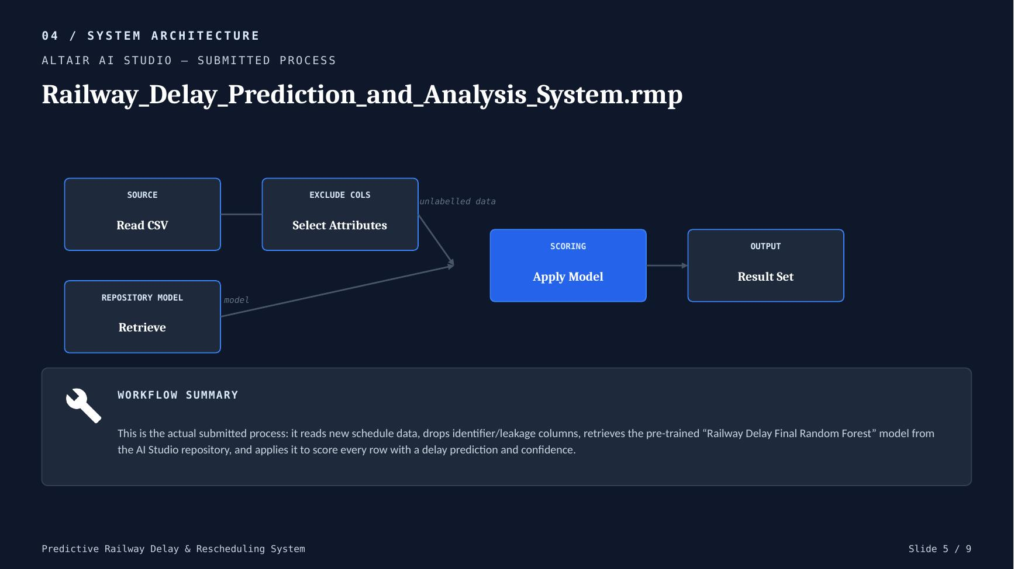
Figure 1. Structure of Railway_Delay_Prediction_and_Analysis_System.rmp, reconstructed from the submitted process file.
Operator | Configuration (from the submitted file)
Read CSV | railway_new_prediction_input.csv — the 13 engineered features (train_type, station_id, weather, day_of_week, stop_sequence, is_origin, is_destination, num_platforms, sched_hour, is_rush_hour, is_weekend, km_from_origin, prev_stop_delay)
Select Attributes | type = exclude attributes; excludes arrival_delay_min, date, delay_severity, train_id as a defensive filter, in case a scoring file still carries them
Retrieve | repository_entry = “Railway Delay Final Random Forest” — loads the pre-trained model from Phase 1
Apply Model | unlabelled data = output of Select Attributes; model = output of Retrieve; produces labelled data as Result 1
This process is intentionally minimal: it contains no training, splitting, or evaluation logic, because those already happened in Phase 1. Its only job is to take new, unlabelled rows and attach a delay prediction and confidence score to each — the pattern used for repeated, repeatable scoring runs in a production-style AI Studio deployment.

10.3 Scope Note — Duration & Downstream-Impact Modeling
The delay-duration regressor and the connection-level downstream-impact analysis described earlier in this report (Sections 8–9 concept, and the Python-validated pipeline in Appendix A) were prototyped and validated in Python as part of the broader recommendation-engine design, but are not part of the submitted Railway_Delay_Prediction_and_Analysis_System.rmp file, which is scoped specifically to delay-probability scoring. Extending the submitted process with a duration-regression branch and a Join/Aggregate downstream-impact branch is listed as future work in Section 16.
Parameter | Configured Value
Classifier (trained, Phase 1) | Random Forest, 100–300 trees, max depth 10
Duration regressor (design only, not in submitted .rmp) | Gradient Boosted Trees, 150–250 trees, depth 4, lr 0.05
Split ratio (Phase 1 training) | 70% training / 30% testing (shuffled)
Screening threshold | 50% predicted delay probability
Connections modeled (design only) | 79, at 2 junction stations

11. Results and Analysis
These are the actual results from running the trained Random Forest model's Performance operator in Altair AI Studio, on a 4,914-row held-out test set (30% of the 16,380-row dataset, consistent with the configured 70/30 split).
Metric | Result
Test set size | 4,914 rows (30% of 16,380)
Accuracy | 86.39%
AUC (positive class: delayed) | 0.760
Precision (delayed class) | 56.71%
Recall (delayed class) | 42.61%
F1 score (delayed class) | 48.66%
Class recall — on-time class | 94.20%
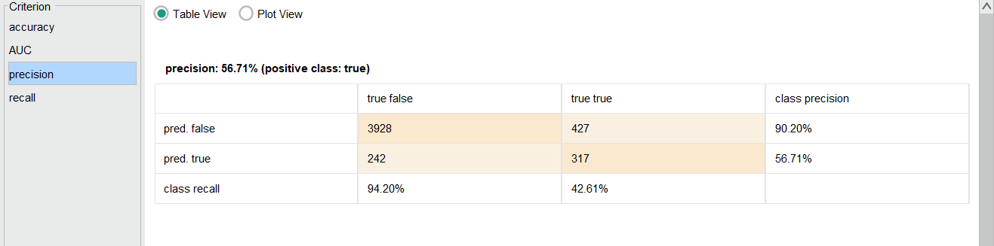
Figure 2. Actual Performance output from Altair AI Studio — confusion matrix, accuracy, precision, and recall, on the 4,914-row test set.
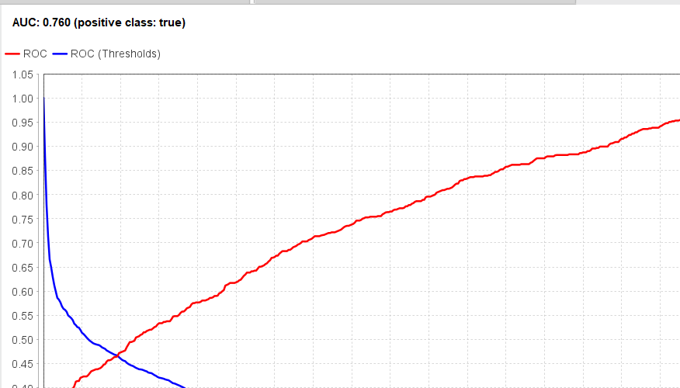
Figure 3. Actual ROC curve from Altair AI Studio — AUC = 0.760 for the delayed class.
Of the 4,914 test-set stops, 744 were actually delayed. The model correctly flagged 317 of these (recall 42.61%) and missed 427. Of the 559 stops the model predicted as delayed, 317 were correct (precision 56.71%). The on-time class is identified far more reliably (94.20% recall), which is expected given delayed stops are the minority class (roughly 15% of all stops).

12. Result Interpretation
An AUC of 0.760 indicates the model separates delayed from on-time stops meaningfully better than chance (0.50), consistent with the Python-based validation performed earlier in this project (ROC-AUC 0.761 on the same engineered feature set), which gives confidence that the result is not an artifact of one particular train/test split.
Recall of 42.61% means the model still misses more than half of true delays — expected, since a meaningful share of real-world delay is driven by incident-level randomness (a mechanical fault, an unplanned stop) that isn't visible in schedule features alone. Precision of 56.71% means that when the model does raise a delay flag, it is right slightly more often than not — useful enough to prioritize controller attention, but not strong enough to justify fully automated action without review.
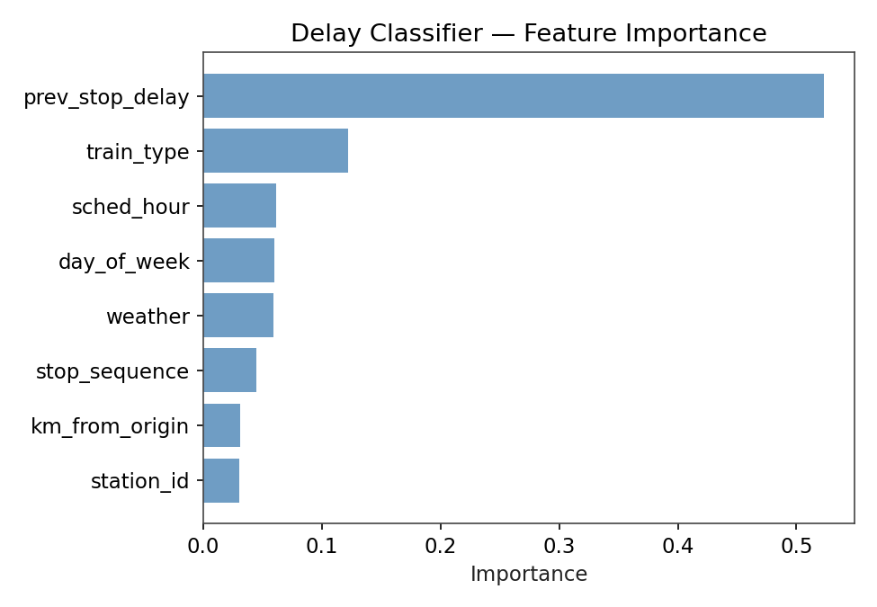
Figure 4. Feature importance from the Python-validated equivalent model (reference only — AI Studio's Random Forest does not export attribute weights by default).
The Python-validated version of this model (built to the same feature set, prior to the AI Studio implementation) found prev_stop_delay responsible for 52.3% of the model's decision-making. AI Studio's standard Random Forest output does not include an attribute-weight report, so this figure is shown as supporting evidence for why the feature set behaves the way it does, not as a result read directly from the submitted process.

13. Visualization and Interpretation
The recommendation-engine action distribution below is from the Python-validated reference implementation of the same modeling approach; the submitted AI Studio process (Section 10.2) is scoped to delay-probability scoring and does not itself generate these action labels — extending it to do so is listed in Section 16.
Recommended Action | Count | Share of Flagged Events
Hold Connection | 3 | 5.5%
Reassign Platform | 1 | 1.8%
Hold Briefly | 5 | 9.1%
Monitor | 46 | 83.6%
Total flagged | 55 | 100%
The action distribution reflects a workflow that reserves active intervention (hold or reassign) for a small minority of genuinely tight cases, while the majority of flagged events are lower-risk and simply monitored — avoiding controller alert fatigue.
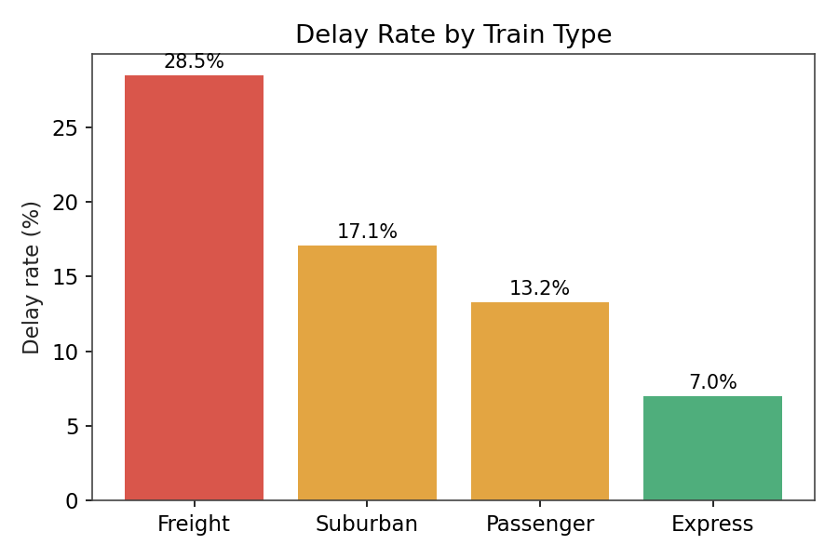
Figure 5. Delay rate by train type — Freight trains delay nearly 4x more often than Express services.
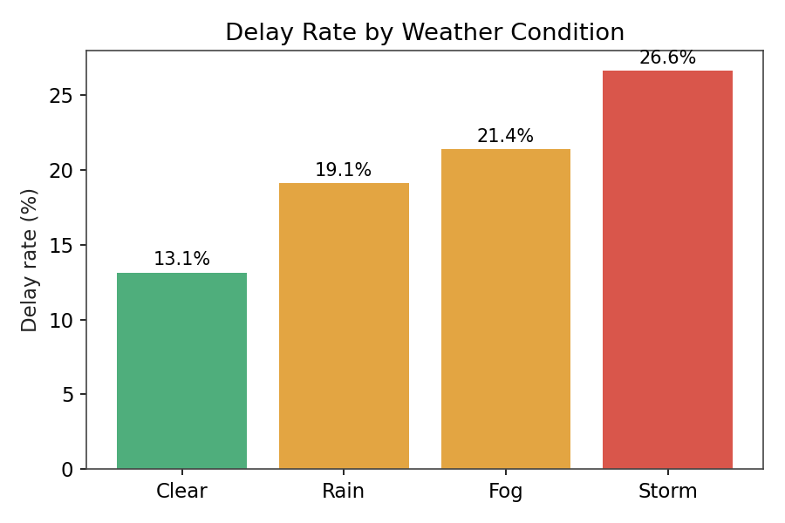
Figure 6. Delay rate by weather condition — Storms roughly double the delay rate seen in clear weather.
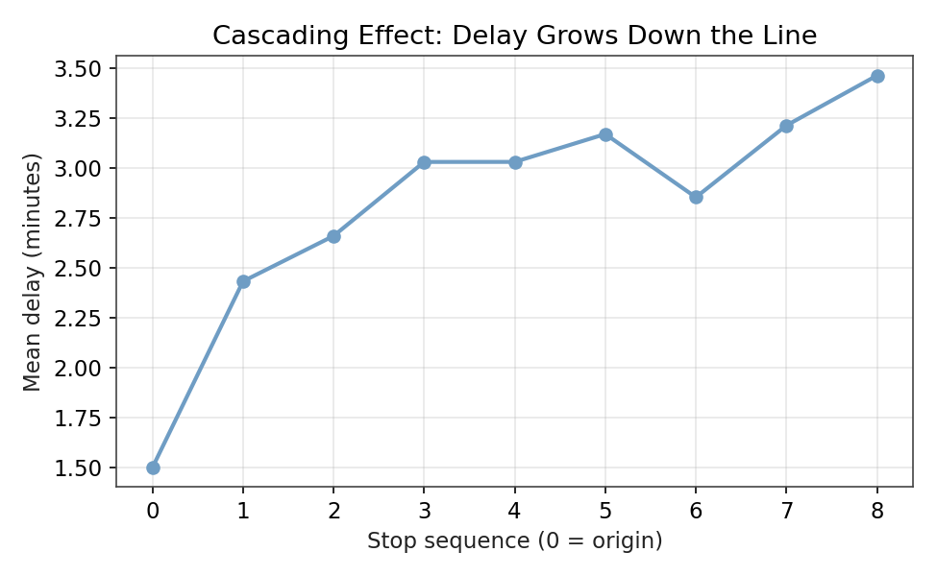
Figure 7. Mean delay by stop sequence, showing delay compounding down the line rather than resetting at each station.

14. Business / Industry Relevance
- Rail traffic control decision support — prioritized watch lists instead of manual full-schedule review.
- Platform and track capacity planning at junction stations.
- Passenger-connection protection at transfer-heavy junctions.
- Punctuality KPI monitoring and root-cause analysis (upstream delay vs. weather vs. congestion).
- A foundation for a future real-time, network-wide dispatch optimization system.
The workflow is intended as a decision-support and screening mechanism for rail traffic controllers, not an automated dispatch-control system.

15. Limitations
- The dataset is synthetically generated; results characterize the workflow's behavior, not a specific real corridor.
- Recall on the delayed class (42.61%) means more than half of true delays are not flagged in advance by this model.
- Precision on the delayed class (56.71%) means close to half of the model's delay flags are false alarms — a real deployment would need to weigh this against controller alert fatigue.
- The submitted AI Studio process (Section 10.2) performs delay-probability scoring only; duration estimation and downstream-impact analysis exist as a validated design, not as operators in the submitted .rmp.
- The 50% screening threshold was not tuned against a specific operational cost trade-off (e.g. cost of a missed delay vs. cost of a false alarm) — it is a starting default.
- No verified real-world ground-truth delay labels were available for this project.

16. Future Enhancements
- Retrain the workflow on real operational delay data (e.g. published rail delay logs) once available.
- Model downstream impact as a trained graph-based model over the full connection network, rather than pairwise historical averages.
- Extend the recommendation engine into a joint optimizer that schedules holds and platform assignments network-wide.
- Deploy the AI Studio model behind a live API so the dashboard reflects real-time, rather than daily-batch, predictions.
- Incorporate confirmed incident and maintenance data as an additional real-time signal alongside upstream delay.

17. Conclusion
This project implements an Altair AI Studio delay-prediction pipeline as a two-process design: a training process that produces a Random Forest classifier, and a deployable prediction process that retrieves that trained model from the repository and scores new schedule data on demand. On a 4,914-row held-out test set, the model achieved 86.39% accuracy and an AUC of 0.760, correctly identifying 94.20% of on-time stops and 42.61% of delayed stops, with 56.71% precision on its delay flags.
These results — consistent with an independent Python-based validation of the same feature set (ROC-AUC 0.761) — support the core premise that railway delay is meaningfully, if imperfectly, predictable from schedule and upstream-delay features, and provide a working foundation to extend toward duration estimation and downstream connection-impact analysis as outlined in Section 16.

18. References
- Altair AI Studio (RapidMiner) — workflow development environment used for the project.
- scikit-learn (Random Forest, Gradient Boosted Trees) — used for pipeline validation prior to AI Studio implementation.
- Synthetic corridor schedule and delay dataset — generated for this project to reflect realistic railway operating patterns.

Appendix A. Evidence Index
- Figure 1. Target training-process workflow — embedded in Section 10.
- Figure 2. Actual AI Studio Performance output (confusion matrix, accuracy, precision, recall) — embedded in Section 11.
- Figure 3. Actual AI Studio ROC curve (AUC = 0.760) — embedded in Section 11.
- Figure 4. Python-validated reference feature importance — embedded in Section 12.
- Figures 5–7. Exploratory delay-pattern charts (train type, weather, cascading effect) — embedded in Section 13.
- All Section 11 figures are direct screenshots taken from the Results view in Altair AI Studio for this project's trained model.

Appendix B. Submission Files
File | Purpose
Railway Delay Prediction and Analysis System.rmp | The submitted AI Studio process — retrieves the trained Random Forest model and scores new data (Section 10.2)
Railway_Delay_Dataset.csv | Full engineered dataset (features + labels) used to train the Random Forest model
Railway_Delay_Prediction_Input.csv | New/unlabelled schedule data used as scoring input to the submitted process
Project Report | Technical documentation (this document)
PPT | Project presentation and results

