University of Central Missouri

Department of Computer Science & Cybersecurity

CS5710 Machine Learning

Fall 2025

Home Assignment 3.

Student name:

Submission Requirements:
- Once finished your assignment push your source code to your repo (GitHub) and explain the work through the ReadMe file properly. Make sure you add your student info in the ReadMe file.
- Comment your code appropriately IMPORTANT.
- Any submission after provided deadline is considered as a late submission.

Part A: Calculation

Q1. Multi-Input Feedforward
Consider a neural network with 3 inputs x1=2, x2=1, x3=3, one hidden layer of 2 sigmoid units, and one sigmoid output.
Weights:
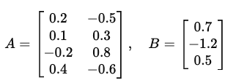
- A includes biases (last row).
- B includes bias (last element).
Tasks
a) Compute hidden pre-activations and activations.
b) Compute the output activation y.

Q2. XOR with ReLU Network
We use the XOR ReLU network from the slides
Extend it with an additional hidden unit:
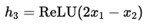
and new output:
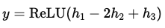
Tasks
a) Compute outputs for all four XOR inputs (0,0),(0,1),(1,0),(1,1).
b) Compare the decision boundary with the original 2-hidden-unit XOR network.
c) Does this extension still compute XOR exactly? If not, which inputs differ?

Q3. Decision Boundary and Misclassification
You train a perceptron with decision rule:
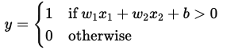
with parameters w1=1, w2=−2, b=1.
Dataset:
(2,1)→1, (1,3)→0, (3,2)→1, (0,1)→0.
Tasks
a) Write the decision boundary equation and sketch it.
b) Classify each point using the perceptron rule. Which ones are misclassified?
c) Compute the perceptron loss (number of mistakes).

Q4. Multi-Layer Forward Pass (Matrix Style)
A network has 2 hidden layers, each with 2 sigmoid units.
- Input (x1,x2)=(2,3)
- First layer weights:
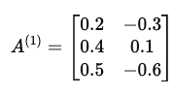
- Second layer weights:
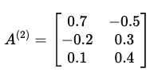
- Output weights: (1.0, −1.2, 0.3)
Tasks:
a) Compute hidden activations in layer 1.
b) Compute hidden activations in layer 2.
c) Compute the final output.

Q5. Linear SVM
We have a dataset in 2D:
- Positive points (y=+1): p1=(1,3), p2=(2,2)
- Negative points (y=−1): n1=(0,0)
Suppose these are the support vectors.
Tasks:
- Augment each point with a bias term.
- Form the dual constraint equations for α1,α2,α3 ​.
- Solve for the dual variables.
- Compute the weight vector
- Extract www and b. Write the final separating hyperplane equation.
- Verify that all support vectors satisfy the margin conditions.

Q6. Nonlinear SVM
Consider two support vectors:
- s1=(1,0), y1=−1
- s2=(2,1), y2=+1
We map them using a quadratic feature transformation:
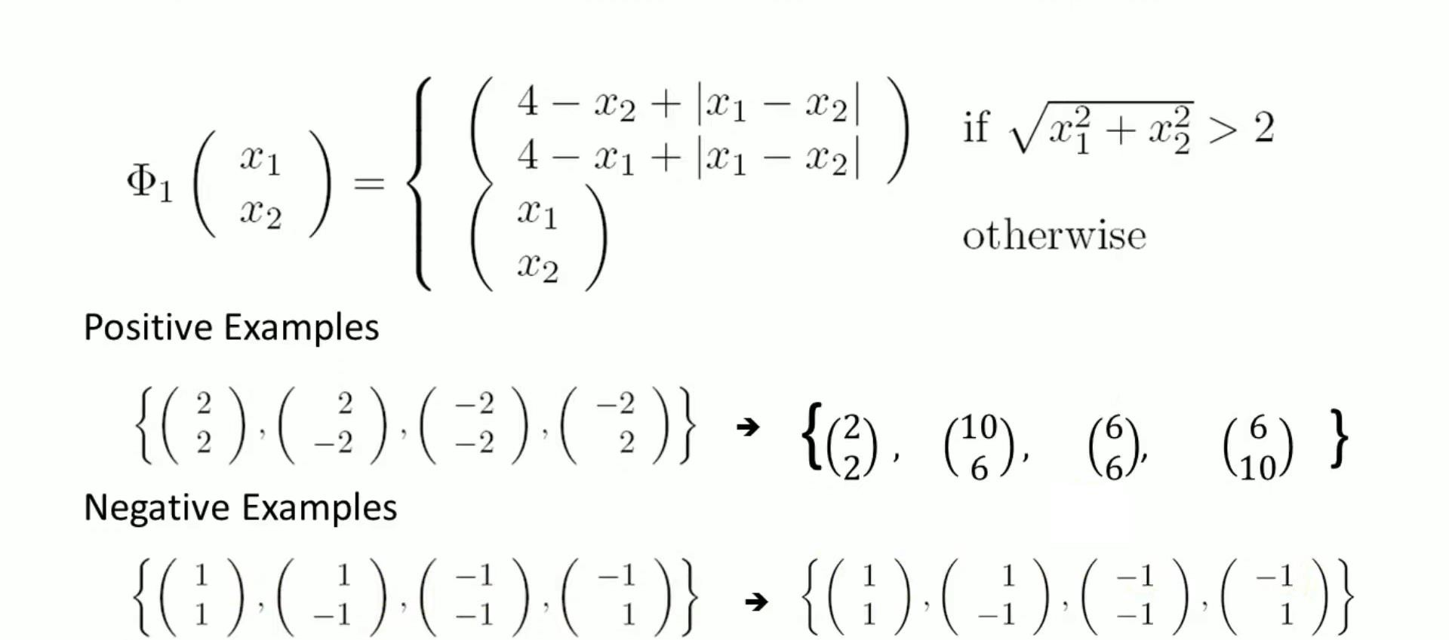

Tasks:
- Compute ϕ(s1) and ϕ(s2).
- Write the margin equations in the transformed space using α1,α2​.
- Solve for α1,α2​.
- Compute the separating hyperplane in feature space.
- Express the decision function
- Using your decision function, classify the new point q=(1,1).

Part B — Short-Answer

Q1. From Biological to Artificial
a) In one sentence each, define neuron, synapse, and activation function in the biological vs. artificial setting.
b) Give two reasons why nonlinearity is required in neural networks.
c) Briefly explain why a DAG assumption is used for feed-forward NNs.

Q2. Architecture & Capacity
a) Define depth and width.
b) What are two distinct roles hidden units might learn (e.g., feature selection vs. projection)?
c) Contrast the cases D < M and D > M in a single-hidden-layer network: what representational trade-offs do they imply?
d) State the universal approximation idea for 1-hidden-layer NNs (informally).

Q3. Perceptron vs. SVM
a) What does the perceptron algorithm optimize?
b) What is the main optimization goal of SVM?
c) Why does SVM typically generalize better than a perceptron? Give one real-world scenario where this difference matters.

Q4. Margins and Support Vectors
a) Define the margin of a dataset.
b) Explain the role of support vectors in determining the separating hyperplane.
c) Why does maximizing the margin lead to robustness against noise?

Q5. PCA Concepts
a) What assumption does PCA make about the structure of the data?
b) State two equivalent definitions of PCA.
c) Why must the data be centered before applying PCA?
d) Explain what the eigenvalue associated with a principal component represents.

Q6. PCA vs. Random Projection
a) How does PCA choose directions compared to random projection?
b) Give one advantage of PCA over random projection, and one disadvantage.

ANSWERS

Q1. Multi-Input Feedforward
Given
$$x=(2,1,3)⇒x^{'}=(2,1,3,1) \\ A=\left[\begin{matrix}0.2 & -0.5 \\ 0.1 & 0.3 \\ -0.2 & 0.8 \\ 0.4 & -0.6\end{matrix}\right]B=(0.7,-1.2,0.5)$$

Step 1: Hidden Pre-Activations
$$z_{1}=2(0.2)+1(0.1)+3(-0.2)+1(0.4)=0.3 \\ z_{2}=2(-0.5)+1(0.3)+3(0.8)+1(-0.6)=1.1$$

Step 2: Hidden Activations
$$h_{1}=σ(0.3)≈0.574h_{2}=σ(1.1)≈0.750$$

Step 3: Output
$$z=0.7(0.574)-1.2(0.750)+0.5=0.0018 \\ y=σ(0.0018)≈0.5004$$

Final Answer
$$h_{1}≈0.574, h_{2}≈0.750, y≈0.5004$$

Q2. XOR with ReLU
Equations
$$h_{1}=ReLU(x_{1}+x_{2}) \\ h_{2}=ReLU(x_{1}+x_{2}-1) \\ h_{3}=ReLU(x_{2}-x_{1}) \\ y=ReLU(h_{1}-2h_{2}+h_{3})$$

Outputs
Input | h1 | h2 | h3 | Output
(0,0) | 0 | 0 | 0 | 0
(0,1) | 1 | 0 | 1 | 2
(1,0) | 1 | 0 | 0 | 1
(1,1) | 2 | 1 | 0 | 0

Conclusion
- Not exact XOR
- Modified decision boundary

Q3. Decision Boundary & Sketch
Step 1: Given
$$w_{1}=1,w_{2}=-2,b=1$$
Decision rule:
$$y=\left\{\begin{matrix}1 & \text{if }w_{1}x_{1}+w_{2}x_{2}+b>0 \\ 0 & \text{otherwise}\end{matrix}\right.$$

Step 2: Decision Boundary Equation
Set:
$$w_{1}x_{1}+w_{2}x_{2}+b=0 \\ x_{1}-2x_{2}+1=0$$

Step 3: Convert to Line Equation (for sketch)
Solve for $x_{2}$:
$$x_{1}+1=2x_{2} \\ x_{2}=\frac{x_{1}+1}{2}$$

Step 4: Find Two Points to Draw Line
Let $x_{1}=0$:
$$x_{2}=\frac{1}{2}=0.5⇒(0,0.5)$$
Let $x_{1}=1$:
$$x_{2}=1⇒(1,1)$$
Classification Table
Point | Value | Prediction
(2,1) | 1 | 1
(1,3) | -4 | 0
(3,2) | 0 | 1
(0,1) | -1 | 0

Final
- Misclassification = 0
- Loss = 0

Q4. Multi-Layer Forward Pass
Input
$$x=(1,-1)⇒x^{'}=(1,-1,1)$$

Layer 1
$$z_{1}=0.3,z_{2}=-1 \\ h^{\left(1\right)}=(0.574,0.269)$$

Layer 2
$$z_{1}=0.448,z_{2}=0.194 \\ h^{\left(2\right)}=(0.610,0.548)$$

Output
$$z=0.558y≈0.636$$

✅ Q5. Linear SVM
Step 1: Given Data
Positive:
$$p_{1}=(1,3),p_{2}=(2,2)$$
Negative:
$$n_{1}=(0,0)$$
Labels:
$$y_{1}=+1, y_{2}=+1, y_{3}=-1$$

Step 2: Augment with Bias
$$p_{1}=(1,3,1),p_{2}=(2,2,1),n_{1}=(0,0,1)$$

Step 3: Dual Constraint
$$∑α_{i}y_{i}=0 \\ α_{1}+α_{2}-α_{3}=0$$

Step 4: Weight Vector
$$w=∑α_{i}y_{i}x_{i} \\ w=α_{1}(1,3)+α_{2}(2,2)-α_{3}(0,0) \\ w=(α_{1}+2α_{2}, 3α_{1}+2α_{2})$$

Step 5: Use Constraint
From:
$$α_{3}=α_{1}+α_{2}$$

Step 6: Margin Conditions
For support vectors:
$$y_{i}(w⋅x_{i}+b)=1$$

For $p_{1}=(1,3)$
$$w⋅x=(w_{1})(1)+(w_{2})(3) \\ =(α_{1}+2α_{2})+3(3α_{1}+2α_{2}) \\ =α_{1}+2α_{2}+9α_{1}+6α_{2}=10α_{1}+8α_{2}$$
Condition:
$$10α_{1}+8α_{2}+b=1$$

For $p_{2}=(2,2)$
$$=2(α_{1}+2α_{2})+2(3α_{1}+2α_{2}) \\ =2α_{1}+4α_{2}+6α_{1}+4α_{2}=8α_{1}+8α_{2} \\ 8α_{1}+8α_{2}+b=1$$

For $n_{1}=(0,0)$
$$w⋅x=0 \\ -1(b)=1⇒b=-1$$

Step 7: Substitute $b=-1$
From equations:
$$10α_{1}+8α_{2}-1=1⇒10α_{1}+8α_{2}=2 \\ 8α_{1}+8α_{2}-1=1⇒8α_{1}+8α_{2}=2$$

Step 8: Solve
Subtract:
$$(10α_{1}+8α_{2})-(8α_{1}+8α_{2})=2-2 \\ 2α_{1}=0⇒α_{1}=0$$
Then:
$$8α_{2}=2⇒α_{2}=0.25 \\ α_{3}=0.25$$

Step 9: Compute w
$$w=(0+2(0.25), 0+2(0.25))=(0.5,0.5)$$

Step 10: Final Hyperplane
$$0.5x_{1}+0.5x_{2}-1=0$$
Multiply by 2:
$$x_{1}+x_{2}-2=0$$

Final Answer (Q5)
- $w=(0.5,0.5)$
- $b=-1$
- Hyperplane:
$$x_{1}+x_{2}=2$$
Q6. Nonlinear SVM
Step 1: Mapping
$$ϕ(x_{1},x_{2})=(x_{1}^{2}, x_{2}^{2}, \sqrt{2}x_{1}x_{2})$$

Step 2: Transform Points
$$s_{1}=(1,0)$$
$$ϕ(s_{1})=(1,0,0)$$

$$s_{2}=(2,1)$$
$$ϕ(s_{2})=(4,1,2\sqrt{2})$$

Step 3: Form Hyperplane
Let:
$$w=(w_{1},w_{2},w_{3})$$

Step 4: Margin Conditions
$$y(w^{T}ϕ(x)+b)=1$$

For $s_{1}$(y = -1)
$$-(w_{1}+b)=1⇒w_{1}+b=-1$$

For $s_{2}$(y = +1)
$$4w_{1}+w_{2}+2\sqrt{2}w_{3}+b=1$$

Step 5: Decision Function
$$f(x)=w_{1}x_{1}^{2}+w_{2}x_{2}^{2}+w_{3}(\sqrt{2}x_{1}x_{2})+b$$

Step 6: Classify $q=(1,1)$
$$ϕ(q)=(1,1,\sqrt{2}) \\ f(q)=w_{1}+w_{2}+w_{3}(\sqrt{2})+b$$

Final Answer (Q6)
- Transformed points:
  - (1,0) → (1,0,0)
  - (2,1) → (4,1,2√2)
- Decision function:
$$f(x)=w_{1}x_{1}^{2}+w_{2}x_{2}^{2}+\sqrt{2}w_{3}x_{1}x_{2}+b$$
- Classification of (1,1):
$$\text{Sign of }f(q)$$

