ASSIGNMENT 1

There are two types of locks:

1) Shared locks are placed on resources whenever a read(SELECT) operation is performed. Multiple shared locks can be placed simultaneously on a resource. Hence one reader doesn’t not lock another read. See below.

We are trying to read course name from ‘Course’ table where course id=110 in one session.

I am trying to perform the same read operation on the same row in another session.

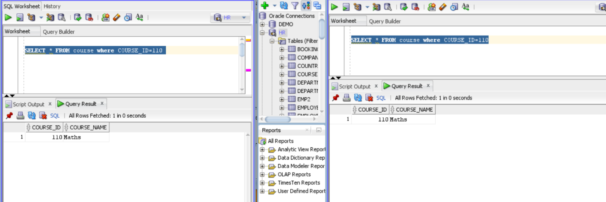

From the above snip, it can be seen that no locking has happened.

2) Exclusive locks are performed on resources whenever write operation (INSERT,UPDATE,DELETE) is performed. The first user(A) who acquires an exclusive locks to the resource will continue to have it and no other user can acquire an exclusive lock on the same. This again leads to two scenarios.

If the user B is trying to read the row that is being modified by user A, then Oracle will display the old set of values for the row as the transaction by User A has not yet been completed(COMMIT OR ROLLBACK).This can sometimes lead to dirty read. Hence user A must place an explicit lock that prevents even viewing by other users.

To sum up, a writer does not implicitly lock a reader.

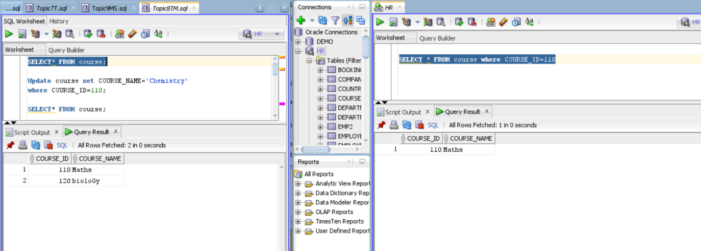

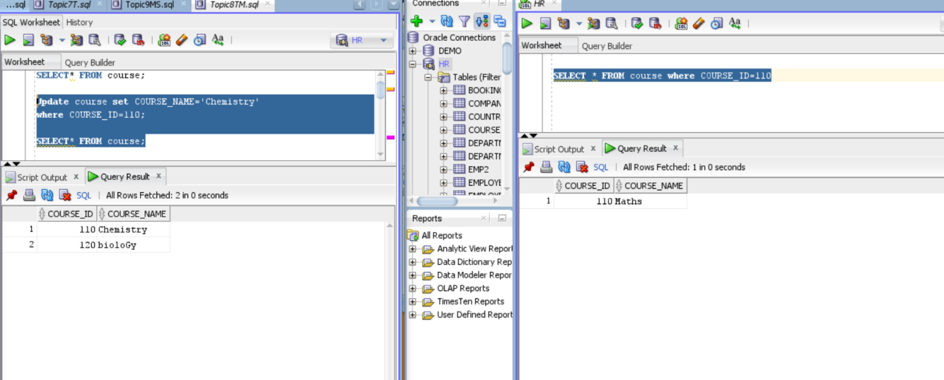

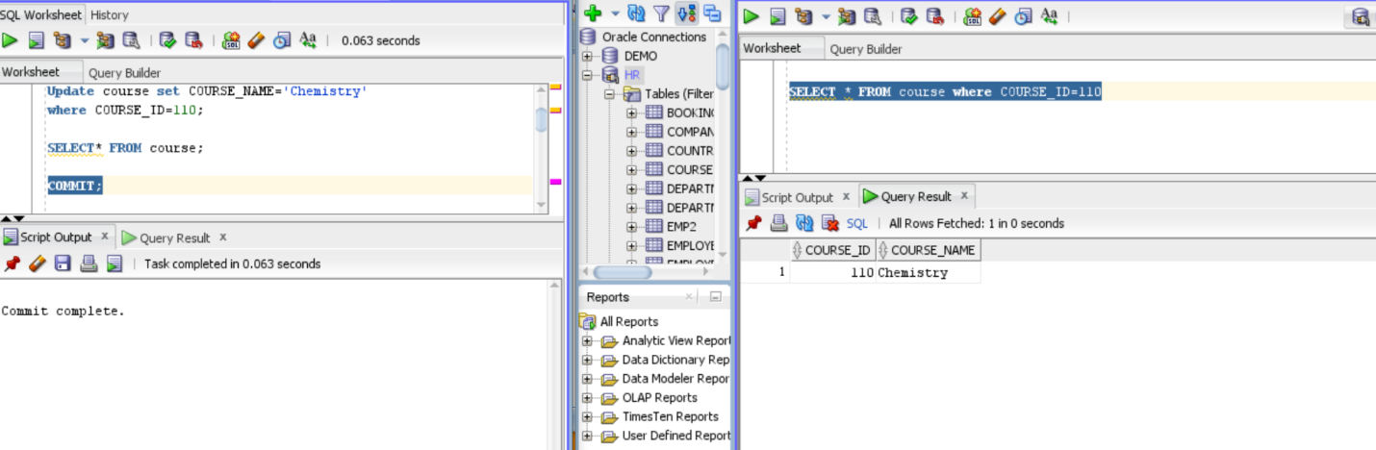

Now, if the user B is trying to modify the row that is being modified by user A, then Oracle will implicitly place lock on that row, so that no further manipulation can be done. So other users need to wait until USER As transaction is completed(COMMIT OR ROLLBACK).

To sum up, a writer will implicitly lock another writer.

