**Assignment 2:**

1)INTERPRETED.

create or replace procedure PROC_ARITH

is

n number:=0;

begin

for i in 1..500000000

loop

n:=n+1;

end loop;

end;

**PLSQL_CODE_TYPE**:INTERPRETED.

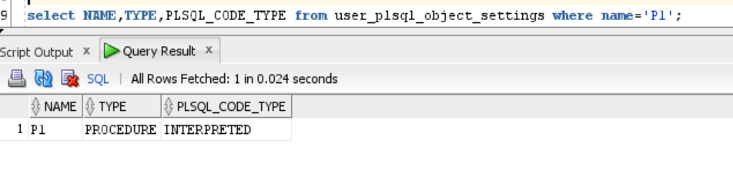

SET TIMING ON;

EXECUTE p1;

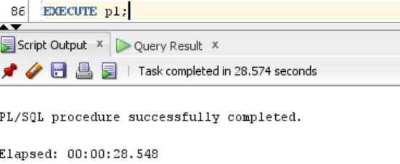

2)NATIVE.

ALTER PROCEDURE P1 COMPILE PLSQL_CODE_TYPE=NATIVE;

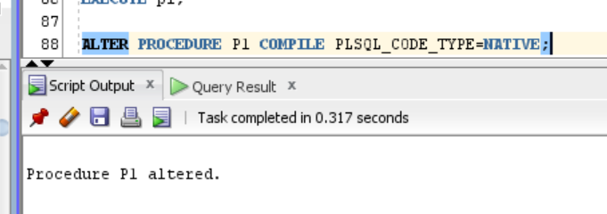

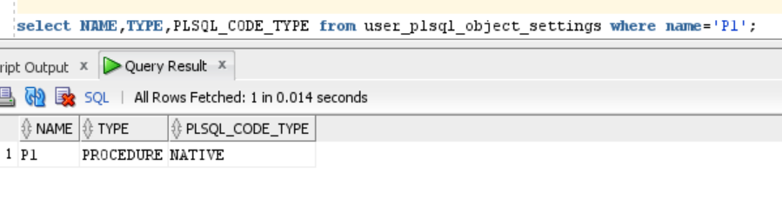

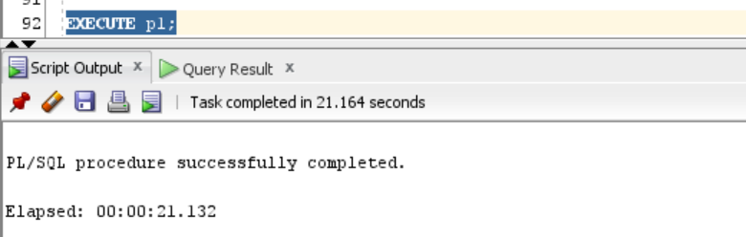

**Observation**: When the PLSSQL_CODE_TYPE was changes to ‘NATIVE’ from the default ‘INTERPRETED’,I could observe a difference of 7.416 seconds, which is an improvement by 25.97(~26)%.

This provides significant time saving and performance improvement.

In Interpreted compilation, PL/SQL library units will be compiled to PL/SQL byte code format which are later executed by the PL/SQL interpreter engine.

In Native compilation,PL/SQL library units will be compiled to native (machine) code.

Such modules will be executed natively without incurring any interpreter overhead.

So this makes native compilation faster.