**Assignment 3:**

1) Default optimization level:2

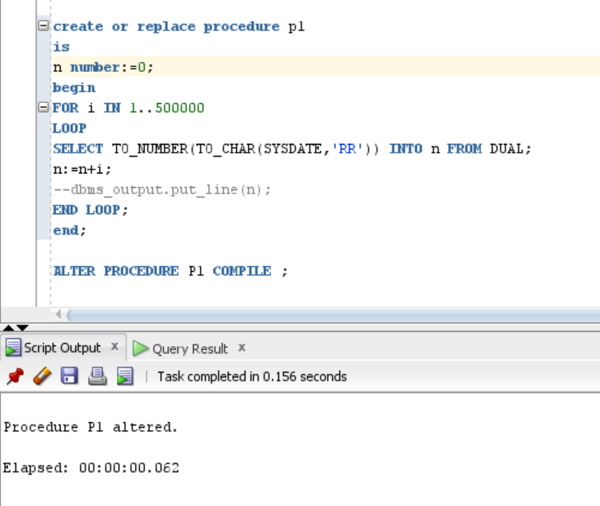

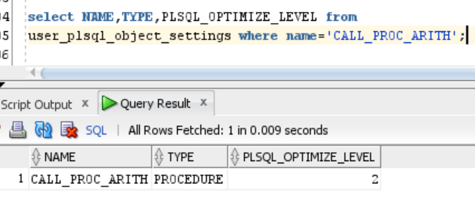

Now we execute the procedure CALL_PROC_ARITH

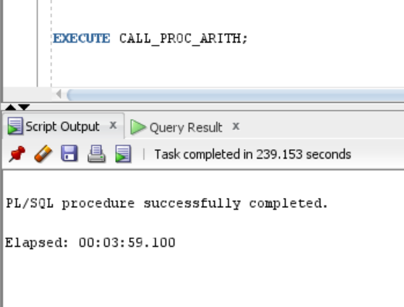

Changed optimization level to 3 at session level.

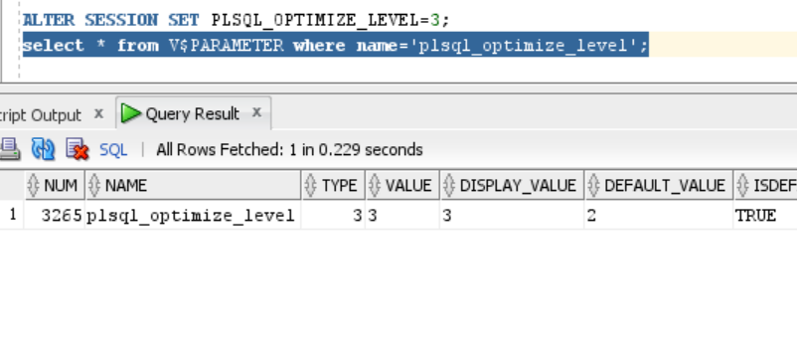

Re- compiled both the procedures. The compilation method of both procedures is set to INTERPRETED.

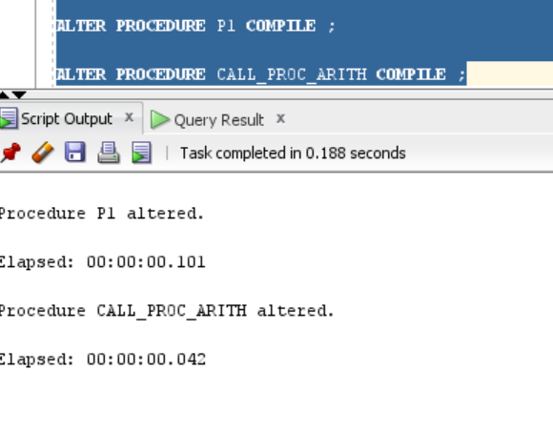

Now we execute the procedure CALL_PROC_ARITH again.

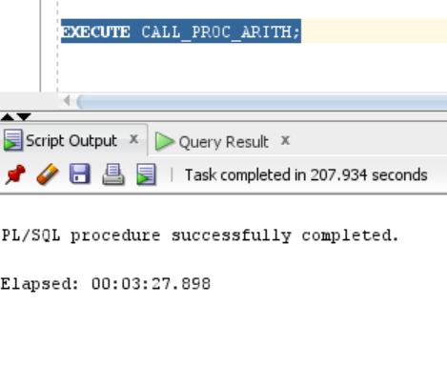

**Observation:** There was a reduction in the time taken to execute the procedure when the optimization level was set to 3.This reduction was by 32 seconds, which is approximately 13.05% reduction in percentage terms.

Higher value of PLSQL_OPTIMISE_LEVEL (3) leads to inline procedure compilation.This feature is not present in PLSQL_OPTIMISE_LEVEL=2.