**DBMS_SCHEDULER JOB SCHEDULING**

**The job is executed every five minutes per scheduler logs.**

**SELECT log_id,log_date,job_name,operation,status,additional_info FROM USER_scheduler_job_log**

**order by log_id;**

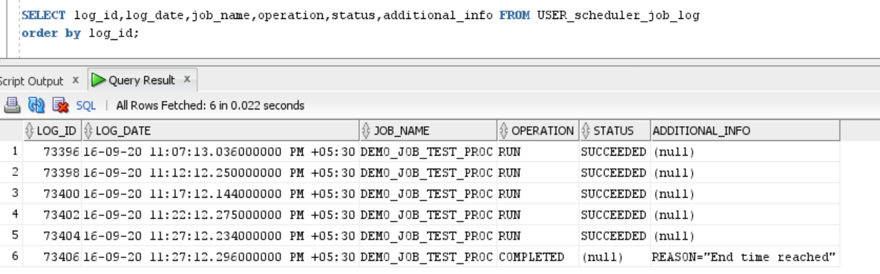

**After disabling using.**

**EXEC DBMS_SCHEDULER.DISABLE('Demo_Job_TEST_PROC');**

**SELECT job_name,job_creator,job_type,job_action,enabled,state FROM USER_SCHEDULER_JOBS;**

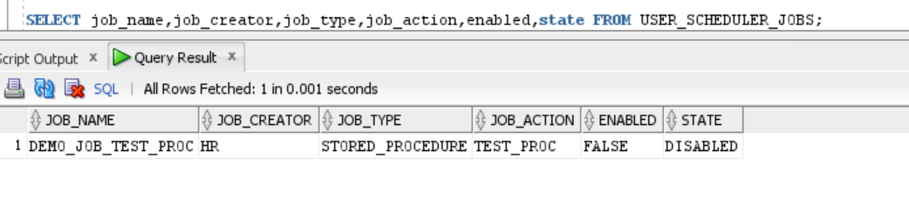

**After job completion.**

**SELECT job_name,job_creator,job_type,job_action,enabled,state FROM USER_SCHEDULER_JOBS;**

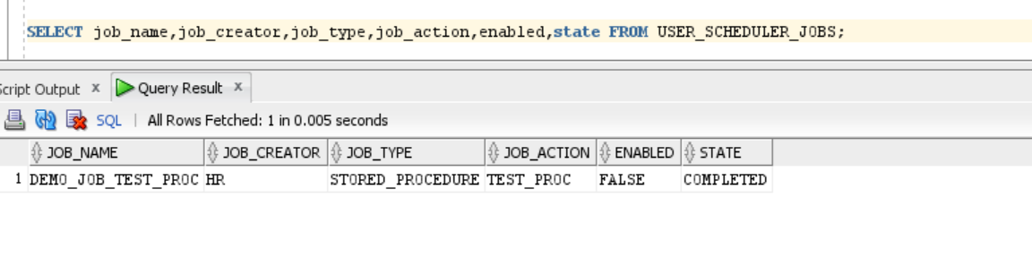

**Dropped the scheduler job.**

**EXEC DBMS_SCHEDULER.drop_job(job_name => 'Demo_Job_TEST_PROC');**

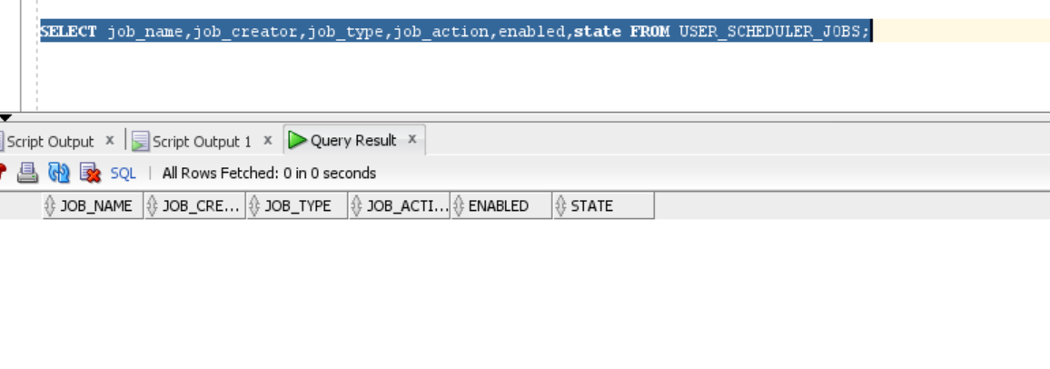

**Job is dropped successfully.**