Obfuscation using WRAP.EXE.

1. Create an sql file as follows containing the stored procedure RET_DATE.

CREATE OR REPLACE FUNCTION RET_DATE

RETURN DATE

IS

v_date DATE;

BEGIN

SELECT SYSDATE INTO v_date from dual;

RETURN v_date;

END;

Save it with the extension test.sql in location C:\Newfolder

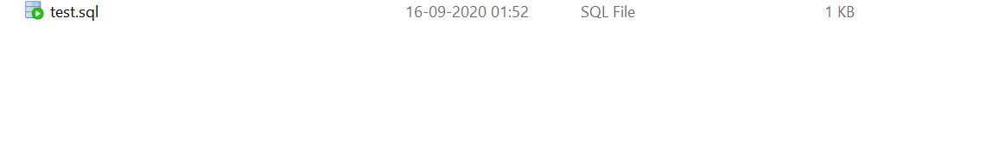

2)Open command prompt and mount tthe location where we have placed the sql file. Then type the following command.

wrap INAME=test.sql

This will create a .plb file in the same directory with same name as that of the sql file.

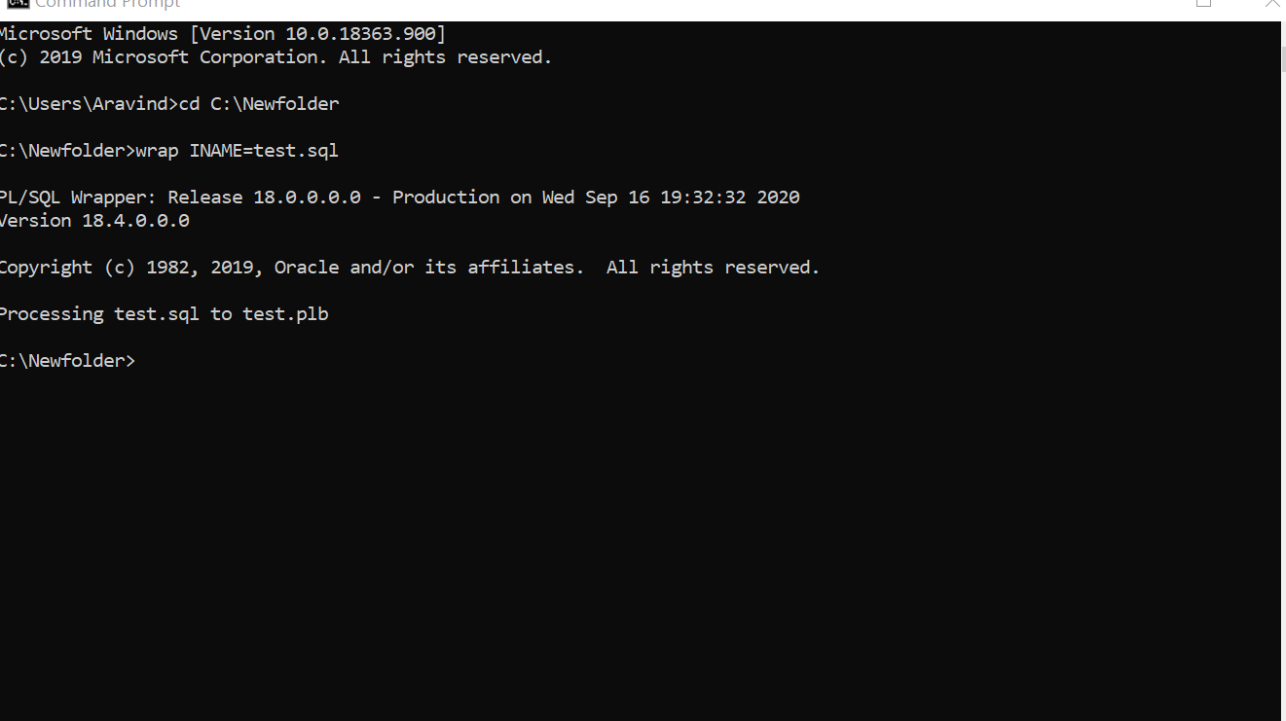

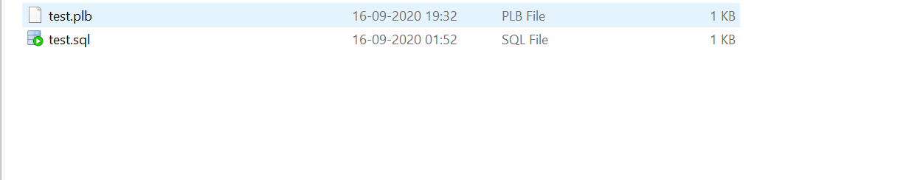

1. In IDE, execute the package file generated in the previous step.

@C:\Newfolder\test.plb;

3)Check the source code. It will appear encrypted.

SELECT LINE,TEXT FROM USER_SOURCE where name='RET_DATE';

