INTRODUCTION

Generative Creativity is one of the most debated areas of all time because there are still many concepts which remain still unresolved. Thinking is very interesting which they tell us thing which we don’t know. Creativity is not limited to art alone it is wide spread in all the aspects of creation, we a say a product or an idea is creative if you have not thought about it or is beyond our knowledge it doesn’t t mean that it never existed .Artificial intelligence e is used in development of the creative art in many of the areas

First I want explain creativity in my words, creativity can never be boundaried.What we say creativity, subjectively existed all the time , but we didn’t know it existed unless suddenly we explore a new space ,then there is a novel thing we find ,we say it is a new idea for us thus creativity. Boden(1995) says that “unpredictability is often said to be the essence of creativity “

This work mainly concentrates on creating pattern with the movement of the zombs, here zombs refere to the small shape which acts as agent throught the program for implementing various strategies and experimnets

Here in this project instead of just using flocking algorithm I attempted to create pattern such that in uses basic rules flocking algorithm and a rule developed by .I extend the idea of using a another set of rules in such a way it produces new results.

The main concept of the project it to create a agents called zombie , which of represent the ideas of zombies in real word which is zombies are humand infecred with virus and they become aggressive towards humans,and a set of humans are created .These zombies and humans follow the movement patter controlled by flocking algorithm.

Zombies are represented in red color and humans are represented in green color .These zombies are attracted towards humans and humans try to run away from the zombies.When the zombie touch humans and still they are close humans agents start to paint in multi color.

Basic rules of FLOCKING algorithm are

The first rule is SEPERATION rule used to avoid the zombies as well humand agent s not to crowd among themselves. The second rule is ALIGNMENT rule used to steer toward the average heading of the other neighbours .The third rule is COHESION rule used to find the average position of the neighbor .The fourth rule which I included is to make the zombies chase the human agents based on the position of individual zombie to the human.

Formally the goal of the project is to demonstarat the differnet types of pattern created with such simple basic rule of separation,alignment ,cohesion along with rule of zombie attacking humans and humans trying to paint different pattern whever attacked.

Informally stating the goal.In this small project the result of the war between the zombie and humans can be identified looking at the pattern created ,if it is more red symbolizing zombie and if more green humanity is spread instead of zombies and multicolored at times when human agents are attacked.

ILLUSTRATION

In illustration of the program I would like to explain the progress of the program from the Start to the end along with some screen shots at each stage.

First stage

First stage was to create a set of zombie agents which need to move through the frame .Once the zombie agents where created the the basic set of rules were assigned to them for controlling there movement this are as stated above separation,alignment and cohesion.

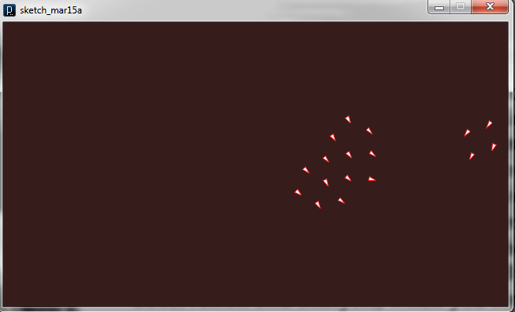

The movement of zombie agent the shows that these follow a pattern for movement along the frame.They maintain the distance between each other ,all zombie move with the relative position of each other.

SECOND STAGE

The second stage of implementation comprises of including the human agents in to the program .This process invlolved creation of the humans along with the zombies .Zombies were given red color to represent bloody nature and humand are given green color to represent humanity.

The movement of the humans agents is also controlled with same set of rule structures.

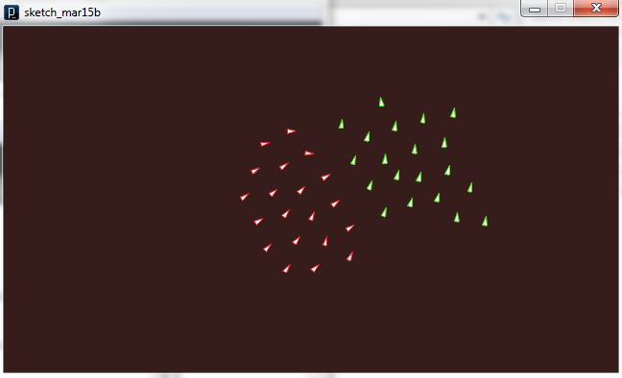

THIRD STAGE :

This stage involved the inclusion of the new rule and other implementation.The zombies were made steer toward the human.The location of the humans along the frame used to steer the zombies towards them .

Here both the zombie and humans paint in there respective colors along the canvas frame.

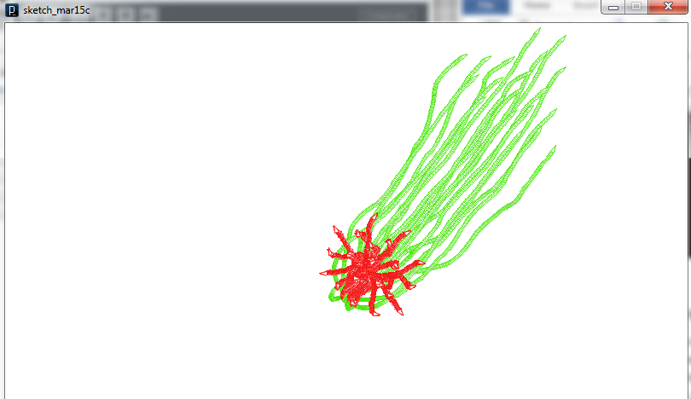

To create a new zombie you can mouse click any where on the canvas frame and they start to behave like other zombie.

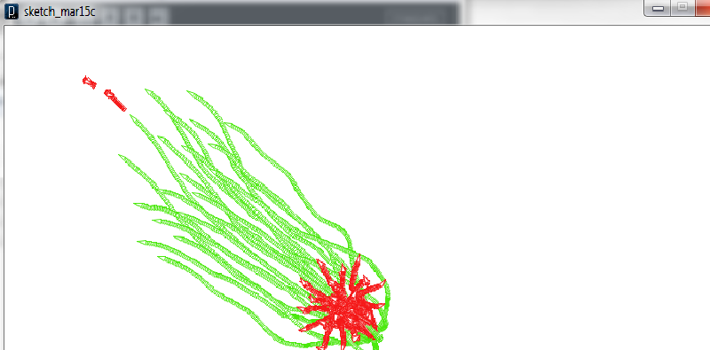

You can see the two new zombie created by mouse click turns toward humans to follow them.

FOURTH STEP

This step is the final step ,small minor change to the beaviour of the zombies and humans in terms of steer speed and basic flocking to rules to create pleseant pattern.

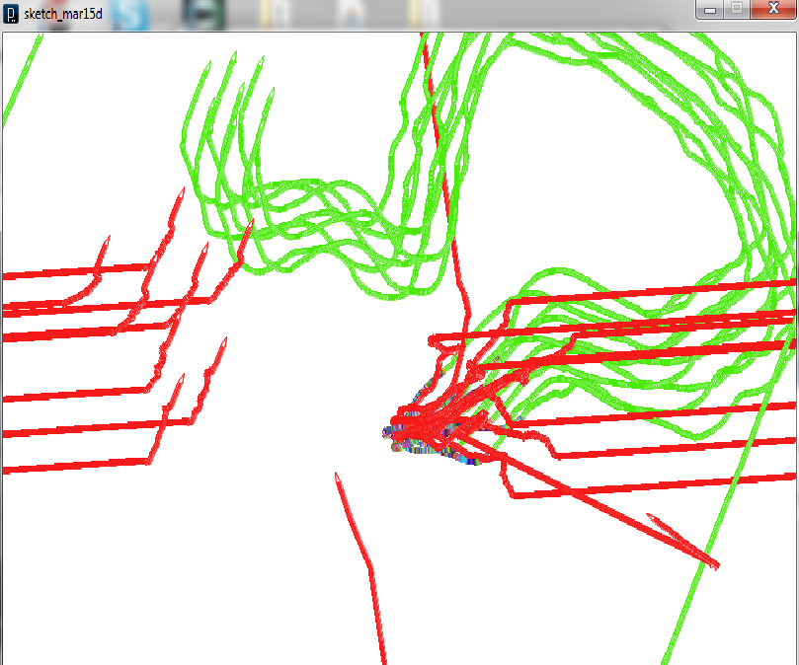

This is the final output you see the pattern if multi color formed when the human where with zombie at starting point

You can also notice the zombies try to move toward the humans from the left in sense of attacking them

rewq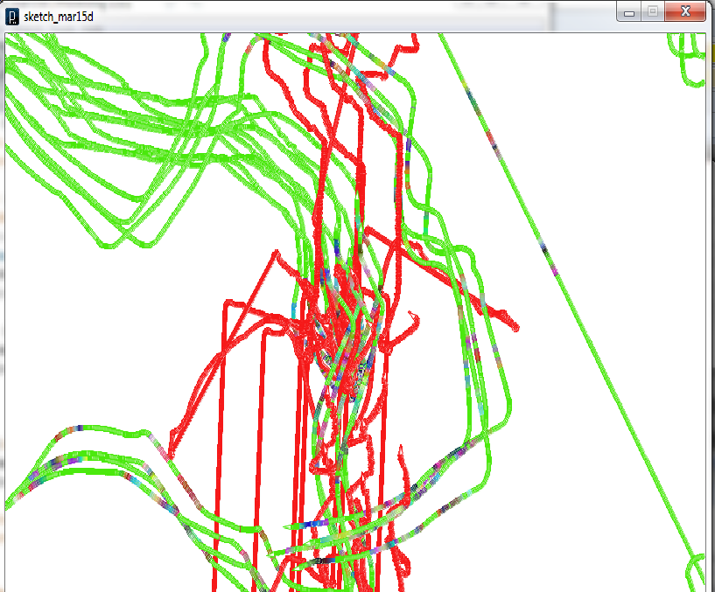

This is another screen short with lots of multi color being drawn over the canvas by afftedted humnas.

SYSTEM OVERVIEW

The program has each separate class files for supporting the function of the zombie and humans.Since the number of class files are limited I am explaining each of them here.

Zombie and Human Class

Zombie class is responsible for creating the zombie with their characters and used to store them in a Arraylist container.

Whenever zombie class is called ,new zombie is instantiated with initial locatin and other characteristics.The movement of the zombie is controlled by four method namely separation,alignment ,cohesion and attraction.These method return values to the alter the the variable location ,velocity, acceleration and attraction.These values are used to control the steer factor of the zombies.

Humans agents are stored in separate class with separate method controlling their movement and chracteristics.Human class have two render function .Render function is used to create the shape of the agents and the color.One render method is used to create the normal voids painting in green and the other render function is used indicate the infected humans painting in multicolor.

There Is another method in human class called paint which takes Arraylist of zombie and humans .For each zombie the distance is calculated with the position of the human.The distance between zombie and human is calculated with Euclidean distance calculation method .This calls the special render method for painting multi color.

FLOCK CLASS

Flock class is to store the zombies and humans as a ArrayList of two different objects and each object is called independently using the run method in their respective classes.

FLOCKING CLASS

Flock class is the main class which hold the setup function of the drawing the canvas background and draw function which calls the flock function iteratively.

LIMITATION

This is not a development software ,this is just a project to exhibit the creativity by artificial means.

Here I have implemented flocking behavior which is common among birds and sheep to control the movement on the humans and zombies.More precisely real behavior of zombies such as crawling and movement towards humans can be implemented

In this humans are not made to repel or move away when the zombie nears them .More naturalistic behavior can improve the performance

We can use this model with further development to test the Mathematical modeling of an out break of zombie infection proposed by,Munz et al(2009).Where they have used a mathematical model to identify the necessary condition required to eradicate zombie infection

There is also a robot called EATR( Energetically Autonomous Tactical Robots) proposed by Defence Advanced Research Projects. Which can feed on bio organic materials to get energy .Such robots results can be tested with this implementation.

Other limitaions

Humans can be made to disappear when ever they are infected by zombies or made to turn in to zombies .I have not implemented this.Humans and zombies stay in same number as they are created.But new zombies canbe created by mouse click anywhere on the screen.

CONCLUSION

This program and course helped me to understand the different aspects of machine creativity and how simple rules and algorithm can be made to seem that they are creative.Success of the project is lies in the different pattern the agents try to make in competing each other and each time they try to create new patterns .The interesting factor is that these patterns really looks spooky in sometimes.

**SELF MARKING**

|  |  |  |
| --- | --- | --- |
| **CRITERIAS** | **MY MARK** | **MAX MARK** |
| WRITING | 10 | 10 |
| DISCURSIVE QUALITY | 9 | 10 |
| PRESENTATION | 10 | 10 |
| RANGE OF RESEARCH | 9 | 10 |
| SYSTEM COMPREHESIBILITY | 9 | 10 |
| SYSTEM QUALITY AND SOPHISTICATION | 9 | 10 |
| OUTPUT | 10 | 10 |
| COURSE AWARNESS | 9 | 10 |

Writing :

Very appropriate writing with necessary reference to source and material.Explain each and every case necessary screen shots for easy understanding.

Discursive Qaulity:

Well pointed out point and discussion with necessary referencing to the source where other such works are beign carried out and explaining where such future works can be and to extend this present project.

Presentation:

Presentation is well done with following the presceibed formats ,numbering font selection, including necessary screen shots and content page and bibliography.

Range of research

Detail analysis of how flocking algorithm and other basic rules invlolved .All the involved literature regarding this works are well understood.

System Comprehesibility:

Code structur is well built with out more cohedsion and less coupling,modularity is maintained by keeping the function of different classe into separate methods and codes is well commented.Transperncy and simplicity is well demonstrated.

System Quality and sophistication:

Function of the program are well developed and perform accurate task assigned to perform without any compromises which plays a major role in quality of the system and performance.

Output:

Working output with deffernt and generative patterns each time , Out put is obtained as expected and as the goal is stated.With aesthetics and smoothness.

Course awareness

This projet itself is inspird by one of the lectures and lab classes .Necessary knowledge and usefulness are demonstrated in explaining the program as well developing it.clearly demonstrated technical knowledge of techniques in generative art different techniques that can be used to and understanding of the same.